

# CS319 - OBJECT ORIENTED SOFTWARE ENGINEERING

# PROJECT ANALYSIS REPORT

# DIGGER UNLIMITED

# PART 1

# **GROUP G**

### **ERKUT ALAKUŞ**

### **DOĞANCAN DEMİRTAŞ**

### **GÜNÇE KALYONCU**

### **CANSU TÜZMEN**

TABLE OF CONTENT

**1.Introduction** **3**

**2.Proposed System** **3**

2.1. Overview 3

2.1.1. Gameplay 4

2.1.2. Leveling 4

2.1.3. The Miner 5

2.1.4. The Monsters 5

2.1.5. Gold & Silvers 6

2.1.6. Bonuses 6

2.1.7. Power-ups 7

2.1.8. Power-downs 8

**3.Functional Requirements** **9**

3.1. Play Game 9

3.2. Select Game Theme 9

3.3. Change Settings 10

3.4. Pause Game 10

3.5. View Credits 11

3.6. How to Play 11

**4.Nonfunctional Requirements** **11**

4.1. Frame rate 11

4.2. Response Time 11

4.3. Platform 11

**5.System Models** **12**

5.1. Use Case Model 12

5.1.1. How to Play 13

5.1.2. View High Scores 14

5.1.3. Play Game 16

5.1.4. View Credits 19

5.1.5. Change Settings 20

**1. Introduction**

Digger Unlimited is an improved and modified version of Digger which is a basic arcade game like *Pac-man* and *Dig Dug*. As in those games, the main aim is that collecting all gold and silvers without being caught by the monsters to finish the level. Unlike the original version, the Digger Unlimited will include new features like themes, bonuses and maps to make it more entertaining. While deciding these features, it is inspired by *Digger*, *Temple Run* and *Jetpack Joyride*:

Digger:

<http://en.wikipedia.org/wiki/Digger_(video_game)>

Temple Run:

<http://en.wikipedia.org/wiki/Temple_Run>

Jetpack Joyride:

<http://en.wikipedia.org/wiki/Jetpack_Joyride>

The game will only available as a desktop application so the player will need a mouse and a keyboard to control and play the game.

**2. Proposed System**

**2.1. Overview**

Unlimited Digger is a basic arcade game likely its ancestors. Basically, the game starts in a mine and there will be at least one tunnel for the Miner to move and two different monsters. There will be also some gold and silvers for scoring and bonuses for changing the course of the game. The main goal of the player is expanding the existing tunnel by digging to collect all the stuff without being touched by these monsters to complete all levels successfully.

* + 1. **Gameplay**

Theplayer needs a keyboard to lead the Miner to move by direction keys and a mouse to click on the buttons like pause.

* + 1. **Leveling**

**  **

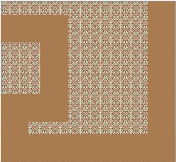 

Figure 1: A representative View of 5 Levels

The game has 5 levels and they are sorted according to their difficulties. When the number of level increases, the total of excavated area at the beginning decreases. Therefore, it gets harder to complete the game without being caught by a monster and collect all gold and silvers.

* + 1. **The Miner**

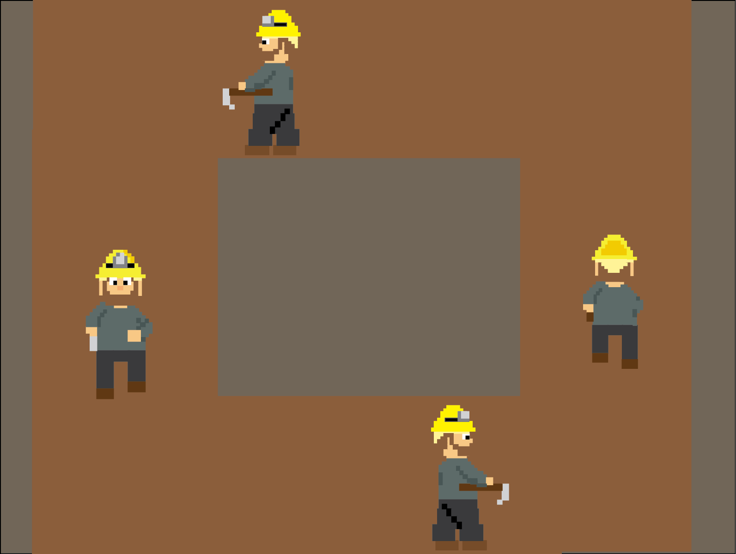

Figure 2: The movement of the Miner

The main character of the game is the miner as the digger. The player could only lead the miner by using the direction buttons of keyboard to make him dig vertically and horizontally.

* + 1. **The Monsters**

** **

Figure 3: The Mole and the Earth Monster

The game contains two different types of monsters which are a mole and an earth monster. Both of them are able to move vertically and horizontally to catch the player without collecting all silvers and gold to finish. The Earth Monster is also able to dig like the Miner. When the player is caught by one of them, one of its lifes is lost.

At the beginning of the game, there is one Earth Monster but the number of the moles increase as levels pass. Until the player collects one of the power-downs, their amount does not change. They start the game in the opposite corner of the miner so that player can complete the game successfully.

* + 1. **Gold & Silvers**

There are some gold and silvers in unexcavated areas at the beginning of the game and player gains more score with collecting golds rather than silvers. The player scores 200 points for gold and 100 points for silver so he should try to collect some power-ups to increase his score for a high one.

* + 1. **Bonuses**

This new version of the game includes some power-ups and power-downs unlike the original to make it more amusing and challenging. These power ups/downs are unknown to the player until he collects them. The program selects these power-ups and power-downs randomly and after the player collects, the program will renew it. In a sense, there is a big possibility that the player collect the same, useful or harmful ones repeatedly and this makes the game more fun. The power-ups and power-downs are:

**2.1.7. Power-ups:**

** ExtraLife:** It gives an extra life to the player.

 **SilverToGold:** It changes all silvers to gold.

 **DoubleGolds:** It multiplies the score of gold by two.

 **DoubleSilvers:** It multiplies the score of silvers by two.

 **Triple Golds:** It multiplies the score of gold by three.

 **TripleSilvers:** It multiplies the score of silvers by three.

 **Magnet:** It helps the player collect gold and silvers more quickly.

 **InvisibleMiner:** It makes the miner invisible so that he can escape from the monsters more easily.

 **DigAll:** It digs all maze.

 **Destroy Monsters:** It destroys the monsters.

**2.1.8. Power-downs:**

 **LoseLife:** It takes one of the lives of the player and if the player has only one life, he dies.

 **GoldToSilver:** It changes all gold to silvers.

 **DigBack:** It sends the player to the start point and cancels the excavated area during the game.

 **DoubleMonsters:** It multiplies the number of the monsters by two.

 **TripleMonsters:** It multiplies the number of the monsters by three.

1. **Functional Requirements**
   1. **Play Game**

Digger Unlimited is an arcade game, based on a simple “Pacman” concept. While playing the game, the aim of the player is to collect all gold and silvers and keep the digger away from the monsters. In the beginning of the game player has 3 lives. Whenever digger touches a monster, it dies and loses one of its lives and starts digging from its beginning location. After losing all 3 lives, game ends and player is directed to the main screen. Also a prompt is shown to the player asking him enter his nick in order to show his score in the game in the high score table.

If player collects all the golds and silvers another level is started with a different map and harder game fiction. Amount of monsters are increased with respect to levels.

Also there are power ups and downs which are distributed randomly among the map as explained in the section 2.1.

* 1. **Select Game Theme**

Player will be allowed to select one of the 4 available themes as a game theme. Depending on the choice, digger and monsters will be changed. Available themes will be:

* Digger Unlimited Theme
* Halloween Theme
* Original Digger Theme
* Christmas Theme
  1. **Change Settings**

Player should be able to change game settings. Available settings are:

* Sound on/off
* Music on/off

These preferences will be stored accordingly and new games will be started with respect to previous choices of user.

* 1. **Pause Game**

Player will be able to pause the game, by pressing the “Escape” button. A sub menu will be displayed with this action. In this sub menu the following menu items will be shown to the player:

* Resume
* Retry
* How to Play
* Go to Main Menu
* Exit

When player clicks on resume item, game will be resumed. If player clicks on “Go to Main Menu” item, he will be redirected to main menu. If player clicks on “Exit” item, he will exit from the game. Player will be directed to a little tutorial screen as he clicks on “How to Play” item and starts the game from the beginning if he clicks on “Retry” item.

* 1. **View Credits**

Player will be able to see the credits, after clicking it from the main menu. Developers’ name and their pixel art drawings will be displayed on the screen. As Digger Unlimited is a modified version of original Digger game, a link to its web site will be given.

* 1. **How to Play**

Player will find useful information about how to move the digger, and what is the main purpose of the game. This will also include definitions of power-up/downs and more information about the monster types.

1. **Nonfunctional Requirements**
   1. **Frame Rate**

Average frame rate of the game will be 30 frames per second.

* 1. **Response Time**

Since Digger Unlimited game will be played locally on a computer, average response time will not be more than 0.5 second.

* 1. **Platform**

Since the game will be written in Java, any computer with Java installation could run the game.

1. **System Models**

**5.1. Use Case Model**

In this section, we will provide use case model and flowcharts of Digger Unlimited game to express it more clearly.

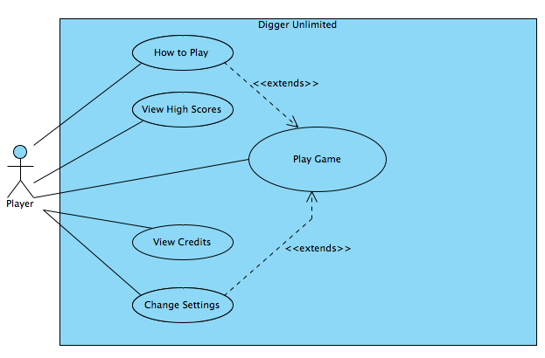 Figure 4: Use Case Model of Digger Unlimited

* + 1. **How to Play**

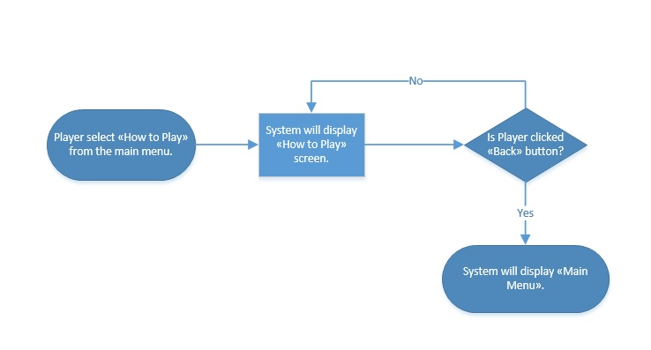

|  |  |  |  |  |
| --- | --- | --- | --- | --- |
| **Use Case ID:** | UC_HP_001 | | | |
| **Use Case Name:** | How to Play | | | |
| **Created By:** | GncKlync | | **Last Updated By:** | - |
| **Date Created:** | 13/10/2014 | | **Last Revision Date:** | - |
| **Actors:** | | Player | | |
| **Description:** | | Player could read the manual of the game to learn how to play the game. | | |
| **Trigger:** | | Player selects “How to Play” from Main Menu. | | |
| **Preconditions:** | | **-** | | |
| **Postconditions:** | | - | | |
| **Normal Flow:** | | 1. Player selects “How to Play” option from the Main Menu. 2. How to Play will be displayed to the Player on screen. | | |
| **Alternative Flows:** | | To A. If Player wants to exit from the How to Play screen  A.1. Player select “Back” button to return “Main Menu”  A.2. System displays “Main Menu” | | |
| **Exceptions:** | | - | | |
| **Includes:** | | - | | |
| **Frequency of Use:** | | - | | |
| **Special Requirements:** | | - | | |
| **Assumptions:** | | Player will read the manual and ACTUALLY learn the game and buttons to play it. | | |
| **Notes and Issues:** | | - | | |

* + 1. **View High Scores**

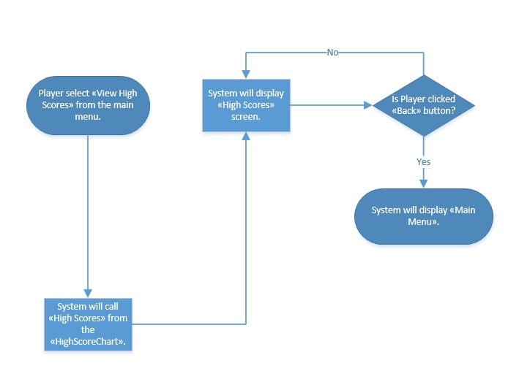

|  |  |  |  |  |
| --- | --- | --- | --- | --- |
| **Use Case ID:** | UC_HS_001 | | | |
| **Use Case Name:** | View High Scores | | | |
| **Created By:** | GncKlync | | **Last Updated By:** | - |
| **Date Created:** | 13/10/2014 | | **Last Revision Date:** | - |
| **Actors:** | | Player | | |
| **Description:** | | This event will display “High Scores” menu when its triggered by the user. Also makes the transition between “High Scores” and “Main Menu”. | | |
| **Trigger:** | | Player select “View High Scores” from Main Menu. | | |
| **Preconditions:** | | **System should keep a record of top ten scores.** | | |
| **Postconditions:** | | - | | |
| **Normal Flow:** | | 1. Display top ten high scores with player names. | | |
| **Alternative Flows:** | | To A. To go back to main menu at any time:  A.1. Player select “Back” button to return “Main Menu”  A.2. System displays “Main Menu” | | |
| **Exceptions:** | |  | | |
| **Includes:** | | HighScoreChart | | |
| **Frequency of Use:** | | - | | |
| **Special Requirements:** | | - | | |
| **Assumptions:** | | If there is not enough high scores saved by the player(less than 10), System will fill out the chart with player name “XXX” and score of “0”. | | |
| **Notes and Issues:** | | - | | |

* + 1. **Play Game**

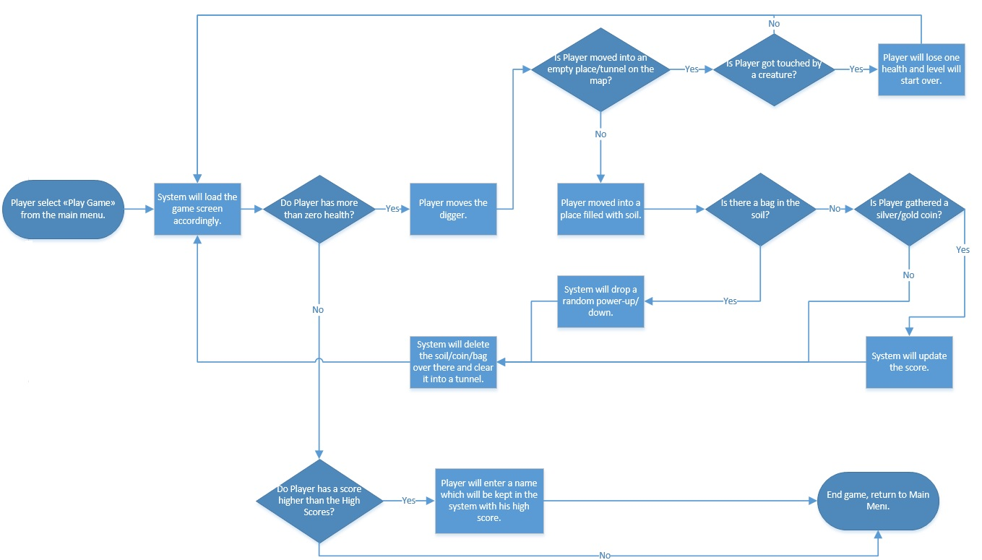

|  |  |  |  |  |
| --- | --- | --- | --- | --- |
| **Use Case ID:** | UC_PG_001 | | | |
| **Use Case Name:** | Play Game | | | |
| **Created By:** | GncKlync | | **Last Updated By:** | - |
| **Date Created:** | 13/10/2014 | | **Last Revision Date:** | - |
| **Actors:** | | Player | | |
| **Description:** | | Player tries to finish the game by completing all the levels with the highest score. System will keep the score, with a desired name from the Player in the end if Player gets a high score. | | |
| **Trigger:** | | Player select “Play Game” from Main Menu. | | |
| **Preconditions:** | | **Game loaded according to the game settings. At start, if Player did not change game settings, game will begin with default settings.** | | |
| **Postconditions:** | | If score is greater than the top 10 high scores, system will update the high score list with this new score by letting Player enter a name for the score. | | |
| **Normal Flow:** | | 1. System starts the game. 2. Player will start from the first level. 3. Player will gather all the silver and gold in the level. 4. System will load the next level, when Player finishes the current one. 5. Play will start to play the next level.  * Steps 3-5 will be repetitive for the all 5 levels of the game.  1. If Player scores higher than a value in the high score chart, System will let player enter a name to save his score to the high score list. Otherwise System will show the high score list only. 2. System returns to Main Menu. | | |
| **Alternative Flows:** | | To 3A. Player tries to finish the level by collecting all the silver and gold coins while running away from the creatures.  3A.1. Player creates roads to coins by digging the map.  3A.2. Map is getting cleaner as the Player moves and digs.  3A.3. If Player comes upon a coin, he will be rewarded with points accordingly.  3A.4. System will update Player’s score.  3A.5. System will check if all the coins are gathered.  -If not player will continue again from the 3A.1.-3A.5.  3A.6. If all the coins gathered by the Player, level ends and System will upload the next level with a new map.  3B. Player gets a power-up or power down.  3B.1. Player will gather the bags, which is not required to finish the level.  3B.2. These bags will drop power-ups/downs.  3B.3. Player will collect a power-up/down.  3B.4. System will clear the power-up/down from the screen, whether Player collects it or it is removed after 15 seconds.  3B.5. If Player claims a power-up/down; System will do the necessary changes over the game accordingly.  -This process is same for every power-up/down process.   1. If Player pauses the game.   A.1. Player press the proper key to pause the game.  A.2. System will pause the game.  A.3. System will show the “Pause Menu”  A.3.1. If Player selects “Resume”, system will return to game.  A.3.2. If Player selects “Return to Main Menu”, System will close the current game and opens the “Main Menu”  A.3.3. If Player selects “Change Settings”, System will call “UC_CS_001” use case.  A.3.4. If Player selects “How to Play”, System will call “UC_HP_001” use case.  A.3.5. If Player selects “Exit Game”’, System will return to the desktop by closing the game. | | |
| **Exceptions:** | | - | | |
| **Includes:** | | - | | |
| **Frequency of Use:** | | - | | |
| **Special Requirements:** | | - | | |
| **Assumptions:** | | - | | |
| **Notes and Issues:** | | - | | |

* + 1. **View Credits**

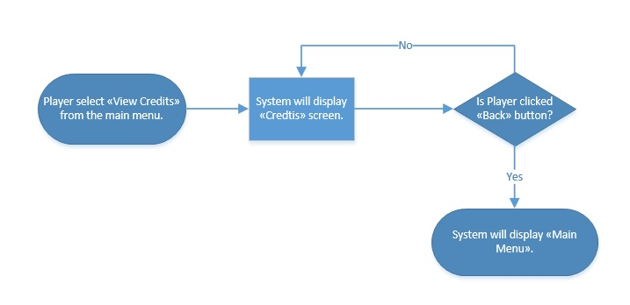

|  |  |  |  |  |
| --- | --- | --- | --- | --- |
| **Use Case ID:** | UC_CR_001 | | | |
| **Use Case Name:** | View Credits | | | |
| **Created By:** | GncKlync | | **Last Updated By:** | - |
| **Date Created:** | 13/10/2014 | | **Last Revision Date:** | - |
| **Actors:** | | Player | | |
| **Description:** | | This event will display “Credits” screen when its triggered by the user. Also makes the transition between “Credits” and “Main Menu”. | | |
| **Trigger:** | | Player select “View Credits” from Main Menu. | | |
| **Preconditions:** | | **-** | | |
| **Postconditions:** | | - | | |
| **Normal Flow:** | | 1. Display information about developers and their messages about the game. | | |
| **Alternative Flows:** | | 1. To go back to main menu at any time:   A.1. Player select “Back” button to return “Main Menu”  A.2. System displays “Main Menu” | | |
| **Exceptions:** | | - | | |
| **Includes:** | | - | | |
| **Frequency of Use:** | | - | | |
| **Special Requirements:** | | - | | |
| **Assumptions:** | | - | | |
| **Notes and Issues:** | | - | | |

* + 1. **Change Settings**

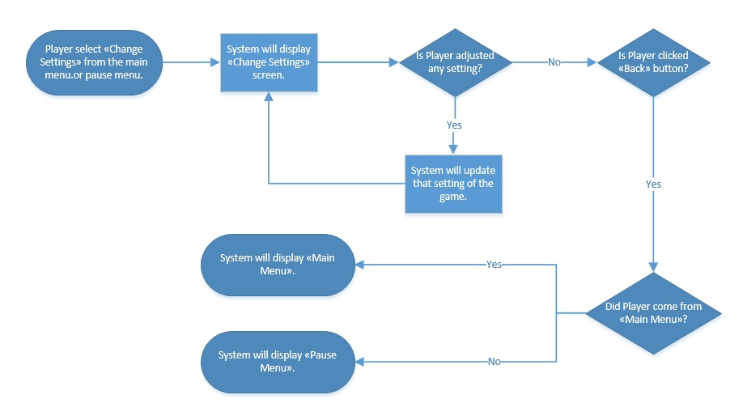

|  |  |  |  |  |
| --- | --- | --- | --- | --- |
| **Use Case ID:** | UC_CS_001 | | | |
| **Use Case Name:** | Change Settings | | | |
| **Created By:** | GncKlync | | **Last Updated By:** | - |
| **Date Created:** | 13/10/2014 | | **Last Revision Date:** | - |
| **Actors:** | | Player | | |
| **Description:** | | Player could change the default game settings such as “theme”, “sound on/off”, “music on/off” from the “Change Settings” screen. | | |
| **Trigger:** | | 1. Player selects “Change Settings” from Main Menu.  2. Player selects “Change Settings” from Pause Menu. | | |
| **Preconditions:** | | **Current – if not changed by the player, default – settings will be shown to the player.** | | |
| **Postconditions:** | | Game settings are updated. | | |
| **Normal Flow:** | | 1. Player selects “Change Settings” option from the main menu or Pause Menu. 2. Game Settings will be displayed to the Player on screen. 3. Player will change/update game settings. 4. System will update the game accordingly. | | |
| **Alternative Flows:** | | To To A. If Player wants to exit from the Game Settings screen  A.1. Player select “Back” button to return previous menu  A.2. System displays “Main Menu” or “Pause Menu” accordingly | | |
| **Exceptions:** | | - | | |
| **Includes:** | | - | | |
| **Frequency of Use:** | | - | | |
| **Special Requirements:** | | - | | |
| **Assumptions:** | | - | | |
| **Notes and Issues:** | | - | | |