Jaskirat Singh Grewal

100365933

INFO1113 S11

Assignment 3

November 14, 2018

Instructor-Abhijit Sen

Team Members:

1. Jaskirat Singh Grewal(100365933):<https://github.com/jazzgrewal/gamerzhere_jaskirat>
2. Rishabh Garg(100371073):<https://github.com/rishabh4899/UseCaseDiagram>
3. Omar Abushbak (100368325):<https://github.com/omarabushbakxx/gamerzhere-omar>
4. Jagjot Singh(100374227):<https://github.com/singhjagjot0013/gamerzhere-jagjotsingh>

**Reviewing**

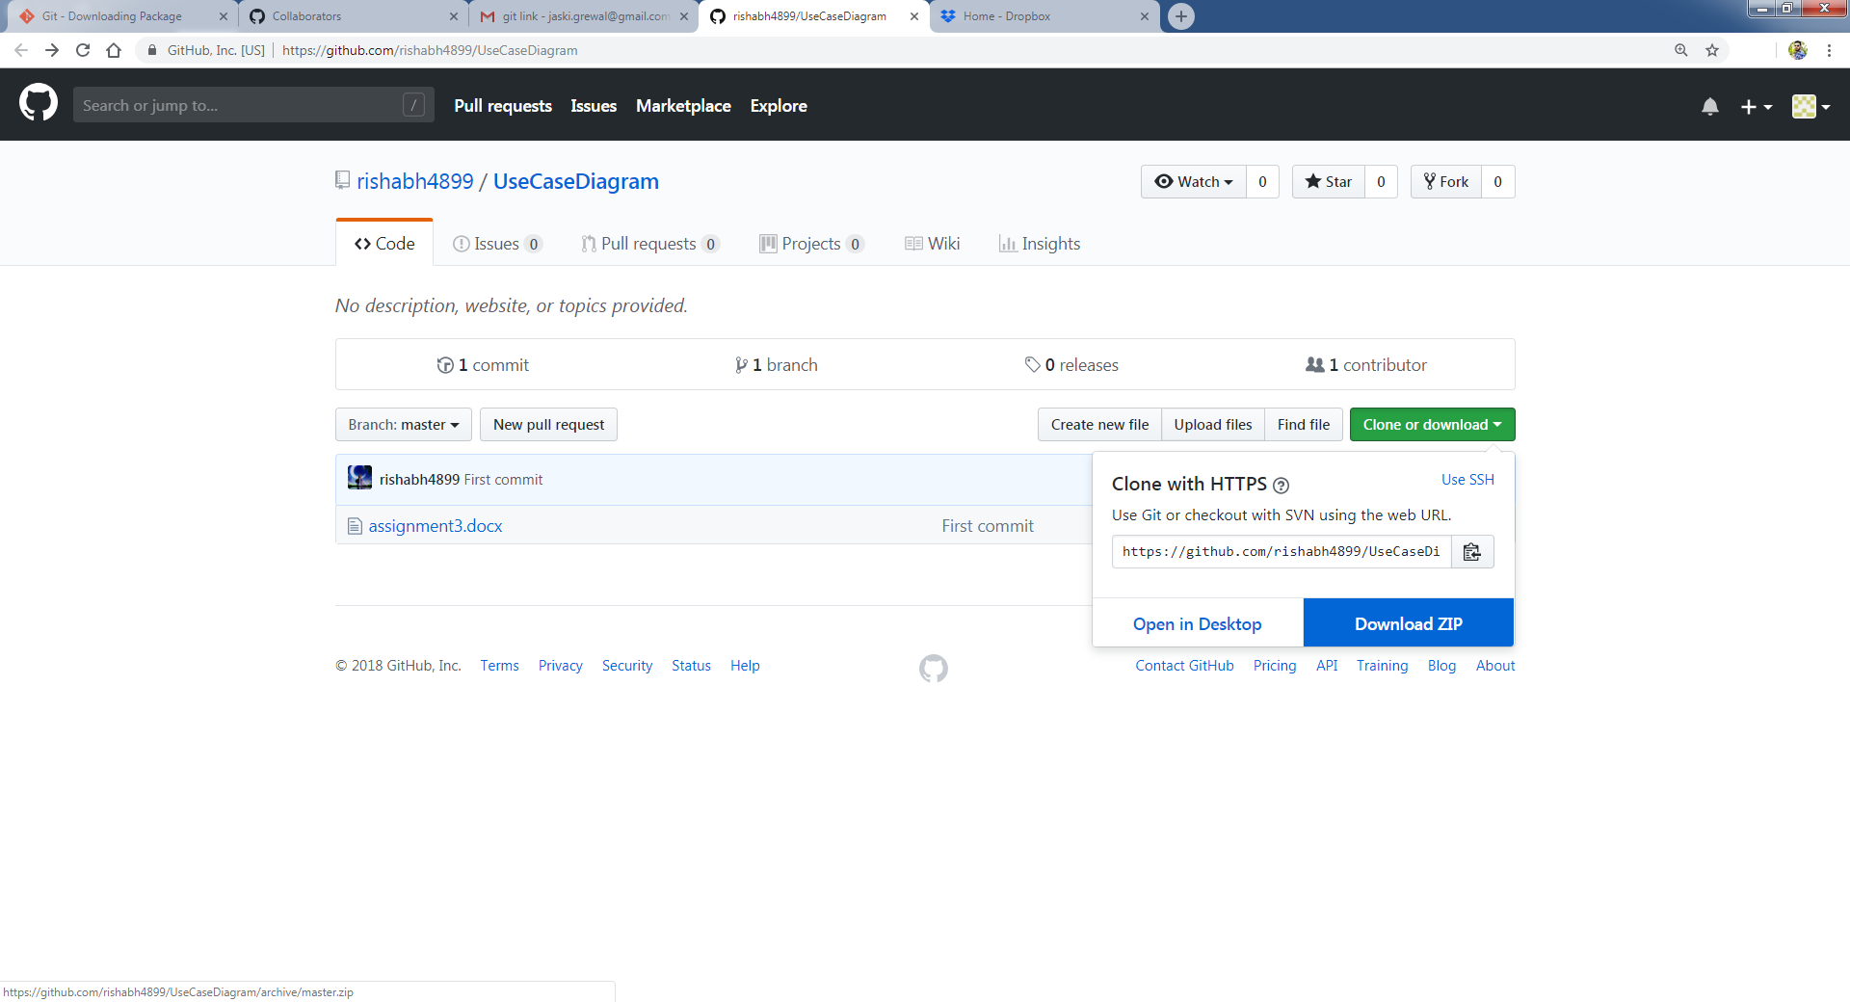

Step 1: Downloading Rishabh Garg’s Assignment 3 file which has UML diagram and the Use Case Description.

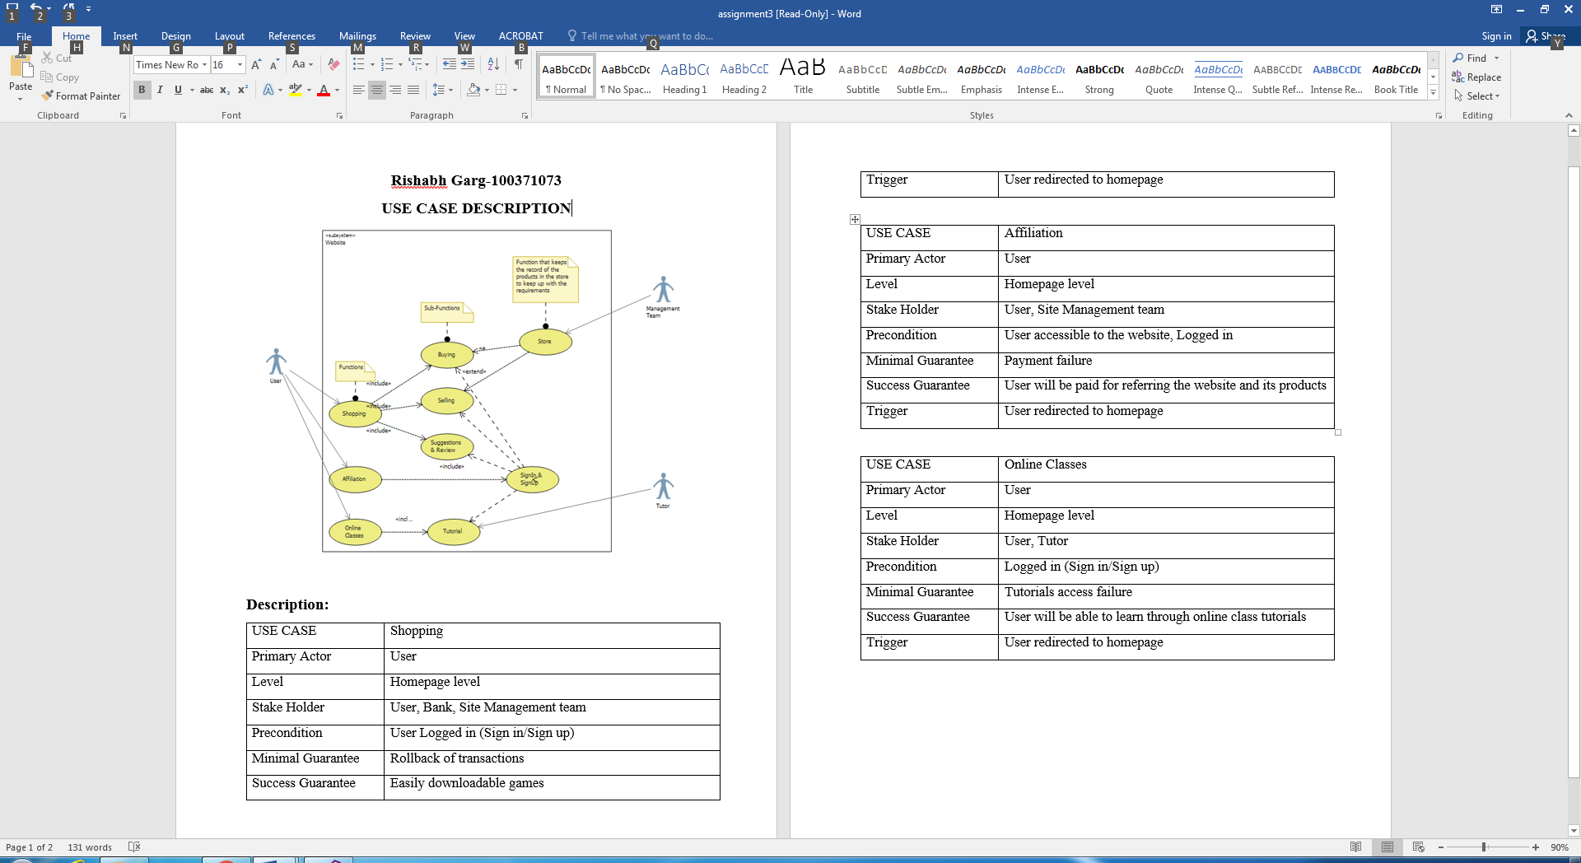

Step 2: Review Screenshot, we took a few ideas from this Diagram for the Final Diagram. But we have to exclude the Use case “Affiliation” because that will make it complicated.

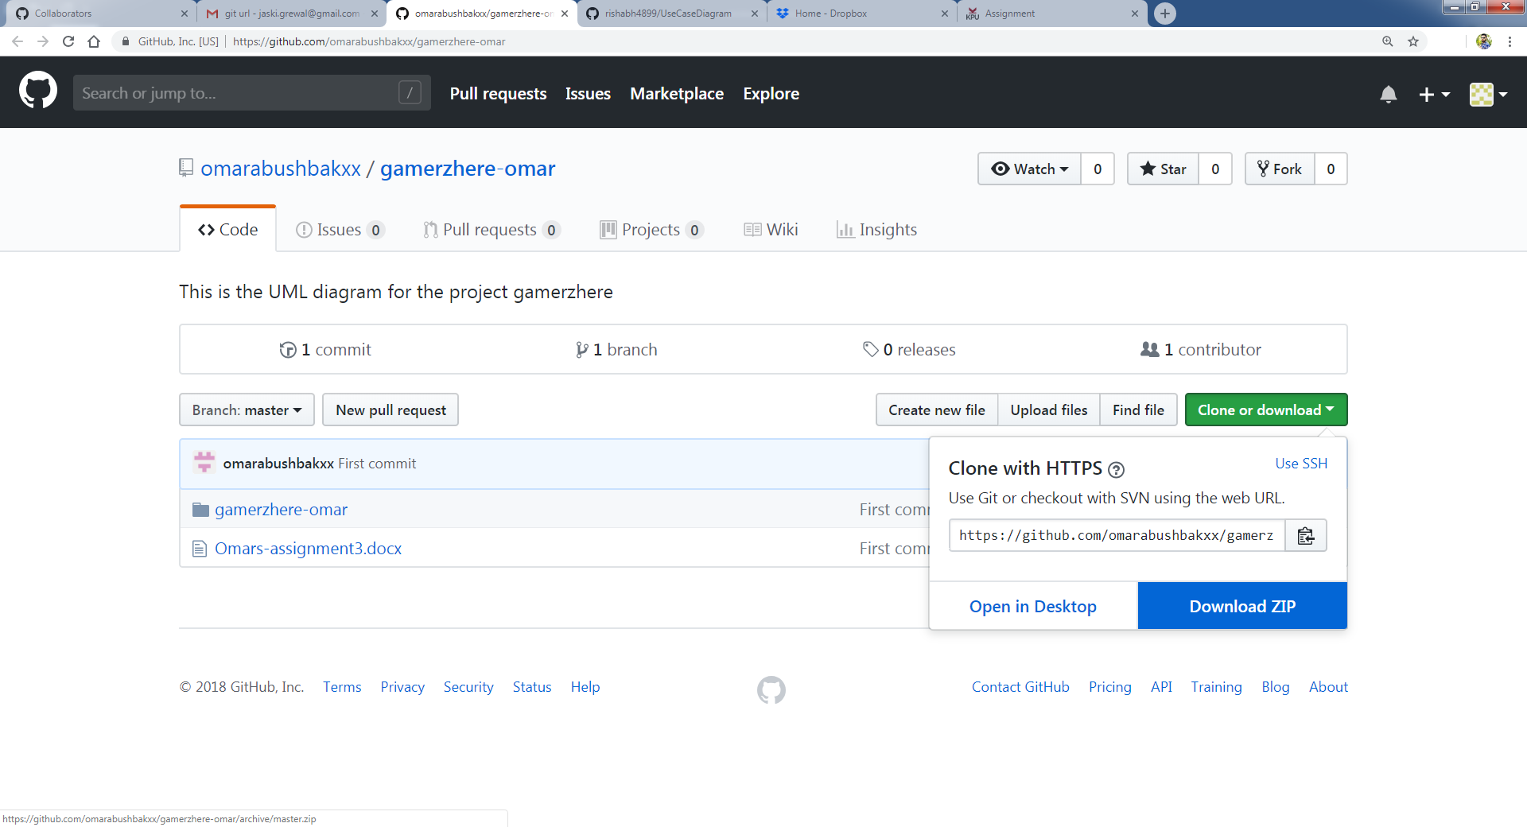

Step 3: Downloading Omar’s doc file which has UML diagram and the Use Case Description.

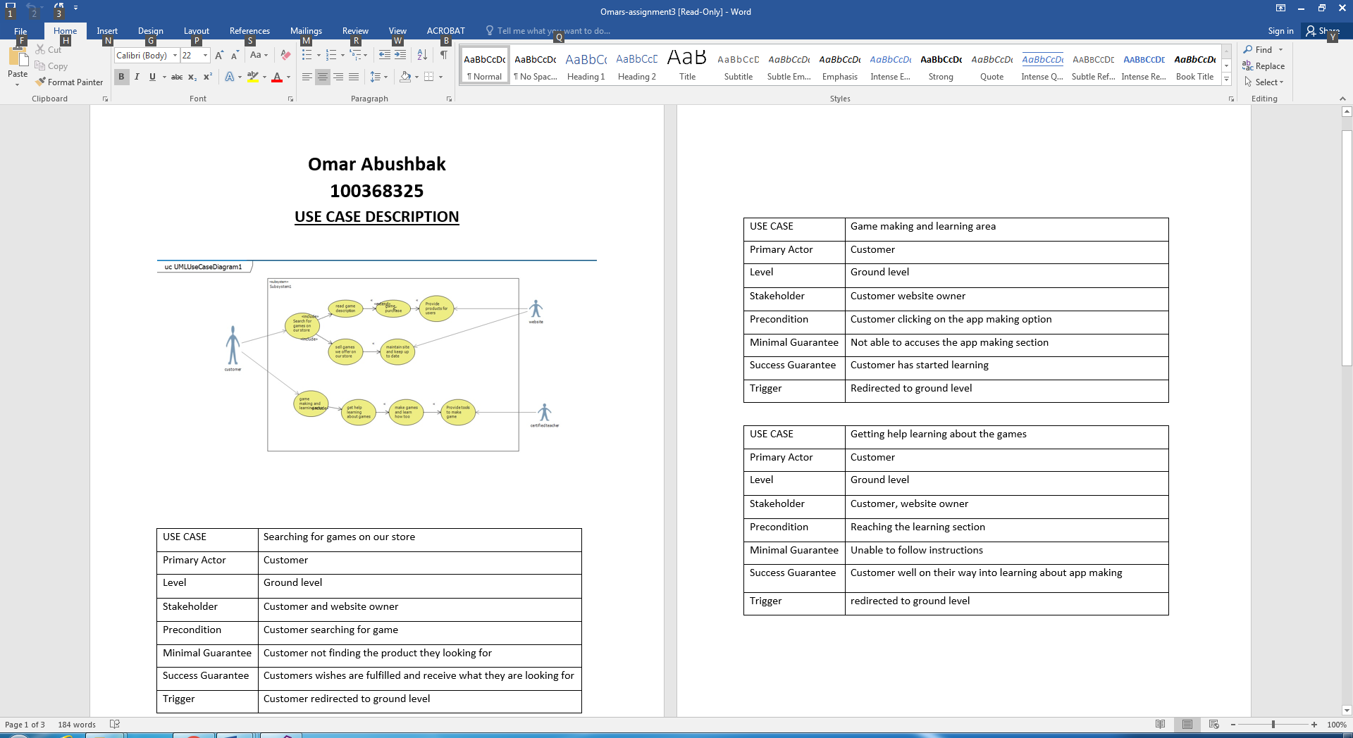

Step 4: Review Screenshot, Omar’s Idea was a bit lengthy we have to cut-down a few things. Like, getting help in games by request, this will make our email and cloud space filled with massages.

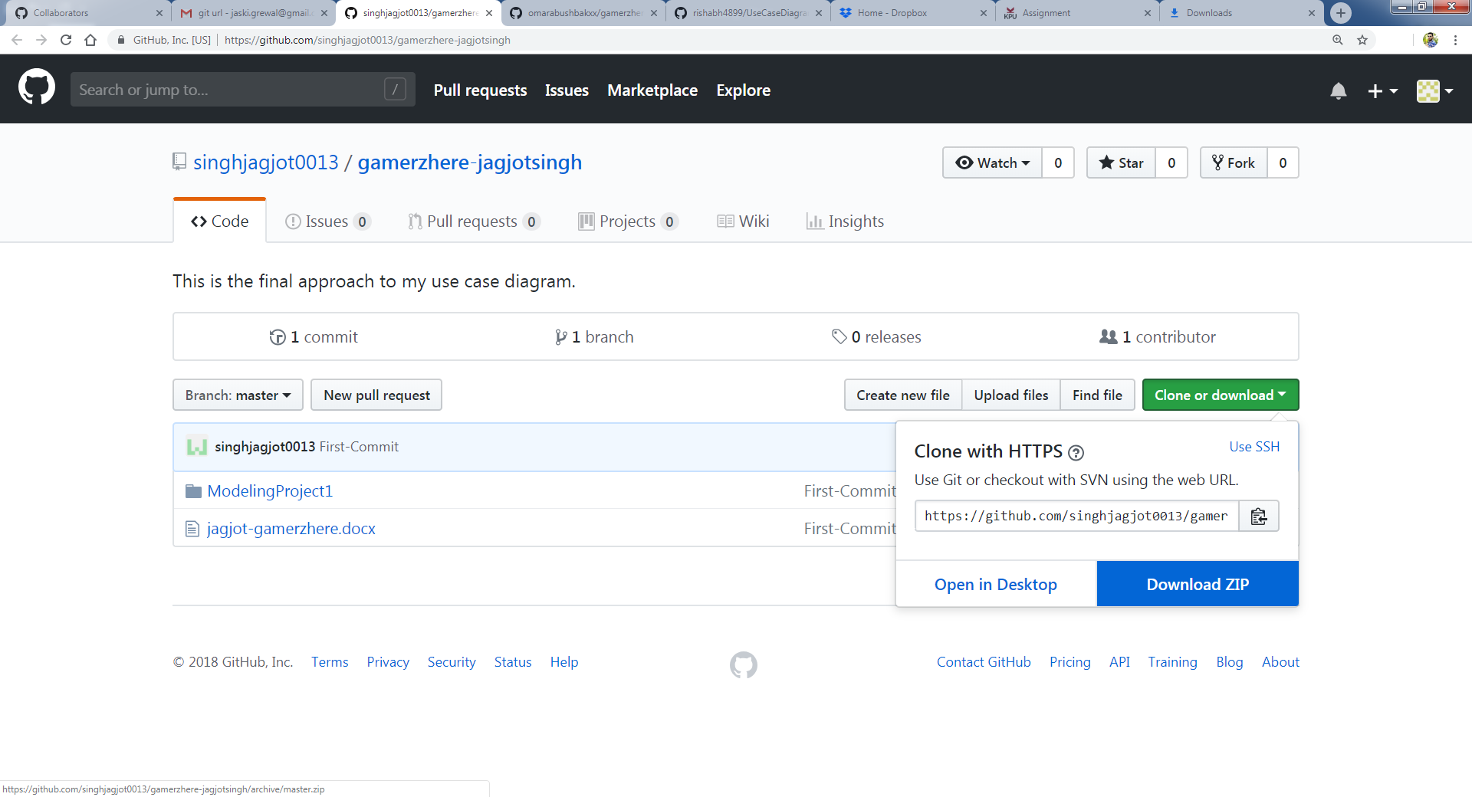

Step 5: Downloading Jagjot’s repository file which has UML diagram and the Use Case Description.

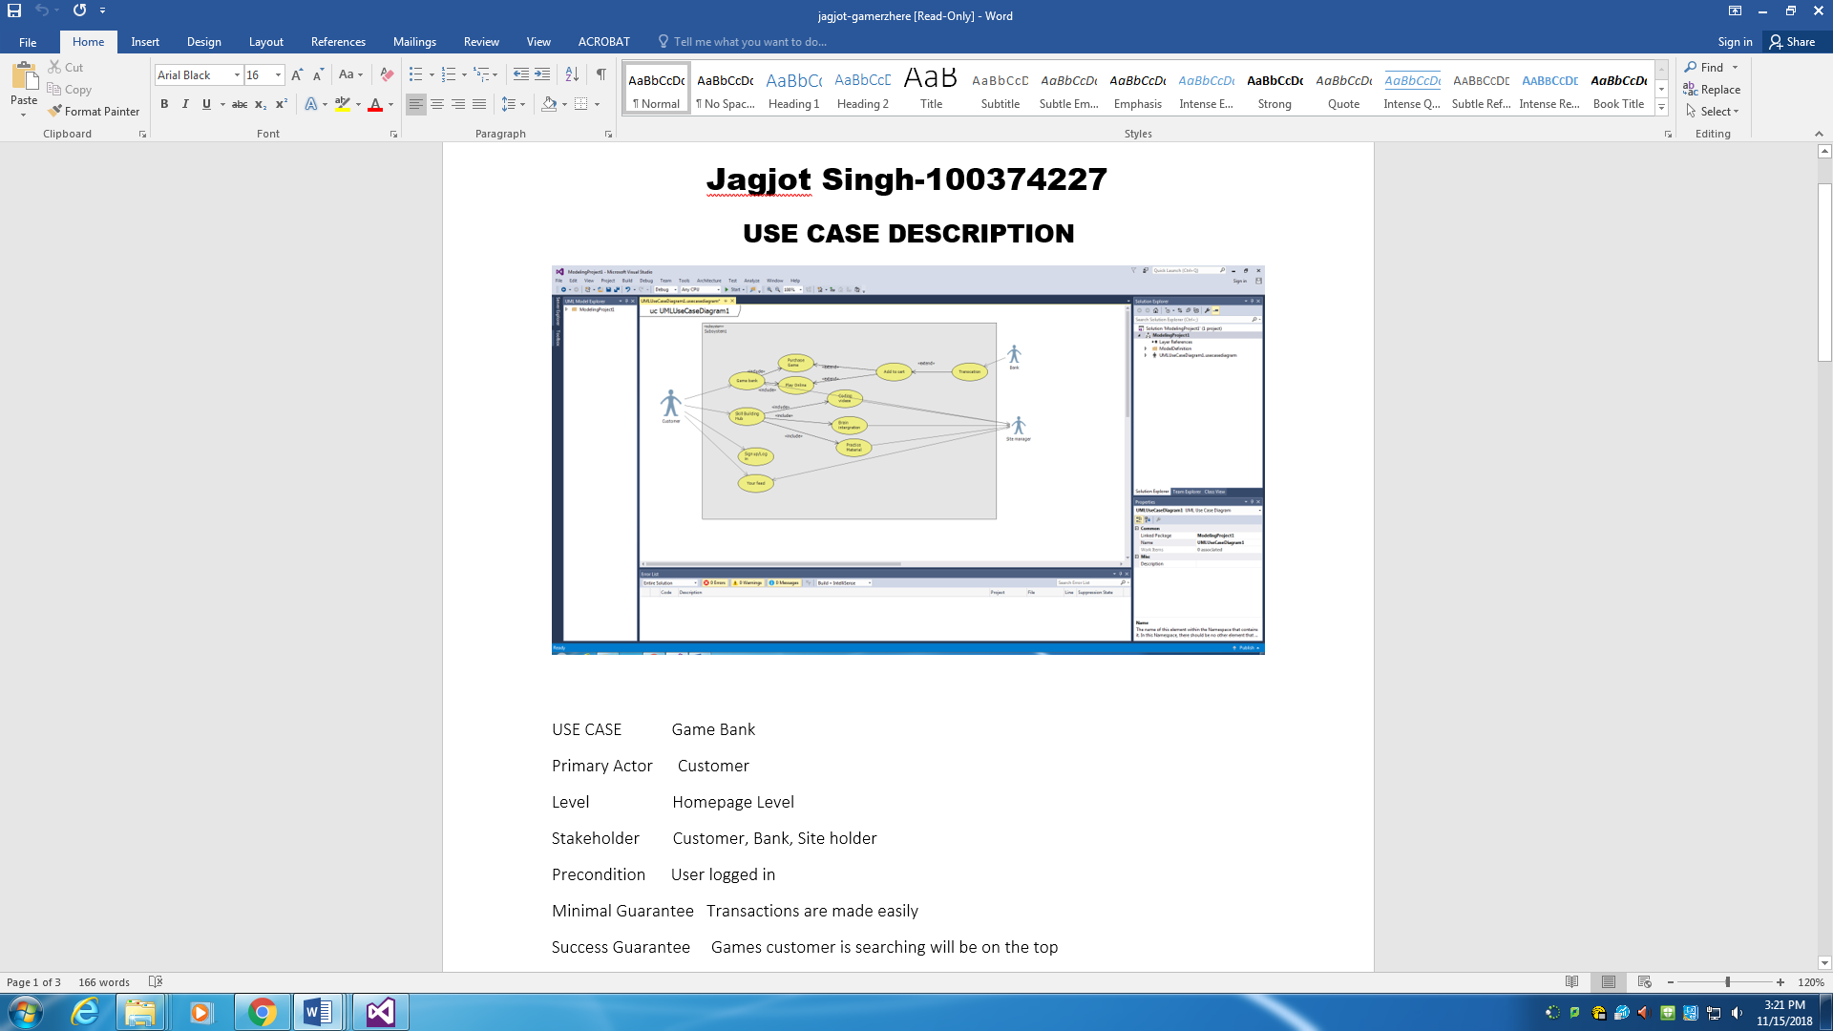

Step6: Review Screenshot, Jagjot’s Idea included Skill Building Hub which had coding videos, Brain Integration and Practice Material, we had to cut down few of those functions.

**Uploading The Final UML Diagram and Adding Collaborators**

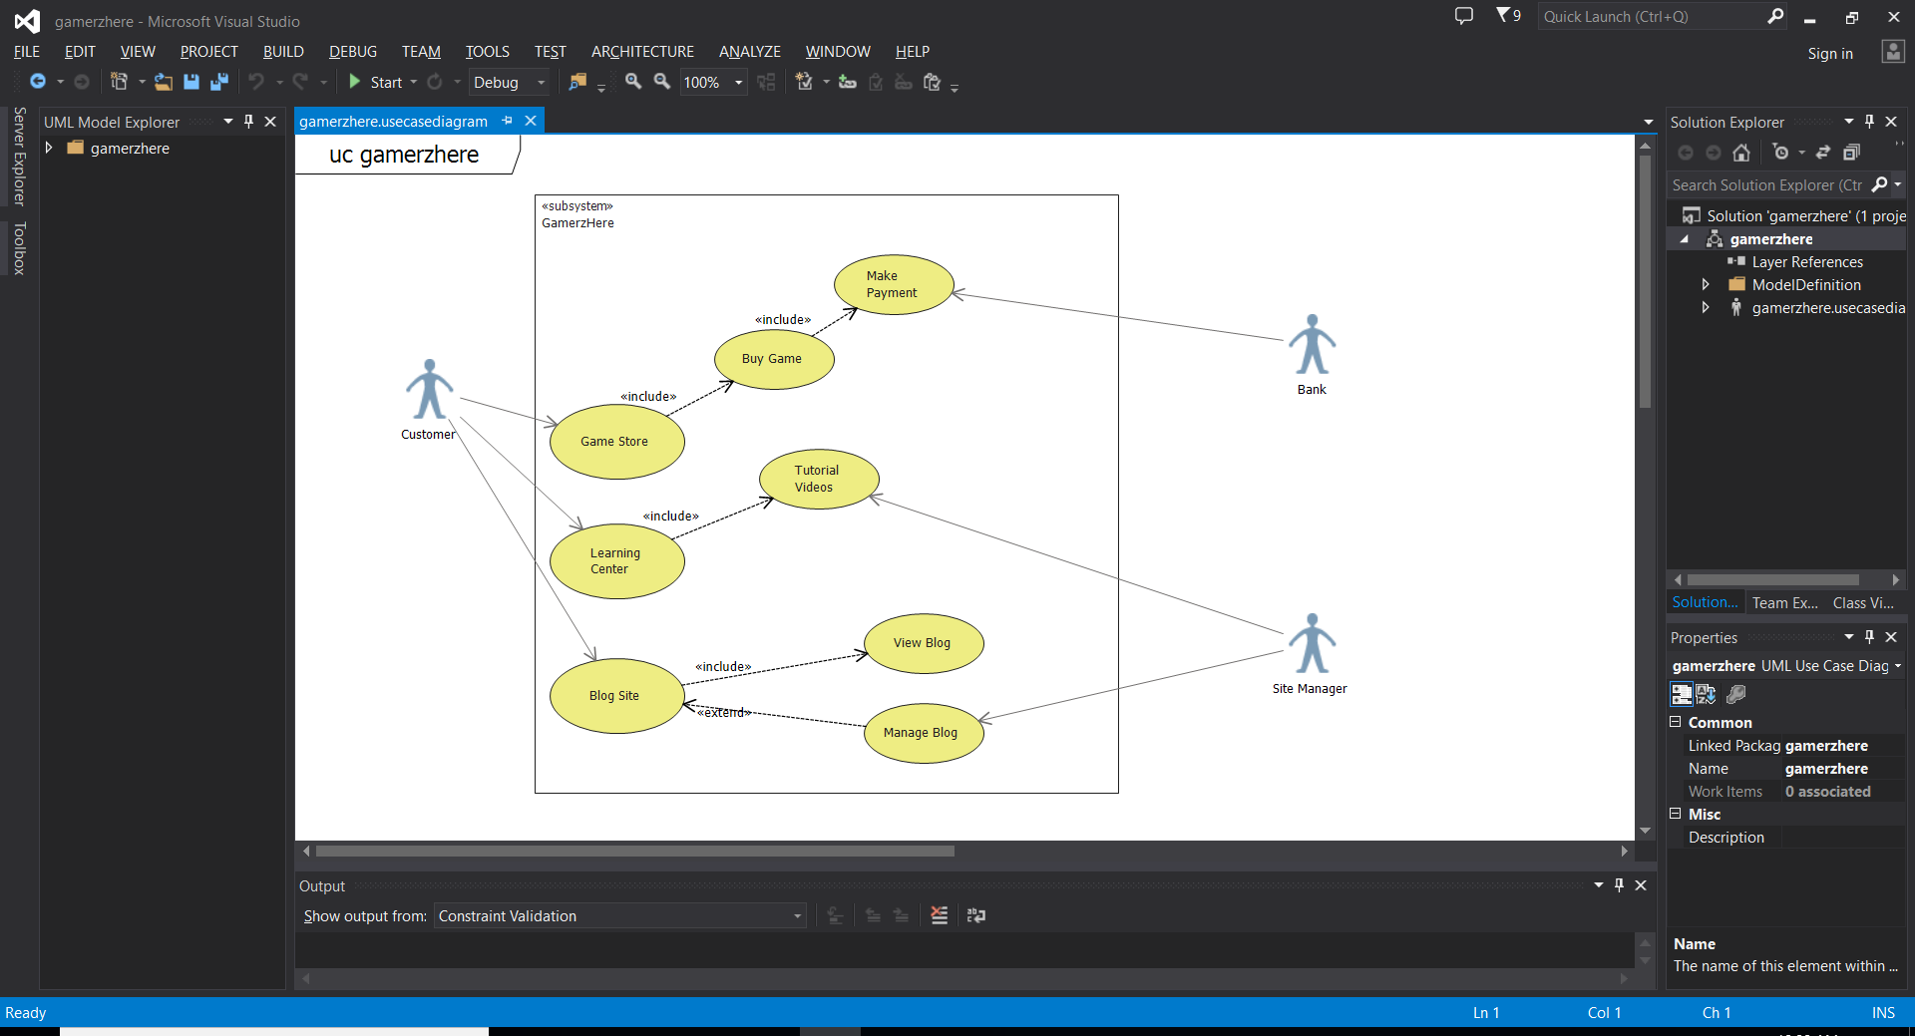

Step 1: Created a neat structured diagram using visual studio 2013.

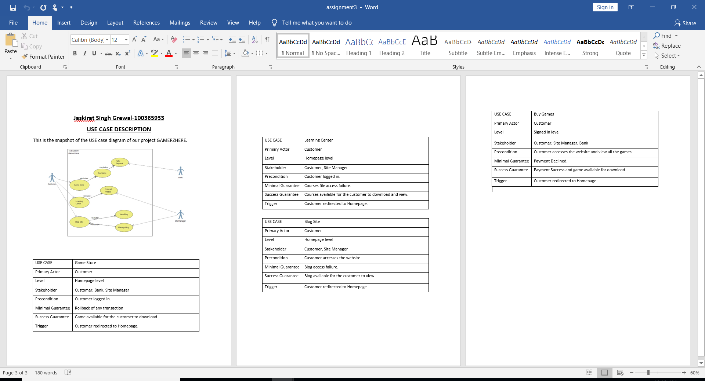

Step 2: Created a word document named gamerzhere_description.docx with a snapshot of the use case diagram and description of all the necessary use cases.

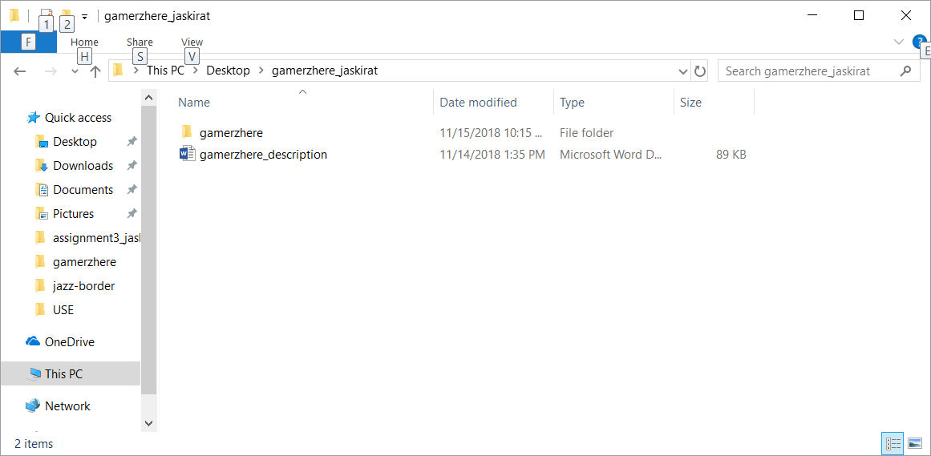

Step 3: Copied both the description and the diagram in a folder named gamerzhere_jaskirat, we will use git init in this folder later.

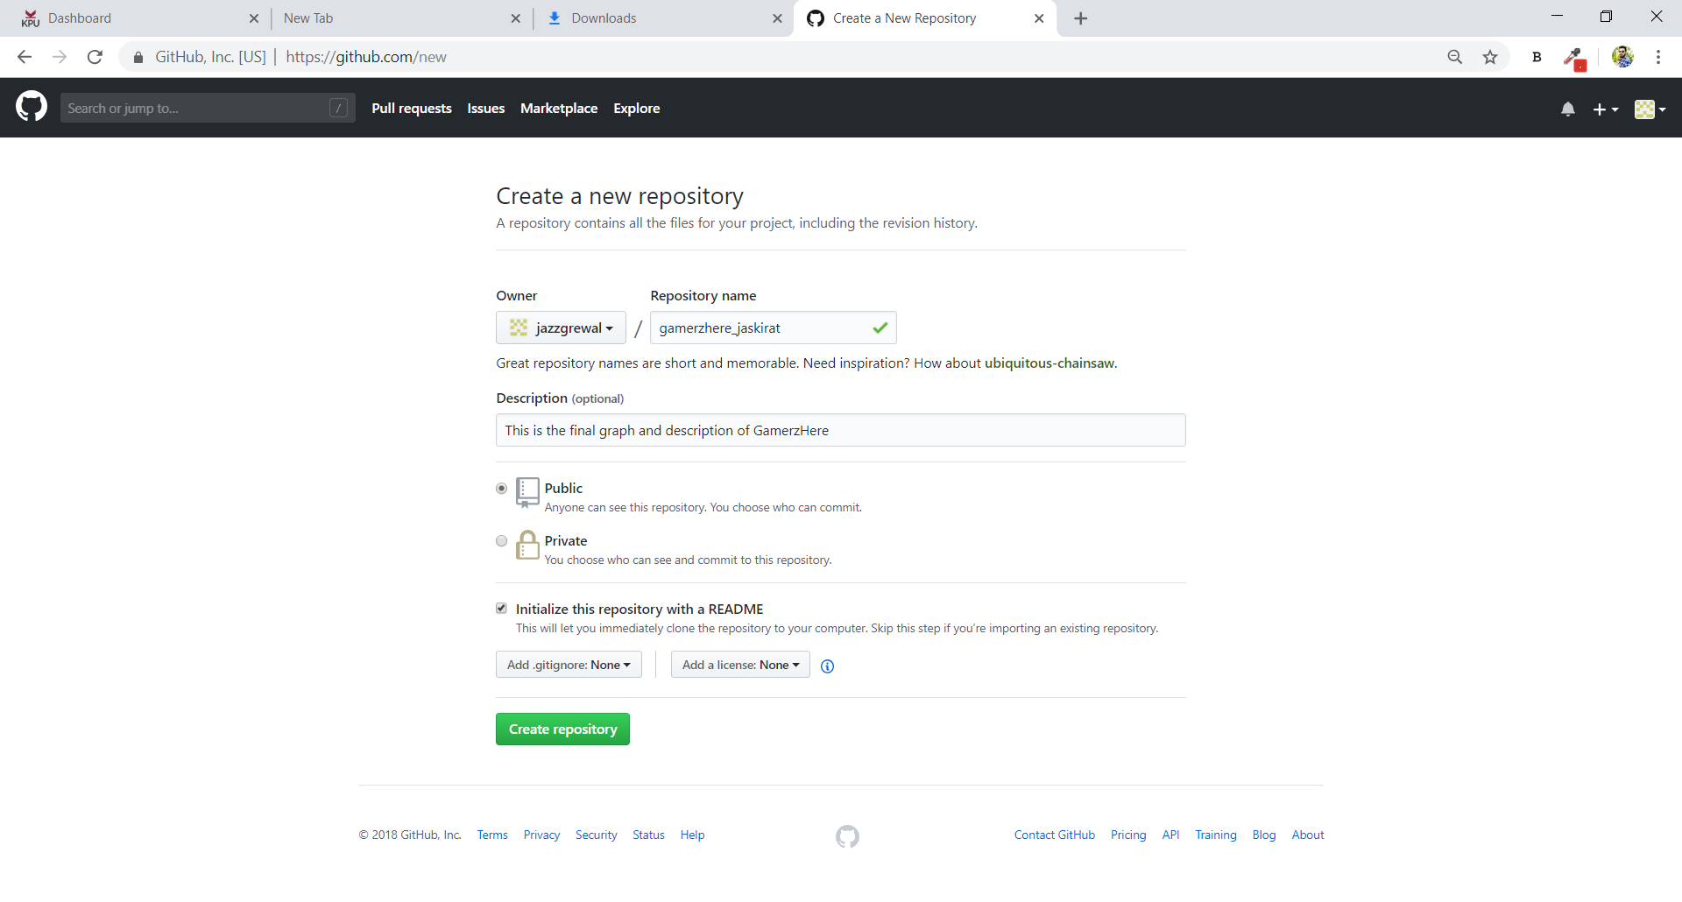

Step 4: Creating a new repository in git named gamerzhere_jaskirat with the description as “This is the final graph and description of GamerzHere”.

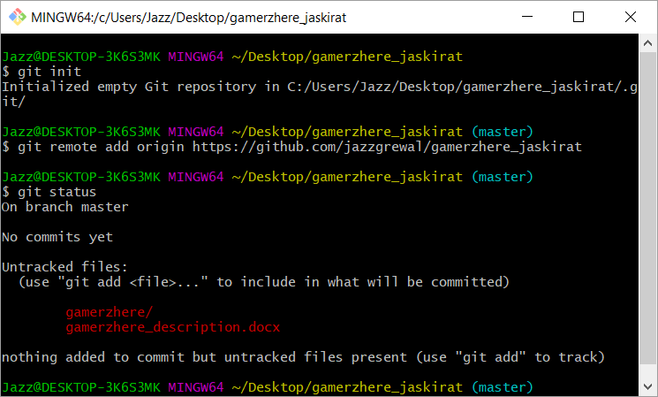

Step 5: Initialize the repository and set the URL.

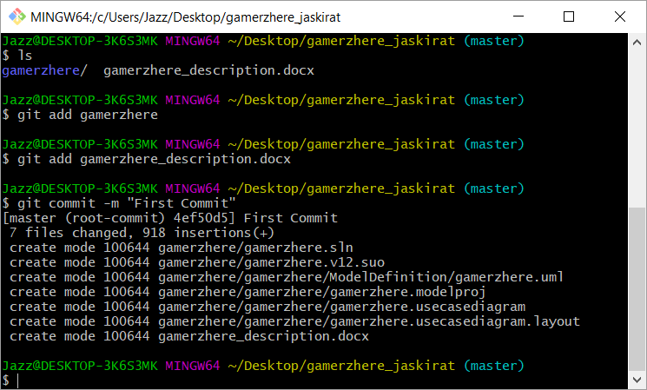

Step 6: Added both the files and named the commit as First Commit

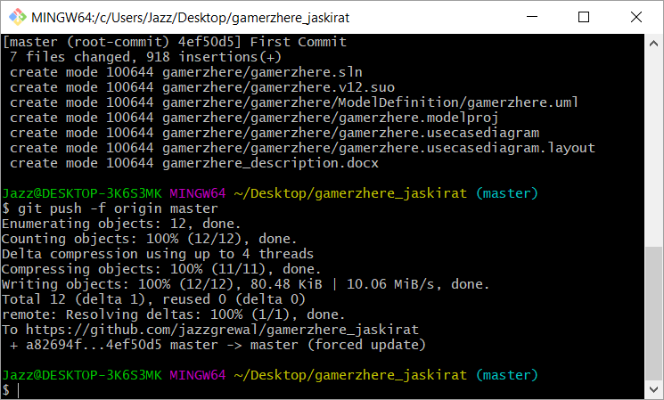

Step 7: Successfully pushed the files to the repository.

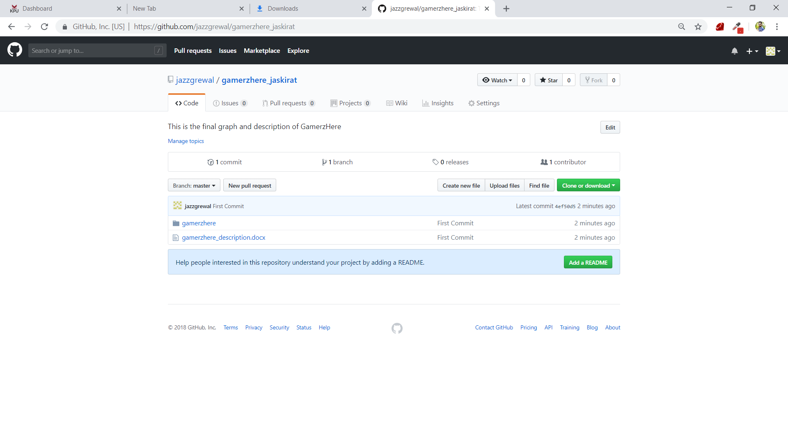

Step 8: We can see our files uploaded on the repository.

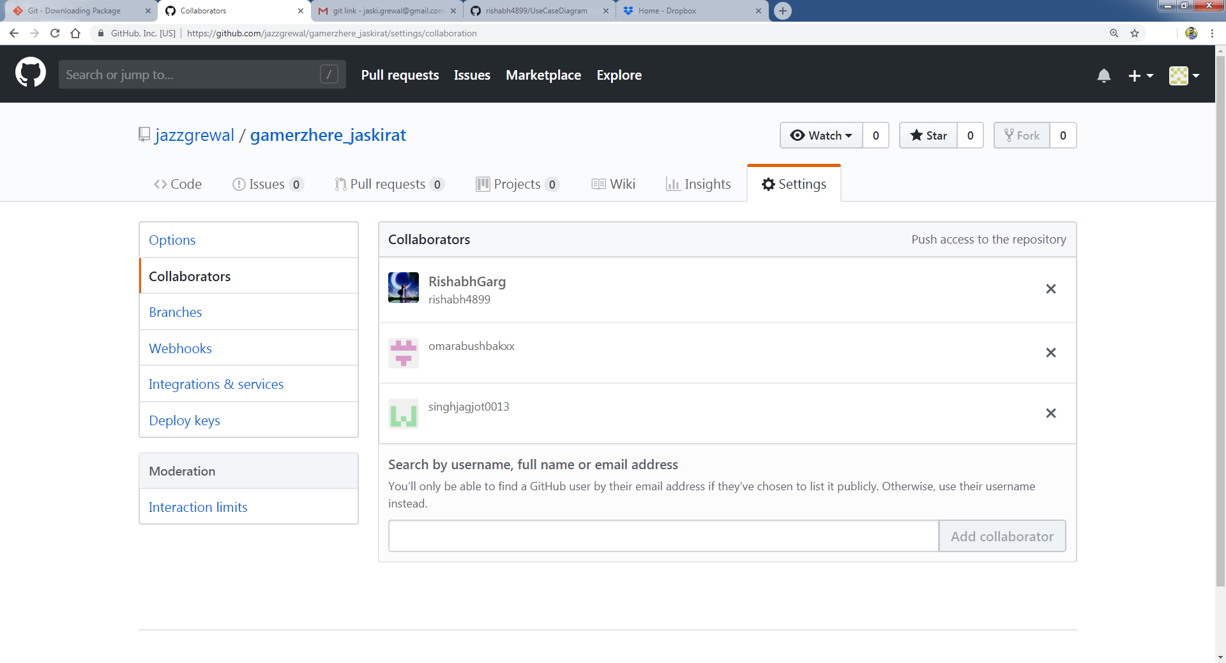

Step 9: Finally Added all the three group members as Collaborators, now they do have access to push anything in this repository in the future.

**References**

1. **Youtube:**

**Use case Diagram Tutorial:** [**https://www.youtube.com/watch?v=zid-MVo7M-E**](https://www.youtube.com/watch?v=zid-MVo7M-E)

**Use case Description Ideas:** [**https://www.youtube.com/watch?v=i3dg99MWLZU**](https://www.youtube.com/watch?v=i3dg99MWLZU)

**2)GitHub references uploaded by instructor on Moodle.**