Jaskirat Singh Grewal

100365933

INFO1113 S11

Final Project

November 14, 2018

Instructor-Abhijit Sen

Team Members:

1. Jaskirat Singh Grewal (100365933):<https://github.com/jazzgrewal>
2. 2) Rishabh Garg (100371073):
3. <https://github.com/rishabh4899>
4. Omar Abushbak (100368325):[https://github.com/omarabushbakxx](https://github.com/omarabushbakxx/gamerzhere-omar)
5. Jagjot Singh (100374227):<https://github.com/singhjagjot0013/>

Final Project Url: <https://github.com/jazzgrewal/gamerzhere_final>

**Contents**

1. Cover Page…………………………………………………….……………………….. 01
2. Contents…………………………………………………..……........................... 02
3. Executive Summary and Gantt Chart…………………..……………… 03-04
4. Introduction……………………………………………………………………………. 05
5. Requirements…………………………………………..……………………………… 06
6. Use Case Diagram & Descriptions………………………………..…… 07 – 09
7. Class Diagram ………………………………………………………………………….. 10
8. Sequence Diagram…………………………………………………………………… 11
9. Interface Prototype ……………………………..…………………………….. 12-14
10. Review Class Diagram …………………………………………….……... 15
11. Database Implementation (**Bonus**)…………………………….. 16-19
12. Project Experience…………………………………………………………….20
13. Work Cited………………………………………………………………………..21

**Executive Summary & GANTT Chart**

Online gaming has become a major trend amongst the teenagers and adults, especially the students. The users access the games on various platforms like online gaming websites, XBOX, PS4. There are studies that have proven the benefits on the cognitive abilities for the students, as the gamers are surveyed having higher IQ than majority of the non-gamers. Also, these games assist students to boost the problem-solving skills, coordination and management.

Considering the trend of online gaming, our team came up with an idea to develop a gaming website (Gamerzhere). The main features of the website include:

* Gaming store -- offers latest games with special deals.
* Affiliate program – chance for the users to promote our website and earn some money.
* Learning section -- offers tutorials for the game developers to create their own 2D or 3D games.

The major tasks in this Gamerzhere project included gathering the project requirements, creating the use case, class and sequence diagrams, building the prototype for an awesome website which gives the team a general idea how the actual project is going to look like and how the Users (or customers) will interact with it.

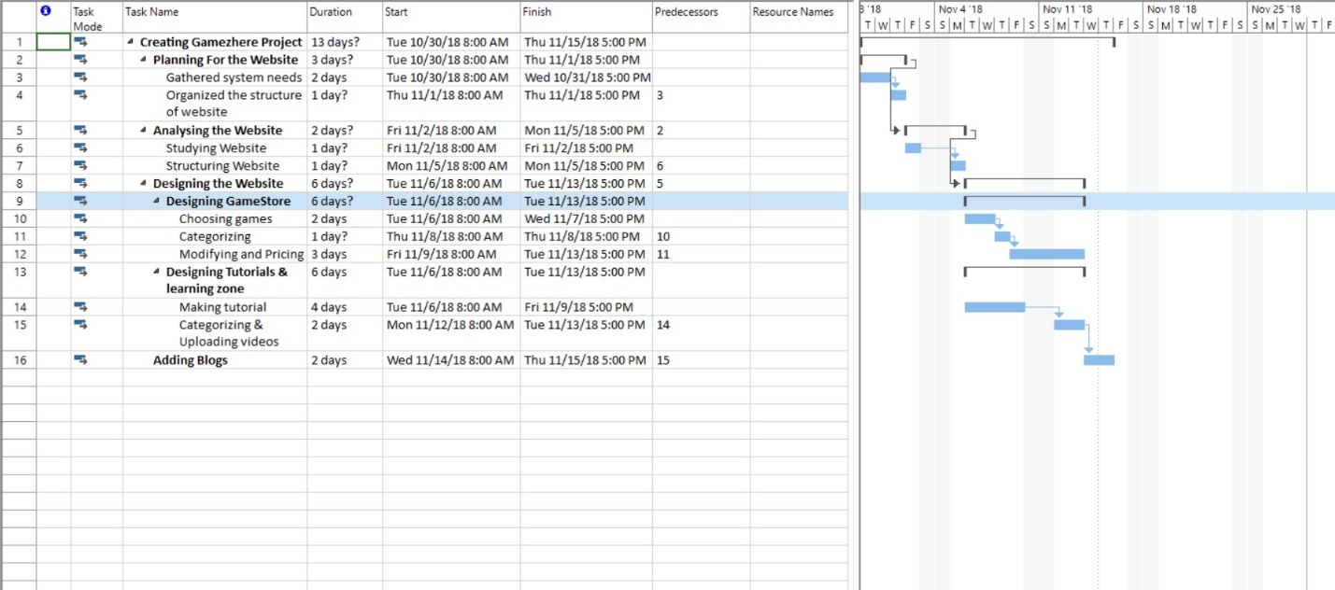

This is the Gantt Chart of Our Project GamerzHere which clearly portraits all the necessary steps towards the development of the Project.

Gantt Chart is really useful for the team as it makes it easy to assign different tasks to different individuals and takes care that project is being done on time.

However, this is just a screenshot of our Gantt Chart, the actual .mpp file is uploaded on the repository.

Github url:<https://github.com/jazzgrewal/gamerzhere_final>

**INTRODUCTION**

The project our team is currently working on is to develop a website which is totally devoted to Games. The main purpose of the website is to offer the users a platform from where they can access everything related to games. The website is distributed into three main sections which are as follows.

The Gaming store:

The store section is generally a place where the user can buy games at low price than the usual with all the updated and remastered versions of games with special offers and great deals occasionally. Moreover, if you have a game no longer in use, the store section offers you a chance to sell it online with authentic buyers (Terms & Conditions apply).

Your Own Blog: Users of GamerzHere have access to our Blog site where they can post their blogs regarding Games and their interests and also some walkthrough or Game review blogs so that other users can get the reviews before buying a Game. We’ve designed our Blog database in such a way that users can also comment on Blogs other users have posted. Not only this, they can always Create, update or delete their blogs any time.

The Learning Section:

We aim to not only provide user the privilege of buying games, but we also tend to provide tutorials and lessons on how to create your own 2D or 3D games using the easiest and elaborated ways. The lessons can also be done on demand so the user can always drop off their ideas in the comment section.

**Requirements**

It took a whole lot of awesome tools for us to make an amazing project like GamerzHere. If we start down from technical or functional software and tools the list goes here:

1. Visual Studio 2015- It is an awesome tool which helped us to deal with most of our diagrams and charts. (including USE case diagram)

2. Microsoft Word – To make all the reports and document each and every single step of our project and assignments.

3. Microsoft Project – To make an awesome Gantt Chart for the project, which is the basic step or the foundation plan of the project.

4. Lucid Chart – To make some of the diagrams like Sequence diagram, in an unbelievably simple way.

5. Wireframe – The best possible web tool out there which makes excellent high quality prototypes in fast and exportable manner.

6. GitHub – The most important Web tool version control, without which project was impossible.

7. Git Bash – The CLI (Command Line Interface) to interact with GitHub and help to upload our files to the repository.

8. Drop Box – To keep our files safe on the cloud so that we can access our files securely wherever and whenever we want.

9. Google Drive – To transfer files to and from amongst the team members.

10. Gmail – Our personal Email account to communicate with each other.

11. WhatsApp – Probably the most famous mobile app, which helped our team members to communicate over voice and video calls.

12. Mobile Phones – All of our team members were having mobile phones.

13. Laptops – All our team members were having their own laptops.

**USE CASE DESCRIPTION**

This is the snapshot of the USE case diagram of our project GAMERZHERE.

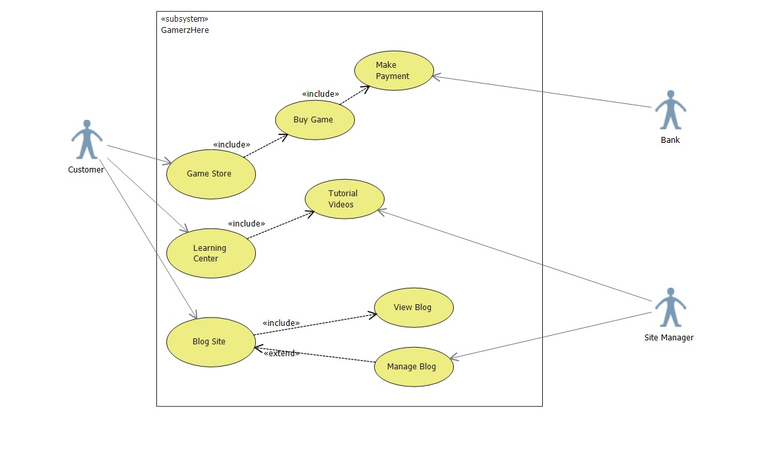

|  |  |
| --- | --- |
| USE CASE | Game Store |
| Primary Actor | Customer |
| Level | Homepage level |
| Stakeholder | Customer, Bank, Site Manager |
| Precondition | Customer logged in. |
| Minimal Guarantee | Rollback of any transaction |
| Success Guarantee | Game available for the customer to download. |
| Trigger | Customer redirected to Homepage. |

|  |  |
| --- | --- |
| USE CASE | Learning Center |
| Primary Actor | Customer |
| Level | Homepage level |
| Stakeholder | Customer, Site Manager |
| Precondition | Customer logged in. |
| Minimal Guarantee | Courses file access failure. |
| Success Guarantee | Courses available for the customer to download and view. |
| Trigger | Customer redirected to Homepage. |

|  |  |
| --- | --- |
| USE CASE | Blog Site |
| Primary Actor | Customer |
| Level | Homepage level |
| Stakeholder | Customer, Site Manager |
| Precondition | Customer accesses the website. |
| Minimal Guarantee | Blog access failure. |
| Success Guarantee | Blog available for the customer to view. |
| Trigger | Customer redirected to Homepage. |

|  |  |
| --- | --- |
| USE CASE | Buy Games |
| Primary Actor | Customer |
| Level | Signed in level |
| Stakeholder | Customer, Site Manager, Bank |
| Precondition | Customer accesses the website and view all the games. |
| Minimal Guarantee | Payment Declined. |
| Success Guarantee | Payment Success and game available for download. |
| Trigger | Customer redirected to Homepage. |

This was the Use Case Diagram and its description, however to view the original USE case Diagram file you can always visit the following GitHub url:

<https://github.com/jazzgrewal/gamerzhere_jaskirat>

**Class Diagram**

Here’s our project GamerzHere’s class Diagram which includes all the features of our project. It clearly shows interaction between different objects including Website, Database, Bank. Within the Website comes awesome objects that is, Buying Games, Online Tutorial and Blogging.

Each object has got its own unique functions. Which can be clearly viewed in the Diagram.

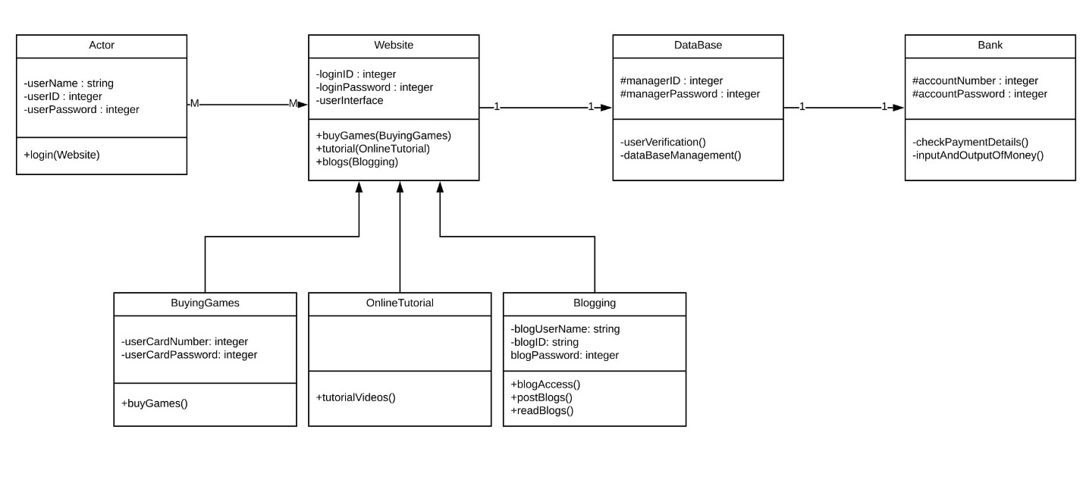

This was the Class Diagram Screenshot, however to view the original Class Diagram file you can always visit the following GitHub url:<https://github.com/jazzgrewal/gamerzhere_final>

**Sequence Diagram**

The following is the Sequence Diagram based on only One Function from the Class Diagram.

These Diagram portraits each and every process or interaction that takes place between different objects when an Actor(Customer) attempts to buy a Game from our website. (Note: The Alternative Box itself represents the lifetime of a task as well).

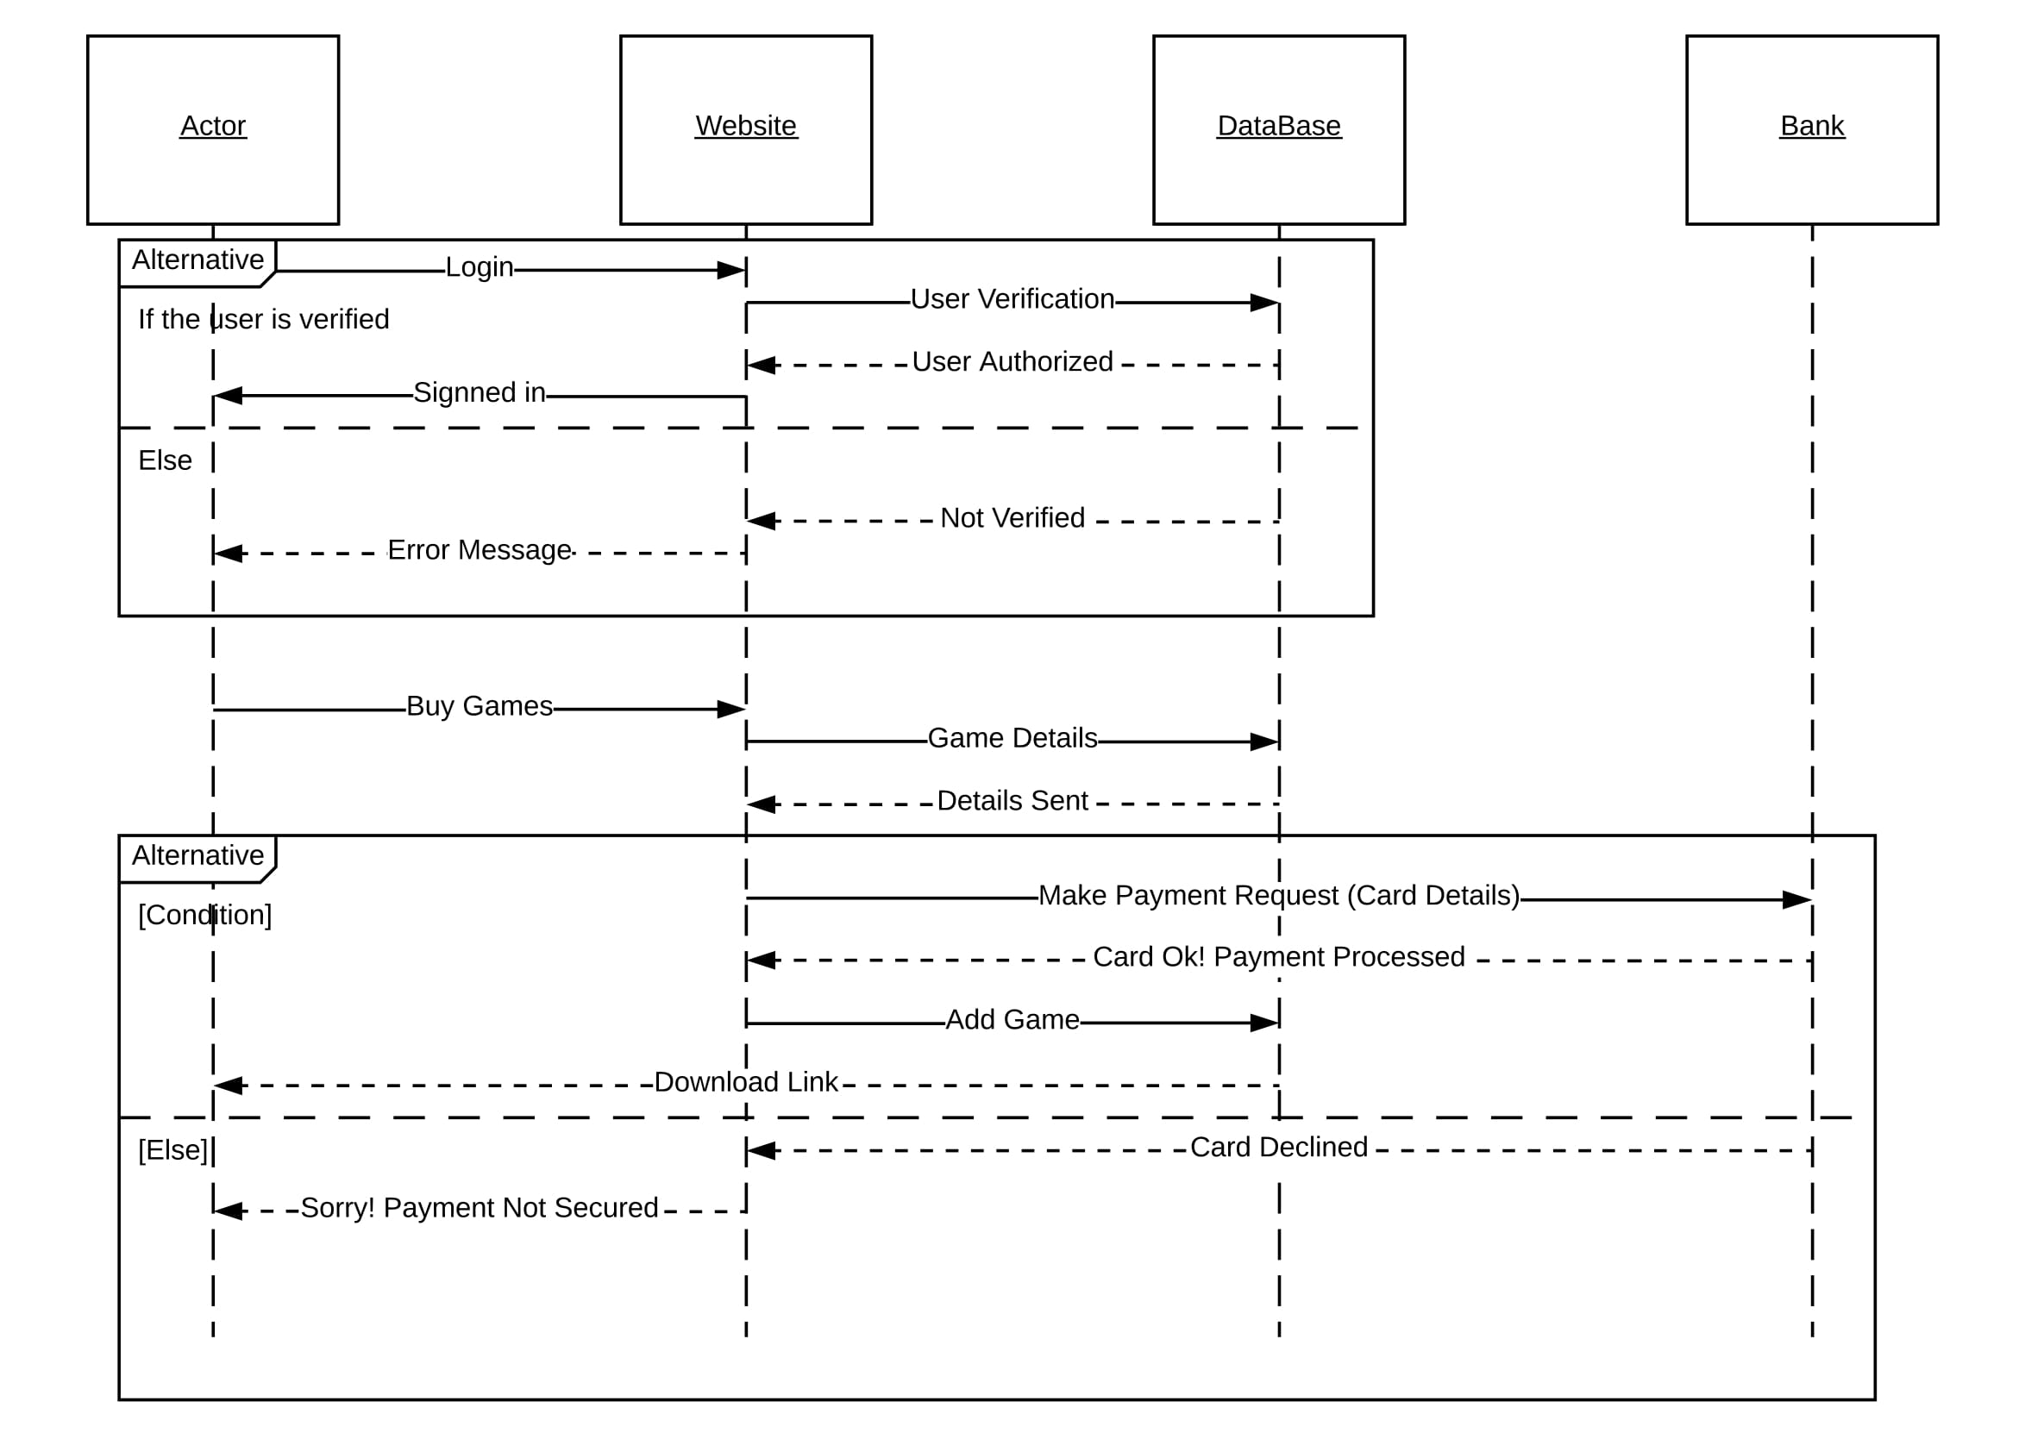

This was the Sequence Diagram Screenshot, however to view the original Sequence Diagram file you can always visit the following GitHub url: <https://github.com/jazzgrewal/gamerzhere_final>

**Interface Prototype**

Here’s The Prototype (Graphical User Interface model) of our Awesome Website

***GamerzHere***

1. 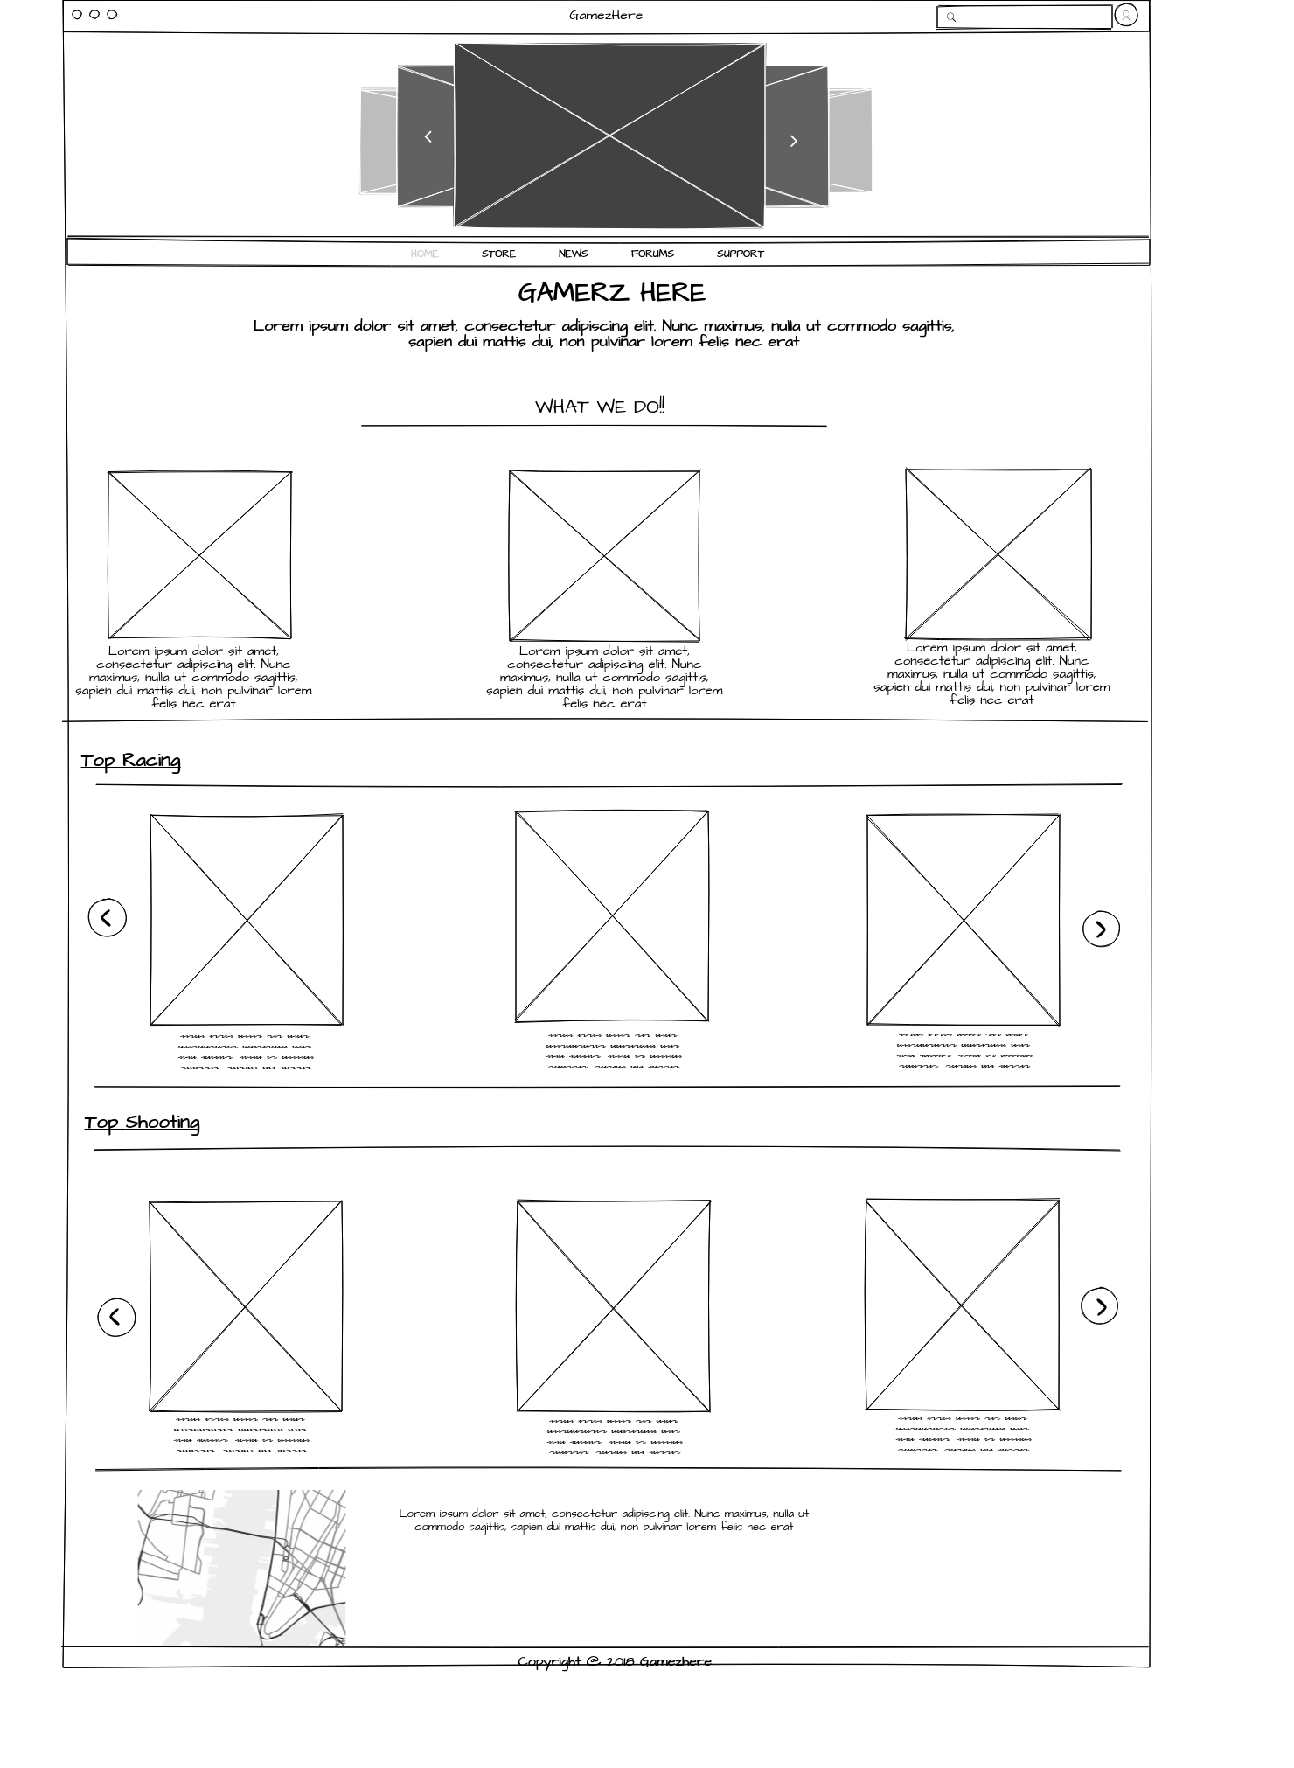

This is the main page of website where Customers can view all the Games, of different Categories, Games which are Trending and the Blog Posts.

The Main page also portraits what we do, that is 3 boxes (Selling Games, Blogging App, and Learning Center).

2.

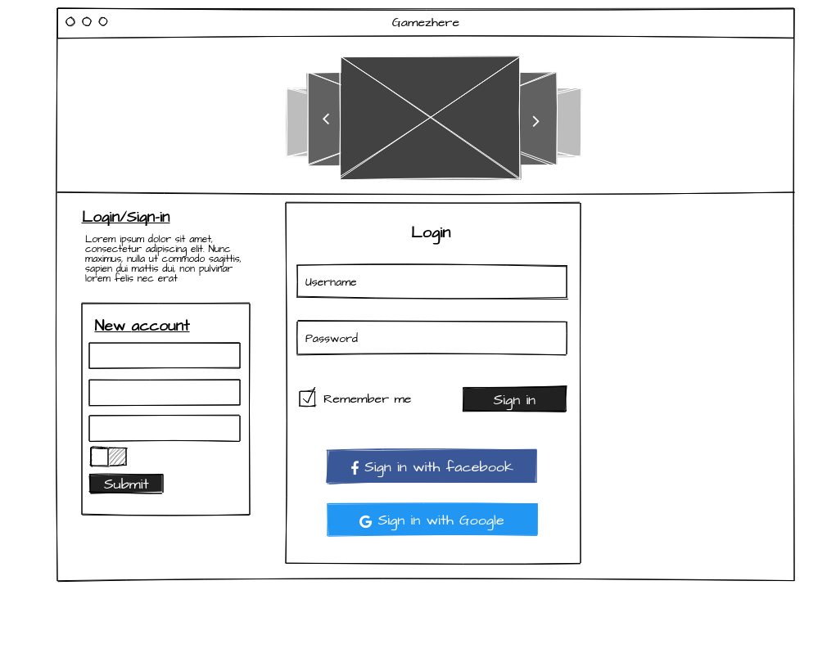

This is the User Login/Signup page prototype. Users can also register through their Facebook or Google account.

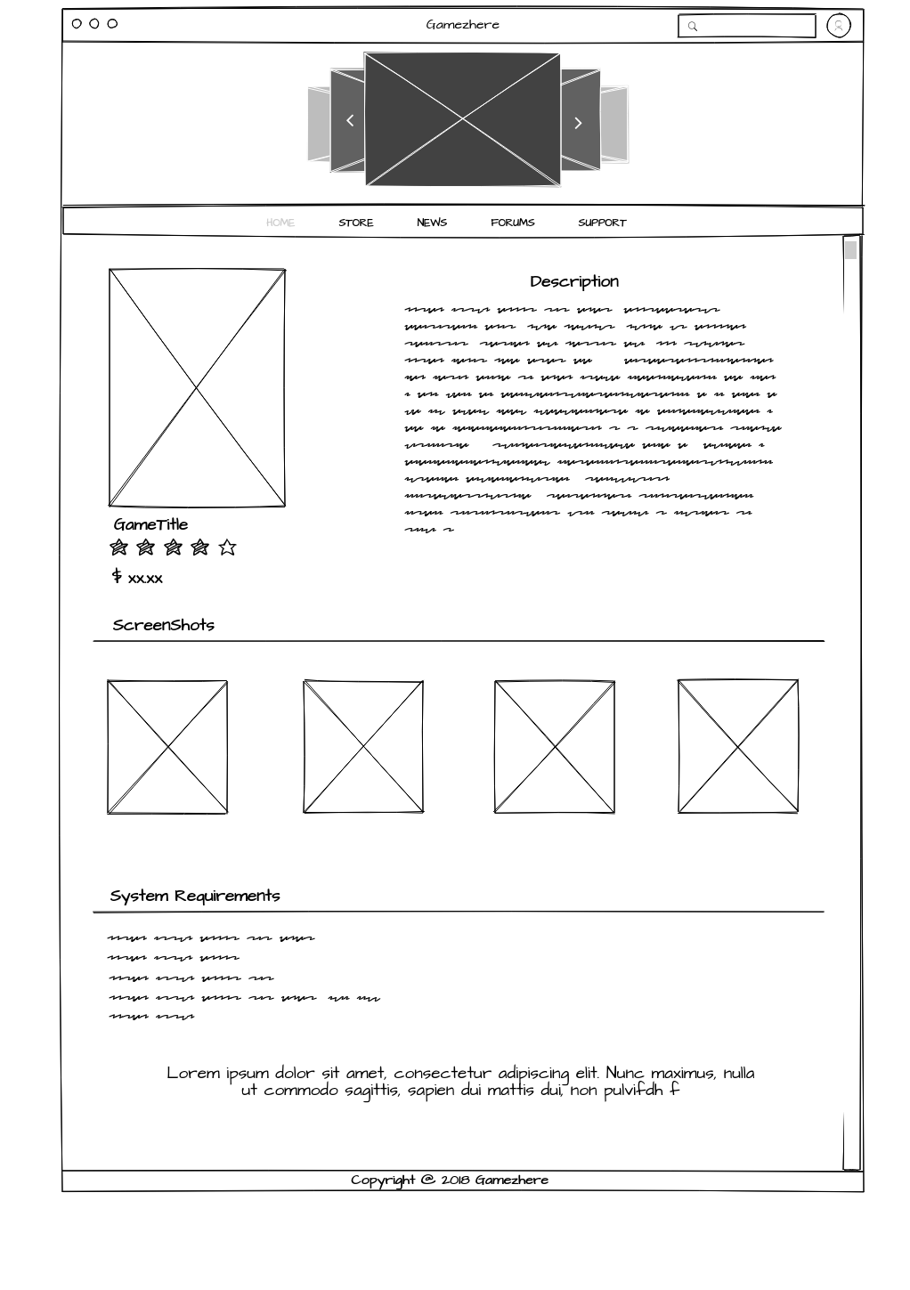

This is the description page of a particular page.

Note: These are Zoomed Out Views of our Prototype. Too see the full HTML view you can always download the file from our GitHub Url : <https://github.com/jazzgrewal/gamerzhere_final>

**Class Diagram Review and Deciding Database Elements**



1NF: There could be one table containing all the information, that is the blogs (ID, description, etc), games (ID, description, etc) and comments. But this involves a lot of repetition of similar data like, One User can have many Blogs which involves repetition of same USER data. To avoid that and get the table to the first Normal Form according to DBMS, we make separate tables (or collections) for Blogs, Users, Games and Comments. (clear in the database implementation part).

2NF: Even if we have got different tables (or collections) and things are in the 1stNF, we have to define some relationships between different tables and assign Primary ID to different tables.

3NF: We assigned One to many relations with USER, BLOGS, COMMENTS and GAMES which gets our Database to 3rd NF.

After having a deep look and reviewing the class diagram we came upon the conclusion, that we should choose Buying Games and Blogging as the main functions for our Database implementation.

A User will have to sign up, all the User information will be stored in the Database under the collection USER.

Each Games will be contained within a collection called Games, which has ID, Description, Image and Users.

Each Blog will be contained within a collection called BLOG.

Blogs and Games will have ONE to MANY relationship, with the USER. (Further Explained in the Database Implementation part).

**Database Implementation (*BONUS*)**

Having a look at the class Diagram and deciding the database elements and relationship is an intermediate level task but IMPLEMENTATION is where it gets tuff and we have to focus a lot to do it.

And we succeeded in doing this task, here’s the database structure and description which we implemented in Microsoft Access.

Starting from the relationship.

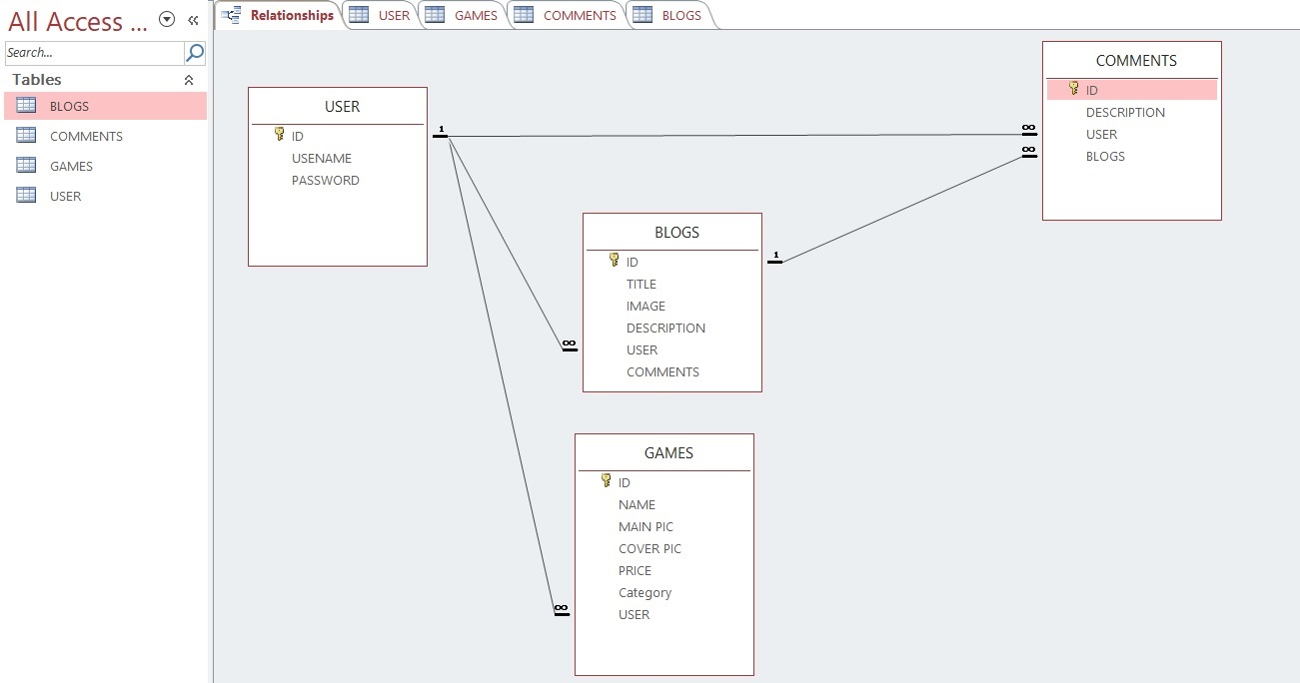

In this Relationship diagram, we have got 4 tables (or collections).

First, User ID and user field of BLOGS has got a One to many relationships. Which means many blogs can be created by One single User.

Now Our USER table can be expanded anytime to view all the BLOGS posted by that user. Below is the screen shot of that.

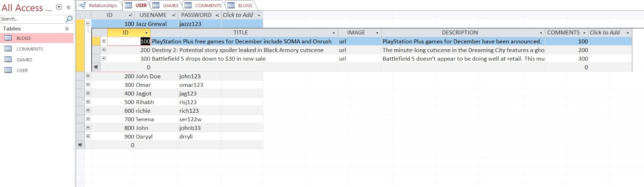

In this Screenshot We’ve expanded User 100 to view all the Blogs Posted By him.

Second, User ID and user field of GAMES has got a One to many relationship as well. Which means many multiple Games can be bought by One Single User.

Third, User ID and user field of COMMENTS has got a One to many relationships. Which means many COMMENTS can be created by One single User.

Fourth, Blogs ID and blogs field of COMMENTS has got a One to many relationships. Which means many comment can be made for One Single Blog.

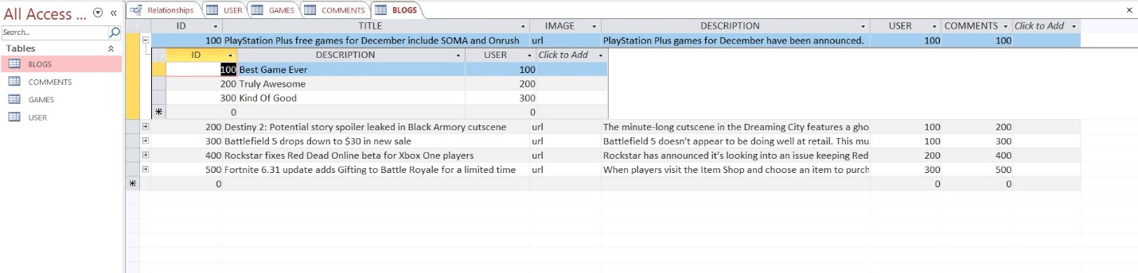

Now following are the screenshots of each and every table along with their sample data.

1.USER

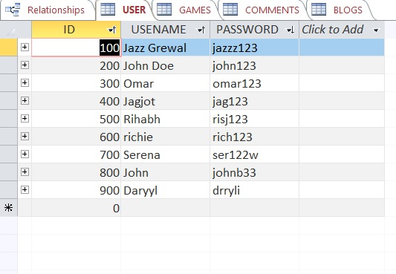

2. Blogs

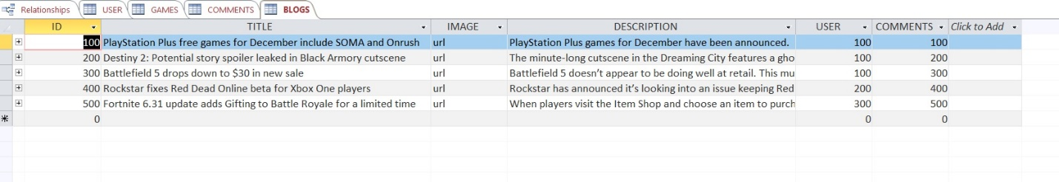

3.Games

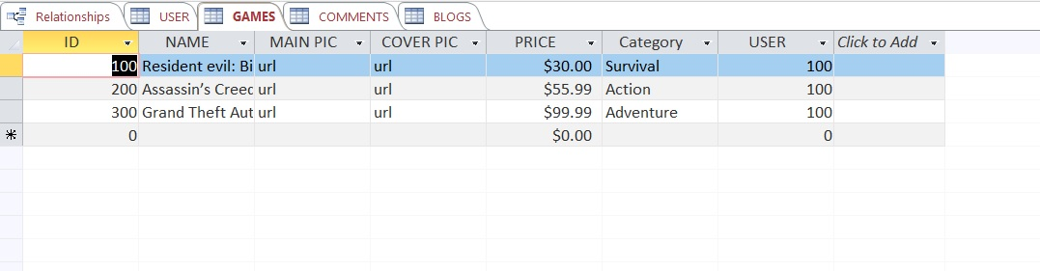

4.Comments

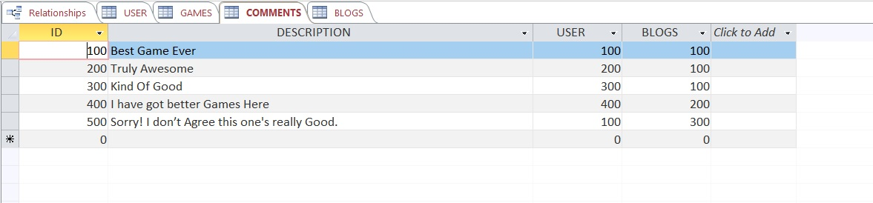

This was our Database. The actual file named **Final_Project.accdb** has been uploaded on the GitHub repository.

url:<https://github.com/jazzgrewal/gamerzhere_final>

**Project Experience**

Right from the very beginning every team member has been working hard on getting their portion of the project done. Rishabh has been managing all our team graphs such as Pert graph and creating our website prototype. Jag jot and Omar took care of the group documents, and our project manager Jazz (Jaskirat) has been working on getting the project done on time, taking care of the online repository, database implementation and assigning different tasks to every team member while making sure it gets done to the best of our ability. However, even though we all worked hard on our parts we also hit a couple of speed bumps on the way. A couple things that didn’t work in our project are, creating the actual website. As we were executing our project plan, we realized that creating a website that fits our project view was going to be very difficult. We did a lot of research and couldn’t find a way to make a website that allows users to purchase items off and create their own games. Even though we were devasted about not being able to create a website, we were able to create a prototype of what our website is going to look like. All though the speed bumps hit hard we didn’t let it stop us from doing our best. Some things that went well in our group projects were, being able to finish everything on time. Every team member took their assignments very seriously and worked on it with care. All the team members got along, Not only were we able to execute a good project as a group, but we also got closer as a group. We got to know each other and felt happy working together, at no point of creating this project was there any mis-communication between any of the team members.

**Work Cited (Bibliography)**

We loved working on this Project but it would have never been possible without these resources which has always been our backbone when it comes to do any technical tasks.

Google- The Best Search Engine.

YouTube- <https://www.youtube.com/watch?v=UI6lqHOVHic>

YouTube- <https://www.youtube.com/watch?v=pCK6prSq8aw>

Microsoft Support Docs- <https://support.office.com/en-us/article/create-a-new-database-32a1ea1c-a155-43d6-aa00-f08cd1a8f01e>

YouTube - <https://www.youtube.com/watch?v=MhfNQci_VzU>

GitHub Support Docs.

Instructor Files by Instructor.

Thank You Abhijit

We would like to thank our awesome instructor Abhijit Sen who has really been supportive in all the small steps throughout the project. At very first we thought it’s really difficult to create a project like this and using GitHub was really getting crazy. But Abhijit assigned us with assignments where we get good Hands On practice with GitHub which was really helpful.

Once Again a huge thanks Abhijit for being awesome.