**Jaskirat Singh Grewal-100365933**

**USE CASE DESCRIPTION**

This is the snapshot of the USE case diagram of our project GAMERZHERE.

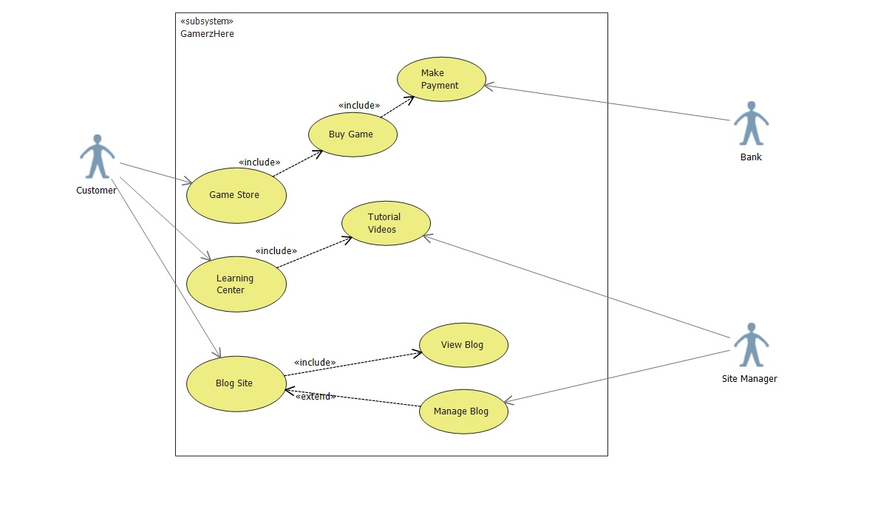

|  |  |
| --- | --- |
| USE CASE | Game Store |
| Primary Actor | Customer |
| Level | Homepage level |
| Stakeholder | Customer, Bank, Site Manager |
| Precondition | Customer logged in. |
| Minimal Guarantee | Rollback of any transaction |
| Success Guarantee | Game available for the customer to download. |
| Trigger | Customer redirected to Homepage. |

|  |  |
| --- | --- |
| USE CASE | Learning Center |
| Primary Actor | Customer |
| Level | Homepage level |
| Stakeholder | Customer, Site Manager |
| Precondition | Customer logged in. |
| Minimal Guarantee | Courses file access failure. |
| Success Guarantee | Courses available for the customer to download and view. |
| Trigger | Customer redirected to Homepage. |

|  |  |
| --- | --- |
| USE CASE | Blog Site |
| Primary Actor | Customer |
| Level | Homepage level |
| Stakeholder | Customer, Site Manager |
| Precondition | Customer accesses the website. |
| Minimal Guarantee | Blog access failure. |
| Success Guarantee | Blog available for the customer to view. |
| Trigger | Customer redirected to Homepage. |

|  |  |
| --- | --- |
| USE CASE | Buy Games |
| Primary Actor | Customer |
| Level | Signed in level |
| Stakeholder | Customer, Site Manager, Bank |
| Precondition | Customer accesses the website and view all the games. |
| Minimal Guarantee | Payment Declined. |
| Success Guarantee | Payment Success and game available for download. |
| Trigger | Customer redirected to Homepage. |