Table of Contents

[To update the table of contents, select the message below and press F9]

**No table of contents entries found.**

1. Pages
   1. Page Tree

Home

My Survey

View Survey

Edit Survey

Create Survey

My Questions

My Reports

Show Report

* 1. Home
     1. User Interface

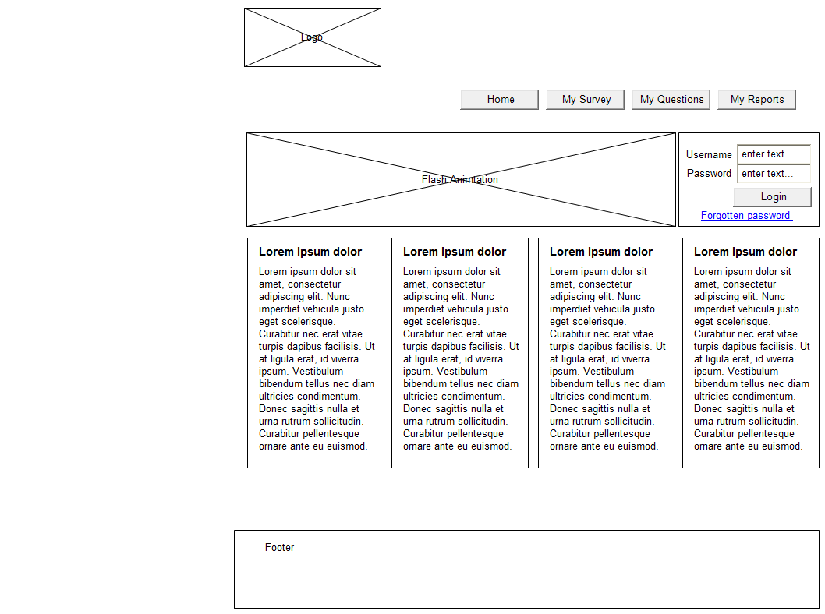

* 1. My Survey

This page shows all the created survey that the use has running at the moment. it is broken up into two groups that show those that a active and visible 'Currently Active Surveys', and those that are not active or their dates have run out 'Currently Inactive Sureys'

Edit Survey are not editable for surveys that have been used, as allow the editing of used survey can corrupt the data being stored

NOTE : May allow editing in the future with a big warning about the dangers of doing this, but for now no editing

* + 1. User Interface

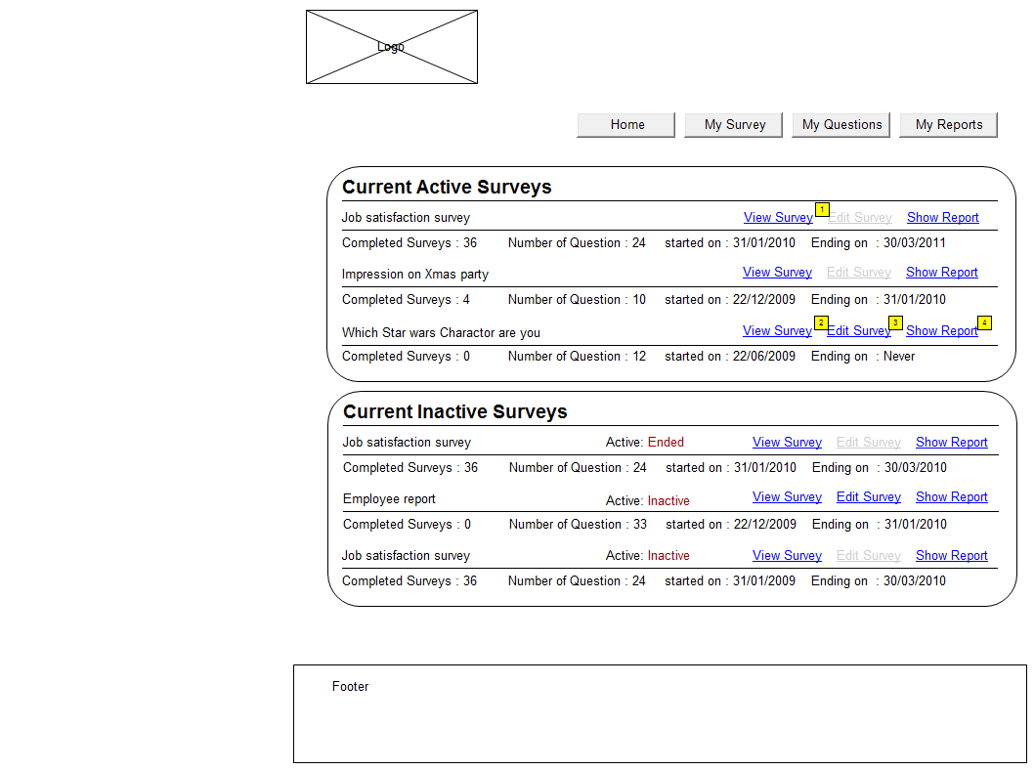

* + 1. Object Table

| Footnote | Interactions |
| --- | --- |
| 1 | OnClick:  Case 1:  Open View Survey in Current Window |
| 2 | OnClick:  Case 1:  Open View Survey in Current Window |
| 3 | OnClick:  Case 1:  Open Edit Survey in Current Window |
| 4 | OnClick:  Case 1:  Open My Reports in Current Window |

* 1. View Survey
     1. User Interface

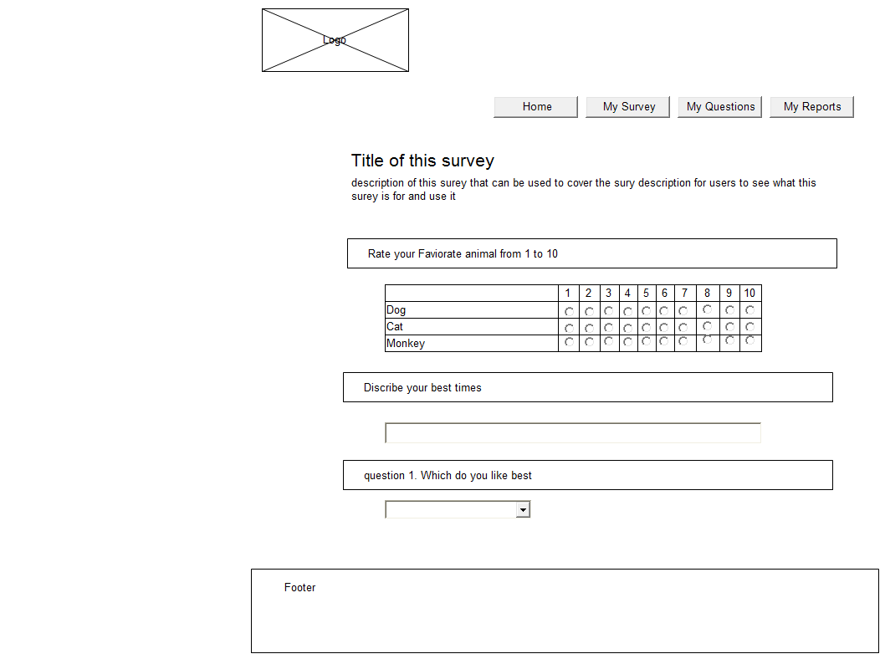

* 1. Edit Survey
     1. User Interface

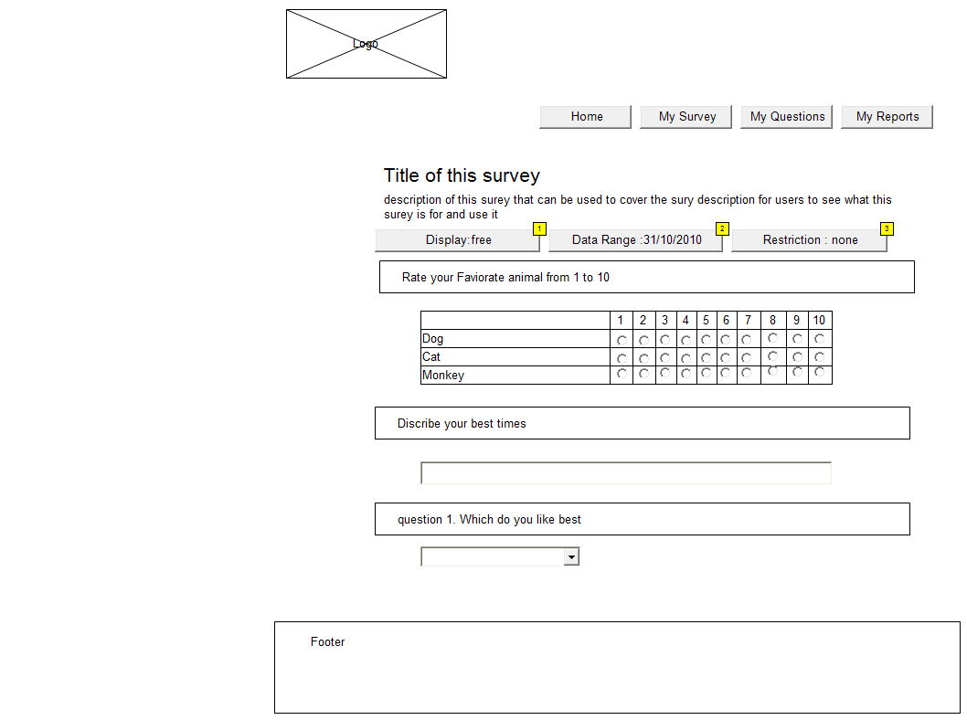

* + 1. Object Table

| Footnote | Label | Interactions |
| --- | --- | --- |
| 1 |  | OnClick:  Case 1:  Toggle Visibility for Display |
| 2 |  | OnClick:  Case 1:  Toggle Visibility for date |
| 3 | Ip range | OnClick:  Case 1:  Toggle Visibility for Panel |

* + 1. Display
       1. State1

User Interface

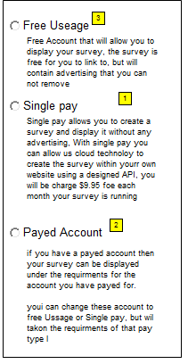

Object Table

| Footnote | Interactions |
| --- | --- |
| 1 | OnClick:  Case 1:  Toggle Visibility for Display |
| 2 | OnClick:  Case 1:  Toggle Visibility for Display |
| 3 | OnClick:  Case 1:  Toggle Visibility for Display |

* + 1. date
       1. State1

User Interface

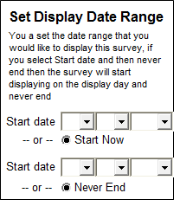

* + 1. ip range
       1. State1

User Interface

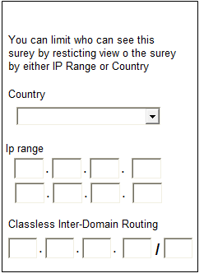

* 1. Create Survey
  2. My Questions
     1. User Interface

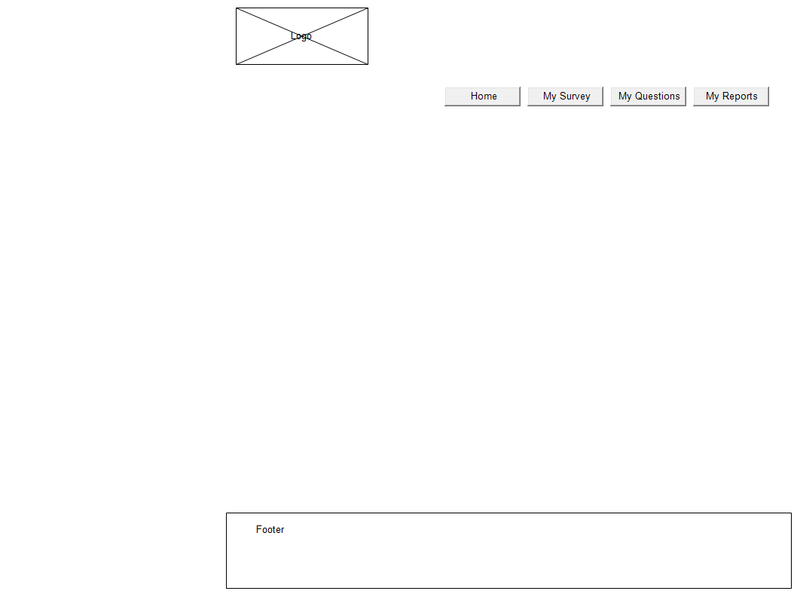

* 1. My Reports
     1. User Interface



* 1. Show Report

1. Masters
   1. Master List

Folder

header/footer

* 1. header/footer
     1. User Interface

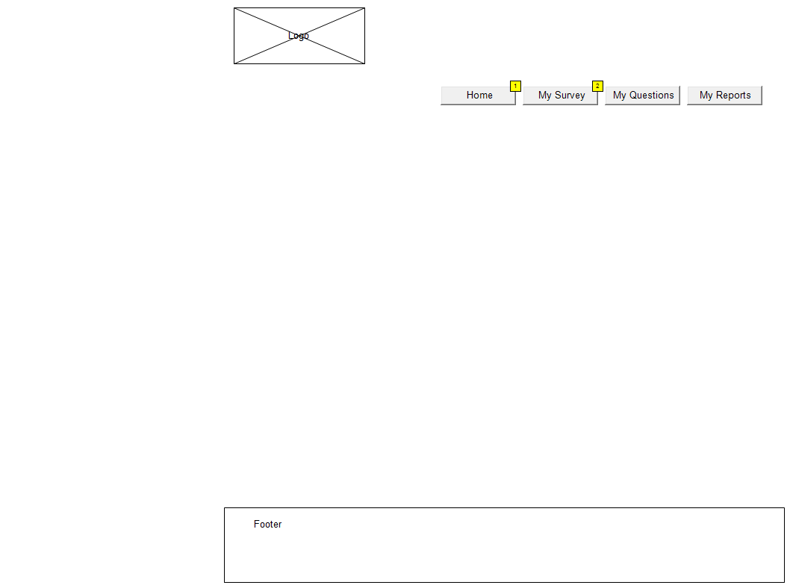

* + 1. Object Table

| Footnote | Interactions |
| --- | --- |
| 1 | OnClick:  Case 1:  Open Home in Current Window |
| 2 | OnClick:  Case 1:  Open My Survey in Current Window |