DELIVERABLE 2 — EXPERIMENTAL EVALUATION
Progress Across Training Stages | Personalized ASR for Dysarthric Speech
Sielo Robotics Use Case | Jeshwanth Premkumar | Winter 2026

−48%  WER Reduction  0.750 → 0.390 |  | −47%  CER Reduction  0.495 → 0.264 |  | >2×  Exact-Match  0.195 → 0.422

1. Overview
This evaluation package presents reproducible results comparing four progressive stages of a personalized Automatic Speech Recognition (ASR) prototype designed to improve recognition of dysarthric/slurred speech, with direct relevance to voice-controlled assistive robotics (Sielo Robotics use case).

Stages evaluated:
- Baseline: Pretrained, non-personalized open-source ASR model (off-the-shelf performance).
- Stage 1: Fine-tuned on short/one-word dysarthric-style utterances (command-focused).
- Stage 2: Further fine-tuned on clean full-sentence synthetic slurred speech (TTS-generated with perturbations to mimic dysarthric articulation).
- Stage 3: Final fine-tuning on noisy full-sentence synthetic slurred speech (added realistic background noise at controlled SNR levels).

Evaluation protocol:
All stages were evaluated on the same held-out final test set, with no overlap with training data, enabling an apples-to-apples comparison. Reported metrics reflect performance on this fixed evaluation set.

2. Key Performance Metrics
Three standard ASR metrics are reported:

WER — Word Error Rate (↓) | Word-level edit distance error rate; directly impacts transcription correctness.
CER — Character Error Rate (↓) | Character-level edit distance; sensitive to articulation differences.
Exact-Match Accuracy (↑) | Percentage of samples transcribed exactly correctly (after normalization). Critical for reliable command execution.

3. Results Summary
Performance progression across stages (fixed final test set):

Stage | Exact Match ↑ | CER ↓ | WER ↓ | WER Reduction vs. Baseline
Baseline | 0.195 | 0.495 | 0.750 | —
Stage 1 (One-word fine-tune) | 0.188 | 0.478 | 0.715 | 4.7%
Stage 2 (Clean full-sentence synthetic) | 0.245 | 0.518 | 0.693 | 7.6%
Stage 3 (Noisy full-sentence synthetic) | ★ 0.422 | ★ 0.264 | ★ 0.390 | ★ 48.0%

Overall gains (Baseline → Stage 3):
- Exact-match accuracy increases from 0.195 → 0.422 (more than 2× improvement).
- CER decreases from 0.495 → 0.264 (47% reduction).
- WER decreases from 0.750 → 0.390 (48% reduction).

Summary: Performance improves cumulatively across stages, with Stage 3 delivering the strongest overall improvement, indicating that later-stage training substantially improves end-to-end transcription correctness on the fixed evaluation set.

4. Visualizations
The package includes the following progression plots (one per metric):

WER Progression Across Training Stages
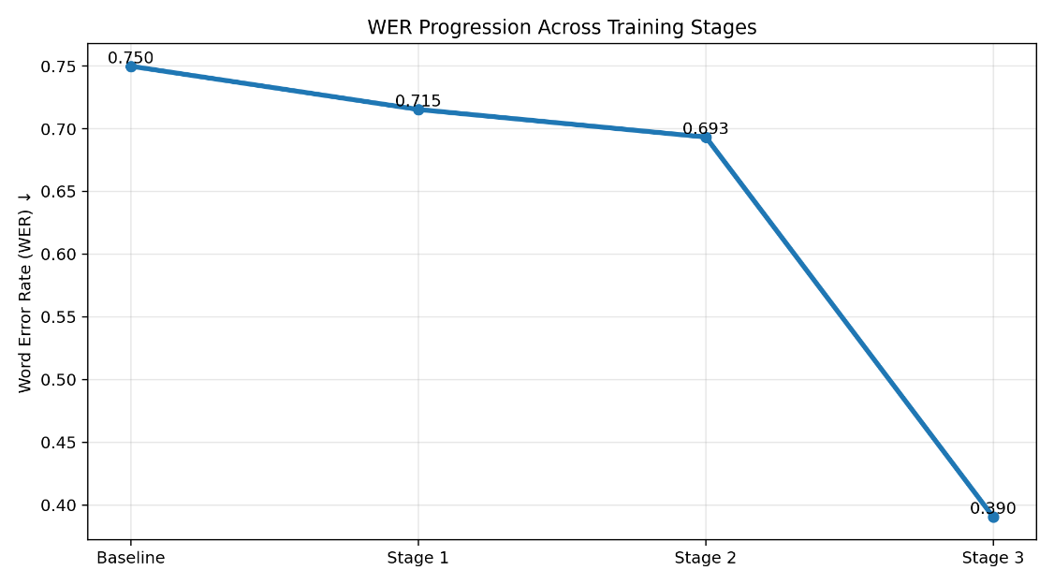
Figure 1: WER decreases across stages, with Stage 3 showing the largest reduction in word-level errors.

CER Progression Across Training Stages
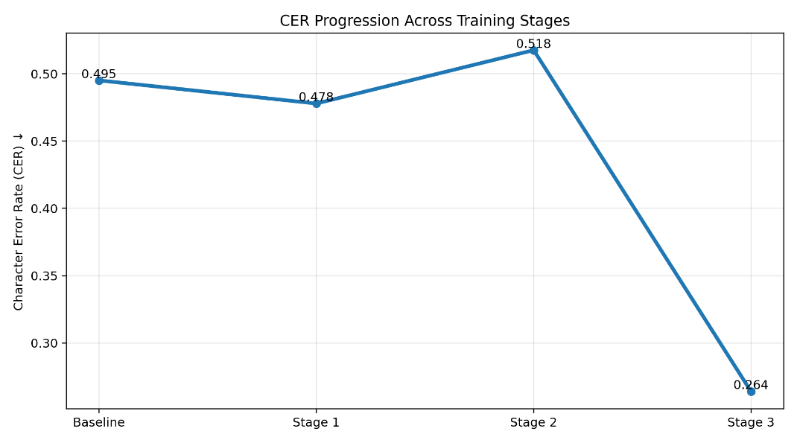
Figure 2: Character-level errors drop substantially at Stage 3, indicating improved transcription stability.

Exact-Match Accuracy Progression Across Training Stages
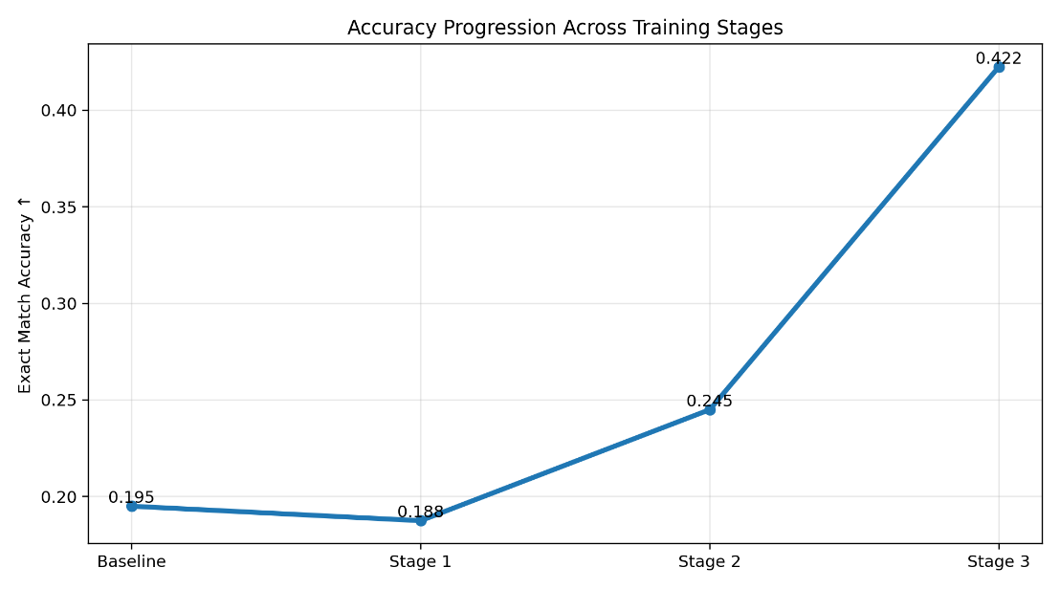
Figure 3: Stage 3 achieves the highest exact-match accuracy, improving end-to-end correctness.

5. Reproducibility Details
To support replication, the package provides:
- ASR backbone: openai/whisper-small.en checkpoint used in evaluation (as specified in the code).
- Fine-tuning protocol: Sequential staged training using PEFT/LoRA adapters with consistent inference settings across stages.
- Preprocessing: Audio standardized to 16 kHz; consistent feature extraction and padding; deterministic decoding.
- Metric computation: WER/CER via standard libraries (e.g., jiwer); exact match via normalized string comparison.

Package contents (folder structure):
- /models/ — stage checkpoints/adapters
- /scripts/ — evaluation + plotting scripts
- /data/ — test metadata + transcripts
- /results/ — metric CSVs, plots, summary table
- README.md — step-by-step reproduction instructions and dependencies

6. Limitations and Notes
- Results reflect performance on the current fixed final test set; generalization may vary with new speakers, severity levels, and environments.
- Exact-match accuracy is strict and may undercount near-correct outputs; WER/CER provide a broader view of progress.
- Synthetic data realism may influence performance; adding more real-user data over time can strengthen validity.

