Doctors-Patients (Each doctor sees many patients and each patient sees many doctors.)

doctor has a name and qualification patient have name and address

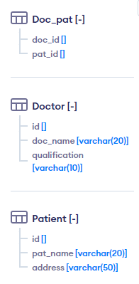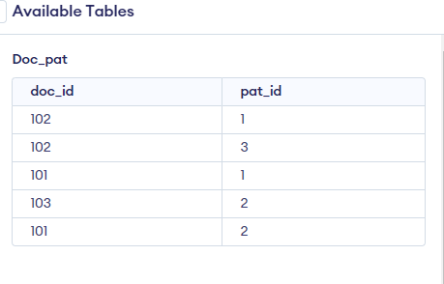

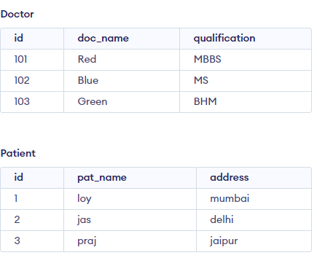

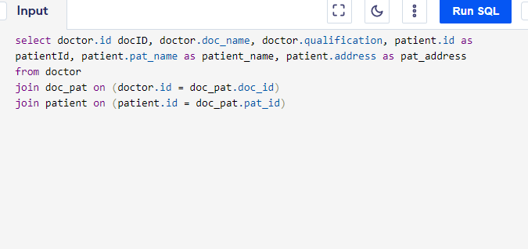

Final Result:

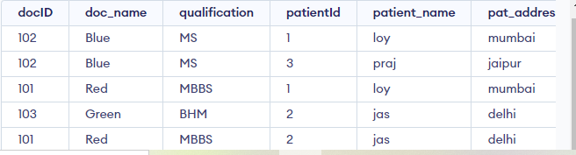

There are employees and teams. Team has a name and employees have a unique employee id,name and email. Each team has a team lead, who is also an employee. Each employee can be a member of multiple teams.

Eg: An employee with name ‘Neenu’ is part of the teams ‘Frond-end’ and ‘Back-end’

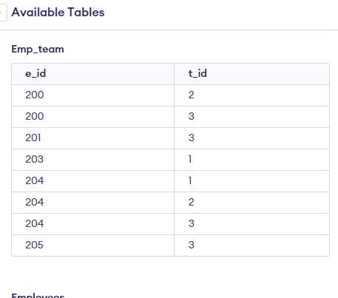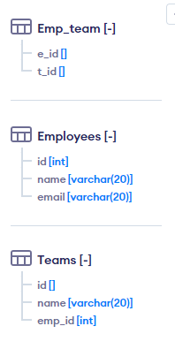

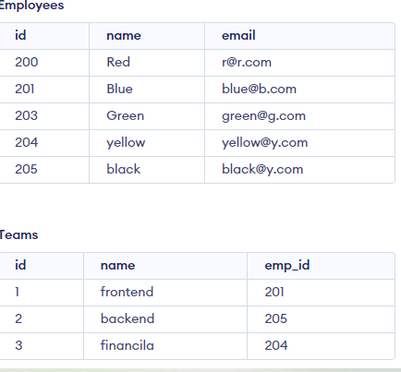

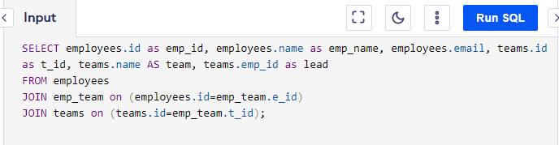

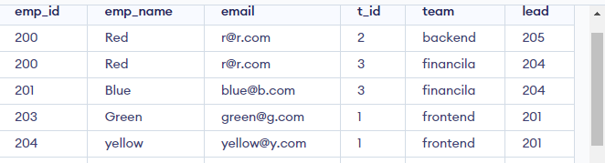

* List employees with their team leads.

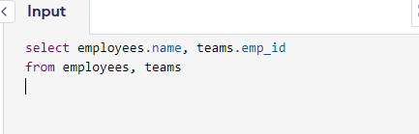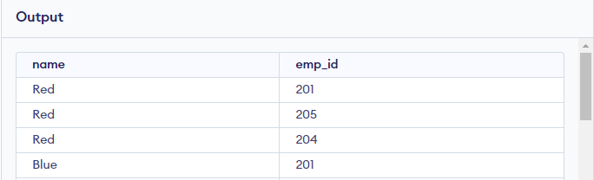



1. List employees that are on more than one team.

