The week in 7 charts
26th of October 2026

----------------------------------------------------------------------------------------------

Chart #1: AI’s debt bill is becoming a problem for tech stocks

This chart tracks five-year credit-default swaps: the cost of insuring companies’ debt against default. Rising lines signal growing concern about creditworthiness.

Oracle’s spread approaches 300 basis points, equivalent to roughly $300,000 annually to insure $10 million of debt. SpaceX and Broadcom also show sharp increases.

Investors are questioning whether future AI revenues will justify today’s enormous spending on chips, data centers and power.

That uncertainty pressures equities through three channels:
- Financing: Higher borrowing costs reduce potential investment returns.
- Valuations: Heavy spending absorbs cash, while uncertain profits encourage investors to pay lower earnings multiples.
- Contagion: Financial pressure on cloud operators could slow orders for chipmakers and infrastructure suppliers.

With AI leaders heavily weighted in the Nasdaq index, these concerns amplify index declines.

Rising CDS spreads reflect and can reinforce market anxiety. They neither imply imminent defaults nor explain the entire recent sell-off.

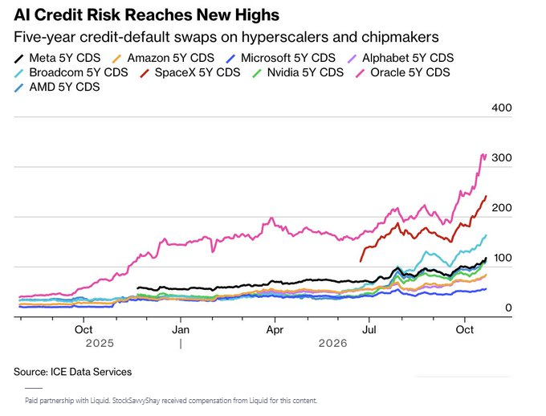

Source: Bloomberg

Chart #2: World’s largest wealth fund posts $30 billion loss after bond market turbulence

Despite gains in equities, Norway’s wealth fund reported a USD 30 billion loss in Q3, due to weaker bonds and a stronger Norwegian krone.

📉 The world’s largest sovereign wealth fund reported a third-quarter loss of 278 billion Norwegian kroner as rising interest rates dragged down fixed-income investments.

With its portfolio valued at around USD 2.3 trillion, the results highlight how bond market movements can shake even the world’s biggest institutional investors.

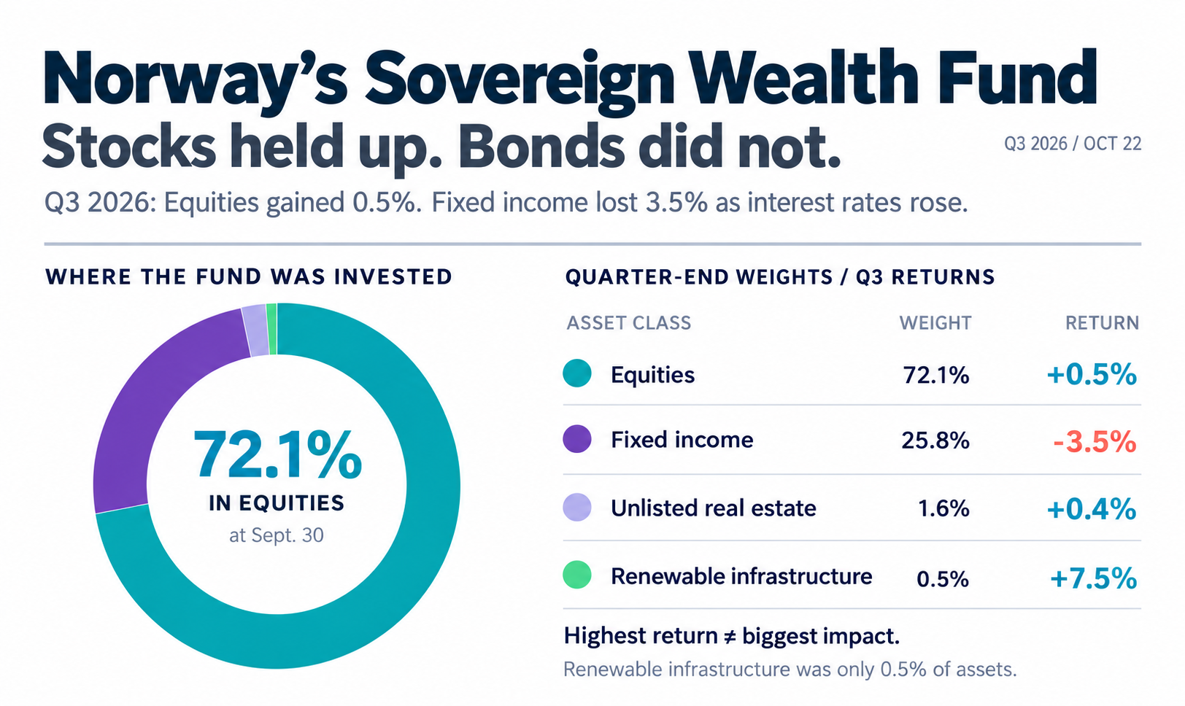

Source: AInvest Wire

Chart #3: France’s debt problem has no single political owner

Decades of fiscal slippage have pushed debt towards 120% of GDP.

Now the arithmetic is tightening: Higher yields → higher interest costs → wider deficits → more debt.

Modest growth makes that cycle harder to break. Reforms face fierce resistance. Political instability makes lasting consolidation harder.

France’s economic model faces a tougher test as borrowing costs rise and debt accumulates.

The question reaches beyond Paris: Can France stabilise its finances before market pressure turns a national fiscal problem into a eurozone crisis?

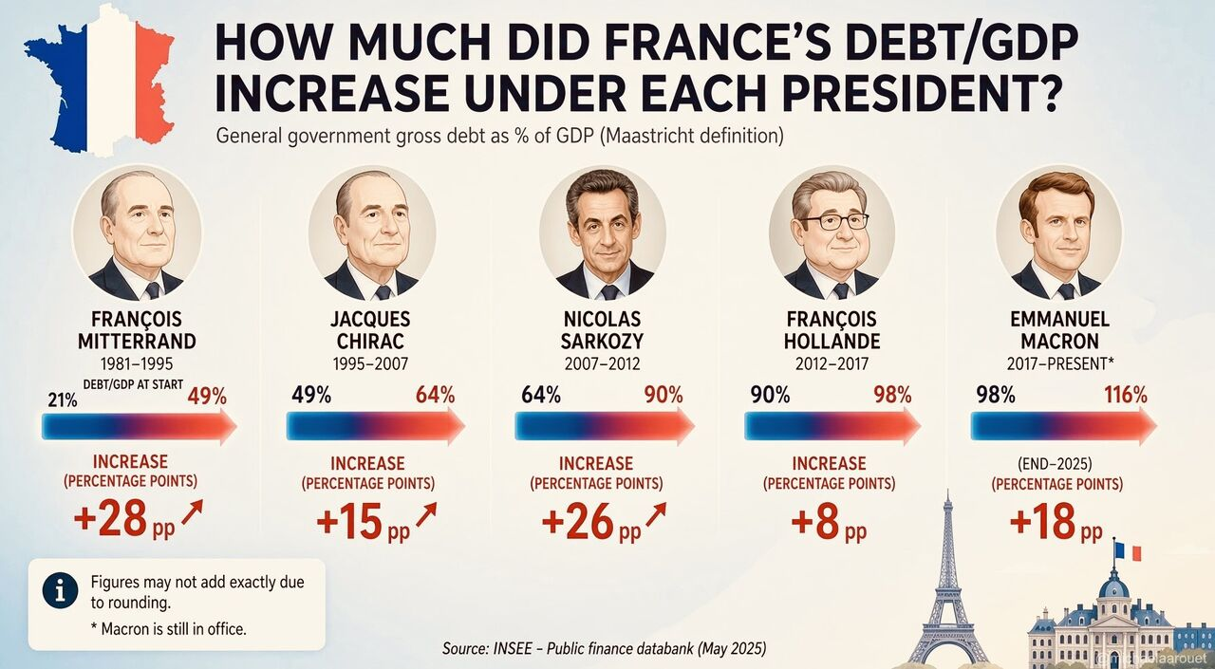

Source: Michel A. Arouet, INSEE

Chart #4: France’s fiscal problem is becoming a corporate earnings problem

On Wednesday, Carrefour shares reportedly plunged more than 13% after the company cut its outlook, warning that looting and store disruptions could cost €80–200 million in operating income.

But the damage extends beyond supermarkets.
Debt near 119% of GDP.
A deficit above 5%.
Public spending around 57% of GDP.

Now add unrest that hurts confidence, disrupts businesses and threatens tax revenues.

The vicious circle tightens:
→ Persistent deficits require more borrowing.
→ Higher yields increase interest costs.
→ Weak growth complicates consolidation.
→ Political resistance makes reform harder.

France is not inevitably heading for a debt crisis. But postponing difficult decisions keeps raising the eventual cost.

The risk for Europe? A French fiscal shock would test the eurozone on a scale Greece never could.

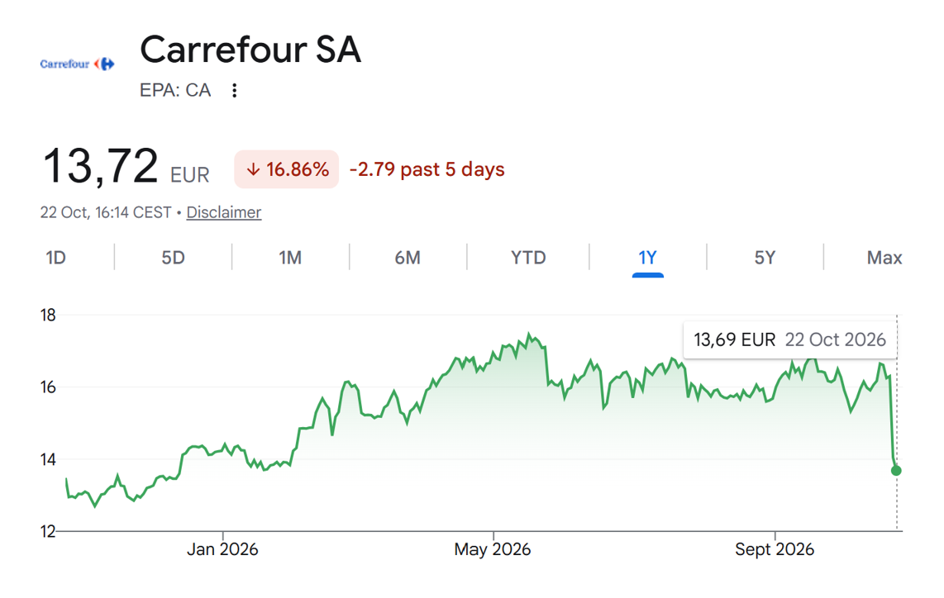

Source: Michel A. Arouet

Chart #5: The Musk Universe

A Bloomberg-inspired chart showing how intertwined Elon Musk’s companies are.



Source: Bank Syz

Chart #6: Europe’s housing market has flipped

Here are the 3-year changes in €/m² for selected cities in Northern and Southern Europe.

Luxembourg −11%
Paris −4%
London −2%
Vienna −2%

Montenegro coast +79%
Sofia +64%
Málaga +59%
Alicante +48%
Zagreb +44%

While the “old” European market has flattened, more affordable cities are growing fast.

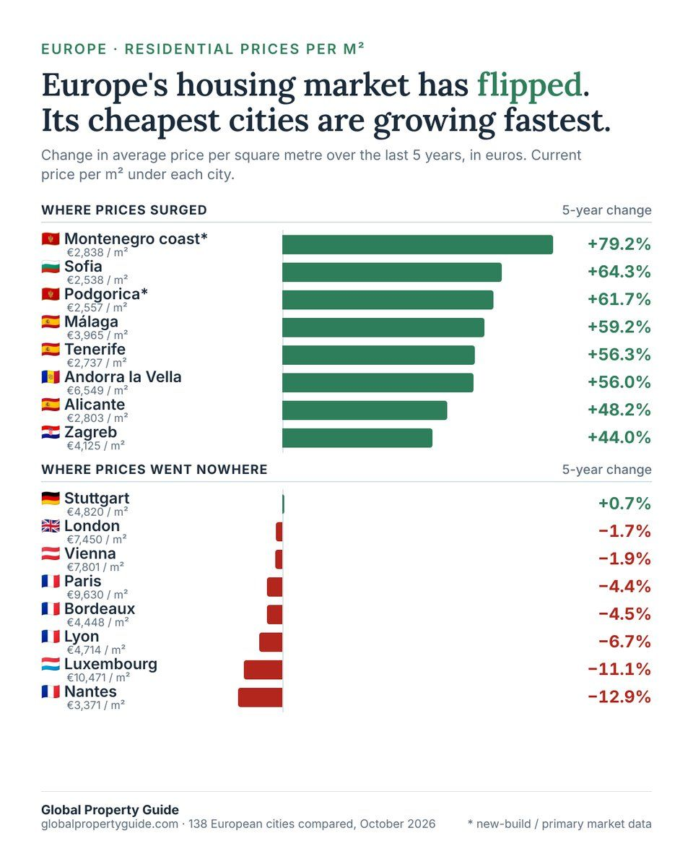

Source: Global Property Guide on X

Chart #7: Pass rate for final CFA exam stays BELOW decade average

Bloomberg’s Katherine Doherty: “The pass rate for the third and final level of the CFA exam slipped in the latest testing period, remaining below its decade average.

In August, 47% of candidates passed the Level III test, down from a 50% success rate in both February and August of last year, the CFA Institute said Tuesday. That’s below the 50% average pass rate over the past 10 years, which has not been exceeded since 2020.”

The institute continues to find that test-takers who delay their exams have a much lower chance of success. First-timers scored significantly above the average pass rate for the final testing level, with 56% succeeding, while those with at least one deferral had a 31% pass rate, the institute said.

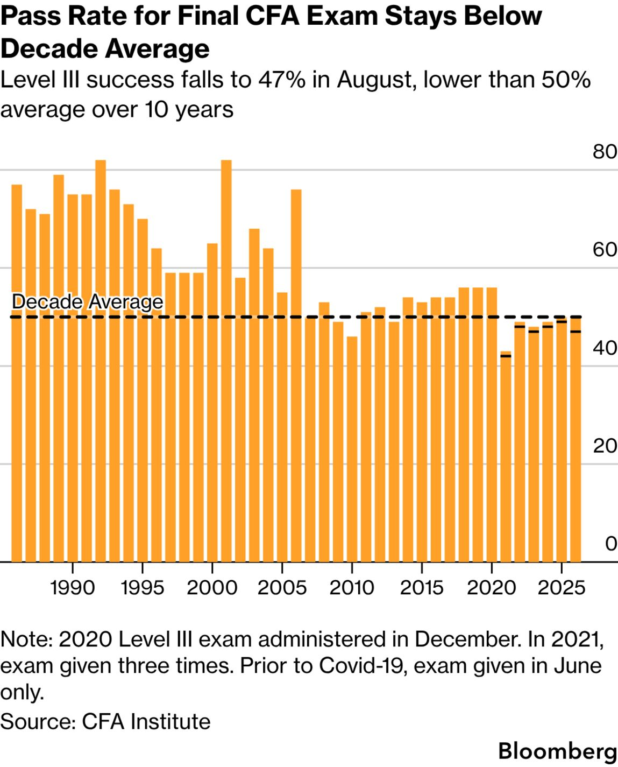

Source: Bloomberg, Harald Berlinicke, CFA 🍵

