The week in 7 charts

November 16th, 2026

------------------------------------------------------------------------------------------------------------------------------

Chart #1; Microsoft’s outage goes global

On Friday morning, Microsoft is currently experiencing a massive global outage, with services disrupted across multiple regions as the company works to restore normal operations

This map shows the affected regions across the world. China appears to remain unaffected, possibly because it operates separate Microsoft service infrastructure from the rest of the world.

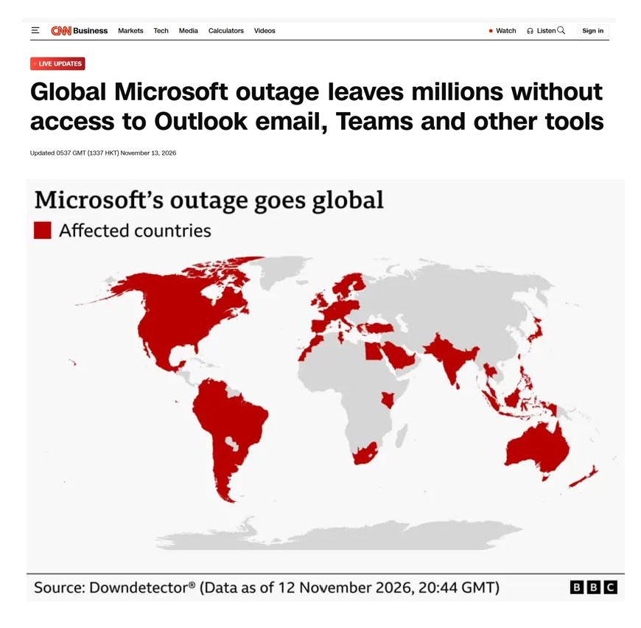

Source: Rerum Novarum, BBC, CNN

Chart #2: Nvidia is not the world's largest company anymore…

How things can turn so quickly…

CEO resigned, with an ongoing investigation.

The stock is down 36% from its all-time high.

Over $2 trillion wiped from its market cap.

It lost the No. 1 spot to Apple.

Shares price hit its lowest level since July 2025 and recorded its 6th straight weekly drop, the longest since 2012.

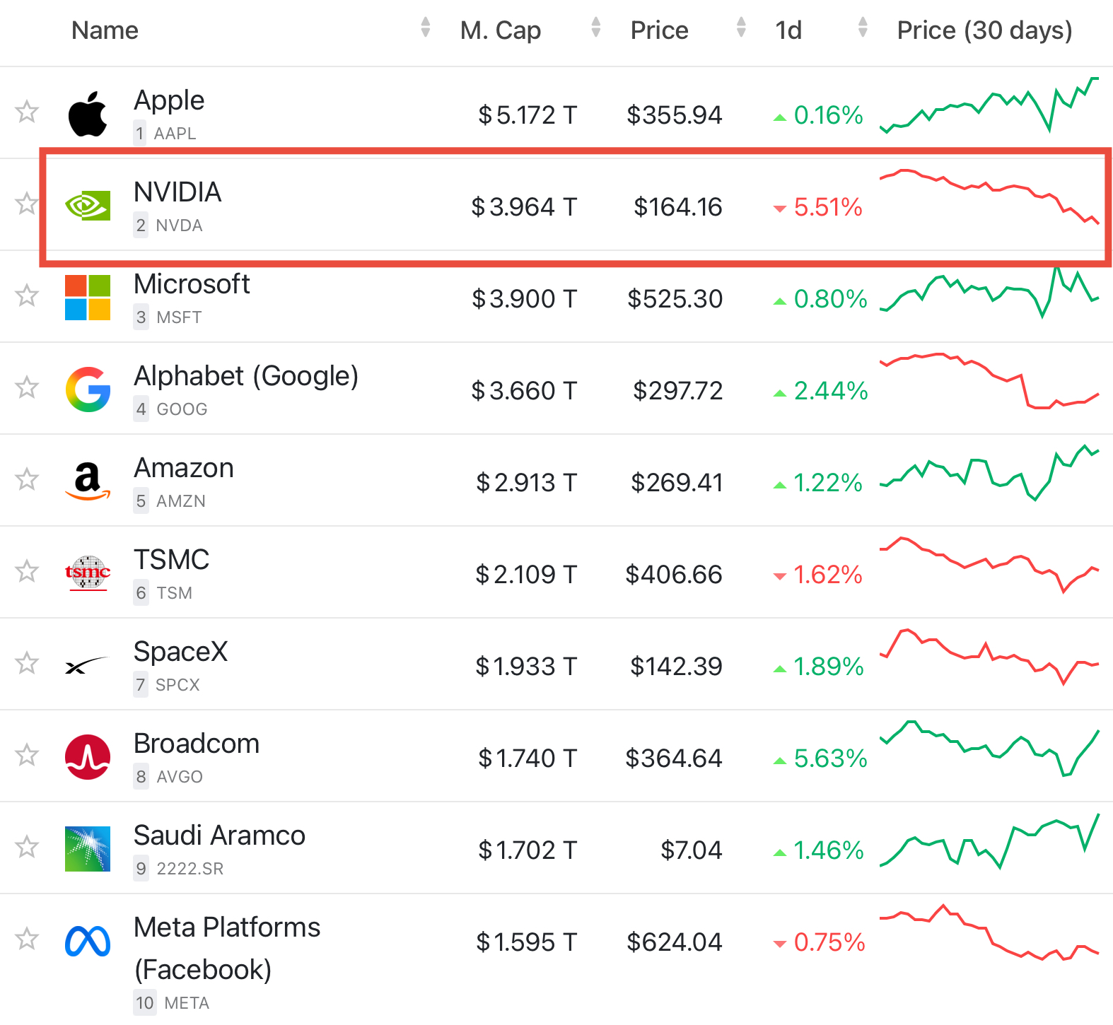

Source: Bull Theory, companiesmarketcap.com

Chart #3: Nvidia stock is getting cheaper

Nvidia $NVDA now trades at ~10x forward earnings which makes it cheaper than nearly every other AI name

- Broadcom 17x
- TSMC 18x
- Alphabet 19x
- AMD 33x

Only Micron is cheaper at 4.3x

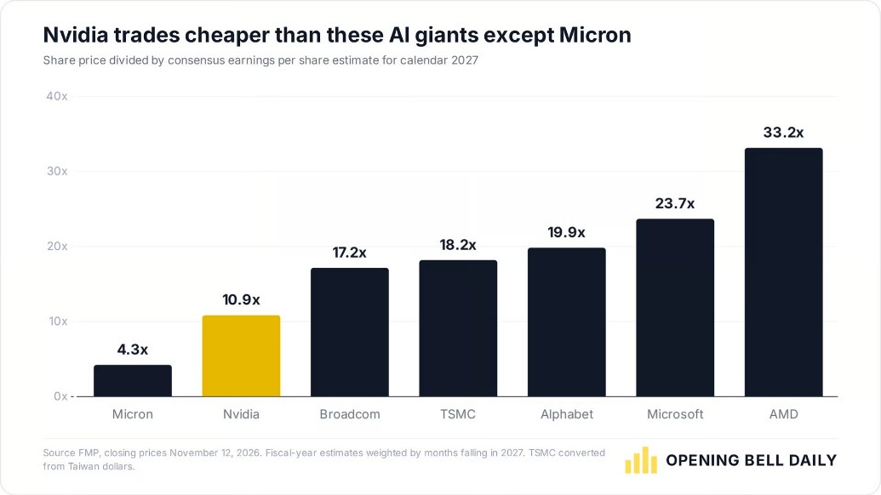

Source: Phil Rosen @philrosenn
Chart #4: Could Nvidia’s role in financing the AI buildout be about to change?

Goldman expects Nvidia to honor its existing commitments. The open question is what happens to new deals. If lenders are asking for backstops of 25% or more, will Nvidia keep providing them on the same terms? Or could new deals get smaller, take longer to close, or cost more?

If Nvidia pulls back, how much more would neoclouds and AI labs have to pay to borrow, with CCC spreads already near the widest levels of this cycle?

The first clue could come on Tuesday, November 17, when Colette Kress reports Q3 results. If she’s asked about the $500 billion, her answer could give investors a sense of how willing Nvidia is to make fresh commitments.

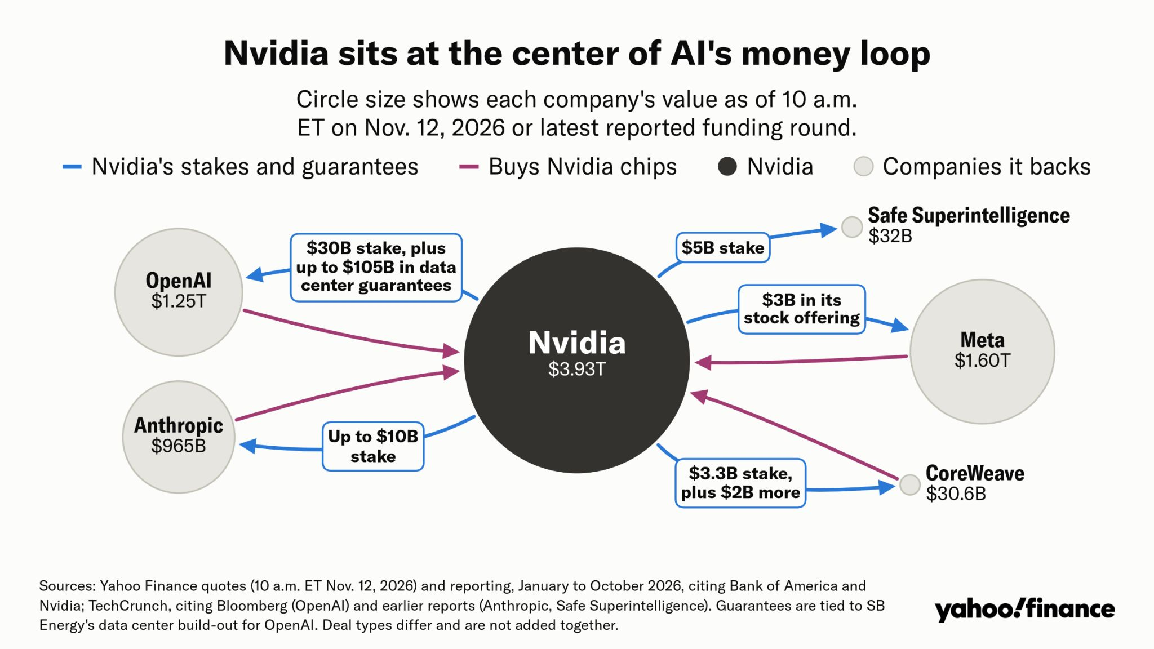

Source. zerohedge, GS, yahoo Finance

Chart #5: Who really owns Nvidia?

Nvidia has no controlling shareholder. Vanguard and BlackRock manage the largest reported blocks of shares, while Jensen Huang is the largest individual shareholder disclosed in Nvidia’s 2026 proxy, with a 3.41% beneficial stake. That figure includes shares held through trusts and the Huang family foundation.

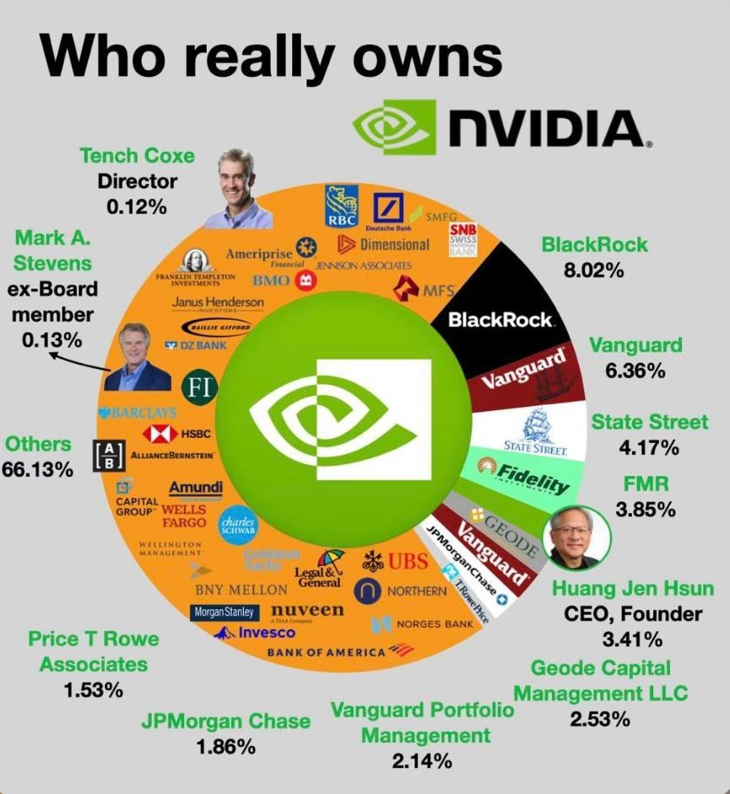

Source: Kondwelani Kalinda
Kukula Capital

Chart #6: Can SpaceX catch up with Telecom giants?

SpaceX’s connectivity revenue grew 69.5% year over year in Q3 2026.

AT&T grew 7.2%. T-Mobile grew 6.3%. Verizon grew 2.9%.

SpaceX generated $5.25 billion in connectivity revenue and $3.49 billion in adjusted EBITDA.

Consumer revenue rose 57%, while government and enterprise revenue jumped 91%.

Starlink’s subscriber base doubled, even as average revenue per user fell from $83 to $69.

The telecom giants still generate roughly 4–6 times as much revenue across their respective connectivity and service businesses.

But Starlink’s next move could bring it into more direct competition with them. SpaceX has agreed to acquire nationwide low-band spectrum for Starlink Mobile.

Can Starlink turn its lead in growth into a meaningful share of the mobile market?

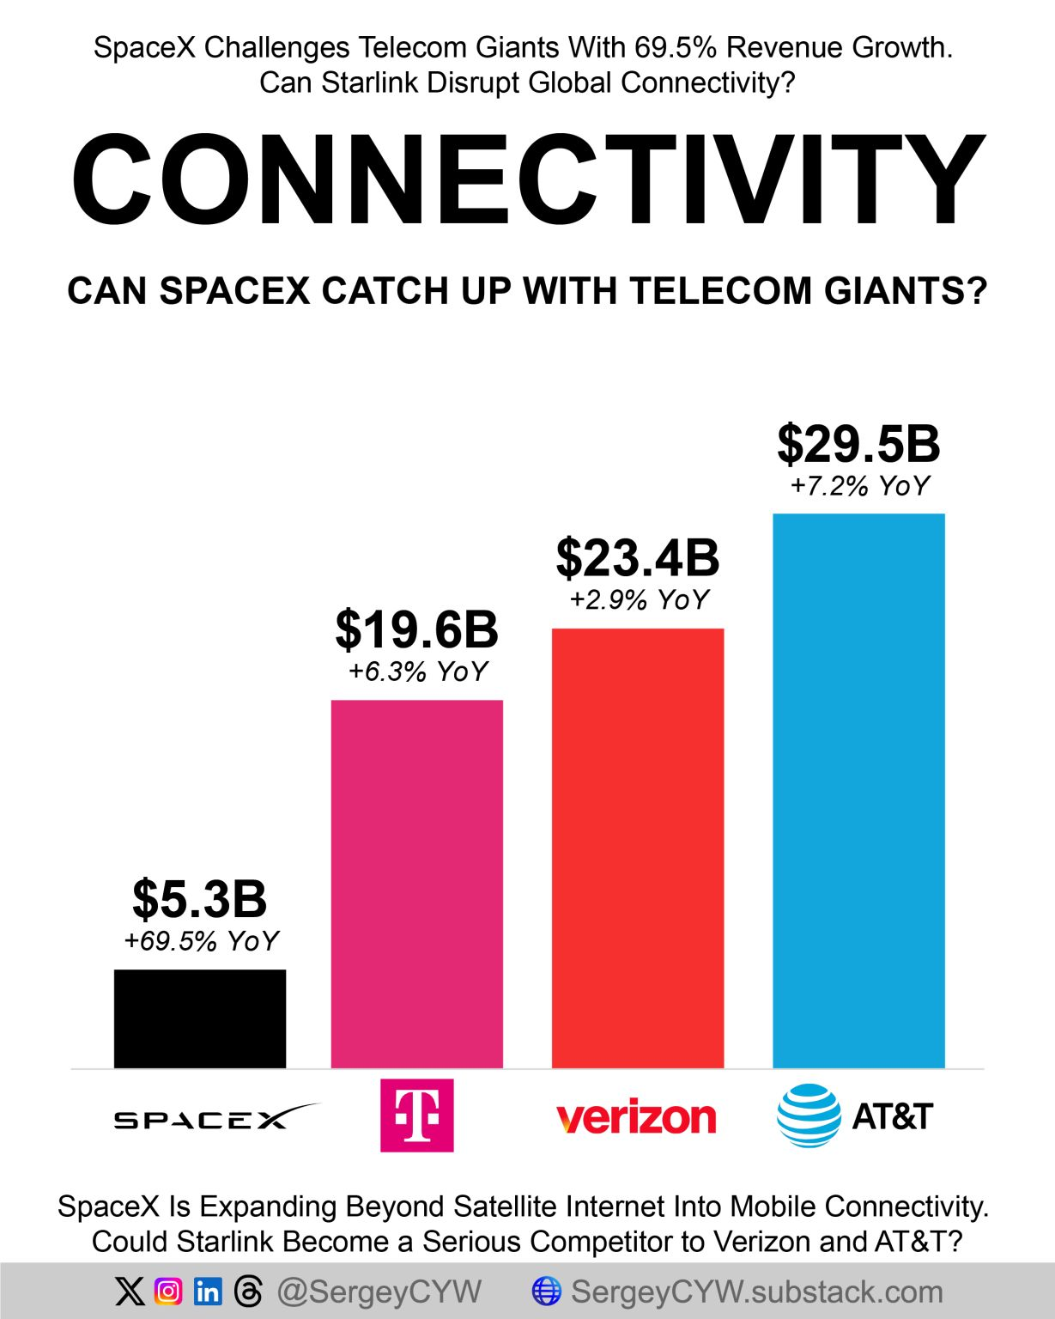

Source: Sergey
@SergeyCYW

Chart #7: Binance has fully recovered the assets hacked

Binance confirms it has fully covered the assets affected by the $6.3 BILLION hack and publishes a new proof-of-reserves snapshot.

Binance says once the zero-knowledge proof is generated, users will be able to independently verify that their balances in the snapshot were backed at least 1:1.

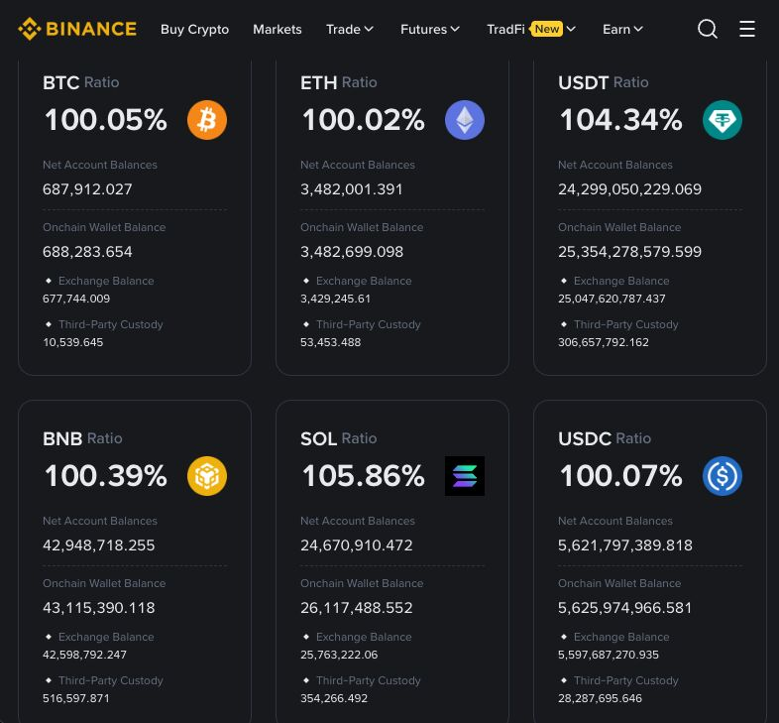

Source: Coin Bureau

