The week in 7 charts
9 November 2026
Chart #1: US equities record their largest one-day loss in market value
On Thursday 5 November, US equities had one of their weakest sessions of the year. The S&P 500 fell 4.4% to close at 7,354, the Nasdaq 100 lost around 6.4% and the Philadelphia Semiconductor Index (SOX) dropped 12.3%, leaving it roughly 38% below its June peak. The selling was broad-based: decliners outnumbered advancers by more than five to one, and 84% of trading volume was on the downside.
Approximately $2.8 trillion of market capitalisation was erased in a single session, the largest one-day loss on record according to the source cited below. The previous record, of about $2.69 trillion, was set during the COVID-19 sell-off.
The catalyst was political. Wednesday's post-election rally had rested on relief that the uncertainty was over and on the prospect of a divided government, but it reversed within a day. Investors began to assess what stronger Democratic results, particularly in state governments, could mean for AI infrastructure. The concerns are concrete: electricity and water consumption, permitting, and the rising cost of building data centres. A disappointing profit outlook from Qualcomm added to the pressure on semiconductor stocks.

Source: Litest (@Litest)
Chart #2: What has followed a 5% drop in the Nasdaq?
In short: a quick rebound, then often a retest
Thursday's 5.52% decline in the Nasdaq Composite was its eighth drop of more than 5% since 2015. In the seven previous episodes:
- The next day: 6 of 7 rebounded.
- One week later: 5 of 7 were lower.
- Three months later: 6 of 7 were higher, with an average gain of 23%.
The sample is small, and three of the seven episodes date from March 2020. Even so, it is a reminder that an initial rebound does not necessarily mean the selling is over. Past performance is not a guide to future results.
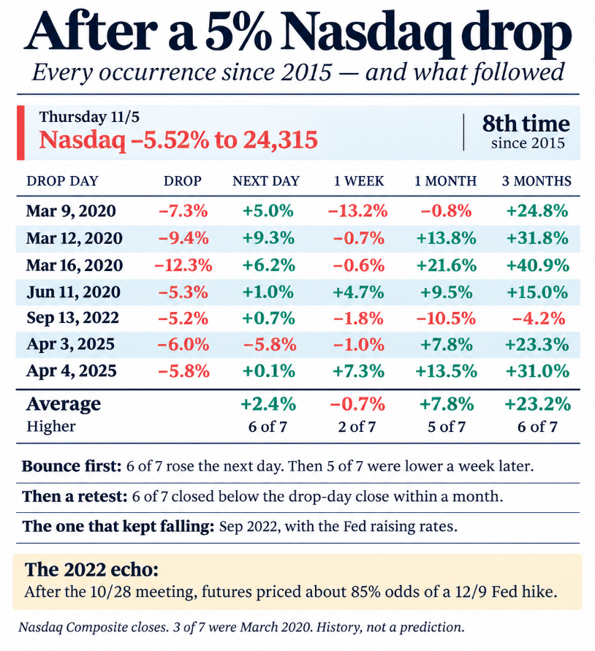
Source: Donald Dean (X), based on Nasdaq Composite closing levels
Chart #3: US equities have fallen even as earnings estimates have been revised upwards
The more estimates rose, the more valuation multiples compressed. Since 30 June, forward earnings-per-share (EPS) estimates have risen by 32% for Memory, 31% for AI Infrastructure and 30% for Semiconductors, while forward price-to-earnings (P/E) ratios over the same period fell by 50%, 36% and 35% respectively. All 20 semiconductor constituents of the S&P 500 have de-rated.
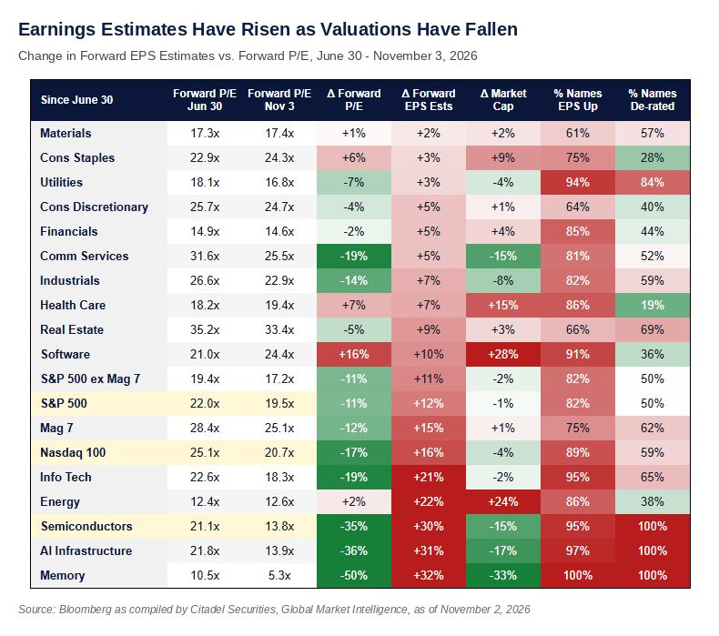
Source: Zero Hedge, Citadel Securities
Chart #4: The largest stock market declines ever recorded
A visual comparison of the biggest equity market crashes on record, and how Thursday's move fits into that history.
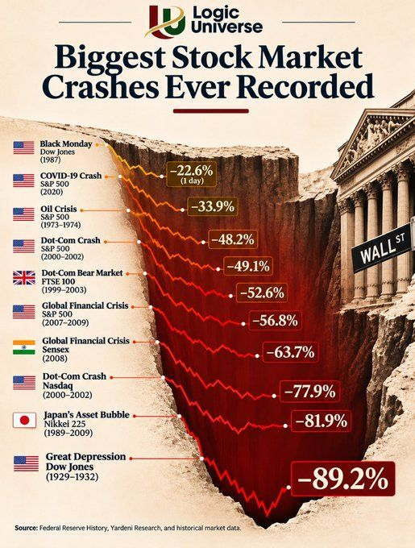
Source: Logic Universe
Chart #5: Could US equities benefit from a post-midterms rebound?
According to J.P. Morgan's Market Intelligence team, history suggests that the US midterm elections could provide support for equities. Since 1990, the S&P 500 has delivered average gains of 5.4%, 11.4%, 12.5% and 14.7% over the following 3, 6, 9 and 12 months respectively, with a positive outcome in every instance at the 6, 9 and 12-month horizons.
J.P. Morgan also notes that the recent de-risking does not yet look fully capitulative, as quantitative selling and elevated technology positioning remain risks. However, widespread deleveraging and momentum exposure falling to just 30% of its peak suggest the stage may be set for a rebound in alpha.
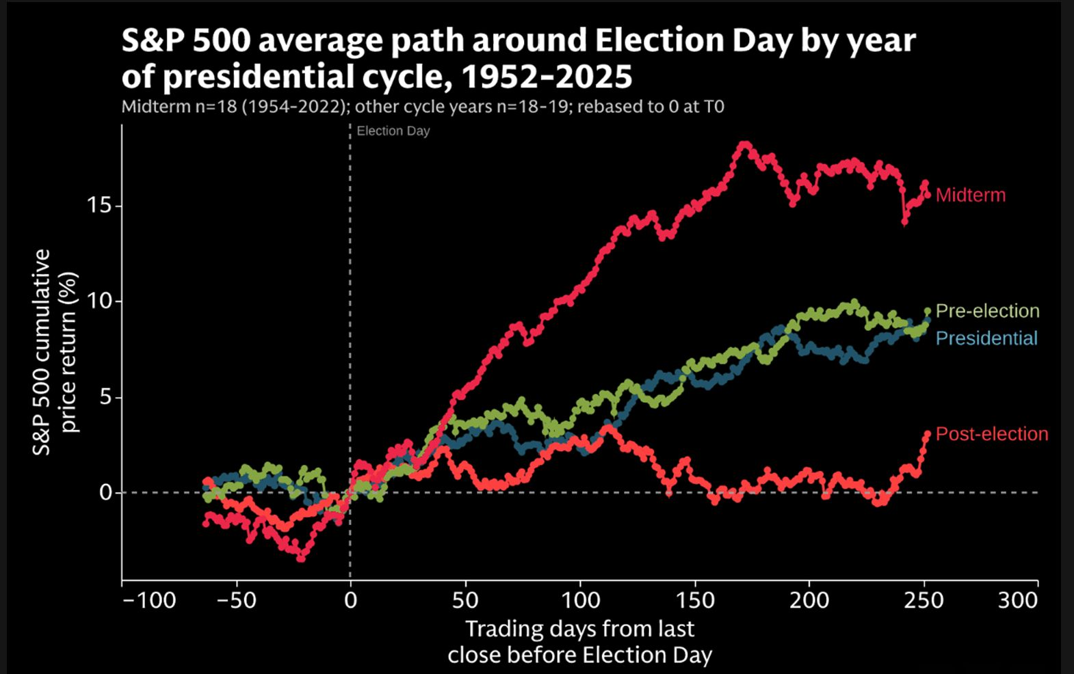
Source: J.P. Morgan, TME
Chart #6: Whichever party is in power, the long-term trend for equities and sovereign debt is upward
Over the long term, the US S&P 500 and US public debt have both trended higher under Democratic and Republican administrations alike. Government borrowing is likely to continue, and nominal growth should remain strong enough to provide a tailwind for equities. On this evidence, the outcome has been broadly similar whichever party holds the White House.
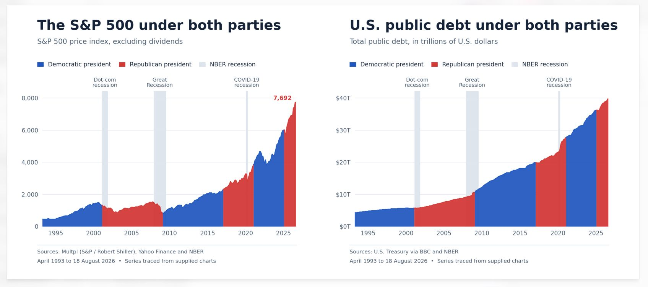
Source: Multpl (S&P / Robert Shiller), Yahoo Finance, U.S. Treasury via BBC, NBER
Chart #7: AI and data centre investment is unlikely to slow down soon
The view that US data centre spending could collapse after the Democratic gains overlooks the fact that the CHIPS Act, passed under President Biden, revitalised domestic semiconductor manufacturing. The same administration also launched a compute race with China by introducing broad export controls on advanced semiconductor equipment.
AI and data centre investment is now seen as a matter of both national security and economic prosperity, and we do not expect the investment cycle to end anytime soon.
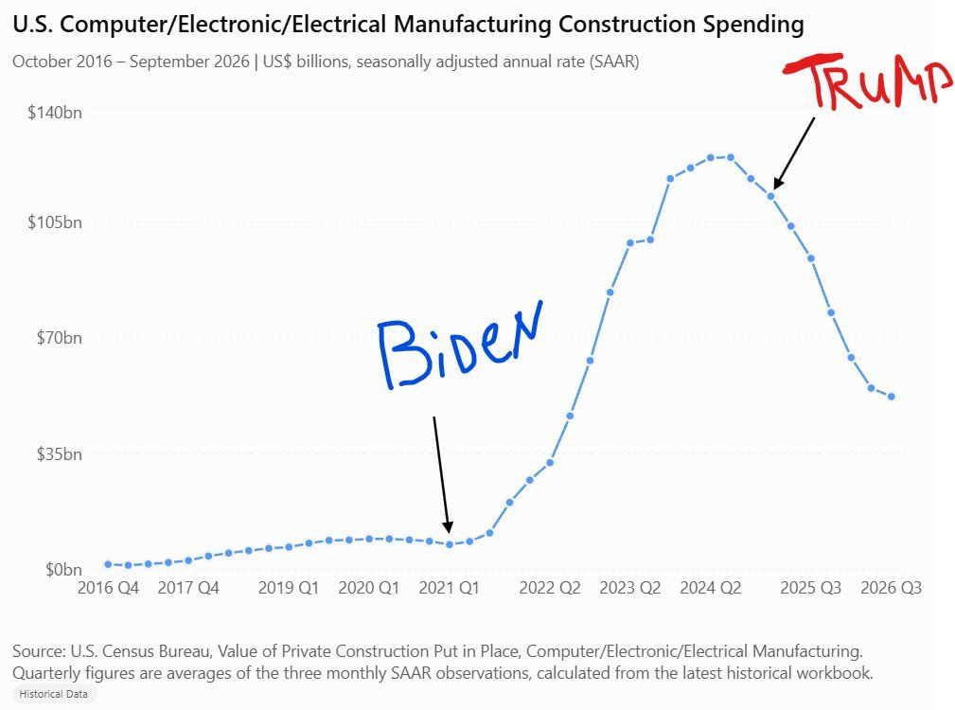
Source: U.S. Census Bureau (Value of Private Construction Put in Place), via Monolith_Cap
Important information
This document is provided for information purposes only. It does not constitute investment advice, a personal recommendation, or an offer or solicitation to buy or sell any financial instrument. Past performance is not a reliable indicator of future results. Information and third-party content are drawn from sources believed to be reliable, but their accuracy and completeness are not guaranteed. Opinions expressed are as of the date of publication and are subject to change without notice.

