The week in 7 charts
16 November 2026
Chart #1: A Microsoft service failure spreads across the globe
Late on 12 November and into Friday 13 November, Microsoft suffered a widespread service failure that reached users in numerous countries while its engineers worked to bring systems back online. CNN Business reported that millions of people lost access to Outlook email, Teams and other tools.
The map below, built from Downdetector data as of 12 November at 20:44 GMT, highlights the affected countries. China is not shaded. One possible explanation is that Microsoft operates its services there on infrastructure that is separate from the rest of the world, although this has not been confirmed.
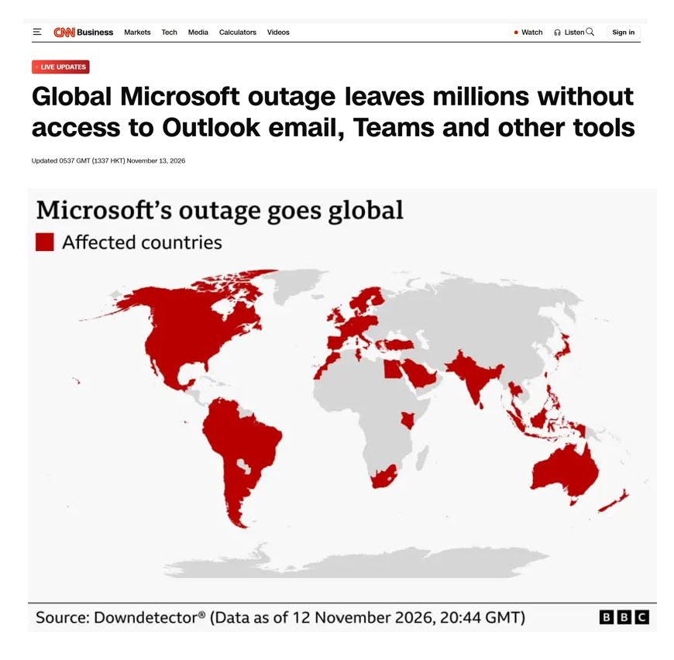
Sources: Downdetector data via BBC; CNN Business; Rerum Novarum
Chart #2: Nvidia loses its place as the world's most valuable company
The reversal has been swift. According to the sources cited, Nvidia's chief executive has stepped down while an investigation is under way. The shares now trade about 36% below their all-time high, which represents more than $2 trillion of lost market capitalisation, and Apple has taken over as the largest listed company.
Nvidia's share price has dropped to its lowest level since July 2025 and has fallen for six weeks in a row, its longest losing streak since 2012. In the table below, Apple is valued at $5.17 trillion and Nvidia at $3.96 trillion.
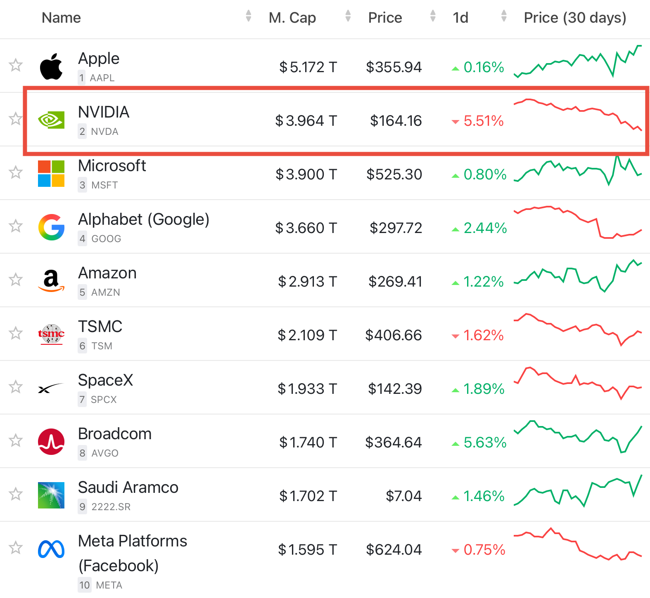
Sources: Bull Theory; companiesmarketcap.com
Chart #3: Nvidia now looks inexpensive next to its AI peers
Using consensus earnings-per-share estimates for calendar 2027 and closing prices on 12 November 2026, Nvidia trades at 10.9 times earnings, a lower multiple than almost every other major AI company. Broadcom stands at 17.2 times, TSMC at 18.2 times, Alphabet at 19.9 times, Microsoft at 23.7 times and AMD at 33.2 times. Micron is the only company in the group priced lower, at 4.3 times.
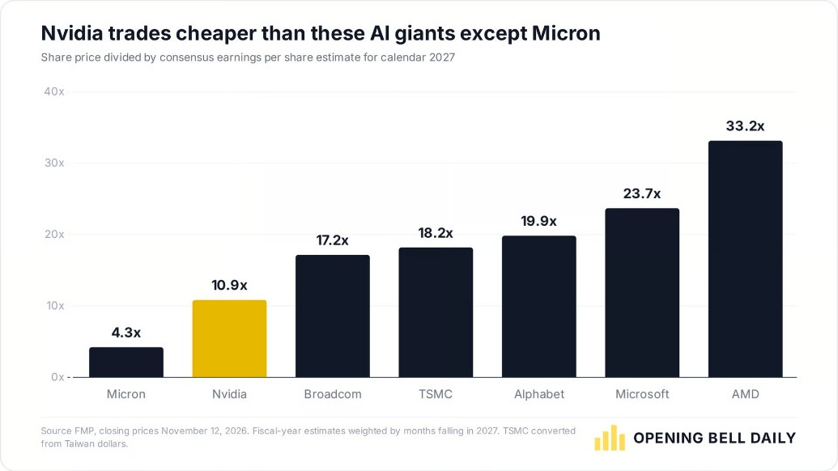
Sources: Opening Bell Daily (price data: FMP), shared by Phil Rosen (@philrosenn)
Chart #4: Is Nvidia's part in funding the AI build-out about to shift?
Goldman Sachs expects Nvidia to stand by the commitments it has already made. The uncertainty concerns future agreements. If lenders demand guarantees covering 25% or more, will Nvidia keep offering them on identical terms, or might new transactions turn out smaller, slower to close or more expensive?
Should Nvidia step back, neocloud operators and AI laboratories could face noticeably higher borrowing costs, with spreads on CCC-rated debt already close to the widest of this cycle.
An early indication may come on Tuesday 17 November, when Nvidia's Colette Kress presents third-quarter results. If she is questioned about the $500 billion figure, her reply could show how ready the company is to take on fresh commitments.
The graphic maps Nvidia's stakes and guarantees, including, for example, a $30 billion stake in OpenAI plus up to $105 billion of data-centre guarantees. Its publisher notes that the different deal types should not be added together.
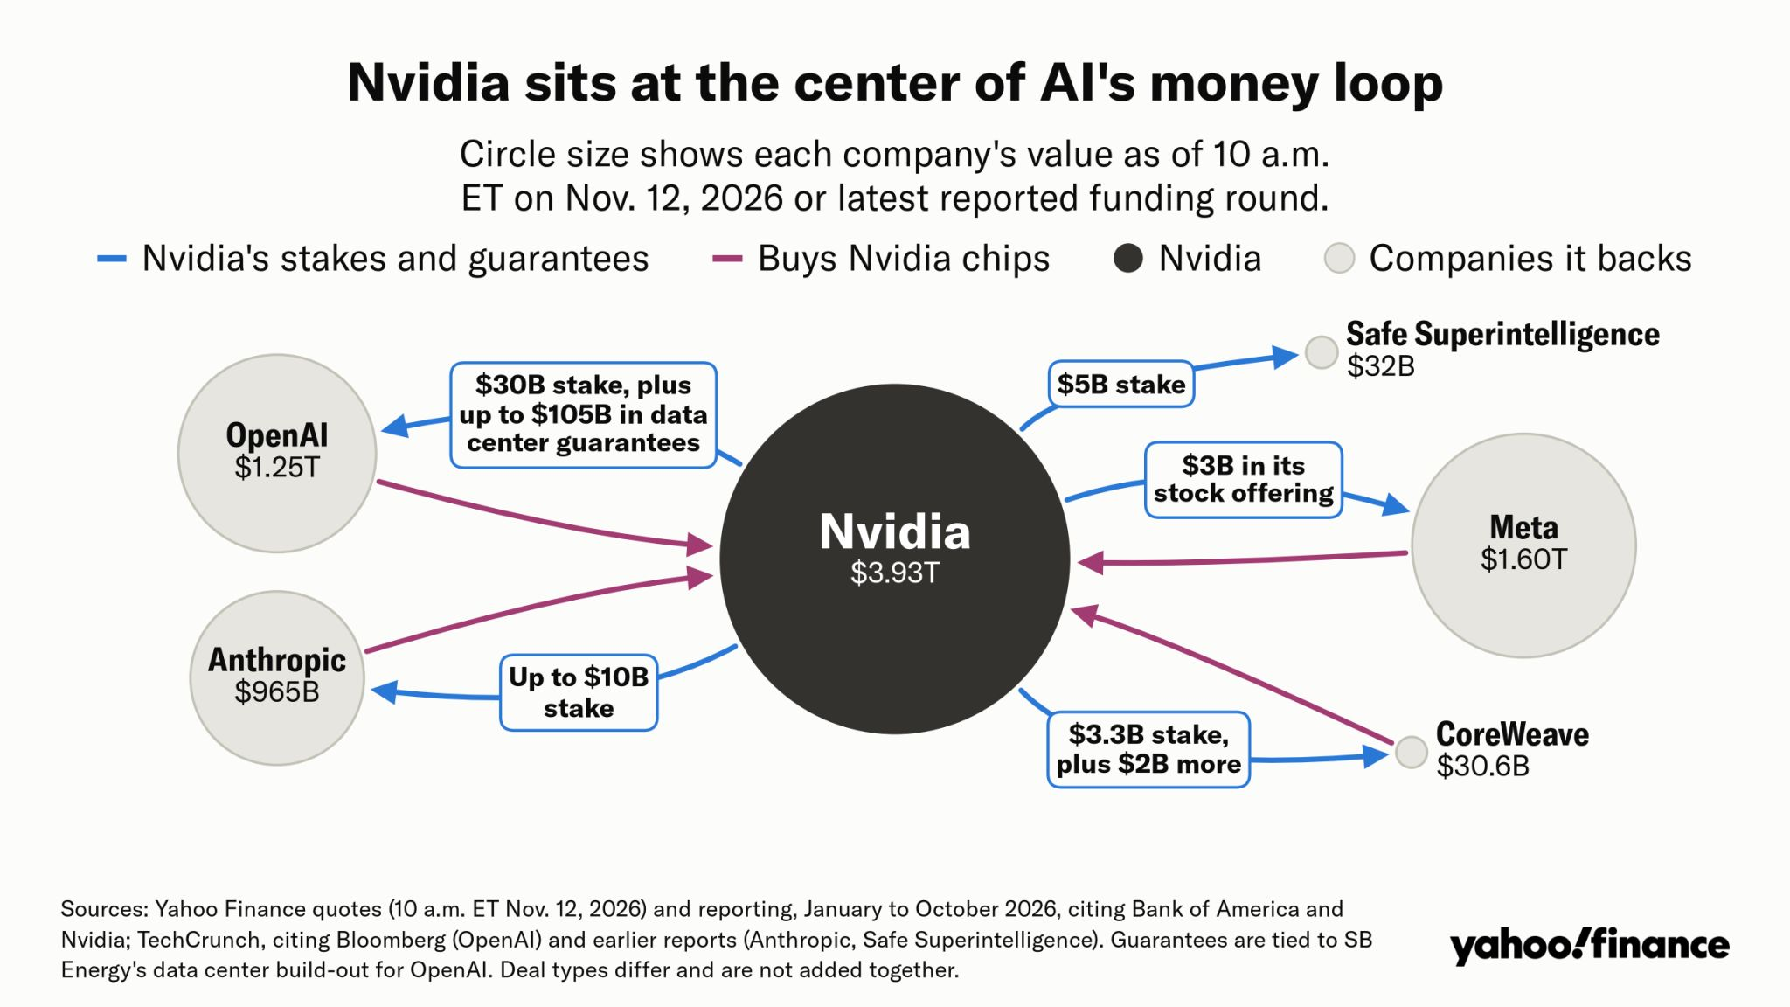
Sources: Zero Hedge, Goldman Sachs; graphic: Yahoo Finance
Chart #5: Who are Nvidia's shareholders?
No single investor controls Nvidia. The largest reported holdings belong to the asset managers BlackRock (8.02%) and Vanguard (6.36%). Among individuals, founder Jensen Huang is the biggest shareholder named in Nvidia's 2026 proxy statement, with a beneficial interest of 3.41%, a figure that includes shares held through trusts and the Huang family foundation.
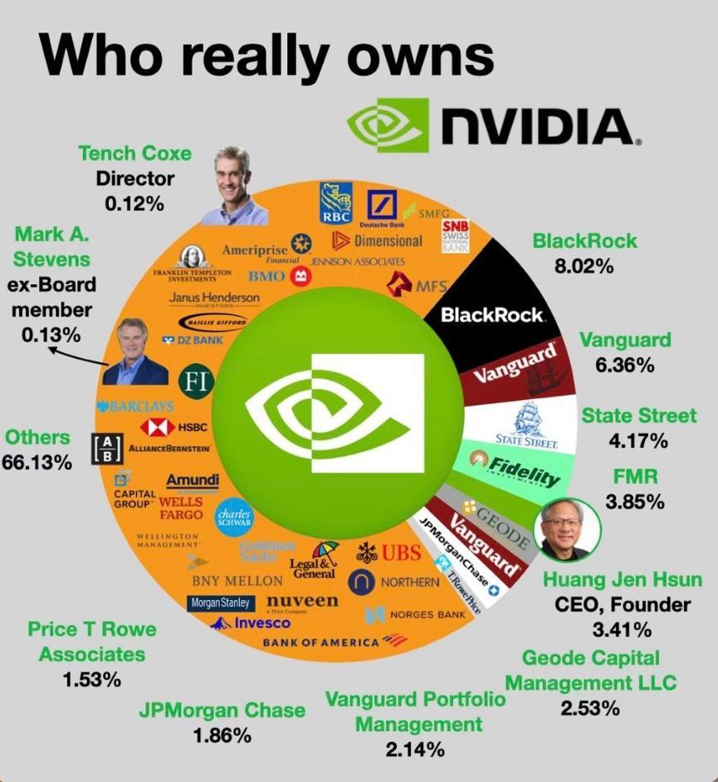
Source: Kondwelani Kalinda, Kukula Capital
Chart #6: Is SpaceX closing in on the telecom incumbents?
In the third quarter of 2026, SpaceX's connectivity revenue climbed 69.5% from a year earlier, against 7.2% at AT&T, 6.3% at T-Mobile and 2.9% at Verizon. The business brought in $5.25 billion of revenue and $3.49 billion of adjusted EBITDA. Consumer revenue grew 57%, while government and enterprise revenue surged 91%. Starlink's customer base doubled, even though average revenue per user slipped from $83 to $69.
Scale still favours the incumbents, whose connectivity and service businesses each earn roughly four to six times as much. The competitive picture could nonetheless shift: SpaceX has agreed to buy nationwide low-band spectrum to power Starlink Mobile. The open question is whether Starlink can turn its growth lead into a significant slice of the mobile market.
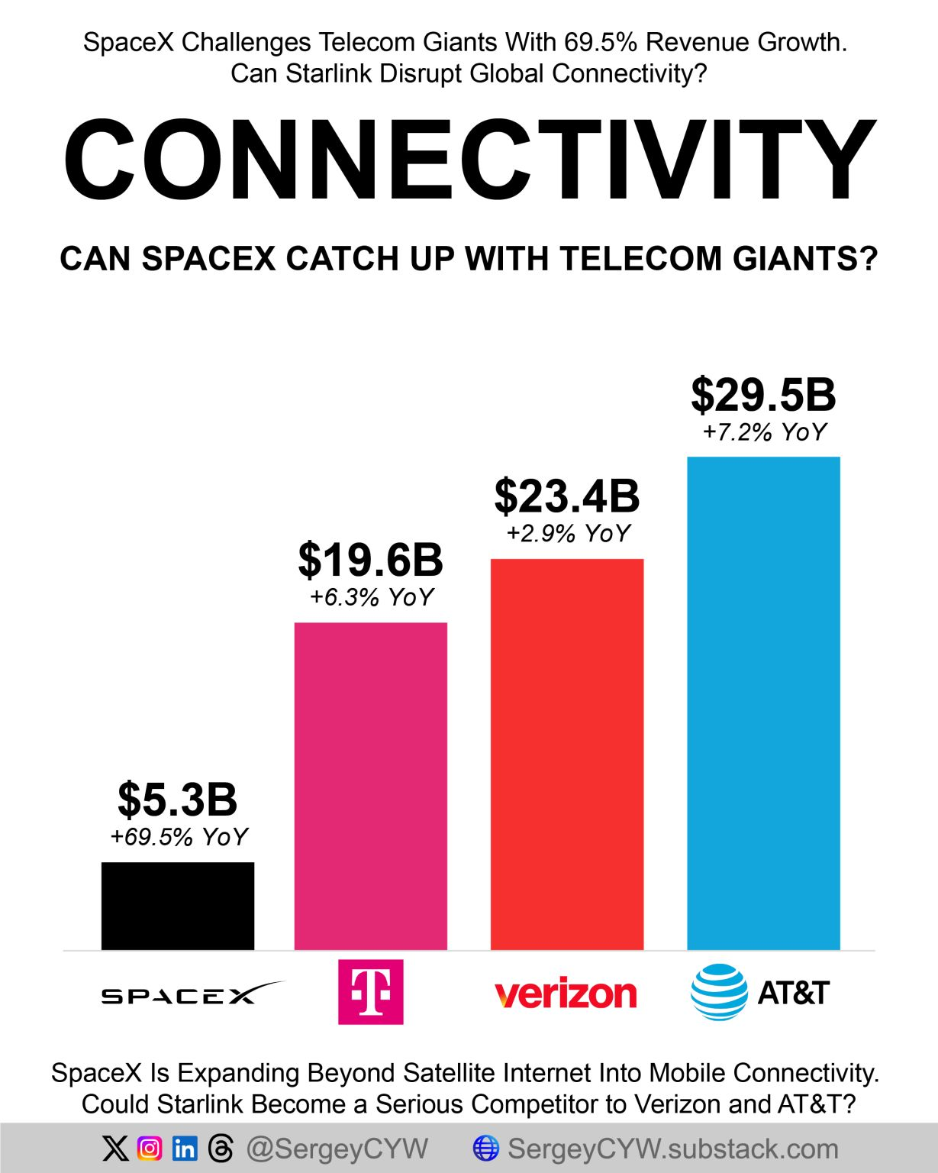
Source: Sergey (@SergeyCYW)
Chart #7: Binance says it has covered the assets lost in its $6.3 billion hack
Binance has announced that it has fully covered the assets affected by the hack, which it puts at $6.3 billion, and has released a new proof-of-reserves snapshot. According to the exchange, once the associated zero-knowledge proof has been generated, users will be able to check independently that the balances in the snapshot were backed at least one-for-one.
The page captured below lists reserve ratios of 100.05% for bitcoin, 100.02% for ether, 104.34% for USDT, 100.39% for BNB, 105.86% for SOL and 100.07% for USDC.
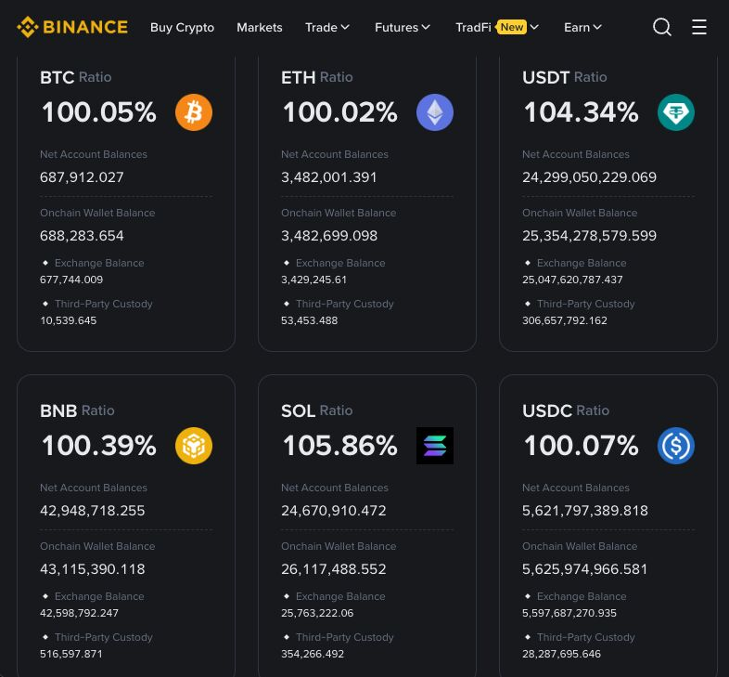
Source: Coin Bureau (screenshot of Binance's proof-of-reserves page)
Important notice
This material is circulated for general information only. It is neither investment advice nor a personal recommendation, and it should not be taken as an offer or invitation to buy or sell any security or other financial product. Past performance does not guarantee future results. Statements of fact and third-party content are taken from sources believed to be reliable, but their accuracy and completeness cannot be guaranteed. Opinions are those held on the date of publication and may change without notice.

