AD-HOC OPINION · ENERGY INFRASTRUCTURE
Enbridge: a reliable dividend, but little growth per share
27 October 2026 · Syz Research
Prices are as of the close on 26 October 2026 (Toronto listing, CAD).
IMPORTANT NOTICE
This note is intended for professional and qualified investors only. It reviews Enbridge ahead of its third-quarter 2026 results, which the company will publish on 6 November before the market opens. Figures quoted here run to the second quarter of 2026 and to company announcements made since. Please read the important information at the end of this document.
North American pipelines: steady cash, harder growth
A sector valued for its income  Large pipeline operators earn most of their profits from regulated tariffs and long-term contracts that pay for reserved capacity whatever the volumes or the oil price. Investors therefore treat them partly as bond substitutes: they own them for a high, growing dividend rather than for rapid earnings growth.  Demand is supportive. Gas exports as liquefied natural gas are expanding, data centres need new gas-fired power, and Canadian crude still depends on pipelines to reach US refineries. Assets already in the ground gain value because new routes are hard to permit. |  | Growth now comes through deals and debt  2026 has seen a wave of pipeline acquisitions. Enbridge agreed to buy Tallgrass's crude business for USD 2.55bn and Salt Creek Midstream's crude gathering business for USD 600m, and Williams bought Momentum Midstream for USD 5.5bn. These deals add earnings, but they are paid for with debt and new shares, so growth per share is slower than growth in total profits.
  WHAT THIS MEANS FOR INVESTORS
  The sector suits investors seeking dependable income. The key checks are what is paid for that income, and whether the dividend can keep growing without stretching the balance sheet. For Enbridge, the dividend is secure, but per-share growth has stalled while the valuation has risen.
ENBRIDGE SECOND QUARTER 2026 AT A GLANCE (CAD)
 | Q2 2026 | COMPARISON
Adjusted EBITDA | 4.78bn | +2.8% y/y (4.64bn)
Adjusted earnings per share | 0.63 | -3% y/y (0.65)
Distributable cash flow | 2.95bn | 2026 guidance 5.70 to 6.10 per share
Debt to EBITDA | 5.1x | Above the 4.5x to 5.0x target range
Secured growth backlog | 41bn | Record level
2026 adjusted EBITDA guidance | 20.2 to 20.8bn | Reaffirmed
Source: Syz Research, Bloomberg, Company data
AD-HOC OPINION · ENERGY INFRASTRUCTURE
Enbridge (ENB CN)
A 5.7% dividend from contracted assets, with earnings per share that have not grown since 2023
Share price  CAD 67.65  All-time high CAD 80.21 (24 Jul) | Performance 2026 to date  +3%  -16% from the July high | Forward P/E  23.6x  Median since 2021: 18.5x | Dividend yield  5.7%  CAD 3.88 a year, raised for 31 years

1. What the company does  Enbridge is North America's largest energy infrastructure company. Its Mainline, the world's longest crude oil pipeline system, carries about 3 million barrels a day from western Canada to US refineries, and liquids pipelines provide about half of group EBITDA. It also runs major US gas pipelines such as Texas Eastern, gas utilities in Ontario and, since the purchase of three Dominion utilities, in Ohio, Utah and North Carolina, plus a smaller renewable power business. About 98% of EBITDA comes from regulated or long-term contracted assets.  2. Why it could do well  The secured growth backlog reached a record CAD 41bn in July, much of it in US gas pipelines and utilities serving LNG exports and data centres. Management reaffirmed 2026 guidance of CAD 20.2 to 20.8bn of adjusted EBITDA and CAD 5.70 to 6.10 of distributable cash flow per share, and targets about 5% annual growth in both after 2026. The Tallgrass and Salt Creek purchases extend its crude network to the Rockies and the Permian, and should add to earnings from 2027.  3. What sets it apart  Scale and contracts. Few companies own hard-to-replicate networks in both crude and gas, and its cash flows have been resilient through oil price cycles. The dividend has risen for 31 consecutive years. At CAD 3.88 a year, it absorbs about two thirds of the midpoint of 2026 distributable cash flow guidance (Syz calculation), a comfortable level for a pipeline company. |  | 4. Is the share cheap?  No. At 23.6x forward earnings, Enbridge trades well above its median of 18.5x since 2021. Consensus forward EPS has slipped from about CAD 3.05 in January 2023 to CAD 2.87 today, while the multiple rose from about 18x to 24x: the share's rise since 2023 came entirely from re-rating. In the second quarter, EBITDA grew 2.8% but adjusted EPS fell to CAD 0.63 from 0.65, as higher interest and depreciation absorbed the growth. The share has fallen 16% since its July high, which removes some of the excess. The 5.7% yield, rather than earnings growth, is what an investor is buying.  5. Main risks  Leverage first: debt stands at 5.1x EBITDA, above the 4.5x to 5.0x target range. That prompted a CAD 3.0bn share issue in September (44.7m shares at CAD 66.85, about 2% dilution) before Tallgrass contributes. Per-share growth could keep lagging total growth if more equity is needed. Line 5 still faces legal challenges in Michigan and Wisconsin. As a high-yield stock, Enbridge is also sensitive to rising bond yields.  6. What to watch next  Third-quarter results on 6 November, with the leverage update after the share issue. The December dividend announcement and 2027 guidance. The closing of the Tallgrass deal. The handover from Greg Ebel to Michele Harradence, head of the gas utilities business, as CEO on 1 January 2027.
CONCLUSION
We see Enbridge as a dependable income holding rather than a growth story. The dividend looks secure, but per-share earnings have not grown in three years and leverage is stretched, so the valuation leaves little room for disappointment. An investor holding it for income could keep it as a core position, noting the overlap if the portfolio also holds Williams, TC Energy or other pipeline names. An investor looking for capital gains could find better growth elsewhere. An investor without exposure who wants the yield could build a position gradually rather than in one go.
AD-HOC OPINION · ENERGY INFRASTRUCTURE
Charts
Charts as of the close on 26 October 2026.
Chart 1 · ENB CN: a strong run, cut short in August
Daily closing price in CAD and 200-day moving average since January 2023
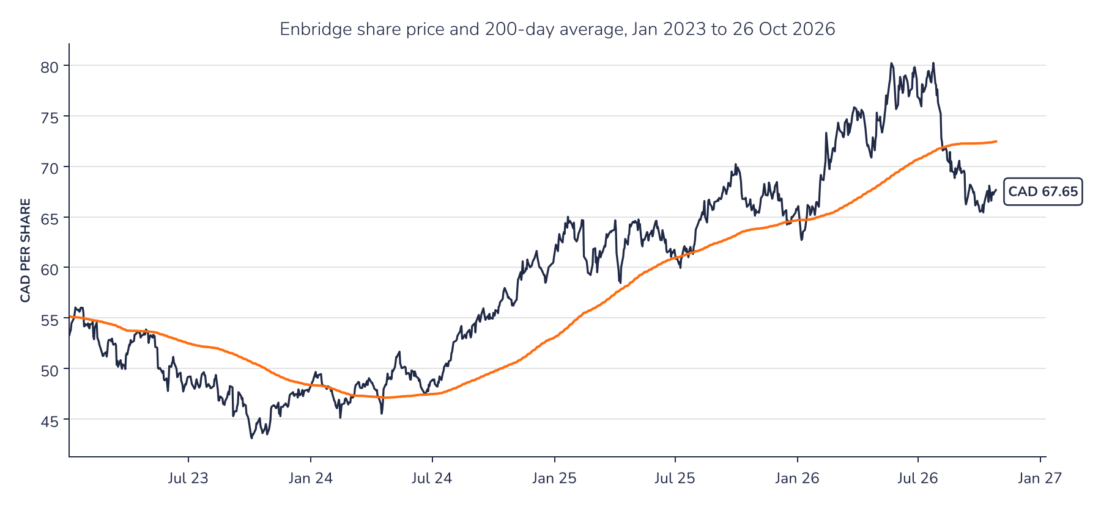
Source: Syz Research, Bloomberg
Chart 2 · ENB CN: the multiple rose while earnings did not
Consensus forward 12-month EPS in CAD (top) and forward P/E (bottom) since January 2023; the dashed line is the median P/E since 2021
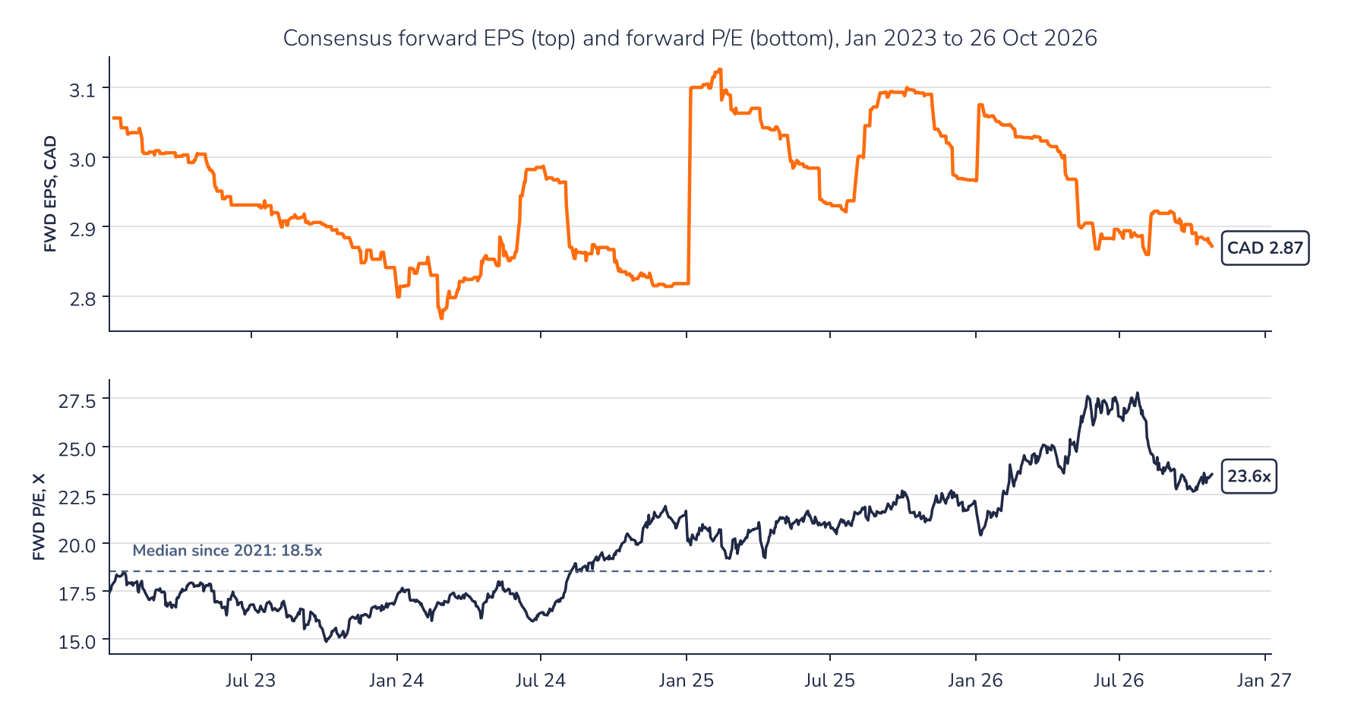
Source: Syz Research, Bloomberg
AD-HOC OPINION · ENERGY INFRASTRUCTURE
Sources
Syz Research, Bloomberg, Company data
Important information
This communication has been issued and made available to recipients for the purpose of advertising investment services and/or financial instruments. It has been sent for information purposes and cannot be considered as an offer or a personalised recommendation to buy or sell a financial instrument or any other investment or currency. This communication does not constitute investment research within the meaning of regulatory rules applicable in the European Economic Area, or research under the rules of the U.S. Self-Regulatory Organizations.
This information is made solely for professional and institutional clients as defined by the Swiss Financial Services Act, as well as qualified investors according to the Swiss Collective Investment Schemes Act. It is not intended for retail clients or non-qualified investors and consequently cannot be transmitted to any third party.
This communication is not directed to any person in any jurisdiction where, by reason of that person's nationality, residence or otherwise, its dissemination or use is prohibited. It cannot be quoted, reproduced, disclosed, distributed or otherwise referred to, in whole or in part, to any third party without the Bank's prior written consent.
This communication may contain information on past performances of a financial product, all kinds of economic and financial valuations and analyses, as well as opinions of the Bank or of third parties. Any market valuations, terms and calculation methods, yields and opinions expressed are subject to change without notice. The information and opinions contained herein have been compiled and provided in good faith, based on information obtained from sources believed to be trustworthy. However, such information has not been independently verified. No guarantee, representation, or warranty of any kind, whether express or implied, is provided by the Bank or by relevant data vendors and other sources with respect to the accuracy, reliability, currentness or exhaustiveness of the information communicated, the methodology employed or the prices contained herein.
Past performance is not a reliable indicator of current or future results. Any reference to the past performance of an investment does not guarantee its future performance. Fluctuations in exchange rates may adversely affect the value, price or income of any investment.
Nothing in the present communication constitutes investment, legal, accounting or tax advice. This information is purely objective since it does not take into consideration the personal situation (including financial knowledge and experience), the investment objectives and risk profile of any recipient. Moreover, certain financial instruments mentioned (in particular, but not exclusively, derivatives, options and futures) involve a high risk of loss and may not be suitable. Accordingly, recipients should consult their own advisors on such matters, including but not limited to the possible tax consequences of investing in any financial product mentioned herein, and make their own assessment of the suitability of such investment product.
Should a recipient make an investment on the basis of the present communication, the recipient alone shall bear the consequences thereof. In no event shall the Bank, its directors, employees, affiliates or agents be held responsible for damages of any kind arising out of the use of all or part of the information provided herein.

