AD-HOC OPINION · ENERGY INFRASTRUCTURE
Williams: a quality pipeline, with the power story already in the price
27 October 2026 · Syz Research
Prices are as of the close on 26 October 2026 (New York listing, USD).
IMPORTANT NOTICE
This note is intended for professional and qualified investors only. It reviews Williams ahead of its third-quarter 2026 results, which the company will publish on 2 November after the US market close. Figures quoted here run to the second quarter of 2026 and to company announcements made since. Please read the important information at the end of this document.
US gas infrastructure: weak gas prices, strong demand for pipes
A cheap commodity, a valuable network  US natural gas remains inexpensive. The Henry Hub benchmark traded around USD 3.1 to 3.2 per MMBtu in mid-October, with storage above its five-year average. For producers this is a headwind; for pipeline owners it matters much less, because most of their revenue comes from fees for reserved capacity rather than from the gas price.  What drives pipeline value is demand for new capacity. Two sources stand out: liquefied natural gas exports from the Gulf Coast, and gas-fired power for data centres, whose electricity needs are growing faster than grids can connect them. |  | Pipeline companies move into power  Some operators now build gas power plants directly at data centre sites, "behind the meter", so customers do not have to wait for a grid connection. Owning the gas supply and the pipeline gives them a cost and timing edge. Williams is among the most advanced of the large US operators in this field, with its first project for Meta in Ohio already partly in service.
  WHAT THIS MEANS FOR INVESTORS
  The sector offers fee-based cash flows with a growth kicker from power demand. The question for an investor is price: the market already pays a premium for the data centre theme, so the next leg of returns depends on new contracts being signed, not on the theme itself.
WILLIAMS SECOND QUARTER 2026 AT A GLANCE (USD)
 | Q2 2026 | COMPARISON
Adjusted EBITDA | 1.92bn | +6% y/y
Available funds from operations | 1.45bn | +10% y/y
Adjusted earnings per share | 0.50 | +9% y/y (0.46)
Dividend coverage (AFFO) | 2.26x | 2.16x a year earlier
Debt to adjusted EBITDA | 3.67x | About 3.9x expected at year-end
2026 adjusted EBITDA guidance | 8.3 to 8.5bn | Midpoint raised by 200m
Source: Syz Research, Bloomberg, Company data
AD-HOC OPINION · ENERGY INFRASTRUCTURE
Williams Companies (WMB US)
An irreplaceable gas network turning into a power supplier, valued as if the transition were already done
Share price  USD 71.75  All-time high USD 79.40 (19 May) | Performance 2026 to date  +19%  Flat over six months | Forward P/E  29.4x  Median since 2021: 22.7x | Dividend yield  2.9%  USD 2.10 a year, +5% in 2026

1. What the company does  Williams moves about one third of US natural gas. Its core is Transco, the country's largest gas pipeline system by volume, running from the Gulf Coast to New York. Most earnings come from regulated, fee-based transport and storage contracts, so they depend little on the gas price. Williams also gathers and processes gas in the Marcellus, Haynesville and Rockies basins, runs a gas marketing arm and, since 2025, builds gas power plants for data centres ("Power Innovation").  2. Why it could do well  Growth is visible and contracted. In August, management raised 2026 adjusted EBITDA guidance to USD 8.3 to 8.5bn and lifted its long-term target to 11%+ annual EBITDA growth through 2030. The first phase of Socrates, a 400 MW project for Meta in Ohio, is in service, with phase two due in the fourth quarter. Williams has announced more than 2.6 GW of power projects and cites a pipeline of over 6 GW. The USD 5.5bn purchase of Momentum Midstream, closed on 3 September, adds Haynesville gathering capacity of 6 Bcf/d feeding Gulf Coast LNG and industrial demand.  3. What sets it apart  Transco cannot be replicated: new interstate pipelines take years to permit, so existing routes gain value as demand grows. Williams also funds growth smartly. In July, a Blackstone-led group committed USD 5.34bn for 49% of five power projects, covering its share of their capital spending and paying Williams about USD 0.9bn upfront, while Williams keeps control and a buyback right. This protects the balance sheet, at the cost of sharing future profits. |  | 4. Is the share cheap?  No. At 29.4x forward earnings, Williams trades well above its median of 22.7x since 2021. Since January 2023, consensus forward EPS has risen by about a third, from USD 1.80 to USD 2.44, while the multiple went from about 18x to 29x: most of the share's doubling came from re-rating, not earnings. Even if earnings per share grew at the 11% EBITDA target, it would take about two and a half years at today's price to bring the multiple back to its median (Syz calculation). The share has stalled since February, a sign that the power story is largely priced. The 2.9% dividend yield, covered more than twice, offers some support.  5. Main risks  Valuation is the first: at this multiple, a delay in new power contracts could weigh on the share even if results are solid. The guidance increase came from the Momentum deal rather than the base business. The 2026 growth capital budget of USD 7.3 to 7.9bn brings execution and permitting risk on large projects such as the Northeast Supply Enhancement pipeline. Leverage rises to about 3.9x at year-end, and about USD 2bn of new shares issued to Momentum's sellers could weigh on the stock as they are sold. The marketing arm adds quarterly noise.  6. What to watch next  Third-quarter results on 2 November, the first with Momentum. Any new behind-the-meter contract with a data centre customer. Completion of Socrates phase two in the fourth quarter. The 2027 guidance, expected early in 2027, for the pace of growth and leverage.
CONCLUSION
We like Williams as a business: a unique network, contracted growth and a well-covered, rising dividend. We are more cautious on the share, which already prices much of the power opportunity at 29x earnings. An investor who holds it could keep a core position for its quality and income, without adding at this level, especially if the portfolio already carries other data centre or US power names. An investor without exposure could wait for the third-quarter results and evidence of new power contracts, or build a position gradually rather than in one go.
AD-HOC OPINION · ENERGY INFRASTRUCTURE
Charts
Charts as of the close on 26 October 2026.
Chart 1 · WMB US: a doubling since 2023, then a pause
Daily closing price in USD and 200-day moving average since January 2023
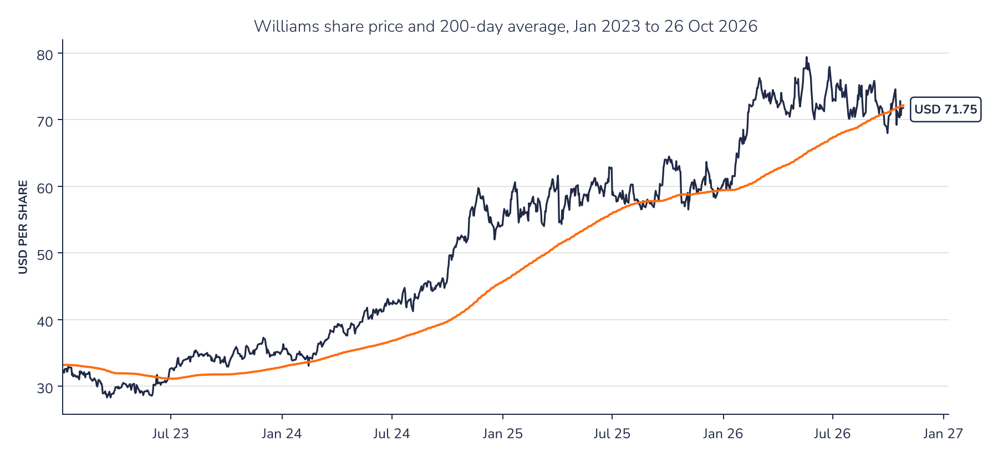
Source: Syz Research, Bloomberg
Chart 2 · WMB US: the multiple has risen faster than earnings
Consensus forward 12-month EPS in USD (top) and forward P/E (bottom) since January 2023; the dashed line is the median P/E since 2021
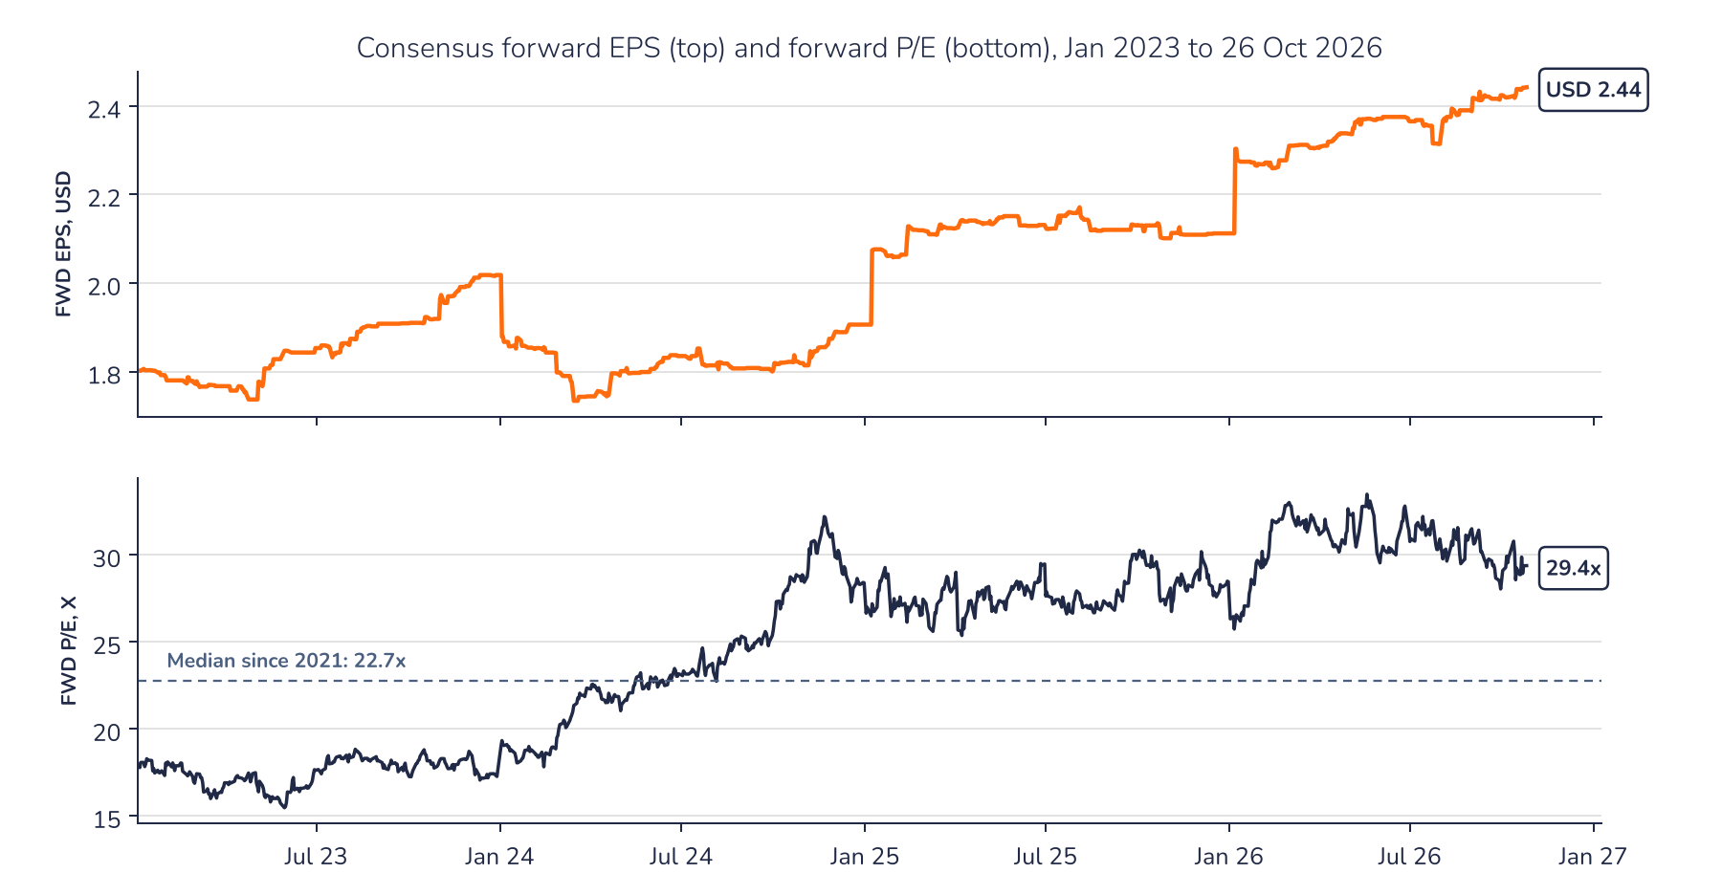
Source: Syz Research, Bloomberg
AD-HOC OPINION · ENERGY INFRASTRUCTURE
Sources
Syz Research, Bloomberg, Company data
Important information
This communication has been issued and made available to recipients for the purpose of advertising investment services and/or financial instruments. It has been sent for information purposes and cannot be considered as an offer or a personalised recommendation to buy or sell a financial instrument or any other investment or currency. This communication does not constitute investment research within the meaning of regulatory rules applicable in the European Economic Area, or research under the rules of the U.S. Self-Regulatory Organizations.
This information is made solely for professional and institutional clients as defined by the Swiss Financial Services Act, as well as qualified investors according to the Swiss Collective Investment Schemes Act. It is not intended for retail clients or non-qualified investors and consequently cannot be transmitted to any third party.
This communication is not directed to any person in any jurisdiction where, by reason of that person's nationality, residence or otherwise, its dissemination or use is prohibited. It cannot be quoted, reproduced, disclosed, distributed or otherwise referred to, in whole or in part, to any third party without the Bank's prior written consent.
This communication may contain information on past performances of a financial product, all kinds of economic and financial valuations and analyses, as well as opinions of the Bank or of third parties. Any market valuations, terms and calculation methods, yields and opinions expressed are subject to change without notice. The information and opinions contained herein have been compiled and provided in good faith, based on information obtained from sources believed to be trustworthy. However, such information has not been independently verified. No guarantee, representation, or warranty of any kind, whether express or implied, is provided by the Bank or by relevant data vendors and other sources with respect to the accuracy, reliability, currentness or exhaustiveness of the information communicated, the methodology employed or the prices contained herein.
Past performance is not a reliable indicator of current or future results. Any reference to the past performance of an investment does not guarantee its future performance. Fluctuations in exchange rates may adversely affect the value, price or income of any investment.
Nothing in the present communication constitutes investment, legal, accounting or tax advice. This information is purely objective since it does not take into consideration the personal situation (including financial knowledge and experience), the investment objectives and risk profile of any recipient. Moreover, certain financial instruments mentioned (in particular, but not exclusively, derivatives, options and futures) involve a high risk of loss and may not be suitable. Accordingly, recipients should consult their own advisors on such matters, including but not limited to the possible tax consequences of investing in any financial product mentioned herein, and make their own assessment of the suitability of such investment product.
Should a recipient make an investment on the basis of the present communication, the recipient alone shall bear the consequences thereof. In no event shall the Bank, its directors, employees, affiliates or agents be held responsible for damages of any kind arising out of the use of all or part of the information provided herein.

