AD-HOC OPINION · MINING ROYALTIES
Altius Minerals: a record quarter, a sharp correction
27 October 2026 · Syz Research
Prices are as of the close on 26 October 2026 (Toronto listing, CAD).
IMPORTANT NOTICE
This note is intended for professional and qualified investors only. It reviews Altius Minerals after its preliminary third-quarter revenue release of 20 October and ahead of full results on 10 November. Please read the important information at the end of this document.
Royalty companies: revenue without running the mine
How royalties work  A royalty company provides upfront money to a mine or energy project and in return receives a share of its revenue for many years, without paying operating or expansion costs. Margins are high and the model scales easily, but the royalty holder has no say in how or when the asset is developed.  Most listed royalty companies focus on gold and silver. A smaller group, including Altius, focuses on base metals, fertilisers, battery metals and, increasingly, renewable power. |  | Renewables and lithium: two different cycles  Renewable power royalties pay out as wind and solar farms produce electricity, which makes them steady once projects are built. Lithium royalties behave very differently: lithium prices collapsed in 2023 and 2024 and remain volatile, so revenue swings with the market.
  WHAT THIS MEANS FOR INVESTORS
  Royalty companies are usually valued on the worth of their royalties rather than on current earnings, and tend to trade at a premium for their low costs and diversification. The question for an investor is whether the growth now coming from renewables and lithium justifies that premium.
ALTIUS THIRD QUARTER 2026 PRELIMINARY REVENUE (CAD)
 | Q3 2026 | COMPARISON
Attributable royalty revenue | 33.2m | +55% y/y (21.4m)
Electricity (renewables) | 13.2m | Largest contributor
Base metals | 8.5m
Potash | 4.6m
Lithium | 4.2m | Down from 6.4m in Q2
Iron ore | 1.6m
Interest and investment income | About 9m | Included in the total above
Source: Syz Research, Bloomberg, Company data
AD-HOC OPINION · MINING ROYALTIES
Altius Minerals (ALS CN)
A diversified royalty portfolio pivoting to power and lithium, now 26% below its September high
Share price  CAD 50.59  All-time high CAD 68.70 (22 Sep) | Performance 2026 to date  +24%  -26% from the September high | Forward P/E  66.7x  Median since 2021: 57.3x | Q3 attributable revenue  CAD 33.2m  +55% y/y, preliminary

1. What the company does  Altius owns royalties on mines and power projects run by others. Its portfolio includes base metal royalties, notably on the Chapada copper mine in Brazil; potash royalties in Saskatchewan; iron ore interests in Labrador; lithium royalties acquired with Lithium Royalty Corp in March 2026; and a 50% stake in Great Bay Renewables, which funds US wind, solar and storage projects in exchange for revenue royalties. A project generation unit stakes mineral ground, sells it to developers and keeps royalties.  2. Why it could do well  Growth is coming from new assets. Preliminary third-quarter attributable revenue reached a record CAD 33.2m, up 55% on a year earlier, with electricity now the largest contributor. In 2026, Altius bought Lithium Royalty Corp for about CAD 520m, raised its Great Bay Renewables stake to 50% and enlarged its credit facility, while a CAD 181.5m share issue in July strengthened the balance sheet. The Kami iron ore project, the Curipamba mine in Ecuador and the Arthur gold project in Nevada could add value over the next few years.  3. What sets it apart  Origination. Altius creates many of its royalties itself at low cost through project generation. The clearest example is Arthur, where it sold a 1% royalty to Franco-Nevada in 2025 for up to USD 275m while keeping 0.5%. Its focus on base metals, fertilisers and renewables, rather than gold, also sets it apart from most royalty peers. |  | 4. Cheap, or a value trap?  Neither clearly. At 66.7x forward earnings, the share is still above its median of 57.3x since 2021, even after falling 26% since 22 September. Forward EPS has roughly doubled since the end of 2025, from CAD 0.39 to CAD 0.76, on the back of acquisitions. The record quarter needs context: about CAD 9m of the CAD 33.2m came from interest and investment income, mainly on financing for renewable projects, rather than from royalties, and lithium revenue fell from the second quarter. Royalty companies are usually valued on their assets rather than on earnings, but the correction has removed only part of the premium. The dividend yield is below 1%.  5. Main risks  Altius has no control over the projects it depends on: timelines for Kami, Curipamba or Arthur rest with their operators. Revenue remains sensitive to copper, potash and especially lithium prices. The renewables business depends on US power markets and policy toward wind and solar. Acquisitions were paid partly in shares, and the July share issue at CAD 60.50 is now above the market price, which can weigh on sentiment. No clear cause has been given for the recent fall, which makes the short term hard to read.  6. What to watch next  Full third-quarter results on 10 November, including the contribution of the consolidated renewables business. Feasibility work on Kami and Arthur. First production at Curipamba, expected in 2027. Any new acquisition, and how it is financed.
CONCLUSION
We see Altius as a well-run royalty company whose pivot to renewables and lithium adds growth, but also new sources of volatility. The recent fall offers a better entry point than in September, yet the valuation still assumes the new assets deliver, and the record quarter was flattered by interest income. An investor without exposure could build a position gradually, using weakness rather than buying in one go. An investor who holds it could keep the position and wait for the full third-quarter results before adding.
AD-HOC OPINION · MINING ROYALTIES
Charts
Charts as of the close on 26 October 2026.
Chart 1 · ALS CN: a strong run, then a 26% fall
Daily closing price in CAD and 200-day moving average since January 2023
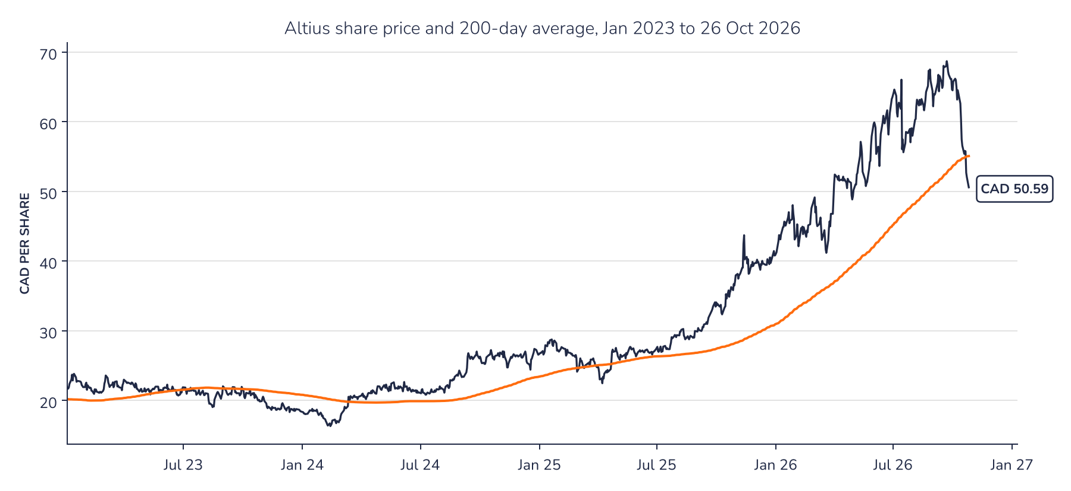
Source: Syz Research, Bloomberg
Chart 2 · ALS CN: earnings estimates rebounded in 2026
Consensus forward 12-month EPS in CAD (top) and forward P/E (bottom) since January 2023; the dashed line is the median P/E since 2021
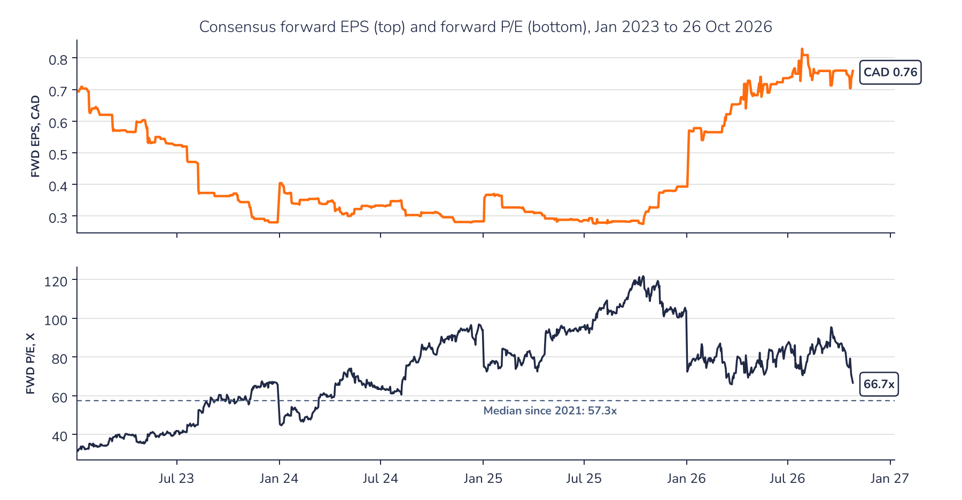
Source: Syz Research, Bloomberg
AD-HOC OPINION · MINING ROYALTIES
Sources
Syz Research, Bloomberg, Company data
Important information
This communication has been issued and made available to recipients for the purpose of advertising investment services and/or financial instruments. It has been sent for information purposes and cannot be considered as an offer or a personalised recommendation to buy or sell a financial instrument or any other investment or currency. This communication does not constitute investment research within the meaning of regulatory rules applicable in the European Economic Area, or research under the rules of the U.S. Self-Regulatory Organizations.
This information is made solely for professional and institutional clients as defined by the Swiss Financial Services Act, as well as qualified investors according to the Swiss Collective Investment Schemes Act. It is not intended for retail clients or non-qualified investors and consequently cannot be transmitted to any third party.
This communication is not directed to any person in any jurisdiction where, by reason of that person's nationality, residence or otherwise, its dissemination or use is prohibited. It cannot be quoted, reproduced, disclosed, distributed or otherwise referred to, in whole or in part, to any third party without the Bank's prior written consent.
This communication may contain information on past performances of a financial product, all kinds of economic and financial valuations and analyses, as well as opinions of the Bank or of third parties. Any market valuations, terms and calculation methods, yields and opinions expressed are subject to change without notice. The information and opinions contained herein have been compiled and provided in good faith, based on information obtained from sources believed to be trustworthy. However, such information has not been independently verified. No guarantee, representation, or warranty of any kind, whether express or implied, is provided by the Bank or by relevant data vendors and other sources with respect to the accuracy, reliability, currentness or exhaustiveness of the information communicated, the methodology employed or the prices contained herein.
Past performance is not a reliable indicator of current or future results. Any reference to the past performance of an investment does not guarantee its future performance. Fluctuations in exchange rates may adversely affect the value, price or income of any investment.
Nothing in the present communication constitutes investment, legal, accounting or tax advice. This information is purely objective since it does not take into consideration the personal situation (including financial knowledge and experience), the investment objectives and risk profile of any recipient. Moreover, certain financial instruments mentioned (in particular, but not exclusively, derivatives, options and futures) involve a high risk of loss and may not be suitable. Accordingly, recipients should consult their own advisors on such matters, including but not limited to the possible tax consequences of investing in any financial product mentioned herein, and make their own assessment of the suitability of such investment product.
Should a recipient make an investment on the basis of the present communication, the recipient alone shall bear the consequences thereof. In no event shall the Bank, its directors, employees, affiliates or agents be held responsible for damages of any kind arising out of the use of all or part of the information provided herein.

