AD-HOC OPINION · ENERGY INFRASTRUCTURE
Energy Transfer: a 6.6% yield, with strings attached
27 October 2026 · Syz Research
Prices are as of the close on 26 October 2026 (New York listing, USD).
IMPORTANT NOTICE
This note is intended for professional and qualified investors only. It reviews Energy Transfer ahead of its third-quarter 2026 results, which the partnership will publish on 3 November before the US market opens. Figures quoted here run to the second quarter of 2026 and to announcements made since. Please read the important information at the end of this document.
US midstream: record volumes, steady income
Volumes at record levels  US pipeline operators are moving record volumes of gas, NGLs and crude oil. Permian output keeps growing with oil above USD 100 a barrel, Gulf Coast LNG terminals are taking more gas, and data centres are signing direct gas supply deals. For the largest networks, this means more fees at little extra cost.  Most of these companies are paid for capacity rather than for the commodity, so their cash flows are steadier than those of producers, and many return the bulk of that cash to investors. |  | Partnerships: high yields, different rules  Several large operators, including Energy Transfer, are organised as master limited partnerships (MLPs). They issue units rather than shares and pay distributions rather than dividends. MLPs usually offer higher yields than corporations, but they come with specific US tax reporting (a K-1 form) and withholding rules for non-US holders.
  WHAT THIS MEANS FOR INVESTORS
  MLPs suit income-focused investors who can handle the tax administration. Before investing, a non-US investor should check how the custodian handles MLP units, since US withholding can apply to both distributions and sale proceeds.
ENERGY TRANSFER SECOND QUARTER 2026 AT A GLANCE (USD)
 | Q2 2026 | COMPARISON
Adjusted EBITDA | 5.07bn | +31% y/y (3.87bn)
Net income attributable to partners | 2.09bn | +80% y/y (1.16bn)
Distributable cash flow | 2.59bn | +32% y/y (1.96bn)
Quarterly distribution per unit | 0.34 | Over 3% above a year earlier
2026 adjusted EBITDA guidance | 18.8 to 19.1bn | Raised from 18.2 to 18.6bn
2026 organic growth capital | 5.6 to 5.9bn | Excluding Sunoco and USA Compression
Source: Syz Research, Bloomberg, Company data
AD-HOC OPINION · ENERGY INFRASTRUCTURE
Energy Transfer (ET US)
One of the largest US pipeline networks, paying a 6.6% distribution well covered by cash flow
Unit price  USD 20.60  52-week high USD 21.73 (10 Sep) | Performance 2026 to date  +25%  +23% over 12 months | Forward P/E  11.9x  Median since 2021: 10.1x | Distribution yield  6.6%  USD 1.36 a year, raised quarterly

1. What the company does  Energy Transfer owns one of the largest and most diversified energy networks in the United States, with more than 140,000 miles of pipelines in 44 states. It gathers and processes gas; transports gas, crude oil and NGLs; runs fractionation plants and export terminals such as Nederland in Texas; and holds stakes in Sunoco and USA Compression. Around 90% of earnings come from fees, and no single segment provides more than about a third of EBITDA.  2. Why it could do well  Results are strong. Second-quarter adjusted EBITDA rose 31% to USD 5.07bn on record volumes, and the 2026 guidance was raised to USD 18.8 to 19.1bn. The Hugh Brinson pipeline, carrying Permian gas to north Texas, is in service, and Energy Transfer has agreed to build facilities supplying a 900 MW expansion of Crusoe's AI data centre campus in Abilene. The USD 2.6bn purchase of Vaquero Midstream, due to close in the fourth quarter, adds 675 MMcf/d of Delaware Basin processing and is expected to add to cash flow per unit from the start.  3. What sets it apart  Scale and the payout. Few networks match its reach across gas, crude and NGLs, which lets it sell integrated services and capture extra margin along the chain. Distributable cash flow of USD 2.59bn in the second quarter covered the distribution about twice (Syz calculation), leaving room to fund growth and keep raising the payout within the targeted 3% to 5% a year. |  | 4. Is the share cheap?  Reasonably priced. At 11.9x forward earnings, the units trade above their median of 10.1x since 2021, but far below the 27x to 29x of Targa and Williams. Since January 2023, consensus forward EPS has risen only about 9%, from USD 1.59 to USD 1.73, while the multiple went from about 7x to 12x: the re-rating has largely played out, and further gains would need earnings growth. The 6.6% distribution yield is the main attraction, and it is well covered.  5. Main risks  Capital discipline is the main question. Energy Transfer has a history of large acquisitions and heavy spending, with organic growth capital of USD 5.6 to 5.9bn this year and the large Desert Southwest gas pipeline ahead. The Vaquero deal is paid partly in 33.3m new units. Legal challenges around the Dakota Access pipeline remain an overhang. Part of the 2026 strength reflects high oil prices and wide regional price gaps, which may not last. For non-US investors, MLP tax reporting and withholding add cost and complexity.  6. What to watch next  Third-quarter results on 3 November, including the ramp-up of Hugh Brinson. The closing of the Vaquero acquisition. The second phase of Hugh Brinson in early 2027. The 2027 guidance and capital budget early next year.
CONCLUSION
We see Energy Transfer as the most attractive income vehicle among the US pipeline groups we have reviewed: the payout is high, well covered and growing, and the valuation is undemanding. The trade-offs are an appetite for large projects and deals, and the tax complexity of the MLP structure. An investor seeking income who can hold MLP units could build or keep a position, sized with any overlap with Targa, Williams or Enbridge in mind. An investor for whom K-1 reporting or US withholding is a problem could prefer corporate peers, accepting a lower yield.
AD-HOC OPINION · ENERGY INFRASTRUCTURE
Charts
Charts as of the close on 26 October 2026.
Chart 1 · ET US: steady gains since 2023
Daily closing price in USD and 200-day moving average since January 2023
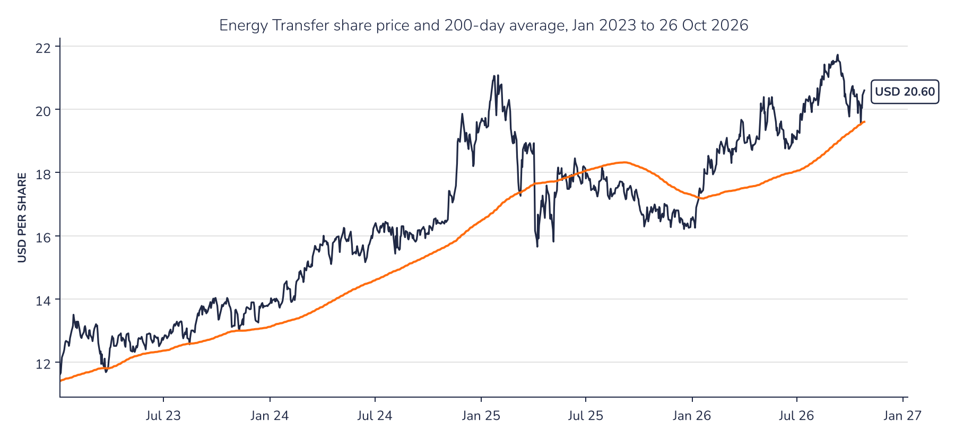
Source: Syz Research, Bloomberg
Chart 2 · ET US: the re-rating has outpaced earnings
Consensus forward 12-month EPS in USD (top) and forward P/E (bottom) since January 2023; the dashed line is the median P/E since 2021
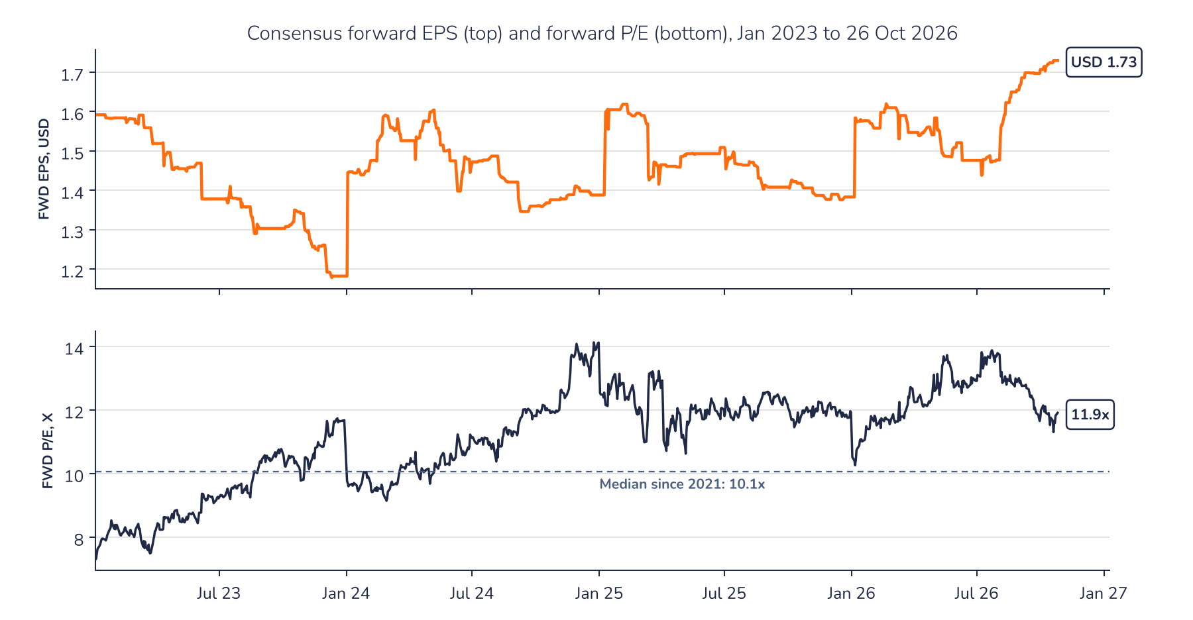
Source: Syz Research, Bloomberg
AD-HOC OPINION · ENERGY INFRASTRUCTURE
Sources
Syz Research, Bloomberg, Company data
Important information
This communication has been issued and made available to recipients for the purpose of advertising investment services and/or financial instruments. It has been sent for information purposes and cannot be considered as an offer or a personalised recommendation to buy or sell a financial instrument or any other investment or currency. This communication does not constitute investment research within the meaning of regulatory rules applicable in the European Economic Area, or research under the rules of the U.S. Self-Regulatory Organizations.
This information is made solely for professional and institutional clients as defined by the Swiss Financial Services Act, as well as qualified investors according to the Swiss Collective Investment Schemes Act. It is not intended for retail clients or non-qualified investors and consequently cannot be transmitted to any third party.
This communication is not directed to any person in any jurisdiction where, by reason of that person's nationality, residence or otherwise, its dissemination or use is prohibited. It cannot be quoted, reproduced, disclosed, distributed or otherwise referred to, in whole or in part, to any third party without the Bank's prior written consent.
This communication may contain information on past performances of a financial product, all kinds of economic and financial valuations and analyses, as well as opinions of the Bank or of third parties. Any market valuations, terms and calculation methods, yields and opinions expressed are subject to change without notice. The information and opinions contained herein have been compiled and provided in good faith, based on information obtained from sources believed to be trustworthy. However, such information has not been independently verified. No guarantee, representation, or warranty of any kind, whether express or implied, is provided by the Bank or by relevant data vendors and other sources with respect to the accuracy, reliability, currentness or exhaustiveness of the information communicated, the methodology employed or the prices contained herein.
Past performance is not a reliable indicator of current or future results. Any reference to the past performance of an investment does not guarantee its future performance. Fluctuations in exchange rates may adversely affect the value, price or income of any investment.
Nothing in the present communication constitutes investment, legal, accounting or tax advice. This information is purely objective since it does not take into consideration the personal situation (including financial knowledge and experience), the investment objectives and risk profile of any recipient. Moreover, certain financial instruments mentioned (in particular, but not exclusively, derivatives, options and futures) involve a high risk of loss and may not be suitable. Accordingly, recipients should consult their own advisors on such matters, including but not limited to the possible tax consequences of investing in any financial product mentioned herein, and make their own assessment of the suitability of such investment product.
Should a recipient make an investment on the basis of the present communication, the recipient alone shall bear the consequences thereof. In no event shall the Bank, its directors, employees, affiliates or agents be held responsible for damages of any kind arising out of the use of all or part of the information provided herein.

