AD-HOC OPINION · ENERGY INFRASTRUCTURE
Targa Resources: the best Permian growth story, priced for it
27 October 2026 · Syz Research
Prices are as of the close on 26 October 2026 (New York listing, USD).
IMPORTANT NOTICE
This note is intended for professional and qualified investors only. It reviews Targa Resources ahead of its third-quarter 2026 results, which the company will publish on 5 November before the US market opens. Figures quoted here run to the second quarter of 2026 and to company announcements made since. Please read the important information at the end of this document.
Permian midstream: more gas, more liquids, more pipes
High oil prices keep Permian drilling busy  The Permian Basin in west Texas and New Mexico is the largest US oil field. Each barrel of oil there comes with natural gas and natural gas liquids (NGLs) such as ethane and propane, which must be gathered, processed and moved to the Gulf Coast. With Brent above USD 100 a barrel for most of 2026, producers have kept drilling and these volumes keep rising.  Pipeline capacity has struggled to keep up. Bottlenecks around the Waha hub in west Texas have at times pushed local gas prices below zero in recent years, and new pipelines are being built to carry the gas toward Texas and Louisiana markets. |  | Exports pull the chain  US exports of liquefied petroleum gas (LPG) keep growing. Companies that own the full chain, from the gas plant to the export dock, can collect a fee at every step and profit when regional prices diverge. Targa is one of a handful of operators that own the whole chain.
  WHAT THIS MEANS FOR INVESTORS
  The Permian offers the fastest volume growth in US midstream, but it remains tied to oil drilling. The question for an investor is how much of that growth is already priced: the best-positioned names now trade at premium multiples.
TARGA SECOND QUARTER 2026 AT A GLANCE (USD)
 | Q2 2026 | COMPARISON
Adjusted EBITDA | 1.60bn | +38% y/y (1.16bn)
Net income attributable to Targa | 765m | +22% y/y (629m)
Quarterly dividend per share | 1.25 | +25% y/y
Consolidated leverage | 3.4x | Within the 3x to 4x target
2026 adjusted EBITDA outlook | 5.7 to 5.9bn | Top end of the range expected
2026 growth capital | About 5.0bn | Raised from 4.5bn in August
Source: Syz Research, Bloomberg, Company data
AD-HOC OPINION · ENERGY INFRASTRUCTURE
Targa Resources (TRGP US)
A fully integrated Permian NGL chain delivering record results, at a record share price
Share price  USD 304.68  All-time high, set on 26 Oct | Performance 2026 to date  +65%  +98% over 12 months | Forward P/E  26.8x  Median since 2021: 21.6x | Dividend yield  1.6%  USD 5.00 a year, +25% in 2026

1. What the company does  Targa is the largest gatherer and processor of natural gas in the Permian Basin. Its gathering and processing business collects gas at the wellhead and separates out the liquids. Its logistics business then moves the NGLs by pipeline to its fractionation hub at Mont Belvieu, Texas, where they are split into products, and exports LPG from its Galena Park terminal near Houston. Most earnings come from fees, but part of the processing business is still paid as a share of the products sold, which keeps some exposure to commodity prices.  2. Why it could do well  Volumes and contracts. Second-quarter adjusted EBITDA reached a record USD 1.60bn, up 38% on a year earlier, and management expects 2026 to land at the top end of its USD 5.7 to 5.9bn range. In August, Targa signed 20-year agreements with ExxonMobil covering Delaware and Midland acreage, with three new processing plants (about 825 MMcf/d) and a new gas pipeline due in the first half of 2028, and up to five more plants under study. The 25% dividend increase signals confidence in future cash flow.  3. What sets it apart  Integration. Keeping molecules on its own system from the well to the dock lets Targa earn a fee at each step and capture marketing gains when prices differ between regions. Acreage dedications from leading Permian producers, now including a 20-year anchor with ExxonMobil, give volume visibility into the 2040s. Leverage of 3.4x is comfortable for the sector. |  | 4. Is the share cheap?  No. At 26.8x forward earnings, Targa trades above its median of 21.6x since 2021. Unlike some peers, the rise rests on real earnings growth: consensus forward EPS has nearly doubled since January 2023, from about USD 5.97 to USD 11.35. A re-rating from about 12x to 27x did the rest, and the share has quadrupled. Part of the recent strength is less repeatable: press reports put second-quarter marketing gains, linked to regional price gaps, at around USD 250m, and these could fade as new pipelines ease bottlenecks. The 1.6% dividend yield offers little support if sentiment turns.  5. Main risks  Valuation first: after a 65% rise this year, a slowdown in Permian drilling or a fall in oil prices could hit both earnings estimates and the multiple. Targa still has more commodity exposure than most large US midstream groups. Growth capital of about USD 5bn in 2026 keeps free cash flow thin until large projects start up. Long lead times for turbines and compressors could delay new plants.  6. What to watch next  Third-quarter results on 5 November, and whether 2026 EBITDA comes in above the range. The 2027 outlook, expected early in 2027, for capital spending and the timing of higher free cash flow. Progress on the ExxonMobil plants and any decision on the additional plants under study.
CONCLUSION
We like Targa as the best-positioned operator in the Permian, with earnings growth that justifies part of its re-rating. The share, however, sits at an all-time high and a premium multiple, which leaves little room for disappointment. An investor who holds it could take partial profits to bring the weight back to target, keeping a core position for its growth. An investor without exposure could build a position gradually, after the third-quarter results, rather than chase the recent rise. Holders of Energy Transfer or Williams already have overlapping US midstream exposure.
AD-HOC OPINION · ENERGY INFRASTRUCTURE
Charts
Charts as of the close on 26 October 2026.
Chart 1 · TRGP US: a fourfold rise since 2023
Daily closing price in USD and 200-day moving average since January 2023
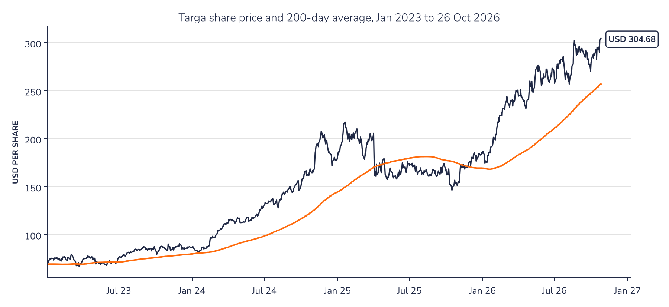
Source: Syz Research, Bloomberg
Chart 2 · TRGP US: earnings and the multiple have both doubled
Consensus forward 12-month EPS in USD (top) and forward P/E (bottom) since January 2023; the dashed line is the median P/E since 2021
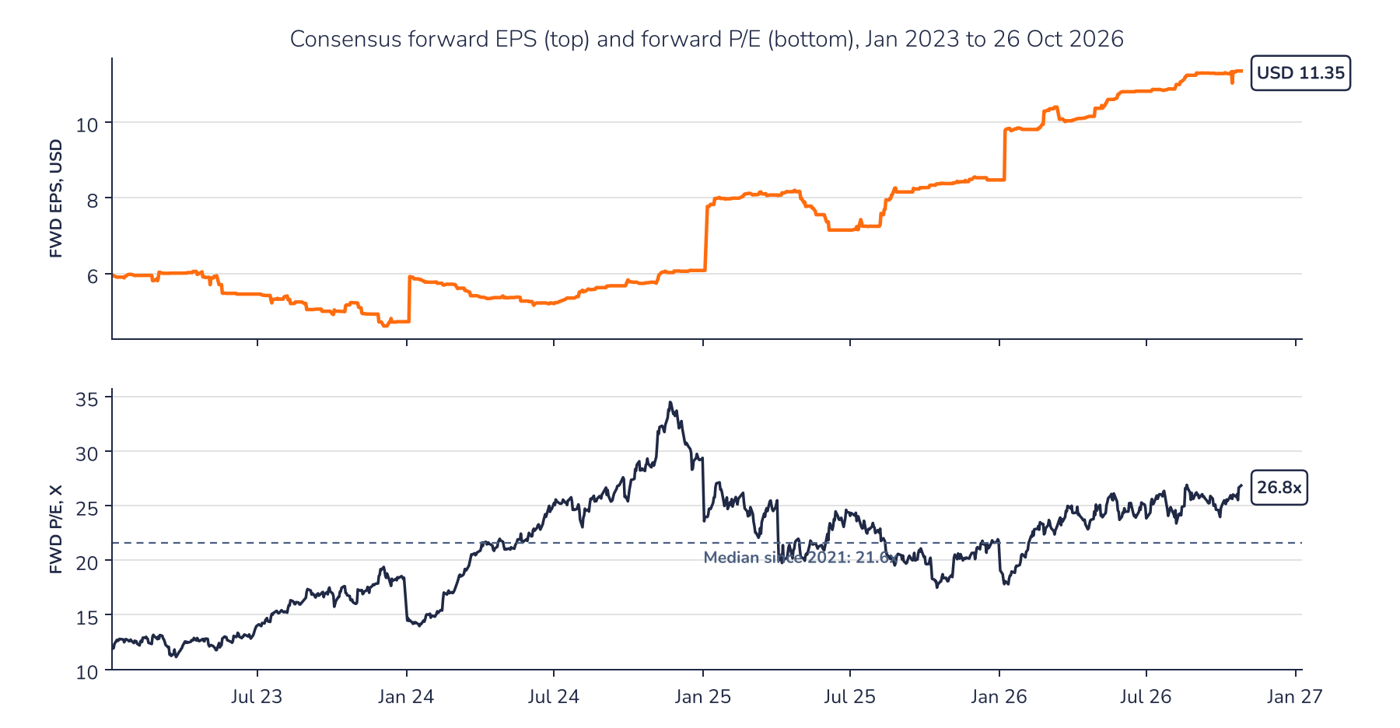
Source: Syz Research, Bloomberg
AD-HOC OPINION · ENERGY INFRASTRUCTURE
Sources
Syz Research, Bloomberg, Company data
Important information
This communication has been issued and made available to recipients for the purpose of advertising investment services and/or financial instruments. It has been sent for information purposes and cannot be considered as an offer or a personalised recommendation to buy or sell a financial instrument or any other investment or currency. This communication does not constitute investment research within the meaning of regulatory rules applicable in the European Economic Area, or research under the rules of the U.S. Self-Regulatory Organizations.
This information is made solely for professional and institutional clients as defined by the Swiss Financial Services Act, as well as qualified investors according to the Swiss Collective Investment Schemes Act. It is not intended for retail clients or non-qualified investors and consequently cannot be transmitted to any third party.
This communication is not directed to any person in any jurisdiction where, by reason of that person's nationality, residence or otherwise, its dissemination or use is prohibited. It cannot be quoted, reproduced, disclosed, distributed or otherwise referred to, in whole or in part, to any third party without the Bank's prior written consent.
This communication may contain information on past performances of a financial product, all kinds of economic and financial valuations and analyses, as well as opinions of the Bank or of third parties. Any market valuations, terms and calculation methods, yields and opinions expressed are subject to change without notice. The information and opinions contained herein have been compiled and provided in good faith, based on information obtained from sources believed to be trustworthy. However, such information has not been independently verified. No guarantee, representation, or warranty of any kind, whether express or implied, is provided by the Bank or by relevant data vendors and other sources with respect to the accuracy, reliability, currentness or exhaustiveness of the information communicated, the methodology employed or the prices contained herein.
Past performance is not a reliable indicator of current or future results. Any reference to the past performance of an investment does not guarantee its future performance. Fluctuations in exchange rates may adversely affect the value, price or income of any investment.
Nothing in the present communication constitutes investment, legal, accounting or tax advice. This information is purely objective since it does not take into consideration the personal situation (including financial knowledge and experience), the investment objectives and risk profile of any recipient. Moreover, certain financial instruments mentioned (in particular, but not exclusively, derivatives, options and futures) involve a high risk of loss and may not be suitable. Accordingly, recipients should consult their own advisors on such matters, including but not limited to the possible tax consequences of investing in any financial product mentioned herein, and make their own assessment of the suitability of such investment product.
Should a recipient make an investment on the basis of the present communication, the recipient alone shall bear the consequences thereof. In no event shall the Bank, its directors, employees, affiliates or agents be held responsible for damages of any kind arising out of the use of all or part of the information provided herein.

