Jack Blute

Professor Wetsch

IT 230

10/6/2024

Final Project Part 1

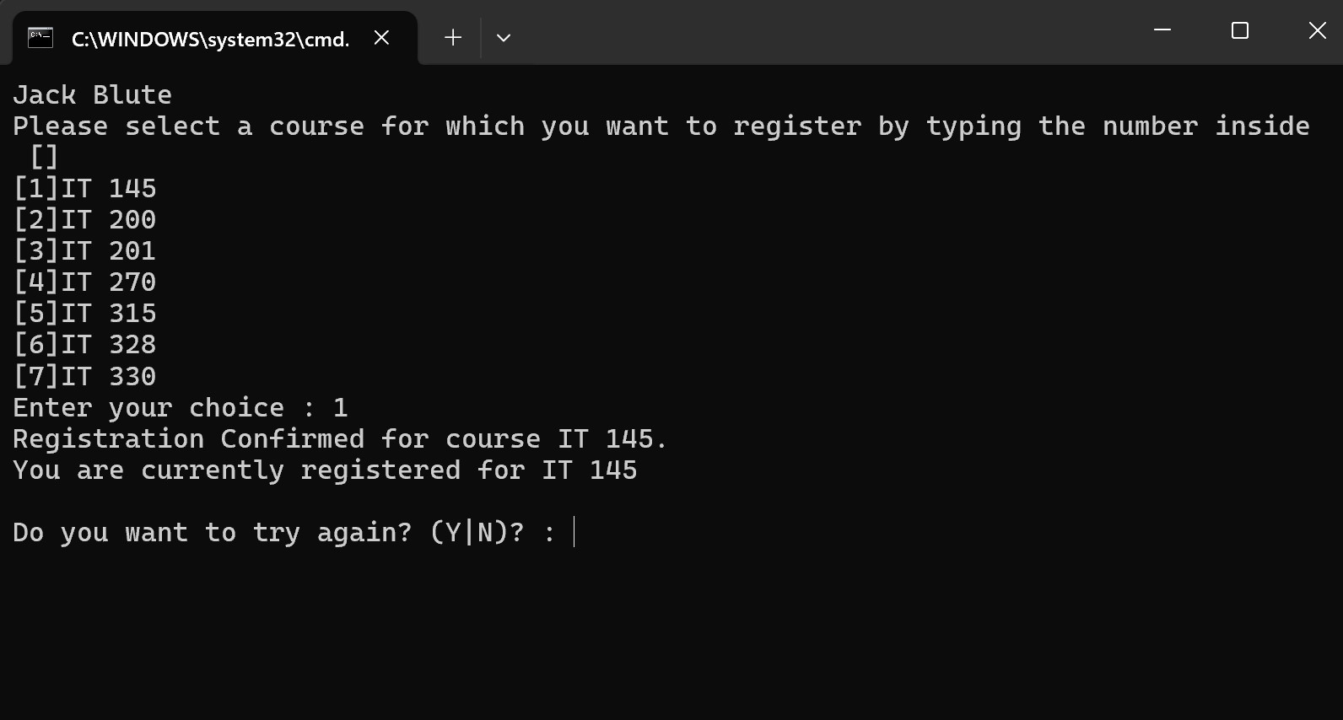

The programming accepts user input and confirms registration by printing confirmed registration message.

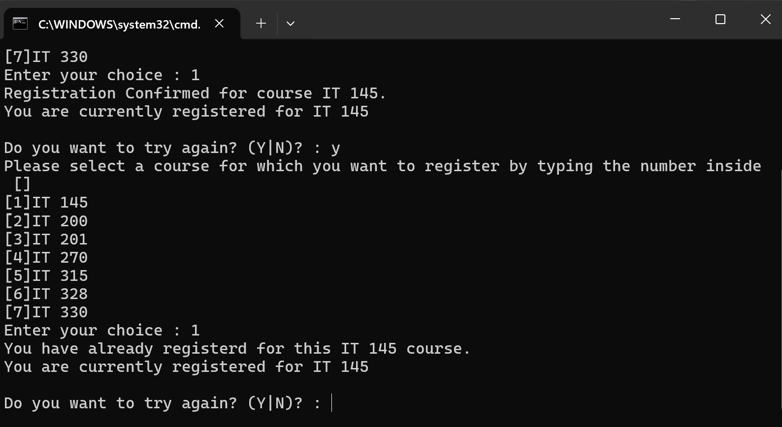

The user successfully clicks the y button to continue the registration process. The program then accepts input number 1 again which is a duplicate class selection. As such the program outputs a different message to the console informing the user the choice has already been selected.

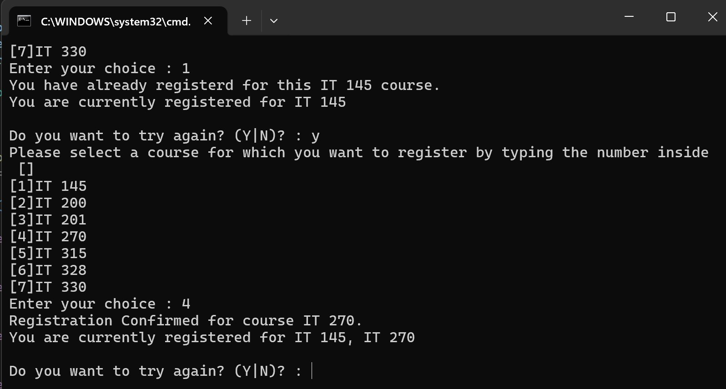

The user inputs their second-class choice by inputting a different integer this time in which the program outputs enrollment success message to the console again.

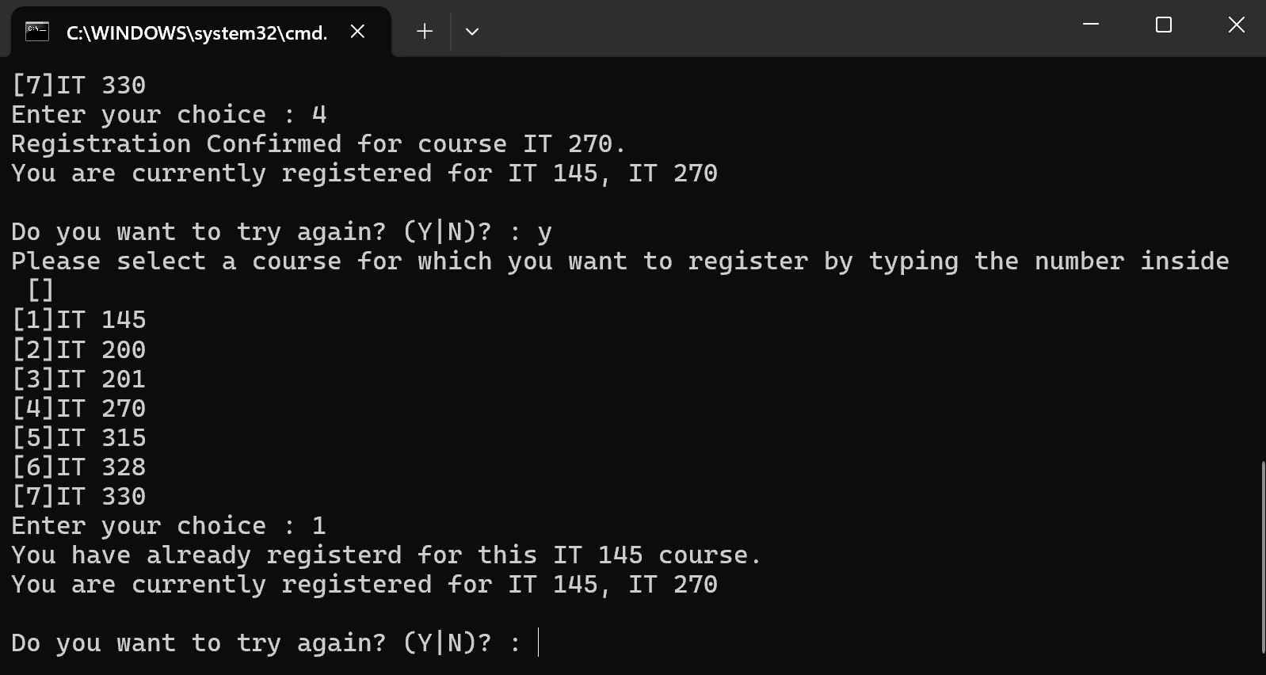

More testing on the console printing you have already registered for X course.

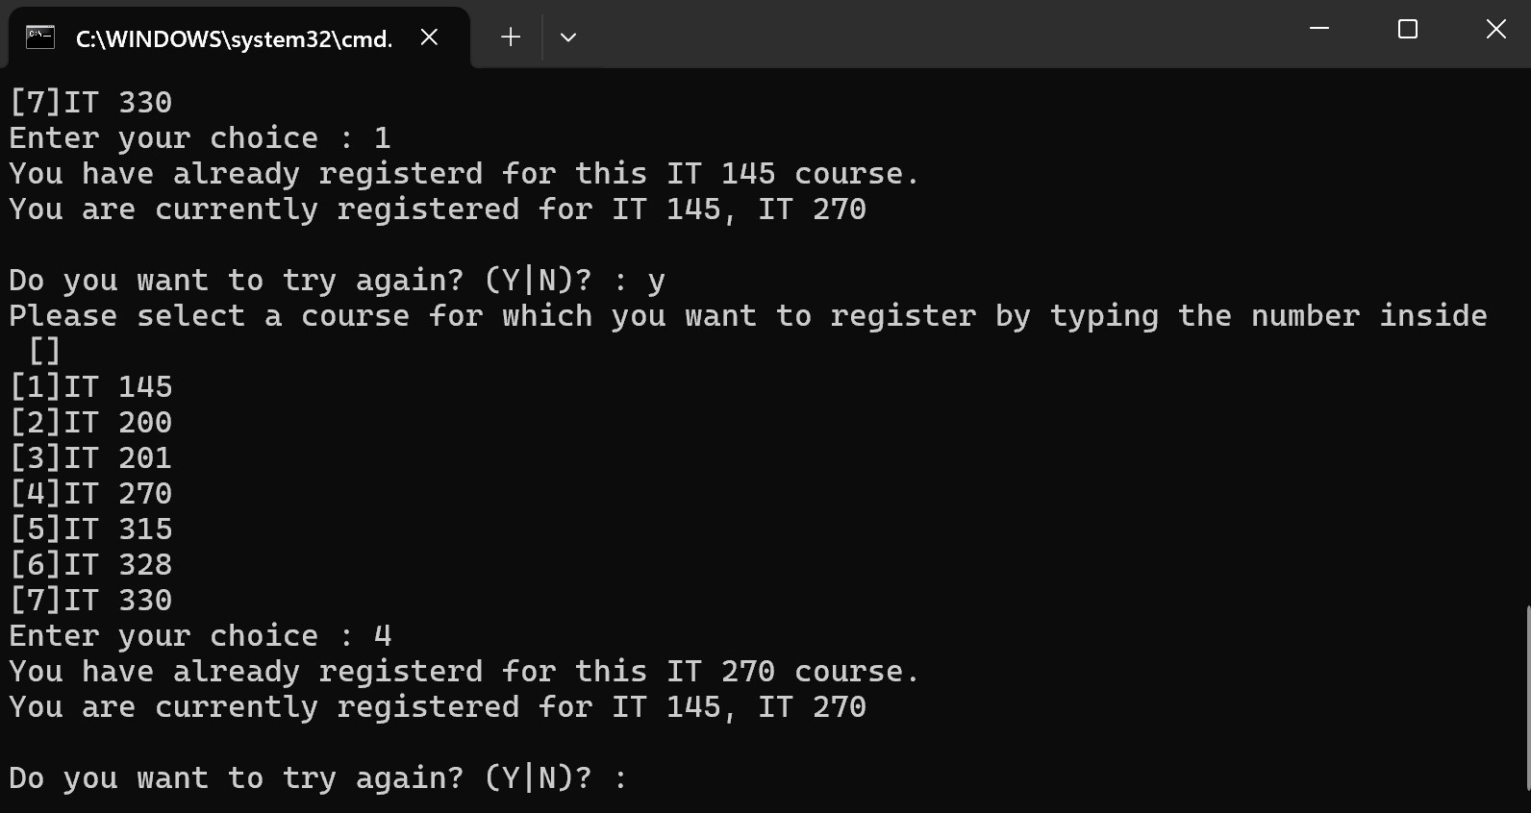

More testing on the console printing you have already registered for X course.

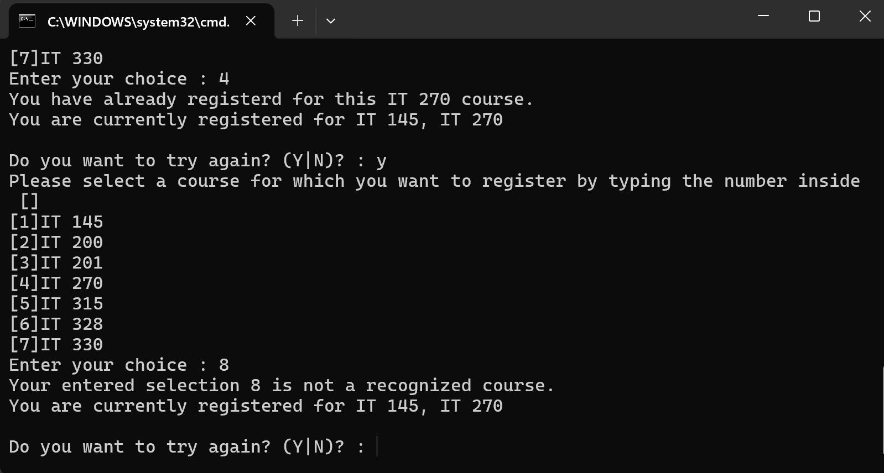

The user inputs a number that is outside what is listed in the course list. The program then outputs to the console the course number the user chose does not exist and promptly asks if they want to try again.

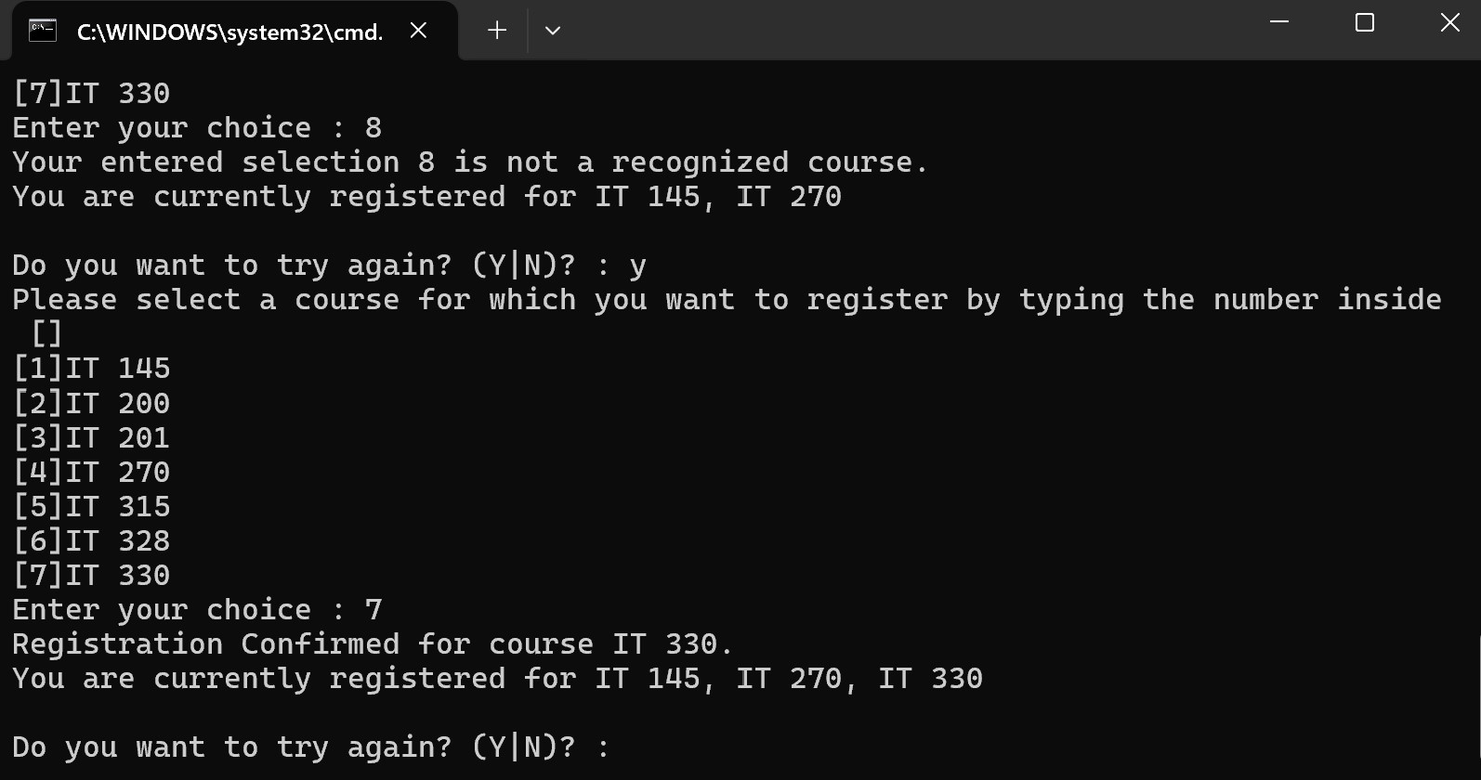

User enrolls in their 3rd and final class, program prints registration success message.

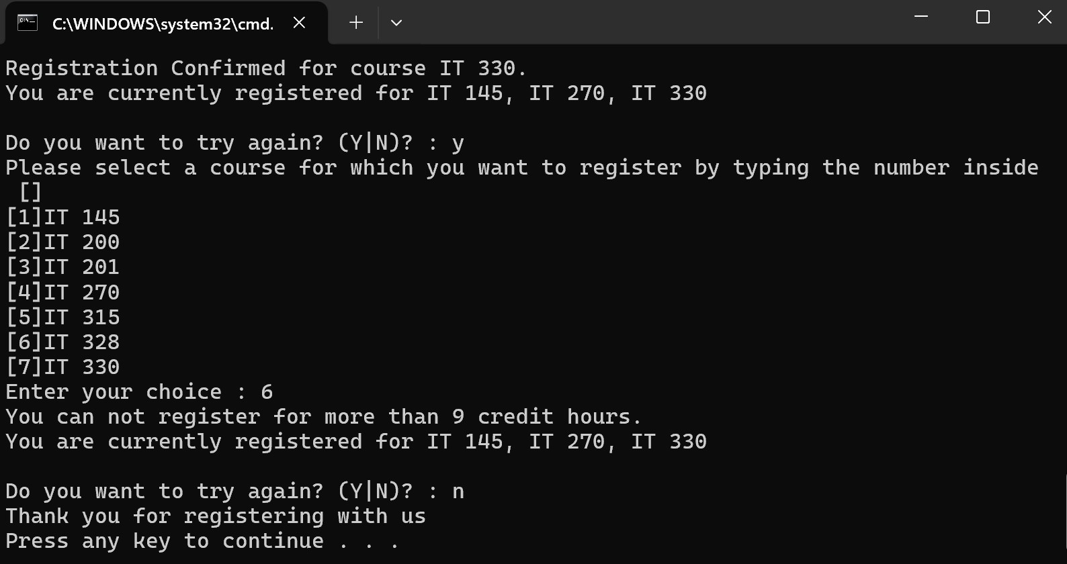

User attempts to enroll in a fourth class, however they have reached the max of 9 credits per semester. The program then outputs to the console they cannot register for more than 9 credit hours. User then enters the n button to quit registration which quits the program.

**Program Code:**

using System;

using System.Collections.Generic;

using System.Diagnostics.Eventing.Reader;

using System.Linq;

using System.Text;

using System.Threading.Tasks;

namespace ConsoleRegisterStudent

{

class Program

{

static void Main(string[] args)

{

(new Program()).run();

}

void run()

{

int choice;

int firstChoice = 0, secondChoice = 0, thirdChoice = 0;

int totalCredit = 0;

string yesOrNo = "";

System.Console.WriteLine("Jack Blute");

do //change to while statement

{

WritePrompt();

choice = Convert.ToInt32(Console.ReadLine());

switch (ValidateChoice(choice, firstChoice, secondChoice, thirdChoice, totalCredit))

{

case -1:

Console.WriteLine("Your entered selection {0} is not a recognized course.", choice);

break;

case -2:

Console.WriteLine("You have already registerd for this {0} course.", ChoiceToCourse(choice));

break;

case -3:

Console.WriteLine("You can not register for more than 9 credit hours.");

break;

case -4: //change case to -4

Console.WriteLine("Registration Confirmed for course {0}.", ChoiceToCourse(choice));

totalCredit += 3;

if (firstChoice == 0)

firstChoice = choice;

else if (secondChoice == 0)

secondChoice = choice;

else if (thirdChoice == 0)

thirdChoice = choice;

break;

}

WriteCurrentRegistration(firstChoice, secondChoice, thirdChoice);

Console.Write("\nDo you want to try again? (Y|N)? : ");

yesOrNo = (Console.ReadLine()).ToUpper();

} while (yesOrNo == "Y");

Console.WriteLine("Thank you for registering with us");

}

void WritePrompt()

{

Console.WriteLine("Please select a course for which you want to register by typing the number inside []");

Console.WriteLine("[1]IT 145\n[2]IT 200\n[3]IT 201\n[4]IT 270\n[5]IT 315\n[6]IT 328\n[7]IT 330");

Console.Write("Enter your choice : ");

}

int ValidateChoice(int choice, int firstChoice, int secondChoice, int thirdChoice, int totalCredit)

{

if (choice < 1 || choice > 7) //choice up to 7, not 70

return -1;

else if (choice == firstChoice || choice == secondChoice || choice == thirdChoice) //changed the && operands to || operands

return -2;

else if (totalCredit >= 9) //greater or equal to

return -3;

else //else statement?

return -4;

}

void WriteCurrentRegistration(int firstChoice, int secondChoice, int thirdChoice)

{

if (secondChoice == 0)

Console.WriteLine("You are currently registered for {0}", ChoiceToCourse(firstChoice));

else if (thirdChoice == 0)

Console.WriteLine("You are currently registered for {0}, {1}", ChoiceToCourse(firstChoice), ChoiceToCourse(secondChoice));

else

Console.WriteLine("You are currently registered for {0}, {1}, {2}", ChoiceToCourse(firstChoice), ChoiceToCourse(secondChoice), ChoiceToCourse(thirdChoice));

}

string ChoiceToCourse(int choice)

{

string course = "";

switch (choice)

{

case 1:

course = "IT 145";

break;

case 2:

course = "IT 200";

break;

case 3:

course = "IT 201";

break;

case 4:

course = "IT 270";

break;

case 5:

course = "IT 315";

break;

case 6:

course = "IT 328";

break;

case 7:

course = "IT 330";

break;

default:

break;

}

return course;

}

}

}