Jack Blute

Professor Wetsch

IT 230

10/20/2024

Final Project Part II

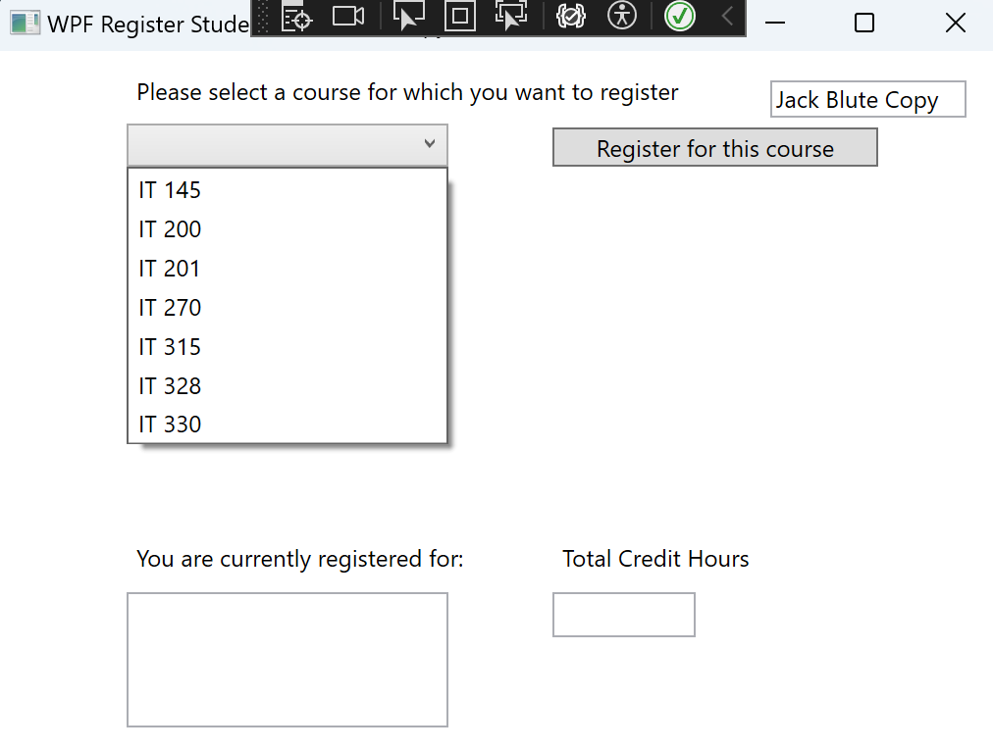

The GUI when the application is first opened, nothing shows in the list box or credit hours box. Each of the IT classes is there to be selected and a register button which reads the string value of the class selection.

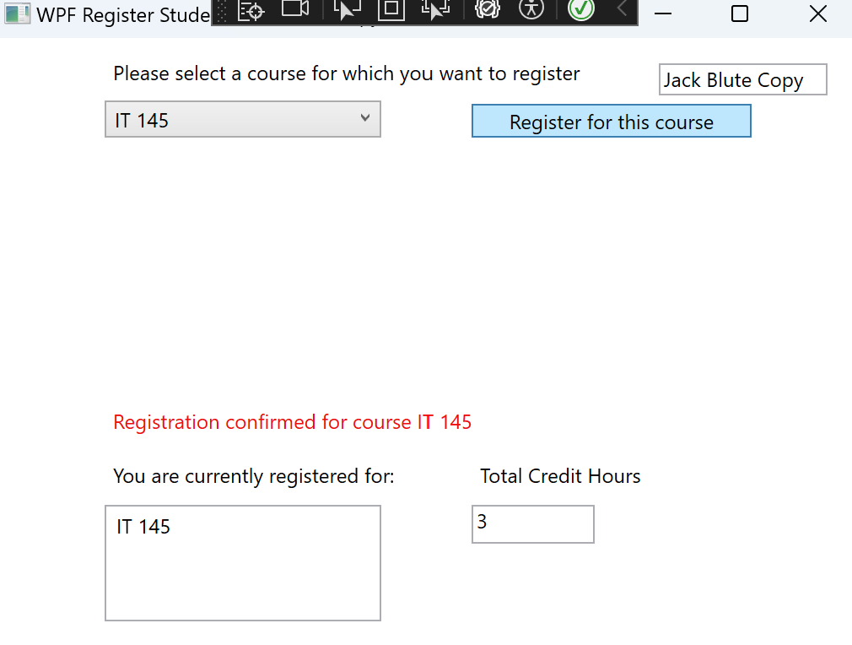

The program successfully reads user course input and displays a registration success message as well as the course name in a list box below with the title “You are currently registered for: ”. Additionally, credit hours is set to 3.

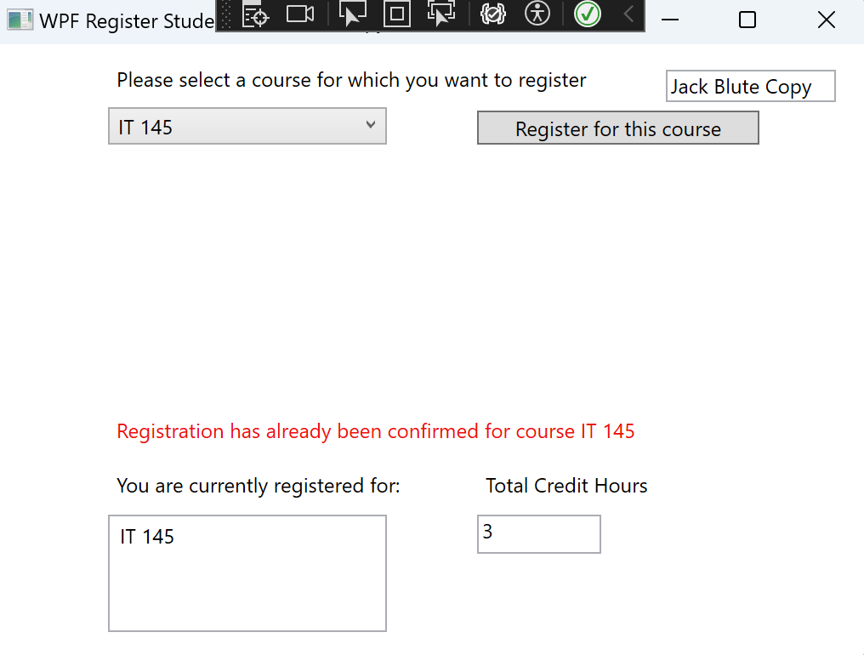

The user tries to enroll in another IT course, but accidentally picks the same one. No classes are added to the list box below and a new message is displayed, “Registration has already been confirmed for course IT 145”. Credit hours stays at three.

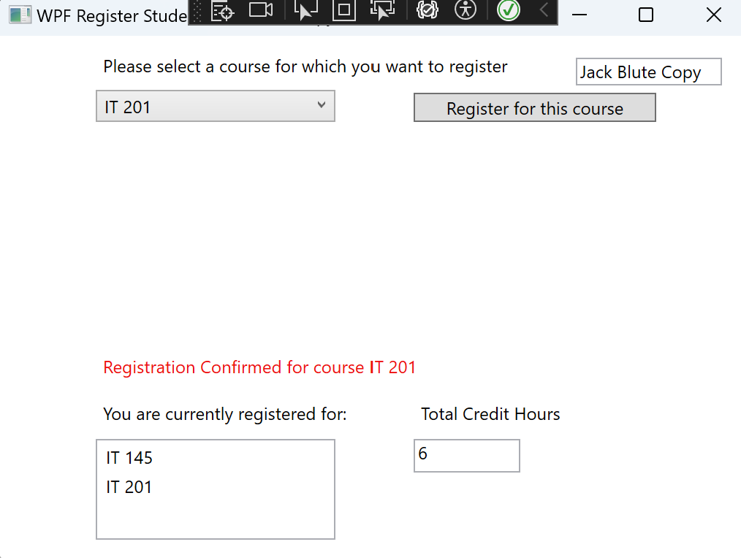

The user correctly enrolls this time in another IT course they are not enrolled in, and the course is added to the list box with a message displaying registration confirmed for course IT 201. Credit hours is set to six now.

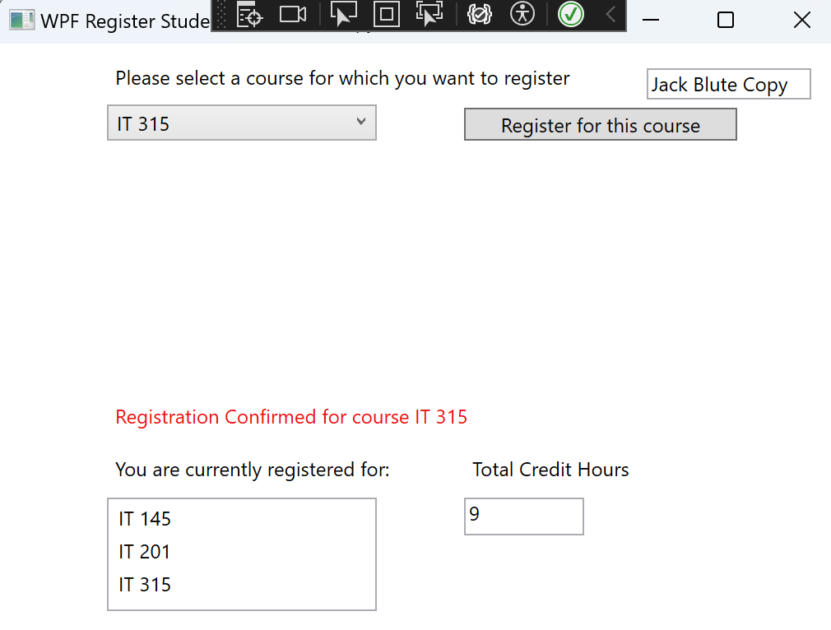

The user enrolls for their third and final course IT 315, which uses up the remaining space in the list box. The confirmation message is once again displayed to the GUI and credit hours is set to 9.

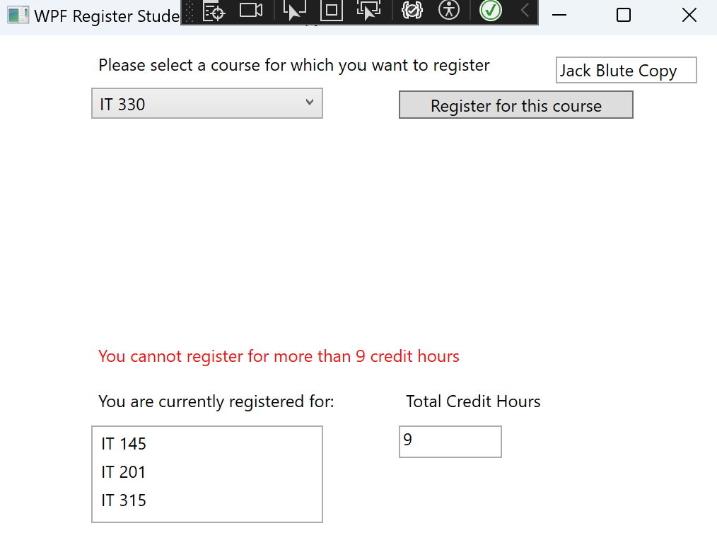

The user does not realize they cannot enroll in more than three courses (9 credit hours) and attempts to register for IT 330. An error message is displayed to the screen saying they cannot enroll for more than 9 credit hours. Credit hours stays at 9.

**Program Code:**

**using System;**

**using System.Collections.Generic;**

**using System.Diagnostics.Eventing.Reader;**

**using System.Linq;**

**using System.Text;**

**using System.Threading.Tasks;**

**using System.Windows;**

**using System.Windows.Controls;**

**using System.Windows.Data;**

**using System.Windows.Documents;**

**using System.Windows.Input;**

**using System.Windows.Media;**

**using System.Windows.Media.Imaging;**

**using System.Windows.Navigation;**

**using System.Windows.Shapes;**

**namespace WPFRegisterStudent**

**{**

**/// <summary>**

**/// Interaction logic for MainWindow.xaml**

**/// </summary>**

**public partial class MainWindow : Window**

**{**

**Course choice;**

**int creditHours = 0;**

**public MainWindow()**

**{**

**InitializeComponent();**

**}**

**private void Window_Loaded(object sender, RoutedEventArgs e)**

**{**

**Course course1 = new Course("IT 145");**

**Course course2 = new Course("IT 200");**

**Course course3 = new Course("IT 201");**

**Course course4 = new Course("IT 270");**

**Course course5 = new Course("IT 315");**

**Course course6 = new Course("IT 328");**

**Course course7 = new Course("IT 330");**

**course1.setName("IT 145");**

**course2.setName("IT 200");**

**course3.setName("IT 201");**

**course4.setName("IT 270");**

**course5.setName("IT 315");**

**course6.setName("IT 328");**

**course7.setName("IT 330");**

**this.comboBox.Items.Add(course1);**

**this.comboBox.Items.Add(course2);**

**this.comboBox.Items.Add(course3);**

**this.comboBox.Items.Add(course4);**

**this.comboBox.Items.Add(course5);**

**this.comboBox.Items.Add(course6);**

**this.comboBox.Items.Add(course7);**

**this.textBox.Text = "";**

**}**

**private void button_Click(object sender, RoutedEventArgs e)**

**{**

**choice = (Course)(this.comboBox.SelectedItem);**

**// TO DO - Create code to validate user selection (the choice object)**

**// and to display an error or a registation confirmation message accordinlgy**

**// Also update the total credit hours textbox if registration is confirmed for a selected course**

**if (creditHours == 0)**

**{**

**this.listBox.Items.Add(choice.getName());**

**string courseName = choice.getName();**

**choice.setName(courseName);**

**choice.SetToRegistered();**

**creditHours += 3;**

**this.textBox.Text = creditHours.ToString();**

**this.label3.Content = "Registration confirmed for course " + courseName;**

**}**

**else if (creditHours > 0 && creditHours < 9)**

**{**

**if (choice.IsRegisteredAlready())**

**{**

**this.label3.Content = "Registration has already been confirmed for course " + choice.getName();**

**}**

**else**

**{**

**string courseName = choice.getName();**

**choice.setName(courseName);**

**choice.SetToRegistered();**

**creditHours += 3;**

**this.textBox.Text = creditHours.ToString();**

**this.listBox.Items.Add(courseName);**

**this.label3.Content = "Registration Confirmed for course " + courseName;**

**}**

**}**

**else if (creditHours >= 9)**

**{**

**this.label3.Content = "You cannot register for more than 9 credit hours";**

**}**

**else**

**{**

**this.label3.Content = "An unexpected error has occured, please try again";**

**}**

**}**

**private void TextBox_TextChanged(object sender, TextChangedEventArgs e)**

**{**

**//this line of code is for the textbox that shows my name at the top of the application**

**}**

**}**

**}**