**Impacts of Drying and Rewetting on the Radiocarbon Signature of Respired CO2 and Implications for Incubating Archived Soils**

**Jeffrey Beem-Miller1, Marion Schrumpf1, Alison Hoyt1,2, Georg Guggenberger3, and Susan Trumbore1,4**

1Max Planck Institute for Biogeochemistry, Jena, Germany, 2Lawrence Berkeley National Laboratory, Berkeley, CA, USA, 3Institute of Soil Science, Leibniz Universität Hannover, Hannover, Germany, 4Department of Earth System Sciences, University of California, Irvine, CA, USA

Corresponding author: Jeffrey Beem-Miller ([jbeem@bgc-jena.mpg.de](mailto:jbeem@bgc-jena.mpg.de))

**Key Points:**

· ∆14C of CO2 measured in incubations of archived soils provides additional constraints for soil carbon models

· Air-drying and rewetting soils shifted the ∆14C of respired CO2 by 10‰ to 20‰ independent of the duration of storage

· The direction and magnitude of the shift in ∆14C of CO2 differed among forest and grassland soils, emphasizing the importance of sampling year and system C dynamics

Abstract

The radiocarbon signature of respired CO2 (∆14C-CO2) measured in laboratory soil incubations integrates the contribution of soil carbon pools across a wide range of ages, making it a powerful model constraint. Incubating archived soils enriched by “bomb-C” from mid-20th century nuclear weapons testing would be even more powerful as it would enable us to trace this pulse over time. However, air-drying, duration of storage, and subsequent rewetting of archived soils may each lead to changes in the relative contribution to respiration from faster or more slowly cycling soil carbon pools. We assessed these effects on ∆14C-CO2 measured in incubations of forest and grassland soils conducted before and after storage. Air-drying and rewetting led to small but significant (α < 0.05) shifts in ∆14C-CO2 relative to undried controls in all three of our experiments, and grassland soils responded more strongly than forest soils. Mean absolute differences (95% CIs) by experiment were: 23.3‰ (±6.6), 19.6‰ (±10.3), and -29.3‰ (±29.1) for grasslands, versus -11.6‰ (±4.1), 12.7‰ (±8.5), and -24.2‰ (±13.2) for forests. Storage durations of 4-14 y did not have a substantial effect on ∆14C-CO2. Our results indicate that air-drying and rewetting soils mobilizes a distinct pool of carbon that would otherwise be inaccessible to microbes, an effect that persists throughout the incubation. However, as the bias in ∆14C-CO2 from air-drying and rewetting is small, measuring ∆14C-CO2 in incubations of archived soils appears to be a promising technique for constraining soil carbon models.

**Plain Language Summary**

Soils play a key role in the global carbon cycle by sequestering carbon from the atmosphere for decades to millennia. However, it is unclear if they will continue to do so as the climate changes. Microbial decomposition of soil organic matter returns carbon back to the atmosphere, and radiocarbon dating of this returning CO2 (∆14C-CO2) can be used to quantify how long carbon is stored in soils. Incubating archived soils could provide unique insight into soil carbon sequestration potential by quantifying the change in ∆14C-CO2 over time. However, air-drying, duration of archiving, and subsequent rewetting of soils may bias estimates of sequestration potential by altering the balance of younger versus older carbon leaving the soil. We compared ∆14C-CO2 from soils incubated with and without air-drying and archiving, and found that the air-dried soils appeared to release slightly older carbon than soils that had never been air-dried (by two years in forests and four years in grasslands). The amount of time the soils were archived did not have an effect. Since the bias from air-drying and rewetting was small, incubating archived soils appears to be a promising technique for improving our ability to model soil carbon cycling under global climate change.

**1. Introduction**

Soil carbon is a heterogeneous mixture of organic matter, some components of which persist in the soil for months or years, while others persist for centuries or millennia. The persistence of soil carbon can be understood through the concept of different “pools” of carbon, each defined by the mechanism by which carbon is stabilized in the soil and characterized by a distinct probability distribution of ages (Sierra et al., 2018). Measuring the radiocarbon signature of heterotrophic respiration (∆14C-CO2) in laboratory incubations is a powerful constraint for modeling soil carbon dynamics because it provides an integrated measure of the weighted contribution to the soil efflux from carbon pools with distinct processing rates (Trumbore, 2000).

The distribution of soil carbon among faster and more slowly cycling pools has important implications for predicting the response of the soil carbon reservoir to changes in inputs or decomposition rates resulting from climate change (Trumbore, 2000). Soils with large pools of slowly cycling carbon would be expected to sequester more carbon with increased inputs than soils dominated by fast cycling pools, while shifts in temperature or moisture regimes may affect decomposition rates differently depending on the stabilization mechanism. ∆14C-CO2 reflects respiration fluxes dominated by the decomposition of fast cycling carbon in contrast to bulk soil ∆14C, which is dominated by large stocks of relatively slowly cycling carbon (Sierra et al., 2018). Both measurements are equally valuable in predicting the response of soil C to global change.

Soil archives offer a window into the past, and incubating archived soils is one opportunity for observing how Δ14C-CO2 changes over time. The pulse of radiocarbon introduced into the biosphere from nuclear weapons testing (“bomb-C”), which peaked in the mid-20th century, (Trumbore, 2009) serves as an ideal tracer for this. New C inputs to the soil over the decades following the bomb-C peak carry distinct annual radiocarbon signatures due to the decline in atmospheric 14C over this period. Following the bomb-C trace in Δ14C-CO2 respired from soils collected and archived over this period could therefore provide unique insight into decadal scale soil C dynamics.

A critical issue with interpreting bomb-C radiocarbon is that there are two points in time at which the Δ14C signature of atmospheric CO2 is identical, due to the curvature of the bomb-C peak. This means observations of Δ14C from a single point in time can be fit to models with different rates of intrinsic decomposition. Trumbore (2000) gives the example of a two independent, homogenous pools of soil carbon, one with an intrinsic decomposition rate (*k*) of 6.6 years and the second with *k* = 50 years, both of which would have a Δ14C of 166‰ in 1996. Observations of Δ14C-CO2 measured in incubations of archived soils could help solve this problem by enabling the contruction of a Δ14C-CO2 time series. The trajectory of ∆14C in a soil carbon pool turning over every 6.6 years is quite different from one with an intrinsic decomposition rate of 50 years (Baisden et al., 2013), a powerful additional constraint for parameterization.

Incubations of archived soils presents challenges, however. Prior to long term storage soils are commonly air-dried, but this process is known to affect biological, physical, and chemical properties of the soil (Bartlett & James, 1980; Jones et al., 2019). Incubation of soils following air-drying and rewetting typically leads to a rapid increase in CO2 production, ranging from hours to several days (the Birch effect), before returning to equilibrium respiration rates (Birch, 1958). Hypothesized sources for the CO2 released following soil rewetting include the lysis of microbial cells subjected to osmotic shock (Warren, 2016; Williams & Xia, 2009), disruption of soil aggregates, osmolytes released from microbes emerging from aridity-induced dormancy (Fierer & Schimel, 2003), or desorption of mineral-associated organic matter, and typically represent a combination of these sources (Kaiser et al., 2015; Slessarev et al., 2020). While the impact of air-drying and rewetting on soil respiration rates has been extensively studied (Borken & Matzner, 2009; Schimel, 2018), the potential effects of air-drying, long-term storage, and rewetting on Δ14C-CO2 has yet to be documented.

If air-drying and rewetting affects the relative contribution of soil organic matter pools with different intrinsic cycling rates to respiration, this should be detectable in ∆14C-CO2. For example, disruption of soil aggregates following drying and rewetting would likely lead to greater accessibility of soil organic matter formerly protected from decomposition via physical occlusion. Drying followed by rewetting could also lead to desorption of organic matter sorbed to minerals, increasing the accessibility of this formerly protected substrate. If drying and rewetting mobilizes carbon from these relatively slowly cycling soil organic matter pools the effect should be detectable as a shift in ∆14C-CO2. However, if the rewetting pulse derives mainly from lysed microbial cells or the release of microbial osmolytes little change in ∆14C-CO2 would be expected.

Obtaining ∆14C-CO2 measurements from incubations of archived soils would be a valuable tool for further constraining and improving soil carbon models, but first the possible effects of air-drying and rewetting, as well as the effect of storage duration, must be assessed.

We designed three experiments to answer the following questions:

1. Is ∆14C-CO2 observed in incubations of soils prior to air-drying altered by the process of air-drying, storage, and subsequent rewetting?
2. What is the effect of air-drying and rewetting alone, i.e. without storage, on ∆14C-CO2?
3. Does the duration of storage affect ∆14C-CO2?

We present the results of these three experiments, along with an applied example of interpreting a time series of ∆14C-CO2 with archived soils. Our results provide insight into long-standing questions about the substrates fueling rewetting pulse respiration, as well as differences in soil C dynamics between forest and grassland ecosystems. We conclude with suggestions for how best to employ the radiocarbon incubation technique with archived soils beyond our sample set.

**2. Materials and Methods**

We devised three experiments to quantify potential shifts in ∆14C-CO2 measured in laboratory soil incubations following air-drying, storage, and rewetting. All three experiments consider the effect of air-drying followed by subsequent rewetting, but with varying storage duration, from less than 1 month (no storage) to 14 years. Experiment 1 focuses on the effects of air-drying and 7 y of storage prior to rewetting (air-dry/rewet + storage), Experiment 2 on the effect of air-drying and rewetting alone, i.e. without storage (air-dry/rewet), and Experiment 3 on the effect of varied storage duration (storage duration). All soils were split following sample collection, with one split air-dried, and the other kept under refrigeration at field-moisture until incubation. For each experiment we considered the undried split to be the control sample and the air-dried split to be the treatment sample.

2.1 Experiment 1: Air-dry/rewet with long-term storage

2.1.1 Experiment 1 sample selection and field sampling

Soils analyzed for Experiment 1 were collected in 2011 from plots established as part of the Biodiversity Exploratories project (Fischer et al., 2010). The samples used in this study comprised a subset of samples originally collected for a different study by Solly et al. (2014). Two ecosystem types (forest and grassland) were sampled from two regions of central Germany, Schorheide-Chorin (Central Germany 1) and Hainich-Dün (Central Germany 2). The two regions have similar climates, but are characterized by different soil textures (Table 1). We used the δ13C signature of respired CO2 (δ13C-CO2) from the second enclosure period of the incubations conducted in 2011 to omit samples containing inorganic carbon, conservatively deeming any samples with δ13C-CO2 > -25‰ as potentially affected by the release of inorganic C (which may be present in previously limed soils in this region). We then selected soils from three grassland plots (50 m by 50 m) and three forest plots (100 m by 100 m) in each of the two geographic regions (n total = 12 sites), using the additional criterion that the ∆14C-CO2 observed in the 2011 incubations fell within the interquartile range observed for the ecosystem type and region. Further details on the soil collection and sampling strategy can be found in Solly et al. (2014).

2.1.2 Experiment 1 sample preparation

Following sample collection, soils for Experiment 1 were sieved to <2 mm at field-moisture and water holding capacity was determined on a 10 g subsample. Briefly, we removed the tips from 50 ml centrifuge tubes and covered them with a fine mesh (<50 µm). We filled the tubes with soil and placed them upright with the mesh-side down in a glass dish filled with deionized water. Tubes were left overnight. The following day we moved them to a second glass dish filled with sand. We allowed the soils to drain for 30 minutes before weighing again to determine the amount of water absorbed. The remaining soil was then split, with one aliquot air-dried at 40º C (air-dry/rewet + storage treatment samples, n = 12), while the other aliquot was left at field moisture (control-1 samples, n = 12). Control-1 samples were stored in re-sealable plastic bags at 4º C until incubation. After air-drying, air-dry/rewet + storage samples were placed in re-sealable plastic bags, and stored inside large plastic boxes in a cool (ca. 15º C) dark room for seven years.

2.1.3 Experiment 1 incubations

Control-1 incubations were performed on single samples due to time and space limitations within the original experiment. Soils were weighed out into 250 ml beakers and placed into 1000 ml mason jars with airtight lids fitted with two sampling ports. The mass of soil used for control-1 incubations ranged from 45 g to 75 g (air-dry equivalent) based on estimated respiration rates from previous work at the sites. Soil masses were adjusted to ensure that enough CO2 would be respired to measure ∆14C-CO2 (> 0.5 mg) following the second enclosure period while at the same time preventing excessive CO2 build-up as this has been shown to negatively impact heterotrophic respiration (MacFayden 1973; Santruckova and Simek 1994).

Soil moisture contents of control-1 samples were adjusted to 60% of water holding capacity (WHC) prior to sealing the jars, either from field moisture (control-1 samples) or from air-dried conditions (air-dry/rewet + storage samples). We moistened the soil from the top by means of a perforated luerlock cap attached to a 10 ml syringe that emitted water in small droplets for minimal disturbance. All control-1 samples were incubated for 4 d following moisture adjustment (the first enclosure period), after which the jars were flushed with CO2-free air and allowed to accumulate CO2 for a second enclosure period of 14 d.

We performed the air-dry/rewet + storage treatment incubations in duplicate in order to quantify potential laboratory errors. However, owing to a limited quantity of archived soil we reduced the mass of soil incubated to 20 g. As with control-1 samples, soil moisture content was adjusted to 60% water holding capacity prior to flushing and sealing the jars. We maintained the same 4 d first enclosure period to capture the CO2 released during the rewetting pulse. We determined the duration of the second enclosure period for the air-dry/rewet + storage treatment incubations by the amount of CO2 respired. We allowed the air-dry/rewet + storage treatment incubations to proceed until the same amount of CO2 had been respired per g soil C as in the second enclosure period of corresponding control-1 sample incubations, as . Accordingly, the incubation duration of the second enclosure period for the air-dry/rewet + storage treatmentincubations varied (Table 2).

Headspace CO2 concentrations for control-1 incubations were measured once at the end of the first enclosure period, but were measured daily during the first enclosure period for air-dry/rewet + storage incubations. We measured headspace CO2 concentrations one to three times per week during the second enclosure period for both control-1 and air-dry/rewet + storage treatmentincubations, with more frequent measurements made for samples with faster respiration rates. Headspace gas samples were collected and analyzed for ∆14C and δ13C content at the end of both the first enclosure period and the second enclosure period for the air-dry/rewet + storage treatmentincubations, but these measurements were only made following the second enclosure period for control-1 samples. All samples were incubated at 20º C.

2.2 Experiment 2: air-dry/rewet without long-term storage

2.2.1 Experiment 2 sample selection and field sampling

We returned to the Central Germany 1 region (Hainich-Dün) in July 2019 to collect samples for Experiment 2 from the same plots originally sampled for Experiment 1 in 2011. We observed similar ∆14C-CO2 across both Central Germany regions in Experiment 1, so we restricted the resampling to just Hainich-Dün to save on cost and time. At each plot (n = 6) we collected three cores from the same depth interval as 2011 (0-10 cm), which were then homogenized to yield one composite sample. Following the protocol from the 2011 sampling, any aboveground vegetation was clipped, and organic horizons were scraped away prior to coring at the forest plots.

2.2.2 Experiment 2 sample preparation

Following sample collection, soils for Experiment 2 were sieved to <2 mm at field moisture and WHC was determined on a 10 g subsample. The remaining soil was then split, with one aliquot air-dried at 40º C (air-dry/rewet treatment samples, n = 6), while the other aliquot was left at field moisture (control-2 samples, n = 6). Control-2 samples were stored in re-sealable plastic bags at 4º C until incubation. After air-drying, air-dry/rewet treatment samples were placed in re-sealable plastic bags, and stored inside large plastic boxes in a cool (ca. 15º C) dark room for two months prior to incubation.

2.2.3 Experiment 2 incubations

Incubation conditions for control-2 and air-dry/rewet treatment samples were identical. Incubations were performed in duplicate. We weighed out 20 g (air-dry equivalent) of soil into 250 ml beakers and placed them into the same style incubation vessels as used for the Experiment 1 incubations. Prior to sealing the jars we adjusted the soil moisture content to 60% WHC in the same manner as Experiment 1 samples (section 2.1.3): either from field moisture (control-2 samples) or from air-dried conditions (air-dry/rewet samples). Following moisture adjustment jars were flushed with CO2-free air, sealed, and left to incubate for a 4 d first enclosure period. After the first enclosure period the jars were flushed again, and CO2 was allowed to accumulate for a second enclosure period (Table 2).

Headspace CO2 concentrations of both contol-2 and air-dry/rewet incubations were measured following the same protocol as the air-dry/rewet + storage incubations in Experiment 1: daily during the rewetting pulse period, and one to three times per week during the second enclosure period depending on respiration rates. Headspace gas samples were collected and analyzed for ∆14C and δ13C content at the end of both the rewetting pulse period and the second enclosure period. Control-2 samples were allowed to incubate until > 0.5 mg of CO2-C was present in the jar headspace, which is the quantity needed to measure ∆14C. Incubations for the air-dry/rewet treatment samples were allowed to proceed until the same amount of CO2 was respired per g of soil C as in the corresponding control-2 sample. All samples were incubated at 20º C.

2.3 Experiment 3: storage duration

We were forced to modify the incubation conditions for Experiment 3 samples slightly from the protocols followed for Experiments 1 and 2 in order to accommodate the variation in experimental design of the initial incubations, which were conducted by different investigators in different labs as part of six unrelated experiments. We designated these initial incubations as the control samples for Experiment 3 (hereafter “control-3”).

2.3.1 Experiment 3 sample selection

The main criteria for sample selection for Experiment 3 were: 1) samples were split prior to original incubation, with one portion air-dried and archived in amounts adequate for a repeated incubation; 2) ∆14C-CO2 was measured from soils incubated close to the time of collection following one to three weeks of incubation. We sought to cover a range of storage duration times (between 4 and 14 y, contrained by the availability of samples), and a range of soil types and climatic conditions, (SI Table 1).

2.3.2 Experiment 3 sample preparation

Sieving protocols varied among control-3 samples, with some samples sieved to 2-mm while others remained unsieved (SI Table 1). All soils obtained for the storage duration incubations were air-dried splits made prior to control-3 incubations.

2.3.3 Experiment 3 Incubations

Control-3 incubation soil mass, replication, temperature, and adjusted moisture varied according to the objectives of the original investigators (Table 2). Soil mass and replication of corresponding storage duration treatment sample incubations varied by the amount of soil material available. We kept the soil moisture the same between paired control-3 and storage duration treatment incubations. However, all storage duration treatment incubations were conducted at 20ºC for simplicity, as while temperature has known effects on respiration rates, it has been shown that it does not affect ∆14C-CO2 (Vaughn and Torn, 2019).

We did not have information on either the duration of or the amount of CO2 respired during the rewetting period for all of the control-3 samples. Rather than impose a first enclosure period with an arbitrary duration, we decided to incubate the storage duration treatment samples for a single enclosure period beginning immediately after rewetting. We felt this was justified as we did not observe significant differences between first and second enclosure period ∆14C-CO2 in the first two experiments (Results 3.2). We allowed respiration in the storage duration treatment samples to proceed until the same amount of CO2 had been respired per g of soil C as in the second enclosure period of the corresponding control-3 sample incubations.

We measured headspace CO2 concentrations every three days for the first two weeks of the storage duration treatment sample incubations, and weekly as needed thereafter; control-3 CO2 measurement frequency varied. Aliquots of jar atmosphere were collected once the samples reached target CO2 concentrations and was subsequently analyzed for ∆14C. We conducted the majority (n = 16) of the Experiment 3 storage duration treatment incubations in 2018 at the Max Planck Institute for Biogeochemistry (MPI-BGC) but the remainder (n = 12) of the treatment sample incubations were performed in 2009 at the University of California Irvine (UCI) (SI Table 1).

2.4 Soil analyses

Total carbon and nitrogen contents of the Central Germany samples were determined by dry

**Table 1.**

*Mean soil properties by sampling region\**

|  |  |  |  |  |  |  |  |  |  |  |  |  |  |  |  |  |  |  |  |  |  |  |
| --- | --- | --- | --- | --- | --- | --- | --- | --- | --- | --- | --- | --- | --- | --- | --- | --- | --- | --- | --- | --- | --- | --- |
|  |  |  |  |  | |  | | Nutrients | | | | | | Particle size | | | | | | | | |
|  |  |  |  |  | |  | | Organic C | | | Total N | | | Sand | | | Silt | | | Clay | | |
| Experiment | Region | Ecosystem** | MAT | | MAP | | n*** | | Mean | sd | | Mean | sd | | Mean | sd | | Mean | sd | | Mean | sd | |
|  |  |  | *°C* | | *mm yr-1* | | *sites* | | *g kg-1* | | | | | | | | | | | | | | |
| 1 | Central Germany 1 | forest | 8.3 | | 550 | | 3 | | 22.1 | 8.1 | | 1.1 | 0.3 | | 861 | 44 | | 92 | 27 | | 47 | 20 | |
| 1 | Central Germany 1 | grassland | 8.3 | | 550 | | 3 | | 22.8 | 1.5 | | 2.2 | 0.1 | | 731 | 99 | | 158 | 75 | | 111 | 31 | |
| 1, 2, 3 | Central Germany 2 | forest | 7.25 | | 650 | | 3 | | 23.7 | 0.5 | | 1.7 | 0.1 | | 54 | 18 | | 754 | 7 | | 193 | 15 | |
| 1, 2, 3 | Central Germany 2 | grassland | 7.25 | | 650 | | 3 | | 41.8 | 1.9 | | 3.9 | 0.1 | | 32 | 17 | | 553 | 78 | | 414 | 65 | |
| 3 | Oak Ridge, USA | forest | 14.1 | | 1360 | | 2 | | 24.9 | 0 | | 1.1 | 0.1 | | - | - | | - | - | | - | - | |
| 3 | Sierra Nevada, USA | forest | 9.8 | | 960 | | 2 | | 28.4 | 1.4 | | 1.1 | 0.1 | | 700 | 141 | | 210 | 85 | | 100 | 71 | |
| 3 | Harvard Forest,USA | forest | 7.9 | | 1075 | | 1 | | 60 | - | | - | - | | - | - | | - | - | | - | - | |
| 3 | Duke FACE, USA | forest | 15.5 | | 1140 | | 1 | | 16.6 | - | | 0.8 | - | | - | - | | - | - | | - | - | |

* The Central Germany regions are from the Biodiversity Exploratory project: Schorheide-Chorin (region 1) and Hainich-Dün (region 2). Climate data for these sites are from Fischer et al. (2010). Harvard Forest nutrient data from Gaudinki et al. (2000); climate data are the ten-year averages from 1991 to 2000 (Boose et al., 2012); all Oak Ridge data are from Cisneros-Dozel et al. (2006); Duke FACE data are from Hopkins et al. (2012); Sierra Nevada data are from Koarashi et al. (2009). Note that not all data were available for all sites. ** Central Germany 2, Harvard Forest, and Oak Ridge forest sites are mixed deciduous; Central Germany 2 forest sites include both coniferous and deciduous stands; Sierra Nevada and Duke FACE forest sites are exclusively coniferous. Grasslands were all cool-season grasses (C3 photosynthetic pathway). *** See Table 2 for the total number of samples per experiment, and Table 3 for the number of samples per site per experiment.

combustion in a CN analyzer (Vario Max, Elementar Analysensysteme GmbH, Hanau, Germany) following fine grinding with a ball-mill (Retsch MM400, Hanau, Germany). Soil texture of the Central Germany samples was determined using the pipette method following removal of organic matter (Schlichting et al., 1995). Soil property data for the samples from all other regions were obtained from the original investigators (Gaudinski et al. 2000; Cisneros et al., 2005; Hopkins et al. 2012; Koarashi et al. 2012; Solly et al. 2014) (Table 1).

2.5 Isotopic analyses

For all three experiments, we separated CO2 from the gas samples collected from incubation jar headspace using a vacuum line, with splits of the purified CO2 analyzed for both δ13C and ∆14C. Radiocarbon analyses were conducted at the MPI-BGC accelerator mass spectrometer facility (Steinhof, 2013) or the UCI W.M. Keck Facility for Accelerator Mass Spectrometry (Xu et al., 2007) (SI Table 1). Radiocarbon values are reported in units of ∆14C, defined as the deviation in parts per thousand of the ratio of 14C to 12C from that of the oxalic acid standard measured in 1950. In order to account for potential mass-dependent fractionation effects, the 14C/12C ratio of all samples is corrected to a common δ13C value of -25 per mil (Stuiver & Polach, 1977). Although the effect was small, ∆14C data from air-dry/rewet + storage samples (Experiments 1 and 3) were also corrected for depletion of 14C in the samples due to radioactive decay that occurred during storage.

Measurements of δ13C (Experiments 1 and 2 only) were made at MPI-BGC (Delta+XL, Thermo Finnigan, Bremen, Germany). Data are reported using δ13C notation, which refers to the deviation in parts per thousand of the ratio of 13C/12C in the PDB standard.

2.6 Statistical analysis

We compared the mean differences between treatment and control sample ∆14C-CO2 and δ13C-CO2 within ecosystem types for each experiment in order to assess the significance of the treatment effects. We quantified the analytical error associated with the radiocarbon incubation method by calculating the mean of the variance measured among replicates for all samples that were replicated. For samples that were not replicated we used the mean of the replicate variance measured across all samples. We calculated mean differences between control and treatment

**Table 2.**

*Experimental design*

|  |  |  |  |  |  |  |  |  |  |  |  |  |  |
| --- | --- | --- | --- | --- | --- | --- | --- | --- | --- | --- | --- | --- | --- |
|  |  |  |  |  |  |  |  | Enclosure period*** | | | | | |
|  |  |  |  |  |  | Moisture content** | | 1st (rewetting pulse) | | | 2nd | | |
| Experiment | n | Treatment | Reps* | Sampling date | Incubation date | Intial | Adjusted | Time | ∆14C? | δ13C? | Time | ∆14C? | δ13C? |
|  |  |  |  | *year* | *year* | *% grav* | *% grav* | *days* |  |  | *days* |  |  |
|  |  |  |  |  |  |  |  |  |  |  |  |  |  |
| 1 | 12 | control-1 | 1 | 2011 | 2011 | 24-55 (11) | 24-61 (13) | 4 | no | no | 14 | yes | yes |
| 12 | air-dry/rewet + storage | 2 | 2011 | 2018 | <1 | 24-61 (13) | 4 | yes | yes | 5-45 | yes | yes |
| 2 | 6 | control-2 | 2 | 2019 | 2019 | 17-40 (10) | 22-42 (9) | 4 | yes | yes | 10-38 | yes | yes |
| 6 | air-dry/rewet | 2 | 2019 | 2019 | <1 | 22-42 (9) | 4 | yes | yes | 7 | yes | yes |
| 3 | 29 | control-3 | 1-3 | 1999-2011 | 1999-2011 | 6-95 (18) | 18-95 (17) | 1-10 | no | no | 5-14 | yes | no |
| 29 | storage duration | 1-3 | 2018 | 2009, 2018 | <1 | 18-95 (17) | - | - | - | 5-45 | yes | no |

*Laboratory incubation replicates. ** Min. and max. values given for control samples, with standard deviations in parentheses. Initial moisture content for treatment samples was <1% following air-drying. Moisture content was adjusted to 60% of water holding capacity for all Experiment 1 and Experiment 2 samples (Methods), but as WHC was not determined for all of Experiment 3 samples the gravimetric (grav) data is provided instead. *** First enclosure period duration range is only taken from a subset of the samples where it was explicitly reported (n = 4, Hopkins et al. 2012 and Koarashi et al. 2012). The duration was reported as an estimate for some samples (1 week, n = 20, Cisneros et al. 2005) or not reported at all for other samples (n = 4, Gaudinski et al. 2000). ∆14C-CO2 and respiration rates from the first enclosure period were only measured for 2 of the 29 control-3 samples (Koarashi et al. 2012). As we did not find significant differences between ∆14C-CO2 of the 1st and 2nd enclosure periods (Results), we decided to incubate the storage duration samples in Experiment 3 for single enclosure period in order to better control the total amount of CO2 respired.

samples and the variance of this mean difference, and then determined the pooled mean and variances. We calculated pooled statistics separately for forest and grassland soils in Experiments 1 and 2, but pooled across ecosystem type for Experiment 3 as the direction of trend was the same for both forest and grassland soils in Experiment 3 and we only had a limited number of grassland soils (n = 3).

The pooled mean is simply the average of the individual sample means weighted by the number of replicates. We determined the pooled variance (**Eq. 1**) using the method of O’Neil (2014), which takes into account both sampled and unsampled variance for a finite population. We used this variance to determine 95% confidence intervals around the pooled mean difference, which we deemed significant if the confidence interval did not overlap zero.

**Eq. 1**

All statistical analyses were performed in R (R Core Team 2019).

2.7 Conceptual model

We developed a conceptual model for the forested sites from a single region, Hainich-Dün (Central Germany 2), to illustrate potential sources for the carbon respired following the air-drying and rewetting treatments imposed in this study. We implemented a two-pool parallel model with inputs partitioned between slow and fast cycling soil C pools, and no transfers between pools, using the Soil R package (Sierra et al., 2014). In an earlier study, Schrumpf et al., (2015) estimated intrinstic decomposition rates and pool sizes for empirically defined soil C pools using a density fractionation procedure for sites in the same region. We approximated the intrinsic decomposition rates for the fast and slow pools of our model using Schrumpf et al. (2015)’s mean estimates for the free light fraction and the heavy fraction from the 0-5 cm depth increment (4-1 y and 115-1 y for the fast and slow pools, respectively). Schrumpf et al. (2015) found that 10 percent of the carbon in the 0-5 cm depth layer was in the free light fraction. We used this fraction for the partitioning between the fast and slow pools, under the assumption that the free light fraction corresponds to the fast pool. Following Schrumpf et al. (2015), we assumed a lag time of 8 y for inputs.

**3. Results**

3.1. Respiration rates

We observed consistent differences between control and treatment sample respiration rates in Experiment 1 and Experiment 2, with control sample respiration rates lower than treatment sample respiration rates in both experiments (Fig. 1). However, the magnitude and timing of peak respiration rates diverged among experiments and between grassland and forest soils (Fig. 1). Maximum respiration rates were more than twice as high in grassland soils than in forest soils for air-dry/rewet + storage treatment samples in Experiment 1 (Fig. 1a), but were similar across ecosystem types for the air-dry/rewet treatment samples in Experient 2 (Fig. 1b). Respiration rates for Experiment 3 samples are shown in Supplementary Figure 1, but CO2 flux rates cannot be meaningfully interpreted given the differences in incubation temperature, approach to the rewetting pulse, and the wide variation in CO2 measurement frequency among samples.

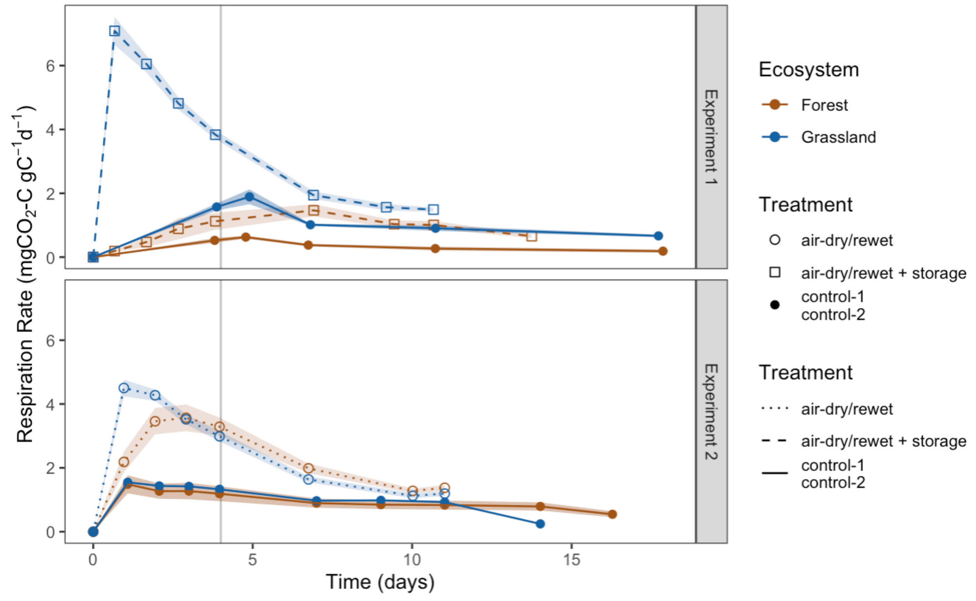

**Figure 1.** Respiration rates for Experiment 1 (Air-dry/rewet + storage) and Experiment 2 (Air-dry/rewet only) samples

**a)** Experiment 1 samples; **b)** Experiment 2 samples. Vertical gray line at day 4 demarcates the end of the first enclosure period. Points show measurements and lines show trends in mean respiration rate. Shaded ribbons represent one standard error of the mean. The final measurement points for a few samples which took > 18 d to reach CO2 targets are excluded for display reasons; respiration rates for those samples remained constant. Note that headspace CO2 concentrations for control-1 samples (panel a) were only measured once during the first enclosure period (day 4) in contrast to daily measurements for all other samples.

3.2. First and second enclosure period ∆14C-CO2 and δ13C-CO2

We did not see significant differences when we compared ∆14C-CO2 from the first enclosure period to that of the second enclosure period. This was true for all comparisons made within experiment, treatment, and ecosystem groups, with one exeception: grassland control-1 samples had slightly higher ∆14C-CO2 in the second enclosure period compared to the first (mean difference = 10.4‰, 95% CI = [6.0‰, 14.8‰]). When we combined data across experiments, ecosystem types, and treatments, the mean difference in ∆14C-CO2 between enclosure periods was only 2.0‰ (95% CI = [-1.0‰, 5.0‰]). (We excluded the forest control-2 sample that was clearly an outlier (Fig. 2) from this combined analysis).

We note that due to lower respiration rates during the first enclosure period only three of the six forest soils in the air-dry/rewet + storage treatment group from Experiment 1 (Fig. 2) generated enough CO2 to measure the radiocarbon content. In addition, it was not possible to compare ∆14C-CO2 across enclosure periods for the control-1 samples as ∆14C-CO2 of the first enclosure period was not measured in 2011.

However, we did observe significant differences between the δ13C-CO2 of the first enclosure period and that of the second enclosure period for the forest soils in the air-dry/rewet + storage treatment group in Experiment 1 (mean difference = -1.16‰, 95% CI = [-1.69‰, -0.63‰]) and the grassland soils in the control group in Experiment 2 (mean difference = 0.85‰, 95% CI = [0.64‰, 1.07‰]) (Supplemental Fig. 2). Note that as with ∆14C, δ13C-CO2 was not measured for the first enclosure period of control-1 incubations.

3.3. Overall treatment effects on ∆14C-CO2 and δ13C-CO2

We observed consistent differences between control and treatment sample ∆14C-CO2 in the second enclosure period in all three experiments (Table 3). Treatment sample incubations typically resulted in differences between 20‰ and 40‰ relative to control sample incubations, although the majority of the differences were within ±20‰. The samples from Oak Ridge are an exception in that mean difference in ∆14C-CO2 between storage treatment samples and corresponding control-3 samples was -44.0‰ (Table 3).

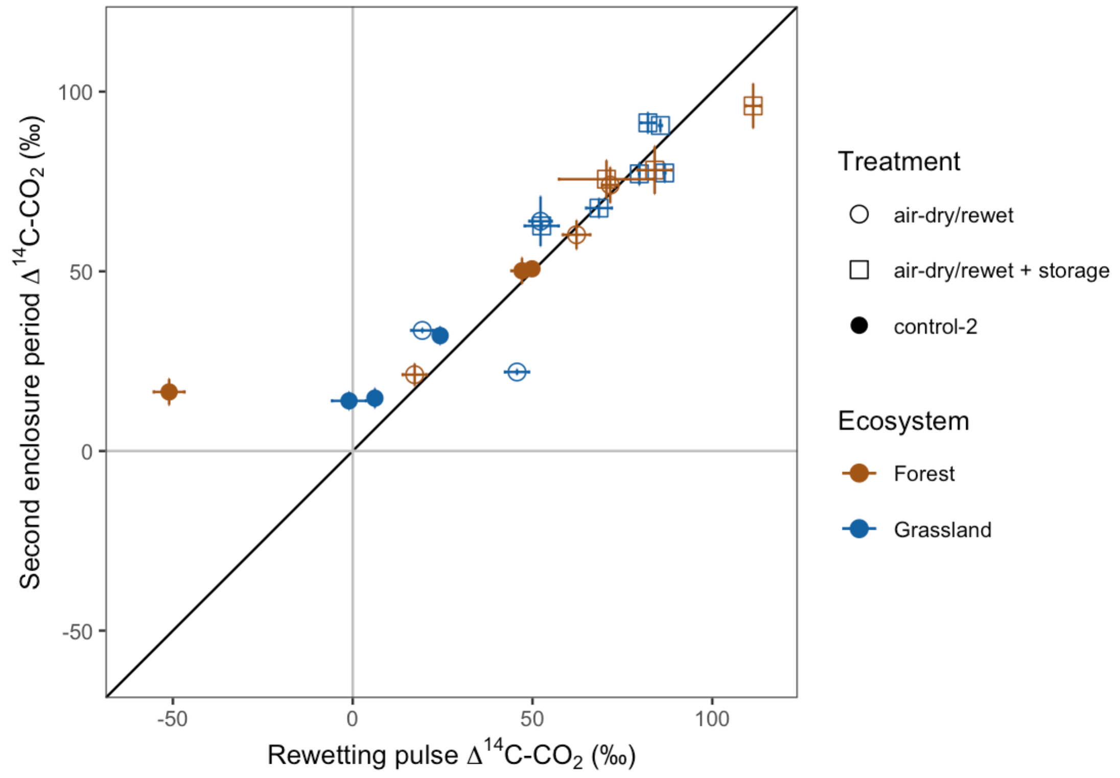

**Figure 2.** ∆14C-CO2 of the rewetting pulse (first enclosure period) versus the second enclosure period.

Points are means of laboratory duplicates and error bars are the min. and max.. Note that Δ14C-CO2 was not measured for the first enclosure period (rewetting pulse) in control-1 samples; additionally samples from three of the forest plots of the air-dry/rewet + storage samples from Experiment 1 failed to accumulate enough CO2 during this period to measure Δ14C-CO2.

Forest and grassland soil ∆14C-CO2  shifted in opposite directions following treatment in Experiment 1: the air-dry/rewet + storage treatment led to depletion in forest soils, but enrichment in grassland soils (Table 3). In contrast, both forest and grassland soils in Experiment 2 responded to the air-dry/rewet treatment with enrichment in ∆14C-CO2. Experiment 3 treatment sample ∆14C-CO2 tended to be depleted relative to the controls (points below the 1:1 line in Fig. 3) for the majority of forest and grassland soils.

Treatment samples in Experiment 1 and Experiment 2 consistently showed significant differences (alpha = 0.05) in δ13C-CO2 relative to the controls for both forest and grassland soils (Supplementary Fig. 3). Differences in δ13C-CO2 were slightly larger in forest soils than grassland soils across experiments (Table 3). Comparisons of δ13C-CO2 were not made for Experiment 3 samples owing to a lack of data for the control-3 samples.

3.4. Storage duration effect on ∆14C-CO2

We used data from both Experiment 1 and Experiment 3 to assess the effect of storage duration. The longest duration of storage was 14 y, while the shortest was 5 y. Over this range of time we did not observe a trend in the difference between control and treatment ∆14C-CO2 with increasing duration of storage (Fig. 4).

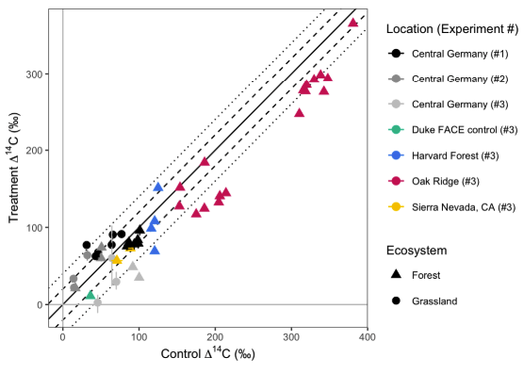

**Figure 3.** Overall treatment effect on Δ14C-CO2

Points show data from all three experiments and are the mean of laboratory replicates (for replicated samples); error bars are standard deviation of replicates. Solid line is 1:1. For context, the dashed and dotted lines show differences of ±20‰ and ±40‰. The samples from both Central Germany sites (Hainich-Dün and Schorfheide-Chorin) behaved similarly in Experiment one, so samples analyzed in the same experiment are are coded with the same colors in the above figure.

3.5. Time series analysis of ∆14C-CO2 (Experiments 1 and 2)

A subset of the sites sampled for Experiment 1 in 2011 were resampled for Experiment 2 in 2019. This time series allows us to assess both the change in ∆14C-CO2 of respiration over time in control-1 versus control-2 samples, as well as the potential impact of air-drying and rewetting on any observed changes. The absolute value of the mean difference in ∆14C-CO2 between control and treatment samples was greater in grassland samples than in forest samples at both time points: in 2011 (Experiment 1) and 2019 (Experiment 2) (Table 3).

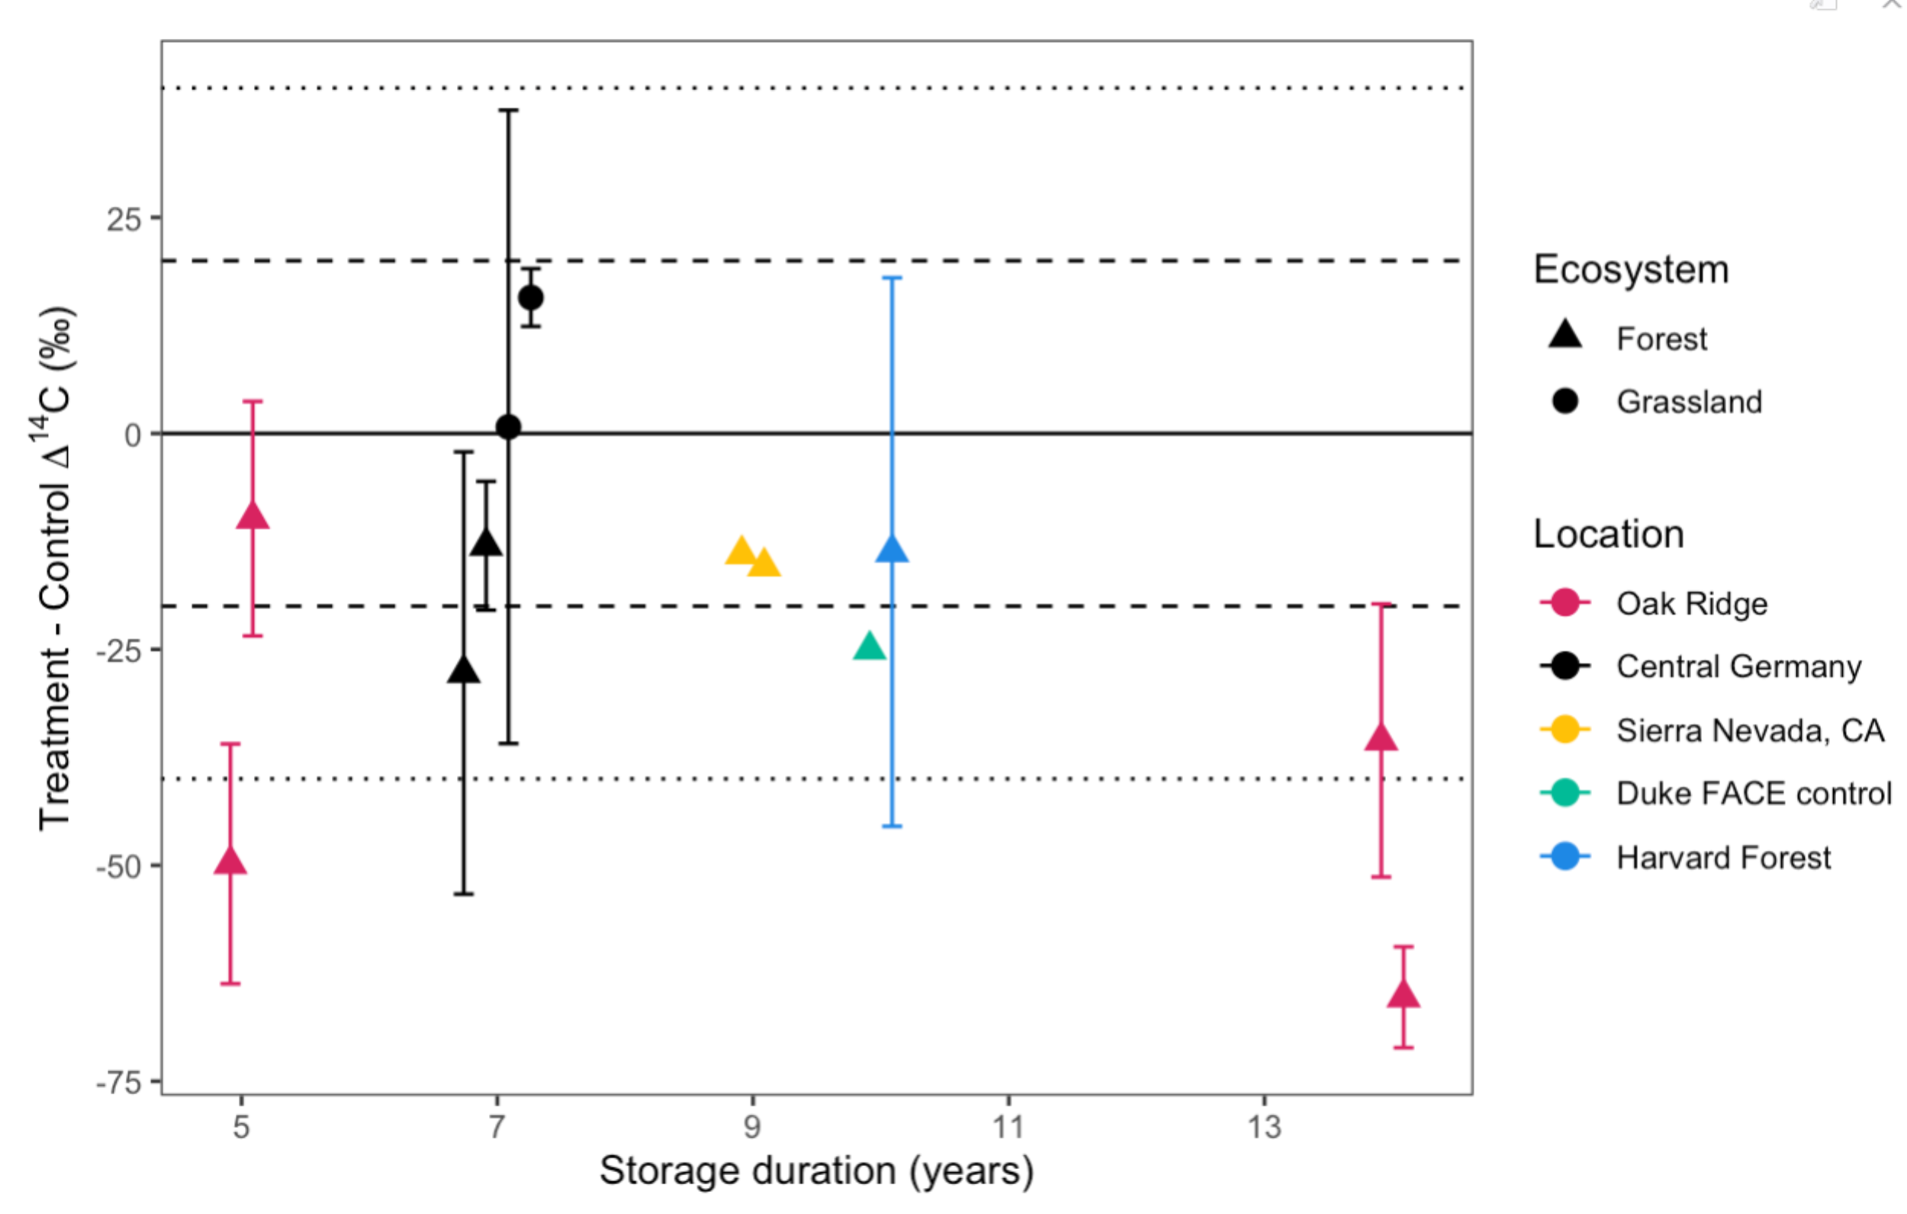

**Figure 4.** Treatment effect on Δ14C-CO2 in relation to storage duration

Points show data from experiments 1 and 3. Data are averaged by site (some regions had multiple sites, Table 3) and error bars show the standard deviation for the site mean. Note that Central Germany samples from Experiments 1 and 3 are averaged together here. For context, the dashed and dotted lines show differences of ±20‰ and ±40‰.

The difference between respired ∆14C-CO2 and the atmosphere in the year of sampling (∆∆14C) is an important indicator of soil C cycling rates. Sample Δ14C-CO2 was enriched relative to the atmosphere across ecosystem types for all samples, i.e. ∆∆14C values were positive (Fig. 5, Table 3). However, we observed smaller ∆Δ14C-CO2 values in grassland soils than in forest soils at both time points (Table 3). Comparing ∆∆14C-CO2 between control and treatment samples within ecosystem types, we observed lower values in control samples than in treatment samples at both time points for the grassland soils. We saw the same trend for forest samples collected in 2019. In contrast, treatment samples from the forest soils collected in 2011 had lower ∆∆14C-CO2 values than did control samples.

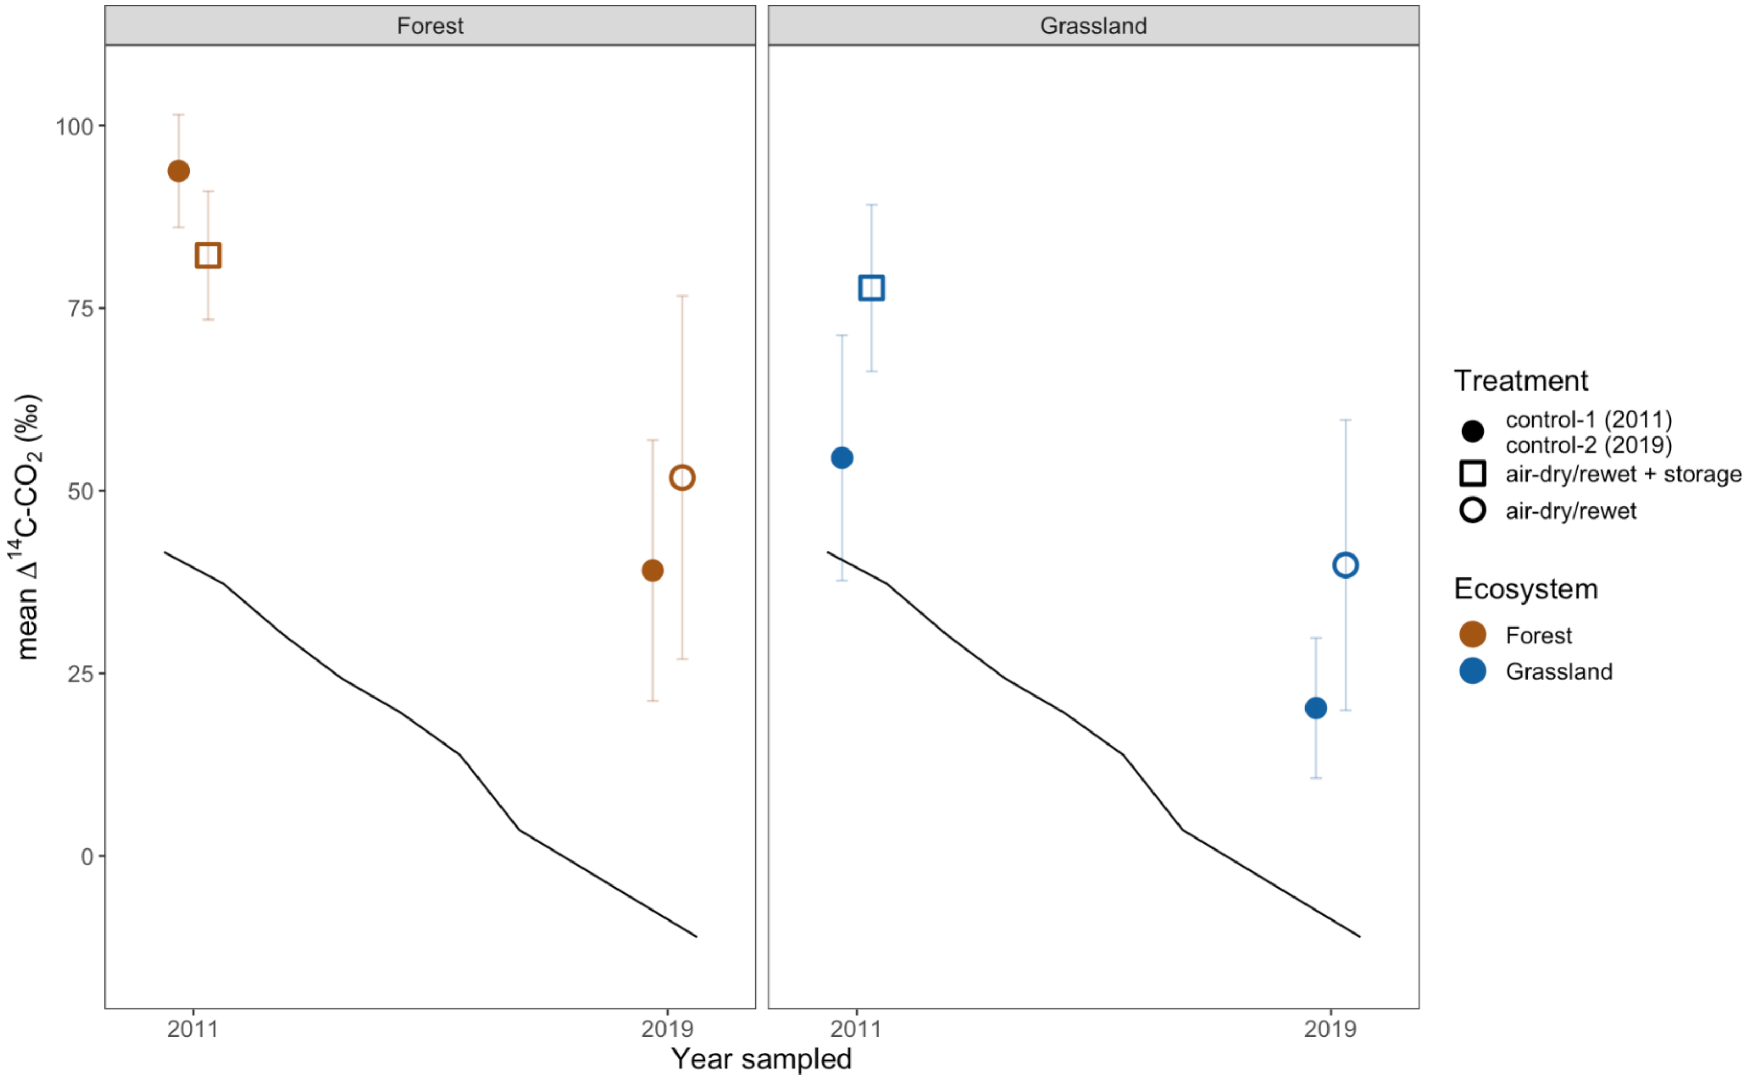

**Figure 5. Time series of control and treatment Δ14C-CO2 (Experiments 1 and 2)**

Points show mean Δ14C-CO2 within ecosystem and treatment groups; error bars show the pooled standard deviation. Points are jittered to prevent overplotting. Atmospheric ∆14C-CO2 data (black line) are from Graven et al. (2017) up to the year 2015, while data beyond 2015 are extrapolated (Sierra, 2018). All atmospheric radiocarbon data are for the northern hemisphere (zone 2).

**4. Discussion**

4.1. Implications for constraining soil carbon models

The results from all three experiments in this study show that measuring ∆14C-CO2 in incubations of air-dried and archived soils is a promising technique for constructing time series of respired ∆14C-CO2 and constraining soil carbon models. We observed that air-drying and rewetting shifted observed ∆14C- CO2 relative to control incubations of soils that had never been air-dried, but these differences were relatively small: on the order of 10 to 25 per mille, if we exclude the samples from the Oak Ridge labeling experiment (Table 3). Differences between control and treatment ∆14C- CO2 were significant for all three experiments (Table 3), however, suggesting that the process of drying and rewetting leads to utilization of substrates with distinct ∆14C signatures.

4.2 Interpreting treatment effects on the age of respired CO2

Data from samples collected at the same location (Hainich-Dün) at two different time points (for Experiment 1 in 2011 and Experiment 2 in 2019) illustrate both the potential of the archive incubation approach and the challenges inherent in interpreting radiocarbon data. For example, we observed enrichment following the air-drying and rewetting treatment in the forest soils collected in 2019 (Experiment 2) and the grassland soils collected in both 2011 (Experiment 1) and 2019 (Experiment 2), but depletion in forest soils collected in 2011 (Experiment 1). We believe that this reversal in trend is a function of the sampling year, and the relative trajectories of ∆14C in slow and fast cycling soil carbon pools over time. The conceptual model we developed illustrates this phenomenon and highlights the importance of the year of sampling in determining whether air-drying and rewetting will lead to enrichment or depletion (Fig. 6).

The data from the Hainich-Dün forest sites suggest that the shift in ∆14C-CO2 due to air-drying and rewetting is from mobilization of carbon from more slowly cycling soil C pools. Following treatment, ∆14C-CO2 of respired CO2 (gold points) shifts towards the curve showing the trajectory of slow pool ∆14C over time (blue line), indicating an increased contribution to respiration from this pool. Due to the crossing of the slow and fast pool curves in 2015, an increased contribution of the slow pool to respiration following treatment would lead to relative depletion of ∆14C-CO2 in 2011, but relative enrichment of ∆14C-CO2 in 2019, which is what we observed.

Data from Experiment 1 and Experiment 3 showed that storage duration does not have a strong effect on ∆14C-CO2, at least within a period of 5 to 14 y (Fig. 4). In contrast to the forest soils, the grassland samples analyzed from Hainich-Dün show enrichment of a similar magnitude in response to both the air-dry/rewet + storage treatment in 2011 and the air-dry/rewet treatment in 2019 (Fig. 5, Table 3). We interpret this as additional evidence that storage does not affect the shift in ∆14C-CO2 following air-drying and rewetting. If we apply the conceptual model in Fig. 6 to the results from the grassland soils, the data suggest that either carbon is being mobilized from a slowly cycling carbon pool that had already become more enriched than the faster cycling pool prior to 2011, or that the air-drying and rewetting treatment is mobilizing faster cycling carbon in grassland soils but not forest soils. The more parsimonious explanation is that the air-drying and rewetting treatment is mobilizing additional carbon from a more slowly cycling pool in both forest and grassland soils, but with different effects on ∆14C-CO2 due to differences in relative cycling rates of carbon in forest versus grassland ecosystems.

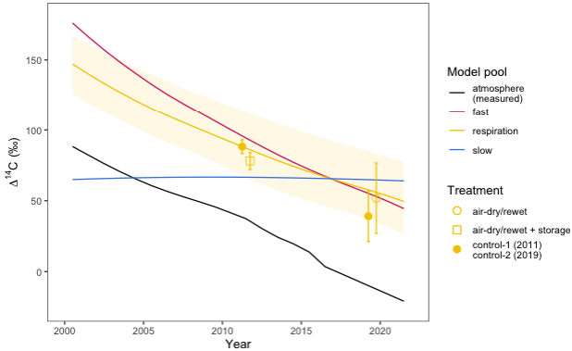

**Figure 6**. **a)**Modeled trajectories of soil ∆14C over time for the Hainich-Dün forest region and ∆14C of heterotrophic respiration (gold points) observed in this study shown in relation to the atmosphere. Points are jittered to prevent overplotting; error bars show standard deviations. Ribbon shows maximum range of respired CO2 predicted with model parameters for the fast and slow pools set to the 75th and 25th quartile values (upper bound) or 25th and 75th quartile values (lower bound) as estimated by Schrumpf et al. (2015) **b)** *(inset)* ∆14C of soil pools, heterotrophically respired CO2, and the atmosphere for the whole bomb-C period (1950 to 2020). Atmospheric ∆14C-CO2 data are from Graven et al. (2017) up to the year 2015, while data points from 2015 to 2019 are extrapolated (Sierra, 2018b). All atmospheric radiocarbon data is for the northern hemisphere (zone 2).

4.3. Potential role of pre-aged C inputs in forest versus grassland soils

A key difference in carbon cycling between forest and grassland ecosystems is the potential for carbon storage in woody tissues after it is fixed from the atmosphere (Gaudinski et al., 2000). Carbon entering the soil in forest ecosystems may be “pre-aged” compared to inputs in grassland ecosystems. Earlier work in some of the same Central German forest and grassland ecosystems analyzed in this study (the Hainich-Dün and Schorfheide-Chorin regions) provides support for the pre-ageing of carbon in forest ecosystems: Solly et al. (2013) found the mean age of the carbon in fine roots in the forest ecosystems to be approximately 10 y, in comparison to 1 to 2 y for fine roots in the grassland ecosystems. This pre-aging, or lag effect, for fine root inputs may explain the greater ∆∆14C values seen for the respiration from forest ecosystems as compared to the grassland ecosystems in this study (Table 3). Additionally, a greater lag in forest systems would also mean that the crossing point for the ∆14C curves of the slow and fast cycling soil carbon pools (e.g. the blue and magenta lines in Fig. 6), would be later in time relative to grassland soils. Again, if the fast and slow soil carbon pool curves crossed between 2011 and 2019 for the forest soils, but had already crossed by 2011 in the grassland soils, this would explain the differences in the treatment responses observed in this study between the two ecosystem types. This could be tested by comparing the ∆14C of empirically defined “fast” and “slow” carbon pools over this time period relative to observed ∆14C-CO2, e.g. free light particulate organic matter and mineral-associated organic matter (cf. Schrumpf et al., 2015). However, this is beyond the scope of this study.

4.4. ∆14C-CO2 of the rewetting pulse versus the second enclosure period

We hypothesized that the CO2 released immediately following moisture adjustment, i.e. the rewetting pulse, would be older than the CO2 released during the second enclosure period. However, in contrast to our expectations, we did not find a significant difference in ∆14C-CO2 between these two respiration periods. This finding was true for all of the samples in which we measured ∆14C-CO2 in both the rewetting pulse period and a second enclosure period (Fig. 3). These results suggest that the change in substrate availability initiated by air-drying and rewetting is not limited to the rewetting pulse.

There is a large body of literature that provides evidence for different chemistry of the substrates fueling the rewetting pulse compared to that of the substrates fueling basal respiration (Franzluebbers et al., 2000; Wu and Brooks, 2005; Xiang et al., 2008; Williams and Xia, 2009). However, as other recent work has shown, persistence of soil organic matter is not soley due to chemistry (Lützow et al., 2006; Marschner et al. 2008; Schmidt et al.; 2011; Dungait et al., 2012). The similarity in ∆14C across substrates utilized in the rewetting pulse and the second enclosure period that likely diverge in chemistry is therefore in line with the modern paradigm (Lehmann and Kleber, 2015; Lehmann et al. 2020). Alternatively, microbial recycling over the relatively short duration of the incubations in this study (mean = 9 d) could also explain the lack of change in ∆14C-CO2 between enclosure periods. For context, we note that the mean amount of CO2 respired in the incubations in this study was 0.8 percent of the initial total soil organic carbon. This microbial recycling hypothesis is also supported by the shifts in δ13C observed between the rewetting pulse and the second enclosure period, which we found to be significant.

4.5. Implication of δ13C-CO2 shifts following drying and rewetting

The consistent enrichment in δ13C-CO2 seen following both the air-dry/rewet + storage treatment and the air-dry/rewet treatment (Table 3, Supplemental Fig. 3) could be due to many possible scenarios. Microbial recycling is one mechanism that has been shown to lead to enrichment in δ13C (Wynn et al., 2005), and this process ahs also been shown to be enhanced following air-drying and rewetting (Brödlin et al., 2019; Slessarev et al., 2020). Another scenario is that the fuel for the rewetting pulse is microbial in origin, but derived from microbes that have been dormant for more than a decade. Such a scenario would explain the concomitant shift in ∆14C-CO2, but to our knowledge such a response has not been previously documented. While we cannot rule out this interpretation, such an argument is complicated by the fact that older soil organic matter also tends to be enriched in δ13C due to the ongoing process of decomposition, and thus mobilization of older, extracellular C would be in line with the observed shift in δ13C-CO2 seen in both the air-dry/rewet and the air-dry/rewet + storage samples (Wynn et al., 2005). As noted previously, the ∆14C unit accounts for mass-dependent fractionation effects, thus this phenomenon does not affect the radiocarbon results as reported. We observed greater enrichment of δ13C-CO2 in forest soils than in grassland soils, which could indicate greater microbial recycling in forest soils or potentially more mobilization of mineral-associated organic matter in forest soils than in grassland soils following treatment. Mineral-associated organic matter has been shown to be more enriched in δ13C as well as older on average than bulk soil organic matter (Schrumpf et al., 2013), a combination of observations that indicate more mineral-associated organic carbon may have been released upon rewetting in the forest soils than in the grassland soils. However, the similarity in the direction of the δ13C-CO2 response across forest and grassland soils (Supplemental Fig. 3) suggests that a similar mechanism is at work in both ecosystems.

4.6. Quantifying the treatment effect on ∆14C-CO2

Nearly all of the forest soils analyzed in this study exhibited depletion of ∆14C-CO2 following air-drying/rewet + storage treatment (Fig. 3, Fig. 4). However, the depletion in the forest soils was greatest in the samples from Oak Ridge (magenta triangles, Fig. 3), which had been substantially enriched in ∆14C above background levels through artificial means. This localized 14C plume was released from a nearby incinerator four years prior to sample collection, and resulted in 14C enrichment of both surface litter and root inputs that persisted until the time of sample collection (Cisneros-Dozal et al., 2006). These samples were included precisely because the highly enriched label was concentrated in the most recently fixed carbon, and therefore should be a sensitive indicator of mobilization of older (> 4 y) versus younger soil carbon.

One explanation for the greater shift observed in the Oak Ridge soils as compared to the non-labeled forest soils is that for these labeled soils the difference between the carbon fixed in the past two decades and the labeled carbon introduced to the soil in the past four years is much larger than the difference between carbon fixed in the past two decades and the ∆14C of atmospheric C fixed in the past four years for the non-labeled forest soils. Taken generally, this indicates that C mobilized by air-drying and rewetting comes primarily from CO2 fixed from the atmosphere during the bomb period, likely one to two decades previously. Alternatively, the greater difference observed in the Oak Ridge samples may suggest that the most recently fixed carbon in archived soils is lost over the storage period. However, given that storage of air-dried samples has not been linked to substantial loss of soil C in previous studies (cite?), this seems unlikely.

data

**Table 3.**

*∆14C and δ13C of respired CO2 in the 2nd enclosure period\**

|  |  |  |  |  |  |  |  |  |  |  |  |  |
| --- | --- | --- | --- | --- | --- | --- | --- | --- | --- | --- | --- | --- |
|  |  |  |  |  | | | | | Difference (treatment - control) | | | |
|  |  |  |  | ∆14C-CO2 | | | δ13C-CO2 | | ∆14C-CO2 | | δ13C-CO2 | |
| Experiment** | Ecosystem | Treatment | n | Mean | Mean ∆∆ | sd*** | Mean | sd*** | Mean | CI95*** | Mean | CI95*** |
|  |  |  |  | ‰ | | | | | | | | |
| 1 | forest | air-dry/rewet + storage | 6 | 82.2 | 44.9 | 8.8 | -24.2 | 1.1 |  |  |  |  |
| 1 | forest | control-1 | 6 | 93.8 | 56.5 | 7.7 | -26.8 | 0.2 | -11.6 | [-15.7, -7.5] | 2.38 | [1.83, 2.92] |
| 1 | grassland | air-dry/rewet + storage | 6 | 77.8 | 40.5 | 11.4 | -27.2 | 0.5 |  |  |  |  |
| 1 | grassland | control-1 | 6 | 54.5 | 17.2 | 16.8 | -27.7 | 0.4 | 23.3 | [16.7, 29.9] | 0.51 | [0.18, 0.83] |
| 2 | forest | air-dry/rewet | 3 | 51.8 | 62.9 | 24.9 | -24.5 | 1.4 |  |  |  |  |
| 2 | forest | control-2 | 3 | 39.1 | 50.2 | 17.9 | -26.1 | 0.8 | 12.7 | [4.2, 21.2] | 1.56 | [0.41, 2.72] |
| 2 | grassland | air-dry/rewet | 3 | 39.8 | 50.9 | 19.9 | -27.5 | 0.4 |  |  |  |  |
| 2 | grassland | control-2 | 3 | 20.2 | 31.4 | 9.6 | -28.6 | 0.3 | 19.6 | [9.3, 29.9] | 1.11 | [ 0.57, 1.66] |
| 3a | forest | storage duration | 9 | - | - | - | - | - |  |  |  |  |
| 3a | forest | control-3 | 9 | - | - | - | - | - | -24.2 | [-37.4, -11.0] | - | - |
| 3a | grassland | storage duration | 3 | - | - | - | - | - |  |  |  |  |
| 3a | grassland | control-3 | 3 | - | - | - | - | - | -29.3 | [-58.4, -0.2] | - | - |
| 3b | forest | storage duration | 17 | - | - | - | - | - |  |  |  |  |
| 3b | forest | control-3 | 17 | - | - | - | - | - | -44.0 | [-52.0, -35.9] | - | - |

* Experiment 3 storage duration treatment samples were only incubated for a single enclosure period and so data were measured following this period. **Results from Experiment 3 reported separately for the enriched samples from Oak Ridge (3b) and the non-enriched samples (3a). Mean control and treatment ∆14C-CO2 are only reported for Experiments 1 and 2 where the aggregated data are representative of one site at one point in time. *** Calculated using pooled variance (Methods).

In contrast to the forest sites, almost all of the soils from grassland sites exhibited enrichment in ∆14C-CO2 following air-drying + storage (Fig. 3). However, our interpretation is that these data are consistent with the same general mechanism as in forests: air-drying and rewetting of grassland soils increases the contribution of more slowly cycling carbon to respiration. There are two compelling explanations for why this increased contribution from the slow pool leads to enrichment in grasslands in our dataset, rather than depletion as in the majority of the forest soils we analyzed. First, the oldest grassland samples analyzed were not collected until 2011, on average several years later than the forest soils. Second, as discussed previously, the crossing point of the fastest cycling soil carbon pool and the more slowly cycling pools should occur earlier in grassland soils due to a smaller vegetative lag effect. The grassland soils that were observed in both 2011 (Experiment 1) and 2019 (Experiment 2) showed enrichment following air-drying and rewetting (Fig. 5), suggesting that the crossing point of the slow and fast cycling carbon curves occurred prior to 2011 in these soils.

While we cannot say with certainty what mechanism is driving the response observed, the mobilization of a larger pool of soil C following rewetting of grassland soils is supported by the significantly greater increase in respiration rates that we observed in grassland soils as compared to forest soils. However, it is clear that overall treatment differences are not driven solely by the amount of CO2 released, but rather by changes in the carbon pools fueling respiration. This general response holds across both forest and grasslands soils, and is supported by the fact that: 1) we did not observe a significant difference between the rewetting pulse ∆14C-CO2 and ∆14C-CO2 release in the second enclosure period within incubations, 2) nor did we observe a significant relationship between the amount of CO2 released and the difference observed between control and treatment ∆14C-CO2 (SI Fig. xx).

**5. Conclusion**

Air-drying and rewetting of soils leads to significant differences in the ∆14C of respired CO2 in laboratory incubations when compared to incubations of the same soils without air-drying. The magnitudes of these differences do not appear to be affected by the duration of storage and are within 25‰ for the majority of forest soils and 40‰ for the more limited number of grassland samples studied. Mean differences between control and treatment incubations for Experiment 1 and Experiment 2 samples, for which the samples were analyzed in the same laboratory, were only 12.1‰ and 20.4‰, for forest and grasslands respectively. Our results suggest that when analyzing ∆14C-CO2 of recently collected soils along with those from an archive, both samples should undergo the same air-drying and rewetting procedure to minimize bias and make the results more comparable.

Determining the exact mechanism driving the differences in ∆14C-CO2 is beyond the scope of this study, but our results suggest that the pulse of CO2 released upon rewetting air-dried soils is fueled predominantly by older carbon. Specifically, the differences observed in this study point to mobilization of substrate from soil organic matter pools dominated by carbon fixed between two and three decades previously. Furthermore, this shift in ∆14C-CO2 persists beyond the rewetting pulse, suggesting that simply excluding the rewetting pulse CO2 when measuring ∆14C-CO2 does not eliminate the bias introduced by air-drying and rewetting. The shift in ∆14C-CO2 is greater for grassland than for forest soils, indicating that the pool of carbon that is mobilized by this process is either more susceptible or larger in grassland ecosystems than in forests. However, we advise caution in extending these results to soils from very different climates or with very different mineral assemblages, as such soils may respond differently to air-drying and rewetting. Overall, the results of this study suggest that measuring the ∆14C of respired CO2 in laboratory incubations of archived soils is a promising technique for improving quantitative interpretation of soil C dynamics, provided that the minor bias introduced by air-drying and rewetting is accounted for, and can provide a strong constraint for soil C models in the future.

**Acknowledgments, Samples, and Data**

Code and data have been archived on Zenodo as a github release (v1.0) with the DOI 10.5281/zenodo.4106666. The file ‘arc-inc_data-wrangling_2020-07-30.Rmd’ within the zip file of the repository release contains the R script for running all analyses and generating all figures in the text. The authors would like to acknowledge the invaluable assistance of M. Rost in the laboratory and the field, and I. Schoening, M. Cisneros-Dozal, J. Koarashi, F. Hopkins, C. Lawrence, and S. Trumbore for sharing data and details on control-3 sample incubations. Funding was provided by the European Research Council (Horizon 2020 Research and Innovation Programme, grant agreement 695101; 14Constraint).

**References**

Baisden, W. T., Parfitt, R. L., Ross, C., Schipper, L. A., & Canessa, S. (2013). Evaluating 50 years of time-series soil radiocarbon data : towards routine calculation of robust C residence times. *Biogeochemistry*, *112*, 129–137. https://doi.org/10.1007/s10533-011-9675-y

Bartlett, R., & James, B. (1980). Studying Dried, Stored Soil Samples — Some Pitfalls. *Soil Sci. Soc. Am. J*, *44*, 721–724.

Birch, H. F. (1958). The effect of soil drying on humus decomposition and nitrogen availability. *Plant and Soil*, *10*(1), 9–31. https://doi.org/10.1007/BF01343734

Boose E, Gould E. 2021. Harvard Forest Climate Data since 1964. Harvard Forest Data Archive: HF300 (v.2).

Borken, W., & Matzner, E. (2009). Reappraisal of drying and wetting effects on C and N mineralization and fluxes in soils. *Global Change Biology*, *15*(4), 808–824. https://doi.org/10.1111/j.1365-2486.2008.01681.x

Brödlin, D., Kaiser, K., Kessler, A., & Hagedorn, F. (2019). Drying and rewetting foster phosphorus depletion of forest soils. *Soil Biology and Biochemistry*, *128*(May 2018), 22–34. https://doi.org/10.1016/j.soilbio.2018.10.001

Cisneros-Dozal, L. M., Trumbore, S., & Hanson, P. J. (2006). Partitioning sources of soil-respired CO2 and their seasonal variation using a unique radiocarbon tracer. *Global Change Biology*, *12*(2), 194–204. https://doi.org/10.1111/j.1365-2486.2005.001061.x

Dungait, J.A.J., Hopkins, D.W., Gregory, A.S., Whitmore, A.P. (2012). Soil organic matter turnover is governed by accessibility not recalcitrance. *Global Change Biology, 18*(6), 1781:1796. https://doi.org/10.1111/j.1365-2486.2012.02665.x

Feng, W., Shi, Z., Jiang, J., Xia, J., Liang, J., Zhou, J., & Luo, Y. (2016). Methodological uncertainty in estimating carbon turnover times of soil fractions. *Soil Biology and Biochemistry*, *100*, 118–124. https://doi.org/10.1016/j.soilbio.2016.06.003

Fierer, N., & Schimel, J. P. (2003). A Proposed Mechanism for the Pulse in Carbon Dioxide Production Commonly Observed Following the Rapid Rewetting of a Dry Soil. *Soil Science Society of America Journal*, *67*(3), 798–805. https://doi.org/10.2136/sssaj2003.0798

Fischer, M., Bossdorf, O., Gockel, S., Hänsel, F., Hemp, A., Hessenmöller, D., Korte, G., Nieschulze, J., Pfeiffer, S., Prati, D., Renner, S., Schöning, I., Schumacher, U., Wells, K., Buscot, F., Kalko, E. K. V., Linsenmair, K. E., Schulze, E. D., & Weisser, W. W. (2010). Implementing large-scale and long-term functional biodiversity research: The Biodiversity Exploratories. *Basic and Applied Ecology*, *11*(6), 473–485. https://doi.org/10.1016/j.baae.2010.07.009

Franzluebbers, A.J., Haney, R.L., Honeycutt, C.W., Schomberg, H.H., Hons, F.M. (2000). Flush of Carbon Dioxide Following Rewetting of Dried Soil Relates to Active Organic Pools. *Soil Science Society of America Journal, 64,* 613:623*.*

Gaudinski, J. B., Trumbore, S. E., Davidson, E. A., & Zheng, S. (2000). Soil carbon cycling in a temperate forest: radiocarbon-based estimates of residence times, sequestration rates and partitioning of fluxes. *Biogeochemistry*, *51*, 33–69. https://doi.org/10.1023/A:1006301010014

Graven, H., Allison, C. E., Etheridge, D. M., Hammer, S., Keeling, R. F., Levin, I., Meijer, H. A. J., Rubino, M., Tans, P. P., Trudinger, C. M., Vaughn, B. H., & White, J. W. C. (2017). Compiled records of carbon isotopes in atmospheric CO2 for historical simulations in CMIP6. *Geoscientific Model Development*, *10*(12), 4405–4417. https://doi.org/10.5194/gmd-10-4405-2017

Hopkins, F., Torn, M.S., Trumbore, S.E. (2012). Warming accelerates decomposition of decades-old carbon in forest soils. *Proceedings of the National Academy of Sciences, 109*(26), E1753-E1761. https://doi.org/10.1073/pnas.1120603109

Jarvis, P., Rey, A., Petsikos, C., Wingate, L., Pereira, J., Banza, J., David, J., Miglietta, F., Borghetti, M., Manca, G., & Valentini, R. (2007). Drying and wetting of Mediterranean soils stimulates decomposition and carbon dioxide emission: the “Birch effect.” *Tree Physiology*, *27*, 929–940.

Jenkinson, D. S., Poulton, P. R., & Bryant, C. (2008). The turnover of organic carbon in subsoils. Part 1. Natural and bomb radiocarbon in soil profiles from the Rothamsted long-term field experiments. *European Journal of Soil Science*, *59*(2), 391–399. https://doi.org/10.1111/j.1365-2389.2008.01025.x

Jones, A. R., Gupta, V. V. S. R., Buckley, S., Brackin, R., Schmidt, S., & Dalal, R. C. (2019). Drying and rewetting effects on organic matter mineralisation of contrasting soils after 36 years of storage. *Geoderma*, *342*, 12–19. https://doi.org/10.1016/j.geoderma.2019.01.053

Kaiser, M., Kleber, M., & Berhe, A. A. (2015). How air-drying and rewetting modify soil organic matter characteristics: An assessment to improve data interpretation and inference. *Soil Biology and Biochemistry*, *80*, 324–340. https://doi.org/10.1016/j.soilbio.2014.10.018

Kleber, M., Nico, P. S., Plante, A., Filley, T., Kramer, M., Swanston, C., & Sollins, P. (2011). Old and stable soil organic matter is not necessarily chemically recalcitrant: Implications for modeling concepts and temperature sensitivity. *Global Change Biology*, *17*(2), 1097–1107. https://doi.org/10.1111/j.1365-2486.2010.02278.x

Koarashi, J., Hockaday, W.C., Masiello, C.A., Trumbore, S.E. (2012) Dynamics of decadally cycling carbon in subsurface soils. *Journal of Geophysical Research G: Biogeosciences, 117*(3), G03033. https://doi.org/10.1029/2012JG002034.

Lehmann, J., & Kleber, M. (2015). Perspective The contentious nature of soil organic matter. *Nature*, 1–9. https://doi.org/10.1038/nature16069

Lehmann, J., Hansel, C.M., Kaiser, C., Kleber, M., Maher, K., Manzoni, S., Nunan, N., Reichstein, M., Schimel, J. P., Torn, M. S., Wieder, W. R. Kögel-Knabner, I. (2020). Persistence of soil organic carbon caused by functional complexity. *Nature Geoscience*, *13*(8), 529:534. https://doi.org/10.1038/s41561-020-0612-3

Lützow, v.M, Kögel-Knabner, I., Ekschmitt, K., Matzner, E., Guggenberger, G., Marschner, B., Flessa, H. (2006). Stabilization of organic matter in temperate soils: Mechanisms and their relevance under different soil conditions - A review. *European Journal of Soil Science, 57*(4), 426:445. https://doi.org/10.1111/j.1365-2389.2006.00809.x

MacFayden, A. (1973). Inhibitory effects of carbon dioxide on microbial activity in soil. *Pedobiologia, 13*(2), 140:149.

Marschner, B., Brodowski, S., Dreves, A., Gleixner, G., Gude, A. Grootes, P.M., Hamer, U., Heim, A., Jandl, G., Ji, R., Kaiser, K., Kalbitz, K., Kramer, C., Leinweber, P., Rethemeyer, J., Schäffer, A., Schmidt, M.W.I., Schwark, L., Wiesenberg, G. L.B. (2008). *Journal of Plant Nutrition and Soil Science, 171*(1), 91-110. https://doi.org/10.1002/jpln.200700049

O'Neil, B. (2014). Some Useful Moment Results in Sampling Problems. *The American Statistician, 68*(4), 282:296*.* https://doi.org/10.1080/00031305.2014.966589

R Core Team (2020). R: A language and environment for statistical computing. R Foundation for Statistical Computing, Vienna, Austria. URL https://www.R-project.org/

Šantrůčková, H., Šimek, M. (1994). Soil Microorganisms at Different CO2 and O2 Tensions. *Folia Microbiologica, 39*(3), 225:230.

Schädel, C., Beem-Miller, J., Aziz Rad, M., Crow, S. E., Hicks Pries, C. E., Ernakovich, J., Hoyt, A. M., Plante, A., Stoner, S., Treat, C. C., & Sierra, C. A. (2020). Decomposability of soil organic matter over time: the Soil Incubation Database (SIDb, version 1.0) and guidance for incubation procedures. *Earth System Science Data*, *12*(3), 1511–1524. https://doi.org/10.5194/essd-12-1511-2020

Schimel, J. P. (2018). Life in Dry Soils: Effects of Drought on Soil Microbial Communities and Processes. *Annual Review of Ecology, Evolution, and Systematics*, *49*(1), 409–432. https://doi.org/10.1146/annurev-ecolsys-110617-062614

Schimel, J. P., Wetterstedt, J. Å. M., Holden, P. A., & Trumbore, S. E. (2011). Drying/rewetting cycles mobilize old C from deep soils from a California annual grassland. *Soil Biology and Biochemistry*, *43*(5), 1101–1103. https://doi.org/10.1016/j.soilbio.2011.01.008

Schlichting, E., Blume, H. P. and Stahr, K. (1995). *Bodenkundliches Praktikum*, Berlin, , Germany: Blackwell Wissenschafts Verlag.

Schmidt, M.W.I., Torn, M.S., Samuel, A., Dittmar, T., Guggenberger, G., Janssens, I.A., Kleber, M., Kögel-Knabner, I., Lehmann, J., Manning, D.A.C., Nannipieri, P., Rasse, D.P., Weiner, S., Trumbore, S.E. (2011). Persistence of soil organic matter as an ecosystem property. *Nature, 478*, 49-56. https://doi.org/10.1038/nature10386

Schrumpf, M., & Kaiser, K. (2015). Large differences in estimates of soil organic carbon turnover in density fractions by using single and repeated radiocarbon inventories. *Geoderma*, *239*–*240*, 168–178. https://doi.org/10.1016/j.geoderma.2014.09.025

Schrumpf, M., Kaiser, K., Guggenberger, G., Persson, T., Kögel-Knabner, I., & Schulze, E. D. (2013). Storage and stability of organic carbon in soils as related to depth, occlusion within aggregates, and attachment to minerals. *Biogeosciences*, *10*(3), 1675–1691. https://doi.org/10.5194/bg-10-1675-2013

Sierra, C. A., Hoyt, A. M., He, Y., & Trumbore, S. E. (2018). Soil Organic Matter Persistence as a Stochastic Process: Age and Transit Time Distributions of Carbon in Soils. *Global Biogeochemical Cycles*, *32*(10), 1574–1588. https://doi.org/10.1029/2018GB005950

Sierra, C.A. (2018). Forecasting atmospheric radiocarbon decline to pre-bomb values. Radiocarbon, 60(4), 1055-1066. https://doi.org/10.1017/RDC.2018.33

Sierra, C. A., Müller, M., Metzler, H., Manzoni, S., & Trumbore, S. E. (2017). The muddle of ages, turnover, transit, and residence times in the carbon cycle. *Global Change Biology*, *23*(5), 1763–1773. https://doi.org/10.1111/gcb.13556

Sierra, C. A., Müller, M., & Trumbore, S. E. (2014). Modeling radiocarbon dynamics in soils: SoilR version 1.1. *Geoscientific Model Development*, *7*(5), 1919–1931. https://doi.org/10.5194/gmd-7-1919-2014

Slessarev, E. W., Lin, Y., Jiménez, B. Y., Homyak, P. M., Chadwick, O. A., D’Antonio, C. M., & Schimel, J. P. (2020). Cellular and extracellular C contributions to respiration after wetting dry soil. *Biogeochemistry*, *147*(3), 307–324. https://doi.org/10.1007/s10533-020-00645-y

Solly, E., Schöning, I., Boch, S., Kandeler, E., Marhan, S., Michalzik, B., Müller, J., Zscheischler, J., Trumbore, S. E., & Schrumpf, M. (2014). Factors controlling decomposition rates of fine root litter in temperate forests and grasslands. *Plant and Soil*, *382*(1–2), 203–218. https://doi.org/10.1007/s11104-014-2151-4

Solly, E., Schöning, I., Boch, S., Müller, J., Socher, S. A., Trumbore, S. E., & Schrumpf, M. (2013). Mean age of carbon in fine roots from temperate forests and grasslands with different management. *Biogeosciences*, *10*(7), 4833–4843. https://doi.org/10.5194/bg-10-4833-2013

Steinhof, A. (2013). Data Analysis at the Jena 14C Laboratory. *Radiocarbon*, *55*(3–4), 282–293. https://doi.org/10.2458/azu_js_rc.55.16350

Stuiver, M., & Polach, H. A. (1977). Reporting of 14C Data. *Radiocarbon*, *19*(3), 355–363. https://doi.org/10.1017/S0033822200003672

Trumbore, S. (2000). Age of soil organic matter and soil respiration: Radiocarbon constraints on belowground C dynamics. *Ecological Applications*, *10*(2), 399–411. https://doi.org/10.1890/1051-0761(2000)010[0399:AOSOMA]2.0.CO;2

Trumbore, S. (2009). Radiocarbon and Soil Carbon Dynamics. *Annual Review of Earth and Planetary Sciences*, *37*(1), 47–66. https://doi.org/10.1146/annurev.earth.36.031207.124300

Vaughn, L., Torn, M.S. (2019). 14C evidence that millennial and fast-cycling soil carbon are equally sensitive to warming. *Nature Climate Change, 9*, 467:471. https://doi.org/10.1038/s41558-019-0468-y 14

Warren, C. R. (2016). Do microbial osmolytes or extracellular depolymerisation products accumulate as soil dries? *Soil Biology and Biochemistry*, *98*, 54–63. https://doi.org/10.1016/j.soilbio.2016.03.021

Williams, M. A., & Xia, K. (2009). Characterization of the water soluble soil organic pool following the rewetting of dry soil in a drought-prone tallgrass prairie. *Soil Biology and Biochemistry*, *41*(1), 21–28. https://doi.org/10.1016/j.soilbio.2008.08.013

Wu, J., Brooks, P.C. (2005). The proportional mineralisation of microbial biomass and organic matter caused by air-drying and rewetting of a grassland soil. *Soil Biology and Biochemistry, 37*, 507:515. https://doi.org/10.1016/j.soilbio.2004.07.043

Wynn, J. G., Bird, M. I., & Wong, V. N. L. (2005). Rayleigh distillation and the depth profile of 13C/ 12C ratios of soil organic carbon from soils of disparate texture in Iron Range National Park, Far North Queensland, Australia. *Geochimica et Cosmochimica Acta*, *69*(8), 1961–1973. https://doi.org/10.1016/j.gca.2004.09.003

Xiang, S., Doyle, A., Holden, P. A., & Schimel, J. P. (2008). Drying and rewetting effects on C and N mineralization and microbial activity in surface and subsurface California grassland soils. *Soil Biology and Biochemistry*, *40*, 2281–2289. https://doi.org/10.1016/j.soilbio.2008.05.004

Xu, X., Trumbore, S. E., Zheng, S., Southon, J. R., McDuffee, K. E., Luttgen, M., & Liu, J. C. (2007). Modifying a sealed tube zinc reduction method for preparation of AMS graphite targets: Reducing background and attaining high precision. *Nuclear Instruments and Methods in Physics Research, Section B: Beam Interactions with Materials and Atoms*, *259*(1), 320–329. https://doi.org/10.1016/j.nimb.2007.01.175