Table S1 Results of statistical comparisons among and within groups of soil respiration ratios (RR) for temperature treatments

Group | Sub-group | RR₊₊ | 95% CI | Number of studies | Q_{T} | Q_{B} | Q_{M} | P-valueª
All Studies* |  | 0.1791 | 0.1402-0.2179 | 178 | 527.173 |  |  | 0
Ecosystem* |  | 0.1769  (0.1313) | 0.1324-0.2213 | 175 | 410.124 | 8.0548 | 402.069 | 0.0896
 | Desert ecosystem | -0.1438 | -0.4762-0.1887 | 7
 | Farmland ecosystem* | 0.2428 | 0.1330-0.3525 | 29
 | Forest ecosystem* | 0.1969 | 0.1267-0.2672 | 70
 | Grassland ecosystem* | 0.1505 | 0.0742-0.2268 | 63
 | Urban ecosystem | 0.1301 | -0.1630-0.4231 | 6
 | Wetland ecosystem | n.a. | n.a. | 3
Climate* |  | 0.271 | 0.1882-0.3537 | 124 | 230.397 | 17.387 | 213.010 | 0.0430
 | Alpine climate* | 0.1771 | 0.0551-0.2992 | 27
 | Mediterranean climate | -0.0918 | -0.4233-0.2396 | 6
 | Monsoon climate of medium latitudes | 0.1524 | -0.0235-0.3283 | 14
 | Subtropical monsoon climate | -0.097 | -0.2607-0.0667 | 14
 | Temperate continental climate* | 0.151 | 0.0488-0.2531 | 49
 | Temperate grassy climate* | 0.2704 | 0942-0.4467 | 14
 | Temperate marine climate | 0.1652 | -0.0864-0.4168 | 10
 | Subtropical humid monsoon climate* | 0.494 | 0.3528-0.6353 | 26
 | Tropical desert climate | n.a. | n.a. | 2
 | Tropical maritime climate | n.a. | n.a. | 3
 | Tropical monsoon climate | n.a. | n.a. | 3
 | Tropical rainforest climate | n.a. | n.a. | 1
 | Warm temperate humid monsoon climate | 0.242 | -0.0228-0.5067 | 9
Elevation* |  | 0.1757 | 0.1313-0.2201 | 178 | 407.227 | 20.110 | 387.118 | 0.0012
(m) | ≤100* | 0.1605 | 0.0234-0.2976 | 25
(m) | 100<x≤500* | 0.2186 | 0.1130-0.3241 | 32
(m) | 500<x≤1000* | 0.2263 | 0.0964-0.3562 | 22
(m) | 1000<x≤1500 | 0.0357 | -0.0555-0.1270 | 47
(m) | 1500<x≤2000 | 0.0754 | -0.0895-0.2404 | 16
(m) | >2000* | 0.3024 | 0.2085-0.3964 | 36
Temperature* |  | 0.1776 | 0.1377-0.2176 | 174 | 505.127 | 132.650 | 372.477 | 0
(℃) | ≤0 | n.a. | n.a. | 2
(℃) | 0<x≤1 | -0.0085 | -0.0849-0.0679 | 44
(℃) | 1<x≤2* | 0.1282 | 0.0515-0.2049 | 47
(℃) | 2<x≤3* | 0.1895 | 0.0972-0.2818 | 40
(℃) | 3<x≤4* | 0.367 | 0.2013-0.5326 | 14
(℃) | 4<x≤5 | 0.1821 | -0.0123-0.3765 | 10
(℃) | 5<x≤10* | 0.4504 | 0.3068-0.5941 | 15
(℃) | >10* | 1.4822 | 1.0294-1.9350 | 4
DUR* |  | 0.171 | 0.1256-0.2164 | 178 | 403.779 | 36.330 | 367.449 | 0
 | <1q* | 0.3546 | 0.2770-0.4322 | 56
 | 1q<x<0.5y* | 0.1312 | 0.0057-0.2567 | 28
 | 0.5y<x<1y | 0.0461 | -0.0233-0.1155 | 79
 | >1y | 0.104 | -0.0817-0.2897 | 15
*Significant effect of disturbance on group (P < 0.05).
ªOnly groups represented by two or more studies were included in comparisons.
n.a. means no sufficient data, i.e. observation number ≤ 5.
Number in parentheses represent global terrestrial RR^{GT}₊₊ to temperature treatment weighted by the area and mean Rs in each ecosystem.

Table S2 Results of statistical comparisons among and within groups of soil respiration ratios (RR) for precipitation treatments

Group | Sub-group | RR₊₊ | 95% CI | Number of studies | Q_{T} | Q_{B} | Q_{M} | P-valueª
All Studies* |  | 0.2834 | 0.4184-0.5484 | 134 | 239.6166 |  |  | 0
Ecosystem* |  | 0.2837 (0.3312) | 0.4124-0.5530 | 134 | 248.0084 | 19.5864 | 228.422 | 0.00149
 | Desert ecosystem* | 0.8325 | 0.5781-1.0869 | 13
 | Farmland ecosystem* | 0.4557 | 0.1872-0.7243 | 12
 | Forest ecosystem* | 0.4488 | 0.3364-0.5613 | 53
 | Grassland ecosystem* | 0.4434 | 0.3016-0.5852 | 34
 | Urban ecosystem* | 0.5412 | 0.2679-0.8145 | 10
 | Wetland ecosystem* | 0.3292 | 0.0413-0.6171 | 12
Climate* |  | 0.4903 | 0.4206-0.5600 | 124 | 214.2863 | 20.0019 | 194.2845 | 0.0179
 | Mediterranean climate | n.a. | n.a. | 5
 | Subtropical monsoon climate* | 0.3033 | 0.0747-0.5318 | 13
 | Temperate arid and semi-arid climate* | 0.6188 | 0.3345-0.9030 | 10
 | Temperate continental climate* | 0.6535 | 0.4358-0.8712 | 14
 | Temperate continental desert climate | n.a. | n.a. | 2
 | Temperate grassy climate* | 0.5912 | 0.3481-0.8342 | 12
 | Temperate marine climate* | 0.3354 | 0.0703-0.6004 | 10
 | Subtropical humid monsoon climate* | 0.6115 | 0.3425-0.8805 | 11
 | Tropical desert climate | 0.3491 | -0.1603-0.8586 | 6
 | Tropical maritime climate | n.a. | n.a. | 1
 | Tropical monsoon climate* | 0.6652 | 0.4480-0.8825 | 14
 | Tropical rainforest climate | n.a. | n.a. | 2
 | Tropical savanna climate | 0.1924 | -0.0908-0.4756 | 10
 | Warm temperate humid monsoon climate* | 0.4395 | 0.2656-0.6133 | 24
Elevation* |  | 0.4836 | 0.4199-0.5472 | 134 | 250.2835 | 22.0098 | 228.2736 | 0.001
(m) | ≤100* | 0.3734 | 0.2155-0.5312 | 25
(m) | 100<x≤500* | 0.311 | 0.1866-0.4354 | 37
(m) | 500<x≤1000* | 0.5837 | 0.3998-0.7677 | 18
(m) | 1000<x≤1500* | 0.6709 | 0.5537-0.7881 | 39
(m) | 1500<x≤2000* | 0.4155 | 0.0053-0.8257 | 6
(m) | >2000* | 0.4557 | 0.1602-0.7513 | 9
Precipitation* |  | 0.4829 | 0.4144-0.5514 | 134 | 216.0903 | 35.484 | 180.6064 | <0.001
(%) | ≤20%* | 0.9033 | 0.7282-1.0784 | 21
(%) | 20%<x≤50%* | 0.4451 | 0.3533-0.5370 | 75
(%) | 50%<x≤100%* | 0.3618 | 0.1870-0.5366 | 22
(%) | >100% | 0.1729 | -0.0658-0.4117 | 16
DUR* |  | 0.5166 | 0.4456-0.5877 | 120 | 215.1387 | 12.4679 | 202.6709 | 0.00594
 | <1q* | 0.6107 | 0.5197-0.7018 | 70
 | 1q<x<0.5y* | 0.4231 | 0.1960-0.6501 | 14
 | 0.5y<x<1y* | 0.3628 | 0.2099-0.5158 | 29
 | >1y | 0.1688 | -0.3084-0.6459 | 7
*Significant effect of disturbance on group (P < 0.05).
ªOnly groups represented by two or more studies were included in comparisons.
n.a. means no sufficient data, i.e. observation number ≤ 5.
Number in parentheses represent global terrestrial RR^{GT}₊₊ to precipitation treatment weighted by the area and mean Rs in each ecosystem.

Table S3 Outcomes of test for publication bias (temperature treatment).

Group | Sub-group | N | Kendall's tau rank | Spearman rank | Rosenthal's fail-safe numbers | Egger’s P-value
All Studies* |  | 178 | τ:-0.070 | ρ:-0.109 | 4109.2 | 0.416
 |  |  | P:0.1713 | P:0.1539
Ecosystem* | Desert ecosystem | 7 | τ:-0.143 | ρ:-0.179 | 56.5 | 0.0103
 |  |  | P:0.6523 | P:0.7017
 | Farmland ecosystem* | 29 | τ:-0.192 | ρ:-0.263 | 408.4 | 0.326
 |  |  | P:0.1434 | P:0.1679
 | Forest ecosystem* | 70 | τ:0.057 | ρ:0.096 | 465.6 | 0.215
 |  |  | P:0.4876 | P:0.4309
 | Grassland ecosystem* | 63 | τ:0.104 | ρ:0.129 | 380 | 0.057
 |  |  | P:0.2405 | P:0.3245
 | Urban ecosystem | 6 | τ:0.20 | ρ:0.257 | 62.4 | 0.478
 |  |  | P:0.573 | P:0.6227
 | Wetland ecosystem | 3 | n.a. | n.a. | n.a. | n.a.
Climate* | Alpine climate* | 27 | τ:0.053 | ρ:0.074 | 163.3 | 0.231
 |  |  | P:0.7086 | P:0.7257
 | Mediterranean climate | 6 | n.a. | n.a. | n.a. | n.a.
 | Monsoon climate of medium | 14 | τ:0.165 | ρ:0.279 | 93 | 0.253
 | latitudes |  | P:0.4115 | P:0.338
 | Subtropical monsoon climate | 14 | τ:-0.451 | ρ:-0.596 | 0 | 0.002
 |  |  | P:0.0248 | P:0.0246
 | Temperate continental climate* | 49 | τ:0.126 | ρ:0.123 | 299.1 | 0.072
 |  |  | P:0.2069 | P:0.4058
 | Temperate grassy climate* | 14 | τ:0.033 | ρ:0.086 | 90.8 | 0.281
 |  |  | P:0.8695 | P:0.7708
 | Temperate marine climate | 10 | τ:0.056 | ρ:0.117 | 83.7 | 0.081
 |  |  | P:0.8348 | P:0.7650
 | Subtropical humid monsoon | 26 | τ:0.015 | ρ:0.008 | 159.7 | 0.186
 | climate* |  | P:0.9122 | P:0.9696
 | Tropical desert climate | 2 | n.a. | n.a. | n.a. | n.a.
 | Tropical maritime climate | 3 | n.a. | n.a. | n.a. | n.a.
 | Tropical monsoon climate | 3 | n.a. | n.a. | n.a. | n.a.
 | Tropical rainforest climate | 1 | n.a. | n.a. | n.a. | n.a.
 | Warm temperate humid | 9 | τ:-0.167 | ρ:-0.183 | 81.7 | 0.335
 | monsoon climate |  | P:0.5316 | P:0.6368
Elevation* | ≤100* | 25 | τ:-0.319 | ρ:-0.465 | 143.8 | 0.081
(m) |  |  | P:0.1291 | P:0.1219
(m) | 100<x≤500* | 32 | τ:0.016 | ρ:-0.033 | 180.3 | 0.125
(m) |  |  | P:0.8967 | P:0.8577
(m) | 500<x≤1000* | 22 | τ:0.039 | ρ:0.089 | 217.5 | 0.561
(m) |  |  | P:0.7996 | P:0.6948
(m) | 1000<x≤1500 | 47 | τ:-0.179 | ρ:-0.261 | 246.2 | 0.086
(m) |  |  | P:0.0767 | P:0.0760
(m) | 1500<x≤2000 | 16 | τ:-0.257 | ρ:-0.464 | 94.4 | 0.265
(m) |  |  | P:0.1815 | P:0.0813
(m) | >2000* | 36 | τ:0.112 | ρ:0.151 | 190.2 | 0.109
(m) |  |  | P:0.3503 | P:0.3926
Temperature* | ≤0 | 2 | n.a. | n.a. | n.a. | n.a.
(℃) | 0<x≤1 | 44 | τ:-0.133 | ρ:-0.245 | 0 | <0.001
(℃) |  |  | P:0.2025 | P:0.109
(℃) | 1<x≤2* | 47 | τ:-0.180 | ρ:-0.268 | 339.3 | 0.339
(℃) |  |  | P:0.0737 | P:0.0690
(℃) | 2<x≤3* | 40 | τ:0.000 | ρ:0.030 | 210.2 | 0.522
(℃) |  |  | P:1.000 | P:0.8559
(℃) | 3<x≤4* | 14 | τ:0.341 | ρ:0.371 | 74 | 0.051
(℃) |  |  | P:0.0897 | P:0.1910
(℃) | 4<x≤5 | 10 | τ:-0.111 | ρ:-0.176 | 330 | 0.436
(℃) |  |  | P:0.6547 | P:0.6272
(℃) | 5<x≤10* | 15 | τ:-0.124 | ρ:-0.111 | 92.9 | 0.292
(℃) |  |  | P:0.520 | P:0.6944
(℃) | >10* | 4 | τ:-0.333 | ρ:-0.400 | 55.8 | 0.926
(℃) |  |  | P:0.4969 | P:0.600
DUR* | <1q* | 56 | τ:-0.018 | ρ:-0.012 | 503 | 0.004
 |  |  | P:0.8431 | P:0.9311
 | 1q<x<0.5y* | 28 | τ:-0.069 | ρ:-0.033 | 134.4 | 0.771
 |  |  | P:0.1849 | P:0.8682
 | 0.5q<x<1y | 79 | τ:0.140 | ρ:0.189 | 0.4 | 0.097
 |  |  | P:0.0681 | P:0.0944
 | >1y | 15 | τ:-0.143 | ρ:-0.186 | 90.7 | 0.005
 |  |  | P:0.4579 | P:0.5075
*Significant effect of disturbance on group (P < 0.05).
No publication bias if the P-value of rank correlation tests and Egger’s tests are > 0.05.
n.a. means no sufficient data, i.e. observation number < 5.
No publication bias if the Rosenthal's fail-safe numbers are greater than 5k+10, where k is the observation number.
Boldface type indicates significance at P < 0.05.

Table S4 Outcomes of test for publication bias (precipitation treatment).

Group | Sub-group | N | Kendall's tau rank | Spearman rank | Rosenthal's fail-safe numbers | Egger’s P-value
All Studies* |  | 134 | τ:0.151 | ρ:0.191 | 10073.4 | 0.801
 |  |  | P:0.10957 | P:0.08687
Ecosystem* | Desert ecosystem* | 13 | τ:-0.077 | ρ:-0.066 | 52 | 0.272
 |  |  | P:0.7143 | P:0.8305
 | Farmland ecosystem* | 12 | τ:0.121 | ρ:0.196 | 28.3 | 0.242
 |  |  | P:0.5832 | P:0.5419
 | Forest ecosystem* | 53 | τ:0.113 | ρ:0.110 | 1396.8 | 0.073
 |  |  | P:0.2315 | P:0.4310
 | Grassland ecosystem* | 34 | τ:0.184 | ρ:0.232 | 936.9 | 0.133
 |  |  | P:0.1268 | P:0.1872
 | Urban ecosystem* | 10 | τ:0.333 | ρ:0.406 | 64.1 | 0.861
 |  |  | P:0.1797 | P:0.2443
 | Wetland ecosystem* | 12 | τ:0.000 | ρ:0.070 | 25.5 | 0.004
 |  |  | P:1.0000 | P:0.82902
Climate* | Mediterranean climate | 5 | n.a. | n.a. | n.a. | n.a.
 | Subtropical monsoon climate | 13 | τ:0.231 | ρ:0.280 | 36.5 | 0.867
 |  |  | P:0.27213 | P:0.35376
 | Temperate arid and semi-arid | 10 | τ:0.111 | ρ:0.067 | 10 | 0.374
 | Climate* |  | P:0.65472 | P:0.85481
 | Temperate continental climate* | 14 | τ:0.385 | ρ:0.486 | 517.6 | 0.129
 |  |  | P:0.05536 | P:0.07828
 | Temperate continental desert climate | 2 | n.a. | n.a. | n.a. | n.a.
 | Temperate grassy climate | 12 | τ:0.061 | ρ:0.049 | 193.9 | 0.220
 |  |  | P:0.78386 | P:0.87992
 | Temperate marine climate | 10 | τ:0.333 | ρ:0.382 | 180.2 | 0.796
 |  |  | P:0.17971 | P:0.27626
 | Subtropical humid monsoon | 11 | τ:0.091 | ρ:-0.009 | 21.1 | 0.365
 | climate |  | P:0.6971 | P:0.97884
 | Tropical desert climate* | 6 | τ:0.200 | ρ:0.314 | 4.5 | 0.091
 |  |  | P:0.57303 | P:0.5441
 | Tropical maritime climate | 1 | n.a. | n.a. | n.a. | n.a.
 | Tropical monsoon climate* | 14 | τ:0.253 | ρ:0.363 | 84.5 | 0.002
 |  |  | P:0.20798 | P:0.20256
 | Tropical rainforest climate | 2 | n.a. | n.a. | n.a. | n.a.
 | Tropical savanna climate | 10 | τ:-0.067 | ρ:-0.127 | 57.2 | 0.074
 |  |  | P:0.78845 | P:0.72606
 | Warm temperate humid | 24 | τ:0.152 | ρ:0.151 | 87.4 | 0.215
 | monsoon climate |  | P:0.29751 | P:0.48035
Elevation* | ≤100* | 25 | τ:0.253 | ρ:0.358 | 221 | 0.017
(m) |  |  | P:0.07590 | P:0.07917
(m) | 100<x≤500* | 37 | τ:0.063 | ρ:0.061 | 1169.6 | 0.085
(m) |  |  | P:0.58279 | P:0.72017
(m) | 500<x≤1000* | 18 | τ:-0.059 | ρ:-0.108 | 339.9 | 0.935
(m) |  |  | P:0.73318 | P:0.66866
(m) | 1000<x≤1500* | 39 | τ:0.231 | ρ:0.278 | 1021.4 | 0.212
(m) |  |  | P:0.03859 | P:0.08668
(m) | 1500<x≤2000* | 6 | τ:0.067 | ρ:-0.029 | 10.4 | 0.030
(m) |  |  | P:0.8509 | P:0.95715
(m) | >2000* | 9 | τ:0.278 | ρ:0.333 | 23.8 | 0.524
(m) |  |  | P:0.29715 | P:0.3807
Precipitation* | ≤20%* | 21 | τ:0.124 | ρ:0.194 | 431.1 | 0.636
(%) |  |  | P:0.43238 | P:0.40066
(%) | 20%<x≤50%* | 75 | τ:0.187 | ρ:0.227 | 2467.2 | 0.079
(%) |  |  | P:0.07759 | P:0.05065
(%) | 50%<x≤100%* | 22 | τ:0.307 | ρ:0.392 | 267.8 | 0.019
(%) |  |  | P:0.04528 | P:0.07084
(%) | >100% | 16 | τ:0.133 | ρ:0.165 | 88.9 | 0.057
(%) |  |  | P:0.47130 | P:0.54215
Time | ≤1q | 70 | τ:0.006 | ρ:0.002 | 2149.7 | 0.442
 |  |  | P:0.94915 | P:0.98521
 | 1q<x≤0.5y* | 14 | τ:0.200 | ρ:0.232 | 193.4 | 0.122
 |  |  | P:0.29870 | P:0.40510
 | 0.5y<x≤1y* | 29 | τ:0.286 | ρ:0.402 | 443.5 | 0.126
 |  |  | P:0.04038 | P:0.04155
 | >1y | 7 | τ:0.143 | ρ:0 | 18.4 | 0.001
 |  |  | P:0.6207 | P:1
*Significant effect of disturbance on group (P < 0.05).
No publication bias if the P-value of rank correlation tests and Egger’s tests are > 0.05.
n.a. means no sufficient data, i.e. observation number < 5.
No publication bias if the Rosenthal's fail-safe numbers are greater than 5k+10, where k is the observation number.
Boldface type indicates significance at P < 0.05.

Table S5 Intra-set correlations of MAT, MAP, elevation, warming/rainfall and DUR for the first two axes of PCA.
*, p<0.05; **, p<0.01.
Variables |  | Initial conditional effects | p-value | Variables |  | Initial conditional effects | p-value
Temperature treatments | MAT | 0.595 | 0.002** | Precipitation treatments | MAT | 0.839 | 0.003**
Temperature treatments | MAP | 0.494 | 0.002** | Precipitation treatments | MAP | 0.720 | 0.004**
Temperature treatments | Elevation | 0.102 | 0.001** | Precipitation treatments | Elevation | 0.595 | 0.005**
Temperature treatments | Warming | 0.012 | 0.07 | Precipitation treatments | Rainfall | 0.483 | 0.005**
Temperature treatments | DUR | 0.009 | 0.018* | Precipitation treatments | DUR | 0.279 | 0.023*
MAP: mean annual precipitation; MAT: mean annual temperature; DUR: duration of the experiment

Table S6 Multiple regression analysis of soil respiration for temperature treatments with two-way, three-way, four-way and five-way interaction terms in relation to global change factors. The p-values were determined by permutational multivariate analysis of variance (PERMANOVA). “ns” means no significance (p > 0.05).

Global change factors | R² | p-value
MAT | 0.0343 | ns
MAP | 0.8611 | ns
Elevation | 0.0839 | 0.006
Warming | 0.0849 | <0.001
DUR | 0.3362 | ns
MAT×MAP | 0.2135 | 0.004
MAT×Elevation | 0.1972 | ns
MAP×Elevation | 0.4407 | 0.044
MAT×Warming | 0.0240 | <0.001
MAP×Warming | 0.1050 | ns
Elevation×Warming | 0.0705 | 0.008
Warming×DUR | 0.1713 | ns
MAT×MAP×Elevation | 0.1629 | ns
MAT×MAP×Warming | 0.2244 | 0.049
MAT×Elevation×Warming | 0.1626 | ns
MAP×Elevation×Warming | 0.1444 | ns
MAT×Warming×DUR | 0.0306 | ns
MAP×Warming×DUR | 0.1912 | ns
Elevation×Warming×DUR | 0.3815 | ns
MAT×MAP×Elevation×Warming | 0.2402 | ns
MAT×MAP×Warming×DUR | 0.2931 | ns
MAT×Elevation×Warming×DUR | 0.2956 | ns
MAP×Elevation×Warming×DUR | 0.5514 | 0.038
MAT×MAP×Elevation×Warming×DUR | 0.8385 | 0.044

Table S7 Multiple regression analysis of soil respiration for precipitation treatments with two-way, three-way, four-way and five-way interaction terms in relation to global change factors. The p-values were determined by permutational multivariate analysis of variance (PERMANOVA). “ns” means no significance (p > 0.05).

Global change factors | R² | p-value
MAT | 0.385 | 0.004
MAP | 0.1323 | 0.007
Elevation | 0.0913 | 0.025
Rainfall | 0.6079 | 0.001
DUR | 0.1186 | 0.004
MAT×MAP | 0.0354 | 0.003
MAT×Elevation | 0.0407 | ns
MAP×Elevation | 0.0333 | ns
MAT×Rainfall | 0.0556 | 0.001
MAP×Rainfall | 0.0101 | 0.001
Elevation×Rainfall | 0.0215 | ns
Rainfall×DUR | 0.089 | 0.005
MAT×MAP×Elevation | 0.0606 | ns
MAT×MAP×Rainfall | 0.0155 | 0.001
MAT×Elevation×Rainfall | 0.0708 | ns
MAP×Elevation×Rainfall | 0.1483 | 0.042
MAT×Rainfall×DUR | 0.0694 | 0.002
MAP×Rainfall×DUR | 0.1079 | 0.002
Elevation×Rainfall×DUR | 0.062 | ns
MAT×MAP×Elevation×Rainfall | 0.0412 | ns
MAT×MAP×Rainfall×DUR | 0.1095 | 0.002
MAT×Elevation×Rainfall×DUR | 0.3656 | 0.008
MAP×Elevation×Rainfall×DUR | 0.2551 | 0.017
MAT×MAP×Elevation×Rainfall×DUR | 0.2066 | 0.029

Figure S1 Weighted response ratios (RR₊₊) of Rs to temperature treatments in individual sub-groups (climates (a), elevations (b), temperatures (c) and DUR (d)) and loin all sub-groups (mean). Error bars indicate 95% confidence intervals (CI), sample size for each variable is shown next to the configuration term, the * symbol indicates statistical significance (P<0.05). Only the results for the climate subgroup (a) were significant (Table S2).
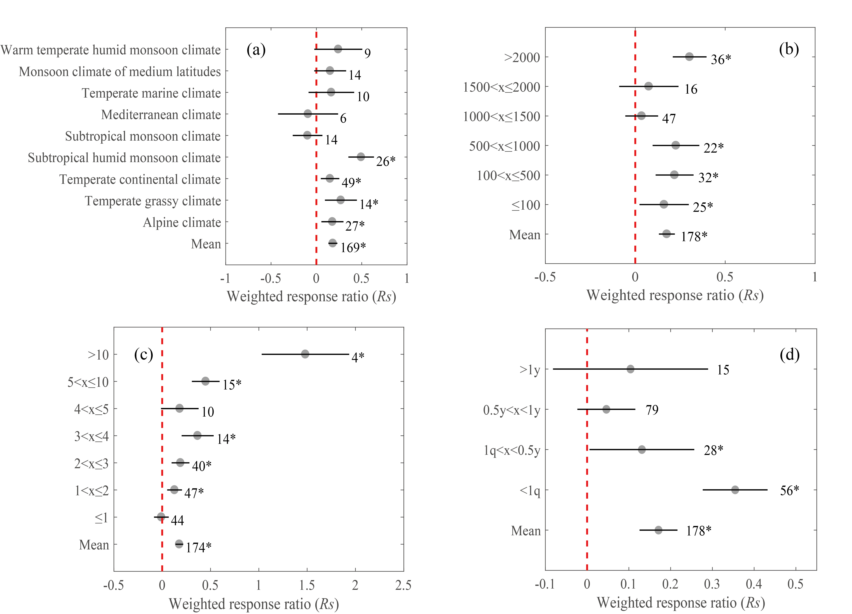

Figure S2 Weighted response ratios (RR₊₊) of Rs to precipitation treatments in individual sub-groups (climates (a), elevations (b), temperatures (c) and DUR (d)) and in all sub-groups (mean). Error bars indicate 95% confidence intervals (CI), sample size for each variable is shown next to the configuration term, the * symbol indicates statistical significance (P<0.05)

Figure S3 Relationships of the response ratio of Rs with MAT for temperature treatments.

Figure S4 Relationships of the response ratio of Rs with change of precipitation, where the red dots are representing decreasing precipitation and the black dots are representing increasing precipitation.

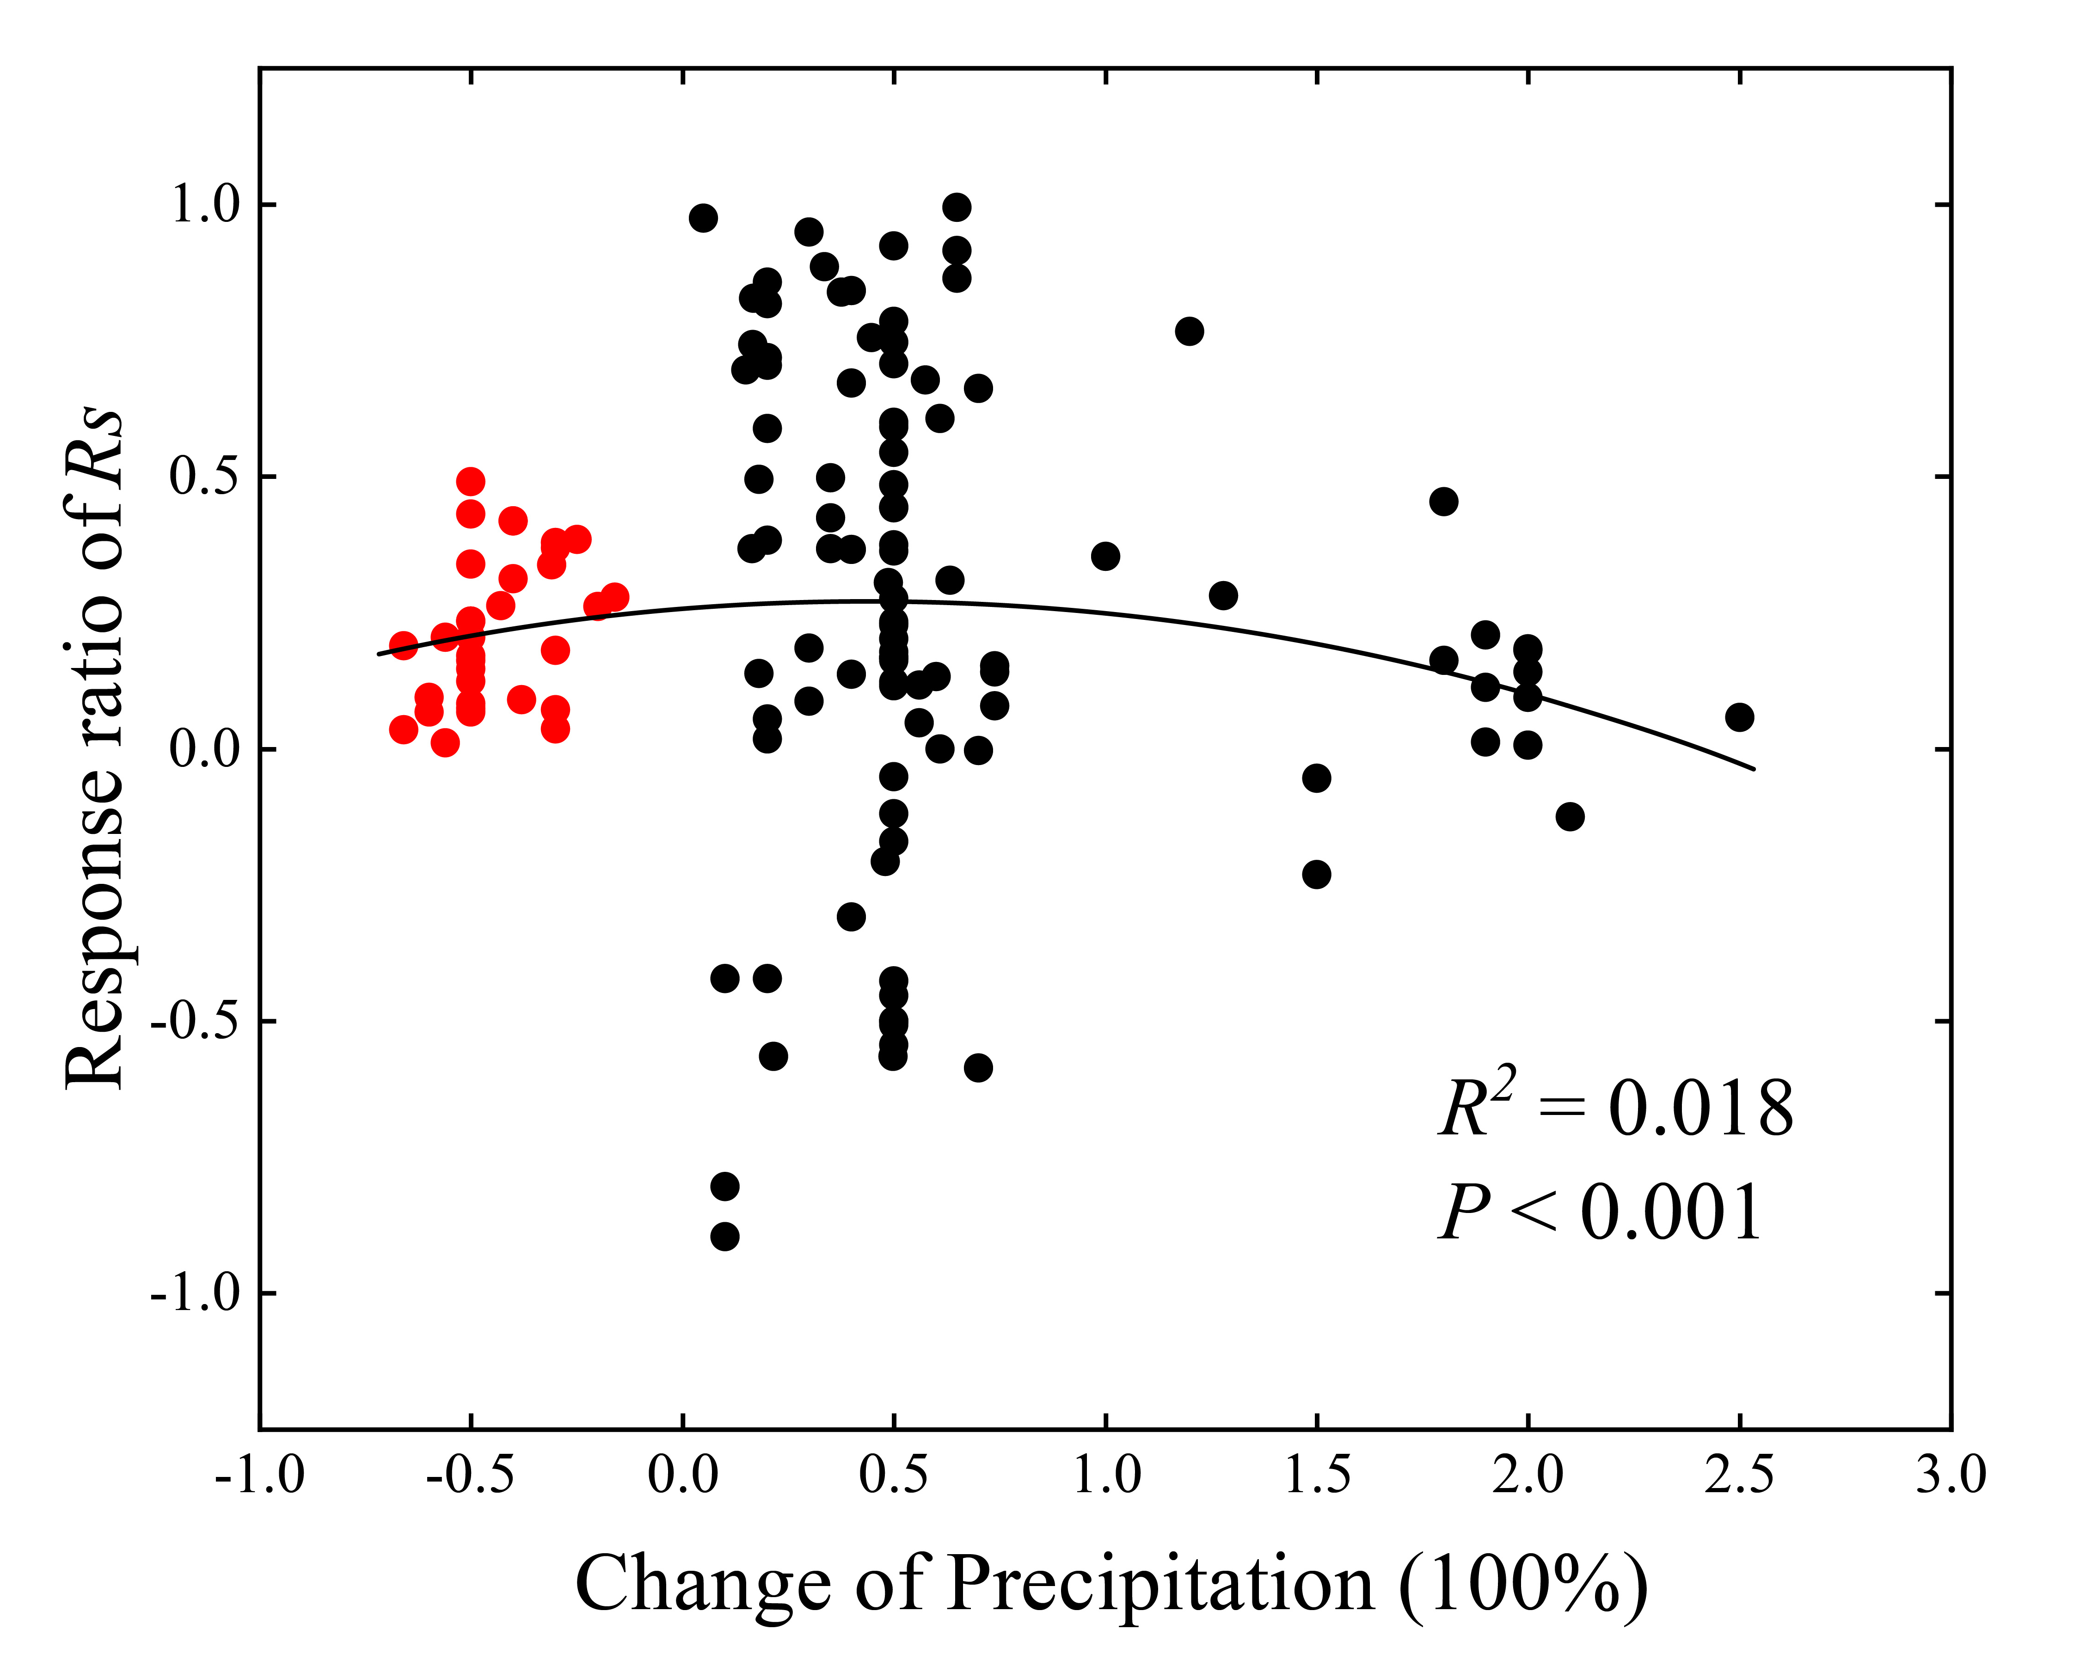
Figure S5 Principal component analysis (PCA) correlation analysis heat map. (a) Temperature treatments. (b) Precipitation treatments. Where darker colors represent strong correlations.

