Table 1. SWEDDIE warming experiments. MAT: mean annual temperature, MAP: mean annual precipitation, PET: potential evapotranspiration, USDA-NRCS: United States Department of Agriculture-Natural Resources Conservation Service.
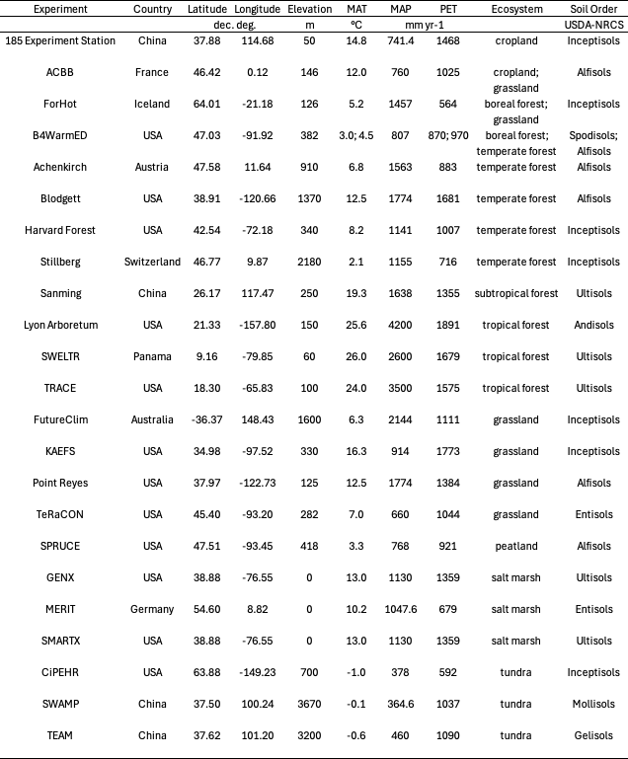
Figure 1. Map of SWEDDIE experiments
