Introduction
Ecosystem warming experiments offer key insights into the functioning of plants, microbes, and biogeochemical processes in a warmer world, but are limited by their ecological context, within site heterogeneity, and instrumentation. The Soil Warming Experiment to Depth Data Integration Effort (SWEDDIE) is a joint platform developed by the DeepSoil2100 network (23 warming experiments worldwide) to overcome these limitations through the creation of a network-wide database.
The SWEDDIE database is designed with FAIR (Free Accessible Interoperable Reuseable) principles to accommodate a wide range of data types, with a streamlined data ingestion system and user-friendly query and reporting tools. Comprehensive metadata reporting standards enable SWEDDIE to serve as a repository for past, present, and future datasets. Harmonization of data is facilitated with data dictionary files that accompany and describe variables in each data file and also store sensor and methods information. SWEDDIE consists of both publicly accessible and network-only data tiers, and is hosted on ESS-DIVE (link) to leverage existing data repository infrastructure. Data ingestion, wrangling, and synthesis tools for SWEDDIE are also available in a companion R package.
A key tenet of SWEDDIE is the inclusion of soil measurements below 0.2 m, as the warming response of C stocks in deeper soil layers remains both highly uncertain and consequential for the global C cycle. Accordingly, we welcome new sites and data submissions, provided that > 1 °C warming has been observed below this depth. We present here the first synthesis analysis with SWEDDIE focused on the impact of warming on soil moisture, while also serving to test the SWEDDIE data model and refine the harmonization approach. The results of this analysis provide quantitative evidence that warming leads to decreased soil moisture throughout the soil profile, but with more drying in surficial compared to deeper soil layers. The degree of warming correlates with the magnitude of soil drying, but the specific relationship between warming and drying varies by site and seasonally.
SWEDDIE is at its core a community project. The results of the preliminary soil moisture analysis are a key building block of one of the next planned synthesis efforts: using selected experiments to benchmark soil C warming responses with the ecosys model. This demonstrates the positive feedback inherent to this platform, i.e., that active community engagement leads to improved data coverage, which in turn enhances the capacity to generalize warming responses across ecological gradients, inform site- to global-scale models, and quantify potential experimental biases.

Methods

Scope and experiment criteria
The DeepSoil 2100 project was initiated with a particular emphasis on deep soil warming, thus the majority of sites in SWEDDIE are those with active heating throughout the soil profile, e.g., to at least 1 m depth. However, SWEDDIE also includes sites with active above ground heating with at least a X C change in soil temperature between control and heated plots observed at 20 cm or deeper. We did not include experiments that used passive open top chamber methods, primarily because those methods do not heat the soil beyond the top 10 cm or so, and the magnitude of heating reported in the literature is inconsistent and variable. The majority of sites in SWEDDIE are still operational, but this is not a requirement for inclusion. We welcome data from any site with > 1 y of ≥ 1 °C warming, provided observed data are available for at least 0 to 0.3 m of depth.

Individual ecosystem warming experiments are the fundamental unit of organization of SWEDDIE, meaning that all data in the database, i.e., each entry, is associated with a unique experiment. The database was designed to be flexible enough to include any type of data, including fluxes, soil properties, vegetation characteristics, microbial genomics, etc. This flexibility is achieved via a unique hybrid data model defined by a combination of fixed format (template-based) tables and open format data tables.

Data model
The database consists of three fixed format “core” data tables, which describe the experimental infrastructure (“experiment”), site characteristics (“site”), and the experimental design (“plot”), along with an unlimited number of open format measurement data tables (“dat”), one for each unique measured variable at each site. Currently all tables are in .csv format, and although this is not a requirement, the R tools built to facilitate data ingestion rely on .csv input. These tools can be adapted as needed if other file formats are employed in the future.

Experiment
The experiment table provides information about the physical infrastructure installed in each experiment. This includes the method of warming (infrared, cables, rods, open topped chambers, etc.), sensors installed, data types collected, beginning and end dates of warming, as well as additional treatments imposed (elevated CO2, precipitation manipulation, nutrient additions, etc.). The “exp_name” variable provides the key linkage between this and other core tables.

Site
The site table provides information about the climate, soils, and vegetation for each experiment. Experiments may have one or more sites, each of which is uniquely defined by the combination of the “exp_name” and “sit_name” variables.

Plot
The plot table defines the experimental design, and each record (row) of this table is defined by a unique combination of the “exp_name”, “sit_name”, and “plt_name” variables. The plot table serves to link imposed treatments with measured data, and therefore the values for “plt_name” in all dat tables must match with those recorded in the plot table. In order to accommodate the diversity of experimental design choices across the network as well as reflect the naming conventions employed within individual experiments, this table contains additional columns for blocks and sub-blocks as applicable. Imposed heating is encoded in the plt_heat_level variable, defined as the difference, in °C, from the control. Additional treatments are encored in the variables plt_treat_add_name, plt_treat_add_level, and plt_treat_add_units, which define the treatment name (e.g., “elevated CO2”, “precipitation”, etc.), treatment level, and units respectively. Plots with multiple treatments are accommodated through semi-colon separated lists. For example, a plot with elevated CO2 at 100 ppm above ambient and 50 percent reduced precipitation, the values in the plt_treat_add_name column would be “elevated CO2; reduced precipitation”, the values in the plt_treat_add_level column would be “100; 50”, and the values in the plt_treat_add_level column would be “100; 50”, and the values in the plt_treat_add_units column would be “ppm above ambient; percent of ambient”.

Data
Data observation (dat) tables are designed to be as simple as possible to facilitate harmonization and avoid confusion or duplication with variable names. Each table must contain a minimum of three identification columns: the unique plot identifier (‘plt_name’), which must be an exact match with one of the plt_name values in the plot table, a timestamp column, and a data column. Depth-resolved data should contain an additional column for the depth at which the observation was made, or paired upper and lower depth columns for measurements made over a depth interval. Additional columns in the input data table are ignored and dropped during ingestion.

Data dictionaries
Each data file must be accompanied by a data dictionary file. The data dictionary file has the same number of rows as columns in the data file, with the first column containing the data file column names and subsequent columns providing further information including: a short text description, data type (i.e., numeric, string, etc.), semi-controlled variable name, units, method information, sensor make and model, and any notes relevant for data interpretation. The variable name is semi-controlled in the sense that users will be prompted with a list of previously used variable names during ingest in order to facilitate harmonization with already ingested data (see “Scripted data ingestion” below). A template for the data dictionary file is provided in the supplemental information along with a guide to assist with filling it out.

File level metadata
Each experiment must have an additional ‘file level metadata’ file (FLMD). The FLMD provides information about the data source, date range covered, missing value codes, target variable, versioning, and UTC offset for each dat table. The design of this table is based on the guidelines provided by ESS-DIVE.

Scripted data ingestion
Data entry is a major challenge in database construction. The rationale for dispensing with template based data entry, controlled vocabulary, and minimizing required columns in data files was to simplify the submission process for data providers. However, this approach does require the creation of the separate data dictionary and file level metadata files. We sought to automate this process as much as possible through the use of helper scripts that create these files and populate the fields via interactive console prompts. Currently these scripts are written in the R programming language and can be accessed by installing and loading the SWEDDIE R package from the project Github site. The primary function of these scripts is to identify the name of the target variables and split the input data table as necessary so as to yield a separate table for each target variable. During this process the names of the other identification variables in each dat table are also harmonized to match standard names.

Case-study: Quantifying soil warming
All data in SWEDDIE comes from a unique warming experiment and these experiments employ various methods to achieve soil warming. Belowground warming methods include buried resistance cables or rods, while aboveground warming methods are more various and include infrared heaters (IR), forced air heating, open topped chambers (OTC), and manipulation of soil insulation in winter via snow removal/addition. The majority of experiments employ belowground heating, some utilize both above and belowground heating, and a few heat aboveground only.

We characterized the mean realized soil warming over depth and time associated with different warming methods and as a function of environmental variables such as mean annual air temperature, mean annual precipitation, and ecosystem type in order to assess potential method or site biases. First we averaged soil temperature by depth for each treatment (warmed or control) at each time step. Next we calculated the difference between the mean soil temperature of the warmed plots and control plots to yield a measure of realized warming by depth over time. We calculated means, variance, and differences for each level of warming for experiments with more than one warming level.

The duration of warming imposed throughout the year varied across the experiments. The majority of experiments warm year round, but several only heat during the growing season, or in the case of the arctic tundra experiment CiPEHR, warming (snow insulation) is imposed during the winter. We only considered data from the periods when the heating was active in our analyses, a distinction which also removes data from periods when the heating system is malfunctioning.

Many of the experiments in SWEDDIE impose additional treatments beyond warming, such as elevated CO2, modified precipitation, canopy cover, vegetation clipping, or N addition. We did not consider data from these additional treatments in the analyses presented here as many of these treatments were unique to a single experiment.

Case-study: Is warming drying?
Soil moisture is a critical variable influencing both vegetation and the soil microbiome. Quantifying the relationship between warming and soil moisture is therefore essential for interpreting the effects of warming on ecosystem function. Following the same approach as with soil temperature, we determined the difference between soil moisture in warmed and control plots over time and with depth for each experiment in SWEDDIE.

additional data: growing season

Additional analysis: growing season vs. non difference, time series, linear mixed models

Results

Site characteristics
The experiments in SWEDDIE cover a wide range of mean annual temperatures (MAT), mean annual precipitation (MAP), and biomes (Fig. 1; Fig. 2). The best represented ecosystems in SWEDDIE are temperate grasslands (n = 5) and forests (n = 4), followed by temperate salt marsh, tropical forest, and tundra (n = 3 each), then croplands and boreal forest (n = 2 each), and a single peatland ecosystem (n = 1).

Fig. 1 Map of SWEDDIE warming experiment locations. Red points are experiment sites; color shading shows 0-0.1 m soil soil organic C stocks (kg m⁻²). SOC stocks obtained from Soil Grids.
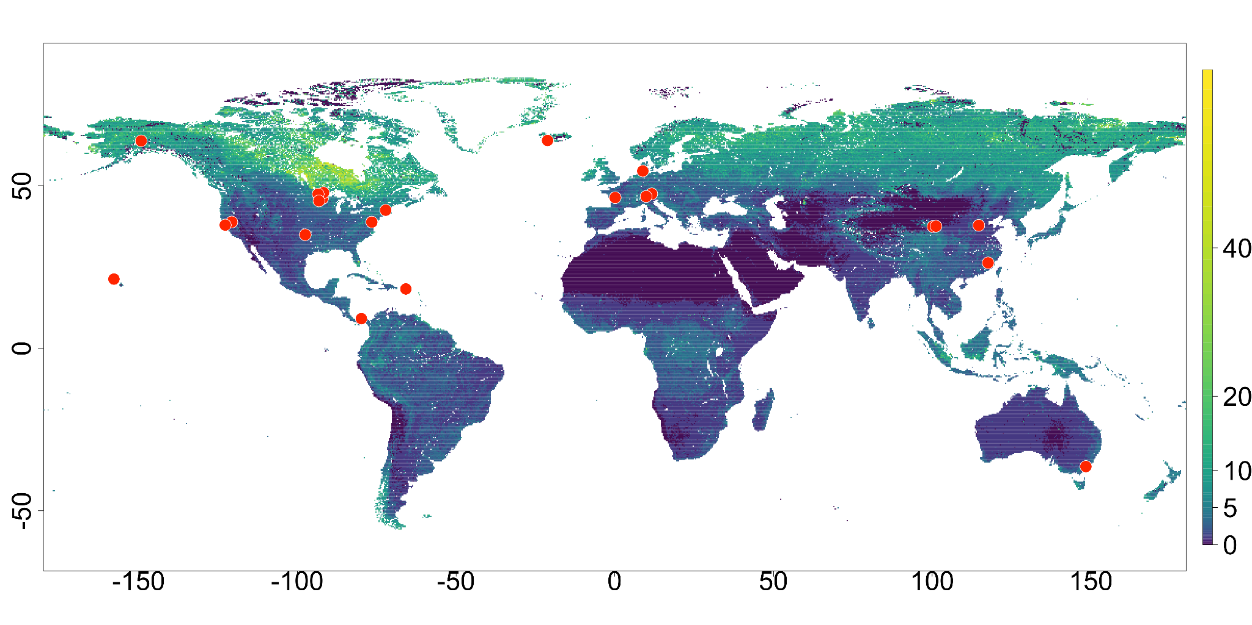The majority of experiments undergo year-round heating, but a few of the colder climate sites are only heated during the growing season (Achenkirch, B4WarmED, FutureClim, Stilberg, SWAMP, TeRaCON) or primarily in winter (CiPEHR). Belowground heating across the experiments is accomplished via buried resistance cables or resistance rods. Resistance rods are typically employed to accomplish deep soil heating, while resistance cables are used to improve uniformity of heating at the soil surface. The ForHot experiment is unique in that increased soil temperatures are achieved via lateral heat transfer from naturally geothermally heated groundwater. Aboveground heating methods are more variable, with infrared heaters being the most commonly used approach. A few experiments deploy open topped chambers for seasonal heating, while two experiments have unique aboveground heating methods: SPRUCE (forced air), and CiPEHR (snow). While a handful of experiments heat both above and belowground, the majority utilize either above or belowground methods.

Fig. 2 Distribution of mean annual temperature, precipitation, and ecosystem type across SWEDDIE experiments. MAT = mean annual temperature (° C), MAP = mean annual precipitation (mm y⁻¹).
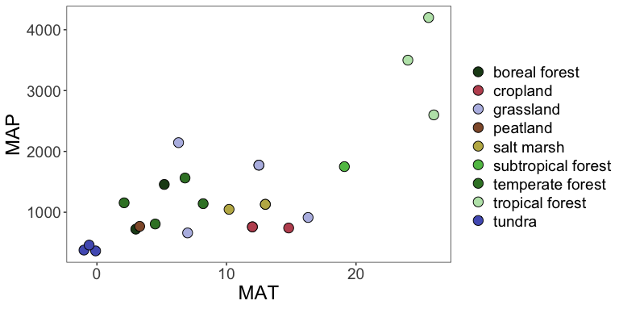

The mean heating duration across all sites was 11.4 y (median = 8.8 y), with the Harvard Forest experiment standing out as having the longest known heating duration (34 y). The ForHot experiment has a site that has been warming for > 60 y, but as the heating is from a natural source, the exact date on which warming began is unknown.

Quantifying soil warming
Target soil warming ranged from +1 °C to +9 °C across all sites for which we had soil warming data. However, realized warming diverged from the target warming temperature over time and with depth at all sites. Warming patterns with depth were largely driven by heating methods. At sites with only aboveground warming, target warming temperatures were reached near the soil surface, but warming attenuated with depth. In contrast, sites with belowground warming methods only tended to have cooler surface soil layers relative to deeper in the profile.

Fig. 3 Depth profiles of soil temperature
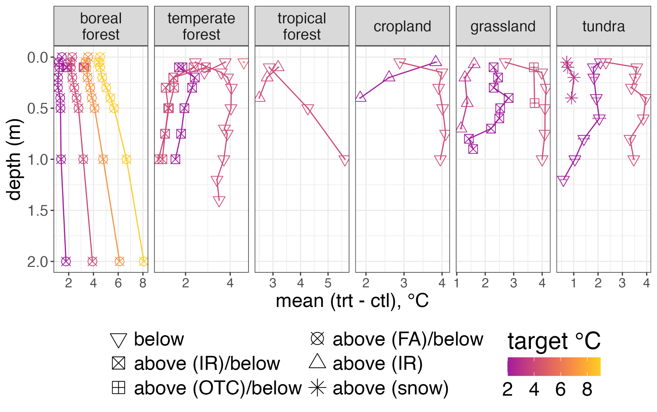

Warming impacts on soil moisture
Warming led to drier soils on average when considered across all sites, and observed soil drying was positively correlated with degrees of warming at those sites where warming led to drying. The drying effect varied by ecosystem, with forest soils tending to dry more per degree of warming than non-forest soils. The sites for which we either did not observe drying with warming or observed increased soil moisture with warming were all non-forest soils in cold climates (CiPEHR, SWAMP, TEAM, FutureClim, TeRaCON). Notably, the only non-tundra site with a pronounced wetting effect (FutureClim) employed open topped chambers (OTC) as the above ground heating method. The tundra sites (CiPEHR, SWAMP, and TEAM) showed the strongest wetting effect. This is consistent with previous studies demonstrating that winter warming in permafrost soils leads to deepening of the active layer, resulting in wetter soils upon spring thaw.
In general, the effect of warming on soil moisture at sites with year-round heating was similar to that for which warming was active for only part of the year. However, the two grassland sites that were warmed all year long (KAEFS, ACBB) exhibited a clear drying effect of warming, while the two that were only warmed for part of the year exhibited either no effect (TeRaCON) or an opposite wetting effect from warming (FutureClim).
Fig. 4 Warming effect on soil moisture. Points show mean, averaged across all depths, error bars show 95% confidence interval. Data are ordered by target degrees of warming. VWC: volumetric water content; “all year” and “partial” refer to the duration of warming on an annual basis.
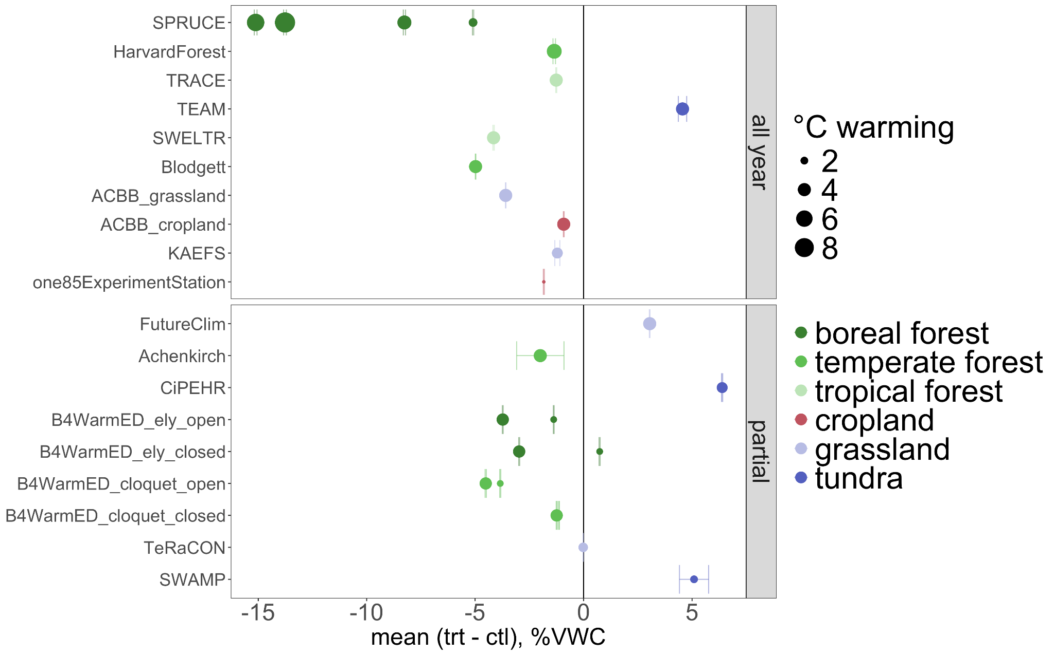
The method of warming was not a strong predictor of soil drying at the profile level, with both aboveground and belowground methods tending to lead to drying in both near surface and deeper soil layers. However, soils warmed with belowground heating systems extending > 1 m consistently showed more drying in subsurface layers than soils warmed only via aboveground methods. Site-specific relationships suggest an influence of both warming method and ecosystem type on depth profiles of soil moisture change with warming. For example, the surface soil layer at the tropical moist forest site, TRACE, exhibited slight (+1% VWC) wetting with warming, while drying with warming was observed below 10 cm. Note that this site was only warmed via aboveground IR heaters. In contrast, the SPRUCE site, which was the only one with forced air as an aboveground warming method, showed a dramatic increase in drying at the upper depth (8 cm) compared to the lower depth (20 cm). Both the cropland and grassland sites at the temperate climate ACBB experiment (belowground warming only) exhibited wetting or no effect of warming on soil moisture at depth, but consistent drying in the surface soil layers. We only had depth resolved soil moisture data at one temperate forest site (Blodgett), and here we observed strong drying at the surface, little effect at 50 cm, and then drying again at the 80 cm. We observed similar soil moisture differences with depth at both tundra sites with depth resolved data (SWAMP, TEAM): an increase in wetting with depth initially, but drying below 50 cm.

Fig. 5 Warming effect on soil moisture by depth. Points show means, error bars show 95% confidence intervals. Point size corresponds to target degrees of warming. VWC: volumetric water content.
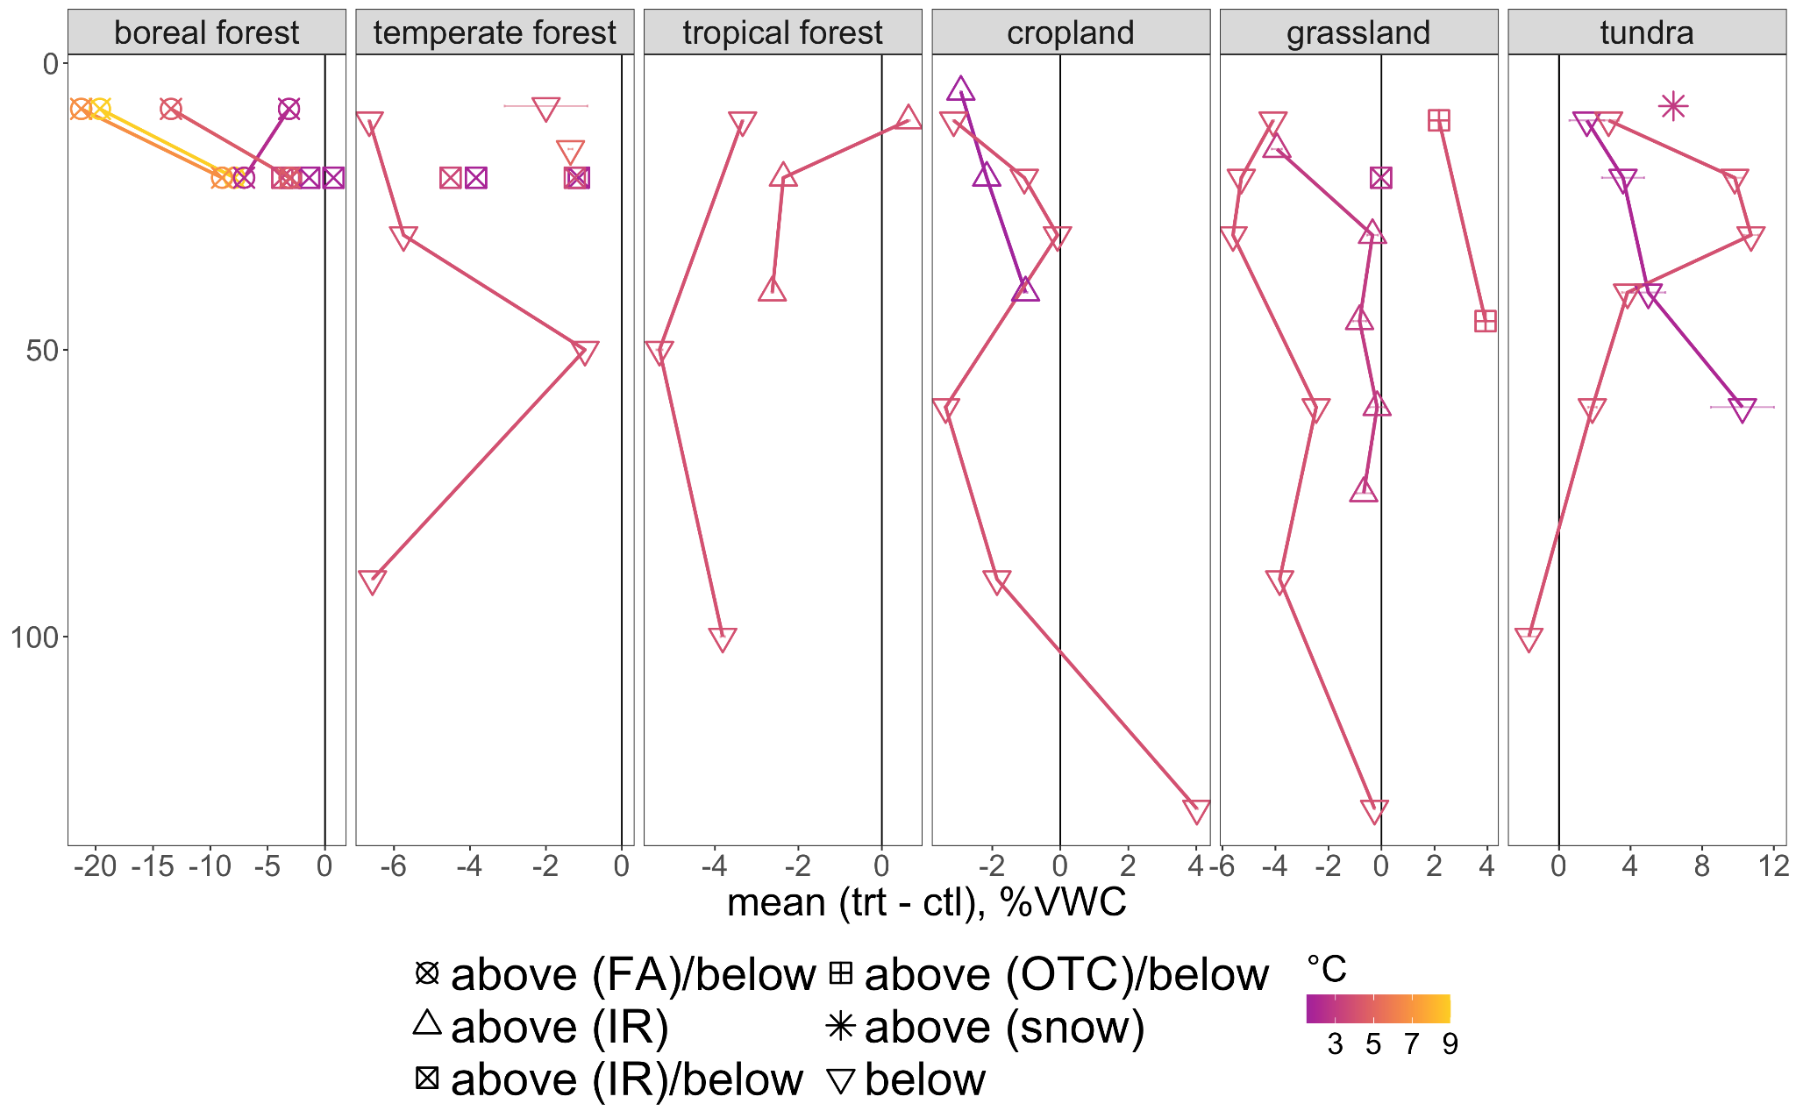
Soil moisture differences between warmed and control plots also varied between the growing season and non-growing season (SI). The drying effect was slightly enhanced during the non-growing season at the boreal forest sites, while the wetting effect at the tundra sites was enhanced during the non-growing season. The tundra sites showed the most variation in soil moisture differences with depth between the growing season and non-growing season, with increased wetting observed throughout the soil profile during the non-growing season at the TEAM site, while the opposite was observed at the SWAMP site, i.e., increased wetting during the growing season, particularly at depth. The grassland sites tended to show more drying with warming during the non-growing season, but the growing season effect was least notable in this ecosystem.
The number of years of warming did not have a notable impact on observed soil moisture differences between warmed and control plots. Anecdotally, the grassland site with the longest warming duration (13 y, TeRaCON) exhibited a transient drying effect with warming during the first three years of the experiment (cite), after which soil moisture did not significantly differ between warmed and control plots for the following ten years. However, sustained soil drying with warming was observed at the Harvard Forest site, which had the longest overall warming duration (34 y).

