Title suggestions:

Integrating across DeepSoil 2100 sites quantifies the mean and range of soil moisture responses to soil warming while providing a road map for community collaboration

Soil warming across 26 diverse ecosystems supports hypothesized soil moisture responses

Getting SWEDDIE: Structure and first results of the Soil Warming Experiment to Depth Data Integration Effort

Structure and first results of the global Soil Warming Experiment to Depth Data Integration Effort - SWEDDIE

Abstract

Introduction
Warming experiments offer insights into the functioning of ecosystems in a warmer world. Individually, warming experiments inform understanding about the specific ecosystem in which they are situated, but considered in a synthesis context these experiments have the potential to reveal underlying general principles of ecosystem warming responses. Such a synthesis effort also facilitates quantification of potential bias from differences in methodology and instrumentation across experiments. Here we introduce the Soil Warming Experiment to Depth Data Integration Effort (SWEDDIE), which is a database developed by the DeepSoil2100 network (currently 23 warming experiments worldwide) to realize these potentials.
Coauthors add bullets with citations here! Soils are very important for ecosystem function and fertility, and it is important to know about the impact of warming on…
Nutrient cycling, microbes, roots,
Warming affects terrestrial ecosystems in many ways, affecting the growth and biodiversity of different groups of organisms, nutrient cycling and biogeochemical processes and thus the carbon sink potential of terrestrial ecosystems, as well as food security and many other ecosystem processes and services (references……). Terrestrial ecosystems absorb approximately 15% of atmospheric carbon (130 Pg) on an annual basis, the majority of which is then respired back to the atmosphere (Ruehr et al., 2023). An estimated 2.5% of this absorbed carbon (3.2 Pg) is retained in vegetation and soils, which is collectively termed the land sink (Friedlingsten et al., 2024). The fate of the land sink is uncertain, however, as ongoing warming is expected to increase soil carbon decomposition rates over time, while a combination of warming and increasing atmospheric CO₂ concentrations could accelerate plant growth (references….) and increase carbon inputs into soils (Crowther et al., 2016; Todd-Brown et al., 2018). However, there is still great uncertainty as to how soils will react to climate change; the reaction of the subsoil in particular is largely unclear.
Subsoils (i.e., below 0.3 m) store X carbon (Jackson et al., 2017) and deep soil BGC responds to warming ( Hicks Pries et al., 2023) remain underrepresented relative to topsoil, despite clear evidence that deep carbon pools can respond strongly to warming (Hicks Pries et al., 2017; Jia et al., 2019; Soong et al., 2020; McGrath et al., 2022). Despite recent advances, multiple knowledge gaps and contradictions persist. Tropical soils, once thought to be relatively insensitive to warming (Koven et al., 2017), have shown unexpectedly large CO₂ emissions under experimental warming (Nottingham et al., 2020; Carter et al., 2020). Similarly, contradictory findings about microbial acclimation, stabilization of soil organic matter, and the role of soil moisture underscore the need to conduct comparative analyses across ecosystems and experiments to improve quantification of warming-induced thresholds (Carter et al., 2020; Tang et al., 2023; McFarlane et al., 2024). Moreover, the physical limitations of many warming methods (e.g., depth of heat penetration, effects on vapor pressure deficit) may introduce systematic biases which can only be resolved via cross-site synthesis.

. These uncertainties underscore the value of a harmonized, multi-site database to resolve the mechanisms underlying warming impacts on soils across ecosystems.
The promise of “big data” is that scientists can leverage the hard work of the past to reveal new insights into ecological processes and mechanisms via synthesis. Yet integrating data across projects, over time, and among research groups creates distinct challenges in the form of communication, data availability, metadata reliability, variation in technical standards (data formats, methodology), transcription of raw data, harmonization, quality control/quality assurance, and cultural expectations and behaviors (Todd-Brown et al., 2022).
Soil databases have proliferated over the past decade and range in scope from soil carbon focused such as ISCN (Nave et al., 2017), measurement focused, such as ISRaD for soil radiocarbon data (Lawrence et al., 2020), COSORE for soil CO₂ fluxes (Bond-Lamberty et al., 2020), SIDb for soil incubation time series studies (Schaedel et al., 2021), or network focused, such as SoDaH (Wieder et al., 2020). There is not a one-size-fits-all solution to soil database creation; each database must respond to the needs of the user community and have a defined scope to determine which datasets are appropriate for inclusion or not. However, regardless of the scope, a challenge common to all databases is the data pipeline. Todd-Brown and others (2022) summarize this as the following sequence of steps: “discovery, acquisition, input and harmonization, curation, gap-filling and pruning, and publication”. The approach to the data pipeline varies across these databases, but overlap in authorship, technological advances and knowhow, as well as active community engagement has led to improvements in performance and utility of these resources over time (Malholtra et al., 2019; Todd-Brown et al., 2022).
A key tenet of modern databases is that data should be FAIR, i.e., Findable, Accessible, Interoperable, and Reusable (Wilkinson et al., 2016). This does not mean all data must be freely accessible to all who wish to use it, but that good data management is essential both for achieving reproducibility in science and building on past work effectively. In other words, it is critical to know how, who, when, and where the data were collected. The development of metadata standards to capture this information is an important first step in ensuring the “FAIRness” of a database.

Earlier database efforts tended to rely on highly structured templates explicitly defining allowable variables, data types, ranges, and names. However, these templates create a barrier to data ingestion given the amount of time needed to translate raw data into the template format. Template-based approaches are also more error prone, requiring human transcription or custom scripts to accomplish the necessary translation of data into the required format (Todd-Brown et al., 2022). While the final output may be highly curated, the template-based approach is also relatively rigid, requiring a priori definitions of allowable variables and data categorization.
Keyed translation is an alternative to the template-based approach that reduces the potential for transcription based errors and preserves traceability of data transformations. This approach relies on a data dictionary to map input data with varying names and definitions onto a target set of names and definitions. This approach is both computationally expensive and requires a certain level of technical knowledge to code the translation scripts. However, in the context of a project like SWEDDIE, in which all data is derived from warming experiments, common elements such as degrees of imposed warming, experimental design, and temporal dynamics provide a common framework for the keyed translation approach.
Flexibility is another hallmark of the keyed translation approach. The ability to add datasets with new variables can be challenging with a template-based approach, but trivial with keyed translation. A drawback of this flexibility is that data curation becomes more challenging in the absence of rigidly defined variables, data types, or data ranges. One solution to this problem is to employ a hybrid approach in which template based data entry is used for relatively static data, such as experimental design, infrastructure, or site characteristics, and a keyed translation approach for observational data.
In this paper we introduce the SWEDDIE database and use it to address a question critical to both warming experiments and the real world: how generalizable or predictable are changes in soil moisture with depth due both to direct effects of warming (including modification of soil moisture and VPD) on evaporation and transpiration and indirect effects through changes in vegetation composition and abundance.

We describe the scope of the SWEDDIE database and criteria for inclusion of current and future warming experiments in the methods section, the pipeline for ingesting data, as well as the process for querying the database and retrieving customized subsets of data, termed reports. The methods section also details the steps taken to quantify warming across the experiments and the analysis of warming impacts on soil moisture. The methods section is followed by the results of the soil temperature and moisture analysis; and associated interpretation and implications. We then discuss the implications of the soil temperature and moisture analysis in the context of future synthesis work with SWEDDIE, and what the next steps should be to improve the utility and usability of the database.
The overall goal of this work is two-fold; to simultaneously create a baseline for comparison across a global network of warming experiments and address a critical climate change knowledge gap by quantifying changes in soil moisture due to warming, as well as seasonal patterns of warming and soil moisture as a function of soil depth, warming methodology, ecosystem, and site specific climate conditions. This analysis of warming efficacy and soil moisture responses to warming serves to stress test the SWEDDIE data model and address key hypotheses; and provides a worked example of the potential benefits and challenges of synthesizing experimental soil warming data. With regard to how soil warming affects soil moisture we hypothesized that ……

Methods

Scope and experiment criteria
The SWEDDIE database currently builds on data gathered within the DeepSoil 2100 network. The DeepSoil 2100 network was initiated with an emphasis on deep soil warming, defined as a mean change in temperature ≥ +1 °C, measured at a depth ≥ 0.3 m over ≥ 1 y. Thus most of the experiments in SWEDDIE are those with active heating throughout the soil profile, e.g., to at least 1 m depth. However, SWEDDIE also includes sites with shallower soil and active above-ground warming experiments at which at least a +1 °C difference in soil temperature between control and heated plots is achieved at 0.2 m or deeper. We excluded experiments that used only passive open top chamber methods for soil warming, primarily because those methods do not warm the soil beyond ca. the top 0.1 m, and the magnitude of warming reported in the literature is inconsistent and variable (citations?Hollister et al. 2023).

The majority of sites in SWEDDIE are still operational, but this is not a requirement for inclusion. We welcome data from any site with > 1 y of ≥ 1 °C warming, provided observed data are available for at least 0 to 0.3 m of depth. Note that severalf experiments currently in the DeepSoil2100 network do not meet all of these criteria, but have been included on a case-by-case basis due to under-representation of the studied ecosystem or long experimental duration.

SWEDDIE consists of both publicly accessible and network-only data tiers. This approach is designed to maximize community engagement by lowering the barriers to data sharing within the network for work in progress, while promoting open data sharing for published datasets. SWEDDIE is hosted on ESS-DIVE (link) to leverage existing data repository infrastructure. Data ingestion, manipulation tools, and both querying and reporting functionality for SWEDDIE are available in a companion R package. However, these can be expanded to other coding languages or software environments in the future pending community interest and engagement.

Data model
Individual ecosystem warming experiments are the fundamental unit of organization in SWEDDIE, meaning that all data in the database, i.e., each “entry”, is associated with a unique experiment. The database was designed to be flexible enough to incorporate any type of data such as fluxes, soil properties, vegetation characteristics, sequencing data, etc. This flexibility is achieved via a unique hybrid data model defined by a combination of fixed format (template-based) tables and open format data tables.
The database consists of three fixed format “core” data tables, which describe the experimental infrastructure (experiment), site characteristics (site), and experimental design (plot), along with an unlimited number of open format measurement data tables (dat), one for each unique measured variable at each experiment. At present all tables are in .csv format. The R tools built to facilitate data ingestion currently rely on .csv input, but this is a convention, not a requirement. The tools can be adapted as needed if other file formats are employed in the future, provided the file formats are non-proprietary in accordance with FAIR principles (cite).

Experiment
The experiment table provides information about the physical infrastructure installed in each experiment. This includes the method of warming (infrared, cables, rods, open topped chambers, etc.), sensors installed, data types collected, beginning and end dates of warming, and additional treatments imposed (elevated CO₂, precipitation manipulation, nutrient additions, etc.). The ‘exp_name’ variable provides the key linkage between this and other core tables.

Site
The site table provides information about the climate, soils, and vegetation for each experiment. Experiments may have one or more sites, each of which is uniquely defined by the combination of the ‘exp_name’ and ‘sit_name’ variables.

Plot
The plot table defines the experimental design, and each record (row) of this table is defined by a unique combination of the ‘exp_name’, ‘sit_name’, and ‘plt_name’ variables. The plot table serves to link imposed treatments with measured data,. therefore the values for ‘plt_name’ in all dat tables must match with those recorded in the plot table. In order to accommodate the diversity of experimental design choices across the network, as well as reflect the naming conventions employed within individual experiments, this table contains additional columns for blocks and sub-blocks as applicable. Imposed heating is encoded in the ‘plt_heat_level’ variable, defined as the difference (in °C) from the control. Additional treatments are encoded in the variables ‘plt_treat_add_name’, ‘plt_treat_add_level’, and ‘plt_treat_add_units’, which define the treatment name, treatment level, and units respectively. Plots with multiple treatments are accommodated through semi-colon separated lists. Ex., for a plot with elevated CO₂ at 100 ppm above ambient and 50 percent reduced precipitation, the values in the ‘plt_treat_add_name’ column would be “elevated CO2; reduced precipitation”, the values in the ‘plt_treat_add_level’ column would be “100; 50”, and the values in the ‘plt_treat_add_units’ column would be “ppm above ambient; percent of ambient”.

Data
Data observation (dat) tables are designed to be as simple as possible to facilitate harmonization and avoid confusion or duplication with variable names. Each table must contain a minimum of three identification columns: the unique plot identifier (‘plt_name’), which must be an exact match with one of the ‘plt_name’ values in the plot table, a timestamp column, and a data column. Depth-resolved data should contain an additional column for the depth at which the observation was made, or paired upper and lower depth columns for measurements made over a depth interval. Additional columns in the input data table are ignored and dropped during ingestion.

Data dictionaries
Each dat file must be accompanied by a data dictionary file. The data dictionary file has the same number of rows as columns in the dat file, with the first column containing the data file column names and subsequent columns providing further information including: a short text description, data type (i.e., numeric, string, etc.), semi-controlled variable name, units, method information, sensor make and model, and any notes relevant for data interpretation. The variable name is semi-controlled in the sense that users will be prompted with a list of previously used variable names during ingestion in order to facilitate harmonization with already ingested data (see “Scripted data ingestion” below). A template for the data dictionary file is provided in the supplemental information along with a guide to assist in filling it out.

File level metadata
Each experiment must have an additional file level metadata file (FLMD). The FLMD provides information about the data source, date range covered, missing value codes, target variable, versioning, and UTC offset for each dat table. The design of this table is based on the guidelines provided by ESS-DIVE (citation? description?).

Scripted data ingestion
Data entry is a major challenge in database construction. The rationale for dispensing with template based data entry, controlled vocabulary, and minimizing required columns in data files was to simplify the submission process for data providers. However, this approach does require the creation of the separate data dictionary and file level metadata files. We sought to automate this process as much as possible through the use of helper scripts that create these files and populate the fields via interactive console prompts. Currently these scripts are written in the R programming language and can be accessed by installing and loading the SWEDDIE R package from the project Github site. The primary function of these scripts is to identify the name of the target variables and split the input data table as necessary so as to yield a separate table for each target variable. During this process the names of the other identification variables in each dat table are also harmonized to match standard names.

Queries and reports
Data is retrieved from SWEDDIE by creating a query that yields a custom report. The report can include all available data or a specific subset. The query specifies the desired target variables and optional filters for depth, temporal range, imposed treatments, site level characteristics, and experiments. This query tool is currently R based with a hierarchical R list object mirroring the data model (experiment level data linked to site level data linked to plot data linked to observed data) as the default output. This R list object can be further flattened and exported as a .csv file if desired.

Quantifying soil warming
We characterized the amount of warming achieved in each experiment as a function of depth by evaluating how the observed temperature difference (treatment - control, ∆T) compared to the target warming for each site and method. This observed-target difference, or residual warming (∆T_{r}), can inform the deployment of each warming method as achieving the true target may require setting the field controls to a higher target. Divergence between observed and target warming also demonstrates the importance of using observed soil temperatures rather than targets when performing analysis of warming impacts.

We first averaged soil temperature by depth for each experiment and treatment (warmed or control) at each time step; note that the frequency of observation varied across experimental sites. Next, we calculated the residual warming by subtracting the target degrees of warming from the time-resolved values of soil temperature to yield a measure of soil warming by depth over time. We calculated means, variance, and differences separately (i.e., for each level of warming) for those experiments with more than one level of warming.

The duration of warming imposed throughout the year varied across the experiments. We only considered data from the periods when the heating was active when quantifying warming. We also removed data from periods when the heating system is malfunctioning. While the majority of experiments undergo year-round heating, several of the colder climate sites are only heated during the growing season (Achenkirch, B4WarmED, FutureClim, Stilberg, SWAMP, TeRaCON) or primarily in winter (CiPEHR).

Many of the experiments in SWEDDIE imposed additional treatments beyond warming, such as elevated CO₂, modified precipitation, canopy cover, vegetation clipping, or nitrogen addition. While these treatments are recorded in the plot table and the data from these plots were ingested into the database, we used data for the warming treatment only in our analyses. The full range of treatments imposed in each experiment is detailed in Table 1.

Case-study: Is experimental warming drying the soil?
Soil moisture is a critical variable influencing both vegetation and the soil microbiome. Quantifying the relationship between warming and soil moisture is therefore essential for interpreting the effects of warming on ecosystem function. Following a similar approach as with soil temperature, we determined the difference between soil moisture in warmed and control plots over time and with depth for each experiment indicated in Table 1.

We compiled additional external data to assess whether soil moisture differences between warmed and ambient plots varied between the growing and non-growing seasons. We extracted start and end of growing season dates from a global satellite based canopy reflectance dataset using the geospatial coordinates of the experimental sites (European Commission Directorate-General Joint Research Centre. Land Surface Phenology Start-of-Season Date 2023-present (raster 300 m), global, yearly - version 1-. https://globalland.vito.be/geonetwork/srv/api/records/clms_global_lsp_sosd_300m_v1_yearly).

Bayesian generalized linear models
We applied a Bayesian generalized linear modeling approach to assess the potential relationship between observed soil moisture (∆M) and soil temperature differences (∆T) across the sites (Eq. 1). We applied a similar model for residual warming (∆T_{r}). We used site as a random variable in both models to account for repeated measurements at a given site over time. We also allowed the slope of the relationship between ∆M and ∆T to vary across sites in the soil moisture model. Further fixed effects in the models included depth, observed ambient soil moisture, observed ambient soil temperature, ecosystem, warming method, and growing season. Experiments in Table 1 utilized a diversity of warming methods, so we recategorized this factor to distinguish between above ground warming only, below ground warming only, or combined above and below ground warming.
For the soil moisture model, we included interaction effects between ∆T and ecosystem in order to test whether the effect of ∆T on ∆M varied among ecosystems, and between ∆T and ambient soil temperature and moisture in order to assess whether the effect of ∆T on ∆M could be mitigated or exacerbated by wet, dry, hot, or cold conditions. Similarly, for the residual warming model, we included the interaction between warming method and depth, warming method and degrees of target warming, and the three-way interaction of warming method, depth, and degrees of target warming.
All statistical analyses were performed in R (R Core Team, 2025). We performed a backwards stepwise approach to identify the best combination of predictor variables using Akaike’s Information Criterion (AIC). Terms that did not improve the model fit were dropped in subsequent model formulations. During this initial exploratory modeling, we used the R packages “lmer” (Bates et al., 2015) and “lmerTest” (Kuznetsova et al., 2017). After selection of the best performing model, we used the R package “brms” (Bürkner, 2021) for the Bayesian generalized modeling. [need notes about the Bayesian model specifications here].
Eq. 1 Linear mixed model formula
$y=Xβ+Zβ+ε$,
$ɛ\sim N\left(0,σ_{j}^{2}\right)$,
$log\left(σ_{j}\right)=γ_{0}+u_{j},u_{j}∼{N\left(0,τ^{2}\right)}_{}$
Where y is the response vector of length n, X is the design matrix for fixed effects with dimensions n x p, $β$ is the p length vector of fixed effect coefficients, Z is the matrix for random effects with dimensions n x q, Z is the variance-covariance matrix of the Gaussian normally distributed random effects.
We accounted for heteroskedasticity in the variance across sites by modeling the residual standard deviation 𝜎 as a log-linear random effect where 𝛾₀ is equal to the average residual standard deviation across all sites and u_{j} is the random deviation from 𝛾₀ at site j. We assumed u_{j} to be normally distributed around 0, with standard deviation of 𝜏².
Eq. 2 Soil moisture model random effects matrix for the ith observation at site, j
$Z =\left[{}_{⠇ }^{1}{}_{⠇}^{∆T_{1}} \right] , b_{j}∼N(0,Σ_{b}),$ $Σ_{b}=\left({}_{pσ_{b_{0}}{σb_{0}}_{1}}^{σ_{b_{0}}^{2}}{}_{σ_{b_{1}}^{2}}^{pσ_{b_{0}}{σb_{0}}_{1}}\right)$
Eq. 3 Residual warming model random effects matrix for the ith observation at site, j
$Z =\left[{}_{⠇ }^{1} \right] , b_{j}∼N\left(0,σ_{j}^{2}\right)$

Eq. 4 Fixed effects matrix for each observation i at site j in the soil moisture model
${∆M}_{ij}$ = $β_{0}+β_{T}⋅∆T_{i}+β_{CtlM}⋅{CtlM}_{i}+β_{CtlT}⋅{CtlT}_{i}+β_{depth}⋅D_{i}$
${+β}_{ctlMxT}⋅∆T_{i}⋅{CtlM}_{i}+β_{CtlTxT}⋅∆T_{i}⋅{CtlT}_{i}$
$+\sum_{e}{}β_{{eco}_{e}}⋅{eco}_{ie}+\sum_{g}{}β_{{growS}_{g}}⋅{growS}_{ig}$
$+\sum_{e}{}β_{{ecoxT}_{e}}⋅{∆T}_{i}⋅{eco}_{ie}$
Where ∆M is the difference in volumetric soil water (VWC) content, ∆T, CtlM, CtlT, and D are the ith observation of observed temperature difference (treatment - control), mean ambient soil temperature, mean ambient soil moisture, and depth, respectively; 𝛽 values are the corresponding model coefficients. The coefficients for the categorical variables of ecosystem (eco) and growing season (growS) are given as sums of the product of the coefficients and a dummy variable for each level e of eco (boreal forest, temperate forest, tropical forest, tundra, grassland, cropland) and g of growS (growing season/non-growing season). The coefficients for the interaction terms of CtlM by ∆T and CtlT by ∆T, are denoted with the subscripts ctlMxT and ctlTxT, while those for each level e of eco are denoted with the subscript ecoxT.
Eq. 5 Fixed effects matrix for each observation i at site j in the soil temperature model
${∆T}_{rij}$ = $β_{0}+β_{T}⋅T_{i}+β_{depth}⋅D_{i}$ + $β_{CtlM}⋅{CtlM}_{i}+β_{CtlT}⋅{CtlT}_{i}+\sum_{w}{}β_{{wrm}_{w}}⋅{wrm}_{iw}+$
$+\sum_{w}{}β_{{wrmxD}_{w}}⋅{wrm}_{iw}⋅D_{i}+\sum_{w}{}β_{{wrmxT}_{w}}⋅{wrm}_{iw}⋅T_{i}+\sum_{w}{}β_{{wrmxDT}_{w}}⋅{wrm}_{iw}⋅D_{i}⋅T_{i}$

Where the coefficient wrm is the warming method, and wrmxT, wrmxD, and wrmxDT are the interaction coefficients for warming method by ∆T, warming method by depth, and warming method by depth by ∆T, respectively.
A further challenge in assessing the potential impact of warming on soil moisture is that not all sites collected soil temperature and moisture data at the same depths or at the same temporal resolution. We addressed differences in the depth of measurement between these two variables by fitting a natural cubic spline function to soil temperature profiles with > 2 observations and predicting soil temperature at the depths of observed soil moisture data as needed. Spline fitting was performed in R, using the functions “spline” and “smooth.spline” from the ‘stats’ package (R Core Team, 2025). We did not predict soil moisture beyond the support of the temperature data, so soil moisture observations outside the range of measured soil temperature were dropped from the analysis; soil temperature observations outside the range of observed soil moisture were also dropped. We averaged all soil moisture and temperature data by plot and depth at a daily timestep prior to fitting the spline function. We also only kept observations of soil temperature and moisture made on the same day.

Results

Site characteristics
The experiments in SWEDDIE cover a wide range of biomes and climate regimes. (Fig. 1; Fig. 2). The most represented ecosystems in SWEDDIE are temperate grasslands (n = 5) and forests (n = 4), followed by temperate salt marsh, tropical forest, and tundra (n = 3 each), then croplands and boreal forest (n = 2 each), and a single peatland ecosystem (n = 1).

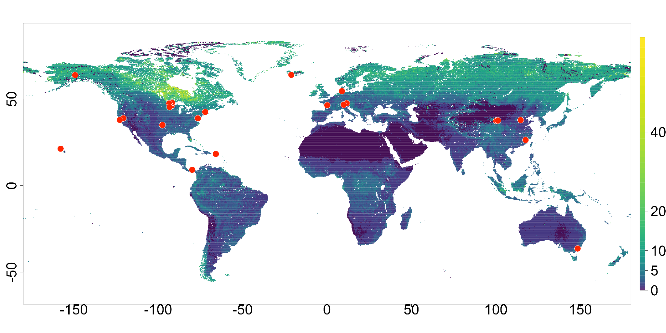
Fig. 1 Map of SWEDDIE warming experiment locations. Red points are experiment sites; color shading shows 0-0.1 m soil organic carbon stocks (kg m⁻²) obtained from SoilGrids250 (Poggio et al., 2021)).

Data in SWEDDIE come from 23 warming experiments employing a range of warming methods. Belowground warming methods include buried resistance cables or rods, while aboveground warming methods are more varied and include infrared heaters (IR), forced air heating, open topped chambers (OTC), and manipulation of soil insulation in winter via snow removal/addition. The majority of experiments employ belowground warming, while some utilize both above and belowground warming (n=x), and a few (n=y) heat aboveground only. Resistance rods are typically employed to accomplish deep soil warming, while resistance cables are used to improve uniformity of warming at the soil surface; an exception is the Harvard Forest experiment, which only employs cables. The ForHot experiment is unique in that the heated plots were warmed from below by geothermally-heated groundwater (Sigurdsson et al., 2016). For aboveground heating, infrared heaters were the most common approach. A few experiments deploy open-top chambers for seasonal aboveground heating in combination with belowground heating, and two experiments have unique aboveground heating methods: i.e., forced air (SPRUCE) or snow fences (CiPEHR).

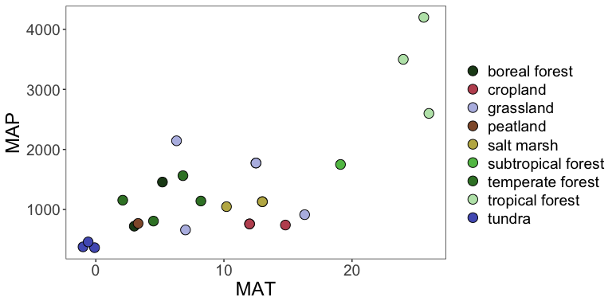
Fig. 2 Distribution of mean annual temperature, precipitation, and ecosystem type across SWEDDIE experiments. MAT = mean annual temperature (° C), MAP = mean annual precipitation (mm y⁻¹).

The mean duration of warming across all sites is 11.4 y (median = 8.8 y), with the Harvard Forest experiment standing out as having been warmed longest (34 y). The ForHot experiment has a site that has been warming for > 60 y, but as the heating is from a natural source, the exact date on which warming began is unknown.

Quantifying soil warming
Target soil warming ranged from +1 °C to +9 °C across all sites (n = 16) for which we had soil temperature data. Observed warming tended to be cooler than target warming on average, but the magnitude of the divergence varied by degrees of warming, warming method, and depth.
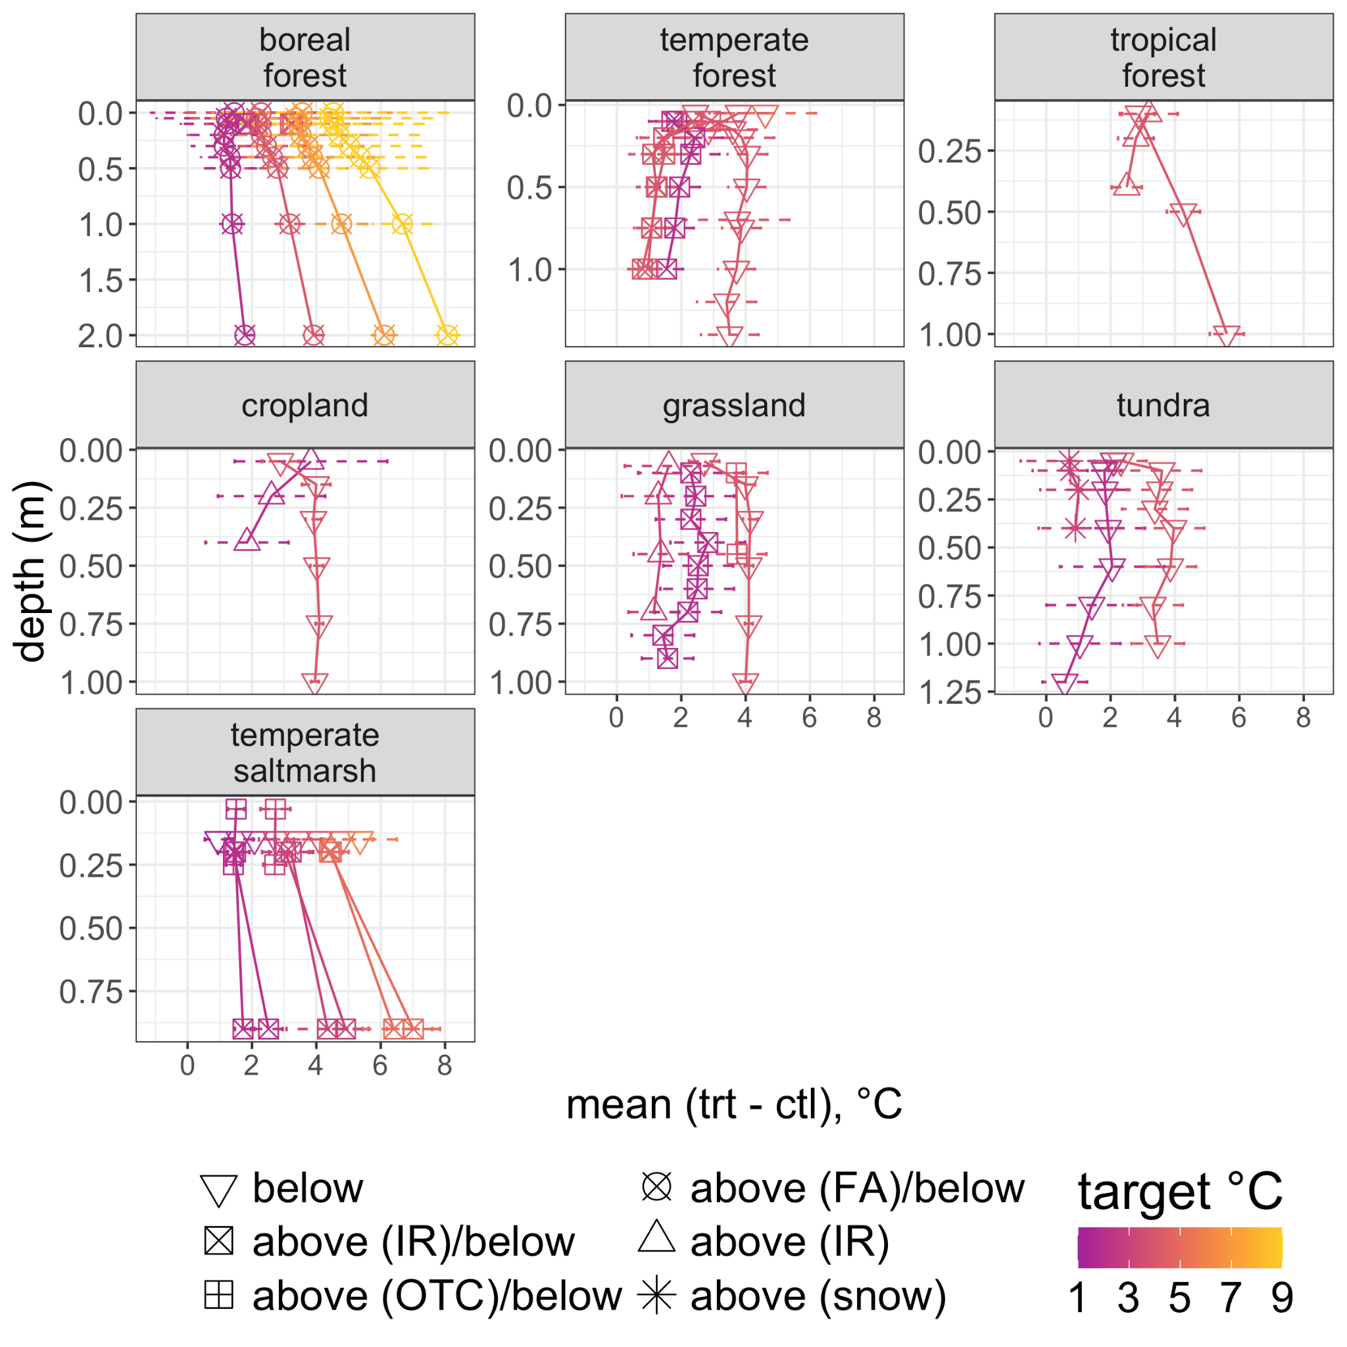
Fig. 3 Depth profiles of soil temperature. Points show means, error bars ±SD.

The model results indicate that achieving target warming becomes more difficult with increasing degrees of target warming. Observed soil temperature differences declined at a mean rate 0.3 °C per degree of target warming. In context, this indicates that observed mean soil temperature difference in an experiment with 3 °C target warming would be expected to be closer to 2 °C. However, we also observed a significant interaction between warming method and target degrees of warming, suggesting that maintaining higher target is relatively more challenging for above ground only warming methods compared to below ground only, and combined above and below ground warming methods. This pattern is also evident in the residual warming, i.e., the mean divergence of observed temperature difference from the target temperature. Residual warming was significantly cooler for the above ground only and combined below and above ground warming methods, but not for below ground only methods.

We also observed substantial variation in warming with depth, which was again largely determined by the warming method. At sites with aboveground warming only, soil temperature differences were closest to the target at the soil surface, but attenuated with depth. In contrast, sites with belowground only warming methods tended to have cooler surface soil layers relative to deeper soil layers. The model predicted difference from target warming over 1 m was a decrease of 1.8 °C for experiments with above ground warming only methods, but increases of 0.6 °C and 0.3 °C for below ground warming only and combined above and below ground warming, respectively.

Warming impacts on soil moisture
Warming led to drier soils on average when considered across all sites, and observed soil drying was positively correlated with degrees of warming at those sites and under those conditions where warming led to drying (n = 21). For these sites, the drying effect varied by ecosystem, with forest soils tending to dry more per degree of warming than non-forest soils (Fig. 4). The sites for which we either did not observe drying with warming or observed the opposite trend of increased soil moisture with warming were all non-forest soils in cold climates (CiPEHR, SWAMP, TEAM, FutureClim). Notably, the only non-tundra site with a pronounced wetting effect (FutureClim) employed open topped chambers (OTC) as the above ground heating method in addition to belowground heating with resistance cables and rods. The tundra sites (CiPEHR, SWAMP, and TEAM) showed the strongest wetting effect with warming. The effect of warming on soil moisture at sites with year-round heating was similar to that for which warming was active for only part of the year (SI).

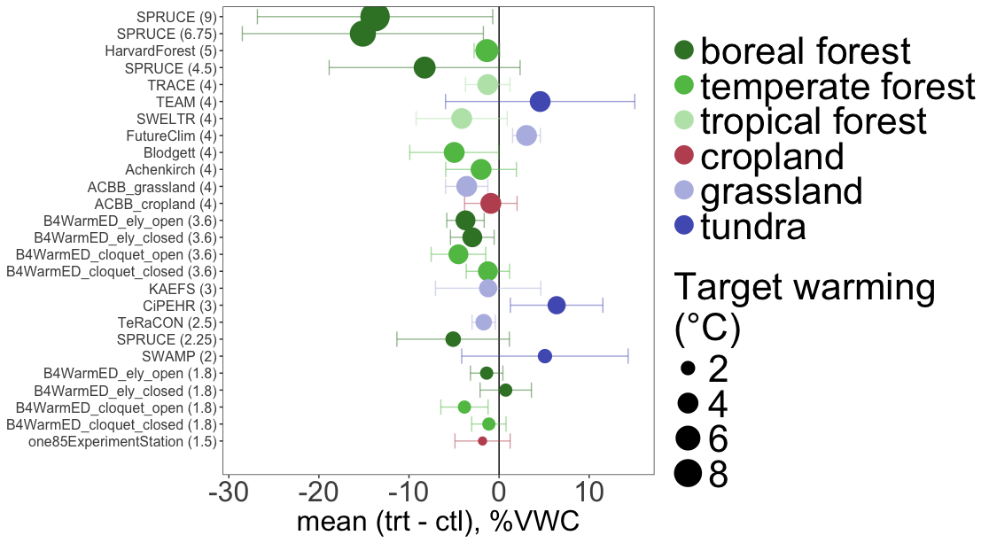
Fig. 4 Warming effect on soil moisture. Points show mean, averaged across depth and time; error bars show ±sd. Data are ordered by experiment and target degrees of warming (shown in parentheses and by point size). VWC: volumetric water content; “all year” and “partial year” refer to the duration of warming on an annual basis. Sites ordered on y-axis by target degrees of warming and site.
The method of warming was not a strong predictor of soil drying at the profile level. Soils warmed with both aboveground and belowground methods tended to be drier in surficial and deeper soil layers, respectively. However, soils warmed with belowground heating extending deeper than 1 m consistently showed more drying in subsurface layers than soils warmed only via aboveground methods. Site-specific relationships suggest an influence of both warming method and ecosystem type on depth profiles of soil moisture change with warming. The tropical moist forest site, TRACE, which was warmed with aboveground IR heaters only, exhibited slight (+1% VWC) wetting with warming at the soil surface, but drying with warming below 0.1 m. In contrast, SPRUCE, which was the only site with forced air as an aboveground warming method, showed a dramatic increase in drying at the upper depth (0-0.08 m) compared to the lower depth (0.08-0.2 m). Both the cropland and grassland sites at the temperate climate ACBB experiment, warmed belowground only, exhibited wetting or no effect of warming on soil moisture at depth, but consistent drying in the surface soil layers. Only a single temperate forest site (Blodgett, belowground warming only) had soil moisture observations for multiple depths, and here we observed strong drying at the surface, little effect at 0.5 m, and then drying again at 0.8 m. Soil moisture increased with warming at all tundra sites up to a depth of 0-0.3 m. However, below 0.3 m soil moisture differences trended in opposite directions for the two tundra sites with depth-resolved data: the TEAM site showed decreased wetting and finally drying at 1 m, while soil moisture at the SWAMP site increased with depth up to the deepest measured layer (0.4-0.6 m).

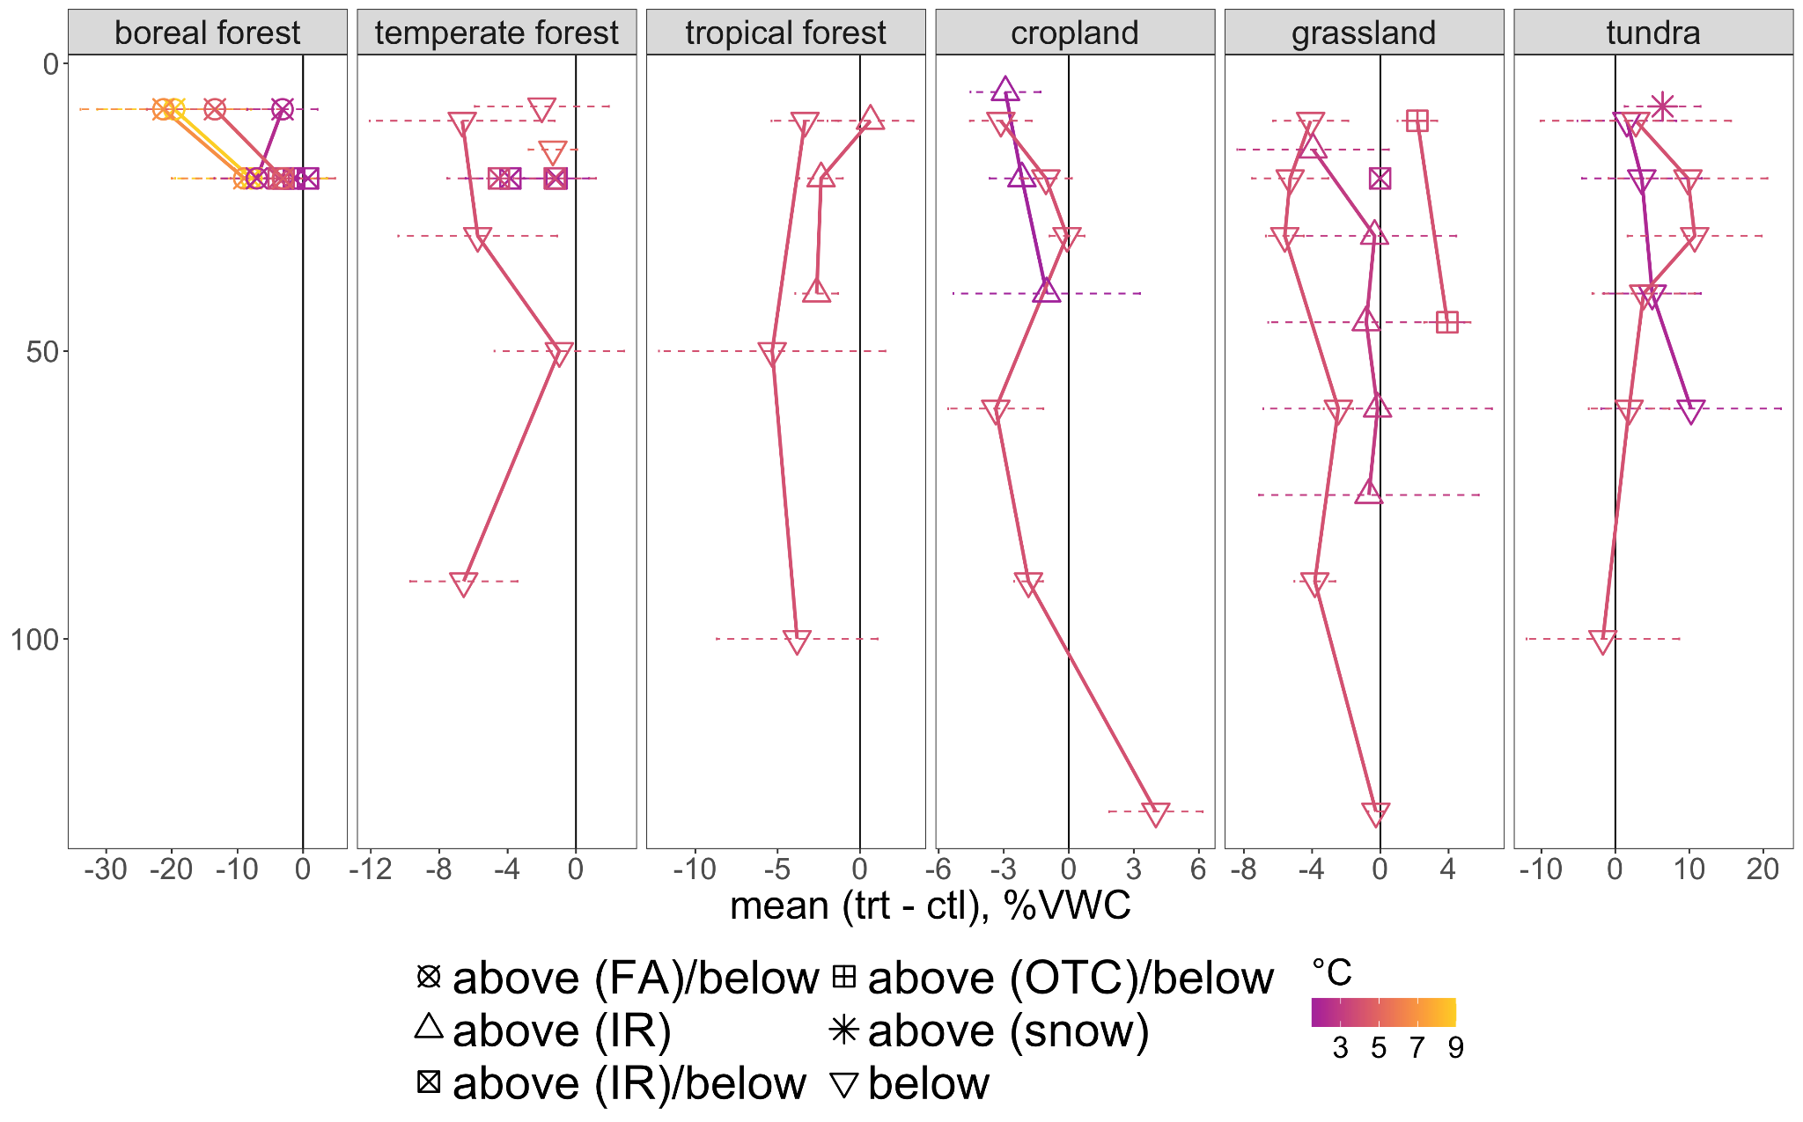
Fig. 5 Warming effect on soil moisture by depth. Points show means, error bars ±SD. Point size corresponds to target degrees of warming. VWC: volumetric water content.
We also compared soil moisture differences between the growing season and non-growing season for sites with year round warming. The drying effect of warming was slightly enhanced during the non-growing season, but not significantly.
We were able to quantify the relationship between observed temperature change and changes in soil moisture with a linear model (Figure X). Warming led to significant soil drying, with an estimated mean drying rate of roughly 3.1 % (-5.7, -07, 95% HPD interval) volumetric water content per degree of warming. However, both the direction and magnitude of this effect depended on the ecosystem. Temperate forest and grassland soils were the only ecosystems for which drying was significant. Warming led to the most drying in boreal forest soils, but was not significant due to high variability. Although warmed soils were drier than control soils in cropland and tropical forests as well, these differences in soil moisture were not significant. In contrast to the other ecosystems, warming led to wetting in tundra soils, although this was not significant at the ecosystem level due to high variability.
Mean soil moisture differences were also significantly affected by ambient soil temperature and soil moisture. The model indicated more drying in wetter soils than drier soils and more drying in warmer soils than colder soils. Ambient soil moisture and temperature also had significant interactions with the degree of warming. Model results suggest that the effect of increasing soil temperature on soil drying becomes weaker with both increasing soil moisture and temperature. We did not observe strong interactions between the degrees of heating and ecosystem type. These interactions were only significantly different from zero in grassland and cropland soils, with slightly less drying estimated with increasing degrees of warming.
Drying tended to decrease with depth, and while significant, the effect was small at 1% VWC over 1 m. Finally, the coefficient for growing season was also significant in the model, with warmed soils drying slightly more in the non-growing season than during the growing season.

CO2 data? We should have data to see how warming affect ecossytem functional processes

Discussion
Soil warming experiments provide a critical constraint for our understanding of the potential impacts of warming on ecosystem processes around the world. ADD SENTENCE OR TWO SHOWING HOW AND WHY. Synthesizing the data from these experiments is an opportunity to assess similarities and differences in ecosystem level responses to warming, and creates an ideal platform for broad tests of mechanistic hypotheses. This first analysis of the effectiveness of soil warming and the impact of warming on soil moisture among various experiments demonstrates the possibilities of the SWEDDIE database and addresses a key knowledge gap, but also reveals challenges in synthesizing data across such diverse experiments and ecosystems.

First SWEDDIE data syntheses revealed that regardless of the warming methodology applied at the individual experiments, most soils were slightly below target warming. A practical implication of this is that setting the target degrees of warming 1 °C above the desired warming level may be desirable to achieve the target warming successfully. The relative magnitude of the target warming is also relevant, given the significant increase in the divergence from target warming observed per degree of target warming. Heat losses at the soil surface are a further concern (reference….). This is a known issue which drove the installation of resistance cables at the soil surface in addition to vertical resistance rods at the Blodgett Forest site (reference….). In an example of the benefit of collaboration across experiments, this adaptation has also been implemented at the ACBB, TEAM, SWELTR, and Point Reyes experiments in this study (references….). However, the increased variability in warming, as well as increased losses of heat at the soil surface should still be expected in the absence of above ground warming methods.

From the perspective of analyzing soil warming experiment data, the consistent negative offset of soil warming from target levels underscores the importance of using directly observed temperature data when analyzing the impacts of warming on ecosystem processes. Similarly, it is critical to account for observed changes in soil moisture due to warming. While soil drying varied across sites and ecosystems, it is clear that warming induced soil drying at the majority of sites, regardless of the warming methodology, and as there are many papers showing that there are both direct thermal effects and indirect soil moisture effects of warming on plant and soil processes; ignoring moisture is not acceptable.

The finding that soils tend to dry with warming is therefore not surprising, but with the SWEDDIE dataset we were able to quantify the overall trend and how potential drying changes by ecosystem, soil depth, and in response to varying baseline soil moisture and temperature conditions. The model results point to ambient moisture as a dominant control on drying, and indicates wetter soils are more susceptible to warming induced soil moisture losses. This follows logically from a theoretical understanding of the relationship between energy balance and evaporation in soils, in that more evaporation is expected with higher energy input when soil moisture is above the permanent wilting point and below the critical moisture threshold. We did not determine critical moisture thresholds, but from a rough comparison to previous global analyses, we expect the majority of our sites to be in transitional soil moisture regimes in which soil moisture is the limiting factor controlling evaporation (Seneviratne et al., 2010). Soil drying also increased with increasing ambient temperature, which is also consistent with theory, as this increases the overall energy in the system and leads to higher evaporative losses.

Tundra ecosystems are a clear exception to the overall trend of warming induced drying. For tundra sites on permafrost, warming-induced thaw of this structural element of the soil can lead to thermokarst collapse. This phenomenon has been documented at CiPEHR, a tundra experiment underlain by permafrost in SWEDDIE. Thermokarst collapse at this site has led to near permanent inundation of the warmed soils due to pooling of water in the resulting depressions. The results in SWEDDIE confirm earlier findings of increased soil moisture in the warmed plots at CiPEHR, but also demonstrate soil wetting with warming in the absence of thermokarst collapse at the other tundra sites.

The specific response of soils wetting in response to warming is more common in cold climate systems within our dataset. There would be no expectation of a difference in soil moisture between warmed and ambient temperature soils in subzero temperatures (< 0 °C). However, if warming were to exceed the 0 °C threshold, this would induce conditions under which the warmed soils had higher soil moisture than ambient condition soils, at least during the spring thaw period. This may partly explain the strong wetting effect observed in the non-permafrost tundra site TEAM and the temperate grassland site FutureClim.

The overall trend towards soil drying with warming was largely unaffected by warming methodology. However, two exceptions to this are notable due to the potential impact of the warming method on the vapor pressure deficit. First, the site where we observed the greatest difference in soil moisture was the SPRUCE site, which was the only site that utilized forced air as an aboveground warming method. Active circulation of warm air in the enclosures constructed for this experiment reduced relative humidity significantly with active warming, conditions which would be expected to increase evaporative soil moisture losses (Hanson et al., 2017). This method also appeared to be associated with higher variability in soil moisture, although as this was the only experiment using forced air heating, we cannot effectively separate methodological effects from site-specific variability.

The second example of where methodology influenced soil drying responses to warming involves the use of open topped chamber (OTC) warming methods. While we did not include experiments with only OTC warming, two of the experiments in SWEDDIE did utilize OTCs for aboveground warming in conjunction with another method. Both of these were sites where soil moisture increased with warming: CiPEHR, and FutureClim. Open topped chambers are known to increase the vapor pressure deficit, and therefore potentially decrease evaporative soil moisture losses. This may explain why the FutureClim site was the only non-tundra site where soil warming led to soil wetting.

Soil drying increased with depth overall, but the magnitude of the effect was small, indicating that warming can be expected to impact soil moisture similarly throughout the soil profile (assuming no substantial changes to water holding capacity with depth). The two primary pathways for soil water losses are evaporation, which is highest at the soil surface, and root uptake. The distribution of roots with depth varies in different ecosystems (Jackson et al., 1996), and this likely underpins baseline differences in soil moisture observed across ecosystems (SI). Despite this, there was no evidence for ecosystem level divergence over the soil profile in drying (or wetting in tundra soils) in response to warming.

Site level variation in soil moisture changes with depth were substantial. This variation likely arises in part from factors beyond those considered in this analysis, such as soil texture or site-specific trends in other factors driving evaporative losses including vegetation dynamics, variation in solar radiation, and other factors affecting the vapor pressure deficit. A clear finding is that soil moisture and temperature are more variable at the soil surface, possibly contributing to the small but significant overall increase in drying with depth predicted in the model with when degrees of warming were held constant. This trend in soil drying is supported by the trends in residual warming. Sites with below ground warming methods had higher mean temperature difference at depth than those warmed with above ground methods only, increasing the likelihood of soil drying.

Belowground methods were the most successful at reaching target warming levels, particularly with depth. However, even soils warmed with above ground only methods saw sustained increases in temperature well below the soil surface. At the KAEFS site with above ground warming, the soil temperature difference at 0.7 m was consistently >+1 °C. The other sites with above ground warming only (TRACE, 185ExperimentStation) did not measure soil temperature to that depth, but we observed +2 °C of soil warming in both experiments at 0.3 m. These findings highlight the importance of these experiments in assessing the impacts of warming on ecosystem processes: soils can be expected to warm substantially below the topsoil. Among other potential impacts, this has substantial implications for the impacts of warming on soil carbon stocks, as previous results from the experiments in the DeepSoil2100 network demonstrate (Hicks Pries et al., 2018; Soong et al., 2021).

Conclusion
We present here the first synthesis analysis with SWEDDIE focused on addressing hypotheses regarding the impact of warming on soil moisture, while also serving to test the SWEDDIE data model and refine the harmonization approach. The SWEDDIE database is designed with FAIR (Free Accessible Interoperable Reuseable) principles to accommodate a wide range of data types, with a streamlined data ingestion system and user-friendly query and reporting tools. Comprehensive metadata reporting standards enable SWEDDIE to serve as a repository for past, present, and future datasets. Harmonization of data is facilitated with data dictionary files that accompany and describe variables in each data file and also store sensor and methods information. A key tenet of SWEDDIE is the inclusion of soil measurements below 0.2 m, as the warming response of carbon stocks in deeper soil layers remains both highly uncertain and consequential for the global carbon cycle. Accordingly, we welcome new sites and data submissions, provided that > 1 °C warming has been observed below this depth.
NEED A SENTENCE OR TWO ABOUT WHAT THE MOISTURE RESPONSES TAKE-HOME MESSAGE IS.
SWEDDIE is at its core a community project. The results of the soil moisture analyses presented here are a key building block of the next planned synthesis efforts: 1) using selected experiments to benchmark soil carbon warming responses with the ecosys model, and 2) quantifying soil CO2 fluxes in response to warming. If, for example, the results of this modeling work provides mechanistic insight into warming induced changes in soil carbon stocks, this would point towards future sampling and observation campaigns to test these mechanisms further in a positive research feedback loop. This can be summarized as a process through which active community engagement leads to improved data coverage, which in turn enhances the capacity to generalize warming responses across ecological gradients, inform site- to global-scale models, and quantify potential experimental biases.

MST notes:

I wonder if SWEDDIE and Deep Soil 2100 have to be totally separate, or if this is a way to make them closer together. Is it fair to say one is a network and one is a database? Is the database focused on sites in that network? Why is either called a project?

Starter list the contributions of the paper.
- Describe the network. Was in EOS but that is not peer reviewed.
- Document the warming, to show how the method(s) work(s) in different environments. To document methods and to make the network a resource for the scientific community.
- Document the database as a resource for scientific community.
- Effect of warming treatment on soil moisture in different environments. Main message (need to check this!) is that warming treatment alters soil moisture; in ways that differ across the range of vegetation types, climates, and in the network.

