Draft

Confronting depth bias in soil warming experiments: First results of the Soil Warming Experiment to Depth Data Integration Effort (SWEDDIE)

Authors:
Jeffrey Beem-Miller^{1,2}
Serita D. Frey³
Andreas Schindlbacher⁴
Viktoria Unger

Affiliations:
- University of Michigan, Institute for Global Change Biology, Ann Arbor, MI, USA
- Lawrence Berkeley National Laboratory, Climate and Ecosystem Sciences Division, Berkeley, CA, USA
- University of New Hampshire, Department of Natural Resources and the Environment, Center for Soil Biogeochemistry and Microbial Ecology, Durham, NH, USA
- Austrian Research Centre for Forests (BFW), Vienna, Austria

Abstract
Field-warming experiments offer insight into the response of ecosystems to rising temperatures, but cross-site comparison is needed to determine both the general tendencies of warming responses and the context dependencies of deviations from those norms. These responses are not limited to the direct effects of temperature but also their indirect effects on soil moisture, a critical factor controlling ecosystem productivity and carbon fluxes. Here we introduce SWEDDIE: the first database to characterize the whole soil profile warming response across 26 distinct soil warming experiments, encompassing forest, grassland, cropland, tundra, and wetland ecosystems. SWEDDIE is needed because prior data bases and syntheses of warming effects on ecosystems were dominated by aboveground warming studies, many of which warmed soil modestly or negligibly during much of the growing season, and reported only growing season averages.
We demonstrate the potential of the SWEDDIE database by quantifying soil temperature and moisture changes for each experiment as a function of depth, warming methodology, ambient climate conditions, and ecosystem, as well as the relationship between soil moisture and imposed warming. Warming attenuated with depth at sites with aboveground warming only, but increased with depth at sites with belowground warming only, as hypothesized. Warming led to soil drying at most sites, and drying was positively correlated with the magnitude of warming. However, the relationship between soil warming and soil drying varied by ecosystem: forest soils dried the most, while tundra soils became wetter with warming. Ambient climatic conditions also significantly influenced the relationship between experimental warming and drying, with more drying per degree of warming observed in soils with higher ambient moisture.
These results underscore the importance of quantifying both observed warming and soil moisture changes when inferring ecosystem warming responses, as trends were not consistent across ecosystems or warming methodologies. Quantifying the impact of deep soil warming on the fundamental ecosystem properties of soil temperature and moisture provides a foundation for future synthesis efforts while demonstrating the power of this actively growing community resource.

Introduction
Field warming experiments provide a unique opportunity to deepen understanding of how warming impacts specific ecosystem processes, yet insights from individual experiments are necessarily limited. For example, many experiments are limited in their duration, leading to omission or misconstruing of long term processes (Melillo et al., 2017). Additionally, experiments employ a variety of warming methodologies, which has the potential to affect warming responses differently, e.g., differences in soil warming with depth could alter the relative impact of warming on above versus belowground processes (Aronson et al., 2009; Reich, 2010; Wang et al., 2019). Synthesizing data across multiple warming experiments, ecosystems, and warming methodologies, with explicit accounting for deep soil warming, is needed to quantify the general principles of ecosystem responses to rising temperatures as well as potential methodological biases. The Soil Warming to Depth Data Integration Effort (SWEDDIE) is a new database created to support such synthesis and provide guidance for the design and implementation of future field warming experiments.
The SWEDDIE database synthesizes data from the experiments of the DeepSoil2100 network of warming experiments. This network formed in early 2020 in recognition of the growing number of deep soil warming experiments, the opportunities for sharing data and practical knowledge for successfully warming the whole active zone of the soil, and the potential for multi-site synthesis activities (Torn et al., 2015; Protti-Sanchez et al., 2025). The majority of warming experiments do not actively warm or observe soil below 0.2 m, despite the fact that roots, microbes, and critical biogeochemical processes continue well below this depth in many soils (Hicks Pries et al., 2023). Yet, both near surface (≤ 0.01 m) and deep soil (≤ 1 m) temperatures are projected to increase at the same rate over the 20th century (Soong et al., 2020; Schmidt et al., 2001). Evidence that top and subsoil C are equally vulnerable to warming induced losses (Hicks Pries et al., 2017) is a prime example of the importance of explicitly considering whole soil warming responses. Alleviating the current bias towards shallow soil responses to warming is a key motivation for DeepSoil2100 and SWEDDIE.
The results from warming experiments conducted over the past few decades document clear responses in plant, animal, and microbial productivity and growth (Warren et al., 2018; Singh et al., 2019; Stuble et al., 2021), biogeochemical cycling rates (Rustad et al., 2001; Bai et al., 2013; Lu et al., 2013), greenhouse gas fluxes (Yan et al., 2022), and biodiversity (Chung et al., 2013), yet these results are at times contradictory. Tropical soils, once thought to be relatively insensitive to warming (Koven et al., 2017), have shown unexpectedly large CO₂ emissions under experimental warming (Nottingham et al., 2020; Carter et al., 2020). Long term warming studies underscore the importance of the temporal dimension of warming responses (Melillo et al., 2017; Liang et al., 2024). Emerging understanding of the temperature sensitivity of soil biogeochemical processes suggest that warming induced increases in fluxes only occur with adequate soil moisture, and this is consistent across both forest and grassland ecosystems as well as across latitudinal gradients (Flanagan et al., 2005; Hicks Pries et al., 2017; Reich et al., 2018; Yang et al., 2022; Liang et al., 2024).
Soil moisture affects not only greenhouse gas fluxes, but uptake of soil water by vegetation, carbon allocation, plant and microbial drought stress responses, soil oxygen availability, soil microbial movement, plant growth, and biogeochemical cycling rates (Walter, 2018). Previous research indicates that soils typically dry in response to experimental warming, but also that soil moisture responses to warming vary with ecosystem, ambient climate conditions, and depth (Xu et al., 2013). Recent work in a tropical forest warmed with infrared heaters found soil moisture dominated over vegetation temperature in controlling plant physiological responses to warming (Carter et al., 2020). Similarly, soil moisture exerted a stronger effect on belowground C allocation than warming in a tallgrass prairie ecosystem (Xu et al., 2013). Soil moisture is also hypothesized to be one of the factors controlling potential microbial acclimation to warming, including shifts in carbon use efficiency (CUE) (Allison et al., 2008; Manzoni et al., 2012). However, a recent metaanalysis of field warming studies found limited support for warming induced shifts in CUE, implicating soil moisture as one of the potential constraints on theorized acclimation along with warming methodology (Zhang et al., 2024).
Various methods have been developed to manipulate soil temperature in field experiments. The most common approach to temperature manipulation in a field setting has involved the use of passive methods, such as passive open topped chambers (OTCs) (Hollister et al., 2023). These methods are inexpensive and result in minimal disturbance to the soil, yet the presence of the chamber confounds warming impacts on vegetation through alterations in canopy light penetration and herbivory, and can alter evapotranspiration rates as well (Aronson et al., 2009; Hollister et al., 2023). Aboveground infrared radiation (IR) heaters are a commonly applied approach to active warming that have the advantage of lower installation cost than resistance cable or rod installations (although typically with higher operational costs) (Aronson et al., 2009). Aboveground IR methods can warm both vegetation and soil. However, the extent and depth of soil warming depends strongly on the vegetative cover and these methods may only warm soils outside of peak vegetation season due to canopy interception of IR (Rich et al. 2015). Buried resistance cables or vertical rods have the advantage of heating soil more evenly over space and time, and enable warming to reach higher temperature targets, such as those that align with end- of- century predictions. On the other hand, installing these methods are more costly and result in more disturbance to the soil than aboveground methods (Peterjohn et al., 1993; Aronson et al., 2009; Rich et al., 2015; Torn et al., 2015; Hanson et al., 2017). Given the variety of warming methodologies across the experiments in SWEDDIE, as well as differences in the seasonality of imposed warming, the first step toward effective synthesis of these data must be quantifying this variation along temporal and spatial gradients in a framework that facilitates quantitative comparison. This has proven to be true for plant responses to warming as well, where metaanalysis suggests that warming methodology and experimental duration are critical factors influencing observed ecophysiological plant responses to warming (Wang et al., 2019).
The goals of this paper are twofold: 1) introduce the SWEDDIE database and quantify realized soil warming to depth across experiments and methodologies; and 2) demonstrate the potential of SWEDDIE by documenting the impacts of experimental warming on soil moisture. Specifically, we ask: does experimental warming lead to changes in soil moisture? How are potential soil moisture changes under experimental warming affected by ecosystem type, depth, warming methodology, and ambient soil temperature and moisture? This analysis of experimental warming efficacy and soil moisture change is intended to provide a baseline for future synthesis work, while simultaneously outlining the potential benefits and challenges of synthesizing in situ deep soil warming data.
We developed two basic hypotheses regarding: 1) the relationship between warming methodology and observed soil temperature depth profiles, 2) the relationship between warming and soil moisture, i.e., with respect to ecosystem type, and ambient soil climate conditions:
- Experimental warming will attenuate with depth at sites with aboveground warming only, increase with depth with belowground warming only, and be most consistent with depth with both above and belowground warming.
- Soil warming will lead to soil drying, but: (a) the magnitude of soil drying in response warming will vary across ecosystems, and (b) the magnitude of soil drying in response warming will be greater in soils with higher ambient soil moisture, in line with current understanding of the physical relationship between soil moisture and evaporation.

Methods

Scope and experiment criteria
The SWEDDIE database (hereafter SWEDDIE) builds on data gathered from experiments in the DeepSoil 2100 network. The DeepSoil2100 network is a consortium of independently operated field soil warming experiments with a shared interest in the impacts of whole soil warming. From this perspective the ideal experiment is one in which a mean change in temperature ≥ +1 °C is measured at a depth ≥ 0.2 m over ≥ 1 y. Although not all of the DeepSoil2100 experiments meet all of these criteria, exceptions have been made on a case-by-case basis due to under-representation of the studied ecosystem or long experimental duration. We excluded experiments that used only passive open top chamber methods for soil warming, primarily because those methods do not warm the soil beyond ca. the top 0.1 m, and the magnitude of warming reported in the literature is inconsistent and variable (Hollister et al., 2023). Warming at all but two (Lyon Arboretum, Stillberg) of the 23 experiments in SWEDDIE is ongoing.
SWEDDIE consists of both publicly accessible and network-only data tiers. This approach is designed to maximize community engagement by lowering the barriers to data sharing within the network while promoting public data sharing for already published datasets. SWEDDIE is hosted by the Environmental Systems Science Data Infrastructure for a Virtual Ecosystem (ESS-DIVE), which is a web-based data repository that defines generalized metadata standards, as well as providing automatic generation of digital object identifiers (DOIs), data sharing and management, as well as querying and reporting tools (Agarwal et al., 2017). The SWEDDIE metadata standards meet the minimum ESS-DIVE requirements, but have been adapted for the specific needs of a soil-focused ecosystem warming experiment database and to facilitate harmonization of variables within our data model. Data ingestion, manipulation tools, and both querying and reporting functionality for SWEDDIE are also available in a companion R package, sweddie. However, these can be expanded to other coding languages or software environments in the future pending community interest and engagement.

Site characteristics
The experiments in SWEDDIE (n = 23) cover a wide range of biomes and climate regimes. (Fig. 1, SI Table 1). The most represented ecosystems in SWEDDIE are temperate grasslands (n = 5) and forests (n = 5), followed by temperate coastal saline wetlands, tropical forest, and tundra (n = 3 each), then temperate croplands and boreal forest (n = 2 each), and lastly one boreal ombrotrophic peatland and one subtropical forest ecosystem. All but one experiment (FutureClim) is located in the northern hemisphere.
Experiments in SWEDDIE employ a range of methods for warming soils (Table 1). Belowground warming methods include buried resistance cables and rods, as well as natural geothermal warming. Resistance rods are typically employed to accomplish deep soil warming, while resistance cables are typically used to improve uniformity of warming at the soil surface. In this study the term “resistance rod” refers to vertically installed stainless steel housing fitted with a length of resistance heating cable and packed with insulating material, e.g., sand. A few experiments only employ cables for belowground warming (Achenkirch, B4WarmED, Harvard Forest), while the ForHot experiment is unique in that the heated plots were warmed from below by geothermally-heated groundwater (Sigurdsson et al., 2016).
Aboveground warming methods are more varied and include infrared radiation (IR) heaters, passive OTCs, active OTCs with forced air warming, and manipulation of soil insulation in winter via snow fences. IR heaters were the most common approach for aboveground warming. A few experiments deploy passive OTCs for seasonal aboveground warming in combination with belowground warming. Most experiments achieve warming with either belowground only m(n = 11) or aboveground only (n =4) methods, but several utilize both above and belowground warming methods (n = 8).
The mean duration of experiment warming in SWEDDIE (v1.0, Beem-Miller et al., 2025) across all manipulation experiments is 11 y (median = 9 y), with FutureClim the shortest (2 years) and Harvard Forest longest continuously monitored warming (34 y). The natural warmed geothermal experiment ForHot has a site with at least 60 y of documented warming, but regular monitoring was only initiated in 2008 (17 y).
Table 1. SWEDDIE experiments
 | Warming
Experiment | temp. range (n) | season | dur. | above | below | max. depth¹ | Additional treatments
 | °C |  | y |  |  | m
185 Experiment Station | 1.5 | all year | 17 | IR |  |  | +N
ACBB | 4 | all year | 7 |  | rods; cables | 2.0 | ecosystem; +N;
Achenkirch | 4 | growing season | 21 |  | cables | 0.0
B4WarmED | 1.7–3.4 (2) | growing season | 17 | IR | cables | 0.1 | canopy cover; ecosystem; -precip
Blodgett | 4 | all year | 12 |  | rods; cables | 2.4 | duration
CiPEHR | 3 | winter | 18 | snow; passive OTC
ForHot | 1–20 (5) | all year | 18 |  | geothermal | >3.0 | duration; ecosystem
FutureClim | 4 | growing season | 3 | passive OTC | rods | 0.8 | -precip.
GENX | 0.7–6.0 (8) | all year | 3 |  | cables | 1.5
Harvard Forest | 5 | all year | 35 |  | cables | 0.1 | +N
Lyon Arb. | 4 | all year | 8 |  | rods | 2.5
KAEFS | 3 | all year | 17 | IR |  |  | clipping; -precip.
MERIT | 1.5–3.0 (2) | all year | 7 | passive OTC | cables | 1.0 | inundation
Point Reyes | 4 | all year | 0 |  | rods; cables | 2.4
Sanming | 5 | all year | 11 |  | cables | 0.1 | +N
SMARTX | 1.7–5.1 (3) | all year | 9 | IR | cables | 1.5 | eCO2; C3/C4
SPRUCE | 2.3–9.0 (4) | all year | 10 | active OTC | rods; cables | 3.0 | eCO2
Stillberg | 4 | growing season | 19 |  | cables | 0.0 | eCO2; vegetation
SWAMP | 2 | growing season | 4 | IR | rods | 0.6
SWELTR | 4 | all year | 9 |  | rods | 1.2
TEAM | 4 | all year | 7 |  | rods; cables | 1.0
TeRaCON | 2.5 | growing season | 14 | IR | rods | 1.0 | eCO2; +N; -precip.
TRACE | 4 | all year | 9 | IR
¹ This is the maximum depth of belowground warming cables or rods.

Database
Individual ecosystem warming experiments are the fundamental unit of organization in the SWEDDIE database. All data in the database, i.e., each “entry”, is therefore associated with a unique experiment. The database was designed to be flexible enough to incorporate any type of data including fluxes, soil properties, vegetation characteristics, sequencing data, etc. This flexibility is achieved via a unique hybrid data model defined by a combination of fixed format (template-based) tables and open format data tables (Fig. SI 1).

Core data
The database consists of three fixed format “core” data tables, which describe the experimental infrastructure (experiment), site characteristics (site), and experimental design (plot), along with an unlimited number of open format measurement data tables (dat), one for each unique measured variable at each experiment. Detailed descriptions of these tables are provided in the supplementary information (SI Methods). At present all tables are in .csv format. The R tools built to facilitate data ingestion currently rely on .csv input, but this is a convention, not a requirement. The tools can be adapted as needed if other file formats are employed in the future, provided the file formats are non-proprietary in accordance with FAIR principles (Wilkinson et al., 2016).

Observations
Data observation (dat) tables are designed to be as simple as possible to facilitate harmonization and avoid confusion or duplication with variable names. Accordingly, each dat table is restricted to observations of a single variable (e.g., soil temperature, soil CO₂ flux, above ground biomass, etc.). These variables are semi-controlled in the sense that users are prompted with a list of previously used variable names during ingestion in order to facilitate harmonization with existing data (see “Scripted data ingestion” below). In addition to the observed data column, dat tables also contain two required identification columns: the unique plot identifier (‘plt_name’), which must be an exact match with one of the ‘plt_name’ values in the plot table, and an observation date (time stamp) column. Note that tables containing depth-resolved data require at least one additional column to record the depth at which the observation was made, or paired upper and lower depth columns if measurements were made over a depth interval. Additional columns in the input data table are ignored and dropped during ingestion.

Metadata
Each dat file must be accompanied by a data dictionary file. This data dictionary file consists of a table with the same number of rows as the number of columns in the dat table. The first column of the data dictionary table contains the dat table column names, while subsequent columns provide further information, including: short text description, data type (i.e., numeric, string, etc.), semi-controlled variable name, units, method information, sensor make and model, and any notes relevant for data interpretation. An example template file for dat data dictionary tables is provided in the supplemental information along with a guide document to assist in filling it out.
Additional metadata for the dat files are stored in a separate file level metadata file (FLMD), one for each experiment. The FLMD describes each dat file, providing information about the data source, date range covered, missing value codes, target variable, versioning, and UTC offset. The design of the FLMD table is based on the guidelines provided by ESS-DIVE (Velliquette et al., 2021).

Scripted data ingestion
Data entry is a major challenge in database construction (Malholtra et al., 2019; Todd-Brown et al., 2022). Earlier soil database efforts tended to rely on highly structured templates explicitly defining allowable variables, data types, ranges, and names (Nave et al., 2017; Lawrence et al., 2020; Schaedel et al., 2020). However, these templates create a barrier to data ingestion given the amount of time needed to translate raw data into the template format. Template-based approaches are also more error prone, requiring human transcription or custom scripts to accomplish the necessary translation of data into the required format (Todd-Brown et al., 2022). While the final output may be highly curated, the template-based approach is also relatively rigid, requiring a priori definitions of allowable variables and data categorization.
Keyed translation is a more flexible alternative to the template-based approach that reduces the potential for transcription based errors and preserves traceability of data transformations (Todd-Brown et al., 2022). This approach relies on a data dictionary to map input data with varying names and definitions onto a target set of names and definitions, but can be more computationally expensive, requires coding knowledge to generate data harmonization scripts, and can present data curation challenges in the absence of rigidly defined variables.
We employed a hybrid data entry approach for SWEDDIE: using keyed translation used for maximum flexibility in ingesting observational data, but template based data entry for relatively static data, such as experimental design, infrastructure, or site characteristics in order to simplify the scripting process. All data in SWEDDIE is derived from warming experiments, which provides a consistent framework for the keyed translation approach in the form of common data elements such as degrees of imposed warming, experimental design, and timestamped data.
The rationale for dispensing with template based data entry, controlled vocabulary, and minimizing required columns in data files was to simplify the submission process for data providers. As part of the simplified data ingestion process we wrote semi-automated helper scripts which create the data dictionary and file level meta data files from raw observed data files via interactive console prompts. These scripts also output simplified dat files if the raw data does not conform to SWEDDIE standards. The primary function of these scripts is to identify the name of the target variables and split the input data table as needed so as to yield a separate table for each variable. During this process the names of the other identification variables, e.g., “date”, “plotID”, etc., in each dat table are also harmonized to match standard names. Currently these scripts are written in the R programming language and can be accessed by installing and loading the sweddie R package from the project Github site.

Queries and reports
Data are retrieved from SWEDDIE by creating a query that yields a custom report. The report can include all available data or a specific subset. The query specifies the desired target variables and optional filters for depth, temporal range, imposed treatments, site level characteristics, and experiments. This query tool is currently R based with a hierarchical R list object mirroring the data model (i.e., experiment level data linked to site level data linked to plot data linked to observed data) as the default output. This R list object can be further flattened and exported as a .csv file if desired.

Quantifying soil warming
We addressed our first hypothesis regarding the impact of different warming methods on depth profiles of soil warming by quantifying observed warming over time and with depth. The duration of warming imposed throughout the year varied across the experiments, but we only considered data from the periods when the heating was active when quantifying warming. We also removed data from periods when the heating system is malfunctioning if this was reported. The majority of experiments (n = 16) undergo year-round warming, but several of the colder climate sites are only warmed during the growing season (Achenkirch, B4WarmED, FutureClim, Stilberg, SWAMP, TeRaCON). One experiment, CiPEHR, included passive OTC warming during the growing season, but warming was primarily achieved through the use of snow fences in winter. Despite this, we only quantified warming during the growing season in this experiment, as these were the only data available. Most, but not all experiments in the DeepSoil2100 network contributed soil temperature data. One experiment (Point Reyes) has been warming for < 1 y, and soil temperature data were not available.
Many of the experiments in SWEDDIE impose additional treatments beyond warming, such as elevated CO₂, modified precipitation, canopy cover, vegetation clipping, or nitrogen addition. While these treatments are recorded in the plot table and the data from these plots were ingested into the database, only data from the ambient temperature and warmed plots were used for the analyses presented here. The full range of treatments imposed in each experiment is detailed in Table 1.
We characterized soil temperature in each experiment over time and with depth for both ambient temperature (control) and warmed plots. We then computed the difference between warmed and control plots (∆ST) at each level of imposed warming. We first averaged temperature by depth for each experiment and treatment (warmed or control) at each time step; note that the frequency of observation varied across experimental sites. We then computed ∆ST for each timestep by depth. In order to test our hypothesis about the impact of warming methodology on realized warming with depth, we calculated residual warming as the difference between expected and observed warming (Wr). Note that “expected” warming was defined in some experiments by the set-point for the thermostat controls, but defined as the mean observed warming across all measurement depths for other experiments.

Quantifying soil moisture changes
Soil moisture is a critical variable influencing vegetation, the soil microbiome, and soil biogeochemical processes. We sought to test our second hypothesis that soil warming would lead to soil drying by first quantifying soil moisture in warmed and control plots, and then computing the difference in soil moisture (warmed - control, ∆SM) over time and with depth for each site for the time periods. As with the soil temperature analysis, we only considered periods when soil was actively warming. We did not include soil moisture data from the saltwater marsh warming experiments in this analysis as soil moisture is determined by different factors in these ecosystems, and additionally, data were not available from most sites due to the challenge of measuring soil moisture in saline environments.

Bayesian generalized linear models
We applied a Bayesian generalized linear modeling approach (SI Eq. 1) to assess the impact of warming methodology on residual warming with depth (SI Eq. 2), and the relationship between observed soil moisture (∆SM) and soil temperature differences (∆ST) across the sites (SI Eq. 3). The residual warming model included warming methodology, depth, and target warming temperature as fixed effects, as well as the interaction between depth and warming methodology. The diversity of warming methods employed across the sites in SWEDDIE (Table 2) made it impossible to compare specific methods, so we recategorized this factor to distinguish between above ground warming only, below ground warming only, or combined above and below ground warming in order to test our specific hypothesis that realized warming with depth varies among warming methods.
We sought to test our hypothesis that soil moisture changes would vary across ecosystems by including ecosystem type in the ∆SM model along with observed ambient soil moisture and observed ambient soil temperature. We also included ambient climate conditions, i.e., soil temperature and moisture, and three interaction terms: 1) between ∆ST and ecosystem, in order to test our second hypothesis that the effect of ∆ST on ∆SM would vary across ecosystems, 2) between ∆ST and ambient soil temperature, and 3) between ∆ST and ambient soil moisture. The interactions between ambient soil conditions and ∆ST address our third hypothesis that the effect of ∆ST on ∆SM would be enhanced under wetter and warmer conditions.
We used site as a random variable in both the ∆ST and ∆SM models in order to account for differences in baseline responses at the site level. Similarly, we allowed the slope of the relationship between ∆SM and ∆ST to vary across sites in the ∆SM model. In both the ∆SM and ∆ST models we included a temporal autocorrelation term to account for memory effects, i.e., day to day correlation. Finally, we also incorporated a spline function to account for site-specific seasonal trends in ∆SM for the ∆SM model. Full model specifications and R code for the analysis are provided in the supplementary information (SI Methods).
A further challenge in assessing the potential impact of warming on soil moisture is that not all sites collected soil temperature and moisture data at the same depths or at the same temporal resolution. We addressed differences in the depth of measurement between these two variables by fitting a natural cubic spline function to soil temperature profiles with > 2 observations and predicting soil temperature at the depths of observed soil moisture data as needed. We did not predict soil moisture beyond the support of the temperature data, so soil moisture observations outside the depth range of measured soil temperature were dropped from the analysis; soil temperature observations outside of the depth range of observed soil moisture were also dropped. We averaged all soil moisture and temperature data by plot and depth at a daily timestep prior to fitting the spline function, as this was the minimum common temporal resolution of the combined dataset. Following this we filtered the data to keep only observations of soil temperature and moisture made on the same day. The spline fitted temperature data was used for running the soil moisture model (SI Eq. 3).
All statistical analyses were performed in R (R Core Team, 2025). We used the R package “brms” (Bürkner, 2021) for the Bayesian generalized modeling, and additionally, the packages “emmeans” (Lenth, 2025) and “performance” (Lüdecke et al., 2021) for post hoc tests.

Results

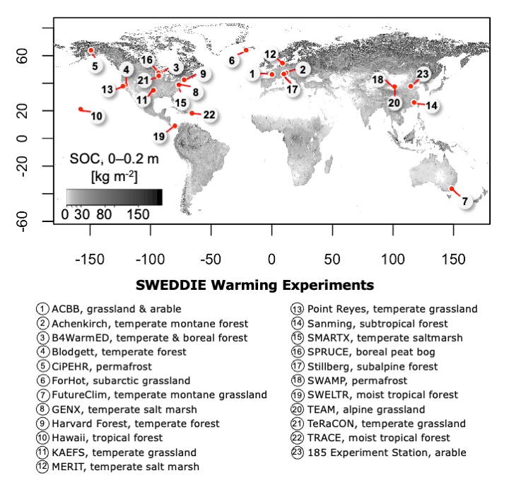
Fig. 1 Map of SWEDDIE warming experiment locations. Red points are experimental sites; shading shows 0–2 m soil organic carbon stocks (kg m⁻²) obtained from SoilGrids250 (Poggio et al., 2021).

Quantifying soil warming
Target soil warming ranged from +1 °C to +9 °C across all sites (n = 23). Observed warming tended to be cooler than target warming on average, but the magnitude of the divergence varied by degrees of warming, warming method, and depth (Fig. 3).
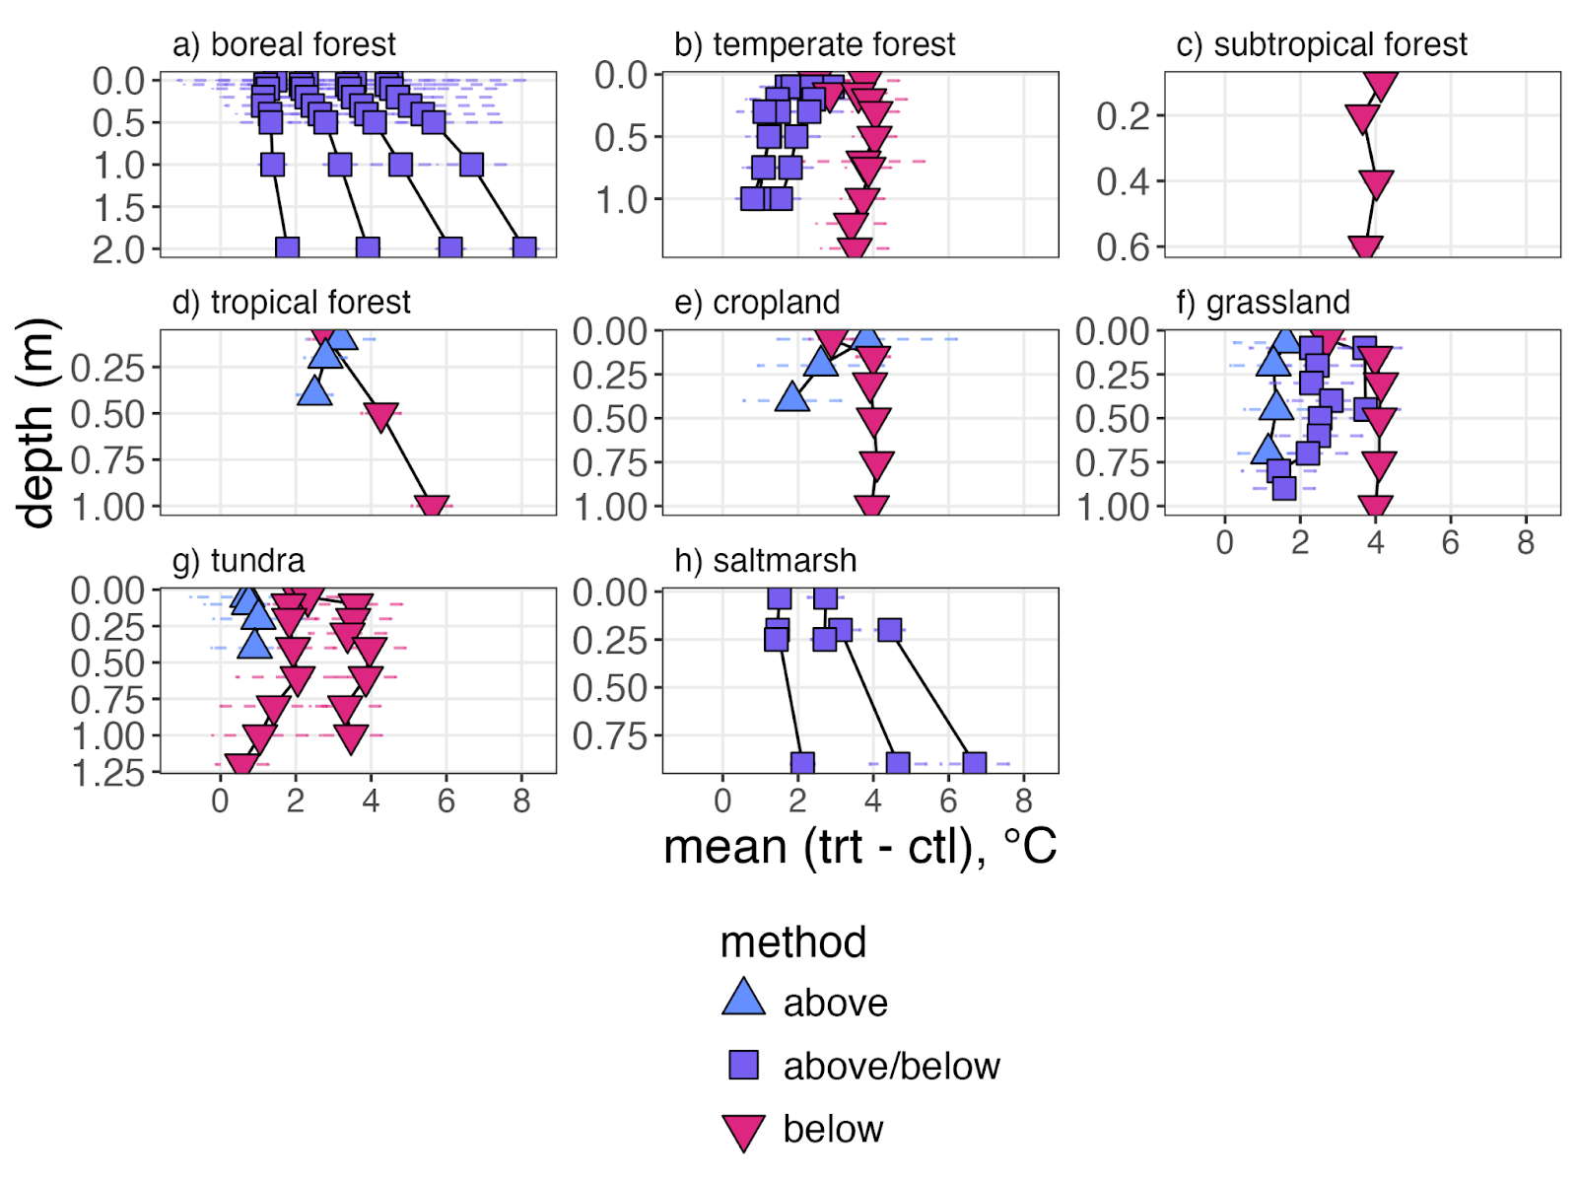
Fig. 3 Depth profiles of soil temperature differences. Points show means, error bars ±SD; trt: warmed; ctl : ambient. Notes: 1) y-axis values differ across plots, 2) sites with only a single observation depth excluded for clarity.
We observed substantial variation in the magnitude of warming with depth among warming methods (Fig. 3). Soils tended to be warmest at the soil surface in experiments with aboveground warming only, but warmest at depth in experiments with either below ground warming alone or combined above and below ground methods (Fig. 4). The Bayesian generalized linear model for residual warming estimated a slight decrease in soil warming with depth with above ground only methods, and a slight increase in warming with depth in experiments warmed with belowground methods, although neither of these trends were significant (Fig. 4).
The model results also indicated that achieving target soil warming becomes more difficult with increasing degrees of target warming (SI Table 1). The mean realized warming estimated by the model was 0.6 °C per target °C (at the dataset mean conditions of 0.33 m depth and + 4 °C warming target). In context this can be interpreted as an experiment targeting +3 °C would achieve closer to +2 °C, or a +6 °C target would achieve closer to +6 °C warming. This does not mean the experiment could not achieve a goal of +3 or +6 °C respectively, but that it would require raising the set point.
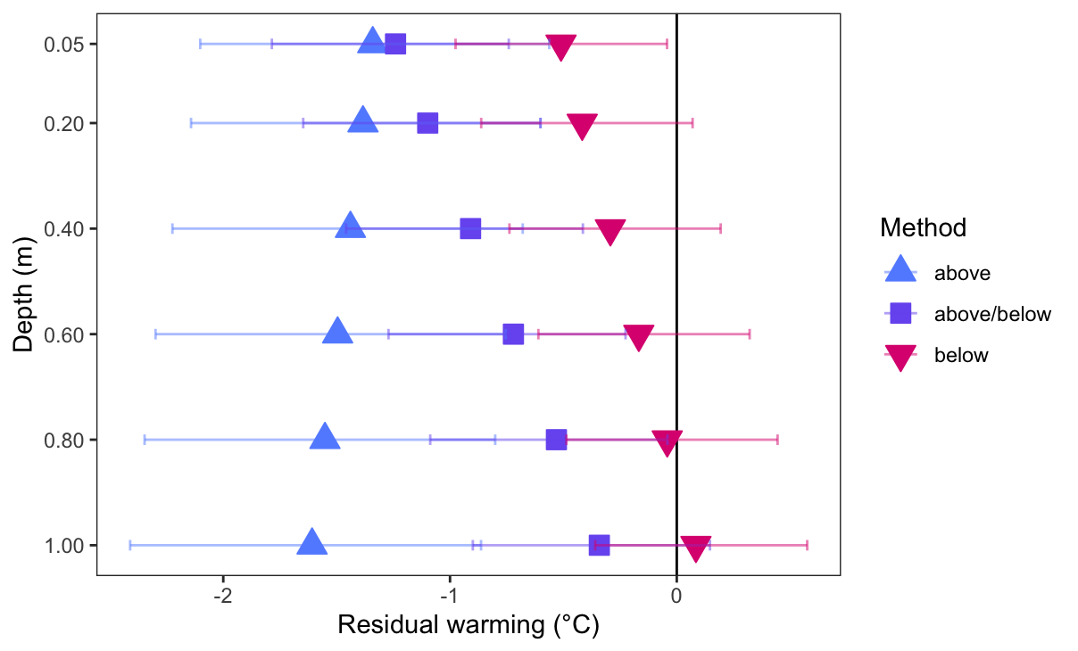
Fig. 4 Model estimated marginal means for residual warming with depth by warming method. Points show residual warming (observed - expected) at +4 °C target warming; error bars show lower 5% and upper 95% highest posterior density interval.

Warming impacts on soil moisture
Warming led to drier soils on average for the majority of sites, but with substantial variation among sites and across ecosystems (Fig. 5). Soil moisture differences also varied substantially with depth (Fig. 6). When compared across experiments (not normalized by imposed warming), forest soils dried the most; within forest types, the magnitude of soil drying was greatest in boreal forest soils and least in tropical soils. Grassland and cropland soils also tended to dry in response to warming, but not at all sites. At the non-forest sites in cool to cold climates (CiPEHR, SWAMP, TEAM, FutureClim) we saw the opposite trend of an increase in soil moisture with warming. Soil moisture at the tundra sites (CiPEHR, SWAMP, TEAM) increased more than at the FutureClim grassland site (Fig. 5). Another commonality across two of these sites (CiPEHR, FutureClim) was the use of passive OTCs for supplemental warming (Table 2), which are not employed at any of the other sites in this analysis.
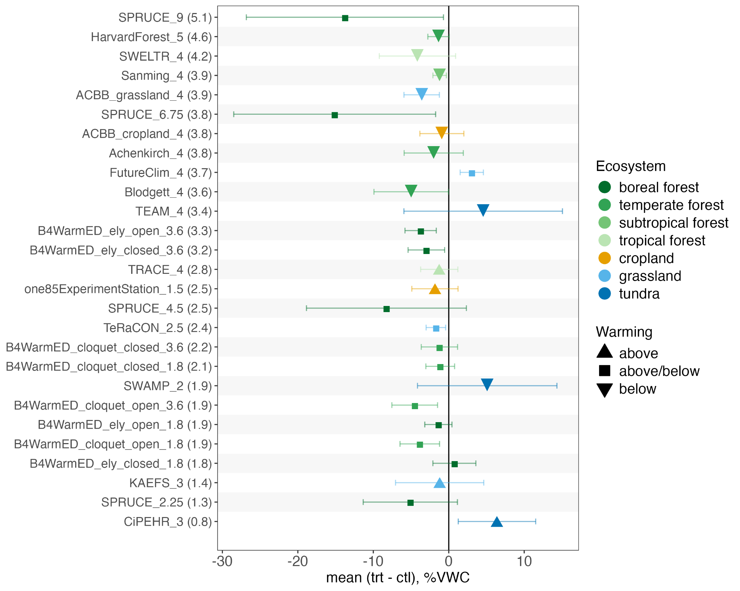
Fig. 5 Observed difference in soil moisture between warmed and ambient temperature plots. Points show mean difference in volumetric water content (%VWC), averaged across depth and time; error bars show ±sd. Y-axis ordered by degrees of realized warming (shown in parentheses); target degrees of warming shown after underscore in site name. See Table 2 for details of warming methodology. Notes: 1) warming for the CiPEHR experiment was primarily conducted in winter, but realized warming is the mean for the growing season, 2) open/closed refers to canopy cover at the B4WarmED sites.
Despite the trend toward soil drying observed at the forested sites, and the trend towards wetting at the tundra sites, ecosystem type was not a strong predictor of soil moisture change in the model (Table 2). The estimated median change in soil moisture with warming did not significantly differ from zero for any of the ecosystems when evaluated at the mean site conditions (Table 2). However, the model did indicate significant ecosystem level differences in both the direction and magnitude of soil moisture changes predicted per degrees of imposed warming (∆ST) (Table 2).
Table 2. Estimated marginal means for the soil moisture model coefficients. Bold face indicates terms with 95% credible intervals excluding zero. Values are evaluated under the dataset mean conditions: +3.3 °C warming, 0.31 m depth, 38% VWC ambient soil moisture, and 9.9 °C ambient soil temperature. ∆ST is the observed change in soil moisture.
Term | Slope | Credible interval |  | Intercept | Credible interval
 |  | 5% | 95% |  | 5% | 95%
boreal forest:∆ST | -0.42 | -0.61 | -0.23 | 1.34 | -3.44 | 6.06
temperate forest:∆ST | -0.17 | -0.71 | 0.37 | -3.14 | -14.68 | 11.22
subtrop. forest:∆ST | 0.11 | -0.33 | 0.56 | -2.83 | -10.78 | 7.81
tropical forest:∆ST | 0.08 | -0.26 | 0.43 | 3.60 | -2.96 | 12.93
grassland | 0.43 | 0.00 | 0.88 | -2.27 | -10.95 | 9.21
cropland | 0.13 | -0.17 | 0.42 | -1.55 | -11.36 | 10.80
tundra | -0.02 | -0.23 | 0.20 | 1.25 | -5.77 | 11.04
ambient soil moist. | -0.07 | -0.08 | -0.06
ambient soil temp. | 0.01 | -0.02 | 0.04
depth | 0.01 | 0.00 | 0.03

When considered across ecosystems, the change in observed soil moisture with warming was not strongly related to the degrees of imposed temperature change, in contrast to our expectations. It was only in the boreal forest soils that we observed a significant increase in drying with increasing temperature, at a rate of -0.4% VWC °C⁻¹ (95% HPD: -0.6, -0.2 %VWC °C⁻¹) (Table 2).
We saw a small but significant effect of ambient soil moisture on the magnitude of soil drying in the model, supporting our third hypothesis. The model estimate for this effect was a 0.07 (95% HPD: 0.06, 0.08) unit decrease in soil moisture (VWC%, defined as volume of water per volume soil) for every unit increase in ambient soil moisture (VWC%) (Table 2). In context, this equates to an additional 1% of soil moisture loss for a relatively dry soil with 15% VWC, but a 6% increase for a relatively wet soil with 85% VWC. We did not observe a significant effect of ambient soil temperature (Table 2).
The conditional R² for the soil moisture model was 0.44, indicating that much of the variance in the soil moisture response to warming is not explained by the combination of degrees of warming, ecosystem, depth, and ambient climate conditions (Fig. SI 5). We observed substantial variation in ∆SM with depth, although these trends were highly variable across sites (Fig. 6) and the effect of depth was only marginal in the model (Table 2). Partitioning of the explained variance indicated substantially more variation in ∆SM across sites (74%) than within sites (21%), and only a minor contribution in variance (5%) from site-specific ∆SM responses to degrees of imposed warming (Table SI 3).
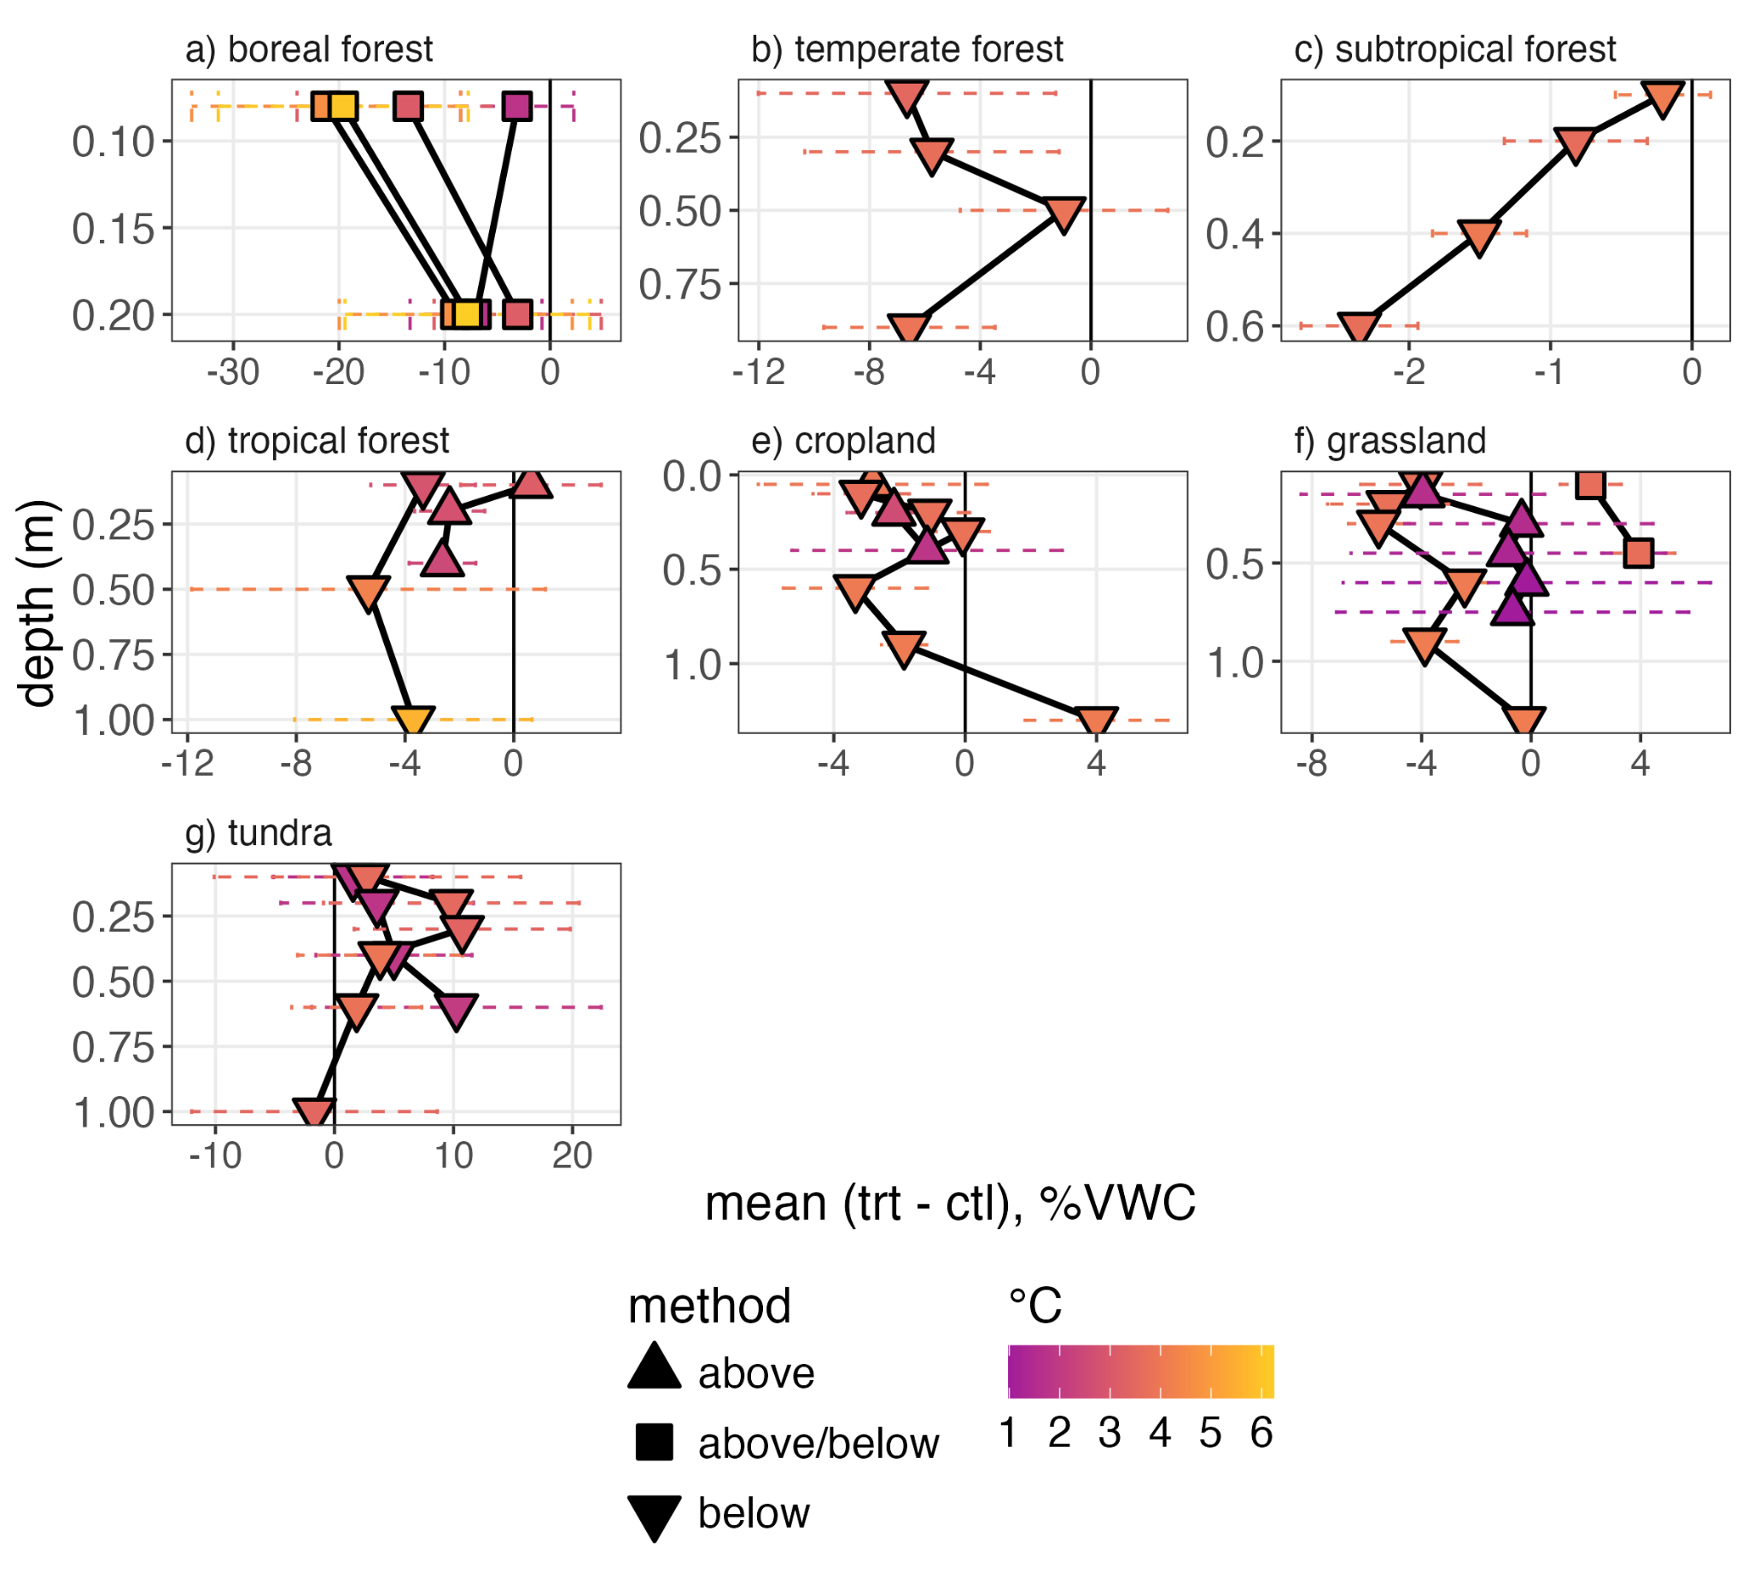
Fig. 6 Observed soil moisture differences by depth. Points show means, error bars ±SD. Color indicates observed degrees of warming (°C). VWC: volumetric water content; trt: warmed; ctl: ambient temperature. Sites with only one depth of observation (i.e., Achenkirch, B4WarmED Cloquet, B4WarmED Ely, CiPEHR, Harvard Forest, and TeRaCON) excluded for clarity of depth trends.
Soil moisture changes due to warming showed distinct temporal trends, including minimal variation on a day to day basis across all sites, and site specific seasonal offsets (Table SI 3). The seasonal offset term varied substantially across sites, suggesting a role for site-specific seasonal drivers of ∆SM, beyond those considered explicitly as fixed effects or the random slope and intercept terms (Fig. SI 4).

Discussion
Soil warming experiments provide critical information for understanding potential impacts of warming on ecosystem processes around the world. The question of how warming affects critical ecosystem services and processes is relevant across scales from microbial decomposition of soil organic matter to ecosystem scale drought to global atmospheric carbon exchange. Yet a great deal of uncertainty remains regarding belowground responses to warming, which may in part be attributed to uneven warming of biologically active soil layers that occurs in most experimental settings. Many published syntheses on soil warming responses rely on observations from studies in which passive OTCs were employed, a method that can in some contexts effectively warm air inside the chamber but does not provide consistent soil warming (Hollister et al., 2023). Aboveground IR based warming can effectively warm soils, especially when foliage canopies are not between the heaters and the soil, but as we demonstrate here, the warming effect attenuates with depth more than in experiments with below ground warming. To better constrain below ground warming responses, it is important to quantify precisely how much the soil is warming across the soil profile. Additionally, it is essential to quantify changes in soil moisture due to warming, given the importance of soil moisture for regulating biological activity.
Using the SWEDDIE database of deep soil warming experiments, we were able to quantify the magnitude of warming achieved in 23 warming experiments in six different biomes spread across the globe. This analysis revealed that regardless of the warming methodology applied at the individual experiments, the magnitude of warming varied with depth. This is not to be interpreted as a failure of experimental design, but rather as another reminder to quantify warming responses using observed, depth-resolved soil temperature data. In the context of synthesis, it is also important to use observed soil temperature data rather than stated target warming, as realized warming varied with depth even with active temperature control. Another point to clarify is that all warming methods were effective at warming soils, despite the relatively greater divergence from target warming temperatures (particularly at depth) observed with above ground only warming. For example, at the KAEFS site with above ground IR warming only, the soil temperature difference between warmed and ambient temperature plots was consistently >+1 °C at 0.7 m. At the other sites with above ground IR warming only (TRACE, 185ExperimentStation) the maximum depth of soil temperature measurement was 0.4 m, with observed mean warming of +2.5 °C and +1.9 °C respectively. It is important to note, however, that the relative warming with depth achieved via above ground IR methods can vary substantially throughout the year due to interference between foliage and the heaters, as previously demonstrated in the B4WarmED experiment (Roy et al., 2015).
Heat losses at the soil surface are the primary concern with belowground resistance cable heating. Recognizing this issue in earlier experiments motivated the installation of resistance cables at the soil surface at the Blodgett Forest site in addition to vertical resistance rods (reference needed?). This adaptation has also been implemented at the more recently built ACBB, TEAM, SWELTR, and Point Reyes experiments, demonstrating the practical benefit of cross-experiment collaboration. However, in spite of the improved warming achieved with the combination of surface cables and buried resistance rods, experiments with this warming configuration still tend to have surface soil temperatures that are warmed less effectively than deeper layers.
These differences in vertical warming gradients should be accounted for when assessing the temperature responses of soil processes by using depth resolved soil temperature data. Accounting for depth is particularly important when comparing warming responses across experiments warmed with above ground methods with those heated below ground only, as the variation in warming with depth may lead to differences in the relative response of above versus belowground processes. For example, an important component of the disagreement in global soil carbon model projections arises from uncertainty regarding the temperature sensitivity of soil organic matter decomposition. Given the evidence for soil carbon losses from deeper in the soil with experimental warming (Hicks Pries et al., 2017), variable warming of this vulnerable soil carbon reservoir due to differences in warming methodologies could lead to misinterpretation of the relative impacts of enhanced primary productivity versus decomposition on soil carbon stock changes in the coming decades. If these experimental manipulation results are to be useful in revealing the underlying soil biogeochemical mechanisms controlling soil carbon stock changes, and thereby improve model projections, soil warming depth profiles must be quantified accurately.
Our second main goal was to quantify changes in soil moisture in response to warming. Soils tend to dry with warming, in line with our hypothesis and the findings of previous studies [Xu et al., 2013; others]. Although warming tended to lead to soil drying, the relative drying response varied at the ecosystem level and with depth, suggesting potential ecosystem level controls on the relationship between soil drying and warming (Fig. 5). We observed clear differences in soil moisture with warming when evaluated at the site level, but these differences were not well explained by the combination of degrees of warming, ecosystem, or ambient climate conditions (Table 3, Fig. SI 5). The lack of explanatory power in these variables reflects the complexity of soil moisture responses to soil warming, and demonstrates the importance of accounting for soil moisture changes explicitly when assessing ecosystem warming responses that may be affected by soil moisture.
We expected to find a positive relationship between the magnitude of warming and soil moisture change at the ecosystem level, but this was only the case for the boreal forest soils (Table 3). This may reflect the fact that this was the only ecosystem in which we had multiple experiments with more than a single warming level, minimizing the impact of site-specific interactions between magnitude of warming and soil moisture change. This illustrates the challenge of comparing warming responses across sites, especially in the context of non-linear temperature responses (Kreyling et al., 2018; Hanson et al., 2015).
Earlier metaanalyses of warming impacts on soil moisture showed stronger support for ecosystem level differences in soil moisture change than we observed, but similarly found that while many soils exhibit drying, others show increased soil moisture with warming, in line with our findings (Xu et al., 2013). The substantial variation in soil moisture changes with warming observed in our data analysis may be due in part to the consideration of deeper soil layers, given that soil moisture varied substantially with depth in our dataset. The high temporal resolution of our dataset may have also contributed to the lack of significant differences in soil moisture changes at the ecosystem level, as we identified substantial site-level differences in the seasonal variation of warming induced soil moisture changes (Fig. SI 4)
Temporal shifts in the sensitivity of soil moisture changes to warming are relevant given the seasonality of many ecosystem processes. For example, if estimating warming effects on gross primary productivity, warming induced soil drying during the most active season of growth would likely have a greater impact than drying during annual periods of minimal plant productivity. The observed seasonal trends likely reflect local climate conditions, but also adaptations of the plant community to site-specific soil moisture conditions.
We would expect the relationship between soil moisture and warming to be non-linear from a theoretical standpoint. More evaporation is expected with higher energy input (warming), but only when soil moisture levels remain in the range between the permanent wilting point and the critical moisture threshold (defined as the point at which soil moisture no longer influences latent heat fluxes) (Hsu et al., 2023). Through comparison to previous global analyses (Seneviratne et al., 2010) we estimate that the majority of our sites fall within this transitional soil moisture regime, indicating that ambient soil moisture is likely to be a critical factor controlling evaporative soil moisture losses. Our model results support this theoretical relationship, with proportionally more drying observed in wetter soils given the same magnitude of warming.
Tundra ecosystems are a clear exception to the overall trend of warming induced drying. For tundra sites on permafrost, warming-induced thaw can lead to thermokarst collapse. This phenomenon has been documented at the CiPEHR experiment in SWEDDIE which is underlain by permafrost. The results in SWEDDIE confirm earlier findings of increased soil moisture in the warmed plots at CiPEHR, but also demonstrate soil wetting with warming in the absence of thermokarst collapse at the other tundra sites (TEAM, SWAMP). The mechanisms behind the increase in soil moisture at these tundra sites and the FutureClim grassland site are not clear from the current dataset, but likely involve site specific interactions, e.g., soil texture, potential influence of ground water or water infiltration outside the warmed plots, and non-temperature related factors influencing evaporative losses that are due to the warming methodology.
We were not able to directly assess the impact of warming methodology on soil moisture in this study, due to the wide range of warming methods in use across the SWEDDIE experiments and the fact that not all methods were represented in each ecosystem. However, from previously published work we know that above ground warming methods can have divergent impacts on soil moisture changes. Specifically, active circulation of warm air in the enclosures constructed for the SPRUCE experiment was found to reduce relative air humidity, which in combination with warming led to shifts in the vapor pressure deficit, and in turn would be expected to increase evaporative soil moisture losses (Hanson et al., 2017). In line with this expectation, we observed the most substantial soil drying response at the SPRUCE experimental site (SPRUCE). In contrast, the passive OTC warming method can increase relative humidity in the chamber headspace, which in turn would be expected to reduce evaporative soil moisture losses. Again, in line with this expectation, we observed increased soil moisture with warming at both sites that employed passive OTCs for above ground warming (CiPEHR, FutureClim). The mitigating effect of the passive OTC system on evaporative soil moisture losses may have contributed to why the FutureClim site was the only non-tundra site where soil warming led to soil wetting.
The variable effect of warming methodology on soil moisture changes is a useful illustration of both the power and the limitations of SWEDDIE for synthesizing ecosystem warming responses. A database with a relatively small number of sites will inevitably run into situations in which methodological effects cannot be effectively separated from site-specific variability, and this limitation must be assessed in combination with the available data when engaging in synthesis. However, the power of SWEDDIE lies in the potential to improve the quantification of warming responses across the entire biologically active portion of the soil profile, as well as how such warming responses may vary over subannual time scales. If we are to reduce the uncertainty in the predictions of future soil carbon stock changes, rates of nutrient cycling, or any other soil processes affected by warming, quantifying both realized warming and attendant shifts in soil moisture is a necessary first step.
The results of the soil moisture and temperature quantification presented here are a key building block of the next planned synthesis efforts: 1) using selected experiments to benchmark soil carbon warming responses with the ecosys model, and 2) quantifying soil CO₂ fluxes in response to warming. If, for example, the results of future modeling work provides mechanistic insight into warming induced changes in soil carbon stocks, it would point towards future sampling and observation campaigns to test these mechanisms further in a positive research feedback loop. The whole process can be summarized as active community engagement leads to improved data coverage, which in turn enhances the capacity to generalize warming responses across ecological gradients, inform site- to global-scale models, and transcend methodological biases.

Conclusion
The SWEDDIE database is a unique community resource built with the aim of supporting synthesis of whole soil warming responses across ecosystems. We envision the current work as both proof of concept and a foundation for future syntheses. These first soil temperature and moisture results demonstrate the scope and extent of baseline data coverage, as well as providing a framework for growing the database with additional datasets. Through the process of data sharing we have also strengthened the DeepSoil2100 network, which has already proved instrumental for knowledge sharing about experimental design and implementation. Given the importance of soil temperature and moisture for controlling biological activity across the soil profile, this is an important first step for identifying and quantifying depth-explicit warming and potentially reducing bias from shallow warming experiments that dominate the current literature.
The direction and magnitude of soil moisture changes induced by warming varied across ecosystems in our study, trending towards drying in temperate and boreal forest soils, remaining unchanged in grassland and cropland soils, and wetting in tundra soils. The lack of a universal relationship between warming and soil moisture changes is unsurprising given the complex interactions between atmosphere, plant, and soil that control soil moisture. However, quantification of these shifts in soil moisture is necessary in order to control for the simultaneous impact of warming on soil moisture and accurately assess the direct effect of temperature on ecosystem warming responses.
Our results demonstrate that all warming methods were successful in warming soils, but that belowground methods were more effective at warming deeper soils and the warming was also more consistent across the soil profile. These methodological differences have important implications for assessing the relationship between warming and depth-dependent ecosystem processes, and these methodological differences must be accounted for to avoid bias in the interpretation of overall warming effects. For example, accounting for methodological differences on soil moisture or soil temperature depth profiles has important implications for assessing the impact of warming on soil carbon stock changes. Subsoils store a substantial amount of carbon, but the temperature sensitivity of decomposition in subsoils is poorly quantified relative to topsoils. Accordingly, we urge future synthesis efforts to use depth-resolved observations of soil temperature and moisture when it is possible, or to acknowledge the potential bias on ecosystem warming responses when they are not.

Supplemental

Methods

Database

Experiment
The experiment table provides information about the physical infrastructure installed in each experiment. This includes the method of warming (infrared, cables, rods, open topped chambers, etc.), sensors installed, data types collected, beginning and end dates of warming, and additional treatments imposed (elevated CO₂, precipitation manipulation, nutrient additions, etc.). The ‘exp_name’ variable provides the key linkage between this and other core tables.

Site
The site table provides information about the climate, soils, and vegetation for each experiment. Experiments may have one or more sites, each of which is uniquely defined by the combination of the ‘exp_name’ and ‘sit_name’ variables.

Plot
The plot table defines the experimental design, and each record (row) of this table is defined by a unique combination of the ‘exp_name’, ‘sit_name’, and ‘plt_name’ variables. The plot table serves to link imposed treatments with measured data,. therefore the values for ‘plt_name’ in all dat tables must match with those recorded in the plot table. In order to accommodate the diversity of experimental design choices across the network, as well as reflect the naming conventions employed within individual experiments, this table contains additional columns for blocks and sub-blocks as applicable. Imposed heating is encoded in the ‘plt_heat_level’ variable, defined as the difference (in °C) from the control. Additional treatments are encoded in the variables ‘plt_treat_add_name’, ‘plt_treat_add_level’, and ‘plt_treat_add_units’, which define the treatment name, treatment level, and units respectively. Plots with multiple treatments are accommodated through semi-colon separated lists. Ex., for a plot with elevated CO₂ at 100 ppm above ambient and 50 percent reduced precipitation, the values in the ‘plt_treat_add_name’ column would be “elevated CO2; reduced precipitation”, the values in the ‘plt_treat_add_level’ column would be “100; 50”, and the values in the ‘plt_treat_add_units’ column would be “ppm above ambient; percent of ambient”.
Fig. SI 1 Entity relationship diagram for a single entry (experiment) in SWEDDIE. 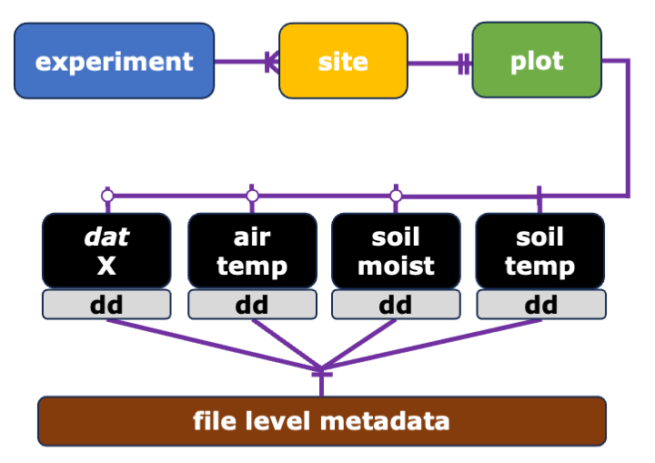

Models
Eq. 1 Generalized likelihood formula for Bayesian linear mixed effect models
$y_{ij} | u_{ij},σ_{j}∼N\left(u_{ij},σ_{j}^{2}\right)$
where y_{ij} is the i-th response of soil moisture difference or soil temperature difference at site j given the fixed effects u_{ij}, and site-specific residual variance $σ$_{j}. We assumed Gaussian normal distributions for both fixed effects and the standard deviation of the site-specific residual variances ($σ_{j}^{2}$). In both models we included a temporal autocorrelation structure to account for memory effects in the residuals, fitted by site, warming treatment, and depth at a daily, i.e., first order, timestep. The ∆SM model also contains an additional cyclical spline function term to account for site-specific seasonal trends in the response of ∆SM (SI Fig. 3).
Eq. 2 Soil temperature model fixed effect matrix u_{ij}
${∆ST}_{ij}$ = $β_{0}+β_{H}⋅H_{i}+β_{depth}⋅D_{i}$ +
$\sum_{w}{}β_{{wrm}_{w}}⋅{wrm}_{iw}+$
$+\sum_{w}{}β_{{wrmxD}_{w}}⋅{wrm}_{iw}⋅D_{i}$

Where ∆ST_{ij} is the ith observation of observed temperature difference (treatment - control) at site j, H_{i} is the warming target (in degrees of heating), and D_{i} is depth. The coefficients for the categorical variables of warming method wrm are given as sums of the product of the coefficients and a dummy variable for each level w of wrm (above ground, below ground, above + below ground). The coefficients for the interaction terms of wrm by D are given as wrmxD_{w}.
Eq. 3 Soil moisture model fixed effects matrix u_{ij}
${∆SM}_{ij}$ = $β_{0}+β_{ST}⋅∆{ST}_{i}+β_{ambSM}⋅{ambSM}_{i}+β_{ambST}⋅{ambST}_{i}+β_{depth}⋅D_{i}$
${+β}_{ambSMxST}⋅∆{ST}_{i}⋅{ambSM}_{i}+β_{ambSTxST}⋅∆{ST}_{i}⋅{ambST}_{i}$
$+\sum_{e}{}β_{{eco}_{e}}⋅{eco}_{ie}+\sum_{g}{}β_{{growS}_{g}}⋅{growS}_{ig}$
$+\sum_{e}{}β_{{ecoxST}_{e}}⋅{∆ST}_{i}⋅{eco}_{ie}$
Where ∆SM_{ij} is the i-th difference (treatment - control) in volumetric soil water (VWC) content at site j, and ambSM and ambST are the ith observation of observed temperature difference , mean ambient soil temperature, mean ambient soil moisture, and depth, respectively; 𝛽 values are the corresponding model coefficients. The coefficients for the categorical variables of ecosystem (eco) and growing season (growS) are given as sums of the product of the coefficients and a dummy variable for each level e of eco (boreal forest, temperate forest, tropical forest, tundra, grassland, cropland) and g of growS (growing season/non-growing season). The coefficients for the interaction terms of ambSM by ∆ST, and ambST by ∆ST, are denoted with the subscripts ambSMxST and ambSTxST, while those for each level e of eco are denoted with the subscript ecoxST.

Tables
Table SI 1 Experiment locations

Experiment | Country | Lat. | Long. | Elev. | MAT | MAP | PET | Ecosystem | Soil Order
 |  | dec. deg. |  | m | °C | mm yr-1 |  |  | USDA
185 Experiment Station | China | 37.88 | 114.68 | 50 | 14.8 | 741 | 1468 | cropland | Inceptisols
ACBB | France | 46.42 | 0.12 | 146 | 12 | 760 | 1025 | grassland; cropland | Alfisols
Achenkirch | Austria | 47.58 | 11.64 | 910 | 6.8 | 1563 | 883 | temperate forest | Alfisols
B4WarmED | USA | 47.03 | -91.92 | 382 | 3.0; 4.5 | 807 | 870; 970 | temperate forest; boreal forest | Spodisols; Alfisols
Blodgett | USA | 38.91 | -120.66 | 1370 | 12.5 | 1774 | 1681 | temperate forest | Alfisols
CiPEHR | USA | 63.88 | -149.23 | 700 | -1 | 378 | 592 | tundra | Inceptisols
ForHot | Iceland | 64.01 | -21.18 | 126 | 5.2 | 1457 | 564 | boreal forest | Inceptisols
FutureClim | Australia | -36.37 | 148.43 | 1600 | 6.3 | 2144 | 1111 | grassland | Inceptisols
GENX | USA | 38.88 | -76.55 | 0 | 13 | 1130 | 1359 | salt marsh | Ultisols
Harvard Forest | USA | 42.54 | -72.18 | 340 | 8.2 | 1141 | 1007 | temperate forest | Inceptisols
Lyon Arboretum | USA | 21.33 | -157.8 | 150 | 25.6 | 4200 | 1891 | tropical forest | Andisols
KAEFS | USA | 34.98 | -97.52 | 330 | 16.3 | 914 | 1773 | grassland | Inceptisols
MERIT | Germany | 54.6 | 8.82 | 0 | 10.2 | 1048 | 679 | salt marsh | Entisols
Point Reyes | USA | 37.97 | -122.73 | 125 | 12.5 | 1774 | 1384 | grassland | Alfisols
Sanming | China | 26.17 | 117.47 | 250 | 19.3 | 1638 | 1355 | subtropical forest | Ultisols
SMARTX | USA | 38.88 | -76.55 | 0 | 13 | 1130 | 1359 | salt marsh | Ultisols
SPRUCE | USA | 47.51 | -93.45 | 418 | 3.3 | 768 | 921 | peatland | Alfisols
Stillberg | Switzerland | 46.77 | 9.87 | 2180 | 2.1 | 1155 | 716 | temperate forest | Inceptisols
SWAMP | China | 37.5 | 100.24 | 3670 | -0.1 | 365 | 1037 | tundra | Mollisols
SWELTR | Panama | 9.16 | -79.85 | 60 | 26 | 2600 | 1679 | tropical forest | Ultisols
TEAM | China | 37.62 | 101.2 | 3200 | -0.6 | 460 | 1090 | tundra | Gelisols
TeRaCON | USA | 45.4 | -93.2 | 282 | 7 | 660 | 1044 | grassland | Entisols
TRACE | USA | 18.3 | -65.83 | 100 | 24 | 3500 | 1575 | tropical forest | Ultisols

Table SI 2 Residual warming model summary

Family: gaussian
Links: mu = identity; sigma = identity
Formula: stR ~ tDif + wrm2 * depth + (1 | sit_name)
Data: df (Number of observations: 240287)
Draws: 4 chains, each with iter = 2000; warmup = 1000; thin = 1;
total post-warmup draws = 4000

Multilevel Hyperparameters:
~sit_name (Number of levels: 23)
Estimate Est.Error l-95% CI u-95% CI Rhat Bulk_ESS Tail_ESS
sd(Intercept) 0.76 0.14 0.55 1.08 1.00 846 1323

Regression Coefficients:
Estimate Est.Error l-95% CI u-95% CI Rhat Bulk_ESS Tail_ESS
Intercept 0.19 0.39 -0.58 0.96 1.00 1337 1522
tDif -0.38 0.00 -0.38 -0.38 1.00 3459 2367
wrm2aboveDbelow 0.04 0.47 -0.93 0.98 1.00 1228 1249
wrm2below 0.79 0.45 -0.11 1.70 1.00 1208 1389
depth -0.00 0.00 -0.00 -0.00 1.00 3841 2687
wrm2aboveDbelow:depth 0.01 0.00 0.01 0.01 1.00 3853 2710
wrm2below:depth 0.01 0.00 0.01 0.01 1.00 3822 2595

Further Distributional Parameters:
Estimate Est.Error l-95% CI u-95% CI Rhat Bulk_ESS Tail_ESS
sigma 1.37 0.00 1.37 1.38 1.00 3486 2146

Draws were sampled using sampling(NUTS). For each parameter, Bulk_ESS
and Tail_ESS are effective sample size measures, and Rhat is the potential
scale reduction factor on split chains (at convergence, Rhat = 1).
SI Table 3 Soil moisture model summary

Family: gaussian
Links: mu = identity; sigma = identity
Formula: sm_mean ~ st_mean * eco + st_mean * control_mean.sm + st_mean * control_mean.st + depth + s(doy, sit_name, bs = "fs") + (1 + st_mean | sit_name)
autocor ~ arma(time = day, gr = sit_name:tDif:depth, p = 1, q = 0, cov = FALSE)
Data: df (Number of observations: 61315)
Draws: 4 chains, each with iter = 2000; warmup = 1000; thin = 1;
total post-warmup draws = 4000

Smoothing Spline Hyperparameters:
Estimate Est.Error l-95% CI u-95% CI Rhat Bulk_ESS Tail_ESS
sds(sdoysit_name_1) 20.23 3.19 14.47 26.81 1.01 1205 2232
sds(sdoysit_name_2) 5.28 4.96 0.23 18.49 1.00 3766 2548
sds(sdoysit_name_3) 16.53 4.14 9.86 25.98 1.00 2350 3106

Correlation Structures:
Estimate Est.Error l-95% CI u-95% CI Rhat Bulk_ESS Tail_ESS
ar[1] 0.99 0.00 0.99 0.99 1.00 3719 2938

Multilevel Hyperparameters:
~sit_name (Number of levels: 19)
Estimate Est.Error l-95% CI u-95% CI Rhat Bulk_ESS Tail_ESS
sd(Intercept) 6.71 1.34 4.61 9.83 1.00 2313 2582
sd(st_mean) 0.48 0.10 0.31 0.73 1.00 1929 2697
cor(Intercept,st_mean) 0.28 0.25 -0.27 0.71 1.00 1471 2093

Regression Coefficients:
Estimate Est.Error l-95% CI u-95% CI Rhat Bulk_ESS Tail_ESS
Intercept 1.34 2.38 -3.44 6.06 1.00 1233 2058
st_mean -0.42 0.10 -0.61 -0.23 1.00 2376 2618
ecocropland -2.89 3.21 -9.26 3.40 1.00 2191 2850
ecograssland -3.62 2.71 -8.85 1.81 1.00 2199 2961
ecosubtropicalforest -4.18 2.31 -8.69 0.41 1.00 2670 3219
ecotemperateforest -4.48 4.22 -12.58 3.82 1.00 1916 2445
ecotropicalforest 2.25 1.68 -0.86 5.52 1.00 2920 3130
ecotundra -0.10 1.84 -3.68 3.63 1.00 2461 2874
control_mean.sm -0.07 0.00 -0.08 -0.06 1.00 6886 3286
control_mean.st 0.01 0.01 -0.02 0.04 1.00 6904 3300
depth 0.01 0.01 -0.00 0.03 1.00 7310 3164
st_mean:ecocropland 0.55 0.15 0.25 0.84 1.00 2658 2963
st_mean:ecograssland 0.85 0.22 0.42 1.30 1.00 3079 2866
st_mean:ecosubtropicalforest 0.53 0.23 0.09 0.98 1.00 4422 3447
st_mean:ecotemperateforest 0.25 0.27 -0.29 0.79 1.00 2506 2687
st_mean:ecotropicalforest 0.50 0.18 0.16 0.85 1.00 4007 3171
st_mean:ecotundra 0.40 0.11 0.19 0.62 1.00 2734 3013
st_mean:control_mean.sm 0.01 0.00 0.01 0.01 1.00 3017 3563
st_mean:control_mean.st 0.01 0.00 0.00 0.02 1.00 6768 3359

Further Distributional Parameters:
Estimate Est.Error l-95% CI u-95% CI Rhat Bulk_ESS Tail_ESS
sigma 1.94 0.01 1.93 1.95 1.01 4778 2614

Figures

Fig. SI 2 Mean annual temperature and mean annual precipitation.

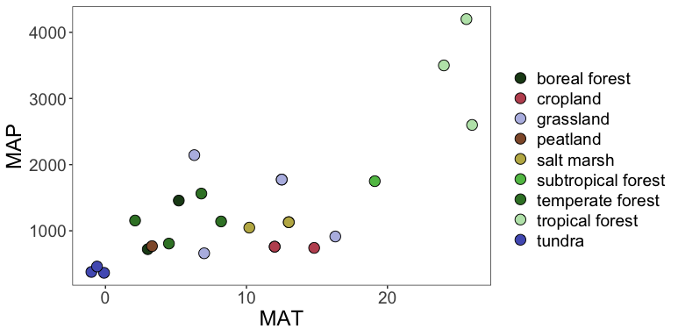

Fig. SI 3 Heating duration
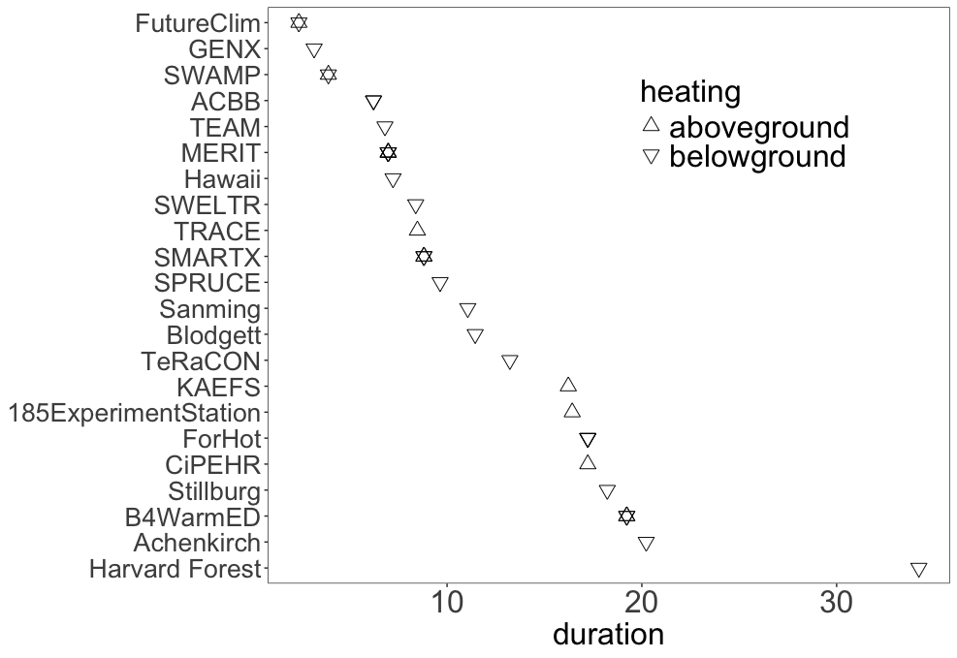

Fig. SI 4 Estimated day of year offset in ∆SM after accounting for fixed and random effects in the ∆SM model. Lines and ribbons show posterior mean and 95% credible intervals, respectively. Notes: depth was set to 0.3 m, and days of the year outside of the range of observed data were excluded for sites with partial year warming (B4WarmED sites, FutureClim, SWAMP, and TeRaCON). 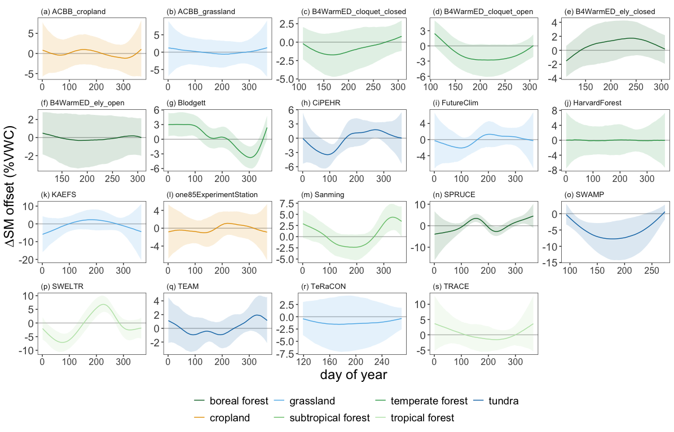

Fig. SI 5 Model predicted ∆SM

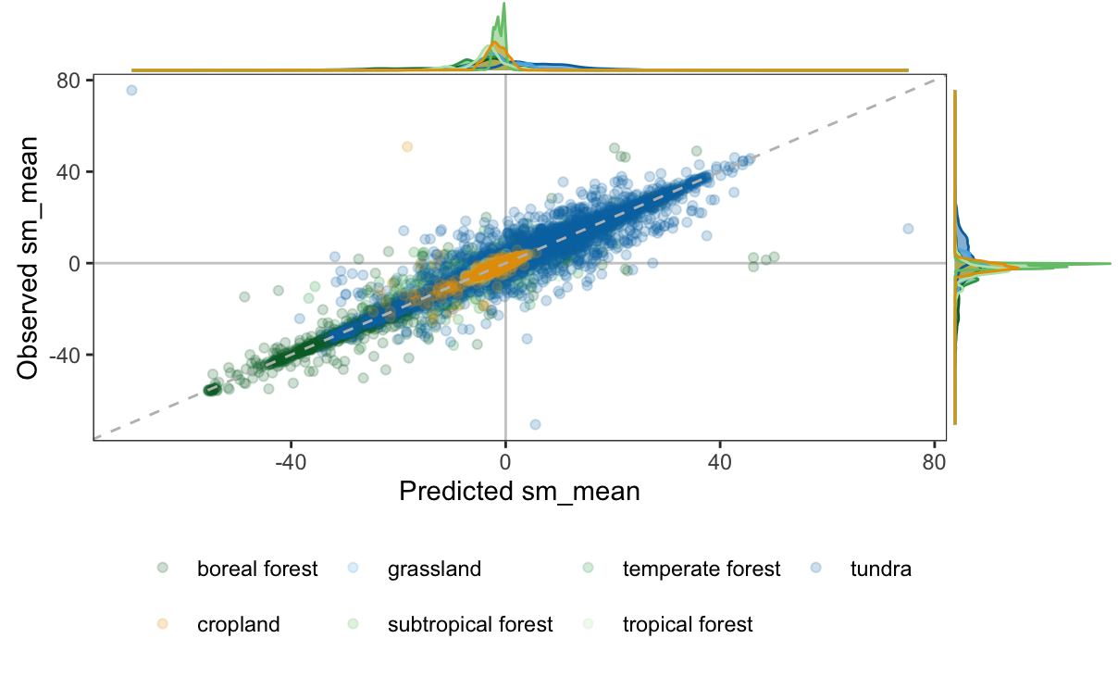

Fig. SI 6 Predicted difference in volumetric soil moisture between warmed and ambient temperature plots as a function of ambient soil moisture and ecosystem type. Lines show estimated marginal means from Bayesian generalized linear model, ribbons show the 75% highest posterior density interval.
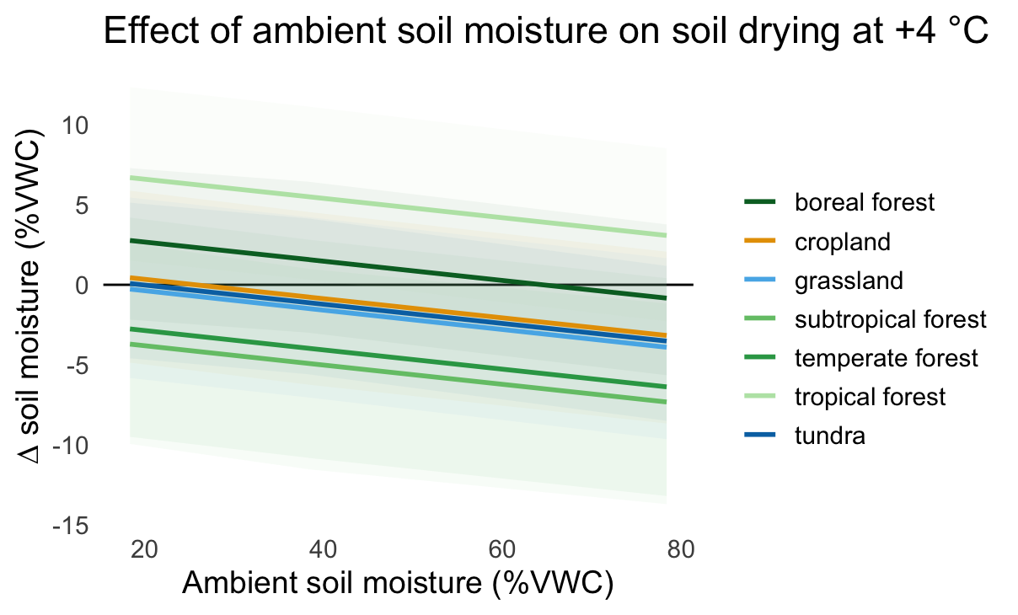

Fig. 7 Ambient soil moisture (x) as a function of depth in cm (y), by ecosystem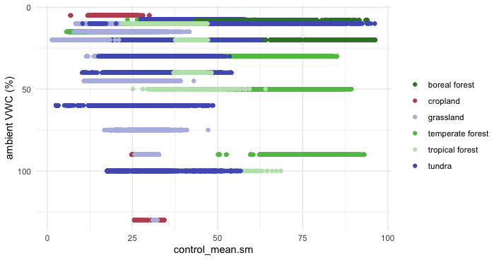

Fig. 8 Frequency distribution of ∆SM by site and depth

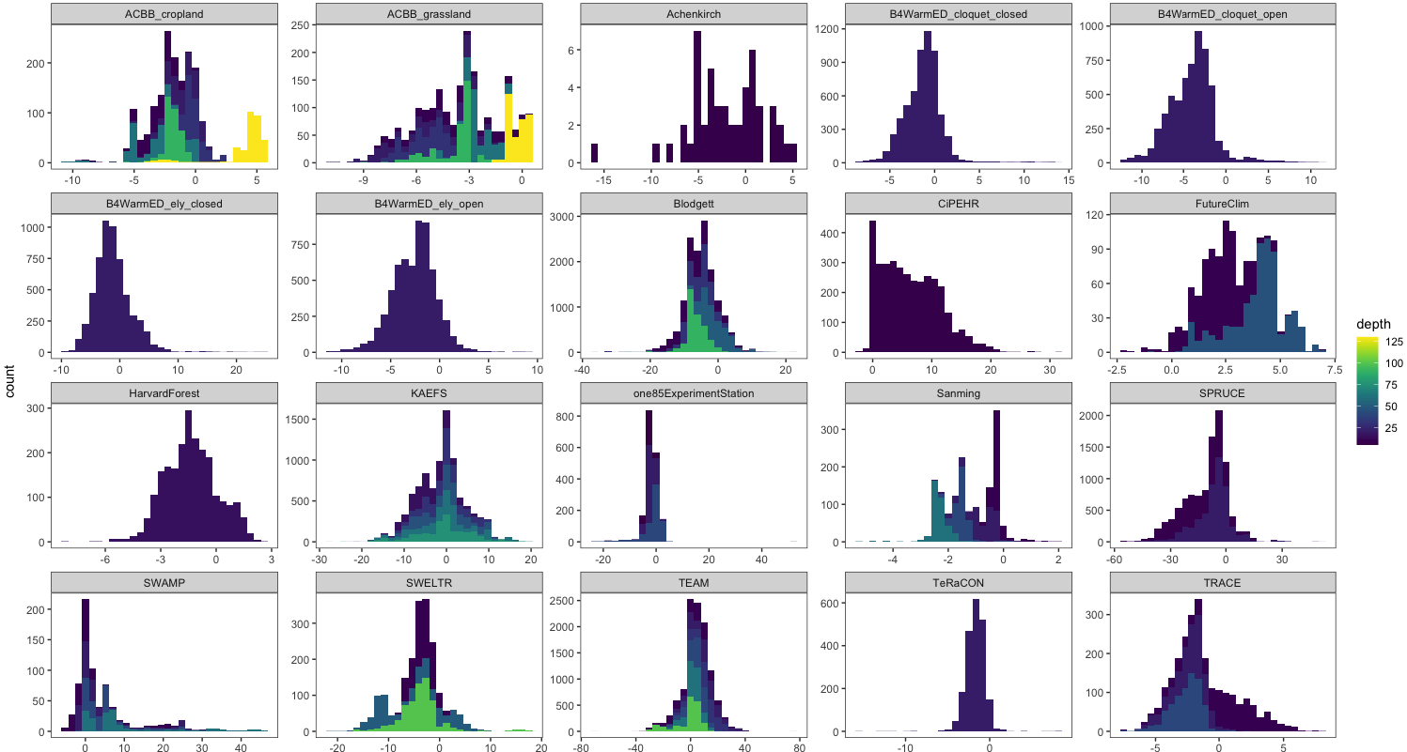

References
Agarwal, D., Varadharajan, C., Cholia, S., Snavely, C., Hendrix, V., Gunter, D., Riley, W.J., Jones, M., Budden, A.E. and Vieglais, D., 2017, December. Environmental System Science Data Infrastructure for a Virtual Ecosystem (ESS-DIVE)-a new US DOE data archive. In AGU Fall Meeting Abstracts (Vol. 2017, pp. IN12B-06).

Allison, S.D. and Treseder, K.K., 2008. Warming and drying suppress microbial activity and carbon cycling in boreal forest soils. Global change biology, 14(12), pp.2898-2909.

Aronson, E.L. and McNulty, S.G., 2009. Appropriate experimental ecosystem warming methods by ecosystem, objective, and practicality. Agricultural and Forest Meteorology, 149(11), pp.1791-1799.

Bai, E., Li, S., Xu, W., Li, W., Dai, W. and Jiang, P., 2013. A meta‐analysis of experimental warming effects on terrestrial nitrogen pools and dynamics. New Phytologist, 199(2), pp.441-451.

Bai, Y., Peng, Y., Zhou, W., Xie, Y., Li, Q., Yang, G., Chen, L., Zhu, B. and Yang, Y., 2023. SWAMP: A new experiment for simulating permafrost warming and active layer deepening on the Tibetan Plateau. Methods in Ecology and Evolution, 14(7), pp.1732-1746.

Bond‐Lamberty, B., Christianson, D.S., Malhotra, A., Pennington, S.C., Sihi, D., AghaKouchak, A., Anjileli, H., Altaf Arain, M., Armesto, J.J., Ashraf, S. and Ataka, M., 2020. COSORE: A community database for continuous soil respiration and other soil‐atmosphere greenhouse gas flux data. Global change biology, 26(12), pp.7268-7283.

Carter, K.R., Wood, T.E., Reed, S.C., Schwartz, E.C., Reinsel, M.B., Yang, X. and Cavaleri, M.A., 2020. Photosynthetic and respiratory acclimation of understory shrubs in response to in situ experimental warming of a wet tropical forest. Frontiers in Forests and Global Change, 3, p.576320.

European Commission Directorate-General Joint Research Centre. Land Surface Phenology Start-of-Season Date 2023-present (raster 300 m), global, yearly - version 1-, 2024. Accessed on 8 Sep. 2025. https://globalland.vito.be/geonetwork/srv/api/records/clms_global_lsp_sosd_300m_v1_yearly

Flanagan, L.B. and Johnson, B.G., 2005. Interacting effects of temperature, soil moisture and plant biomass production on ecosystem respiration in a northern temperate grassland. Agricultural and Forest Meteorology, 130(3-4), pp.237-253.

Falloon, P., Jones, C.D., Ades, M. and Paul, K., 2011. Direct soil moisture controls of future global soil carbon changes: An important source of uncertainty. Global Biogeochemical Cycles, 25(3).

Friedlingstein, P., O'sullivan, M., Jones, M.W., Andrew, R.M., Hauck, J., Landschützer, P., Le Quéré, C., Li, H., Luijkx, I.T., Olsen, A. and Peters, G.P., 2024. Global carbon budget 2024. Earth System Science Data Discussions, 2024, pp.1-133.

Green, J.K., Seneviratne, S.I., Berg, A.M., Findell, K.L., Hagemann, S., Lawrence, D.M. and Gentine, P., 2019. Large influence of soil moisture on long-term terrestrial carbon uptake. Nature, 565(7740), pp.476-479.

Hanson, P.J., Riggs, J.S., Nettles, W.R., Phillips, J.R., Krassovski, M.B., Hook, L.A., Gu, L., Richardson, A.D., Aubrecht, D.M., Ricciuto, D.M. and Warren, J.M., 2017. Attaining whole-ecosystem warming using air and deep-soil heating methods with an elevated CO 2 atmosphere. Biogeosciences, 14(4), pp.861-883.

Hicks Pries, C.E., Castanha, C., Porras, R.C. and Torn, M.S., 2017. The whole-soil carbon flux in response to warming. Science, 355(6332), pp.1420-1423.

Hicks Pries, C.E., Ryals, R., Zhu, B., Min, K., Cooper, A., Goldsmith, S., Pett-Ridge, J., Torn, M. and Berhe, A.A., 2023. The deep soil organic carbon response to global change. Annual Review of Ecology, Evolution, and Systematics, 54(1), pp.375-401.

Hollister, R.D., Elphinstone, C., Henry, G.H., Bjorkman, A.D., Klanderud, K., Björk, R.G., Björkman, M.P., Bokhorst, S., Carbognani, M., Cooper, E.J. and Dorrepaal, E., 2022. A review of open top chamber (OTC) performance across the ITEX Network. Arctic Science, 9(2), pp.331-344.

Jia, J., Cao, Z., Liu, C., Zhang, Z., Lin, L.I., Wang, Y., Haghipour, N., Wacker, L., Bao, H., Dittmar, T. and Simpson, M.J., 2019. Climate warming alters subsoil but not topsoil carbon dynamics in alpine grassland. Global Change Biology, 25(12), pp.4383-4393.

Khan, M.Z., Chabbi, A., Pries, C.E.H., Torn, M.S. and Rumpel, C., 2023. Management impacts on whole soil warming responses of CO2 production and efflux in temperate climate. Geoderma, 440, p.116725.

Kreyling, J., Schweiger, A.H., Bahn, M., Ineson, P., Migliavacca, M., Morel‐Journel, T., Christiansen, J.R., Schtickzelle, N. and Larsen, K.S., 2018. To replicate, or not to replicate–that is the question: how to tackle nonlinear responses in ecological experiments. Ecology Letters, 21(11), pp.1629-1638.

Lawrence, C.R., Beem-Miller, J., Hoyt, A.M., Monroe, G., Sierra, C.A., Stoner, S., Heckman, K., Blankinship, J.C., Crow, S.E., McNicol, G. and Trumbore, S., 2020. An open-source database for the synthesis of soil radiocarbon data: International Soil Radiocarbon Database (ISRaD) version 1.0. Earth System Science Data, 12(1), pp.61-76.

Liang, G., Stefanski, A., Eddy, W.C., Bermudez, R., Montgomery, R.A., Hobbie, S.E., Rich, R.L. and Reich, P.B., 2024. Soil respiration response to decade-long warming modulated by soil moisture in a boreal forest. Nature Geoscience, 17(9), pp.905-911.

Liu, L., Hu, C., Olesen, J.E., Ju, Z., Yang, P. and Zhang, Y., 2013. Warming and nitrogen fertilization effects on winter wheat yields in northern China varied between four years. Field Crops Research, 151, pp.56-64.

Lu, M., Zhou, X., Yang, Q., Li, H., Luo, Y., Fang, C., Chen, J., Yang, X. and Li, B.O., 2013. Responses of ecosystem carbon cycle to experimental warming: a meta‐analysis. Ecology, 94(3), pp.726-738.

Malhotra, A., Todd-Brown, K., Nave, L.E., Batjes, N.H., Holmquist, J.R., Hoyt, A.M., Iversen, C.M., Jackson, R.B., Lajtha, K., Lawrence, C. and Vindušková, O., 2019. The landscape of soil carbon data: emerging questions, synergies and databases. Progress in Physical Geography: Earth and Environment, 43(5), pp.707-719.

Manzoni, S., Taylor, P., Richter, A., Porporato, A. and Ågren, G.I., 2012. Environmental and stoichiometric controls on microbial carbon‐use efficiency in soils. New Phytologist, 196(1), pp.79-91.

Martins, C.S., Nazaries, L., Delgado‐Baquerizo, M., Macdonald, C.A., Anderson, I.C., Hobbie, S.E., Venterea, R.T., Reich, P.B. and Singh, B.K., 2017. Identifying environmental drivers of greenhouse gas emissions under warming and reduced rainfall in boreal–temperate forests. Functional Ecology, 31(12), pp.2356-2368

McFarlane, K.J., Cusack, D.F., Dietterich, L.H., Hedgpeth, A.L., Finstad, K.M. and Nottingham, A.T., 2024. Experimental warming and drying increase older carbon contributions to soil respiration in lowland tropical forests. Nature Communications, 15(1), p.7084.

McGrath, C.R., Hicks Pries, C.E., Nguyen, N., Glazer, B., Lio, S. and Crow, S.E., 2022. Minerals limit the deep soil respiration response to warming in a tropical Andisol. Biogeochemistry, 161(2), pp.85-99.

Melillo, J.M., Frey, S.D., DeAngelis, K.M., Werner, W.J., Bernard, M.J., Bowles, F.P., Pold, G., Knorr, M.A. and Grandy, A.S., 2017. Long-term pattern and magnitude of soil carbon feedback to the climate system in a warming world. Science, 358(6359), pp.101-105.

Nave L, Johnson K, van Ingen C, et al. (2017) International Soil Carbon Network (ISCN) Database v3-1. DOI: 10.17040/ISCN/1305039.

Nottingham, A.T., Meir, P., Velasquez, E. and Turner, B.L., 2020. Soil carbon loss by experimental warming in a tropical forest. Nature, 584(7820), pp.234-237.

Pegoraro, E.F., Mauritz, M.E., Ogle, K., Ebert, C.H. and Schuur, E.A., 2021. Lower soil moisture and deep soil temperatures in thermokarst features increase old soil carbon loss after 10 years of experimental permafrost warming. Global Change Biology, 27(6), pp.1293-1308.

Peterjohn, W.T., Melillo, J.M., Bowles, F.P. and Steudler, P.A., 1993. Soil warming and trace gas fluxes: experimental design and preliminary flux results. Oecologia, 93(1), pp.18-24.

Reich, P.B., 2010. The carbon dioxide exchange. Science, 329(5993), pp.774-775.

Reich, P.B., Sendall, K.M., Stefanski, A., Rich, R.L., Hobbie, S.E. and Montgomery, R.A., 2018. Effects of climate warming on photosynthesis in boreal tree species depend on soil moisture. Nature, 562(7726), pp.263-267.

Reich, P.B., Hobbie, S.E., Lee, T.D., Rich, R., Pastore, M.A. and Worm, K., 2020. Synergistic effects of four climate change drivers on terrestrial carbon cycling. Nature Geoscience, 13(12), pp.787-793.
Rich, R.L., Stefanski, A., Montgomery, R.A., Hobbie, S.E., Kimball, B.A. and Reich, P.B., 2015. Design and performance of combined infrared canopy and belowground warming in the B4Warm ED (Boreal Forest Warming at an Ecotone in Danger) experiment. Global Change Biology, 21(6), pp.2334-2348.

Rich, R.L., Stefanski, A., Montgomery, R.A., Hobbie, S.E., Kimball, B.A. and Reich, P.B., 2015. Design and performance of combined infrared canopy and belowground warming in the B4Warm ED (Boreal Forest Warming at an Ecotone in Danger) experiment. Global Change Biology, 21(6), pp.2334-2348.

Ruehr, S., Keenan, T.F., Williams, C., Zhou, Y., Lu, X., Bastos, A., Canadell, J.G., Prentice, I.C., Sitch, S. and Terrer, C., 2023. Evidence and attribution of the enhanced land carbon sink. Nature Reviews Earth & Environment, 4(8), pp.518-534.

Rustad, L.E.J.L., Campbell, J., Marion, G., Norby, R., Mitchell, M., Hartley, A., Cornelissen, J., Gurevitch, J. and Gcte-News, 2001. A meta-analysis of the response of soil respiration, net nitrogen mineralization, and aboveground plant growth to experimental ecosystem warming. Oecologia, 126(4), pp.543-562.

San Román, A.X., Srikanthan, N., Hamid, A.A., Muratore, T.J., Knorr, M.A., Frey, S.D. and Simpson, M.J., 2024. Long-term warming in a temperate forest accelerates soil organic matter decomposition despite increased plant-derived inputs. Biogeochemistry, 167(9), pp.1159-1174.

Schädel, C., Beem-Miller, J., Aziz Rad, M., Crow, S. E., Hicks Pries, C. E., Ernakovich, J., Hoyt, A. M., Plante, A., Stoner, S., Treat, C. C., and Sierra, C. A.: Decomposability of soil organic matter over time: the Soil Incubation Database (SIDb, version 1.0) and guidance for incubation procedures, Earth Syst. Sci. Data, 12, 1511–1524, https://doi.org/10.5194/essd-12-1511-2020, 2020.

Schindlbacher, A., Schnecker, J., Takriti, M., Borken, W. and Wanek, W., 2015. Microbial physiology and soil CO2 efflux after 9 years of soil warming in a temperate forest–no indications for thermal adaptations. Global Change Biology, 21(11), pp.4265-4277.
Schindlbacher, A., Kwatcho Kengdo, S., Heinzle, J., Tian, Y., Mayer, M., Gadermaier, J., Shi, C., Urbina Malo, C., Liu, X., Inselsbacher, E. and Jandl, R., 2025. Increased Belowground Carbon Allocation Reduces Soil Carbon Losses Under Long‐Term Warming. Global Change Biology, 31(10), p.e70561.

Schmidt, W.L., Gosnold, W.D. and Enz, J.W., 2001. A decade of air–ground temperature exchange from Fargo, North Dakota. Global and Planetary Change, 29(3-4), pp.311-325.

Shaver, G.R., Canadell, J., Chapin, F.S., Gurevitch, J., Harte, J., Henry, G., Ineson, P., Jonasson, S., Melillo, J., Pitelka, L. and Rustad, L., 2000. Global warming and terrestrial ecosystems: a conceptual framework for analysis. Bioscience, 50:10871–82, pp.871-882.

Sigurdsson, B.D., Leblans, N.I., Dauwe, S., Gudmundsdottir, E., Gundersen, P., Gunnarsdóttir, G.E., Holmstrup, M., Ilieva-Makulec, K., Katterer, T., Marteinsdottir, B.S. and Maljanen, M., 2016. Geothermal ecosystems as natural climate change experiments: The ForHot research site in Iceland as a case study. Icelandic agricultural sciences.-Reykjavik, Akureyri, 29, pp.53-71

Singh, J., Schädler, M., Demetrio, W., Brown, G.G. and Eisenhauer, N., 2019. Climate change effects on earthworms-a review. Soil organisms, 91(3), p.114.

Smith, A.J., Noyce, G.L., Megonigal, J.P., Guntenspergen, G.R. and Kirwan, M.L., 2022. Temperature optimum for marsh resilience and carbon accumulation revealed in a whole‐ecosystem warming experiment. Global Change Biology, 28(10), pp.3236-3245.

Soong, J.L., Phillips, C.L., Ledna, C., Koven, C.D. and Torn, M.S., 2020. CMIP5 models predict rapid and deep soil warming over the 21st century. Journal of Geophysical Research: Biogeosciences, 125(2), p.e2019JG005266.

Soong, J.L., Castanha, C., Pries, C.E.H., Ofiti, N., Porras, R.C., Riley, W.J., Schmidt, M.W.I. and Torn, M.S., 2021. Five years of whole-soil warming led to loss of subsoil carbon stocks and increased CO2 efflux, Sci. Adv., 7, eabd1343 [online]

Stuble, K.L., Bennion, L.D. and Kuebbing, S.E., 2021. Plant phenological responses to experimental warming—A synthesis. Global Change Biology, 27(17), pp.4110-4124.

Tang, H., Nolte, S., Jensen, K., Rich, R., Mittmann-Goetsch, J. and Mueller, P., 2023. Warming accelerates belowground litter turnover in salt marshes–insights from a Tea Bag Index study. Biogeosciences, 20(10), pp.1925-1935.

Tian, J., Dungait, J.A., Hou, R., Deng, Y., Hartley, I.P., Yang, Y., Kuzyakov, Y., Zhang, F., Cotrufo, M.F. and Zhou, J., 2024. Microbially mediated mechanisms underlie soil carbon accrual by conservation agriculture under decade-long warming. Nature Communications, 15(1), p.377.

Todd-Brown, K., Zheng, B. and Crowther, T.W., 2018. Field-warmed soil carbon changes imply high 21st-century modeling uncertainty. Biogeosciences, 15(12), pp.3659-3671.

Todd-Brown, K.E., Abramoff, R.Z., Beem-Miller, J., Blair, H.K., Earl, S., Frederick, K.J., Fuka, D.R., Guevara Santamaria, M., Harden, J.W., Heckman, K. and Heran, L.J., 2022. Reviews and syntheses: The promise of big diverse soil data, moving current practices towards future potential. Biogeosciences, 19(14), pp.3505-3522.

Velliquette, T., Welch, J., Crow, M., Devarakonda, R., Heinz, S. and Crystal-Ornelas, R., 2021. ESS-DIVE Reporting Format for File-level Metadata. Environmental System Science Data Infrastructure for a Virtual Ecosystem (ESS-DIVE)(United States); Environmental Systems Science Data Infrastructure for a Virtual Ecosystem.

Walter, J., 2018. Effects of changes in soil moisture and precipitation patterns on plant-mediated biotic interactions in terrestrial ecosystems. Plant Ecology, 219(12), pp.1449-1462.

Wang, D., Wang, H., Wang, P., Ling, T., Tao, W. and Yang, Z., 2019. Warming treatment methodology affected the response of plant ecophysiological traits to temperature increases: a quantitative meta-analysis. Frontiers in Plant Science, 10, p.957.

Warren, R., Price, J., Graham, E., Forstenhaeusler, N. and VanDerWal, J., 2018. The projected effect on insects, vertebrates, and plants of limiting global warming to 1.5 C rather than 2 C. Science, 360(6390), pp.791-795.

Wieder, W.R., Pierson, D., Earl, S., Lajtha, K., Baer, S., Ballantyne, F., Berhe, A.A., Billings, S., Brigham, L.M., Chacon, S.S. and Fraterrigo, J., 2020. SoDaH: the SOils DAta Harmonization database, an open-source synthesis of soil data from research networks, version 1.0. Earth System Science Data Discussions, 2020, pp.1-19.

Wilkinson, M.D., Dumontier, M., Aalbersberg, I.J., Appleton, G., Axton, M., Baak, A., Blomberg, N., Boiten, J.W., da Silva Santos, L.B., Bourne, P.E. and Bouwman, J., 2016. The FAIR Guiding Principles for scientific data management and stewardship. Scientific data, 3(1), pp.1-9.

Xu, X., Sherry, R.A., Niu, S., Li, D. and Luo, Y., 2013. Net primary productivity and rain‐use efficiency as affected by warming, altered precipitation, and clipping in a mixed‐grass prairie. Global change biology, 19(9), pp.2753-2764.

Xu, W., Yuan, W., Dong, W., Xia, J., Liu, D. and Chen, Y., 2013. A meta-analysis of the response of soil moisture to experimental warming. Environmental Research Letters, 8(4), p.044027.

Yan, H., Xie, Z., Jia, B., Qin, P., Zhang, X., Dai, Q., Xie, J., Wang, L., Li, R., Tian, Y. and You, Y., 2024. Estimation of soil moisture thresholds for aggravation of global terrestrial carbon uptake losses. Journal of Geophysical Research: Atmospheres, 129(5), p.e2023JD040392.

Yan, W., Zhong, Y., Yang, J., Shangguan, Z. and Torn, M.S., 2022. Response of soil greenhouse gas fluxes to warming: a global meta‐analysis of field studies. Geoderma, 419, p.115865.

Yang, J., Jia, X., Ma, H., Chen, X., Liu, J., Shangguan, Z. and Yan, W., 2022. Effects of warming and precipitation changes on soil GHG fluxes: A meta-analysis. Science of the Total Environment, 827, p.154351.

Zhang, Q., Feng, J., Li, X., Chen, Y., Schimel, J.P. and Zhu, B., 2024. Effect of field warming on soil microbial carbon use efficiency——A meta-analysis. Soil Biology and Biochemistry, 197, p.109531.

