Supporting information

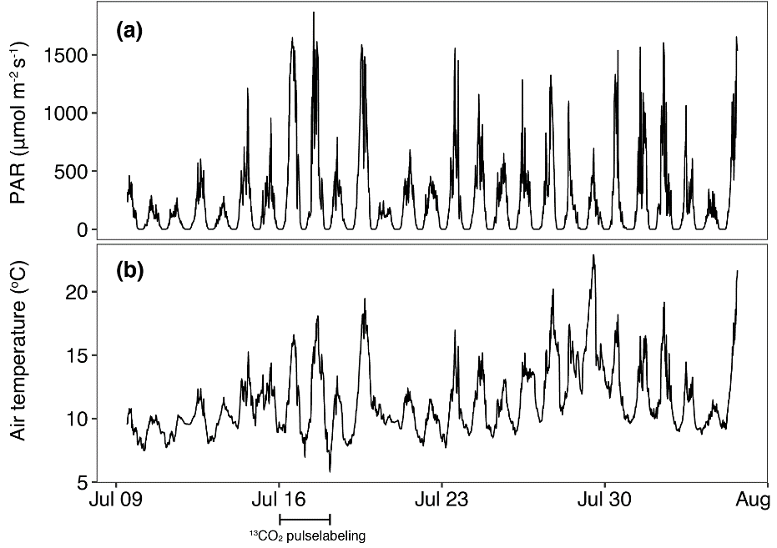
Figure S1: Photosynthetic active radiation (PAR) and air temperature at the study site measured during the main study period.

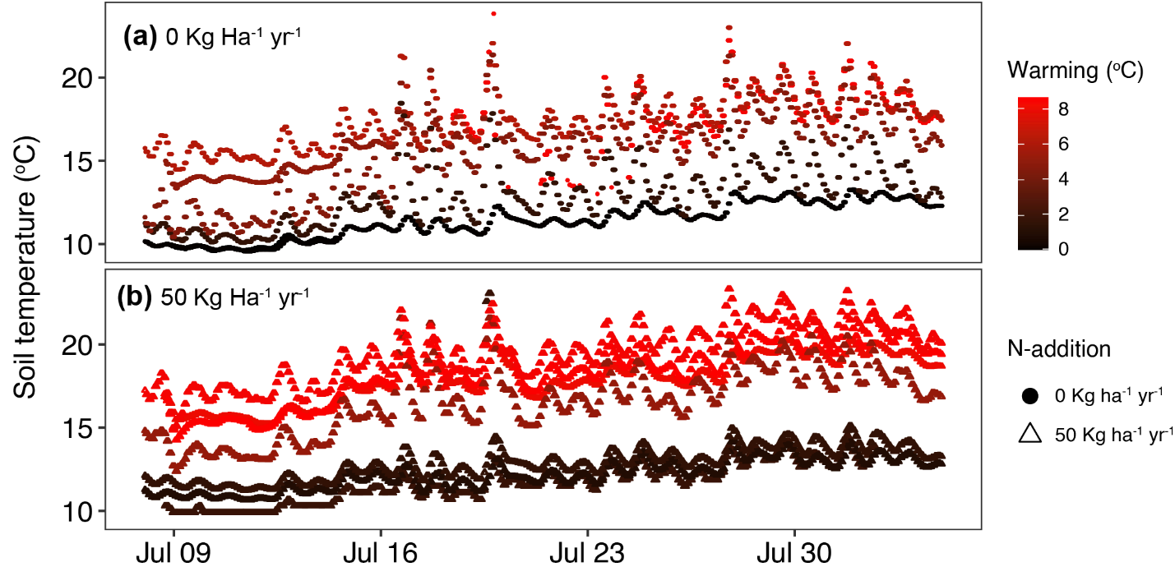
Figure S2: Hourly means of soil temperature measured at 5 cm soil depth during the main study period.

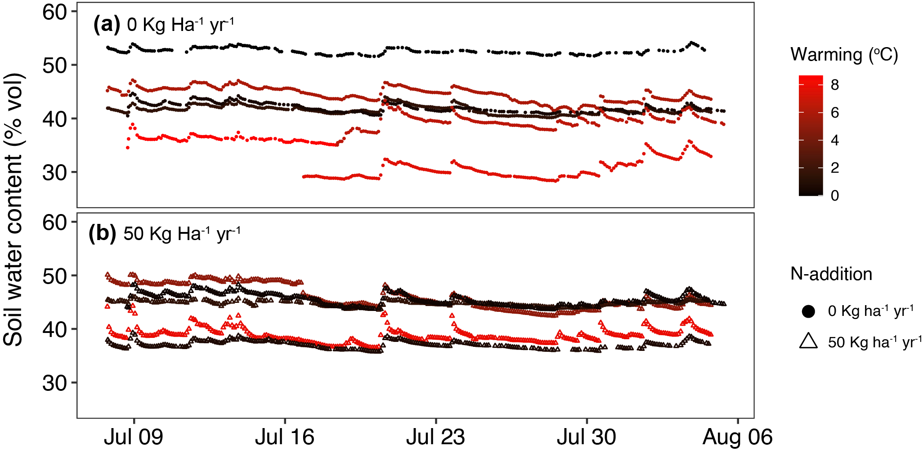
Figure S3: Hourly means of soil water content measured at 5 cm soil depth during the main study period.

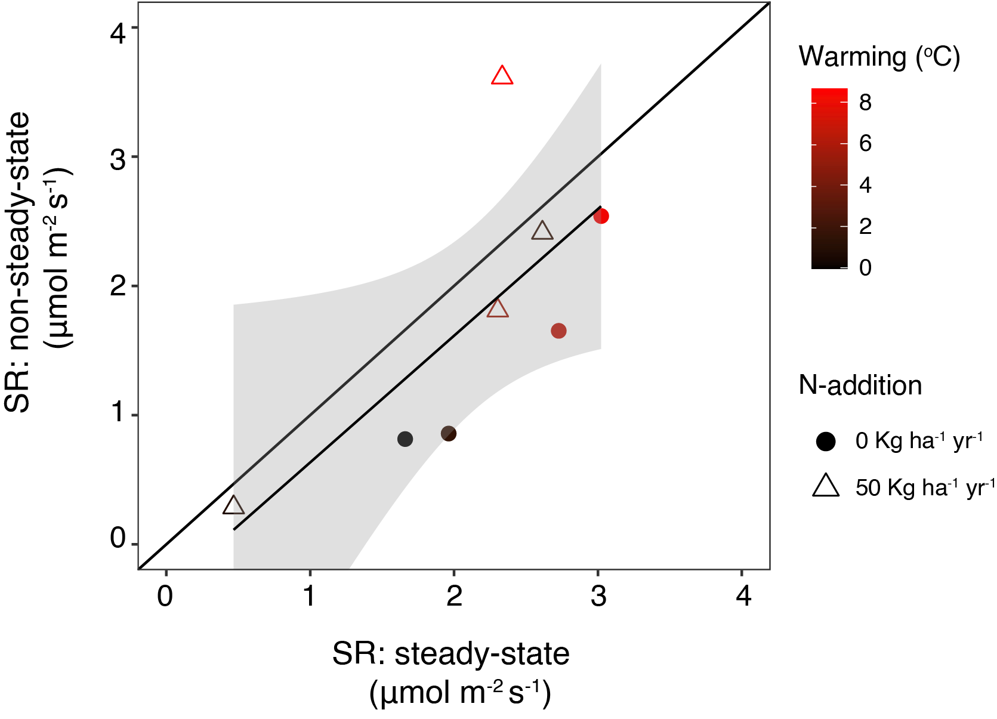
Figure S4: Comparison of steady-state and non-steady-state soil respiration (SR) measurements. Non-steady-state measurements were made on eight plots where also steady-state measurements were performed. The non-steady state measurements were made between 9 AM to 4 PM on July 30, 2018. The mean of steady-state SR measured during the same time duration was used for comparison.

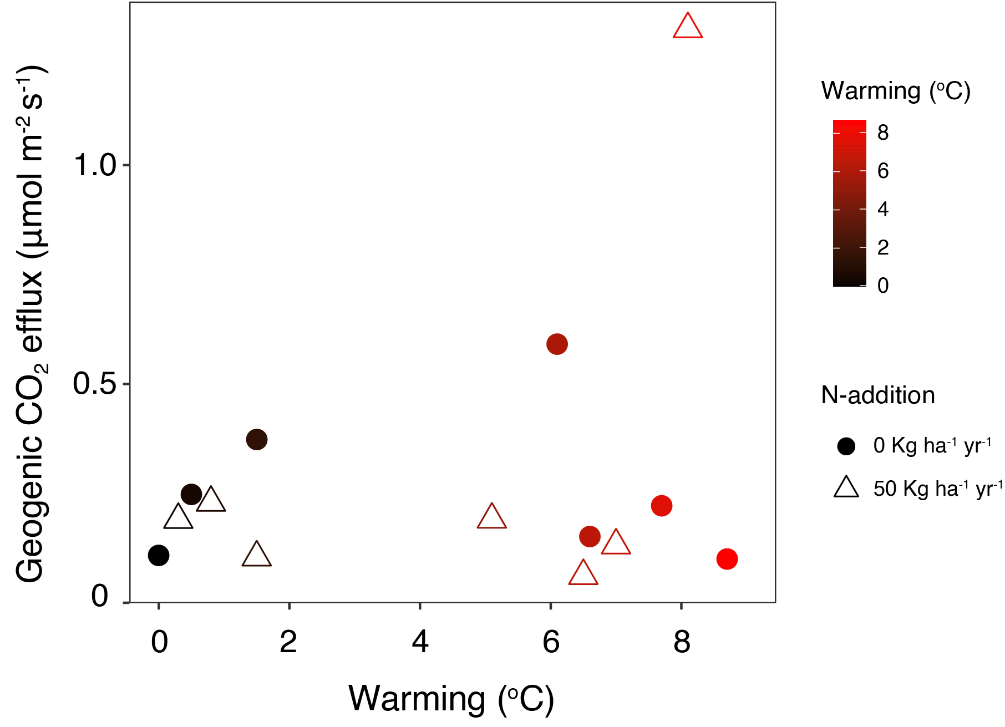
Figure S5: Geogenic CO₂ efflux estimated using a two-pool isotope mixing model on soil CO₂ efflux. Warming did not consistently affect geogenic CO₂ efflux.

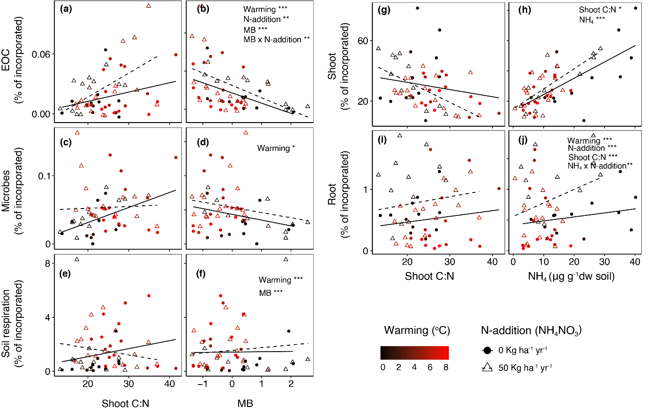
Figure S6: Effects of warming, N addition and microbial biomass and shoot C:N on the relative ¹³C excess (i.e. the proportion of ¹³C taken up during pulse labelling) in (a,b) EOC, (c,d) microbes, (e,f) soil respiration, (g,h) shoot and (I,j) root. MB- Microbial biomass.

