**Parent material and climate interact to control actively cycling and microbially inaccessible soil C**

**Outline**

Question:

1. What factor best explains the variation observed in bulk and respired 14C? Parent material or temperature? Or is the interaction more important? [interaction suggests a role for MAOM...]

* Hypotheses: *Temperature controls respired 14C, parent material controls bulk 14C*

1. How do we quantify this interaction?

Climate change and shifting patterns of land-use will determine whether or not soils will continue to be a sink for atmospheric carbon or become a source in the coming decades. Understanding the response of soil carbon to these changes requires insight into the mechanisms of soil carbon protection. This study compares soils developed on different parent materials across a climate and weathering gradient in order to quantify the relative importance of mean annual temperature and soil lithology for explaining patterns in soil C stocks and carbon persistence.

Climate is the most important explanatory factor for the variation observed in both soil carbon accumulation and persistence globally, due to the strong effect of both temperature and moisture on decomposition rates. However, association of soil organic matter with minerals in the soil has been show to attenuate the effects of climate.

* example of soils with different parent materials under similar climates that have different C stocks and ages
* weathering

(Holding mean annual temperature/MAP constant...) soils rich in poorly crystalline minerals tend to have higher carbon stocks and more depleted 14C than soils with more crystalline minerals, as well as young soils with more primary minerals.

Emerging understanding of the associations formed between soil organic matter and soil minerals demonstrates that neither clay nor parent material alone are adequate for determining soil carbon stocks and soil carbon ages (Beyond bulk, Shi et al, Beyond clay, etc.).

The accumulation and persistence of carbon in soils is a function of both decomposition rates and the accessibility of soil organic matter to the decomposer community present in the soil. Climate is the most important explanatory factor for the variation observed in both soil carbon accumulation and persistence globally.

Global trends in soil carbon stocks and soil carbon ages are well-explained by climate and parent material lithology.

The degree to which one of these factors is more important than the other or the nature of their interaction in governing soil C storage potential

The degree to which these two factors control rates of soil carbon cycling is not clear, however, and

The amount of carbon stored in soil is a function of the carbon inputs relative to the losses. In a steady state system, where inputs and losses are equal, the amount of carbon stored in the soil and the duration of storage are determined by chemical and thermodynamic constraints on decomposition rates, as well as the physical availability of organic matter to decomposer organisms in the soil.

In an ecosystem in which carbon inputs to the soil are balanced by carbon outputs, the amount of carbon stored by a soil is

and the length of time that carbon persists in the soil is determined by the balance f

Direct effects, such as temperature increases, are likely to increase decomposition rates of soil carbon [cite], as is suggested theoretically by the Q10 relationship and empirically in soil warming experiments. Indirect effects, such as pH shifts with changes in precipitation patterns, or alteration of weathering rates, may lead to either increases or decreases of soil carbon stocks as well as potentially redistribute carbon within the soil profile.

Globally, the age of soil carbon is well explained by two main factors: parent material, and climate.

For example, radiocarbon values of carbon in volcanic ash soils tends to be older on average than carbon in soils developed on sedimentary parent materials.

The explanation for this relationship is that parent material has a key influence on mineral organic associations, which are known to protect soil organic matter from decomposition.

The effect of temperature on decomposition rates is thought to control the accumulation of carbon in regions with cooler mean annual temperatures, leading to older mean ages of carbon in these areas

In general, positive values indicate the presence of bomb-radiocarbon, derived from atmospheric testing of nuclear weapons in the 1960s.

In panel B I’ve plotted 14C by mean annual temperature, and here you can see that 14C increases with increasing temperature.

Again, the interpretation here is that on average, soil carbon is older in colder climates and younger in warmer climates.

Of course, climate is more than just mean annual temperature, but looking at MAT alone we still see a strong relationship with 14C.

The simplest explanation for the temperature relationship is the speed of reaction rates. Given the same inputs, a soil at steady state with a slower rate of decomposition will accumulate more organic matter than a soil with a faster decomposition rate.

I should mention that both of these plots use data from the international soil radicoarbon database, ISRaD, which is freely available for anyone to use.

Of course, the simple explanation doesn’t tell the whole story.

The formation of mineral-organic associations that protect soil carbon from decomposition is a function of the mineral assemblage, which in turn, is a function of how the parent material weathers over time.

What you are looking at here are three soils developed on basalt that show progressively more weathering, moving from right to left.

Chronosequence studies have found that oldest carbon tends to be found in soils that are in intermediate stages of weathering.

*[introduce mineral characterization]*

The amount and persistence of soil organic matter found in association with soil minerals varies depending on the physical and chemical properties of the minerals present. While we can infer differences in soil mineral assemblages from parent material, selective dissolution of iron and aluminum provides a quantitative measure of the crystalline and poorly crystalline minerals thought to be most important in protecting soil organic matter from decomposition. These extractions also give insight into how mineral assemblages change over geologic time through weathering. We compared selective dissolution data from our sites (Rasmussen et al. 2018) to the radiocarbon measured in bulk soils and heterotrophically respired CO~2~ (this study) in order to assess the relationship between mineral assemblage and potential mineral protection of soil C.

Oxalate extracts poorly crystalline (short range ordered, SRO) iron oxyhydroxides, e.g. ferrihydrite, as well as SRO aluminosilicates, e.g. allophane and imogolite (Parfitt and Childs, 1988). These minerals have high surface area and variable charge that facilitates the formation of strong innersphere bonds with soil organic matter. The SRO minerals are additionally characterised by a high degree of hydration and are able bind to soil organic matter through both electrostatic attraction and surface complexation (Berhe et al., 2012). Extraction of iron with the dithionite-citrate reagent dissolves poorly crystalline minerals as well as crystalline minerals such as goethite and hematite (Parfitt and Childs, 1988). The crystalline minerals are also capable of binding soil organic matter, but have smaller specific surface area than the poorly crystalline minerals (Kaiser and Guggenberger, 2003).

So the take home message here is that the parent material effect that drives the 14C trends we observe in soils, is actually a function of the interaction of parent material and climate over time.

Which leads us to the central question we set out to answer in this study. We wanted to know if we see different effects on carbon dynamics, as revealed by 14C, across a parent material by climate gradient.

[OK, so this is the sort of relationship between climate and parent material we might expect if climate was not an important predictor of bulk soil 14C, but parent material was. Here we might expect that granite soils would have the youngest carbon, then basalts, and then andesites.

On the other hand, if only climate was important and parent material did not have an effect, we might expect something like the relationship shown on the right, with the oldest carbon at the coldest sites and the youngest carbon at the warmest sites.

If climate and parent material were both important, but had additive effects, we might see a linear decrease in 14C with temperature, but with different intercepts for the different parent materials.]

the 14C content of the bulk soil only tells part of the story.

Most of the carbon that enters the soil does not stick around. But some carbon gets stuck, caught in aggregates, for example, or sorbed to soil minerals. We can represent these dynamics with a simple two pool model, with one pool of fast cycling carbon and one pool of more slowly cycling carbon.

In a multiple pool system, bulk 14C is weighted by the mass of carbon in each pool.

In contrast, the 14C of respired CO2 is weighted by the flux of carbon from each pool.

We can see in a diagram like this how bulk 14C could give us a skewed sense of how soil carbon stocks might respond to changes in inputs due to climate change, or how vulnerable soil carbon stocks might be to changes in climate or landuse.

This is because the amount of C stored in the soil is dependent on the turnover rate of the fast pool, the turnover rate of the slow pool, and the transfer of carbon between the two pools.

The 14C of respired CO2 provides important insight into the mechanisms of carbon protection because by definition, the flux of carbon leaving the soil must be derived from carbon that is both accessible to and decomposable by the microbrial community.

This leads us to the observation that if bulk and heterotrophically respired 14C are different from one another, it indicates that there is a mixture of both fast and more slowly cycling carbon.

Furthermore, there must be some mechanism of physiochemical protection responsible for slowing down the decomposition rate of the more slowly cycling carbon.

**Methods**

*Site descriptions*

We collected samples from 9 sites across a combined gradient of parent material and climate in the Sierra Nevada Mountains of California (Table 1). These mountains are a perfect setting for this study as they make up a natural gradient of parent material and mean annual temperature (MAT). Moving from north to south along the cordillera the parent material changes from basalt to andesite to granite, while the change in elevation headed eastward from the Central Valley leads to a decrease in MAT that is consistent for each parent material.

Total mean annual precipitation is relatively constant with elevation, but it falls mainly as rain at lower elevations, and mainly as snow at higher elevations. There is a slight precipitation gradient running north to south, with MAP of xxx mm yr-1 averaged across the basalt sites in the north, xxx mm yr-1 for the andesitic sites, and xxx mm yr-1 for the granodiorite sites in the south.

Vegetation at the study sites is typical of the Sierra Mixed Conifer habitat (*Parker, I., and W. J. Matyas. 1981. CALVEG: a classification of Californian vegetation. U.S. Dep. Agric., For. Serv., Reg. Ecol. Group, San Francisco.)*. All of the sites are forested and dominated by conifers, although the species composition changes along with climate. Tree species at the lowest elevation, “warm”, sites are predominantly *Pinus ponderosa* mixed with lesser amounts of *Quercus* spp. The canopy species at the mid-elevation cool sites is comprised primarily of *Abies concolor* and *Pinus lambertiana*, while *Abies magnifica* is the dominant species at the highest elevation “cold” sites. Grasses and forbs are present at all sites as are the shrubby species *Arctostaphylos* spp., *Chamaebatia foliolosa*, and *Ceanothus* spp. to varying degrees.

*Sample collection*

We collected samples in September and October of 2019. Sites were located using GPS and geospatial coordinates recorded when the sites were first sampled in 2001 (Rasmussen et al., 2006) and again in 2009 (Rasmussen et al., 2018). At each site we dug three replicate pits down to a depth of 0.3m. Prior to sample collection we compared the soil profiles to the pedon descriptions from the previous sampling campaigns. After confirming profiles were comparable we collected samples from the pit sidewalls in 0.1m increments for each of the three pits. We also measured the depth of the litter layer and collected representative litter samples from each site.

*Soil Physical Analyses and Mineral Characterization*

We obtained soil particle size distributions and bulk density measurements from two previous sampling campaigns at the same sites, in 2001 and 2009. Both qualitative and quantitative approaches were used to determine soil mineral assemblages, including X-ray diffraction (XRD) for the clay (<2µm) fraction, atomic absorption spectroscopy, and non-sequential selective dissolution. Details on these analyses are provided by Rasmussen et al. (20XX). We used the amount of iron selectively dissolved from bulk soils by acid ammonium-oxalate and citrate dithionite as proxies for the quantity of poorly crystalline and crystalline minerals, respectively.

*Carbon, Nitrogen, and Radiocarbon Analysis*

Carbon and nitrogen content was determined on finely ground soils

*Incubations*

Laboratory soil incubations were performed on composite samples from the three replicate pedons sampled at each site. We composited and incubated each depth increment (0-10cm, 10-20cm, 20-30cm) separately in 1 L glass mason jars fitted with sampling ports in the lids. Incubations were performed in duplicate. Prior to the start of incubations we adjusted the soil moisture content to 60% of water holding capacity (WHC). We defined WHC as the gravimetric water content of water-saturated soil placed in mesh covered (50µm) tubes weighed after draining for 30 minutes on a bed of fine sand. Following rewetting we allowed the soils to respire for one week before closing the jars. We measured CO2 accumulation

14C on the bulk soils, and we also measured the 14C of CO2 respired in laboratory incubations.

Carbon and nitrogen

Bulk density, selective dissolution from previous sampling (Rasmussen et al., 2018; 2006?).

We used selective dissolution to quantify poorly crystalline and crystalline minerals in the soil.

*Statistical analysis*

Finally, we used a linear modeling approach to assess the relative explanatory power of climate versus parent material on the observed variation in 14C, as well as potential interactions between these two factors.

We constructed models according to the formula shown here. We modeled each depth layer separately, and considered the two-way interaction between parent material and climate as well as the three-way interaction with time.

**Results**

*Parent material and climate effects on soil carbon stocks.*

You can see in the table on the left that the andesite soils have the highest carbon stocks overall. At the same time, there is also a clear climate gradient, with the highest carbon stocks found in the coldest sites, and the lowest stocks in the warmest sites.

**Radiocarbon**

*Bulk soils*

Ok, let’s look at the 14C results for the bulk soils.

There’s a lot going on here, so I’ll start by walking you through the plot. Depth is on the y-axis, and 14C is on the x-axis. The vertical black line around 0 per mille delta 14C is the atmosphere in the year of sampling. The different colors correspond to the different parent materials and mean annual temperature decreases from the top row to the bottom row.

OK, so first, we can see that 14C declines with depth, as expected.

We also see that the cool sites—in the middle row—tend to be more depleted in 14C than the cold sites, on the bottom.

Moving to the top row, we see that these warm sites show clear parent material differences, with granite more enriched than basalt, and basalt more enriched than andesite.

In contrast, cold sites—down at the bottom—look similar across parent materials.

So there appears to be an interaction between parent material and climate and what we will do next is try to visualize it using linear models.

*Respired 14C*

Just like before, we have depth on the y-axis, and 14C on the x-axis. Again, the thick black vertical line shows the atmosphere in the year of sampling. Solid symbols and lines show bulk 14C while open symbols and dashed lines show respired 14C. There are four points for the respired 14C profiles because we also measured 14C respired from the litter layer.

First, I want to point out that nearly all of the respired 14C measurements are positive values, and enriched relative to the atmosphere. As I mentioned earlier, positive 14C values indicate the presence of bomb-C from after the 1960s, so this tells us that the average age of the respired 14C is in the annual to decadal range, not centennial, as we might surmise for the bulk 14C values.

We can also see a clear effect of parent material on the *difference* between bulk and respired 14C. We can see that bulk and respired 14C are very similar for the granite soils, on the right, slightly offset for the basalts, in the center, and most different for the andesites, on the left.

Looking at the top row, you can also see that respired 14C is similar across lithologies for the warm sites, but if we look down to the cold sites in the bottom row, not so much.

*Mineral assemblages*

What you are looking at here is the quantity of iron extracted from the soil by oxalate on the x-axis, and the difference between bulk and respired 14C on the y-axis.

I’ve averaged the three depth increments to eliminate the trend of 14C with depth. Also, I have excluded the data from the cold granite site, as the respired 14C from the deeper layers in those soils was extremely depleted—older than all of the other respired 14C by two orders of magnitude. While we think this is a real phenomenon, we think it is related to rewetting in the laboratory and is unique to these soils, so we have excluded them from this analysis.

To summarize, what we see here is that there is a strong and highly significant relationship between oxalate extractable iron and the difference between bulk and respired 14C. Again, the way to think about this difference is that it is a measure of the degree to which soil carbon is protected from decomposition.

OK, so now on the left you can see the same graph of oxalate extractable iron as on the previous slide, but I have added a second figure on the right showing the relationship of the crystalline minerals to the difference between bulk and respired 14C.

As you can see from the figure, there is no relationship at all between the crystalline mineral content and the difference between bulk and respired 14C.

So what I think is clear from the previous two figures is, one, that the mineral assemblage is a function of parent material and climate interaction, and two, our data suggest that it is specifically the poorly crystalline minerals that are playing the key role in protecting soil C from decomposition**.**

**Linear model results** *[How to work this in? Where to put it?]*

[need to expand modeling discussion to incorporate respired 14C, too]

We will ignore time in order to focus on the interaction between climate and parent material.

Warm site 14C is greater than at the cool site 14C for all parent materials.

We can also see a clear effect of parent material for the warm and cool sites, with granites being most enriched, andesites least enriched, and basalts somewhere in the middle.

But, when we get to the cold site, all the parent materials look the same.

So the take home message here is that there is a significant climate by parent material interaction.

And, we see that bulk 14C does not follow the same climate trend as we saw in the soil carbon stocks earlier. ***The cool sites tend to have the oldest carbon, rather than the cold sites with the highest carbon stocks.***

**Discussion**

There is a lot to take in here, but I want to focus on two main points:

1. First, we can see that the control of respired 14C switches from climate to parent material with depth. I didn’t show it, but this is also backed up by the linear models.
2. Second, the difference between bulk and respired 14C is a function of parent material.

I said at the beginning that the interaction of parent material and climate over time determines the mineral assemblage found in soils. What I’d like to do now is go beyond parent material and climate to focus directly on the minerals, using the selective dissolution data to try and explain the differences we observed between bulk and respired 14C.

*Mechanisms?*

**SLIDE 42**

In conclusion, I hope I’ve been able to convince you that parent material and climate interactions control both bulk AND respired 14C.

We also saw that trends in respired 14C at the soil surface were best explained by climate, but best explained by parent material in deeper soil layers.

And finally, we saw that poorly crystalline mineral content explained a significant amount of the variation in the *difference* between bulk and respired 14C. We think this provides strong evidence that poorly crystalline minerals play an important role in inhibiting decomposition of soil C.

The next steps with this project will be modeling soil C dynamics at the site using the time series of bulk and respired 14C, as well as radiocarbon data from density fractions, so if you’re interested, stay tuned…

Figures

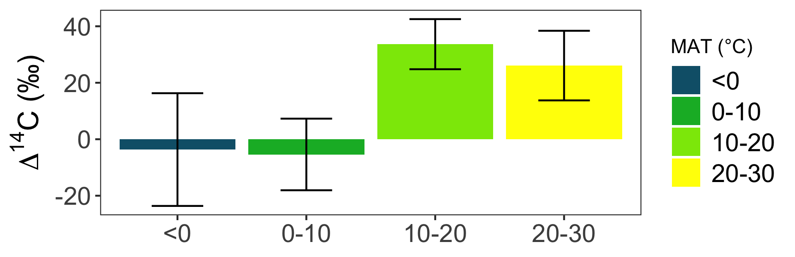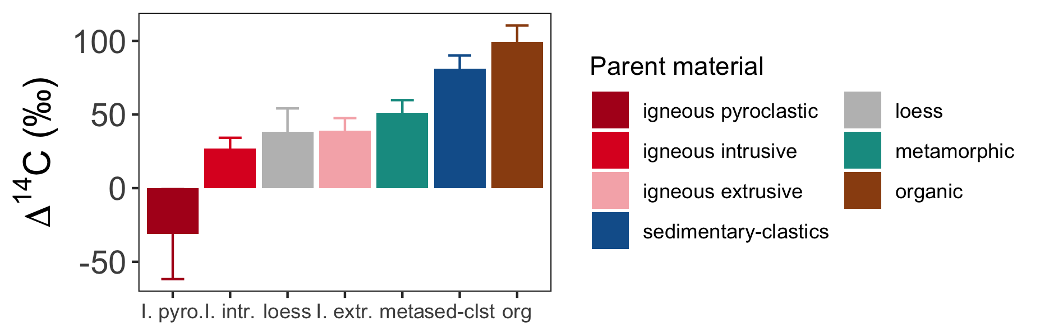

|  |  |  |  |
| --- | --- | --- | --- |
|  | SOC stocks | | |
|  | Parent material | | |
| Climate | Basalt | Andesite | Granite |
|  |  | *kg m-2* |  |
| Cold | 10.1 | 12.9 | 8.1 |
| Cool | 7.0 | 12.5 | 4.2 |
| Warm | 7.9 | 10.5 | 4.4 |

