Soil minerals mediate climatic control of soil C cycling on annual to centennial timescales

Jeffrey Beem-Miller1, Craig Rasmussen2, Alison M. Hoyt1,3, Marion Schrumpf1, Georg Guggenberger4, & Susan Trumbore1

1 Department of Biogeochemical Processes, Max Planck Institute for Biogeochemistry, Jena, Germany

2 Department of Environmental Science, The University of Arizona, Tucson, AZ, USA

3 Department of Earth System Science Science, Stanford University, Stanford, CA, USA

4 Institute of Soil Science, Leibniz University Hannover, Hannover, Germany

Author note

Correspondence concerning this article should be addressed to Jeffrey Beem-Miller, Hans-Knoell-Str. 10, 07745 Jena, Germany. E-mail: [jbeem@bgc-jena.mpg.de](mailto:jbeem@bgc-jena.mpg.de)

Abstract

Climate and parent material both affect soil C persistence, yet the relative importance of climatic versus mineralogical controls on soil C dynamics remains unclear. We compared radiocarbon measurements of bulk soil and heterotrophically respired CO2 made at three time points over two decades along a combined gradient of parent material (andesite, basalt, granite) and climate (MAT: 6.5 °C, 8.6 °C, 12.0 °C). We quantified poorly crystalline and crystalline metal oxide content using selective dissolution, and used linear regression modeling to assess correlations between climate, parent material, metal oxide content, and bulk and respired radiocarbon. Climate explained more variation in bulk and radiocarbon at the soil surface (0-0.1 m), while parent material explained more at depth (0.1-0.2 m, 0.2-0.3 m). The importance of parent material for explaining trends in respired radiocarbon suggests mineral-organic associations affect soil C cycling on annual to decadal timescales. Bulk soil radiocarbon was more closely linked to poorly crystalline metal oxide (PCM) content than MAT, with the oldest C in the 8.6 °C soils where PCM content was highest. PCM (but not crystalline metal oxide) abundance was significantly correlated with the difference between bulk and respired radiocarbon, suggesting a mechanistic role for PCMs in soil C persistence. The rate of change in respired radiocarbon over time was a linear function of MAT for the granite soils with the lowest PCM content, but not in the andesitic or basaltic soils with higher PCM content. We interpret this as evidence that PCMs may attenuate the temperature sensitivity of decomposition.

Soil minerals mediate climatic control of soil C cycling on annual to centennial timescales

# 1 Key messages:

* Mineral assemblages mediate climatic control of soil C age and transit time
* Poorly crystalline metal oxides are correlated with C age and transit time but not crystalline oxides
* Climate controls surface soil C dynamics; mineral assemblage is more important at depth

# 2 Introduction

Understanding the response of soil carbon stocks to current and future changes in climate requires insight into both the physical and environmental factors governing soil carbon dynamics. Climate, and in particular temperature, has been found to be the most important variable for explaining the age of soil carbon in topsoil at local to global scales [Frank et al., 2012; Mathieu et al., 2015; Shi et al. 2020]. Yet our current understanding of soil organic matter decomposition underscores the importance of physical mechanisms that can affect the temperature sensitivity of decomposition, such as the interaction between soil organic matter and minerals [Davidson et al., 2000; Davidson and Janssens, 2006; Rasmussen et al., 2006; Lehmann and Kleber, 2015;]. The effect of mineral-organic associations on the temperature sensitivity of soil organic matter has been addressed in several modeling studies [Abramoff et al., 2019; Riley et al., 2016; Ahrens et al., 2015; Woolf and Lehmann, 2019]. These models typically invoke Michaelis Menten kinetics in addition to an Arrhenius-type temperature response in order to account for energy and substrate limitations on decomposition rates for soil organic matter found in association with minerals [Tang and Riley, 2019; Ahrens et al., 2020]. Studies comparing the relative importance of different soil mineral assemblages versus temperature for explaining soil C dynamics over time *in situ* are scarce, yet critical for testing these model-based findings. We designed the current study to quantify the relative importance of climatic versus mineralogical mechanisms of soil organic C persistence across a combined gradient of mean annaul temperature (MAT) and parent material in order to provide insight into the relevant time scales associated with these mechanisms.

The relevance of soil minerals for mediating soil organic matter protection has been found to be a function of the specific minerals present, rather than the amount of clay or total mineral surface area [Rasmussen et al. 2018a, “Beyond Clay”]. Soil mineral assemblages are dynamic, developing over time as primary minerals inherited from parent material weather to form reactive, poorly crystalline secondary minerals, which in turn eventually weather to increasing stable crystalline species [Slessarev 2022, others…]. Soils enriched in poorly crystalline metal oxides, such as Al and Fe oxyhydroxides, are known to be of particular importance for the accumulation and persistence of soil C [Torn 1997, Maseiello 2004]. The amount of these minerals present is directly related to parent material, but is also a function of primary mineral weathering rates [Slesserav et al. 2022]. Due to the strong effect of climate on weathering rates, different soil mineral assemblages can form from the same parent material under different climatic regimes (Rasmussen et al. 2018b). Conversely, similar mineral assemblages can be found among soils developed on different parent materials given adequate time for weathering and similar vegetation and climate [Graham and O’Geen 2010 “Soil mineralogy trends in California landscapes”]. These differential outcomes demonstrate that climatic and mineralogical controls on soil C cycling are not independent, but interact over the centennial to millenial time scales of soil development.

The strength and sorptive capacity of soil minerals is dependent on ligand exchange, which is a function of not only surface area and charge, but more specifically the density of accessible hydroxyl groups (Kaiser and Guggenberger, 2003; Rasmussen et al., 2018a “Beyond Clay”; Kleber et al., 2015). Poorly crystalline metal oxides are particularly enriched in hydroxyl groups, and batch sorption/desorption experiments have shown that the mineral-organic interactions between pedogenic metal oxide-rich clays are stronger than those with siloxane-rich phyllosilicate clays (Kahle et al., 2004). Furthermore, the reactive properties of pedogenic metal oxides can also facilitate lower strength interactions with soil organic matter through multivalent cation bridging (Kleber et al., 2007). This high reactivity of poorly crystalline Fe oxides is also implicated in the observations that poorly crystalline Fe is correlated with aggregate stability but crystalline Fe oxide content is not (Duiker et al., 2003). The importance of pedogenic metal oxides for explaining both soil C concentration and bulk soil radiocarbon (14C*bulk*) is confirmed by the findings of Rasmussen et al. (Soil systems, 2018a) [other citations?], who observed that oxalate extractable iron was the best predictor of both properties. However, the relevance of mineral-organic associations with specific mineral phases such as poorly crystalline metal oxides or crystalline metal oxides for specific timescales of soil C turnover is poorly studied.

Radiocarbon (14C) is a useful tracer for soil C dynamics over time scales ranging from annual to millennial. The use of 14C to measure timescales of soil carbon decomposition is reliant on our knowledge of the ratio of 12C/14C in the atmosphere. Once CO2 is fixed into organic matter via photosynthesis, this ratio starts to shift as 14C is preferentially lost due to radioactive decay. Changes in the 12C/14C ratio due to radioactive decay are detectable at the relatively longer timescales of hundreds to thousands of years. However, we can detect changes in 14C with nearly annual resolution for the so-called “bomb-C” period, which began with the deployment and atmospheric testing of nuclear weapons in the mid-20th century. This pulse of “bomb-C” led to a doubling of atmospheric 14C concentration prior to the ban on above-ground nuclear tests in 1963. The level of 14C in the atmosphere returned to pre-bomb levels around 2020 (Hua et al., 2021), thus archived samples now represent the best opportunity to construct a high-resolution time series of the bomb-C pulse as it moves through different soil organic matter pools.

Soil is an open system, and this has important implications for the interpretation of radiocarbon measurements of soil C. For most soils, the majority of carbon that enters the soil leaves relatively quickly, with only a small fraction persisting (Sierra et al. 2018). Radiocarbon measurements of bulk soil C (14C*bulk*) typically capture the signal from these persistent pools, while more transient pools dominate measurements of C leaving the soil via heterotrophic respiration (Trumbore 2000). Here we define “transient” for C cycling on annual to decadal timescales, while we use “persistent” to refer to C cycling on centennial to millennial timescales. A diagnostic feature of the radiocarbon measurements of 14C*bulk* and heterotrophically respired CO2 (14C*respired*) is that when these two signals are the same it indicates that all of the C in the soil has an equal probability of being decomposed by microbes and the system is homogenous. However, when 14C*bulk* and 14C*respired* are substantially different this indicates the presence of both labile and persistent pools of soil C.

We turned to the western slope of the Sierra Nevada Mountains, USA to compare and contrast the effects of climate and mineral assemblage on soil C dynamics. Drawing on earlier studies in this region (Jenny et al., 1949; Trumbore et al., 1996; Dahlgren et al., 1997; Rasmussen et al., 2006), we selected soils similar in age and vegetation along a combined gradient of parent material (granite, andesite, basalt) and MAT (12°C = “warm”, 9°C = “cool”, 5°C = “cold”). The climate gradient also represents a weathering gradient, with poorly developed soils at the cold climate sites, intermediately developed soils at the cool climate sites, and highly weathered soils at the warm climate sites (Harradine and Jenny, 1958; Rasmussen et al., 2010). Previous work at these sites confirmed strong differences in mineral assemblages along both the parent material and climate gradients, making these sites an ideal setting for probing the relative influence of climatic and mineralogical factors on soil C dynamics (Rasmussen et al., 2006; others?).

We were able to construct a time series of both 14C*bulk* and 14C*respired* at these sites by combining data from samples newly collected in 2019 with data from archived samples collected in 2001 and 2009. Such a time series provides a crucial constraint for determining the trajectory of bomb-derived 14C concentrations over time (Beem-Miller et al., 2020; Stoner et al., 2020). Whether bomb-C concentrations are increasing or decreasing with time depends on both on the distribution of soil C among pools with different cycling rates as well as the year in which the soil was sampled, and thus cannot be easily determined from observations at a single point in time (Baisden et al. 2003). Using the radiocarbon time series in combination with previously determined mineralogical data, we were able to test several hypotheses regarding the roles of mineralogical versus climatic factors in determining both overall cycling rates and the dynamics of transiently cycling soil C.

We can expect soils with large stocks of persistent soil C to have depleted values of 14C*bulk* relative to soils dominated by fast cycling soil C. If climate proves more important than parent material for determining soil C persistence, than we would expect to see large differences in 14C*bulk* among climate regimes when comparing soils within a given parent material, but minimal differences among parent materials when comparing soils within the same climate regime. However, if parent material proves more important than climate for soil C persistence, we would expect the opposite trends in 14C*bulk*: differences would be greater among parent materials within a given climate regime than among climate regimes within a given parent material. Alternatively, if persistent soil C is associated with specific soil minerals, we would expect an interactive effect of parent material and climate on 14C*bulk*. For example, if soil C persistence is due to the association of soil organic matter with poorly crystalline metal oxides, we would expect to observe the most depleted 14C*bulk* values where the combination of parent material and climate factors has led to the greatest abundance of these specific soil minerals.

Soil C found in association with minerals is typically older than organic matter found in free particulate forms [cite]. Accordingly, we might expect climate to be the dominant factor controlling the amount and cycling rates of C in transiently cycling soil C pools, with mineral factors being less relevant at these shorter timescales. If this hypothesis is correct, we would expect to see greater differences in 14C*respired* among different climate regimes and within a given parent material than we would among different parent materials within the same climate regime. Furthermore, we would expect warmer climate soils to have 14C*respired* values closer to the atmosphere than colder climate soils, due to faster decomposition rates in the actively cycling soil C pools, and accordingly, we would expect 14C*respired* to change more over time at the warmer climate sites than at the colder climate sites.

# 3 Methods

## 3.1 Site descriptions

We collected samples from nine sites across a combined gradient of parent material and climate in the Sierra Nevada Mountains of California (**Table ??**). Parent material changes from basalt to andesite to granite along the north-south axis of the cordillera, while MAT decreases as a function of increaing elevation along the east-west axis. Total mean annual precipitation (MAP) ranges from 910 to 1400 mm yr-1 across the sites. Precipitation increases slightly with elevation (**Table ??**), and falls mainly as rain at lower elevations (< 1400 m), but mainly as snow at higher elevations (> 1800 m). The andesitic and basaltic parent materials receive slightly more precipitation on average than the granitic soils, with MAP values of 1330 (± 75) mm yr-1, 1160 (± 175) mm yr-1, and 1000 (± 85) mm yr-1 for the andesite, basalt, and granite transects, respectively.

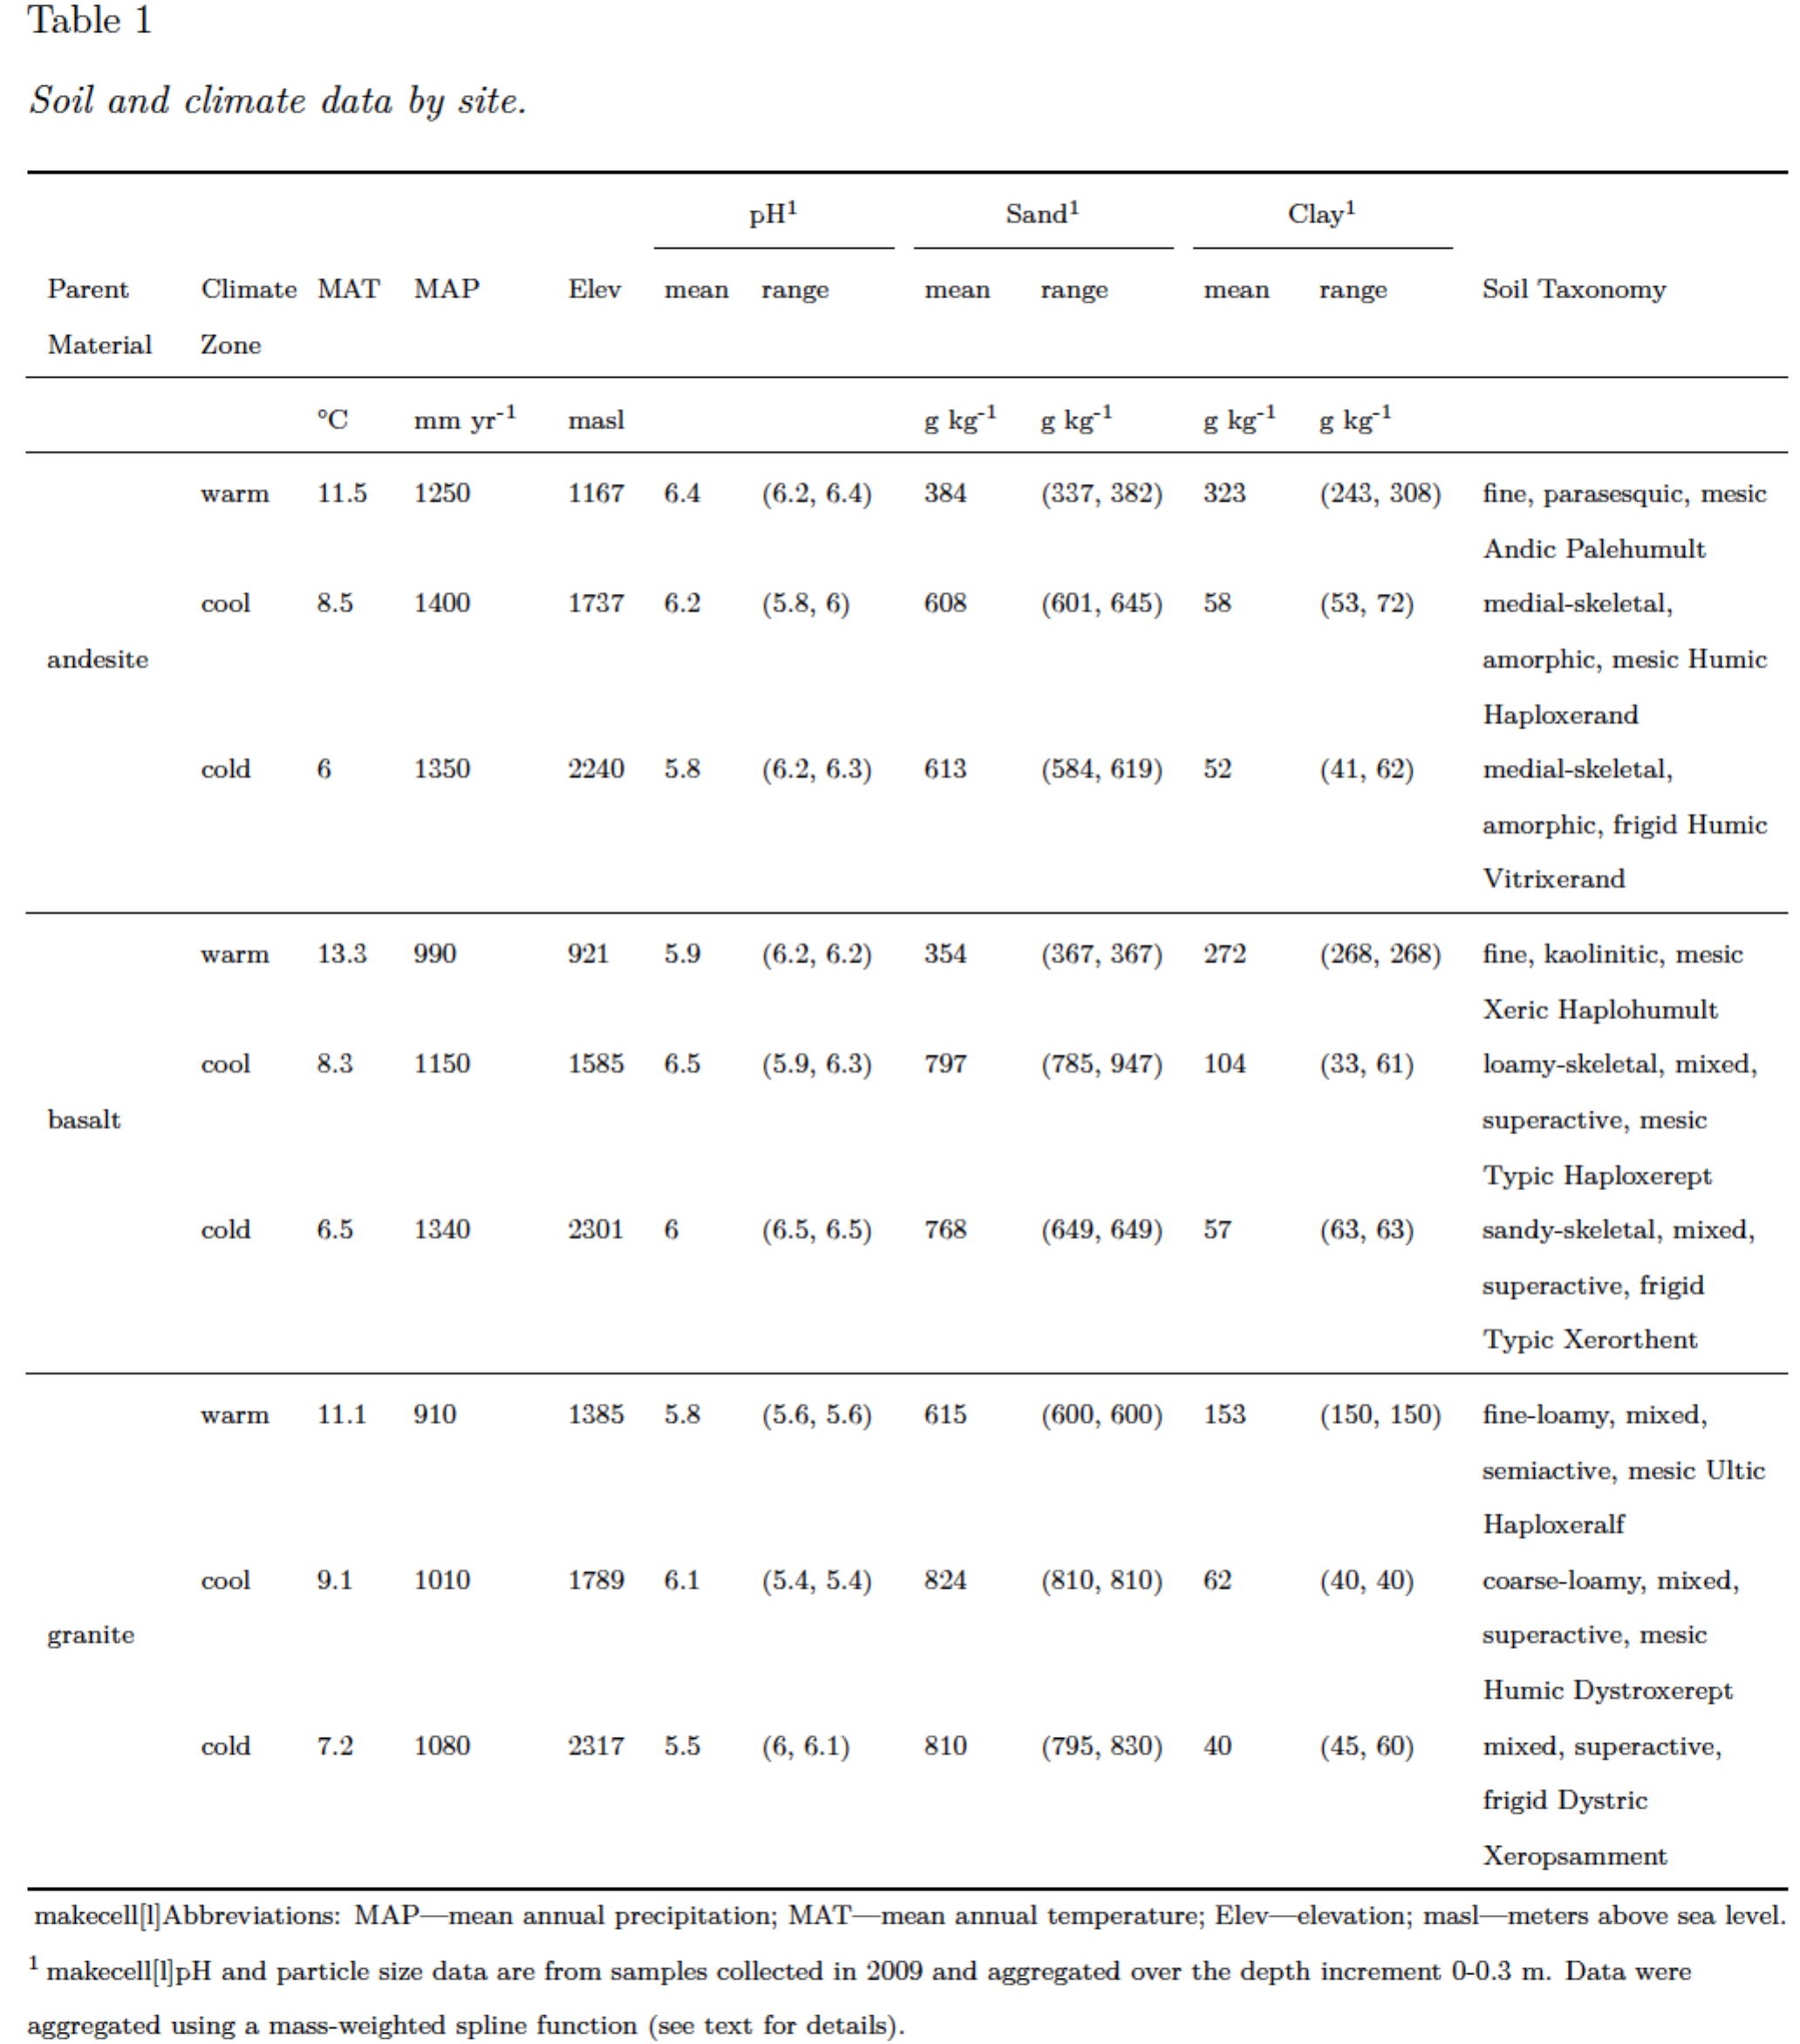

Vegetation at the study sites is typical of the Sierra Mixed Conifer habitat (Parker, I., and W. J. Matyas. 1981. CALVEG: a classification of Californian vegetation. U.S. Dep. Agric., For. Serv., Reg. Ecol. Group, San Francisco). All of the sites are forested and dominated by conifers, although the exact species composition changes along with climate. Tree species at the lowest elevation warm climate sites are predominantly *Pinus ponderosa* mixed with lesser amounts of *Quercus* spp. The canopy species at the mid-elevation cool climate sites consist primarily of *Abies concolor* and *Pinus lambertiana*, while *Abies magnifica* dominates at the high elevation cold climate sites. Species present at all sites include *Calocedrus decurrens* in the canopy, the shrubs *Arctostaphylos* spp., *Chamaebatia foliolosa*, and *Ceanothus* spp. in the understory, and patchy ground cover of grasses and forbs (**Table ??**).

## 3.2 Sample collection

Site locations were initially established in 2001 by C. Rasmussen (Rasmussen et al., 2006), and resampled in 2009 (Rasmussen et al., 2018) and 2019 (this study). Three replicate pits were dug to the depth of the B horizon (2001 sampling), or down to the C horizon (2009 and 2019 sampling). Samples were collected from the pit sidewalls by horizon in 2001 and 2009, and by 0.1 m increments in 2019. For the 2019 resampling, we located the sites using GPS and geospatial coordinates recorded during site establishment. Prior to sample collection we compared the soil profiles to the pedon descriptions from the 2001 sampling campaign to confirm the profiles matched. In 2019 we also measured the depth of the litter layer and collected representative litter samples from each site. However, we only focus on the upper mineral soil layers in this study (0 to ca. 0.3m) as the 2001 sampling was restricted to this depth range.

## 3.3 Incubations

Laboratory soil incubations were performed on composite samples from the three replicate pedons sampled at each site in 2001 and 2019. We omitted the 2009 samples from the incubation experiment to save on time and analysis costs, and because sample material was only available from a single profile at each site. We composited and incubated each depth increment separately in 1 L glass mason jars fitted with air tight sampling ports in the lids. Incubations were performed in duplicate. Prior to the start of incubations we adjusted the soil moisture content to 60% of water holding capacity (WHC). Samples from 2001 were air-dried prior to archiving, and therefore we also air-dried the freshly collected soils from 2019 in order to control for the known effects of drying and rewetting on 14C*respired* (Beem-Miller et al., 2021). We defined WHC as the gravimetric water content of water-saturated soil placed in mesh-covered (50µm) tubes (50ml) weighed after draining for 30 minutes on a bed of fine sand. Following rewetting we allowed the soils to respire for one week before closing the jars. Incubations proceeded until CO2 concentrations in the jar headspace reached approximately 10,000 ppm, at which point we collected a 400 ml gas subsample for radiocarbon analysis. Gas samples were collected with pre-evacuated stainless-steel (Restec) vacuum canisters. All incubations were performed in the dark at 20°C.

## 3.4 Soil Physical Analyses and Mineral Characterization

Data on soil particle size distributions, bulk density, and mineral characterization were obtained from previously published analyses of samples collected at the study sites in 2001 and 2009 (Rasmussen et al. 2006, Rasmussen et al., 2018). Both qualitative and quantitative approaches were used to characterize soil mineral assemblages, including X-ray diffraction (XRD) for the clay (<2 µm) fraction, atomic absorption spectroscopy, and non-sequential selective dissolution. These previous analyses revealed that the dominant mineral species in the soils of the highly weathered warm climate zone were similar across parent materials, but differed substantially across parent materials at the less weathered cool and cold climate sites. Mineral assemblages at the warm climate sites are dominated by 1:1 clays and large accumulations of crystalline iron oxides [Dahlgren et al. 1997 “Soil development along an elevational transect in the western Sierra Nevada, California”; Rasmussen et al. 2007 “Soil Genesis and Mineral Transformation Across an Environmental Gradient on Andesitic Lahar”; Rasmussen et al. 2010 “Basalt weathering and pedogenesis across an environmental gradient in the southern Cascade Range, California, USA”]. In contrast, the cool and cold climate andesitic soils contain high concentrations of poorly crystalline short-range order (SRO) minerals such as allophane and iron oxyhydroxides. The cool and cold climate basaltic soils contain intermediate amounts of SRO minerals, while the granitic soils lack SRO minerals almost entirely, but are rich in quartz and contain relatively more hydroxyl-interlayered vermiculite than soils from the other lithologies.

The previous work at these sites showed that poorly crystalline metal oxide content was the best predictor of both C abundance and 14C*bulk*. Accordingly, our analyses focus on the relationship between radiocarbon measurements and the abundance of poorly crystalline versus crystalline metal oxides as well as 2:1 versus 1:1 clays, but not the whole suite of mineralogical data. For simplification, we use the sum of ammonium-oxalate extractable aluminum and half of the ammonium-oxalate extractable Fe selectively dissolved from bulk soils as a proxy for the abundance of poorly and non-crystalline metal oxides, and the difference of dithionite-citrate extractable Fe and ammonium-oxalate extractable Fe for the abundance of crystalline Fe in the main text. We present the results of additional regression analyses looking at the specific relationships between 14C*bulk*, 14C*respired*, and the concentration of Fe or Al extracted with ammonium-oxalate, Fe extracted with dithionite-citrate, and Al extracted with sodium-pyrophosphate in the supplemental information.

## 3.5 Carbon, Nitrogen, and Radiocarbon Analysis

Total carbon and nitrogen content was determined by dry combustion (2019 samples: Vario Max, Elementar Analysensysteme GmbH) on finely ground soils (2019 samples: Retch MM400). For radiocarbon analysis of 2001 and 2019 samples, we first purified CO2 from combusted soil samples (bulk soils) and incubation flask samples (respired CO2) on a vacuum line using liquid N2. Following purification, samples were graphitized with an iron catalyst under an H2 enriched atmosphere at 550°C. Radiocarbon content was then measured by accelerator mass spectrometry (Micadas, Ionplus, Switzerland) at the Max Planck Institute for Biogeochemisty (Steinhof, 2017). See Rasmussen et al. (2018) for details of C, N, and radiocarbon analysis of the 2009 samples.

We report radiocarbon values using units of 14C, defined as the deviation in parts per thousand of the ratio of 14C–12C from that of the oxalic acid standard measured in 1950. This unit also contains a correction for the potential effect of mass-dependent fractionation by normalizing sample 13C to a common 13C value of -25 per mil (Stuiver & Polach, 1977). Values with 14C >0 indicate the presence of ‘bomb’ C produced by atmospheric weapons testing in the early 1960s. Values with 14C < 0 indicate the influence of radioactive decay of 14C, which has a half-life of 5730 years.

## 3.6 Spline fitting

We used a spline function to compare soil properties from samples collected from different depth intervals in different years and at different sites. We were motivated to use consistent depth increments across sites when resampling in 2019 because of the strong correlation between depth and 14C observed in the 2009 dataset, a correlation also noted in numerous other studies (Mathieu et al., 2015; Shi et al., 2020; others…). We fit a mass-preserving quadratic spline to the 2001 and 2009 profiles in order to convert soil property data to the equivalent depth increments sampled in 2019 (Bishop et al., 2001). We performed the spline fitting with the mpspline function of the GSIF package in R, using a value of 0.1 (Hengl 2019).

## 3.7 Statistical analysis

We used a linear modeling approach to assess the relative explanatory power of climate versus parent material on the observed variation in 14C, as well as potential interactions between these two factors. We constructed separate models for 14C*bulk* and 14C*respired* but with the same equation structure (Eq. 1). For each model we considered the two-way interaction between parent material and climate as well as the three-way interaction with time (**Eq. 1**). For ease of interpretation, we considered the effect of depth by modeling each depth layer separately (0-10 cm, 10-20 cm, 20-30 cm). We also made pairwise comparisons of 14C*bulk* and 14C*respired* across sites and within years, and across years for individual sites. We assessed the significance of the temporal trend for pairwise combinations of parent material and climate using the emmtrends function of the emmeans package (Lenth, 2021). We corrected for multiple comparisons using Tukey’s honestly significant mean difference.

**Eq. 1**

Where is the intercept term, the terms are coefficients, and is random error.

We also considered the relationship between 14C*bulk* and 14C*respired* to gain insight into potential differences in soil C dynamics and persistence mechanisms across our sites (Sierra et al. 2018). We modeled the effects of parent material (**Eq. 2**) and climate (**Eq. 3**) on this relationship separately, as we did not have an adequate number of observations to consider the interaction between these two explanatory variables. For this analysis we used 14C measurements made on samples collected in 2001 and 2019, and data from all depths. The three-way interactions of 14C*bulk* and the explanatory variables (parent material or climate) were not significant with either depth or time for either **Eq. 2** or **Eq. 3**, so we did not include either depth or time as variables in the models.

**Eq. 2**

**Eq. 3**

We assessed the relative importance of poorly crystalline versus crystalline iron minerals in protecting soil C from microbial decomposition by regressing 14C against the concentrations of ammonium-oxalate extractable iron, ammonium-oxalate extractable aluminum, pyrophosphate extractable aluminum, and dithionite-citrate extractable iron (**Eq. 4**). We fit the model for 14C*bulk*, 14C*respired*, and the difference between 14C*respired* and 14C*bulk* (14C*bulk-respired*). We used 14C data from 2001, 2009, and 2019 for the 14C*bulk* model, but only data from 2001 and 2019 for the 14C*respired* and 14C*bulk-respired* models. Selective dissolution was only performed on the soils collected in 2001, but these data were assumed to be comparable for the other time points as they reflect weathering processes operating at timescales beyond the 18-year duration of this study. The regression analysis conducted with **Eq. 4** was done for the combined depth increment of 0 to 0.3 m, as extracted metal concentrations did not change substantially over this increment. Combining depth increments allowed us to control for the depth dependence of 14C as well as simplify interpretation of the data. In order to obtain values for the necessary data over the 0 to 0.3 m depth increment we computed mass-weighted estimates of extractable metal concentrations, carbon mass-weighted means of 14C*bulk* and flux-weighted means of 14C*respired*; these calculations were made prior to determining 14C*bulk-respired*.

**Eq. 4**

Where is the intercept term, is the coefficient for each factor in the model, *Metalx* is the concentration of selectively dissolved metal oxides, time is the year of sampling, and is random error.

# 4 Results

## 4.1 Soil carbon concentrations and flux rates

We observed both parent material and climate effects on soil organic C (SOC) concentration. SOC concentrations were similar among parent materials for the warm climate sites (**Fig. 1, a**), while at the cool and cold climate sites (**Fig. 1, b, c**) the andesitic soils had higher SOC concentrations than either the basaltic or granitic soils. The basaltic and granitic soils had similar SOC concentrations across climate zones, while the cool and cold climate andesitic soils were enriched in C relative to the warm climate soils. Soils showed a similar decrease in SOC concentration with depth across all sites (**Fig. 1**).

We did not observe significant changes in SOC concentration over time for the majority of our sites. We saw the most substantial variation in SOC concentration between 2001, 2009, and 2019 in the surface layers (0-0.1 m), with significant differences observed between years for the warm climate andesitic and basaltic sites, and for all three depth layers at the cold climate andesitc site (**SI Fig. 1**). We observed similar trends in SOC stocks across sites as with SOC concentration, despite lower bulk densities in the andesitic sites with high C concentrations (**SI Fig. 2**). However, we did not assess soil carbon stock changes over time in this study as we did not measure bulk density or coarse fragment content in 2019 (Schrumpf et al., 2013; Beem-Miller et al., 2016).

Flux rates of heterotrophic respiration differed among parent materials and among climate zones. When compared on a carbon basis (mg CO2 g C-1 d-1), flux rates tended to be higher for the andesitic soils than soils from either basaltic or andesitic soils, particularly at depth (**SI Fig. 2**). The exceptions to this trend were the surface (0-0.1 m, 2001 and 2019) and near-surface (0.1-0.2 m, 2019) soils from the warm climate sites (**SI Fig. 2**). Respiration rates for granitic and basaltic soils tended to decrease with decreasing MAT (warm > cool > cold); however, we did not see any clear trend in respiration rates with respect to climate for the andesitic soils (**SI Fig. 2**).

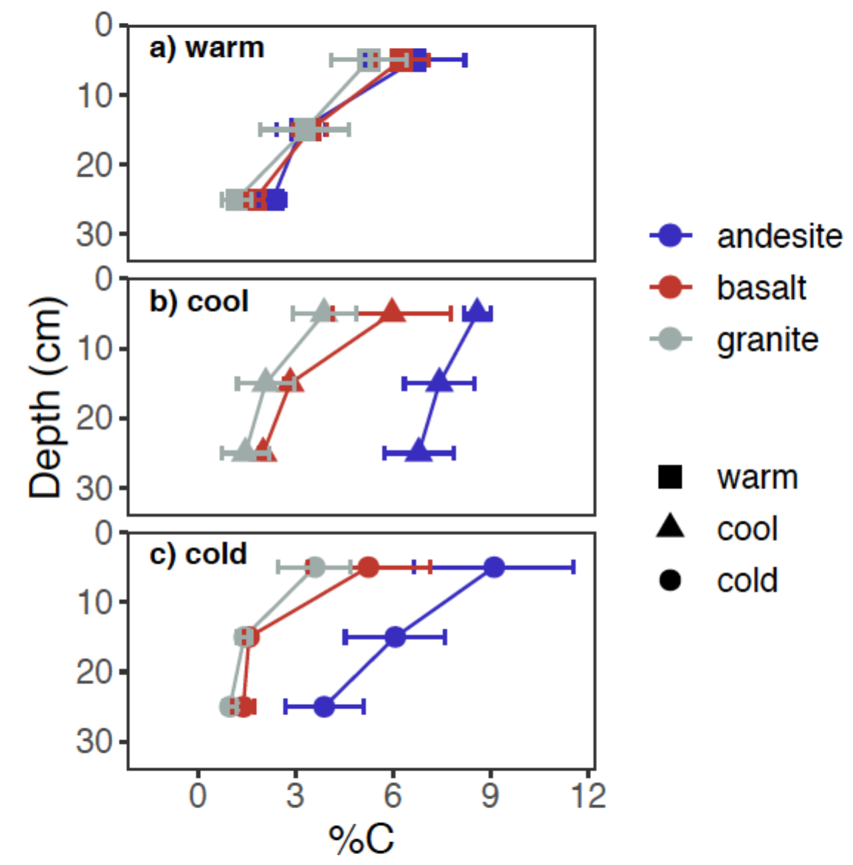

*Figure* *1.*  Profiles of soil C concentration. Points show mean of 2001, 2009, and 2019 data; error bars show ±2SE.

## 4.2 Radiocarbon depth profiles

### 4.2.1 Bulk soil.

14C*bulk* covaried with both parent material and climate. We observed the most enriched 14C*bulk* at the warm climate sites, indicating a preponderance of relatively young, fast-cycling C. However, contrary to what would be expected from the decomposition-temperature relationship, we observed the oldest soil C (i.e. most depleted 14C*bulk* values) at the intermediate MAT cool climate sites rather than at the cold climate sites (**Fig. 2, b, c**) (**Fig. 2, a**). When comparing 14C*bulk* from different parent materials within a given climate zone, 14C*bulk* of andesitic soils tended to be the most depleted, while the granitic soils tended to be the most enriched (**Fig. 2**). We focus on the 2019 data here for simplicity, but 14C*bulk* profiles showed similar patterns in both 2001 (**SI Fig. 2**) and 2009 (Rasmussen et al., 2018).

Analysis of variance for 14C*bulk* revealed significant two-way interactions between parent material and climate at all depths (**Table 1**). This interaction was evident in the differences in 14C*bulk* that we observed among parent materials within each climate zone. We observed the greatest differences in 14C*bulk* among parent materials at the warm and cool sites (**Fig. 2, a, b**), while 14C*bulk* was similar among parent materials at the coldest sites (**Fig. 2, c**). We also found depth to be an important factor influencing the relative importance of climate versus parent material effects on 14C*bulk*. Although 14C*bulk* declined with depth for all sites, climate explained more of the variance in 14C*bulk* in the uppermost soil layer (0-10 cm) whereas parent material explained more in the bottom two layers (10-20 cm, 20-30 cm) (**Table 1**).

### 4.2.2 Heterotrophically respired CO2.

The patterns we observed in 14C*respired* were similar to those we observed in 14C*bulk* (**Fig. 2**). We found climate to the only significant factor for explaining the variance observed in 14C*respired* in the uppermost soil layer (0-0.1 m), while at the deepest depth (0.2-0.3 m) parent material was more important than climate (**Table 1**). Overall, we found the two-way interaction between parent material and climate explained more of the variance in 14C*respired* than it did in 14C*bulk* (**Table 1, values**).

The effect of climate on 14Crespired appeared to be moderated by parent material. Accordingly, we did not observe significant differences in 14C*respired* among the andesitic soils when compared across climate zones at any depth (SI Table XX Tukey results for emm). In contrast, 14C*respired* diverged substantially between climate zones for the basaltic and granitic soils, particularly for the 0.1-0.2 m and 0.2-0.3 m depth layers (**Fig. 2**). Overall, 14C*respired* values across sites were most similar at the soil surface (0-0.1 m), and most divergent at the intermediate depth (0.1-0.2 m) (**Fig. 2**).

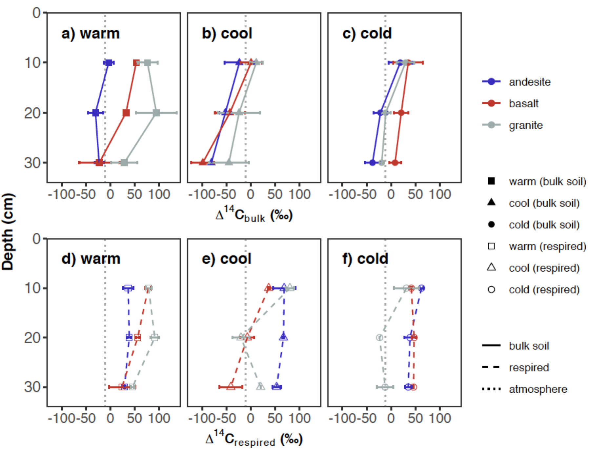

*Figure* *2.*  Depth profiles of 14C*bulk* and 14C*respired* in 2019. Top panels show bulk data, bottom panels show respired data. Panels (a) and (d) show data from the warm climate sites, (b) and (e) from the cool climate sites, and (c) and (f) from the cold climate sites. Black vertical lines show 14C of the atmosphere in 2019. Points show the mean of three replicate profiles for bulk soil, and the mean of laboratory duplicates for respired CO2. Error bars show ±1 SD for bulk soils and the minimum and maximum for respired CO2.

## 4.3 Radiocarbon time series

Temporal trends in bulk and respired 14C reflect the degree to which soil C is exchanging with C fixed from the atmosphere. The average annual decline in 14C atmospheric CO2 between 2001 and 2009 for the northern hemisphere was -5.13 per mille yr-1 (Graven et al., 2017; Sierra, 2018) (**Fig. 3, dotted lines**). Therefore, changes in 14C of soil C that parallel the atmospheric trend must be exchanging relatively rapidly compared to those that change little over the same time period.

### 4.3.1 Bulk soil.

We observed a significant three-way interaction between parent material, climate, and time at all three depths in the linear models (**Eq. 1**) for 14C*bulk* (**Table 1**). The change over time in 14C*bulk* was also affected by depth, with greater differences seen between 2001 and 2019 in the uppermost soil layer than in the deeper layers (**Fig. 3**). We observed a significant decrease in 14C*bulk* over time in both warm and cool climate granitic soils for the uppermost soil layer (0-0.1 m), and additionally for the warm climate andesitic soils (**Fig. 3, a**). In the deeper soil layers (0.1-0.2 m and 0.2-0.3 m), we only observed a significant change over time in 14C*bulk* for the cool climate basalt and granite soils (**Fig. 3, c, d**, 0.2-0.3 m data not shown). 14C*bulk* of the cool climate andesitic soils remained essentially unchanged between 2001 and 2019 for all depths (**Fig. 3, c, d**, 0.2-0.3 m data not shown), underscoring the importance of the interaction between parent material and climate for explaining temporal trends in 14C*bulk*.

The relationship of 14C*bulk* to atmospheric 14C also depended on the combination of parent material and climate. In 2001, the warm climate sites were the only sites where the basaltic and andesitic soils were enriched relative to the atmosphere, and this enrichment was only observed for the uppermost soil layer (**Fig. 3)**). In contrast, granitic soils at both the warm and cool climate sites were enriched relative to the atmosphere in 2001 (**Fig. 3**). For the cold climate sites, where 14C*bulk* was most similar, all three lithologies were depleted relative to atmospheric in both surface and subsoil layers in 2001 (**Fig. 3, e, f**).

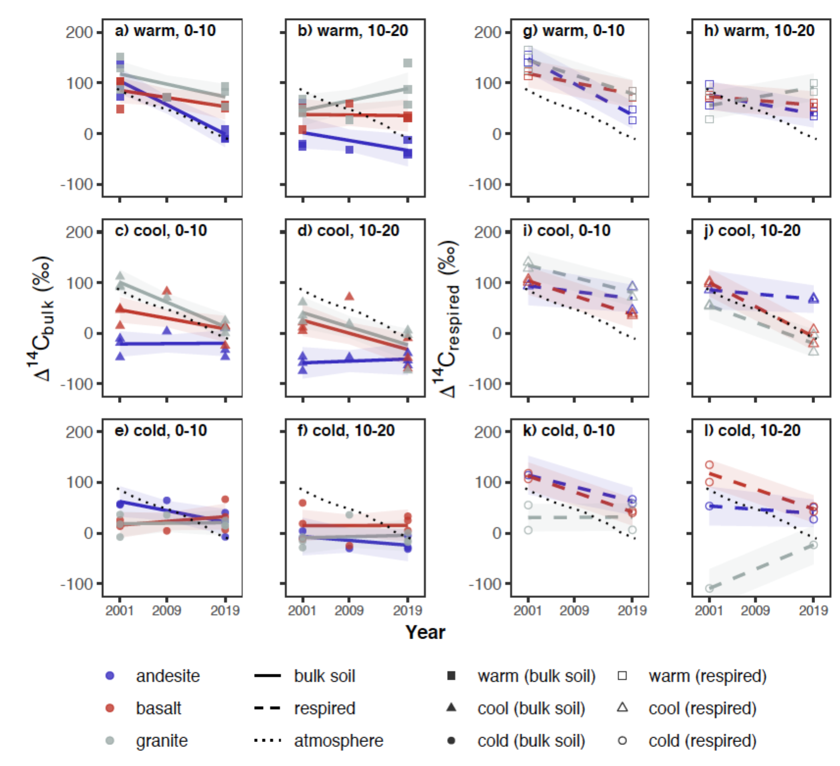

*Figure* *3.*  Temporal trends in 14C for 0-10 cm and 10-20 cm depth layers. Panels a-f show 14C*bulk* data; from left, the first column (panels a, c, and e) show 0-10 cm data, and the second column (panels b, d, and f) shows 10-20 cm data. Panels g-l show 14C*respired* data; the third column from left (panels g, i, k) shows 0-10 cm data, and the rightmost column (panels h, j, and l) shows 10-20 cm data. Points show observed data; lines show linear trend estimates for marginal means; ribbons show 95% confidence intervals for trends. Dotted line shows atmospheric 14C.

We observed that 14C*bulk* tended to decrease or remain unchanged between 2001 and 2019 across sites, but the rates of change in 14C*bulk* were typically smaller than the corresponding change in atmospheric 14C over the same period. Accordingly, 14C*bulk* measured in 2019 tended to be enriched relative to the atmosphere at more sites, and also more enriched at depth than in 2001. We observed surface soil 14C*bulk* (0-0.1 m) in 2019 to be enriched relative to the atmosphere at all sites except for the cool climate andesite soils (**Fig. 3; Fig. 2, d-f**). Furthermore, 14C*bulk* was enriched relative to the atmosphere down to 30 cm at two of the sites in 2019: the warm climate granite soil (**Fig. 2, d**) and cold climate basalt soil (**Fig. 2, f**). 14C*bulk* at the cool climate andesite site was the most depleted relative to the atmosphere at all time points (**Fig. 3**).

### 4.3.2 Heterotrophically respired CO2.

Temporal trends in 14C*respired* tended to be of greater magnitude than what we observed for 14C*bulk* (**Fig. 3, g-l**). However, changes in 14C*respired* between 2001 and 2019 still tended to be smaller in magnitude than the change observed in the atmosphere over this period (**Fig. 3, g-l**). In contrast to 14C*bulk*, 14C*respired* values of both surface and near surface soils (0-0.2 m) were close to atmospheric levels in 2001, while in 2019, 14C*respired* tended to be enriched relative to the atmosphere, even for the deeper soil layers (**Fig. 3, g-l**).

We saw significant decreases in 14C*respired* values of surface (0-0.1 m) soils at seven of the nine sites, with the only exceptions being the cool climate andesitic and cold climate granitic sites (**Fig. 3, g-l**). In absolute terms, the changes in 14C*respired* over time in the uppermost soil layer were greatest at the warm sites (-4 ±2 per mil yr-1), while changes were similar for the cool 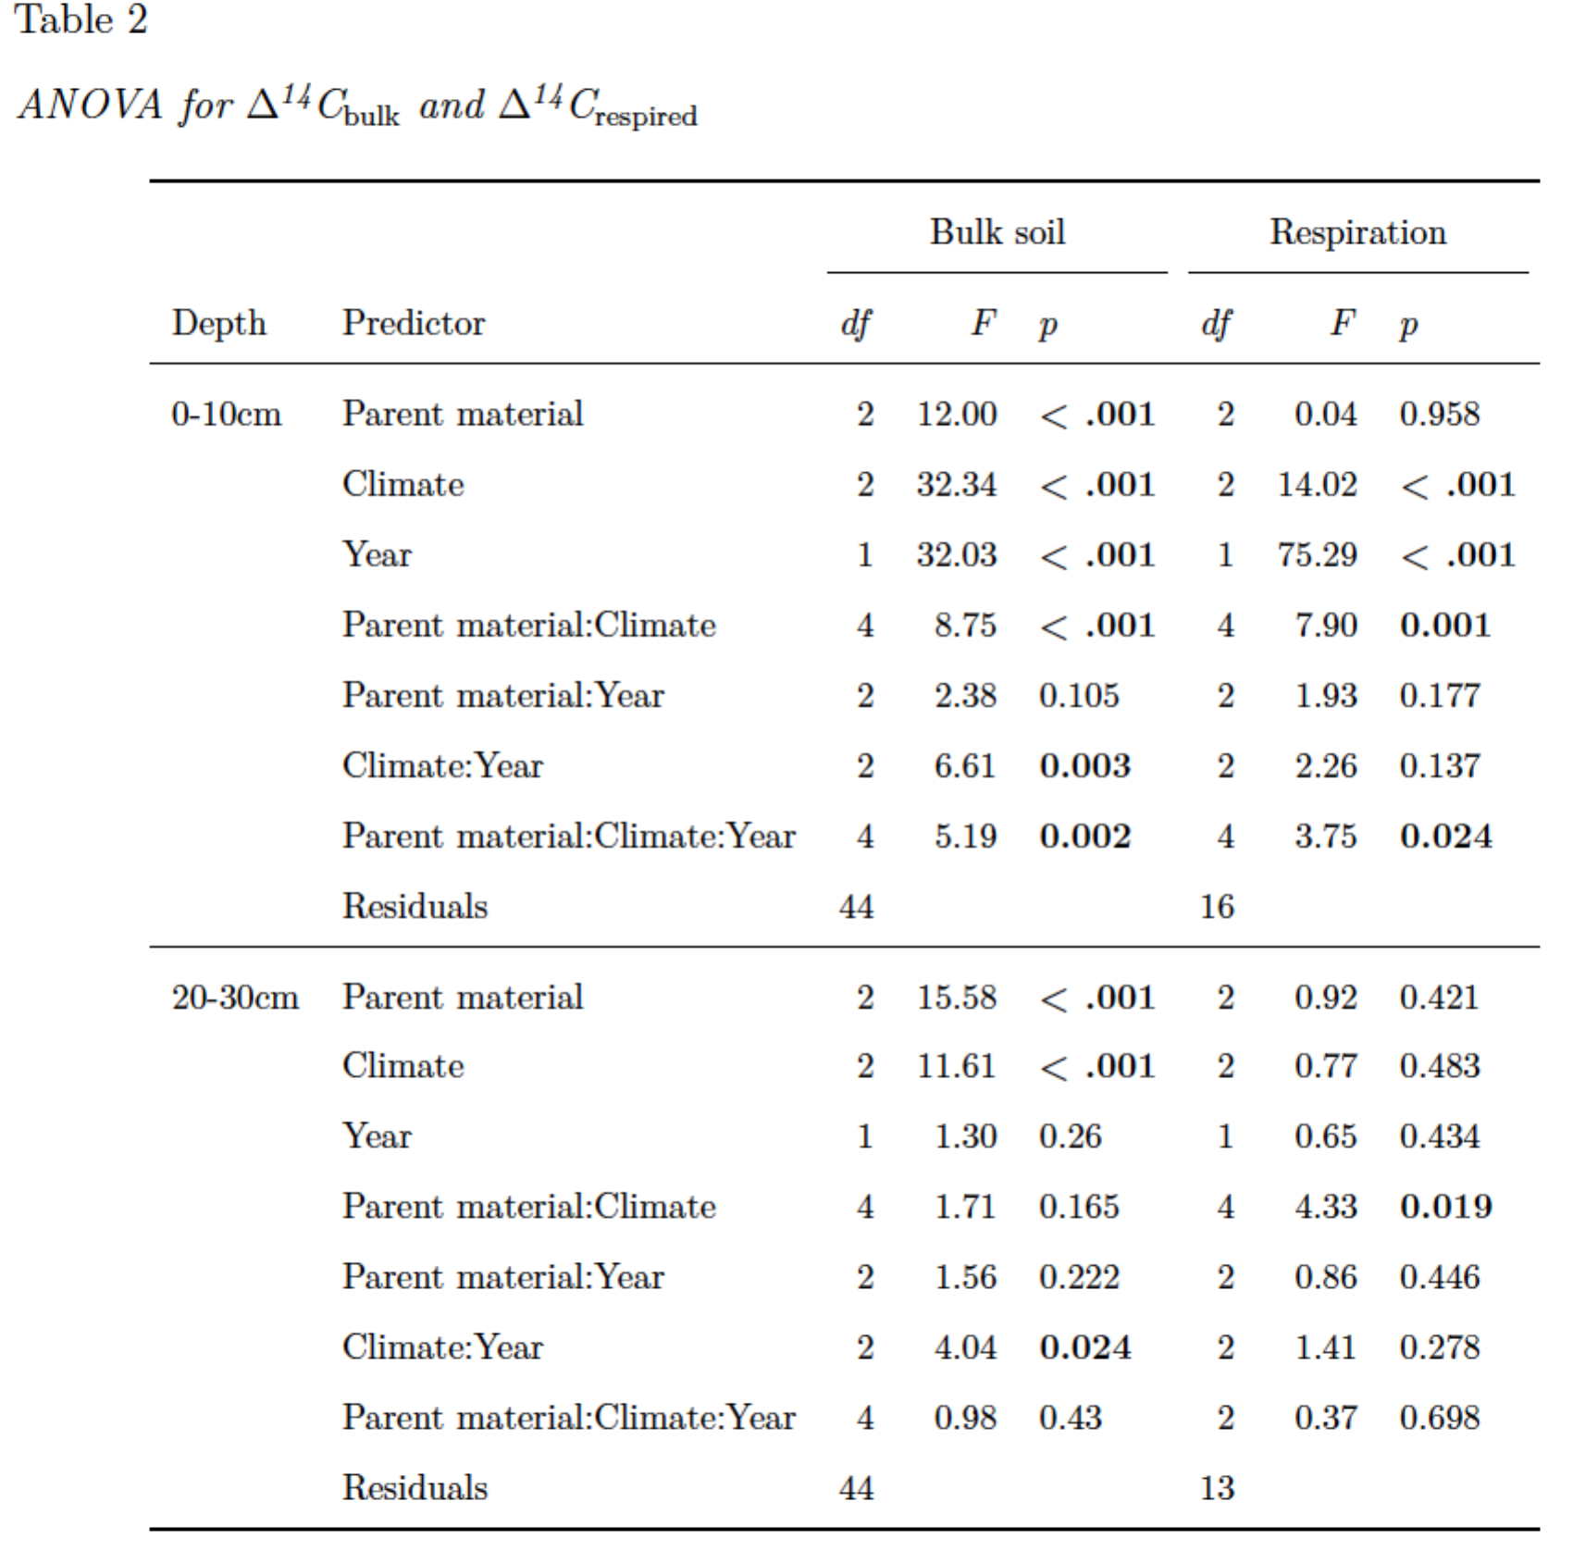and cold sites (-2.7 ±1.2 per mil yr-1, and -2.2 ±2.1 per mil yr-1, respectively). When considered within parent materials, granitic soils showed the greatest decrease in 14C*respired* over time at the warm climate site and the least change at the cold climate site. In contrast, the andesitic soils showed the least amount of change over time at the cool climate sites, while changes over time in the basaltic soils were similar across all three climate regimes. The magnitude of the change in 14C*respired* over time tended to decrease with depth for all soils. We observed significant negative trends over time for 14C*respired* at only four of the nine sites for the 0.1-0.2 m layer (warm andesite, cool basalt, cool granite, and cold basalt) (**Fig. 3**), and only one site for the 0.2-0.3 m layer (cold basalt) (SI Fig. XX). 14C*respired* at the cool andesitic soils remained unchanged at all depths over the study period.

We observed a significant increase in 14C*respired* from 2001 to 2019 at only one site: the cold climate granitic soil (**Fig. 3**). This was also the only soil for which 14C*respired* was more depleted than 14C*bulk*. We observed this anomaly for the deeper soil layers in both 2001 and 2019. We observed 14C*respired* values of -469.1-127.8 per mil for the 8-27 cm layer in 2001, compared to 14C*bulk* values between -30.80 and -10.50. Similarly, we observed 14C*respired* values of -396.70 and -23.50 per mil for the 10-20 cm layer in 2019, compared to -18.10 and 0.40 for 14C*bulk* (SI Table X). However, since these anomalous values of 14C*respired* were restricted to the deeper soil layers from this one site, and were consistent over time, the response appears to be a laboratory artifact unique to these soils. Accordingly, we have excluded these highly depleted samples from the statistical analyses.

## 4.4 Relationship of bulk soil and respired CO2 14C

We assessed the relationship between 14C*bulk* and 14C*respired* using linear regression models for parent material (**Eq. 3**) and climate (**Eq. 4**). We observed 14C*respired* to be enriched relative to 14C*bulk* for almost all sites and all depths, but that the magnitude of the difference depended on both parent material and climate. Accordingly, y-intercepts for all models were equal to or greater than zero, indicating that respired CO2 in these soils is predominantly modern (i.e. < 60 years old) for all but the deepest soil layers, regardless of parent material or climate regime. We found the largest y-intercept values for the soils developed on andesitic parent material, and for soils in the cool climate zones, which indicates that CO2 respired from these soils is relatively enriched in decadally cycling bomb-C.

Slope values less than 1 in these models indicate that every per mille change in 14C*bulk* is associated with a correspondingly smaller change in 14C*respired*. This suggests that the process regulating persistence of soil C on long time scales is distinct from that which regulates more transiently cycling soil C. Similar to what we found for the y-intercepts, modeled slopes for the parent material-only model (**Eq. 2**) were smallest for the andesitic soils (slope = 0.51, 95% CI = [0.22, 0.80]) (**Fig. 4, a**), and for cool climate soils in the climate-only model (**Eq. 3**) (slope = 0.61, 95% CI = [0.30, 0.91]) (**Fig. 4, b**). While we could not directly test the interaction of parent material and climate factors in these models owing to the limited number of observations, we observed that mean differences in 14C*bulk* and 14C*respired* were substantially greater for the cool climate soils developed on andesitic parent material than for the other sites.

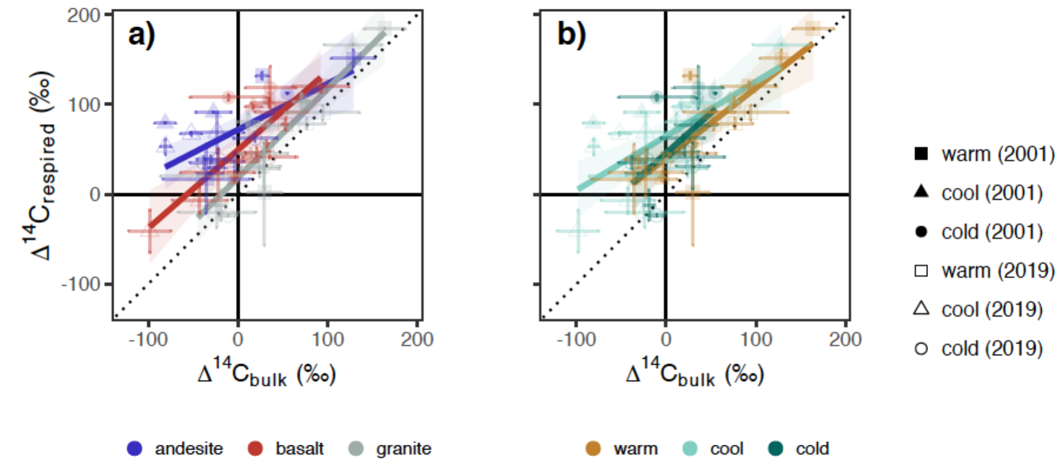

*Figure* *4.*  Parent material and climate effects on the relationship of 14C*bulk* and 14C*respired*. a) Parent material model **(Eq. 3)** and b) Climate model **(Eq. 4)**. Dotted line shows 1:1 relationship. Points show the mean of three replicate profiles for bulk soil, and the mean of laboratory duplicates for respired CO2. Error bars show ±1 SD for bulk soils and the minimum and maximum for respired CO2. Respired CO2 from the cold granite site in 2001 was extremely depleted in 14C and thus is excluded for display purposes.

## 4.5 Mineral assemblages and radiocarbon

Mineral assemblage data is reported fully in Rasmussen et al. (2018). Here we focus on the selective dissolution data with respect to the trends we observed in 14C*bulk*, 14C*respired*, and 14C*respired-bulk*. We observed a significant negative correlation between 14C*bulk* and the concentration of oxalate extractable iron, oxalate extractable aluminum, and pyrophosphate extractable aluminum (SI). For simplicity, we focus here on the sum of oxalate extractable aluminum and half of the oxalate extractable iron as a proxy for non-crystalline metal oxide abundance, and the difference of dithionite-citrate extractable iron and ammonium-oxalate extractable iron as a proxy for crystalline Fe-oxide abundance. The relationship between non-crystalline oxide abundance and 14C*bulk* was highly significant (*p* <0.001), with the model explaining 0 percent of the observed variation. In contrast, we did not find a significant relationship between crystalline Fe-oxide abundance and 14C*bulk*.

We observed a significant relationship between 14C*respired* and poorly crystalline metal oxide abundance for the 2001 samples (*p* = 0.04), but not for the 2019 samples. Accordingly, the combined set of 2001 and 2019 data was only marginally significant(*p* = 0.07). However, we did see a highly significant relationship between poorly crystalline metal oxide abundance and 14C*respired-bulk* (**Fig. 5, a**). As with 14C*bulk*, there was no relationship with crystalline Fe-oxide abundance for either 14C*respired* or 14C*respired-bulk* (**Fig. 5, b**).

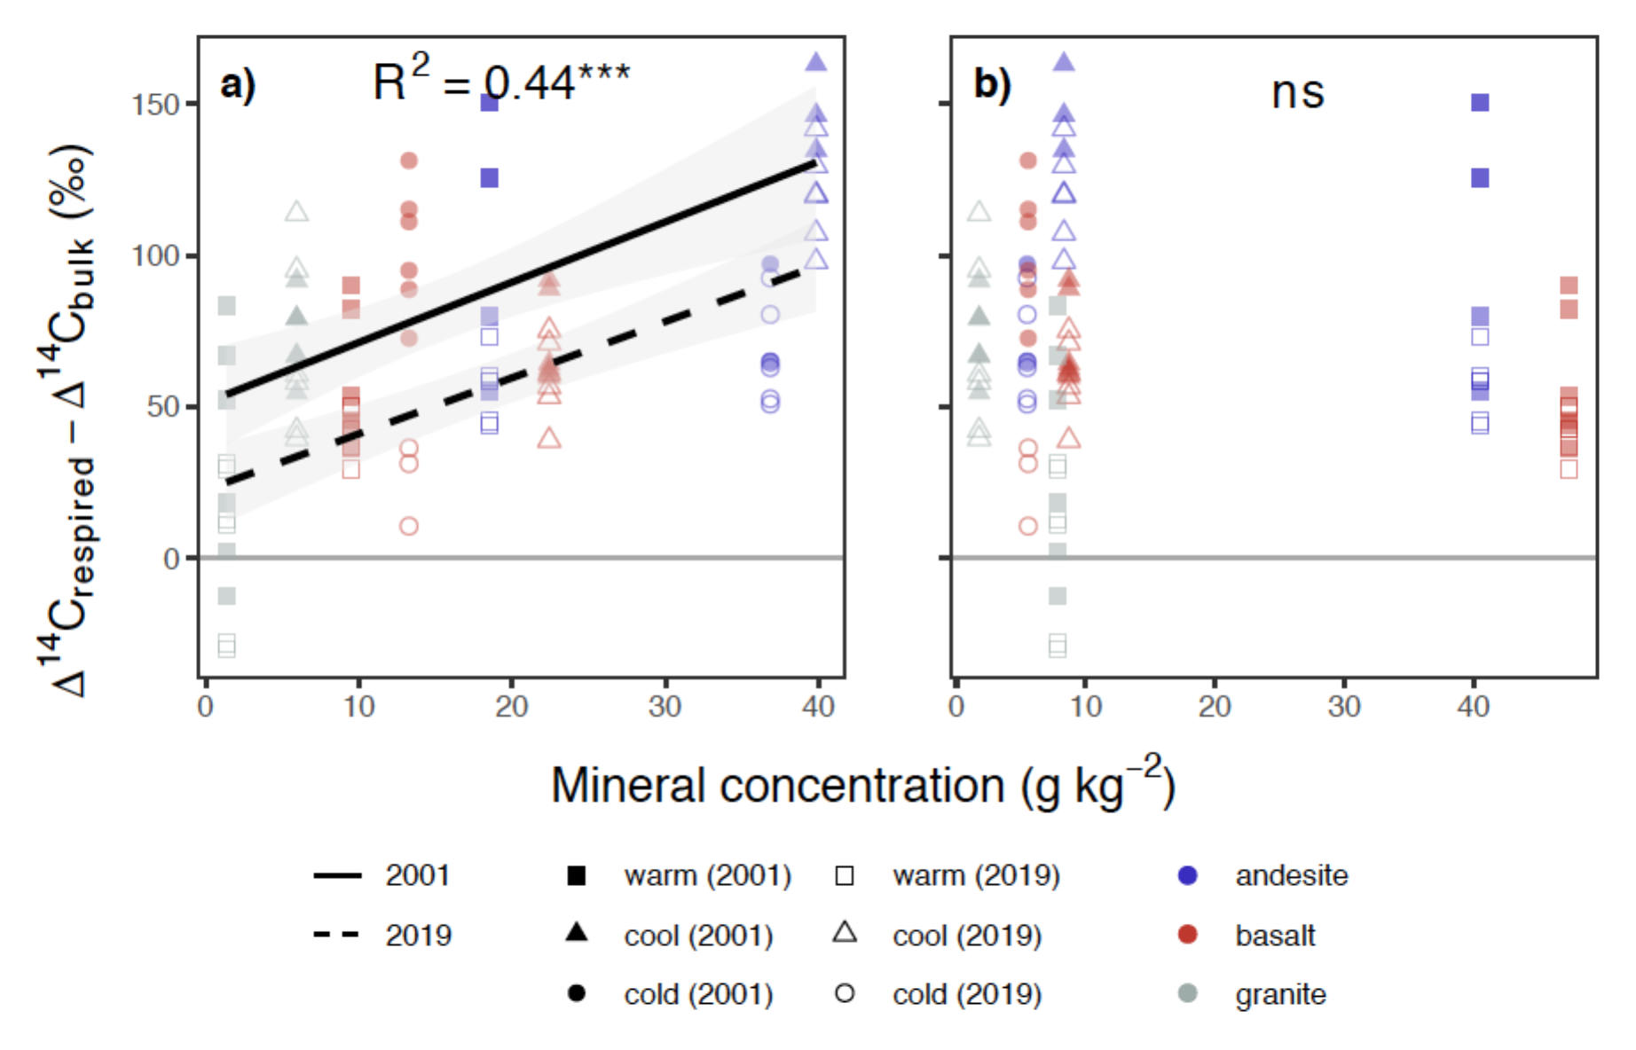

*Figure* *5.*  Relationship of poorly crystalline and crystalline minerals to the difference of 14C*respired* and 14C*bulk* (14C*respired-bulk*). a) Poorly crystalline metal oxide content (oxalate-extractable aluminum + 1/2 oxalate-extractable iron), b) Crystalline Fe content (dithionite-extractable iron - oxalate-extractable iron). Points show mass-weighted mineral concentrations and carbon-weighted values of 14C*respired-bulk* for 0-30cm profiles. Lines show partial slopes for 2001 and 2019 from the linear model fit (**Eq. 5**).

# 5 Discussion

Climatic and mineralogical factors both play key roles in soil carbon persistence. However, the relevance of parent material for explaining soil organic matter persistence in soils with mixed mineralogies is still poorly explained. In the current study we illuminate how parent material interactions with climate lead to the development of distinct mineral assemblages, which in turn control the dynamics of soil C cycling at timescales ranging from annual to centennial. Our key findings are that soil mineral characteristics mediate climatic controls on soil C cycling, and that mineralogical controls on soil C cycling are not limited to soil C persistence on centennial timescales, but are relevant for C cycling on shorter timescales as well.

Our results challenge the primacy of climatic controls on soil carbon persistence, insofar as we observed the most depleted 14C*bulk* in soils of the cool climate zone, not the cold climate zone. We found that climate is a critical factor for explaining the dynamics of both persistent and more transient soil C pools, as measured by proxy with 14C*bulk* and 14C*respired*, respectively. However, our results indicate that soil mineral characteristics moderate the strength of the climate effect. This is particularly apparent at depth. These results are supported by a recent study in which the authors used a depth-resolved model with energy and substrate limitation prescribed by Michalis Menten kinetics to model profiles of 14C*bulk* (Ahrens et al. 2020). The authors found that site mean annual temperature could only explain a minimal amount of variation in the observed radiocarbon profiles, while varying sorption potential in the model allowed for a superior fit.

Previous work at our study sites showed that poorly crystalline metal oxides were key to explaining both soil C accumulation and 14C*bulk* values in these soils (Rasmussen et al., 2018). Our results confirm these findings and extend them to demonstrate a significant correlation between poorly crystalline metal oxide abundance and 14C*respired-bulk* and a marginally significant correlation with 14C*respired*. [say something about raw resp data and bombC issues]. However, we focus here on 14C*respired-bulk*, as this metric offers a unique insight into the magnitude of the difference between the cycling rates of persistent and more transiently cycling soil C.

We would expect the greatest differences between 14C*respired* and 14C*bulk* to be found in soils with a pool of old soil C protected from decomposition in some way, and another pool of soil C that is readily decomposed. In contrast, the smallest differences should occur for soils lacking strong soil C protection mechanisms, in which the majority of soil C has an equal probability of being decomposed by microbes. Accordingly, we observed the smallest differences between 14C*respired* and 14C*bulk* in the soils with the lowest concentration of poorly crystalline metal oxides, while we observed the largest differences in the soils with the highest concentrations of these minerals. We interpret these findings as providing evidence for a key role of poorly crystalline metal oxides in protecting soil organic matter from decomposition. The values of 14C*bulk* in the subsurface layers (0.1-0.3 m) of the soils with low poorly crystalline metal oxide content (e.g. granitic soils) were depleted relative to the atmosphere, indicating persistent soil C, but we also observed similarly depleted values of 14C*respired* in these soils. This suggests that soil C persistence in these soils is due to other physical constraints on decomposition that are alleviated under laboratory incubation conditions, for example transport or isolation [Gleixner et al., 2013].

The soils with the largest difference between 14C*respired* and 14C*bulk* were those that had both strongly depleted values of 14C*bulk* and values of 14C*respired* that were enriched relative to the atmosphere. If we employ a theoretical compartmental model to interpret this finding, a possible scenario would involve one pool of centennial to millennially cycling soil C whose signal dominates the 14C*bulk* signal, and second pool of soil C enriched with C fixed from the atmosphere in the years immediately following the bomb-C spike, e.g. 1964 to 1990, whose signal dominates the 14C*respired* signal. More complex model structures could potentially be fit to these data, but the data provide clear evidence for the presence of at least two distinct pools with strongly depleted C largely inaccessible to the microbial community, and another pool enriched with decadally cycling C dominating the respiration flux. This stands in contrast to the soils with 14C*respired* values close to that of the atmosphere, in which the respired signal is likely dominated by sub-decadally cycling C.

Laboratory studies on soil organic matter associations with poorly crystalline metal oxides such as goethite show that only a portion of the organic matter is so tightly bound as to resist desorption (Kaiser and Guggenberger, 2003). Further studies have demonstrated that a portion of the organic matter can be mobilized by exchange with DOC (Leinemann et al., 2018). In this scenario the highly depleted 14C*bulk* values observed in the soils with high concentrations of poorly crystalline minerals may derive from organic matter that is strongly sorbed or trapped in micropores, while the bomb-C enriched decadally cycling C observed in the respiration flux could derive from the more microbially accessible and DOC-exchangeable mineral associated soil C pool. However, the rates of change over time that we observed for 14C*respired* indicate that annually cycling C is also an important component of soil organic matter at all of our sites.

Our finding that parent material explains more of the variation in 14C*respired* at depth than climate suggests the role of soil minerals in regulating annually to decadally cycling soil C is of particular importance in deeper soil layers. DOC has been shown to move downward through the soil profile via preferential sorption of new soil C inputs and corresponding desorption of older DOC, which is then available to the microbial community (Kaiser and Kalbitz, 2012). This process is mineral controlled, and while we did not test it directly, such a process could explain why we see an increased importance of parent material, and the interaction between climate and parent material, for explaining 14C*respired* trends with depth.

In contrast to what we observed for the poorly crystalline metal oxides, the lack of correlation we observed between crystalline Fe oxides and soil radiocarbon suggests that these minerals do not play an important role in explaining soil C persistence, at least in these soils. Other studies have shown that crystalline Fe oxides do protect soil C from microbial decomposition, but that the overall sorption capacity of these mineral species is low [Kahle et al., 2003]. We observed a large increase in the amount of iron dissolved from crystalline minerals at the warm sites relative to the cool or cold sites, along with a corresponding decrease in soil C concentration and relative enrichment in both 14C*bulk* and 14C*respired*. This increase in crystalline iron was also associated with a corresponding decrease in the amount of poorly crystalline minerals. Together these trends suggest that these soils have lost poorly crystalline minerals through leaching and transformation into crystalline species. The patterns of C concentrations and associated SOC stocks, 14C*bulk*, and 14C*respired* observed across the climate/weathering gradient suggest that weathering of poorly crystalline metal oxides leads to a reduction in soil carbon stocks, which is caused by losses of old 14C depleted carbon associated with these minerals, and that this process is relevant across a range of igneous parent materials.

The sensitivity of decomposition to temperature is of particular interest for understanding how soil C dynamics may change under a warming climate. Comparing the change in 14C*respired* over time for the different climate zones across the different lithologies provides insight into this question. Focusing on the near surface soils (0-0.1 m), where climate effects are strongest, we observed that the rate of change in 14C*respired* over time was correlated with poorly crystalline metal oxide content. We observed a linear relationship between MAT and the rate of change in 14C*respired* over time for the granitic soils, which had low concentrations of poorly crystalline metal oxides in all three climate zones. In contrast, 14C*respired* changed more over time in the coldest climate zone for the basaltic and andesitic soils than in the cool climate zone with higher concentrations of poorly crystalline metal oxides. Furthermore, the change in 14C*respired* over time was similar for all three parent materials at the warm climate zone with minimal poorly crystalline metal oxide content. These findings provide evidence that the temperature sensitivity of soil organic matter decomposition may be attenuated in the presence of poorly crystalline minerals. If this is true, we would expect that potential increases in decomposition rates, and accompanying carbon losses due to climate warming, would be greater in soils lacking substantial concentrations of poorly crystalline metal oxides than in soils enriched in these minerals.

# 6 Conclusion

Our study shows clearly that parent material and climate interact to control soil C dynamics. This interaction was the key to explain trends in 14C*bulk*, which is a proxy for the mean age of soil C, and additionally in 14C*respired*, which reveals the relative contributions of faster or more slowly cycling soil C to respiration. We observed that the trends in both 14C*bulk* and 14C*respired* were best explained by climate at the soil surface, but best explained by parent material in deeper soil layers. The overall importance of climate was reflected in the changes in 14C we observed over time, both for bulk C and respired CO2. We saw greater changes at the soil surface than in the deeper layers, and in the highly weathered soils of the warm climate sites than in the poorly developed soils of the cold sites. Yet contrary to the expected temperature-decomposition relationship, we saw the most depleted 14C*bulk* in the cool climate zone with intermediate MAT, which is also where we saw the least amount of change in 14C over time at all depths.

The effect of the interaction between parent material and climate on soil C dynamics is best explained by the development of distinct mineral assemblages via weathering, in particular the formation and subsequent loss of poorly crystalline metal oxides. We confirm the findings of other studies showing that poorly crystalline minerals are highly correlated with the age of soil C, as measured by proxy with 14C*bulk*. We extend this finding to show that it is specifically the poorly crystalline metal oxide content that is correlated with 14C*bulk*, and that the correlation with crystalline Fe content is not significant. Furthermore, we provide mechanistic evidence for the protective effect of mineral-association on decomposition of soil organic matter by demonstrating that the difference between 14C*bulk* and 14C*respired* is highly correlated with poorly crystalline mineral content. Finally, the signal from decadally cycling soil C in 14C*respired* from the sites enriched with poorly crystalline metal oxides provides preliminary evidence that the association of soil organic matter with these mineral phases may attenuate the temperature sensitivity of decomposition.

In future work we intend to quantify the timescales of soil carbon cycling in mineral and non-mineral associated pools with a compartmental modeling approach, using the radiocarbon time series presented here in addition to radiocarbon measurements of soil density and thermal fractions as constraints. With this modeling framework we also hope to test additional hypotheses regarding mineral association and temperature sensitivity of soil organic matter.