Joao Vitor Bonanoni

Computer Application

Sayed Shah

Nov 11 2020

**Microsoft Excel Assignment #3**

Introduction:

This is an assignment for the computer application class about Microsoft Excel Application and the creation of charts

It was used the Microsoft Excel application, Turnitin and GitHub platform.

During the process there were some difficulties with Excel application and GitHub submission.

Methodology:

This project started with the creation of a Bar chart using the instructions mentioned in the lectures. After it, I created a pie chart, spark line chart, and tabular chart. All of them were based in random data.

Results:

This project could improve my knowledge about Microsoft Excel and GitHub applications.

Conclusion:

The graphs could provide a good visual result and organization of the data.

Future work:

My goal is to keep improving my knowledge over Microsoft Excel.

Images:

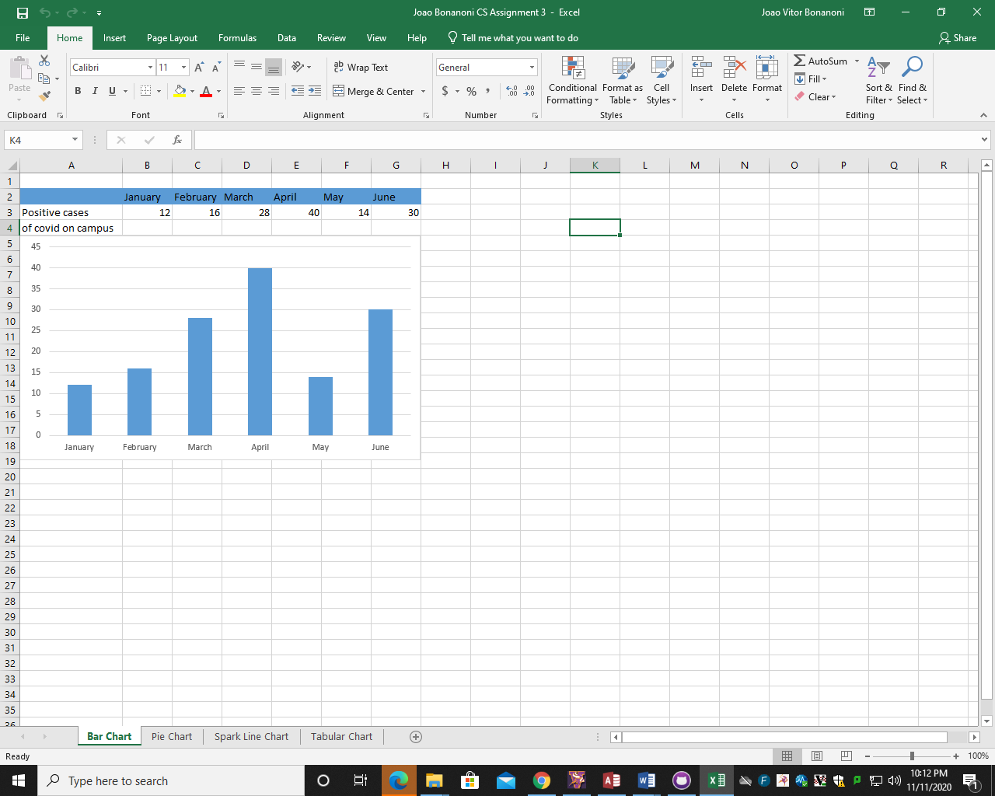

After the creation of this data I clicked the left bottom and created a chart

Data used for this table

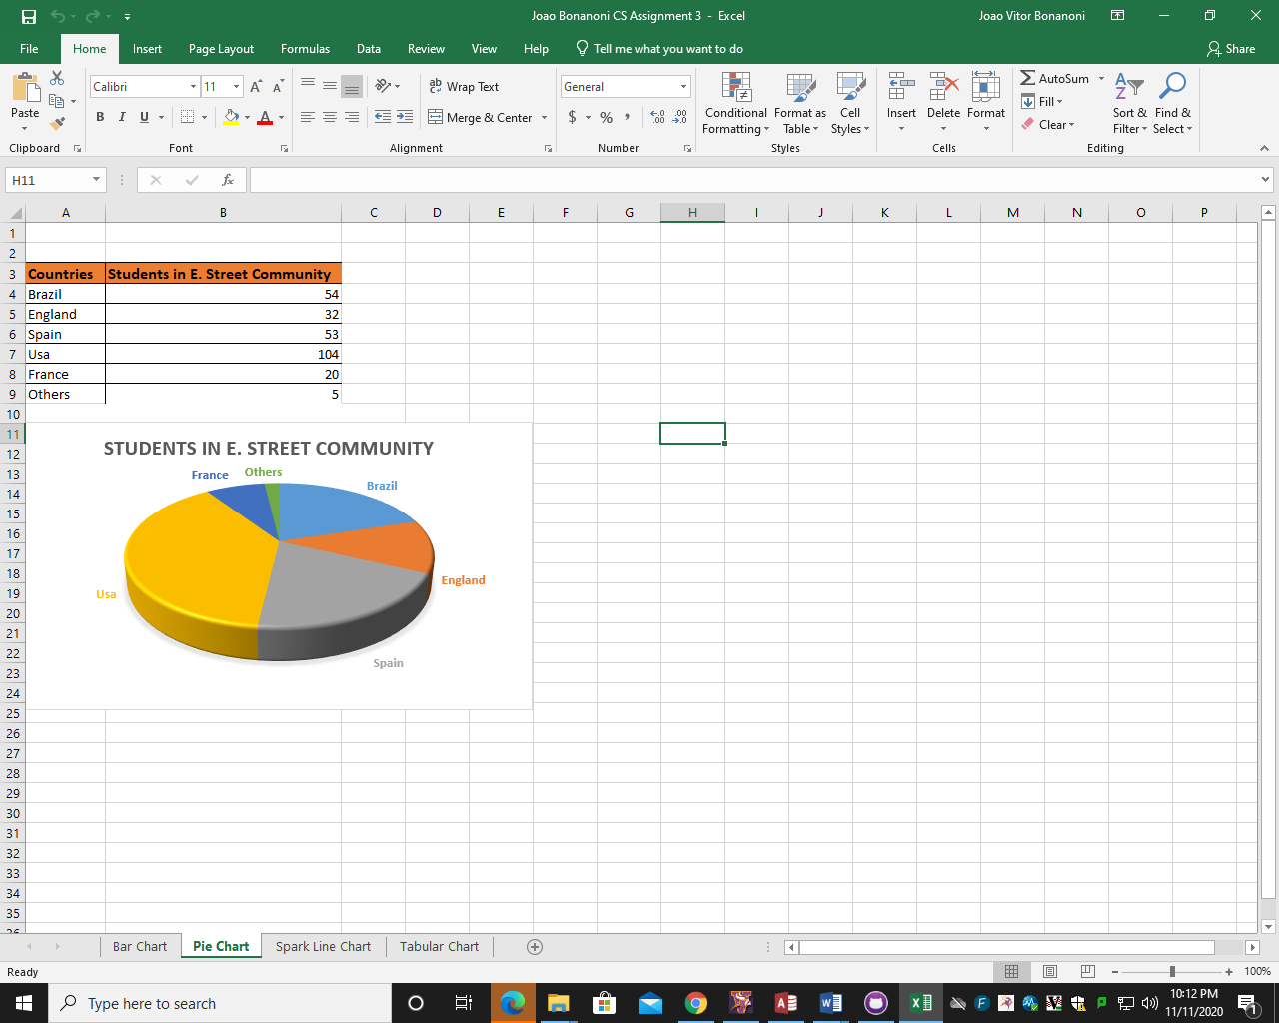

In the next images I repeated the process, but just changed the design of the tables and did some adjusts.

