Rebecca Buechle

Web-330

April 29, 2020

**Personal Portfolio (Milestone 1): Market Research**

**Instructions:**

Search the Internet for at least three (3) single page personal portfolio websites and explore their capabilities. Identify the features, layouts, styles, and overall functionality.

**Deliverables for this assignment:**

* Submit a single word document of at least 250 words describing their features, layouts, styles, and overall functionality. Be sure to include screenshots and objectively identify the advantages and disadvantages of each website.

The first single page profile that I found was <https://brittanychiang.com/> - I really liked how simple this pages layout was. It had all the information that I think an employer would look for when wanting to see someone’s skills. She showcases some of her web development projects as well as some of her JavaScript projects and other project as well. She has everything laid out in a simple to follow style and has a bread crumb type links at the top to the different parts of her page so you don’t have to scroll all the way unless you want to. Some of the features this site includes are bread crumbs at the top to get to certain points on the page, links to social media on the side such as her Github, as well as some mouse overs affects. Overall, the functionality and layout are very simple to follow, and I think she did a great way of showing her work in a non-overwhelming matter. I think an advantage to this site would be that it looks very simple to design something like this but that could also be a disadvantage as well because it could look like any other portfolio you come across.

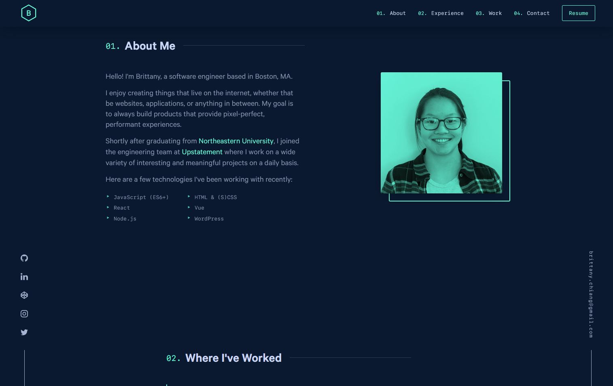

The second page that I found was <https://kyler.design/> - This page was another simple one but I think it might have been a little too simple. I don’t think it included everything that someone would want to know when hiring someone. It did showcase some of his work and tell about his skills but also included some information that I didn’t think really fit what the page was intended for such as how many miles he had currently ran. I did like that he had a contact form at the bottom. As far as the features the site had a form, social media contacts, and a weird stat tracker for running and such. Overall, the functionality of the page was simple nothing over the top and the same could be said for the layout and styles used as well looked like a simple html/css website though maybe his running stats could be linked to some type of program but I’m not sure. This websites advantage is that the site will load on pretty much anything. The disadvantage is that it doesn’t grab my attention at all I was pretty board overall and it just kind of looked thrown together.

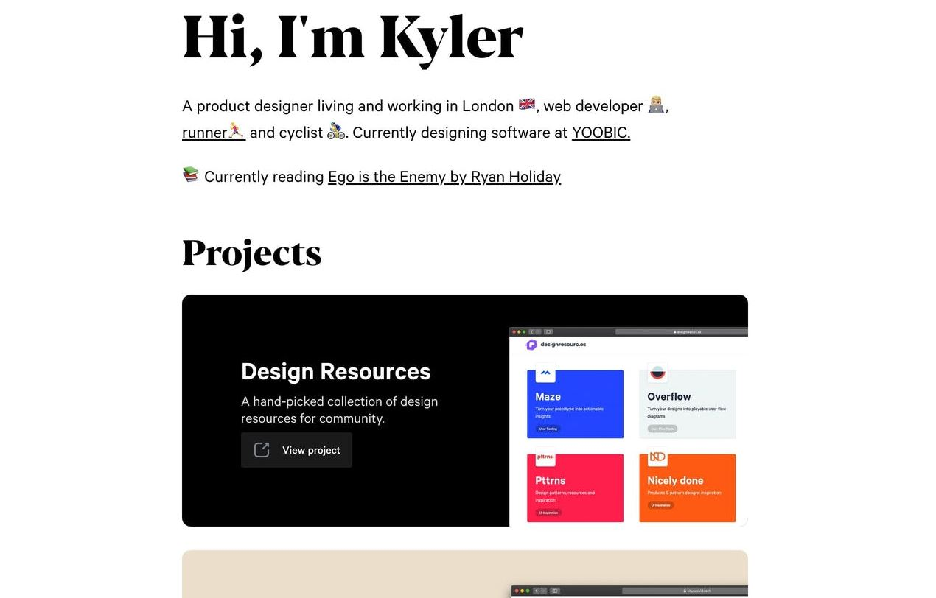

The third page that I came across was <https://owltastic.com/> - which was probably one of my favorites. This page just wowed me it was very easy to follow but she added very small and subtle moving images that kind of grabs your attention as you go. I believe everything she includes is relevant for the page for an employer to see her work and to learn a little bit more about her. Some of the features of this one includes a logo, form for her to contact you, as well as links to her social media accounts, and footer. Overall, the layout to this page is fantastic everything I could want to see is there and its very simple to follow all the way through. The site has a lot of information but isn’t’ crowded. The advantages to this site are that you can tell she put some thought into make it and it doesn’t look like every other plain profile page out there. As far as disadvantaged the only one I could really think of is that it might take a little bit longer to load.

[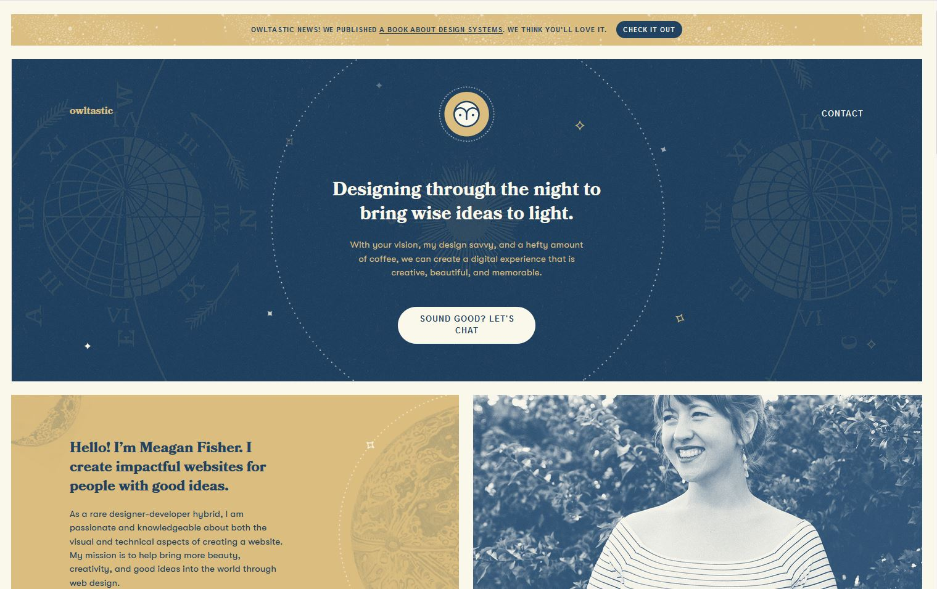](https://owltastic.com/)