Written by

IS204-1

User manual

Stiho Complaint Form & Stiho Complaint Handling System

Team members:

Sayf Akhatou

Mustafa Alemi

Donavan Asmawidjaja

Jesse Baas

Robert Bakker

Dennis Berkhof

Ilyass Charkaoui

Table of contents

1.0 Introduction 1

2.0 System Summary 3

2.1 User Access Levels 3

3.0 Using the System 3

3.1 Home page 3

3.2 Stiho Complaint Form 4

3.2.1 Using the form 4

3.2.2 Confirmation Page 5

3.2.3 Complaint Status Page 5

3.3 Stiho Complaint Handling System 6

3.3.1 Login page 6

3.3.2 Employee complaint overview page 7

3.3.3 Customer List 8

3.3.4 Complaint Detail page 8

3.3.5 Manager complaint overview page 9

3.3.5 Employee list 9

3.3.5 Statistics 9

# 

# 1.0 Introduction

The Stiho complaint form is a web based application, which allow Stiho customers to submit complaints through a web browser, by filling in a form.

The Stiho complaint handling system is a web based application for the employees and managers of Stiho. This application allows the managers and employees to have an overview of all received complaints and allows them to interact with the customers, to solve complaints. The complaints are received through the Stiho complaint form.

# 2.0 System Summary

System Summary section provides a general overview of the system. The summary outlines the user access levels and system’s behavior in case of any contingencies.

## 2.1 User Access Levels

**Stiho Complaint Form**  
The complaint form can only be submitted if the user has a valid customer number. The customer number is a unique number which relates to a known customer of Stiho. An employee can also submit the form for customers with their unique customer number.

**Stiho Complaint Handling System**  
The complaint handling System can only be used by employees and managers who have their personal login information.

The complaint handling System can only be used by users who have valid credentials known to Stiho. It provides two different levels; the employee access level and the manager access level. The employee has permissions to view and respond to complaints submitted by a customer. The manager has permissions to view all complaints, create employees, and view statistics.

# 3.0 Using the System

This section provides a detailed description of system functions.

## 3.1 Home page

After launching the web application the home page is displayed. From here you can access either the *complaint form* (see paragraph 3.2.1) or the *complaint handling system* (see paragraph 3.3.1) by clicking one of the corresponding buttons.

The language can be switched to either English or Dutch.

## 3.2 Stiho Complaint Form

### 3.2.1 Using the form

**1 Company Information**

If you are a known customer of Stiho, you will have a customer number. Fill the number into the field next to *Customer Number*.

By clicking on Search all necessary information will automatically be retrieved and filled in the remaining fields.

**2 Contact person**

This section is used to fill in your contact information. Stiho will use this information to contact you to regarding the progress of your complaint.

*If you are an employee and filling this in for a customer, use this field to fill in the contact information of that customer.*

**3 Complaint**

Use this section to describe the context of your complaint. First choose one of the following categories: **Administration, Quotation, Employee, Delivery, Order or Other.**   
In *Description* field you can describe your complaint.  
Below you can set the priority. Priority is set to Normal by default. Other priorities are: High and Urgent. Optionally you can attach a file to provide additional context.

**4 Submit**

Once you have filled in all fields correctly, you can submit your complaint to Stiho by clicking this button.

### 3.2.2 Confirmation Page

After you submit a complaint, you will see this page: *the Confirmation Page*. On this page the information that is sent to Stiho is displayed. This page also contains a tracking link, where you can follow your complaint.

### 3.2.3 Complaint Status Page

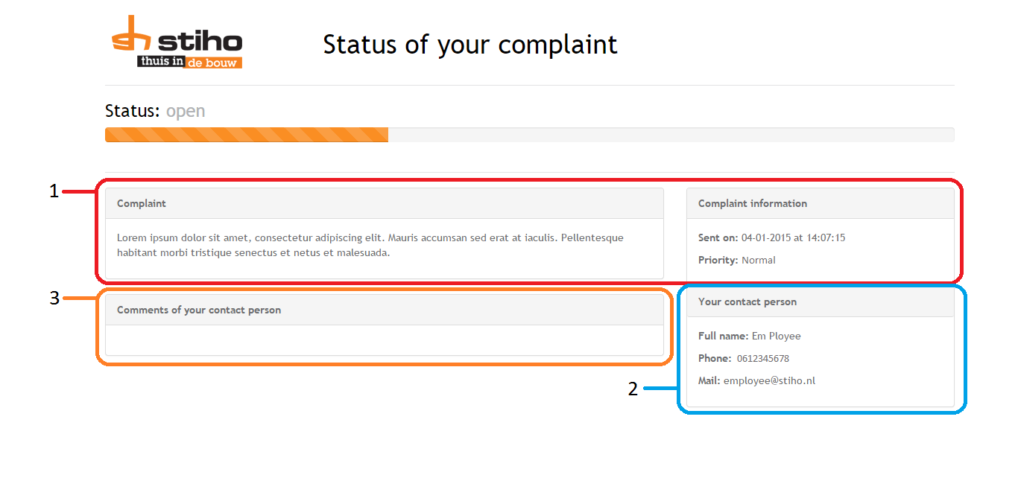

By following the link from the confirmation page and the email that was sent to you; you will see this page; the status page. On the Status page you can follow your complaint’s status. Here you will find your complaint and complaint information (1). If the status is changed, you will see it on this page. Alongside the status you will also see who is handling you complaint with their contact information (2).

Finally you will see comments for your contact person, here you can follow the whole conversation between you and your contact person (3).

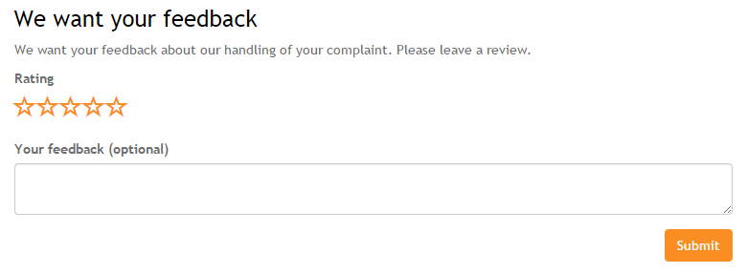

Once your complaint is completely handled, you will see this page. Here you can provide feedback on how the complaint was handled. You can give up to 5 stars and optionally describe the reason of your rating.

## 3.3 Stiho Complaint Handling System

### 3.3.1 Login page

This login page is for both the employee and manager access levels. After filling in your credentials you will be directed to your dashboard.

**Employee level**

### 3.3.2 Employee complaint overview page

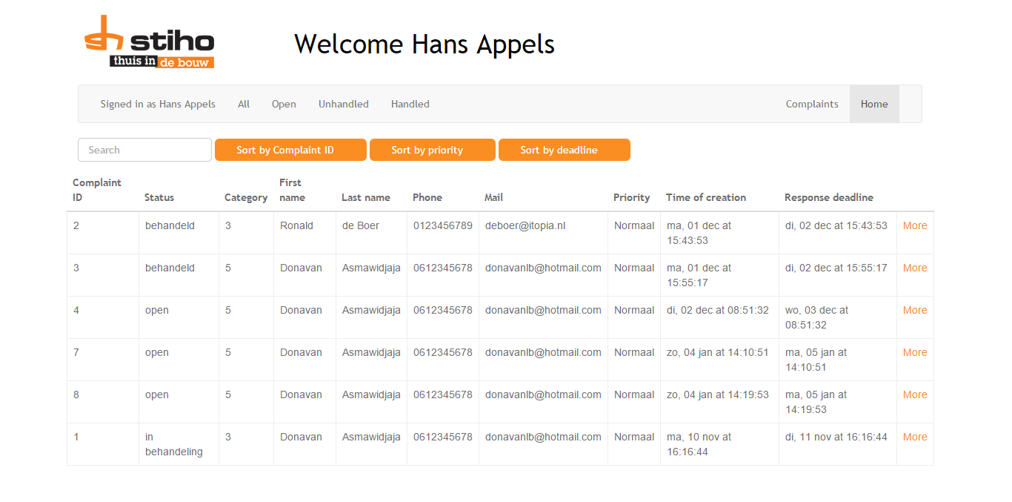

On this page the employee will see all the recent complaints, which are coupled to that employee.  
You can sort on **Complaint ID, Priority and Deadline.**

With the buttons on the menu bar you can filter the complaints on **Open, Unhandled and Handled** or view them all. On the right there is also a button with *Customer* where you can view all customers of Stiho (see paragraph 3.3.3).

If you want to see the complaint in detail and/or interact with the contact person of the complaint, click on **More**. This sends you to the *complaint detail page* (see paragraph 3.3.4).

### 3.3.3 Customer List

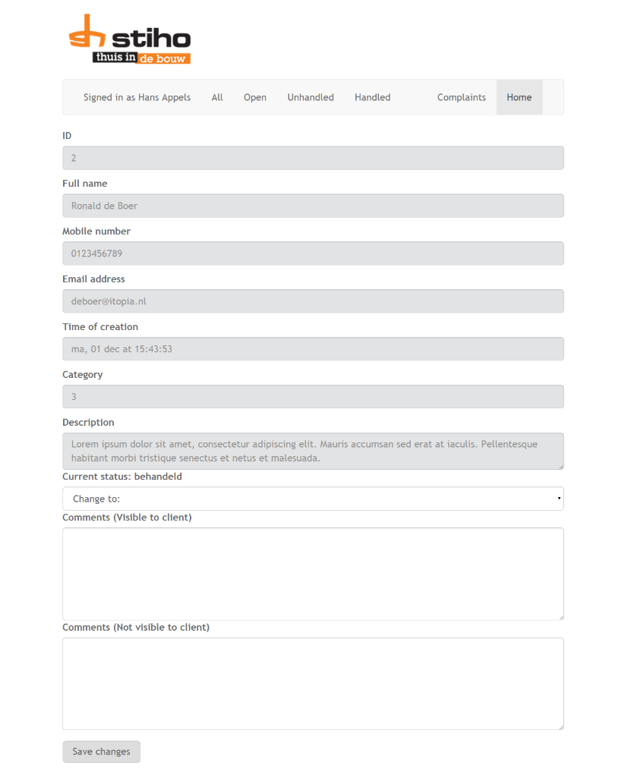On the customer list you can view all the clients of Stiho, if you click on **Show History** you can also see all the complaints of this particular client.

You can also search for a client by its **Company Name and its email address.**

### 3.3.4 Complaint Detail page

On the right, you see the complaint detail page. All the information of the complaint are displayed here.

Alongside the complaint information, you can also change the status of the complaint.

You can also leave a comment to the client, so they get informed about the complaint status.

Lastly you can leave a comment only visible for other employees . Everything filled in in this field, won’t be shown to the client.

**Manager level**

### 3.3.5 Manager complaint overview page

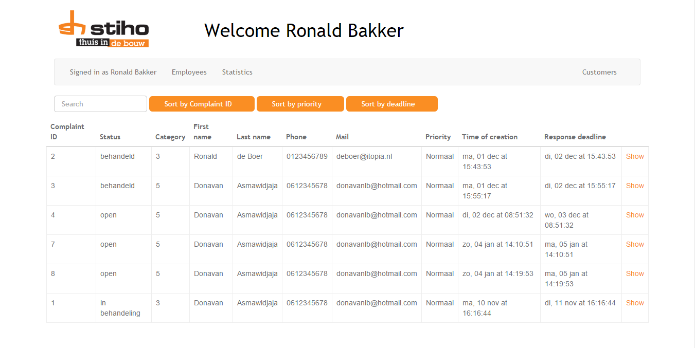

The first thing you see as manager is the list of complaints. The complaints can be sorted on **Complaint ID, Priority and Deadline.**

If you want to see the complaint in detail and/or interact with the contact person of the complaint, click on **Show**. This sends you to the *complaint detail page* (see paragraph 3.3.4).

With the buttons on the menu bar, you can view all the **employees** or see the **statistics** of all complaints. On the right corner is also a button with *Customer* where you can view all customers of Stiho (see paragraph 3.3.3).

### 3.3.5 Employee list

On the employee list page you can view all the employees of Stiho. You can sort the employees on **Employee ID** and **Employee name**. As manager you can **add** or **delete** employees.

### 3.3.5 Statistics

On the statistics page you can view a charts of all the complaints.