# **Statistics: The Science of Decisions Project Instructions**

# **Background Information**

In a Stroop task, participants are presented with a list of words, with each word displayed in a color of ink. The participant’s task is to say out loud the color of the ink in which the word is printed. The task has two conditions: a congruent words condition, and an incongruent words condition. In the congruent words condition, the words being displayed are color words whose names match the colors in which they are printed: for example RED, BLUE. In the incongruent words condition, the words displayed are color words whose names do not match the colors in which they are printed: for example PURPLE, ORANGE. In each case, we measure the time it takes to name the ink colors in equally-sized lists. Each participant will go through and record a time from each condition.

# **Questions For Investigation**

As a general note, be sure to keep a record of any resources that you use or refer to in the creation of your project. You will need to report your sources as part of the project submission.

**1. What is our independent variable? What is our dependent variable?**

Independent variables : word list, whether the words name and color were matched or not.

Dependent variable : response times from 24 participants.

**2. What is an appropriate set of hypotheses for this task? What kind of statistical test do you expect to perform? Justify your choices.**

 (null hypothesis) : There is no difference in response time between viewing congruent and incongruent words. :  = 

 (alternative hypothesis) : response time from congruent is faster(smaller) than it from incongruent :  < 

 : mean of congruent response time

 : mean of incongruent response time

We will perform ‘Dependent t-test for Paired Samples’ for this investigation for four reasons. First, we have less than 30 samples (we have 24). Z-score applies should be above 30 to use. Second, we don’t know population mean and standard deviation. Third, we assume that the distributions are Gaussian. Finally, participants first read congruent words and then read incongruent words. We can’t exclude that reading congruent words first affect reading incongruent words. Therefore we perform the **dependent** t-test.

*Now it’s your chance to try out the Stroop task for yourself. Go to* [*this link*](https://faculty.washington.edu/chudler/java/ready.html)*, which has a Java-based applet for performing the Stroop task. Record the times that you received on the task (you do not need to submit your times to the site.) Now, download* [*this dataset*](https://drive.google.com/file/d/0B9Yf01UaIbUgQXpYb2NhZ29yX1U/view?usp=sharing) *which contains results from a number of participants in the task. Each row of the dataset contains the performance for one participant, with the first number their results on the congruent task and the second number their performance on the incongruent task.*

**3. Report some descriptive statistics regarding this dataset. Include at least one measure of central tendency and at least one measure of variability.**

*Sample mean (Rounded up to two decimal) $μ_{c}$*  *: 14.05 seconds, $μ_{I}$*  *: 22.02 seconds*

*Standard Deviation (Rounded up to two decimal) $S_{C}$*  *: 3.56 seconds, $S_{I}$*  *: 4.80 seconds*

**4. Provide one or two visualizations that show the distribution of the sample data. Write one or two sentences noting what you observe about the plot or plots.**

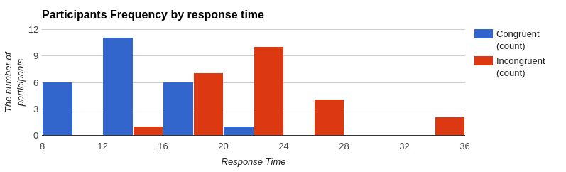

The histogram above shows how many participants responded in each response time. We can see most of participants responded faster when they read congruent words.

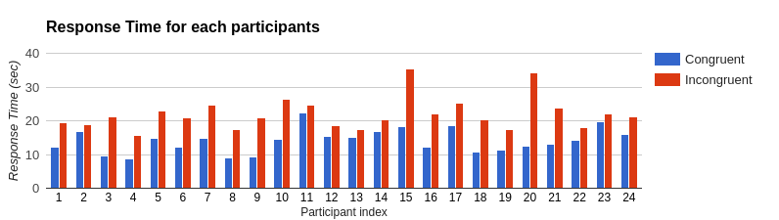

The histogram above shows how each participant responded differently when they read congruent and incongruent words. Visually speaking, we can see that every participant took a longer time when they responded from incongruent words. And this result supports our alternative hypothesis.

**5. Now, perform the statistical test and report your results. What is your confidence level and your critical statistic value? Do you reject the null hypothesis or fail to reject it? Come to a conclusion in terms of the experiment task. Did the results match up with your expectations?**

Confidence level is 95%. $α$ level is 0.05 and degree of freedom is 23. ‘t-critical value’ is -1.714.

 $μ_{D}$ = $μ_{c}$ - $μ_{I}$ = -7.97.

(critical static value) = ${μ_{D} / S_{M} (S_{M} is standard error of mean)}_{}$

= -7.97 / 0.993

= - 8.02

This is statistically significant because t-critical value is greater than the critical static value (-1.714 > -8.02). Therefore, we reject the null. In conclusion, naming the incongruent words take shorter time than naming the congruent words. And it matches up with our expectation as we specified in alternative hypothesis.