Name’s



 

 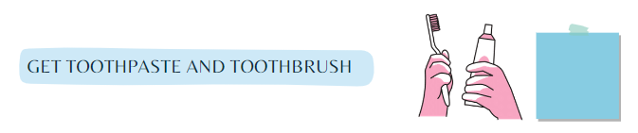

 

 

 

 

 

  

 

 

 

 

 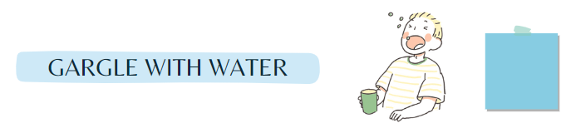

 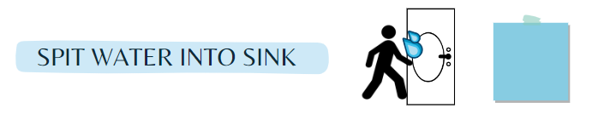

 

 

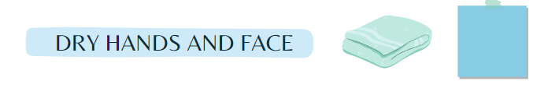



I am working for:________________________________





