Joshua Bailey Module 9 Assignment
CSD 325: Adv. Python
5/17/2026
Status Code
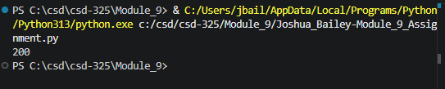
JSON Response (Formatted)
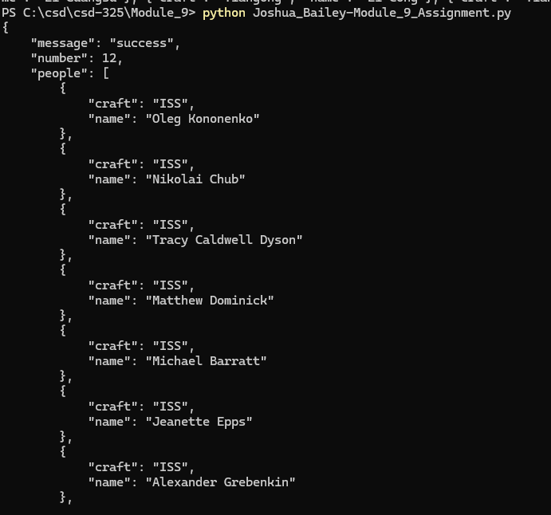
Final – Status, Raw, Formatted.
