Joshua Bailey Module 8 Assignment Flowchart
CSD 325: Adv. Python
5/10/2026
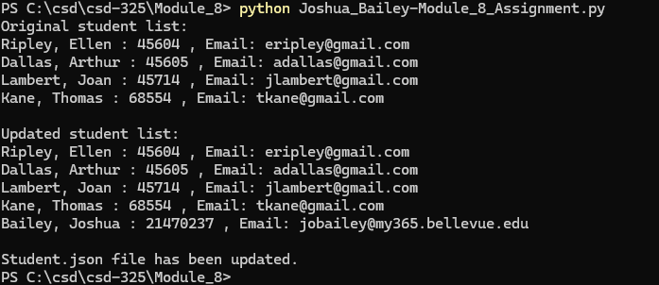
End
Print “Student.json file has been updated.”
Dump updated students into JSON file
Open JSON file as write
Call student_list() function
Print “Updated Student List:”
Append new_student to students
Create new_student
Call student_list() function
Print “Original Student List:”
Load JSON as ‘students’
Open JSON file as read
Start
Define main() function
Define student_list() function

