Joshua Bailey Assignment 2.2
CSD 325: Adv. Python
3/29/2026
Added breakpoint to main function.
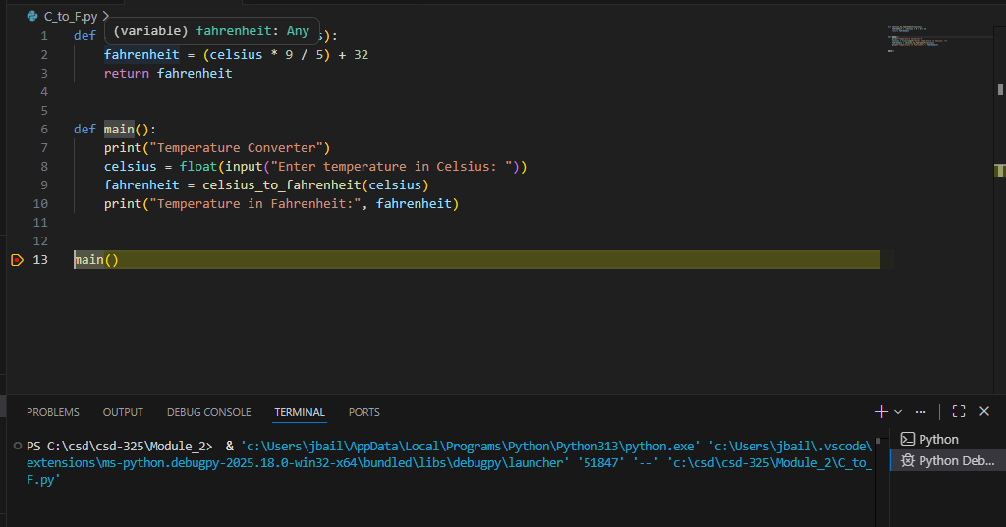
Stepped into main function.
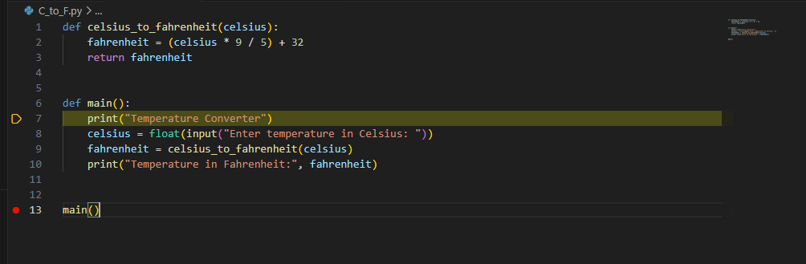

Added a syntax error for main function and examined.
