Joshua Bailey Module 7 Assignment
CSD 325: Adv. Python
5/3/2026
city_functions.py
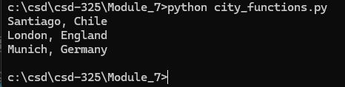
Test pass
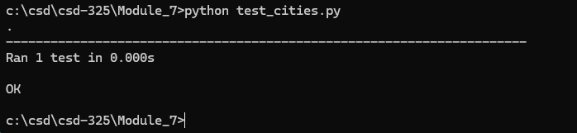
Test fail
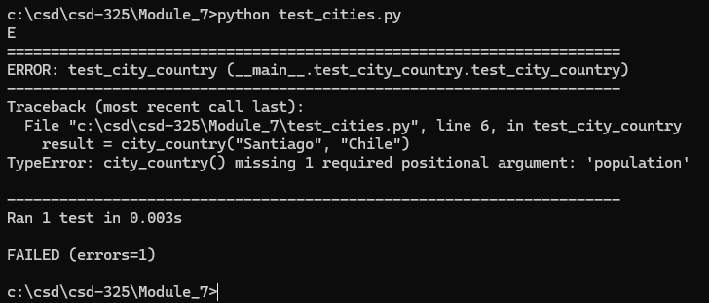

Optional
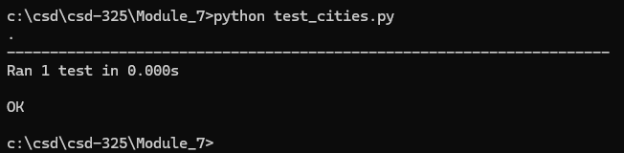
Language fail
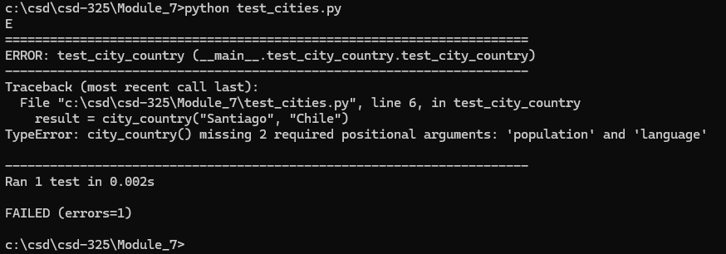
Language Optional
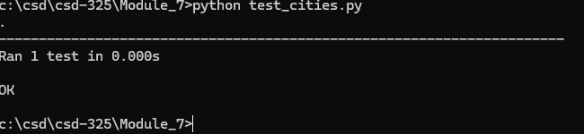
Final
