TO FIELD

Dear XYZ

Paragraphs

Paragraph

Regards,

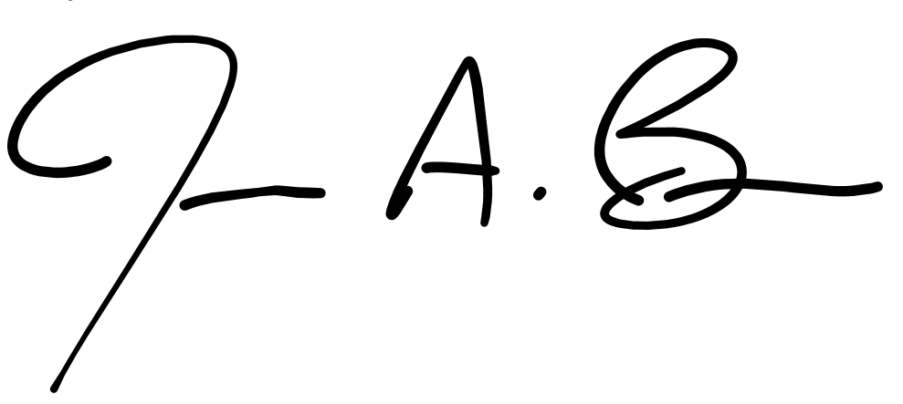

James A. Bain

Professor and Associate Department Head for Academic Affairs

Dept. of Electrical and Computer Engineering