**Test Case Execution Report**

**Test case-1 Check user is able to register by providing all the valid details**

**Step-1** Open the URL[**http://demowebshop.tricentis.com/**](http://demowebshop.tricentis.com/)**,** user will be navigated to home page/ landing page as shown in below image



**Step-2** As shown in the above image, click on register tab, you will be navigated to the page as shown in below image

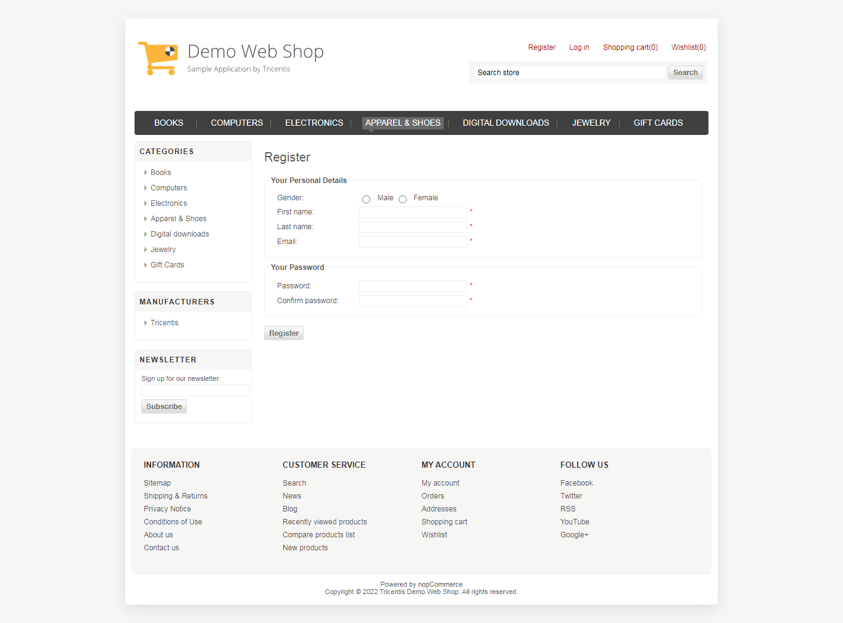

**Step-3** As shown in above image, all the mandatory fields needs to be provided by user

1. Gender-Female

2. First name- Swati

3. Last name- Sharma

4. Email address-swati@mailinator.com

5. password- swati123

6. Confirm password-swati123

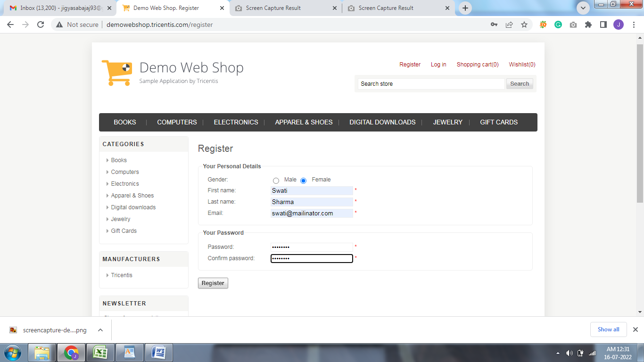

**Step-4** After providing all the details, click on register button as shown in above image, as the user clicks on register button, user is navigated to a page as shown in below image.

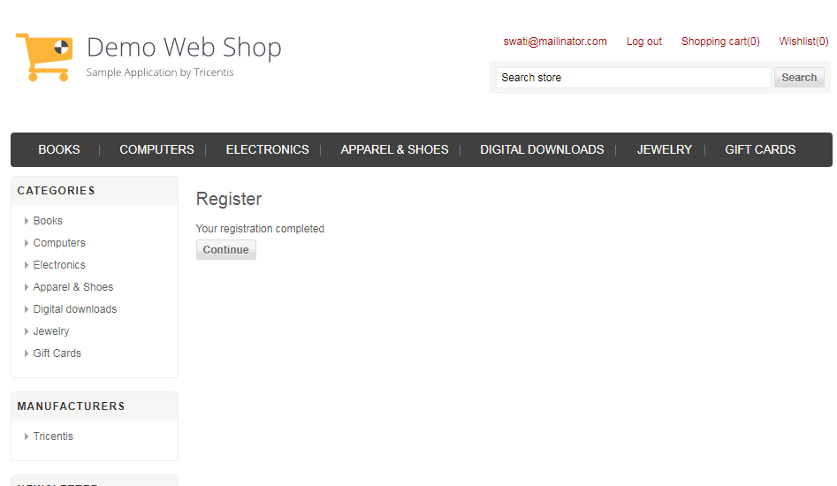

**Test Case-2 Check registered user is able to login with valid details**

**Step-1** Open the URL[**http://demowebshop.tricentis.com/**](http://demowebshop.tricentis.com/)**,** user will be navigated to home page/ landing page as shown in image below



**Step-2** as shown in the above image, click on login tab, you will be navigated to the page as shown in below image

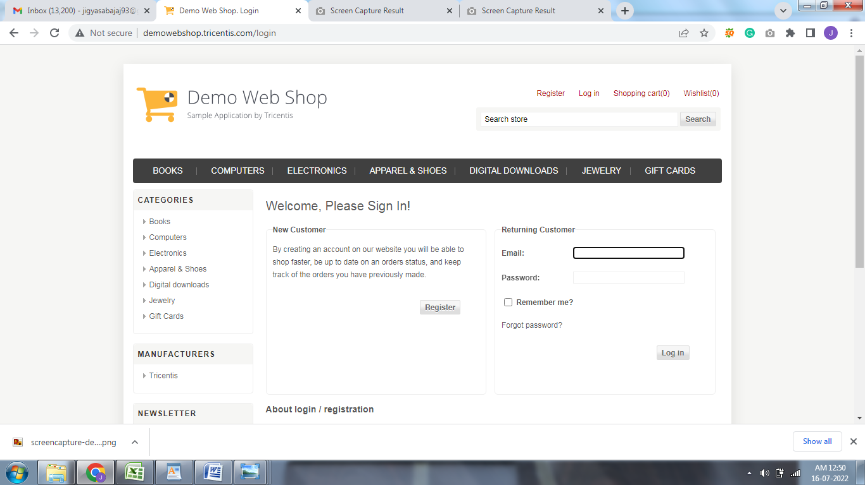

**Step-3** As shown in above image, provide the email and password

1. Email id- swati2mailinator.com

2. password-swati123

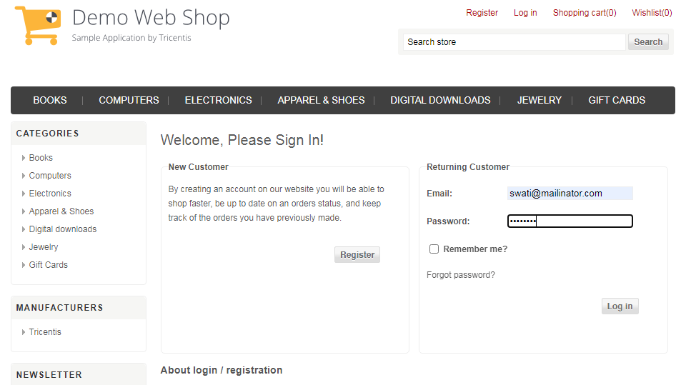

**Step-4** After providing email and password, click on login button, after successful login user will be navigated to a page where they can see there email id as shown below

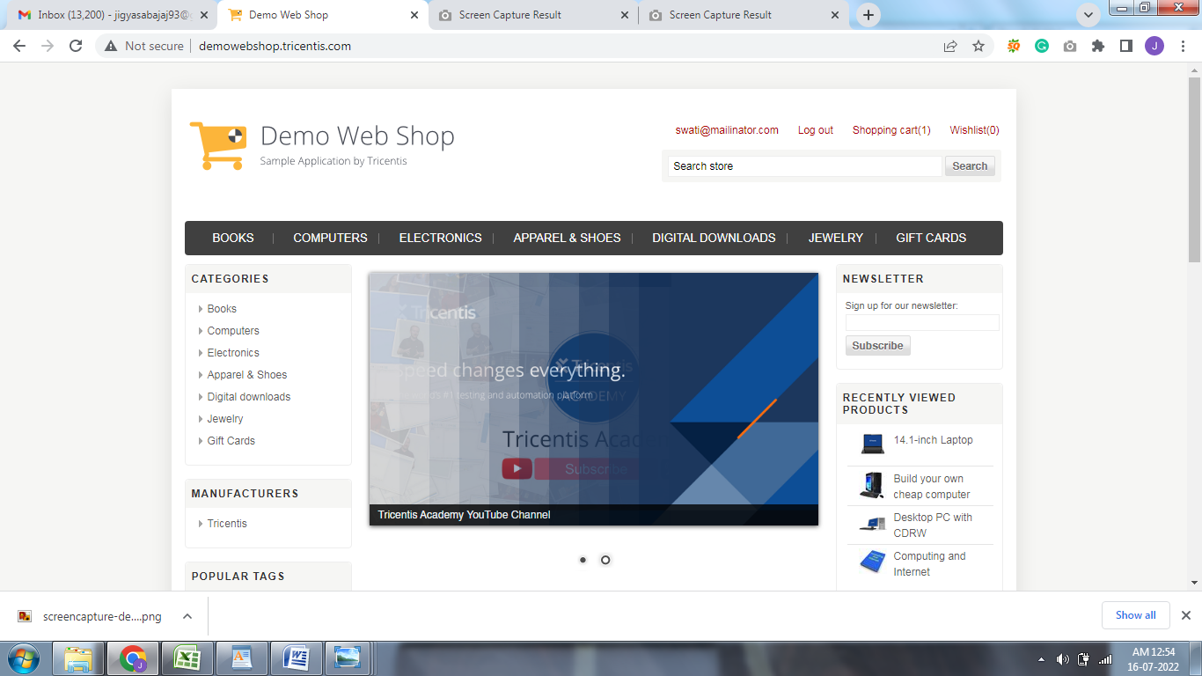

**Test Case-3 Check user is able to add a product to the shopping cart**

**Step-1** Once the user is logged in as shown in steps of **test case2,** then user can browse the categories and sub categories by hovering on the tabs or by selecting any of the caegories from left column as shown below

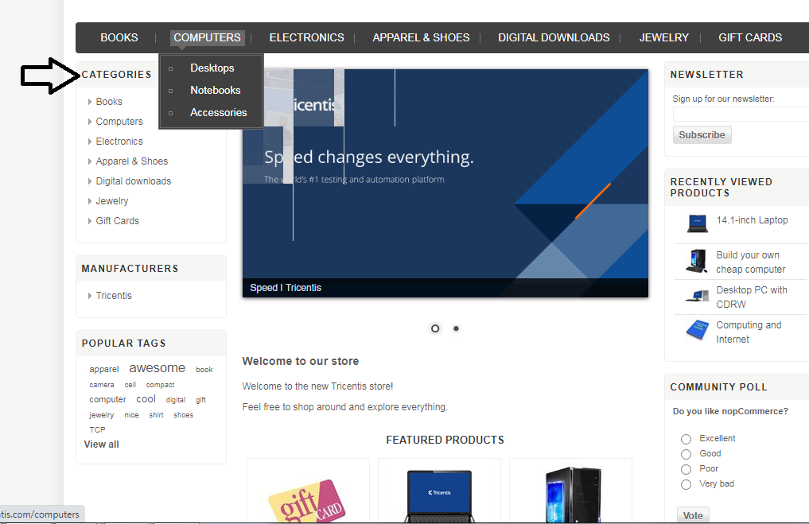

**Step-2** After selecting a category, for ex- if a user selects computer and under that selects a sub-category desktop then the user will be navigated to a page as shown below

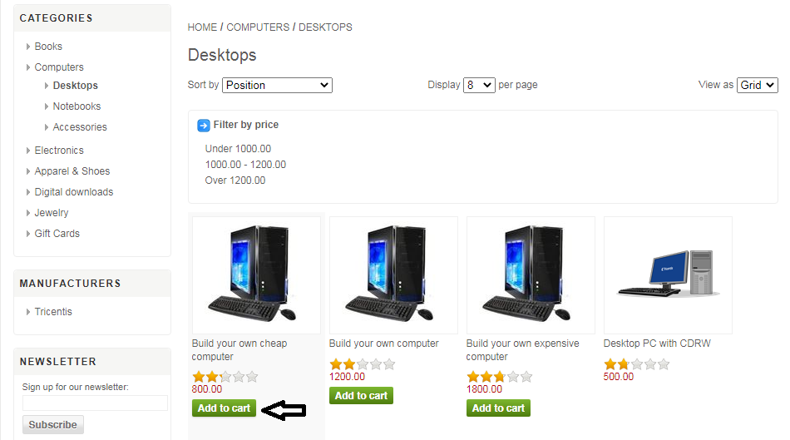

**Step-3** As shown in above image, once the user clicks on add to cart button the user is navigated to the page as shown below.

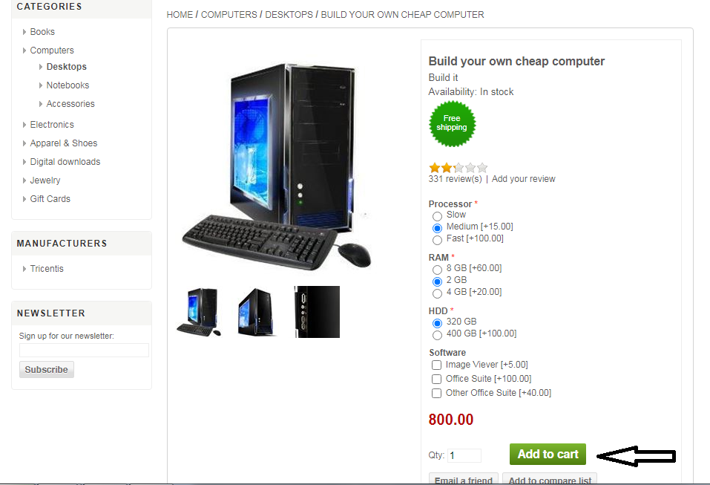

**Step-4** As shown in above image, here the user can either customize the product as per their requirements and then click on add to cart button or can directly click on add to cart button as user clicks on add to cart button, a notification is displayed on the user screen as shown in below image

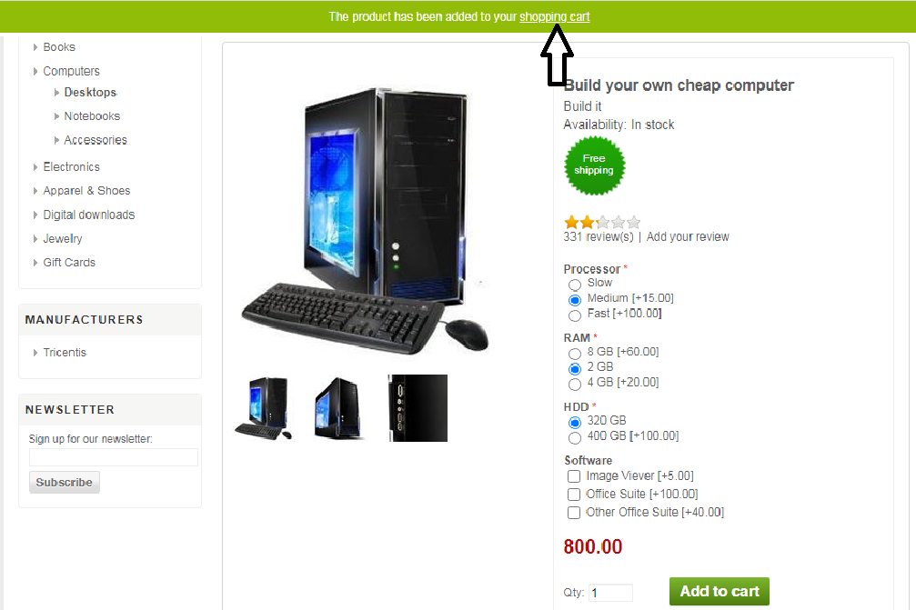

**Step-5** As shown in above image as the user clicks on shopping cart link the user is navigated to the page as shown below

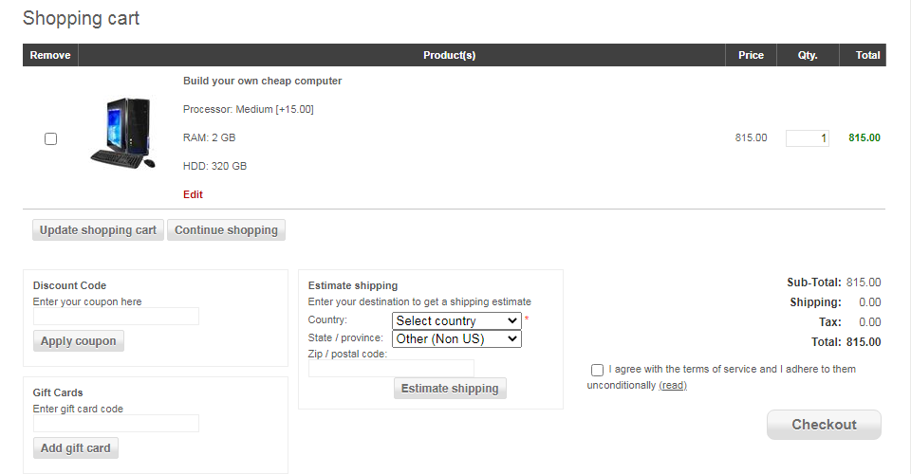

**Test Case-4 Check user is able to place an order from shopping cart with valid payment details**

**Step-1** As shown in above image, User needs to select the country, state, zipcode, click on estimate shipping button, accept the terms and conditon check box as shown in below image

and then click on the checkout button.

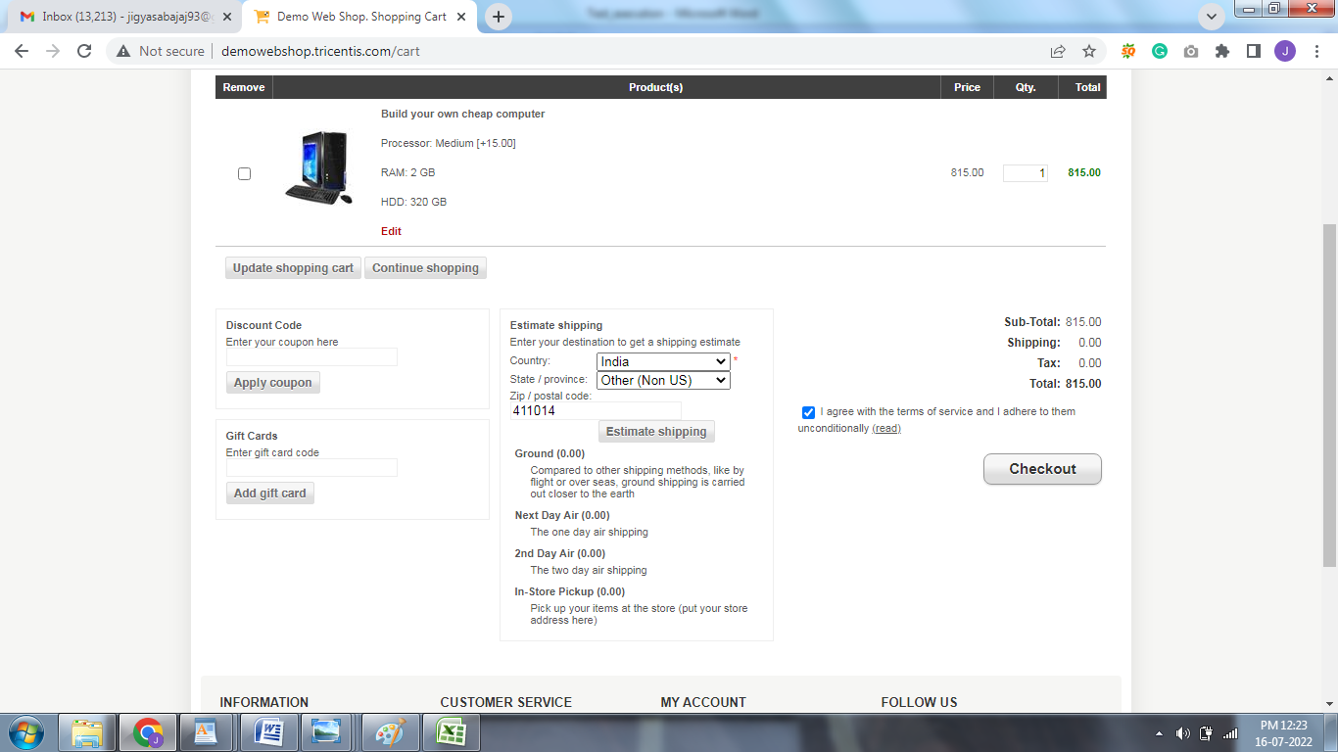

**Step-2** After clicking on checkout button user is navigated to the checkout page as shown in below image, here user will provide all the required details and the click on continue button as shown below

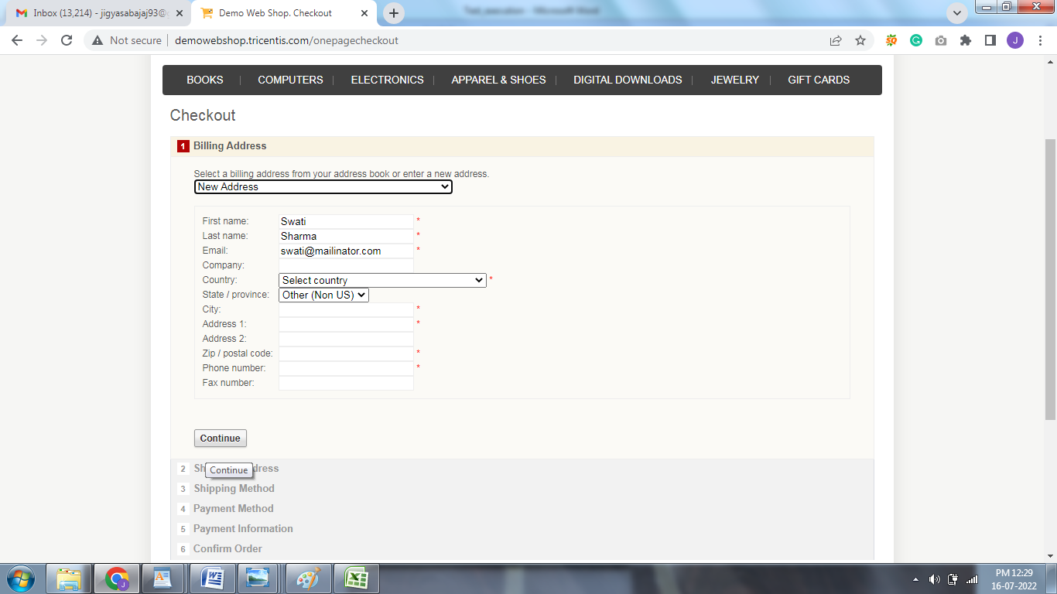

**Step-3** As user clicks on the continue button user is provided with the shipping address details as shown below, here if user wants to select the in store pick up then can selsct the check box or can directly click on continue button.

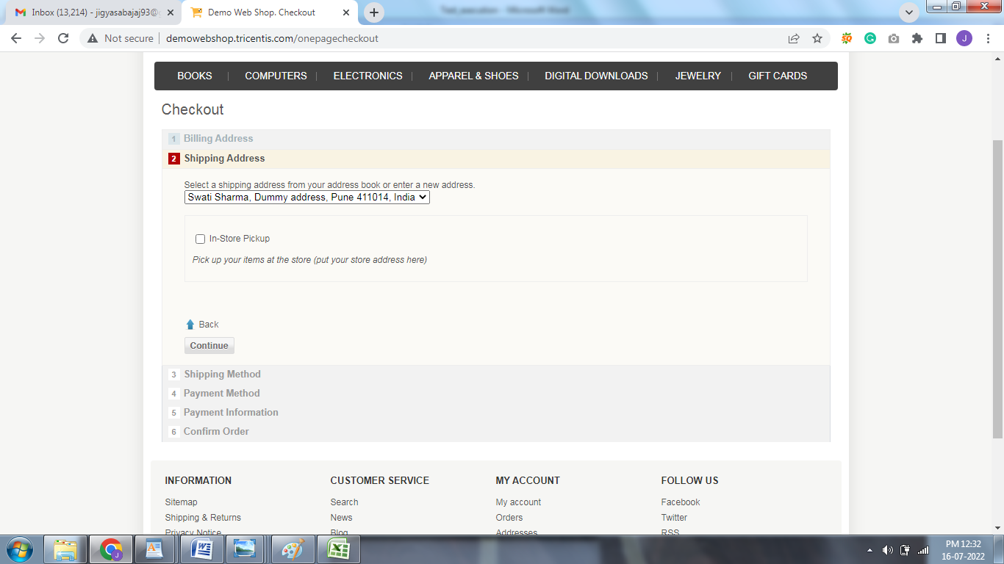

**Step-4** As user clicks on the continue button user is provided with the shipping method details as shown below, here user will select a shipping method and then cllick on continue button

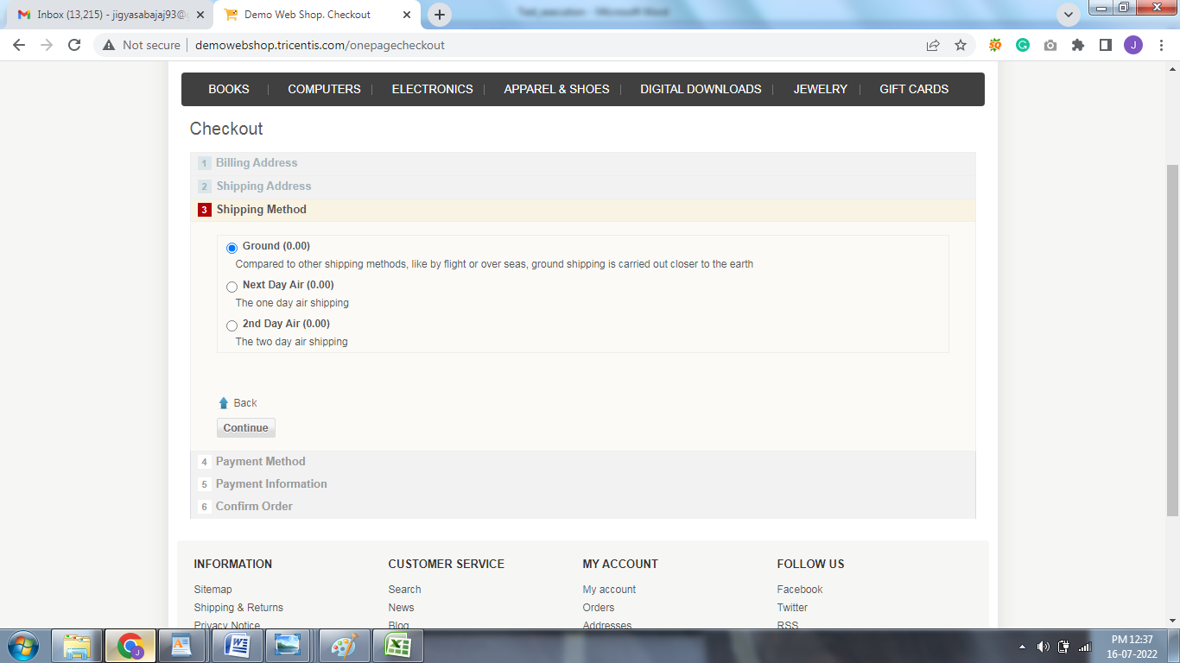

**Step-5** As user clicks on the continue button user is provided with the payment method details as shown below, here user needs to select a payment method and click on continue button as shown below

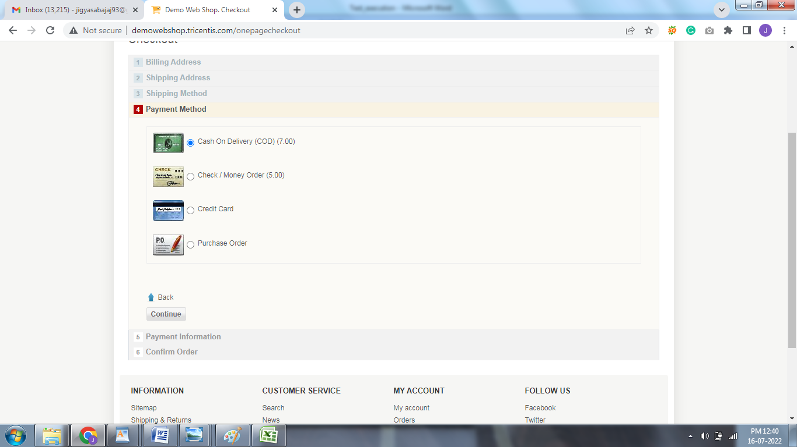

**Step-6** As user clicks on the continue button user is provided with the payment information details as shown below, click on continue button

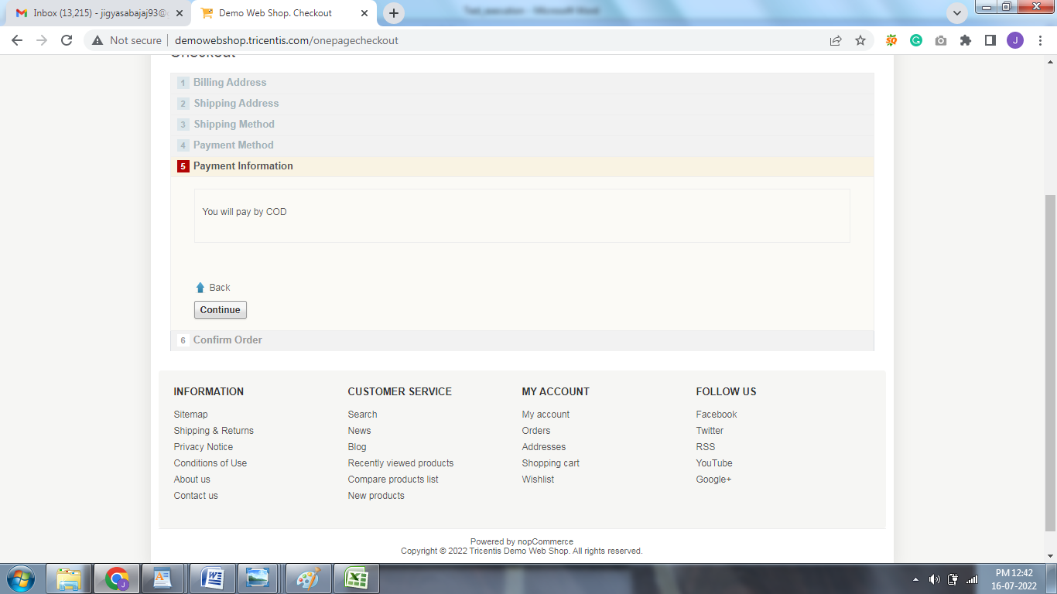

**Step-7** As user clicks on continue button user is navigated to the page as shown below, here the user is provided will the billing details, now click on confirm button

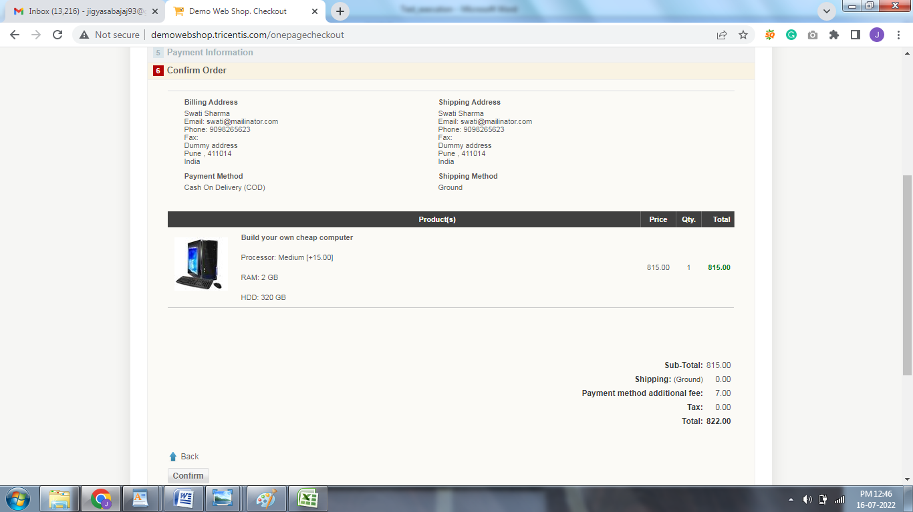

**Step-8** As user clicks on confirm button, user is navigated to the below page where the order number of product is provided to user, hence the order is placed.

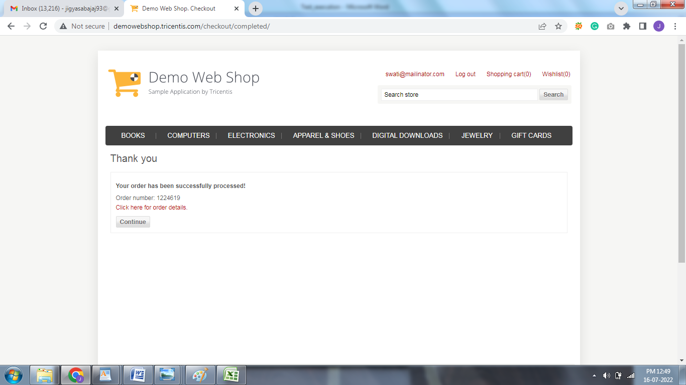

**Test Case-5 Check user is able to place an order from shopping cart with invalid payment details**

Step-1 to step-5 are same as for test case 4, user can refer them

**Step-6** As shown in below image, the user selects an option to pay through credit card and click on continue button

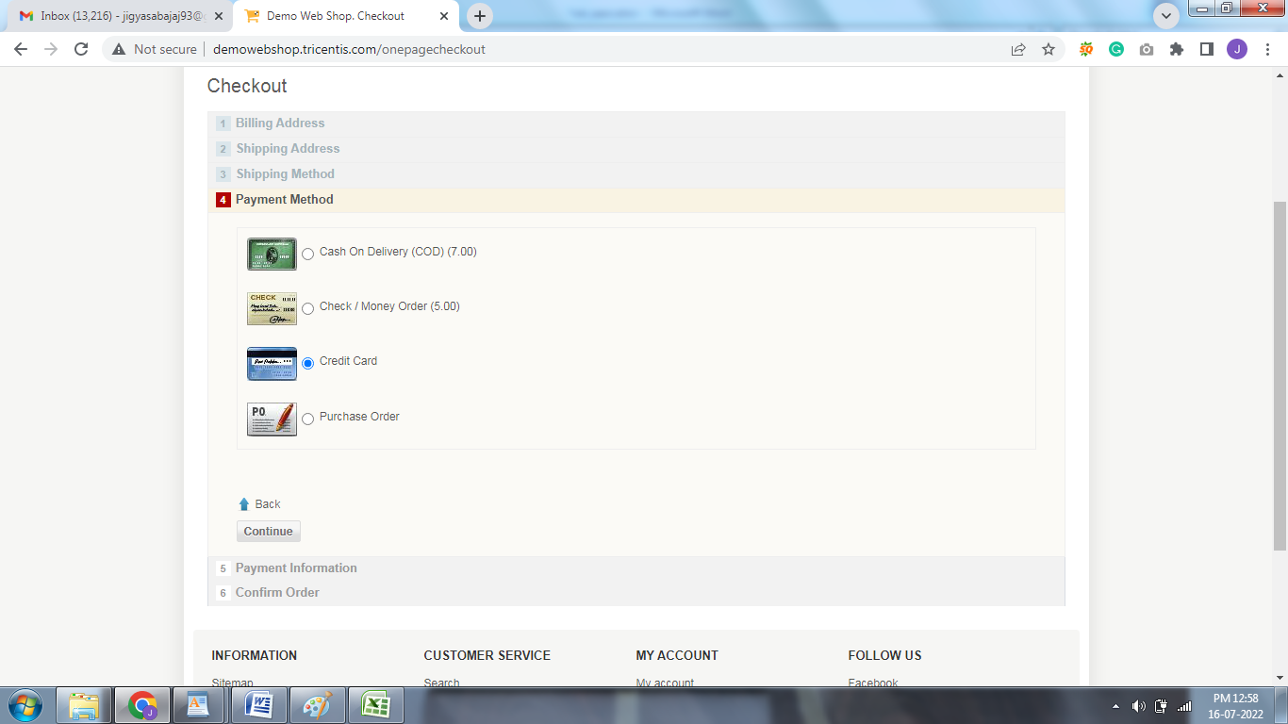

**Step-7** As user clicks on continue button user is provided with the details as shown in below image , here user needs to provide the credit card details and then click on continue button

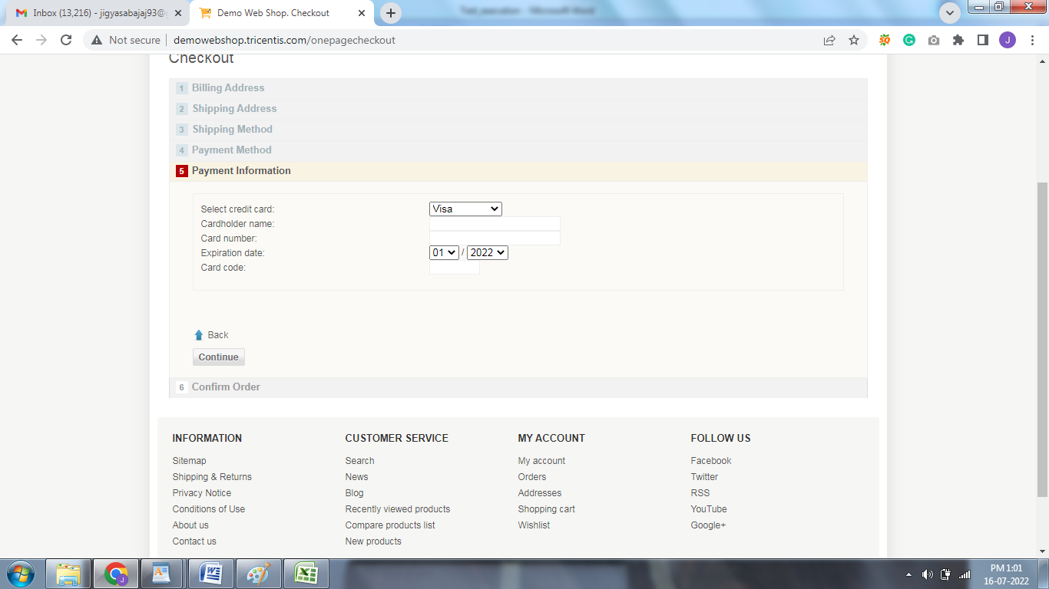

**Step-8** As shown in below image, if the user provides invalid credit card details and click on continue button, then the user is displayed with the error message as shown in below image and cannot place the order.

