CreoleTranslator — Program Specification
Haitian Creole <-> English voice + text translator. Two native clients (iOS / Android), one shared serverless backend (api-proxy Cloud Function), one human review web app (creole-qa).
- iOS repo: CreoleTranslator-iOS/ (SwiftUI). Android repo: CreoleTranslator-android/ (Compose) — FEATURE_PARITY.md is the per-feature file map.
- Backend: api-proxy/functions/src/index.ts (Firebase Functions v2, us-central1, route 'api').
- Review app: creole-qa/public/{index.html, app.js} + firestore.rules, project jbaker-api-proxy (https://creole-qa.web.app).
- No API keys ship in either app; all provider keys live in Secret Manager server-side.

1. Architecture overview
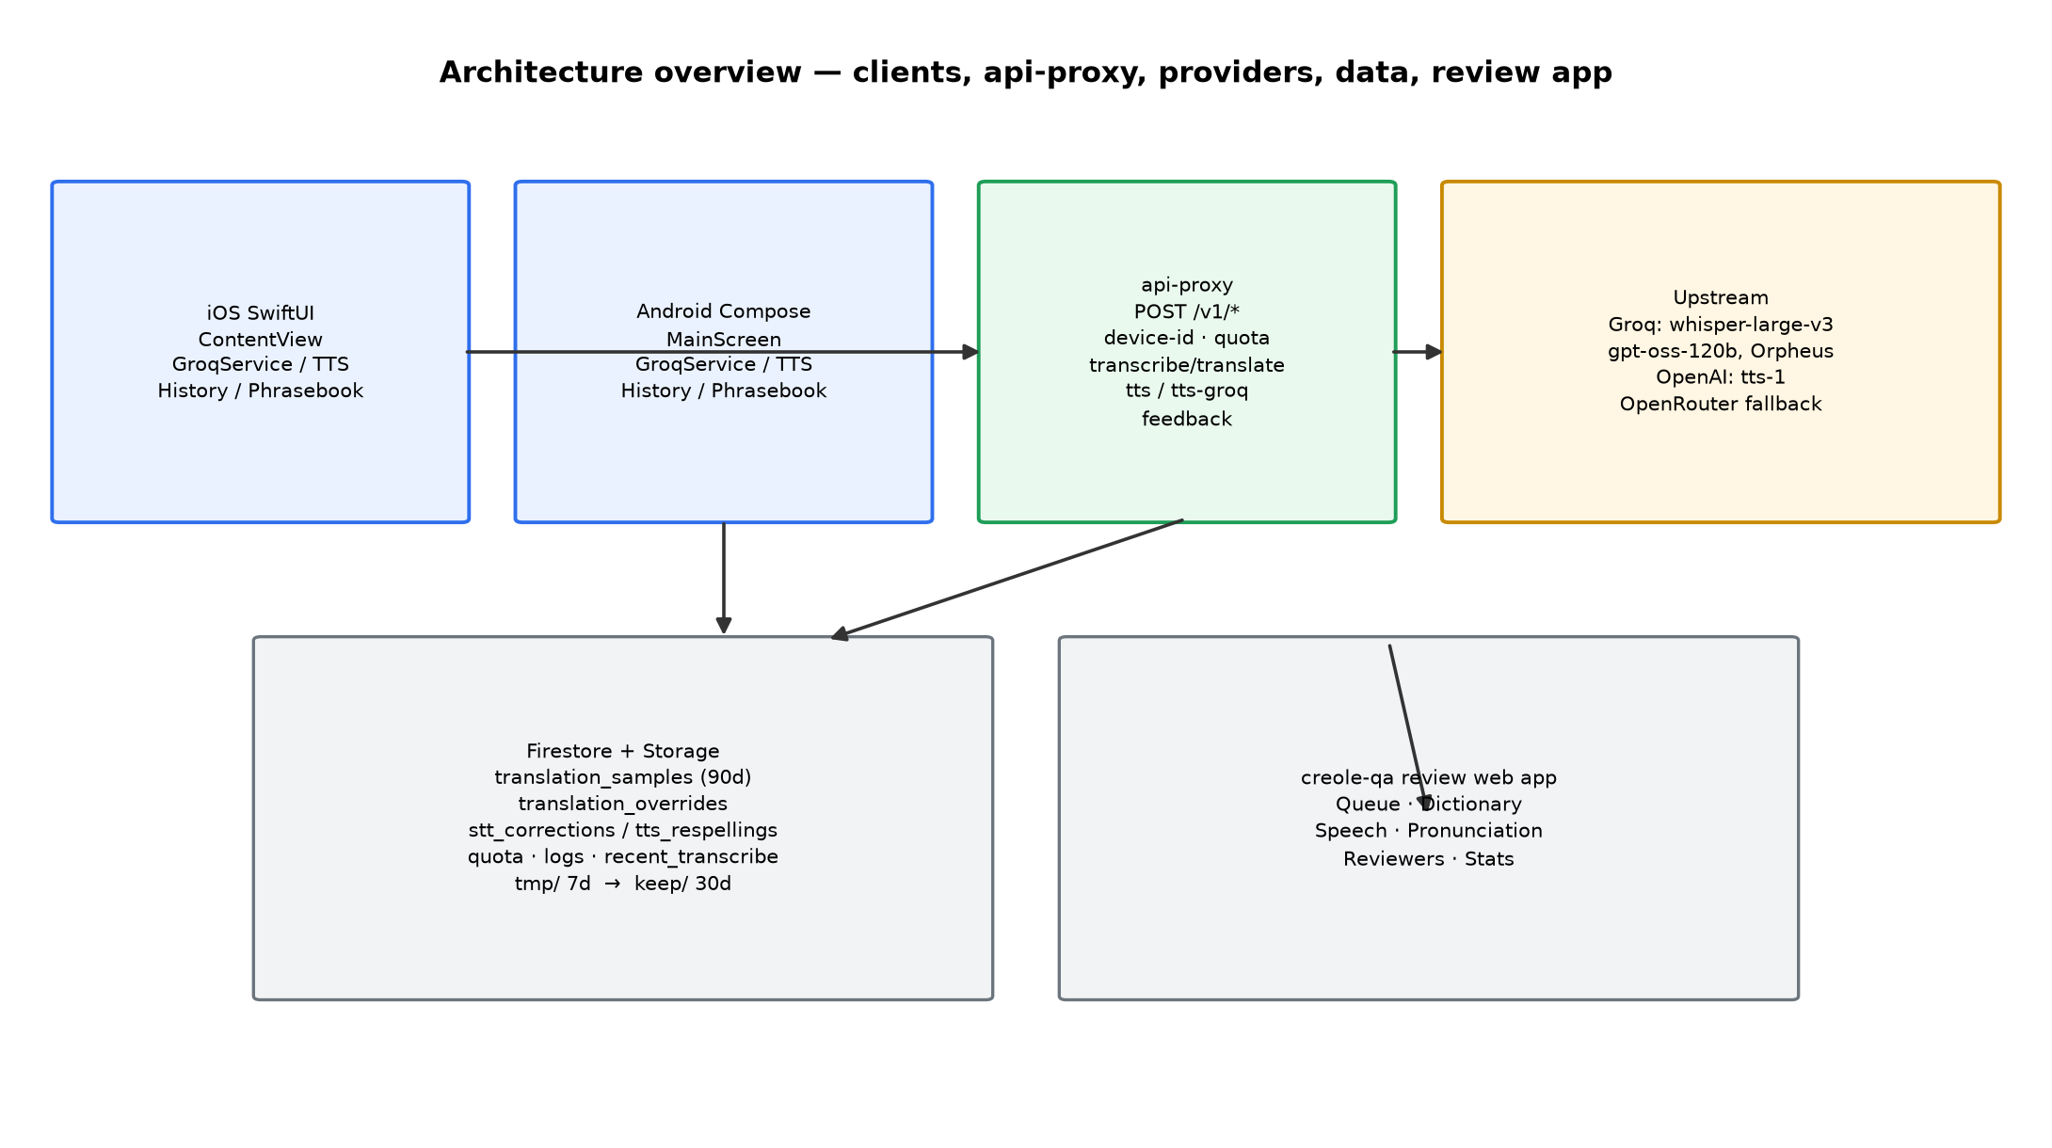
- Clients call POST /v1/* with an x-device-id header (UUID generated once per install). Quota enforced per device + 5000 global/day.
- Transcribe/translate hit Groq; TTS-Creole hits OpenAI tts-1; TTS-English hits Groq Orpheus; OpenRouter is translate-fallback only.
- Every model translation is captured to translation_samples (90-day TTL, no device id). Low-confidence or thumbs-down voice clips are promoted tmp/ -> keep/ (30 days).
- Active translation_overrides are served before any model call; active tts_respellings are substituted into Creole TTS within ~60 s.

1.1 Key constants (keep in sync across iOS, Android, proxy)
Route / constant | Value
Proxy base | https://us-central1-jbaker-api-proxy.cloudfunctions.net/api
POST /v1/transcribe | raw m4a body, x-language ht|en -> {text, provider, transcribeId}
POST /v1/translate | {text, direction ht-en|en-ht, source voice|typed} -> {translation, provider, confidence, sampleId}
POST /v1/tts (Creole default) | {text, voice, speed, language} -> MP3 (tts-1 pinned server-side), 500 chars
POST /v1/tts-groq (English default) | {text, voice, language} -> WAV (Orpheus), truncated 200 chars
POST /v1/feedback | {sampleId, rating up|down, comment?, target translation|stt}
Models | whisper-large-v3 / openai/gpt-oss-120b (temp 0.3, CONFIDENCE 1-5 trailer)
Limits | translate 1000 chars, audio 2 MB; TTS 300/d, translate 200/d, transcribe 100/d per device

2. Translation flows

2.1 Creole to English (voice)
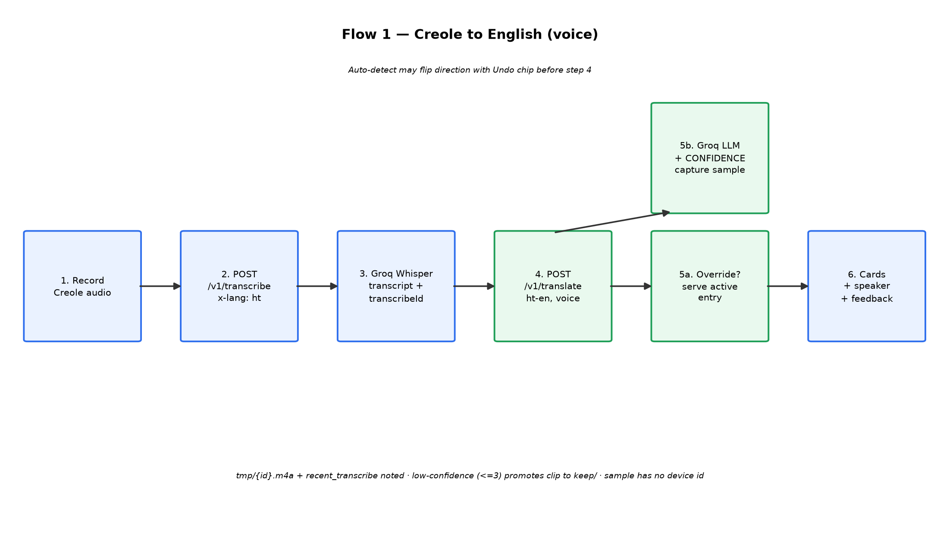
- Record (AVAudioRecorder / Android AudioRecorder) -> /v1/transcribe with x-language: ht (the selected direction's source language is the Whisper hint).
- Proxy saves tmp/{transcribeId}.m4a + recent_transcribe{device}; returns transcript.
- App runs offline auto-detect (LanguageDetector); if confident it disagrees, it flips direction + shows 'Auto-detected X -> Y, Undo' chip.
- /v1/translate {direction ht-en, source voice}: override lookup first (sha1 of direction|normalised input); active hit returns provider 'override', confidence 5, no sampleId (so no feedback buttons).
- Otherwise Groq gpt-oss-120b -> parse CONFIDENCE trailer -> captureSample() -> keepAudio() when confidence <= 3 -> return {translation, confidence, sampleId}.

2.2 English to Creole (voice or typed)
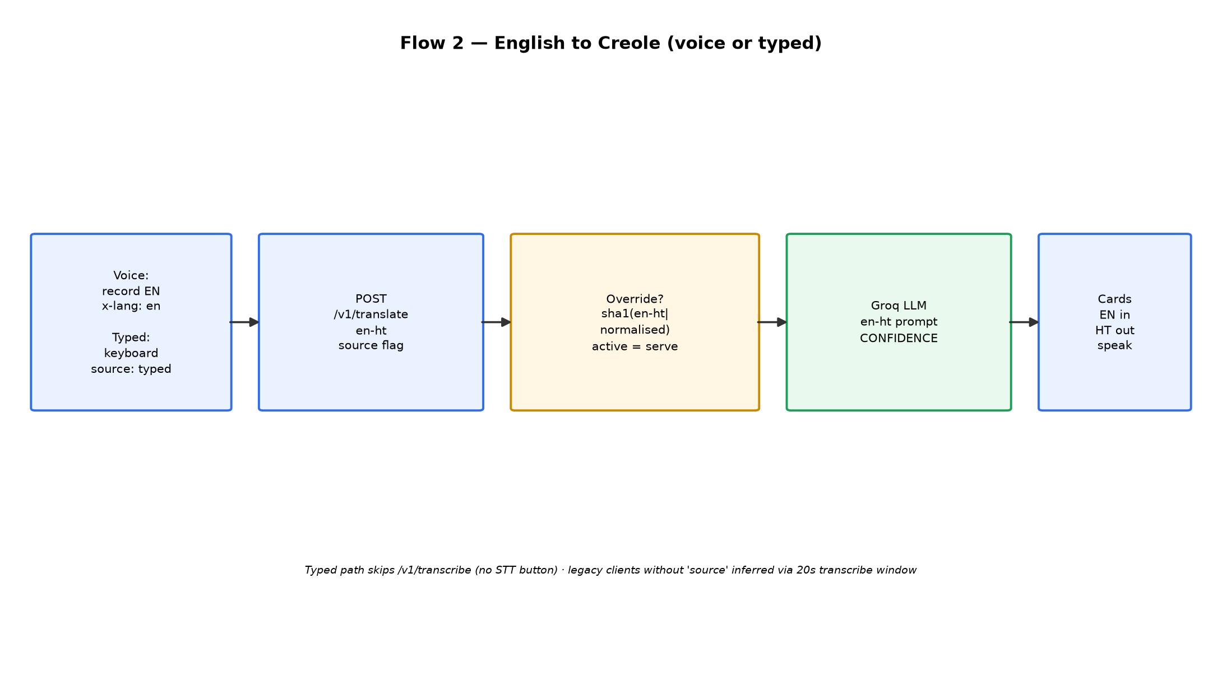
- Identical pipeline with direction en-ht. Typed path skips /v1/transcribe entirely (no transcript, no STT feedback button, transcribeId null).
- Clients v1.8+ send source explicitly; older builds are inferred (translate within 20 s of device's last transcribe = voice). Audio linkage window is 120 s.

3. Speech-to-text flow and backends
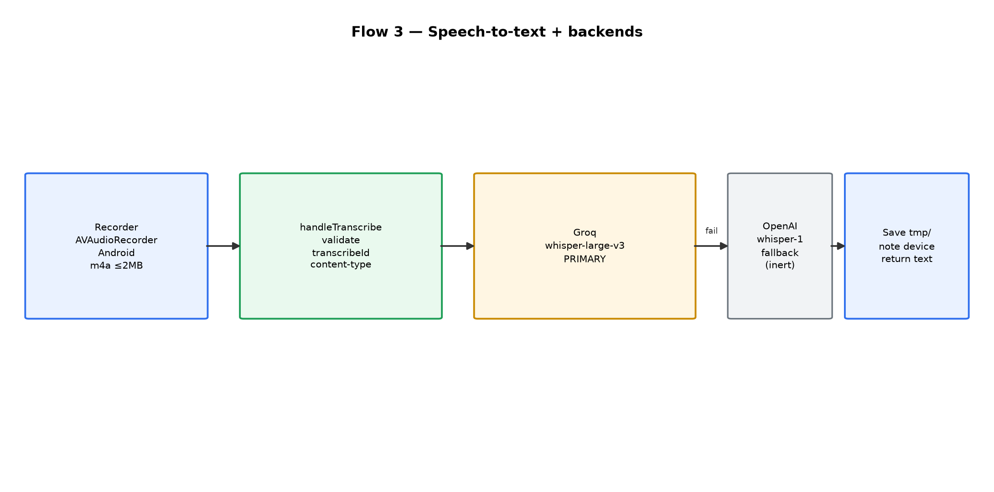
- Primary: Groq whisper-large-v3 via handleTranscribe. Fallback: OpenAI whisper-1 — key not provisioned, so that branch is currently inert.
- On success the proxy always stores tmp/ audio + transient recent_transcribe doc (24 h TTL, plumbing only, never copied into samples).
- App processAudio(): transcribe -> optional resolveDirection(transcript) for auto-detect -> translateText(source: voice).

4. TTS flows and backends
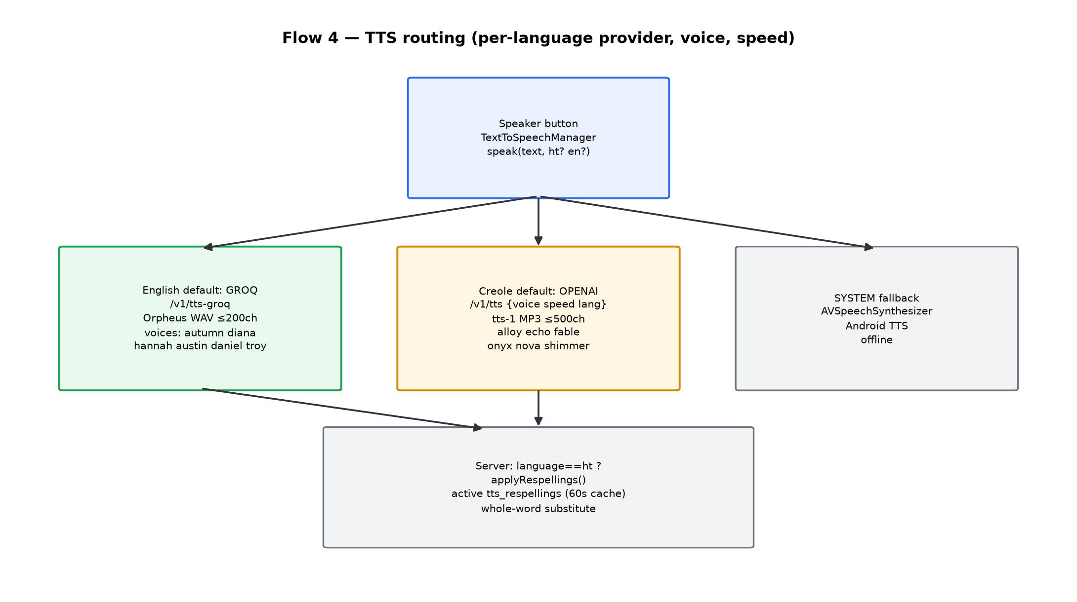
- TextToSpeechManager.speak() reads per-language provider/voice/speed (VoiceSettings: englishProvider default groq/diana/1.0x; creoleProvider default openai/alloy/0.7x).
- English/Groq: GroqService.synthesizeSpeech() -> /v1/tts-groq -> Orpheus WAV -> AVAudioPlayer/MediaPlayer with rate. 6 voices: autumn, diana, hannah, austin, daniel, troy.
- Creole/OpenAI: OpenAITTSService.synthesizeSpeech() -> /v1/tts -> tts-1 MP3 (speed baked in server-side). 6 voices: alloy, echo, fable, onyx, nova, shimmer.
- System fallback (offline device voices) on any TTS throw; logged as tts_fallback_to_computer (Firebase Analytics on iOS).
- Server: when request language == 'ht', whole-word case-insensitive substitution from cached active tts_respellings (60 s cache).
- Free voices: diana + alloy; the rest unlock 24 h via rewarded ad (RewardedAdManager + premiumVoicesUnlockedUntil); gate applies at selection time.

5. On-device storage (local DB)
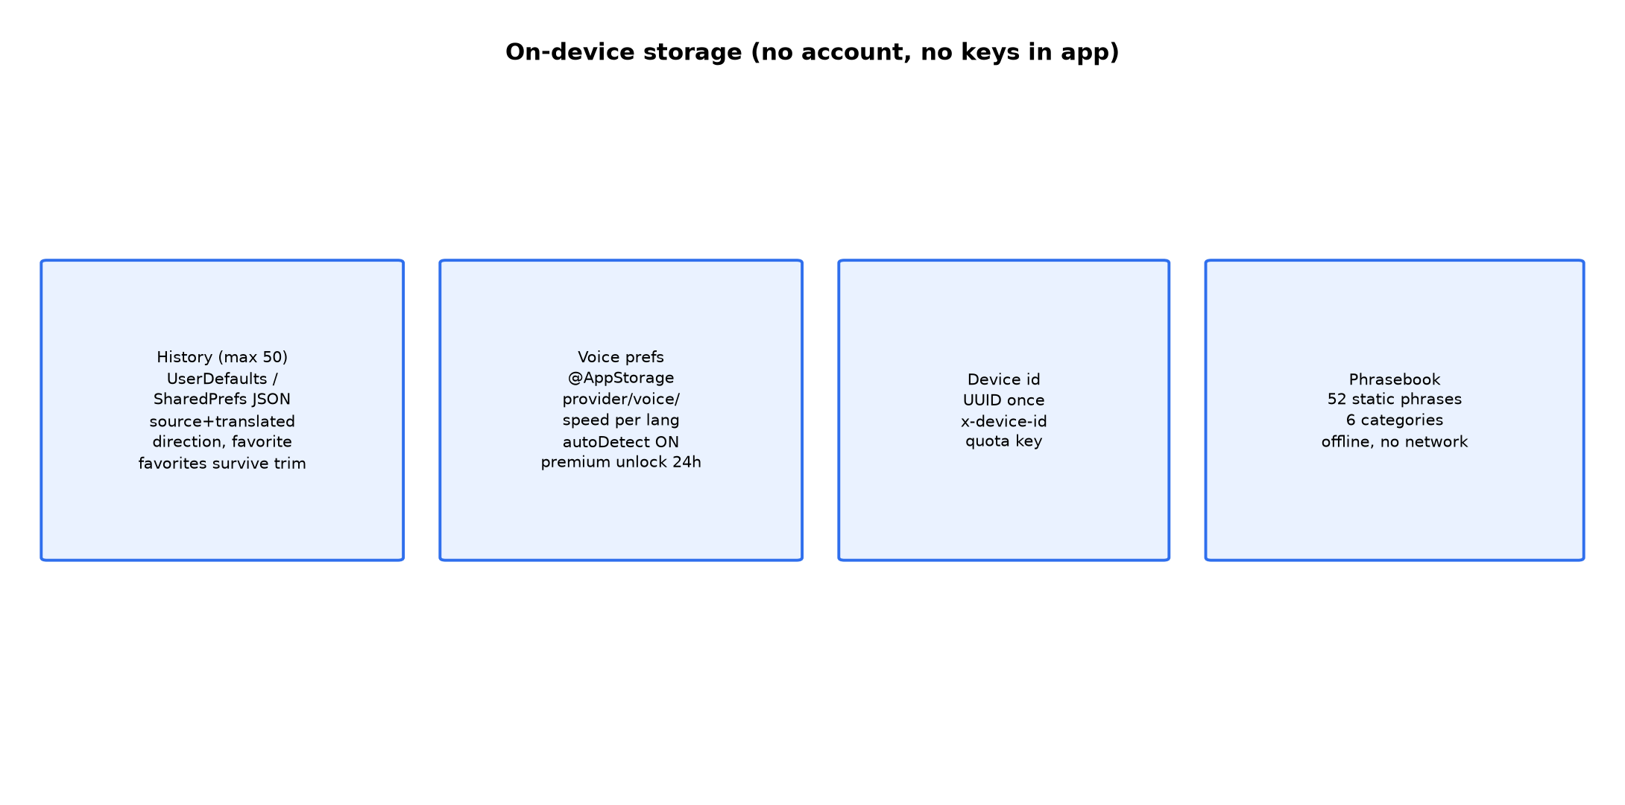
Store | iOS | Android | Contents
History | TranslationHistory.swift -> UserDefaults JSON | TranslationHistoryManager.kt + HistoryScreen.kt | Last 50 {sourceText, translatedText, direction, timestamp, isFavorite}; favorites survive trimming; placeholders/empties never saved
Voice prefs | VoiceSettings.swift (@AppStorage) | VoiceSettings.kt (SharedPreferences) | Providers, voices, speeds, autoDetectLanguage (default ON), premiumVoicesUnlockedUntil
Device id | ProxyDevice.id (UserDefaults UUID) | equivalent | x-device-id header + quota key
Phrasebook | Phrasebook.swift (static) | Phrasebook.kt | 52 phrases / 6 categories, reversible, per-phrase speaker, fully offline

No translation content is stored server-side against a device id; logs hold metadata only.

6. Backend function (api-proxy)
- api (onRequest): CORS for creole-qa + tvsharedlists origins; x-device-id regex; App Check verify (ENFORCE_APP_CHECK=false); quota transaction; dispatch to handleTts / handleTtsGroq / handleTranslate / handleTranscribe / handleFeedback / handleHeartbeat / handleTmdb (+ yelp/extract-restaurant for other apps).
- handleTranslate: override lookup -> Groq chatComplete -> OpenRouter gpt-4o-mini fallback -> captureSample() -> conditional keepAudio().
- handleFeedback: validates sampleId shape; writes rating|comment or sttRating|sttComment + timestamps; thumbs-down with transcribeId and no audioPath promotes the clip.
- usageSummary (token-gated): per-app device/request rollup for the nightly report + Android kill-switch adoption stats.
- activateOverride / activateRespelling (onDocumentWritten triggers): flip status -> active when two DISTINCT reviewers approve the same text (see section 7).

7. Review system — adding / rejecting words, phrases, translations
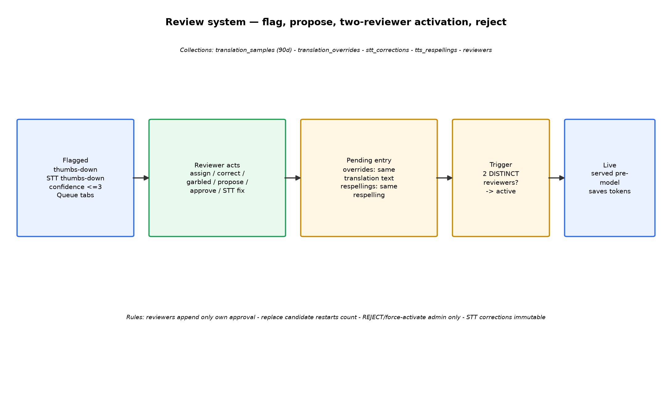

7.1 What enters the queue
A translation_samples doc is written on every model translation: input, output, direction, provider, confidence (1-5|null), source (voice|typed|unknown), transcribeId. Flagged for review when: user thumbs-down on the translation (rating=down + optional 500-char comment), thumbs-down on a voice transcript (sttRating=down, audio kept), or model confidence <= 3 (audio auto-kept). Queue tabs: Mine / Unassigned / All flagged / Reviewed; 'Assign next to me' claims the oldest unassigned item transactionally.

7.2 Reviewer actions (Queue page)
Action | Writes | Effect
Assign to me | samples.assignedTo/assignedAt | ownership (self or unassign only)
Looks right | reviewed:true, verdict:correct | closes item, no dictionary change
Input is garbled | verdict:garbled_input | closes item (voice inputs warn transcript may be wrong)
Propose correction | translation_overrides/{sha1} pending + approvals:[{by}] | starts/joins/replaces proposal; replacement restarts count
I agree — approve | append {by:me} to approvals | 2nd distinct approval -> trigger activates
Save correct transcription | stt_corrections/{sampleId} immutable | builds STT corpus {whisperText -> correctedText}
Re-translate corrected text | live /v1/translate preview | preview only with provider + confidence

7.3 Dictionary (translation_overrides) — add / reject
- Key = sha1(direction + '|' + lowercased/collapsed input); must match overrideKey() in proxy, QA app, and translation_qa.py exactly.
- Pending -> active requires TWO distinct reviewers approving the SAME translation text: Firestore rules only allow appending your own approval or replacing the candidate (which resets approvals); the activateOverride trigger flips status to active + activatedAt.
- Active entries serve before any model (provider 'override', confidence 5, no sampleId -> no feedback buttons) — each correction also saves tokens permanently. Covers single words, phrases, and sentences.
- Rejecting is admin-only (status/activatedAt/note + delete); reviewers cannot reject. Admin can force-Activate or Deactivate back to pending from the Dictionary page.

7.4 Pronunciation (tts_respellings) — add / reject
Same two-person state machine on {word -> respelling}, keyed sha1(lowercased word): propose one word (no spaces) -> second reviewer approves identical respelling -> activateRespelling trigger -> active. Applied whole-word, case-insensitive, Unicode-aware, only when TTS request says language 'ht'. Reviewers audition via Listen box + 'hear respelling / original' buttons (real /v1/tts path). Admin alone can Activate/Deactivate/Reject.

7.5 Speech corpus (stt_corrections) + Reviewers + Stats
- Speech page: read-only {WHISPER HEARD -> ACTUALLY SAID} pairs with clip playback (30 d) + voice/clip/correction counters. Rules: create attributed, never update, admin-deletable.
- Reviewers page (admin): invite by Google email, toggle admin|reviewer, remove (not self); membership checked live at sign-in.
- Stats: captured/flagged/reviewed, thumbs-down vs STT-thumbs-down vs low-confidence split, dictionary active/pending, voice share, per-reviewer table (30-day window).

8. Platform notes
- FEATURE_PARITY.md (Android repo) is the source of truth for the per-feature file map — update it with every feature.
- Platform-only: Android has Firebase Remote Config kill switch (AppAvailabilityManager, android_app_disabled) + heartbeat adoption tracking; iOS has ATT consent + Firebase Analytics TTS-fallback logging. Android GROQ TTS setting falls back to OpenAI proxy TTS.
- Privacy: no device id on samples; audio kept only for low-confidence/thumbs-down voice inputs; samples 90 d, tmp/ audio 7 d, keep/ 30 d; dictionary/corrections/respellings never expire.

