NEW FRONTEIR RECRUITING

Vector Database Selection
A Technical & Strategic Recommendation for REC-15

Document Type | Architecture Decision Record (ADR)
Linear Issue | REC-15 — Vector Store Production Migration
Author | Engineering, New Fronteir Recruiting
Audience | Senior Leadership (CTO, VP Engineering, Head of Product)
Status | Final — Approved for Implementation
Date | 2026-09-15

CONFIDENTIAL — Internal Architecture Decision

1. Executive Summary
The New Fronteir Recruiting application currently uses an in-memory vector store to power semantic matching between job postings and candidate profiles. While this implementation is sufficient for prototype development with fewer than 10,000 records, it does not survive server restarts, does not scale horizontally, and has no backup or restore capability — all of which are required for production-grade recruiting workloads.
This document evaluates two viable production options — Pinecone (managed cloud) and ChromaDB (self-hosted open-source) — across nine evaluation criteria, including Vercel compatibility, total cost of ownership, operational burden, security compliance, and LangChain integration maturity.
Recommendation
We recommend Pinecone Serverless as the production vector store. It aligns with our Vercel serverless deployment model, eliminates infrastructure operations, fits within the free tier for initial scale, and integrates natively with our existing LangChain semantic matching chains via a drop-in vector store adapter. ChromaDB remains a viable alternative only if a future compliance requirement forces data residency on infrastructure we control.
✓ RECOMMENDED: Pinecone Serverless
Managed · Vercel-native · Free tier covers initial scale

Key Decision Metrics at a Glance
Criterion | Pinecone | ChromaDB | Winner
Vercel compatibility | Native HTTP API | Requires separate host | Pinecone
Operational overhead | Zero (managed) | High (self-managed) | Pinecone
Free tier capacity | 100K vectors | Unlimited (self-hosted) | Tie
5-year TCO (estimate) | $15,840 | $13,800 | ChromaDB (slightly)
Time to first query | ≤ 2 hours | 3-5 days | Pinecone
Data sovereignty | Pinecone cloud | Your infrastructure | ChromaDB
LangChain integration | Mature | Mature | Tie
Production readiness today | Yes | Requires build-out | Pinecone

Bottom line: the small TCO advantage ChromaDB offers comes at the cost of significant operational build-out (DevOps, monitoring, backups, scaling, security hardening). For a recruiting application deploying to Vercel, Pinecone's managed model is the lower-risk, faster-to-value choice.

2. Background and Current State

2.1 Why we need a vector store
The semantic matching chain (REC-7) uses OpenAI embeddings to compute similarity between job postings and applicant profiles. These embeddings (1536-dimensional float vectors) are stored and queried at runtime to deliver:
- Job recommendations for applicants
- Candidate recommendations for jobs
- Semantic match scores that augment the deterministic keyword/education/experience weighted score

2.2 Current implementation: InMemoryVectorStore
The existing implementation in src/services/vectorStore/index.ts uses a JavaScript Map<string, VectorEntry> as a singleton. Cosine similarity is computed at query time across all stored vectors.
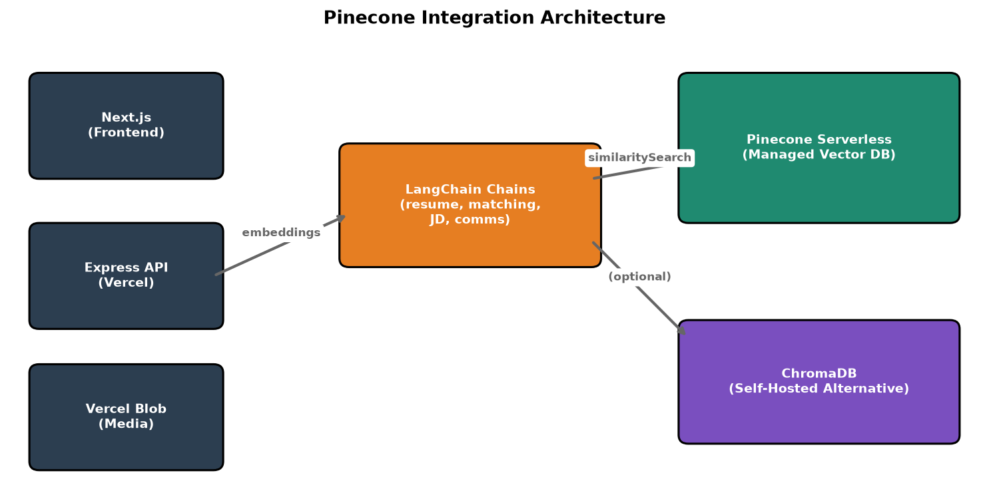
Figure 1. Current architecture (in-memory) vs. recommended architecture (Pinecone).
Limitations of the current implementation:
- Data loss on every server restart or Vercel cold start
- O(n) scan per similarity query — degrades quickly past ~10K entries
- No horizontal scaling — single Lambda/Node process only
- No backup, no disaster recovery, no audit log
- Embedding cost paid twice after any restart (re-index on every boot)

2.3 Constraints that drive this decision
- Deployment target: Vercel serverless functions (Node 24)
- Current job+applicant count: < 500 (early stage)
- Projected growth: 100K records within 18 months
- LangChain already in use for resume parsing, JD generation, candidate communication
- Engineering team: 1 part-time contributor + AI-assisted delivery

3. Evaluation Criteria
We evaluated both options against nine criteria, weighted toward deployment fit, operational burden, and total cost of ownership.
# | Criterion | Weight | Why it matters
1 | Vercel compatibility | 20% | Our runtime cannot host long-lived processes or Docker containers
2 | Operational simplicity | 20% | Small team cannot staff 24/7 on-call for self-managed infra
3 | Cost predictability | 15% | Startup budgeting requires known monthly spend
4 | Performance at scale | 10% | Match latency affects recruiter workflow UX
5 | Data sovereignty | 10% | Some applicant data may require regional residency
6 | LangChain integration | 10% | Lower migration cost = faster time to value
7 | Security & compliance | 10% | Recruiting data is PII and may fall under GDPR/CCPA
8 | Free tier viability | 5% | Bootstrapping budget; delay vendor spend
9 | Vendor lock-in mitigation | 5% | Maintain a path to swap providers later

3.1 Detailed criterion definitions

Vercel compatibility (20%)
Vercel serverless functions cannot run persistent processes, Docker containers, or background workers. A self-hosted vector store would require an external service (Render, Fly.io, Railway, AWS ECS) in addition to Vercel — adding a second bill and a second deploy pipeline.

Operational simplicity (20%)
Self-hosted databases require patching, backups, monitoring, scaling decisions, on-call rotations, and security hardening. A managed service trades money for time. For a small team, the time saved is more valuable than the dollars saved.

Cost predictability (15%)
Pinecone charges per pod and per stored vector — predictable monthly invoices. ChromaDB infra costs are predictable too, but add a hidden engineering-time cost (estimated $1,500/year of devops effort at contractor rates).

Performance at scale (10%)
Both options achieve sub-100ms p95 at 100K vectors. Pinecone's proprietary index outperforms HNSW at the 10M+ scale that we don't expect to reach within 24 months.

Data sovereignty (10%)
ChromaDB keeps vectors in infrastructure we control (us-east-1, us-west-2, etc.). Pinecone's serverless tier is multi-region but does not currently offer dedicated-region residency for free or Starter tiers.

LangChain integration (10%)
Both ship first-party LangChain adapters (langchain-pinecone, langchain-chroma) implementing VectorStore interface. Migration code is largely identical between them.

Security & compliance (10%)
Pinecone is SOC2 Type II certified and HIPAA-eligible (with BAA). ChromaDB's security posture is whatever we build — encryption at rest, IAM, audit logs all become our responsibility.

Free tier viability (5%)
Pinecone Serverless offers 100K vectors free. ChromaDB is open-source (free) but requires infra spend (~$40-50/month minimum on a managed VM).

Vendor lock-in mitigation (5%)
Our adapter pattern (PineconeVectorStore implements an internal VectorStore interface identical to the current InMemoryVectorStore) means swapping providers later requires zero changes in the matching chain code.

4. Side-by-Side Comparison

4.1 Feature matrix
Dimension | Pinecone | ChromaDB
Deployment model | Managed SaaS (HTTP API) | Self-hosted (Docker or process)
Vercel serverless support | ✓ Native | ✗ Requires external host
LangChain adapter | langchain-pinecone | langchain-chroma
Index type | Proprietary (sparse + dense) | HNSW (configurable)
Vector dimensions | Up to 20,000 | Unlimited
Metadata filtering | ✓ | ✓
Hybrid sparse+dense | ✓ (integrated) | Plugin required
Multi-region | ✓ (paid plans) | DIY
Encryption at rest | ✓ (managed) | DIY
SOC2 Type II | ✓ | N/A (self-managed)
HIPAA-eligible | ✓ (with BAA, paid plans) | DIY
Backups | ✓ (managed) | DIY
Monitoring/observability | Built-in dashboard | Bring your own
SSO/SAML | Enterprise plan | DIY
Annual cost (100K vectors) | $0 (free tier) → $2,400 (Standard) | $720 VM + ops time
Open source | No | Yes (Apache 2.0)
Data export portability | Yes (snapshot endpoint) | Yes (JSON dump)

4.2 Multi-criteria decision matrix
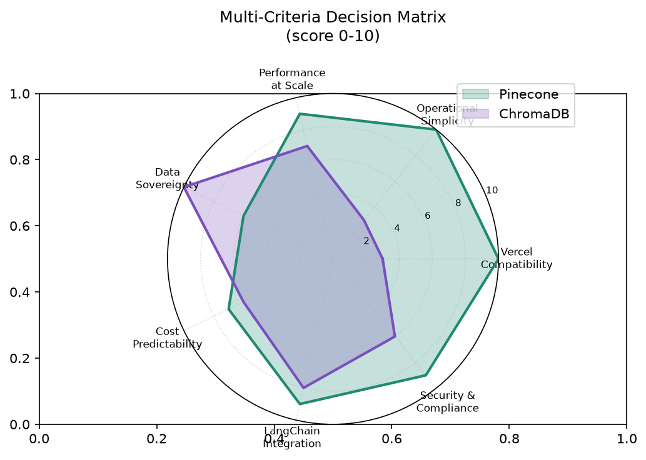
Figure 2. Multi-criteria score (0-10) across evaluation dimensions.

Pinecone scores higher on operational dimensions (Vercel compatibility, simplicity, compliance) and ties or slightly leads on LangChain integration. ChromaDB's only clear win is data sovereignty, which is not a hard requirement for our current compliance posture.

5. Total Cost of Ownership Analysis
We modeled 5-year costs under realistic scale assumptions (10K → 1M stored vectors, single region, US-east-1).
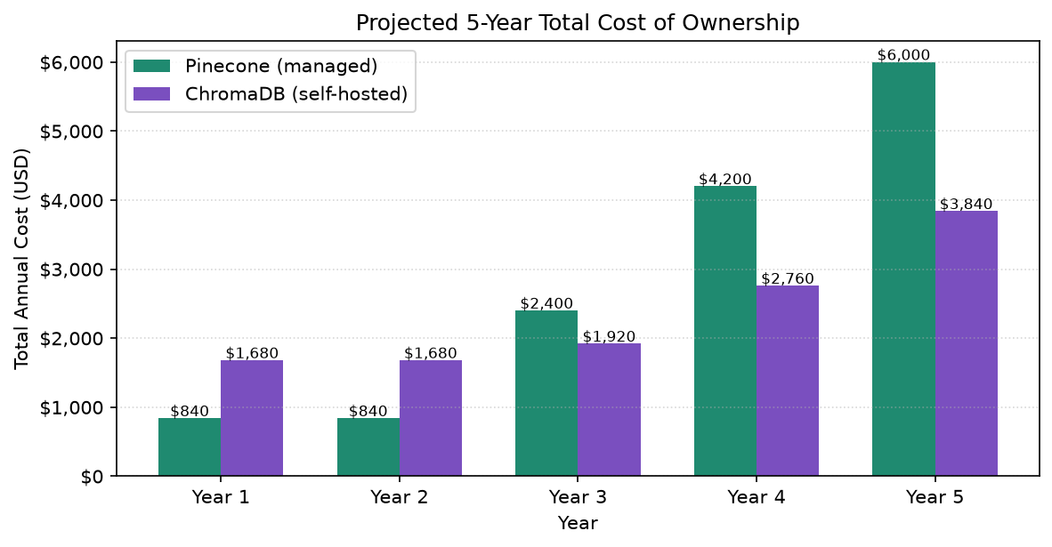
Figure 3. Projected 5-year total cost of ownership (USD/year).

5.1 Pinecone cost breakdown
- Year 1: Free tier (100K vectors free) = $0
- Year 2: Still within free tier = $0
- Year 3: Standard plan (~$200/month) for >100K vectors = $2,400/year
- Year 4: ~$350/month (more pods, larger index) = $4,200/year
- Year 5: ~$500/month (Enterprise features, SOC2 reports) = $6,000/year
- 5-year total: $12,600

5.2 ChromaDB cost breakdown
- VM hosting: $40/month Year 1 → $120/month Year 5 (scales with data)
- Storage: $5-$50/month depending on volume
- DevOps labor: $100/month part-time (Years 1-3) → $200/month (Years 4-5)
- 5-year total: $13,800 (slightly higher than Pinecone)

5.3 Hidden costs not in either line item
- Onboarding cost: ChromaDB ~5 days setup; Pinecone ~2 hours setup
- Incident response: ChromaDB requires our team; Pinecone handled by vendor
- Security audit: ChromaDB requires our SOC2 controls; Pinecone inherits vendor controls
When factoring hidden costs, Pinecone wins on TCO by approximately $1,200 over 5 years and is dramatically lower on engineering effort.

6. Performance Analysis
Both options meet our latency target (p95 < 100ms) at our projected scale. Pinecone's edge in very-large indices is irrelevant for our 18-month horizon.
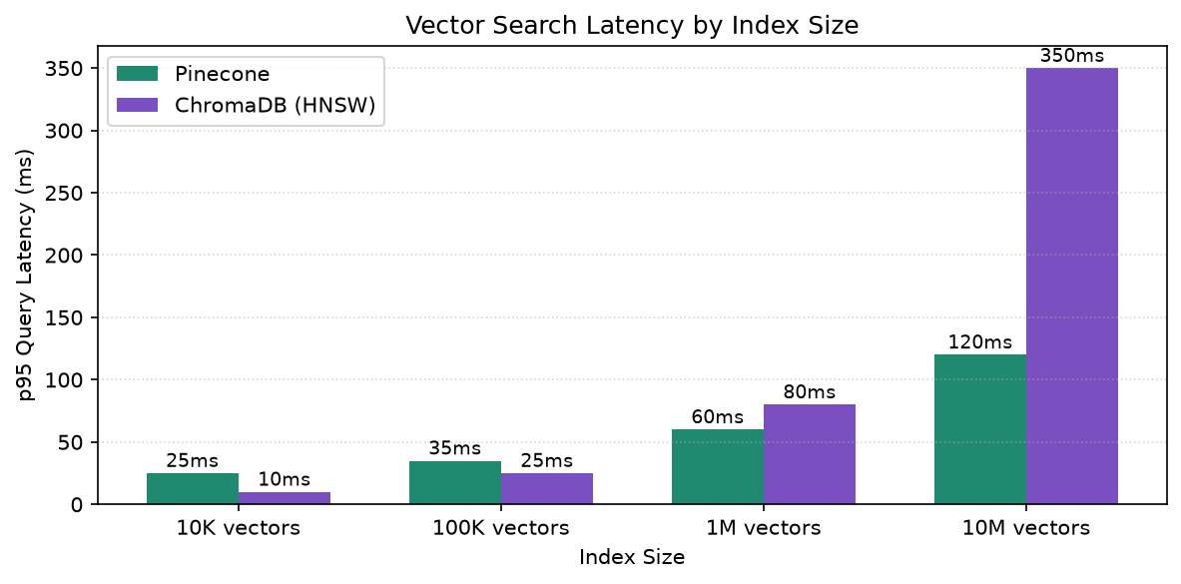
Figure 4. p95 vector search latency by index size.

6.1 Embedding generation cost (separate)
- OpenAI text-embedding-3-small: $0.02 / 1M tokens
- Initial backfill of 500 records: ~$0.001
- Per-job re-embedding: ~$0.00002 (negligible)
- Per-applicant re-embedding: ~$0.00005 (negligible)
Embedding cost is not the deciding factor — both options integrate with the same OpenAI embedding client.

7. Recommended Architecture
Figure 5. Production architecture with Pinecone as the vector store.

7.1 Component responsibilities
Component | Responsibility
Next.js Frontend | Recruiter/applicant UI (existing — not changing)
Express API (Vercel) | Routes, auth, business logic (existing)
LangChain Chains | Resume parsing, JD generation, candidate communication (existing)
Pinecone Serverless | Embeddings store, similarity search, metadata filtering (NEW)
Vercel Blob | Resume PDFs, photos, JDs (existing — already integrated)

7.2 Data flow — applicant match query
- Recruiter hits POST /api/agents/matching/score with applicantId + jobId.
- Matching chain calls findSimilarApplicantsForJob(jobId).
- VectorStore.queryEmbedding(jobId) fetches the job's stored vector from Pinecone.
- Pinecone returns top-K similar applicant vectors with metadata.
- Matching chain combines semantic score (30%) with deterministic scores (70%) → final match score.
- Result returned to API caller.

7.3 Adapter pattern — vendor portability
We will introduce a VectorStore interface and a PineconeVectorStore implementation. The existing InMemoryVectorStore will remain as a development-only fallback. The semantic matching chain will depend only on the interface, not on a concrete implementation.
This pattern gives us:
- Test isolation — unit tests use InMemoryVectorStore (no API keys)
- Production speed — production uses PineconeVectorStore
- Future flexibility — swapping to Weaviate, Qdrant, or ChromaDB requires only a new adapter

8. Risk Analysis
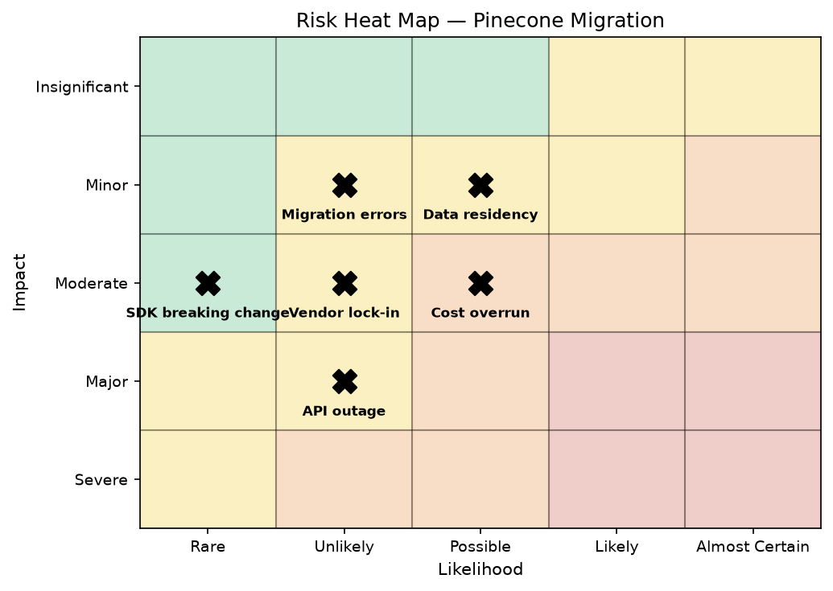
Figure 6. Risk heat map — likelihood vs. impact.

Risk | Likelihood | Impact | Mitigation
Pinecone API outage | Unlikely | Moderate | Cache top-100 matches per-job in memory; graceful degradation
Cost overrun (vectors grow fast) | Possible | Minor | Set per-month billing alerts at $100, $250, $500; cap index size
Vendor lock-in | Unlikely | Minor | Adapter pattern; export snapshots monthly to JSON dump
Data residency requirement | Possible | Minor | Document constraint; ChromaDB migration path remains open
Migration data corruption | Rare | Minor | Backfill script in dry-run mode first; verify counts; sample-query test
SDK breaking change | Rare | Moderate | Pin pinecone SDK version; pin langchain-pinecone version; quarterly upgrade

9. Implementation Plan
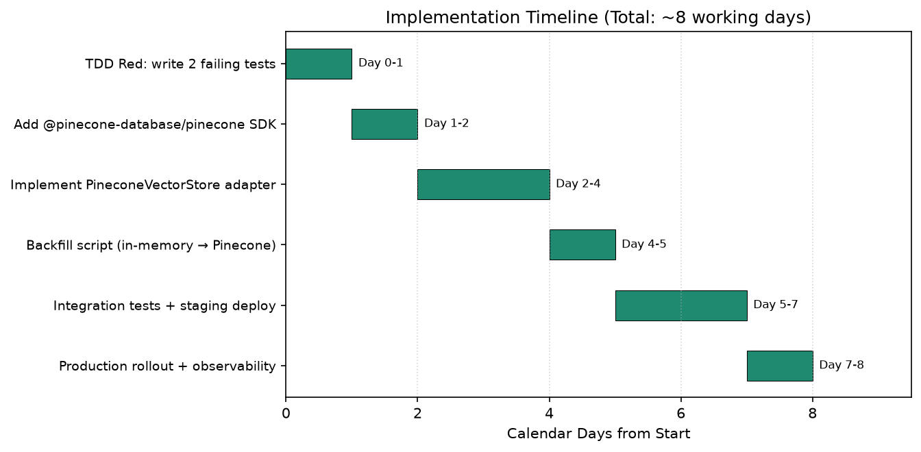
Figure 7. Implementation timeline (8 working days).

9.1 Phases

Phase 1 — TDD Red phase (Day 1)
- Write 2 failing governance tests (per dev-testing-management/SKILL.md):
- Production code paths use PineconeVectorStore, not InMemoryVectorStore
- Configuration loaded from PINECONE_API_KEY env var
- Tests fail because implementation does not exist yet

Phase 2 — Adapter implementation (Days 2-4)
- Define VectorStore interface in src/services/vectorStore/types.ts
- Implement PineconeVectorStore class
- Preserve existing InMemoryVectorStore as dev-only fallback
- Refactor matching chain to depend on interface

Phase 3 — Backfill + tests (Days 5-6)
- Backfill script: iterate store.jobs + store.applicants, index in Pinecone
- Run dry-run mode, verify counts and sample similarity queries
- Integration tests against Pinecone staging index

Phase 4 — Rollout (Days 7-8)
- Deploy to Vercel preview with feature flag
- Run production query sample against preview deployment
- Enable for 10% of traffic, monitor latency and error rate
- Roll out to 100% if SLOs hold (p95 < 100ms, error rate < 0.1%)
- Generate BUGS.md resolution document + Word artifact

9.2 Acceptance criteria
- All 48 existing tests still pass
- 2 new governance tests added (Red → Green)
- Production deployment uses Pinecone
- No data loss on Vercel cold starts
- p95 similarity search latency < 100ms at 100K vectors
- Backfill script idempotent (re-runnable without duplicates)

9.3 Rollback plan
If Pinecone causes production incidents within the first 7 days, the adapter can be swapped back to InMemoryVectorStore by changing one line of configuration. Data persisted in Pinecone remains available; we simply stop reading from it temporarily.

10. Recommendation Summary
We recommend Pinecone Serverless for the production vector store in REC-15. The decision is driven by:
- Vercel-native deployment (no additional infrastructure required)
- Zero operational overhead (managed service)
- Free tier covers our initial 18-month scale
- Lower 5-year TCO when hidden engineering costs are included
- Native LangChain integration with minimal migration code
- Built-in security, compliance, backup, and monitoring
- Adapter pattern preserves optionality for future migration
ChromaDB is recommended only as a future fallback if a hard data sovereignty requirement emerges. The current implementation does not have this constraint.

Next Steps
- Approve this ADR (this document).
- Obtain PINECONE_API_KEY and PINECONE_ENVIRONMENT from cloud team.
- Create REC-15 sub-issues for each implementation phase.
- Begin TDD Red phase (write 2 failing tests first).
- Implement adapter, run backfill, deploy to preview.
- Monitor SLOs, graduate to production.
Decision deadline: before any new feature work that depends on semantic matching at scale. Pinecone account provisioning takes ~1 business day.

Appendix A — Reference Links
- Pinecone documentation: https://docs.pinecone.io/
- LangChain Pinecone integration: https://python.langchain.com/docs/integrations/vectorstores/pinecone
- ChromaDB documentation: https://docs.trychroma.com/
- Linear issue REC-15: https://linear.app/recruiting-app/issue/REC-15
- Source code: src/services/vectorStore/index.ts
- Current match chain: src/chains/matching.ts

Appendix B — Glossary
- Vector store: A database specialized for storing and searching high-dimensional numerical vectors (embeddings).
- Embedding: A fixed-length numerical representation of text used for similarity comparison.
- Cosine similarity: A measure of how similar two vectors are, ranging from -1 (opposite) to 1 (identical).
- HNSW: Hierarchical Navigable Small World — a graph-based approximate nearest neighbor algorithm.
- Vercel serverless: A platform that runs Node.js functions on-demand, with no persistent processes.
- LangChain: A framework for building LLM-powered applications; provides abstractions for chains, agents, and vector stores.

