New Employee Enrollment UI Proposals
Executive and end user review packet

Purpose
This packet presents two employee chat concepts, two HR manual-enrollment concepts, and two HR bulk-upload concepts. It is intended to help reviewers select a visual direction and identify workflow questions before implementation.

Recommendation
Advance Orbit Guide for employee self service and Enrollment Workbench with Import Control Panel for HR. Together they create one calm, guided system while giving each role the amount of structure it needs.

Review decision
Confirm the preferred direction, the level of visible guidance, and which concepts should move into clickable prototypes.

Shared visual foundation
All concepts use a calm mission control theme. The visual system is intentionally light, reassuring, and practical for decisions that can feel personal or complex. The round spaceship is a friendly guide, not a brand mascot that competes with the content.
Element | Direction | Why it matters
Palette | Ink, sky, mist, mission green, coral, sun | Creates clarity without a clinical or heavy interface.
Type | Clear sans serif with a strong hierarchy | Supports scanning by employees and high-volume HR work.
Guidance | One decision at a time with plain-language explanations | Makes benefit selection easier to complete correctly.
Accessibility | Text labels, icons, and status wording work together | Avoids relying on color alone for progress or errors.
Conversation boundary
The employee assistant is scoped to benefit elections, plan comparisons, dependents, costs, and confirmation. The interface should use guided response choices at each step and state its scope plainly. Off-topic input receives a brief redirect to an allowed task; it does not attempt to answer unrelated questions.

Employee self service chat
Employees use a desktop-first guided conversation to make their own benefit selections. The experience should remain focused on their enrollment, use plan comparisons only when helpful, and finish with a clear confirmation summary.

Orbit Guide
A conversational guide paired with a live enrollment summary. The left side handles one decision at a time; the right side continuously shows selections, covered dependents, and the estimated payroll deduction. The animated orbit makes progress visible without turning the experience into a wizard.
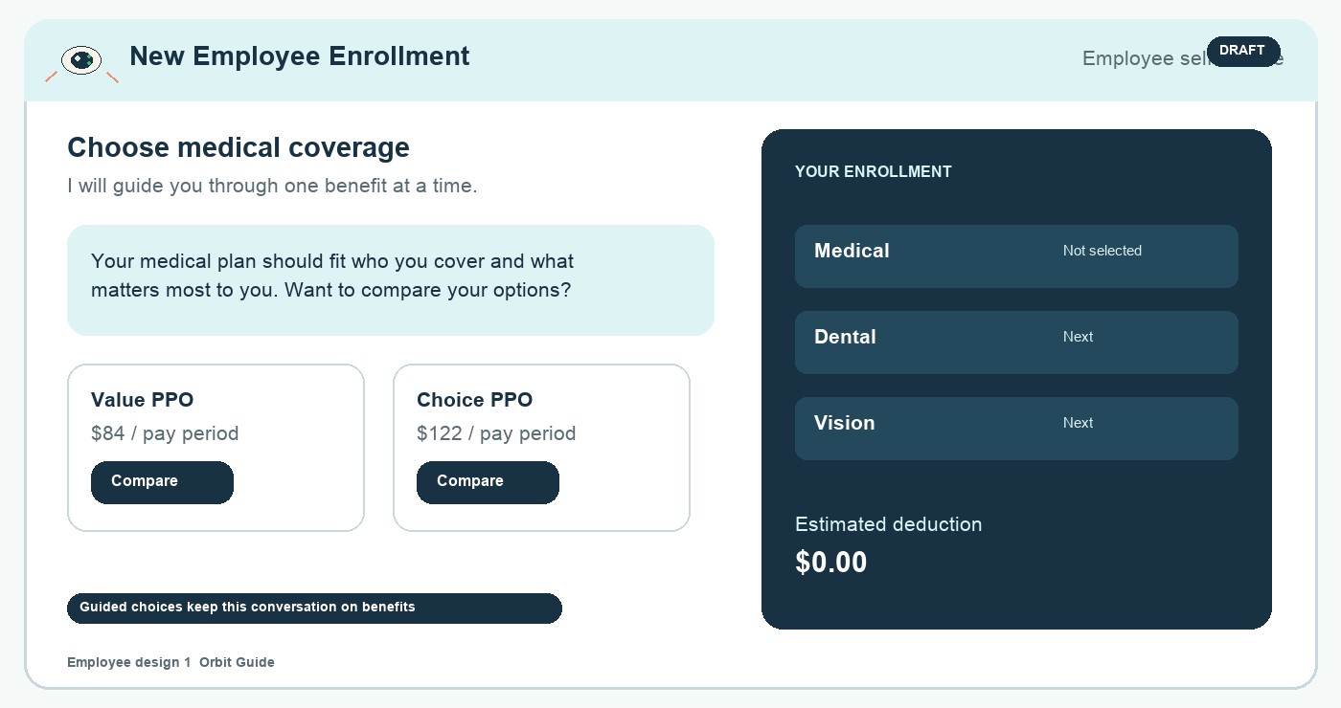
Concept screen 1 Orbit Guide uses a persistent enrollment summary to make choices feel reversible and clear.

Benefit Briefing
A more structured alternative that reads like a short briefing. It favors large guided choices, plain-language education, and an explicit scope statement. The constellation progress line makes the journey visible while preserving the feeling of a conversation.
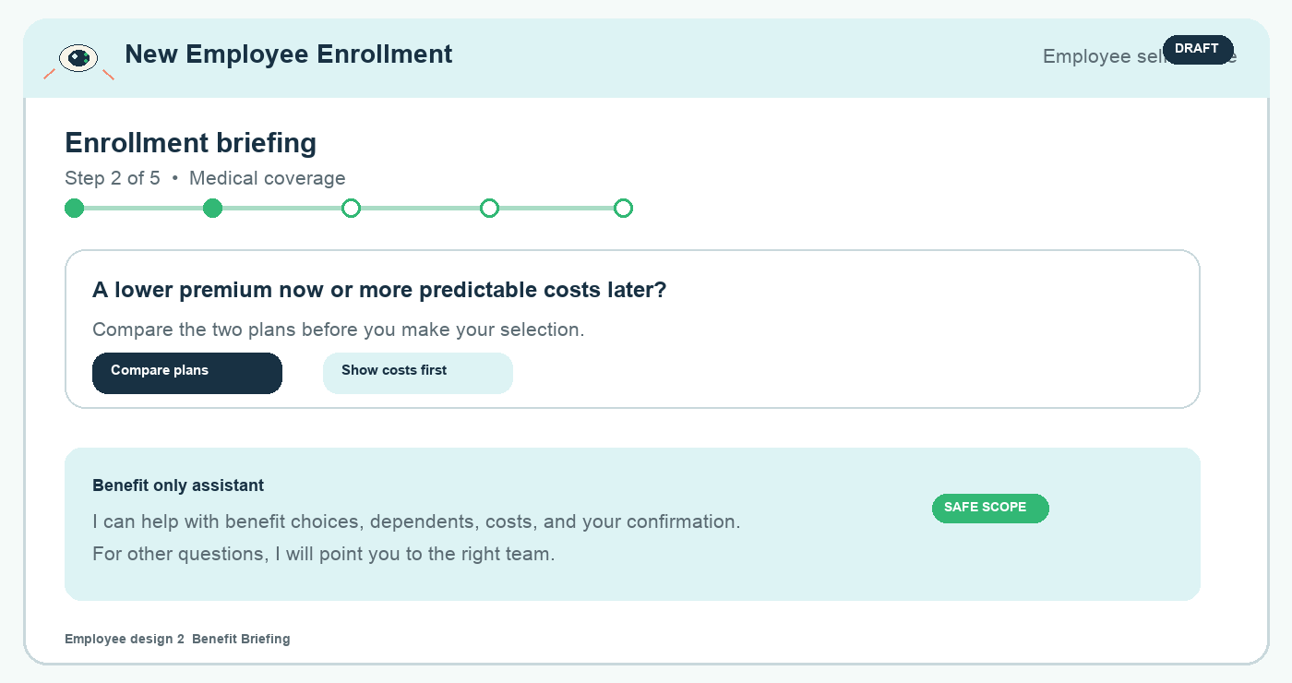
Concept screen 2 Benefit Briefing gives employees a focused, bounded choice at each stage.

HR manual enrollment workspace
HR needs a desktop workspace that supports careful updates to one employee record while retaining access to bulk imports. In both concepts, the manual form is the primary area and the upload function remains in the upper right.

Enrollment Workbench
A task-focused workspace for repeat HR activity. A dark section rail gives immediate orientation, while broad editable sections keep employee details, covered dependents, elections, and payroll cost in one working view. The upload card remains available without interrupting manual work.
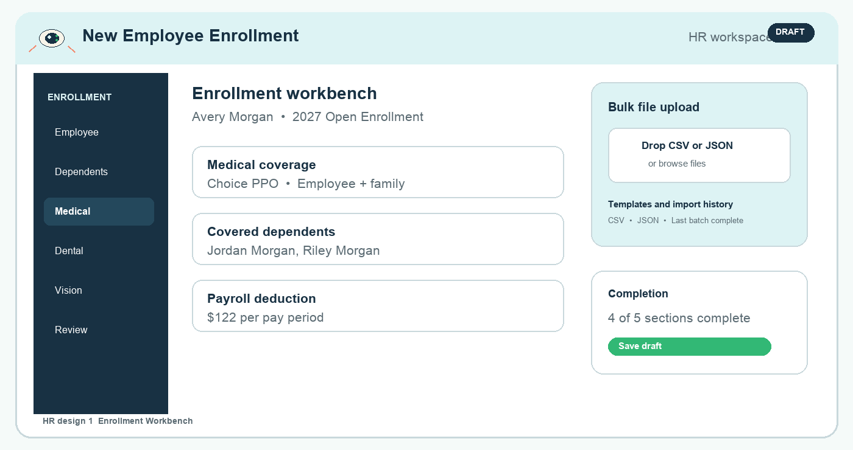
Concept screen 3 Enrollment Workbench prioritizes fast, accurate manual updates.

Enrollment Desk
A warmer dossier-style alternative. Accordion chapters make a complete employee record approachable and help reviewers inspect each section in sequence. It is a good fit if HR values reviewability and a less operational tone over dense throughput.
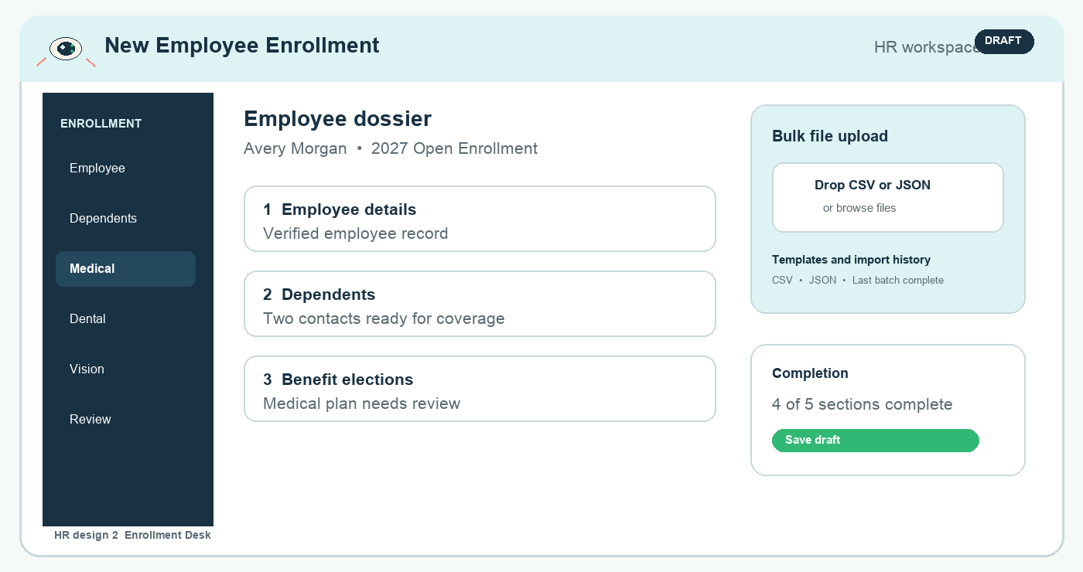
Concept screen 4 Enrollment Desk frames the record as a readable employee dossier.

HR bulk file upload
Bulk import must clearly distinguish upload, validation, review, and completed import. CSV and JSON are supported based on the file suffix. Records require employee data before associated contacts or selections can be created; the interface should surface issues before HR completes the batch.

Import Control Panel
A step-by-step import panel for HR teams that want an explicit preflight experience. The trajectory shows where the batch is in its journey, while a preflight card makes it clear that no records are imported until validation and review are complete.
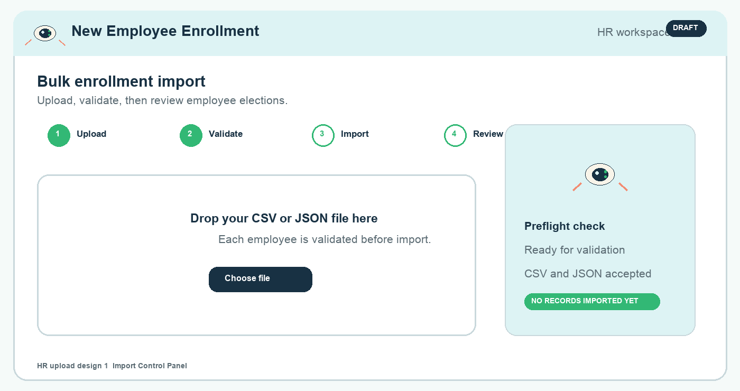
Concept screen 5 Import Control Panel makes the import sequence and preflight status explicit.

Batch Inbox
A queue-oriented alternative for teams managing multiple files. HR can see new, incomplete, and completed batches at a glance, then open a selected batch to resolve row-level issues before import. This option is strongest for recurring enrollment windows.
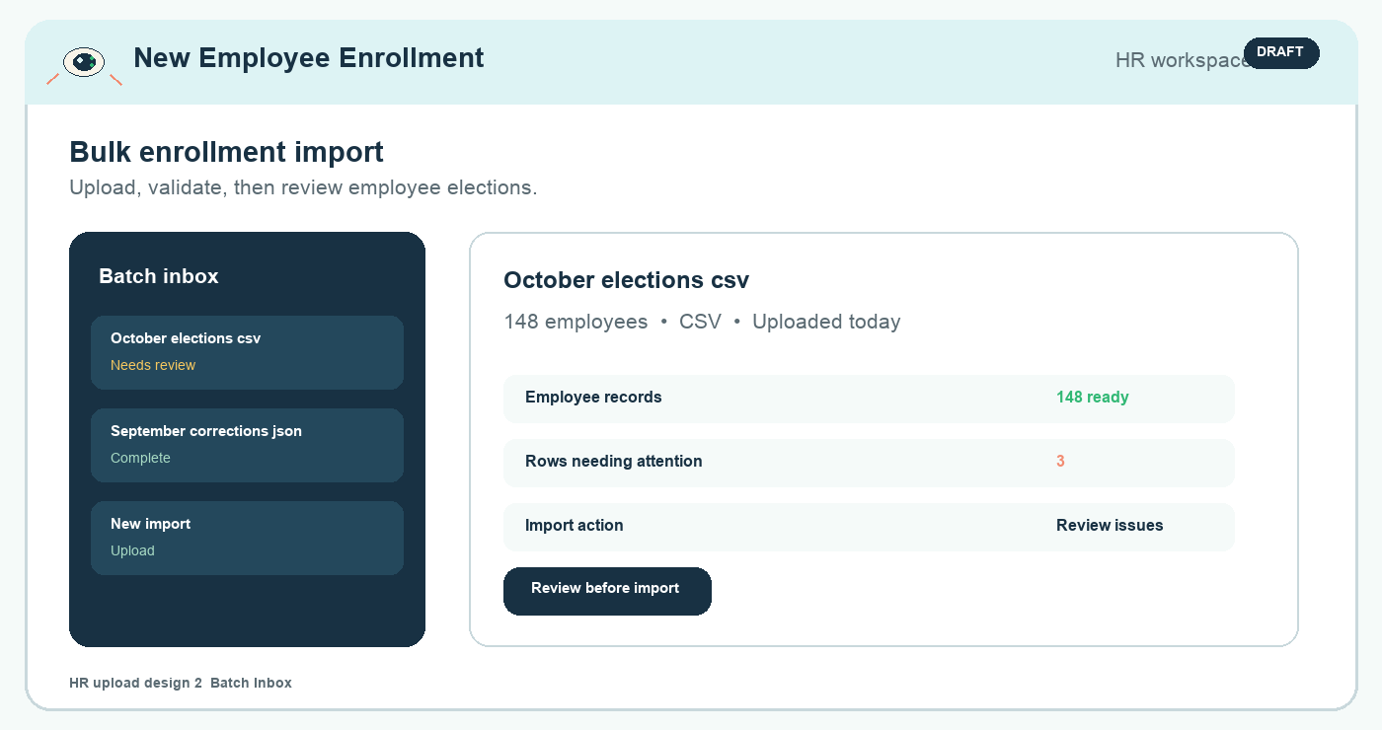
Concept screen 6 Batch Inbox treats uploads as reviewable work items rather than one-off actions.

Review guide
Use this final page to capture feedback during executive and end user sessions. The aim is to decide what to prototype, not to settle every interaction detail in the room.
Audience | Best direction | Primary strength | Decision to validate
Employees | Orbit Guide | Live summary makes choices and costs visible. | Does the persistent summary reduce uncertainty?
Employees | Benefit Briefing | Strongest choice containment and education. | Does the structure still feel conversational?
HR | Enrollment Workbench | Fast, durable manual entry for recurring work. | Is the rail helpful at the expected scale?
HR | Enrollment Desk | Readable record review with softer hierarchy. | Does it support enough throughput?
HR | Import Control Panel | Clear preflight and explicit import stages. | Are the stages enough to prevent errors?
HR | Batch Inbox | Best visibility across multiple import files. | Is batch volume high enough to justify a queue?

Questions for the sessions
• Which screen makes the next action most obvious?
• Where would an employee or HR user expect more explanation before committing?
• Which status or cost detail needs to remain visible throughout the task?
• What would make you hesitate to submit an enrollment or import a file?
Proposed next step
Select the recommended employee and HR directions, then convert them into clickable desktop prototypes with empty, loading, validation-error, and confirmation states for usability review.

