New Employee Enrollment UI Recommendation Packet
C suite and stakeholder decision review


Decision requested
Approve Orbit Guide as the employee enrollment experience and Enrollment Workbench as the HR manual-enrollment experience. Use Import Control Panel as the preflight mode opened from the Workbench upload area. Treat the alternate concepts as supporting patterns rather than separate products.
Area | Decision | Why now
Employee self service | Orbit Guide with Briefing safeguards | It keeps cost, covered dependents, and choices visible while preserving a focused conversation.
HR manual work | Enrollment Workbench | It best supports repeat desktop work while preserving the requested upper-right upload access.
Bulk imports | Import Control Panel with later Batch Inbox | It makes preflight and no-import-yet status explicit; a queue can follow if volume proves it necessary.

What changes before implementation
The proposed changes close the highest-risk gaps: uncertain scope, accidental plan choice, incomplete dependent coverage, unsaved HR work, ambiguous upload status, and insufficient confirmation before records are committed.

Employee recommendation Orbit Guide
Keep Orbit Guide’s live enrollment summary and use Benefit Briefing’s visible progress and clear scope language. The result is a guided, benefit-only conversation rather than a general chatbot or a rigid form wizard.
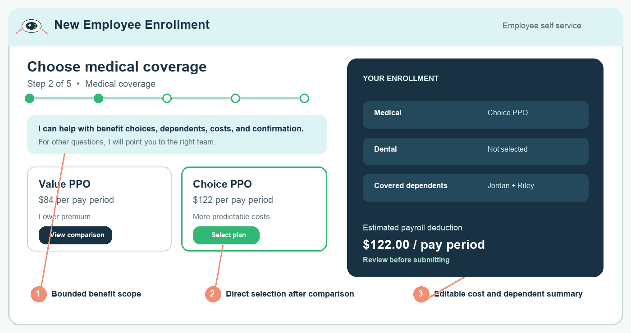
Recommended employee future state The alien spaceship guide stays quiet while scope, progress, selection, and the live cost summary remain explicit.
Change | Decision benefit | Implementation note
Bounded benefit scope | Prevents off-topic drift and makes the assistant’s role understandable. | Offer guided choices; redirect unrelated prompts to the correct team without generating a general answer.
Comparison then selection | Employees can understand a plan before committing, without confusing comparison with the action to select. | Make the selected card and primary selection action unmistakable; retain comparison as a secondary action.
Persistent editable summary | Reduces anxiety by showing cost, plan, and covered dependents before submission. | Provide Change links and a final review; the application computes the cost and eligibility, not the model.
Accessible progress and motion | Makes the journey understandable without relying on animation or color. | Use text status, visible step count, and reduced-motion support for the orbit treatment.

Measures to validate
Can employees explain the next step, identify their per-pay-period deduction, correct a dependent selection, and understand what will happen when they submit?

HR recommendation Enrollment Workbench
Implement the Workbench as one desktop-first screen. The manual form owns most of the workspace; the upload card remains in the upper right and opens import preflight without replacing or discarding the active employee record.
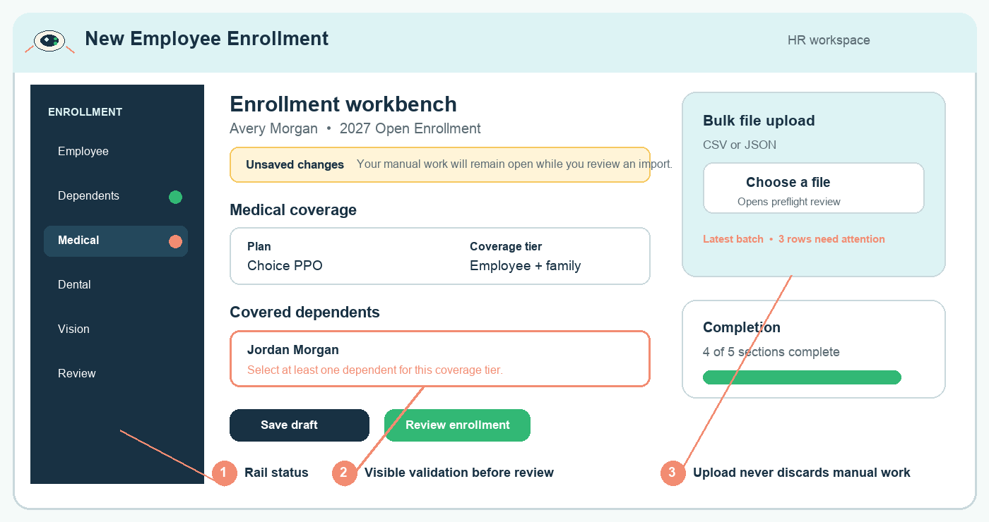
Recommended HR future state Progress and errors appear in the section rail, validation is visible in context, and the upper-right upload area protects unsaved manual work.
Change | Decision benefit | Implementation note
Section rail with states | HR can scan what is complete, incomplete, or blocked before review. | Use text, icons, and error counts together; never use red or green alone.
Real editable form surface | Supports accurate manual updates rather than a dashboard of summary cards. | Show in-context field validation and retain a dedicated review action before submission.
Unsaved-work protection | Prevents the import workflow from interrupting or losing manual edits. | Keep the draft in place while preflight opens in a panel or route; ask before navigating away.
Action hierarchy | Separates draft-saving from final review and uses color semantically. | Reserve green for success/status; use the primary action color for Save draft and Review enrollment.

Import recommendation Import Control Panel
The Workbench upload card should open this explicit preflight mode. Batch Inbox is deferred as a history and queue screen for recurring high-volume windows, not the initial upload experience.
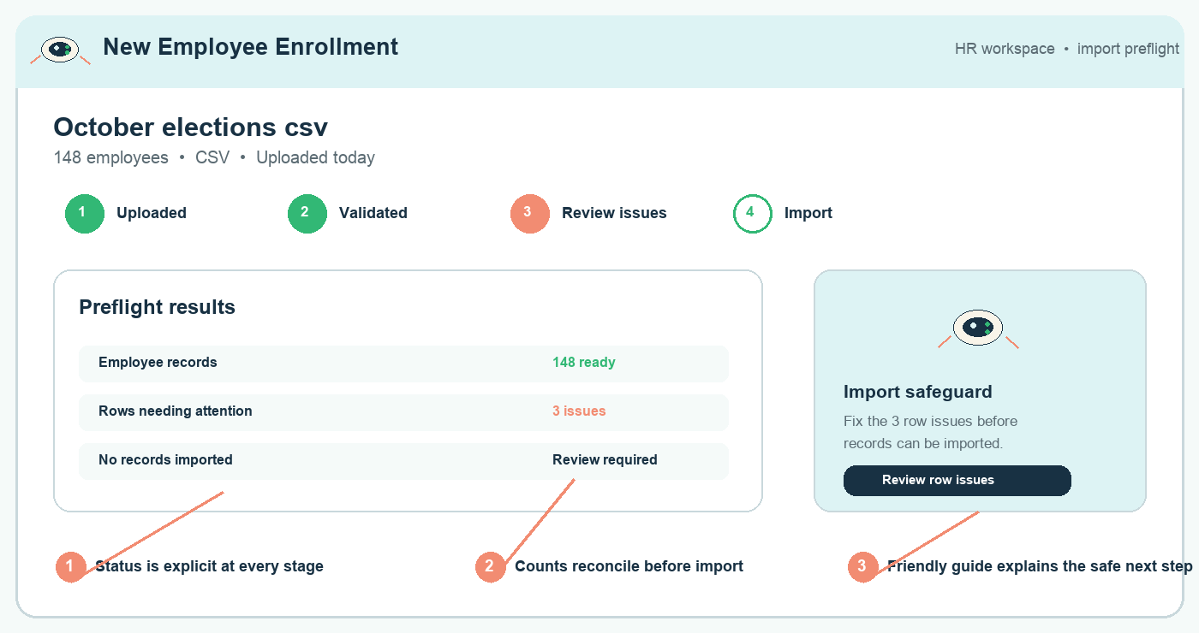
Recommended import future state The four-stage lifecycle, reconciled counts, and a no-records-imported safeguard make the safe next action clear.
Required state | Stakeholder expectation | Prototype proof
File chosen | File type and filename are clear; CSV and JSON are supported. | Show selected-file replacement and cancellation without hidden upload.
Preflight | No employee record is committed while validation is incomplete. | State that no records have been imported and show validation progress.
Rows need attention | Counts and remediation are visible before an import can proceed. | Show a row-error view with safe corrective actions and a return to review.
Completed import | HR can verify what succeeded, what failed, and what needs follow-up. | Show reconciled totals, completion time, and a link to batch history.

Controls that must not be delegated to AI
Plan eligibility, coverage-tier rules, payroll deduction, period status, contact ownership, import counts, and final persistence remain deterministic application controls. The assistant may guide the employee but may not decide or override these rules.

Prototype scope and approval
The next prototype should prove comprehension and error recovery, not merely visual preference. It should be tested with employees, HR operators, Security, and product owners before build commitments are made.
Prototype | Must include | Approval question
Employee Orbit Guide | Dependents, comparison, selection, live summary, off-topic redirect, final confirmation. | Can an employee complete enrollment and explain the cost with confidence?
HR Enrollment Workbench | Editable form, field errors, unsaved-change behavior, section status, review and draft states. | Can HR correct errors and resume work without losing context?
Import Control Panel | File selection, validation, row errors, pre-import review, completion result. | Can HR tell whether records have been imported and what action is required next?

Approval request
Approve the three recommended patterns and authorize clickable prototype work. Defer Batch Inbox until pilot evidence shows concurrent or recurring batch volume warrants a queue. Preserve the light mission-control palette and the alien spaceship with green flashing lights as a restrained guide, not a competing mascot.

Open stakeholder decisions
• What enrollment actions require explicit final confirmation versus draft save?
• What HR error or exception requires escalation rather than self-service correction?
• What batch volume or operational cadence justifies introducing Batch Inbox?
• What supported desktop widths and reduced-motion behavior are required for pilot?

