For quering used the **postman** application.

The queries are given bellow :

1. **List of Pets by Owner** : localhost:XXXXX/api/Pets/Owner?ownerid=X where X = owner id

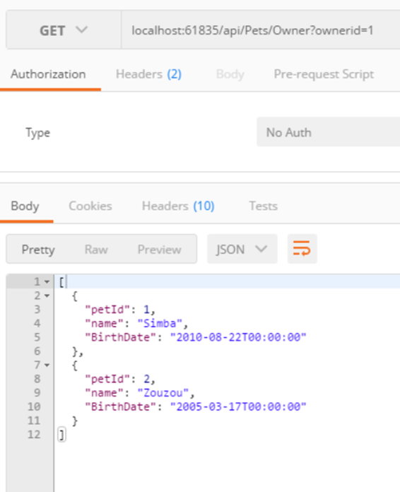

1. **Is PetWalker approved by PetOwner :** not implemented

3. **Get Pet by id** : localhost:XXXXX/api/Pets/1

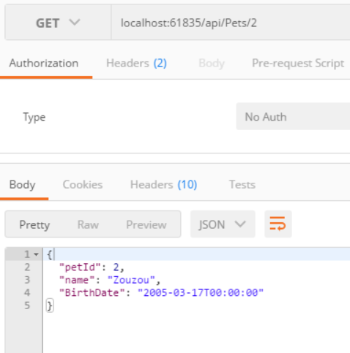

4. **Create a new pet :** Use the POST method and give the json with the details of the new pet

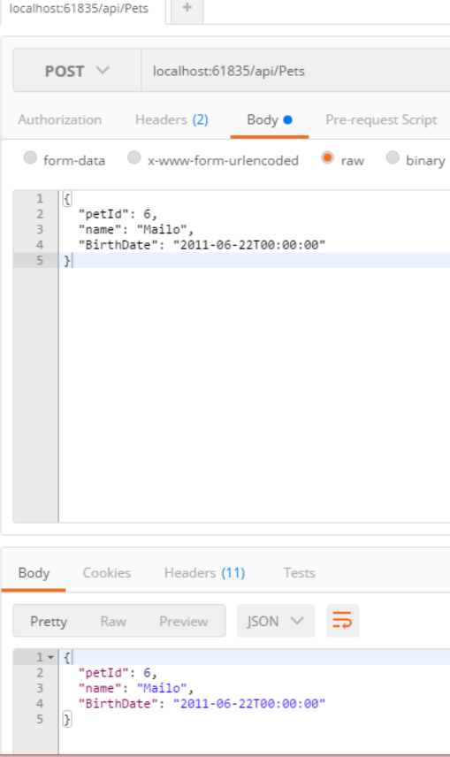

5. **Update an existing pet :** Use the GEt method to take the desired pet for amendment and then use the PUT method in order to change pet values.

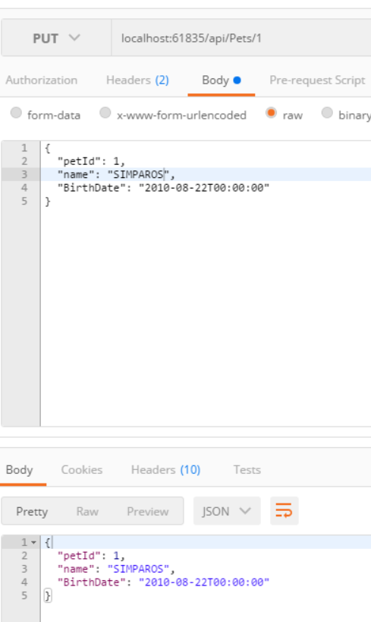

6. **Get pets that are under {nn} years :** localhost:XXXXX/api/Pets/Age?nn=3

nn: is an integer number representing pet’s age

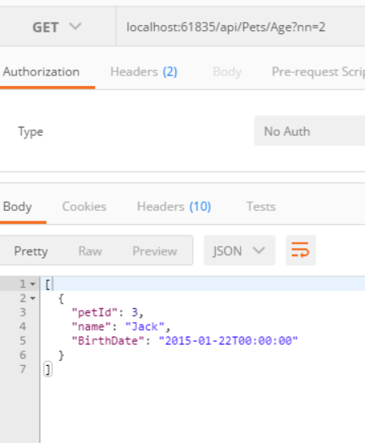

Moreover Authentication was implemented. But there is bug in the authentication controller.

Furtheromore you can also run the following queries:

* localhost:XXXXX/api/PetWalkers
* localhost:XXXXX/api/Owners
* localhost:XXXXX/api/Approvals
* localhost:XXXXX/api/Pets/1 : owners by id
* localhost:XXXXX/api/PetWalkers/1 : Pet walkers by id

The Database(localDB) :

