Budgeting Project

Juan Ballas, John Cason, Zoe Mecklenburg

Bellarmine University

CS150-01

Professor Sarkar

11-15-2023

**Abstract:**

In an era defined by economic intricacies and financial uncertainties, achieving and maintaining financial stability demands a strategic and informed approach to budgeting. Through this paper we will discuss our cutting-edge budgeting program created to guide individuals on a transformative journey toward fiscal responsibility. This paper will provide an overview of our program's purpose, the code used, its key features, the challenges and results of the product.

**Introduction:**

In a world where financial stability is paramount, the journey towards fiscal responsibility begins with effective budgeting. We understand that navigating the complexities of personal finance can be a daunting task, and that is why we are excited to introduce our new budgeting technology. It is a comprehensive and user-friendly budgeting program with the purpose of empowering you on your path to financial wellness.

Our budgeting program offers many different benefits. It provides a user-friendly platform that simplifies the budgeting process, allowing you to set financial goals and track your progress. Our program allows you to analyze your income, expenses, investing, and savings patterns, enabling you to make informed decisions for a more secure financial future.

**Methodology:**

Our budgeting program uses a diverse set of programming elements to ensure optimal functionality. Leveraging the versatility of while loops, for loops, and if functions, the program navigates through various scenarios, providing the correct response to user inputs. Lists and strings are employed to efficiently organize and manage data, while the append function facilitates the seamless addition of new elements to the lists. Additionally, mathematical operations are integrated to perform essential calculations, enhancing the program's capacity to handle numerical data effectively specifically when it came to the investing portion of the code.

**Design and Implementation:**

The approach we took for the buget is simple. We did not try to overcomplicate anything by adding every function we have learnt this year, but rather to stick to a few and make the budget user friendly. The budget is based on lists functions. The budget’s revenues and expenses are divided into sections so the user can add what type of transaction is taking place. Then, a While loop with if functions incorporated into it takes place. This way the user would be able to pick and choose what type of transaction to then add the amount of the transaction. There is “break” functions incorporated when needed depending on users inputs.

Every transaction is added to the lists through append function. At the end, we sum sum all the types of transactions per category to then append it to a list that point out the total value of the category. We have messages printing to guide the user through this experience, and at the end, there is prints with key information showing the conclusions of the whole log.

The budget itself is divided into three sections. The first one is budgeting for the future, which means logging what the user thinks the following period of time will look like financially. The second section is about the actual financial transactions that took place in that period of time. The third and last section is a comparison of them both which helps to see how well the user financially planned that period of time as well as an insight into each category. It shows details on revenues, expenses, and final balance. It also give recommendations of investing and savings, or a recommendation to seek financial advising depending if the final balance is positive or negative.

**Challenges and Solutions**

The biggest challenge was what function to base the whole program on. We were between uding a dictionary where the we would do keys for type of transaction and values for transaction amount to then create another dictionary that had revenues and expenses as keys, and the sum of the values as values. We opted for lists as it seem less coding and easier for the user experience.

Other challenges appeared as we advanced and we had to go trhough some trial and error to see what the outputs were. The biggest solution we found was the break function. It allowed us to navigate through the user menu in a faster way. Then the final challenge was how to add everything up and present it clear and solid in the summary. Here is where the funcions sum and append came to place. We were able to create a list that had the sum of other lists and display it as a single value.

**Results and Findings**

The results and findings of the budget have two sections. The first one is more of the user experience where the user does the data entry, and the program gives a summary of every transaction made. This summary of every transactions looks like this:

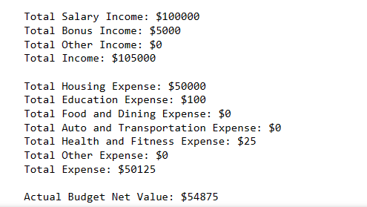

The second one is at the end of the budget experience and gives conclusions of the whole data entry. It will give recommendations depending on the results of what was planned and what happened as well as the final balance. The final summary and recommendations are about how well the user did regarding revenues and expenses, and if there is a chance to invest and save money or seek financial advising. The conclusions show like this:

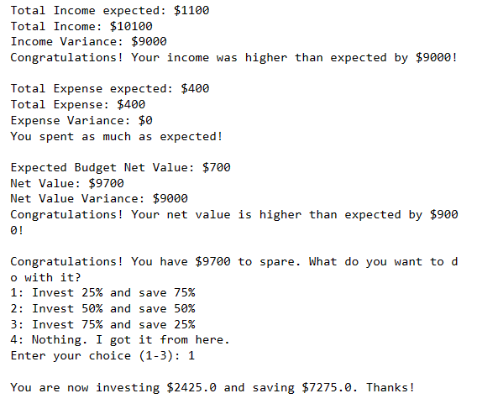

**Discussion**

As a group this project was helpful as some of us are business administration majors. Making a budget really gave us a higher sense of importance of finance in our lives. All three of us are now using budgeting apps to track our finances. This project had a big significance for us.

For the project itself, the users using this program will have some insights into their finances. There are no fancy calculations, but it is nice that it does them for you because it helps with organization. The users will be able to know if they spent more/less than planned or made more/less than planned. This helps with goal setting and keeping a realistic sense of one’s finances. The users may be off about their predictions when first using the program, but it should be more accurate for the second one.

This program also provides the user with options at the end, and it does it for them. Most people who plan on investing do not invest because they do not know how to do so. So, the fact that this app can invest a percentage of what the net balance is after expenses makes a difference.

**Conclusion**

In conclusion, this budget report helped us as a team to learn how we can use Python programming in a real-life situation. Making the program and the codes really gives a clearer sense of how useful these functions are. The project helped us understand the codes we used such as lists, while loops, and if conditions perfectly. There is a difference from doing it in class with our professor than doing it ourselves. Even more starting from an empty notebook.

When it comes to the budget, the key points of it are that it can help someone manage and plan their finances. It allows the user to record transactions and make financial decisions. The code takes care of all the calculations and allocations of the transactions.

**References**

* Module 1 – Introduction to Python
* Module 2 – Lists and Tuples
* Module 3 – If Statements
* Module 5 –While Loop