**CSc 3320: Systems Programming**

Spring 2021 Homework

# 1: Total points 100

Submission instructions:

1. Create a Google doc for each homework assignment submission.
2. Start your responses from page 2 of the document and copy these instructions on page 1.
3. Fill in your name, campus ID and panther # in the fields provided. If this

information is missing in your document TWO POINTS WILL BE DEDUCTED per submission.

1. Keep this page 1 intact on all your submissions. If this *submissions instructions*

page is missing in your submission TWO POINTS WILL BE DEDUCTED per submission.

1. Each homework will typically have 2-3 PARTS, where each PART focuses on specific topic(s).
2. Start your responses to each PART on a new page.
3. If you are being asked to write code copy the code into a separate txt file and submit that as well.
4. If you are being asked to test code or run specific commands or scripts, provide the evidence of your outputs through a screenshot and copy the same into the document.
5. Upon completion, download a .PDF version of the document and submit the same.

Full Name: Jordan Ballou Campus ID: jballou1

Panther #: 02197414

**PART 1**

**Answer the following questions briefly. Provide clear and succinct reasoning.**

**Points per question = 5**

1. Tell the differences between Unix and Linux. Then please list some operating systems (at least three) which belong to Unix but not Linux.

Linex is flexible and unix is not

Linex is open source code and unix is not free and open source

Linux can be installed on variety of computer hardware and Unix requires special hardware and specific cpu

Ubuntu, Red Hat, and Android belongs to Unix but not Linux

1. What is the pipe mechanism in UNIX? And show one command using pipe and explain how the pipe works in it?

It provides a flow of data, connects the output of one command into the input of another

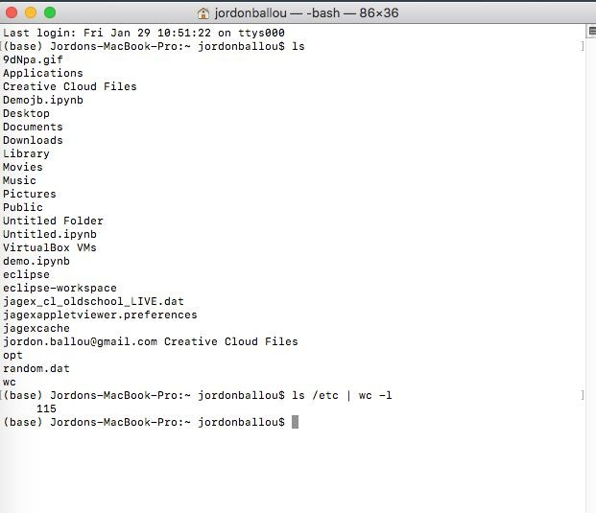

This linux command line “ls /etc | wc -1”lists all files under the base directory and at the same time counts the files and prints the number in the next line. Instead of listing every single file, pipeline cuts that part and jumps ahead to the next command which is counting them.

1. In a Linux system, you can issue the command **ls /** to check the sub directories under root. Please describe the meanings of directory /bin, /dev,

/boot, /usr, /etc, /mnt, /sbin, /var separately. For example, you can say that

/bin contains binary executable files.

/bin - contains binary executable files

/dev - location of special device file for all the devices

/boot - contains files that are used in booting the OS

/usr - location of user programs and files

/etc - where configuration files and directories are located

/mnt - generic mount point which you make a filesystem available to the system

/sbin - standard subdirectory of the root directory in Linux and or Unix-like OS that contains executable programs

/var sub directory of the root directory which the system writes data during the course of its operation

1. What is the meaning of Multitask and Multi-user in a Unix system?

Multitask: Unix can perform multiple jobs at one time, dividing the processor’s time between the tasks so quickly it looks like it’s running at the same time. You can have many windows open.

Multi-user: allows more than one person to use the computer resources at a time and users can share data with one another.

1. What does -rwxr-xr-x mean in terms of permissions for a file? What is the exact unix command (with the octal representation) for changing the permissions to this setting?

The user has read, write and execute permissions; the group and others can only read and execute.

chmod 755 ‘file name’

1. In class, you have learned the meaning of read, write and execute permission for regular files. However, these permissions are also applied to directories. So please describe the meaning of read, write, and execute permission for directory.

Read: Permission gives you the authority to open and read a file, gives you the ability to list its content.

Write: gives you the authority to modify the contents of a file. In a directory, you have the authority to add, remove and rename files stored in the directory.

Execute: allows you to execute or run programs, in Linux/Unix you can only run a program if the permission is set.

**Part II-a**

**Regular Expression**

**Find outcomes for each given basic/extended regular expression (maybe multiple correct answers)**

**Points per question: 2.5**

*Example:*

*‘ab+a’* （*extended regex*）

***Answer****: aba , abba ; Pattern : The matched string should begin and end with ‘a’ and ‘b’ occurs at least once between leading and ending ‘a’)*

Note: 7) to 10) are basic regexes; Note: 11) to 18) are extended regexes.

7) ‘a[ab]*a’

Answer: aa, aaa, aba, aaba

8) ‘a(bc)?’

Answer: a, abc

9) ‘.[ind]*’

Answer: mi, t, tn, td, miidn

10) ‘[a-z]+[a-z]’

Answer: abcd, avc, ad

11) ‘[a-z] (\+[a-z])+’

Answer: a+b, a+b+b

12) ‘a.[bc]+’

Answer: abb, atbc,aucb

13) ‘a.[0-9]’

Answer:at0,ar9

14) ‘[a-z]+[\.\?!]’

Answer:a., abcd?, az!

15) ‘[a-z]+[\.\?!]\s*[A-Z]’

Answer:a.A, abc! Z, abcds?B

16) ‘(very )+(cool )?(good|bad) weather’

Answer: verycoolgood weather, veryverybad weather

17) ‘-?[0-9]+’

Answer:9, -2, -345, 454

18) ‘-?[0-9]*\.?[0-9]*’

Answer:' ', -0t9, -y, 9u9

**Part II-b**

**Regular Expression**

**Write down the extended regular expression for following questions.**

**E.g. Social security number in the format of 999-99-9999. Answer: [0-9]{3}-[0-9]{2}-[0-9]{4}**

**Points per question: 5**

1. Valid URL beginning with “http://” and ending with ".edu" (e.g. [http://cs.gsu.edu,](http://cs.gsu.edu/) http://gsu.edu)

Answer: ^(http):\/\/\ ([A-Z a-z]{2,3}\.)+\.edu$

1. Non-negative integers. (e.g. 0, +1, 3320) Answer: /^\d+$/
2. A valid absolute pathname in Unix (e.g. /home/ylong4, /test/try.c) Answer: /(\/[\w\.])+/
3. Identifiers which can be between 1 and 10 characters long, must start with a letter or an underscore. The following characters can be letters or underscores or digits. (e.g. number, _name1, isOK).

Answer: /(^[_A-Z a-z-]+[\d]*){1,10}/

1. Phone number in any of the following format: 9999999999,999-999- 9999, (999)-999-9999. (Note: all of these formats should be matched by a single regular expression)

Answer: /[\d]{10}\[\d]{3}-[\d]{3}-[\d]{4}\([\d]{3}\)-[\d]{3}-[\d] {4}/

**Part III Programming**

**Points per question: 15**

24. Create a file named homework_instructions.txt using VI editor and type in it all the submission instructions from page1 of this document. Save the file in a directory named *homeworks* that you would have created. Set the permissions for this file such that only you can edit the file while anybody can only read. Find and list (on the command prompt) all the statements that contain the word POINTS. Submit your answer as a description of what you did in a sequential manner (e.g. Step1 … Step 2… and so on..). Add a screenshot to your answer as a proof of evidence.

Step1: Created a directory named “homeworks”

Step2: move into homeworks directory and created txt file “homework_instructions.txt”

Step3:paste homework instructions page 1 into the txt file and saved into homeworks directory

Step4:check to see what permissions were set to by typing “ls -l” in command and set them to user -rw and group and others to -r

Step5: used “grep” command to copy and paste each line that contains the keyword POINTS from the txt file

