Jordon Ballou

Lab3 Out of Lab assignment

Rondel

Part 1

1. Vi Try.c

6. :1,2y

:0

P

7. :1,2d

9. :1,$s/fptr/FTPR/g

Part 2

3. vi RealEstate.csv

6. grep -n -C 2 111 EAST RealEstate.csv

Line 896

8. :50,54 s/,/:/g

11.press o (lowercase o) and type in the beginning of the file and press esc to switch to command mode

13. :wq

Part 3:

1. cd ~/Lab3
2. ls -l Try.c
3. chmod u-r Try.c
4. ls -l Try.c
5. vi Try.c

10.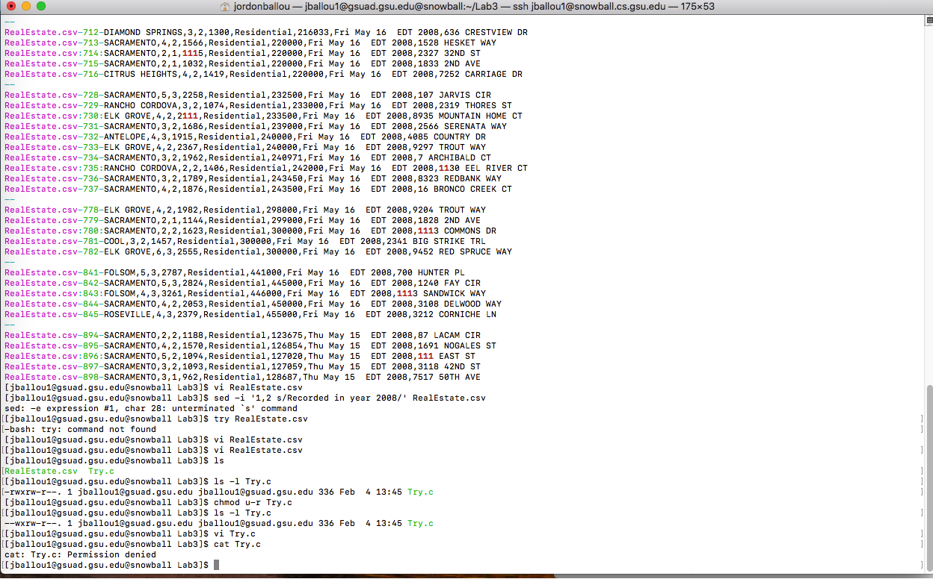

11. chmod 444 Try.c

12. the first -r means the user can only read the program

The second -r means that the group can only read

The last r- means others can only read the program

15.) Error message shows that you cannot edit a read only file

16.) chmod 666 Try.c

17.) -rw-rw-rw-

The first -rw is the user’s permission to write and read

Middle -rw is group’s permission to write and read

Last -rw is other’s permission to read and write

|  |  |  |  |  |  |  |
| --- | --- | --- | --- | --- | --- | --- |
| Owner’s permission | Ls | Mkdir | Cat> | Rm | Cp | cd |
| --- | N | N | N | N/A | N/A | N |
| --x | N | N | N | N/A | N/A | N |
| -w- | N | N | N | N/A | N/A | N |
| -wx | N | N | N | N/A | N/A | N |
| r-- | N | N | N | N/A | N/A | N |
| r-x | N | N | Y | N/A | Y | Y |
| rw- | N | N | N | N/A | N/A | Y |
| rwx | N | N | N | N/A | N/A | Y |