Figures and tables

Juliana Balluffi-Fry

2023-03-28

## Results

General summary

Collar deployment began in November of 2015 and occurred every winter until March of 2021. During this period, the hare cycle was in its increase phase in 2015, peaked during the 2016-2017 winter, crashed from 2017 to 2019, after which it remained in the low until 2021 (Figure 1). Mortality rates changed with the population cycle; hare mortality was lowest in 2016-2017 (cycle peak; 0.1380427 and highest in 2019-2020 (cycle low; 0.2894 ; Figure 1). Snowshoe hare body mass was highest in the peak of the cycle (1.6765877 g) and lowest in the low of the cycle (Figure 2; 1.2741667 g). Some winters accumulated more snow than others, with average snow depth being cm. After initial data cleaning was complete, we analysed gps data from 108 individuals, totaling 627 weekly home ranges. Of these individuals, 163 were male, 464 were female, and of the females 197 were given food add treatments while collared. The mean areas of 90%, 75%, and 50% weekly home ranges (MCPs) were 2.9755929 ha, 1.9493304 ha, and 1.1022009 ha respectively. Results from 90%, 75%, and 50% MCPs were highly correlated (r > 0.78), and we completed all home range size analyses with the 90% MCP results.

Home range results across all cycle phases

Snowshoe hare home ranges were largest in the low of the cycle (2019-2020) and smallest in the peak of the cycle (2016-2017; Figure 3). The AIC comparison ranked the competition-resource model to be the most parsimonious for explaining cross-phase home range sizes. All other models had delta-AICs > 2 (Table 1). The top model, competition-resource, had an R2 of 0.19 . In this model, home range size showed a negative relationship to hare density (insert stat). There was also a negative relationship between home range size and snow depth, and this was shown in all models (Figure 4). Neither body weight, food add, nor their interaction had an effect on home range size (Table 2). The next most parsimonious model was the phase-resource model, which had an R2 of 0.16 . It found that hares in the peak of the cycle had significantly smaller home ranges than hares in the low of the cycle, consistent with the competition-resource model. The predation-resource model was the least parsimonious of the three models, and had an R2 of 0.15 . This model found a positive relationship between mortality rates and home range size (Figure 4).

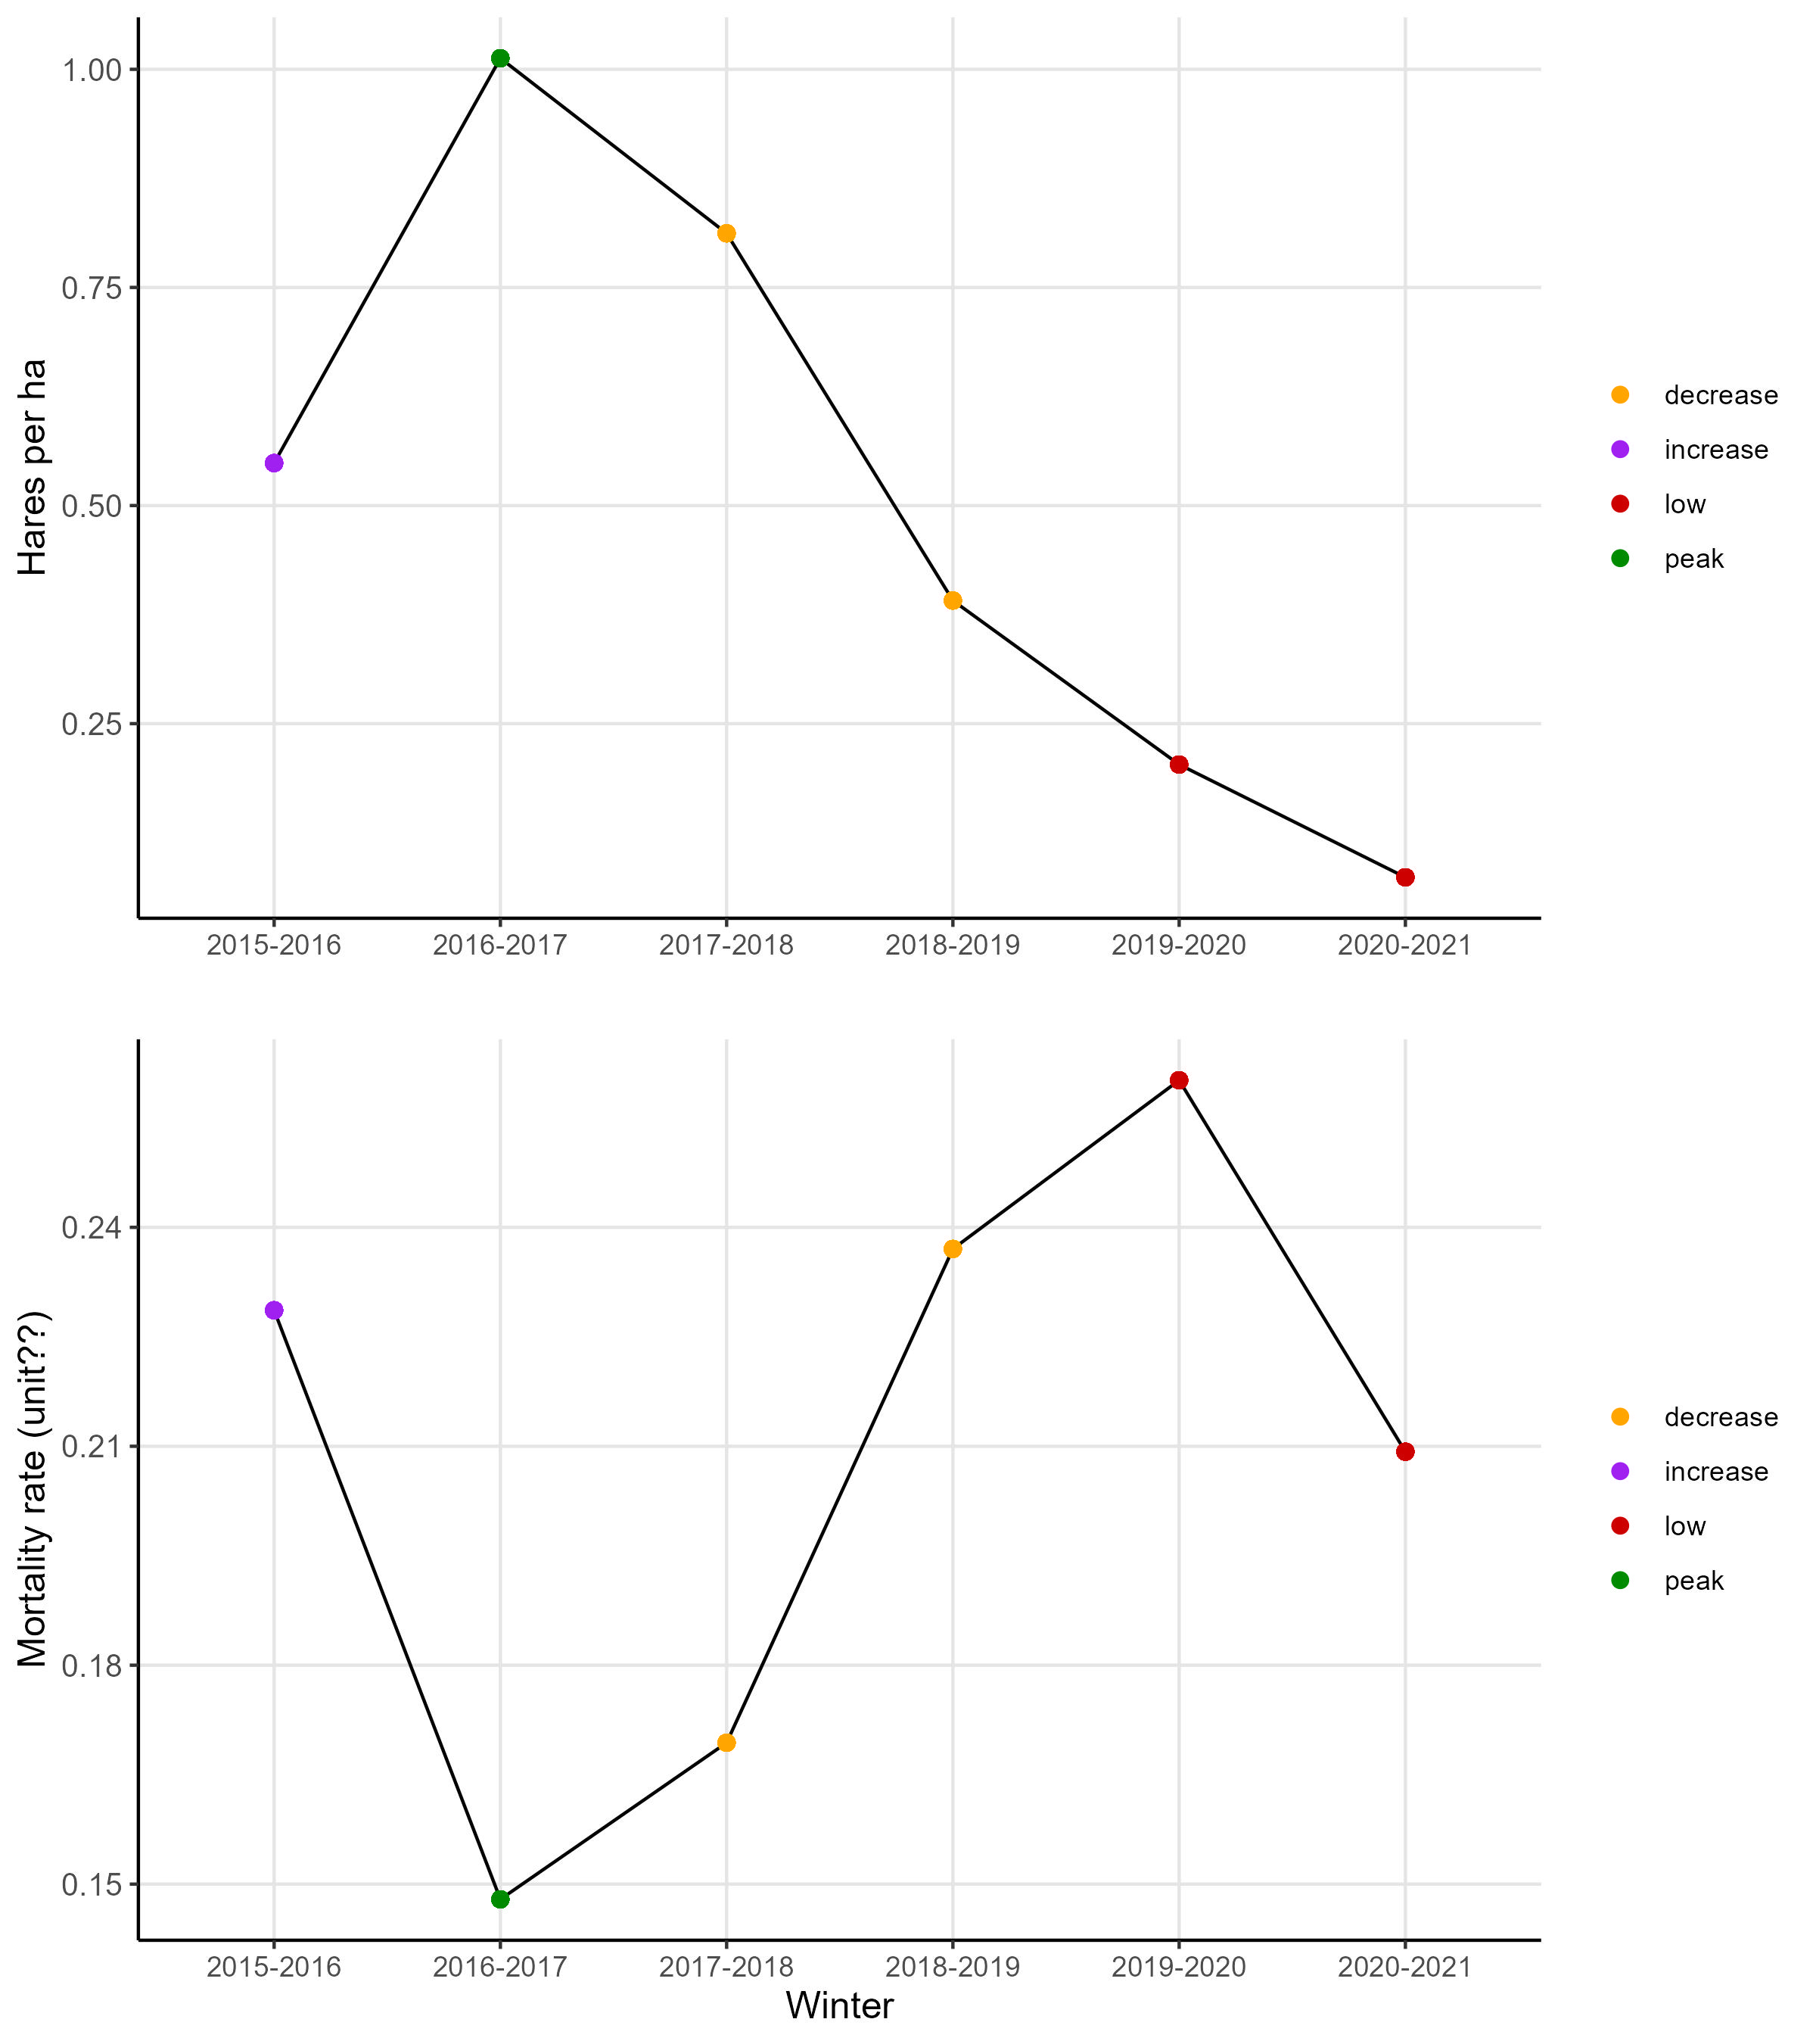

Figure 1. Summary figures of predator-prey densities over the sampled years.

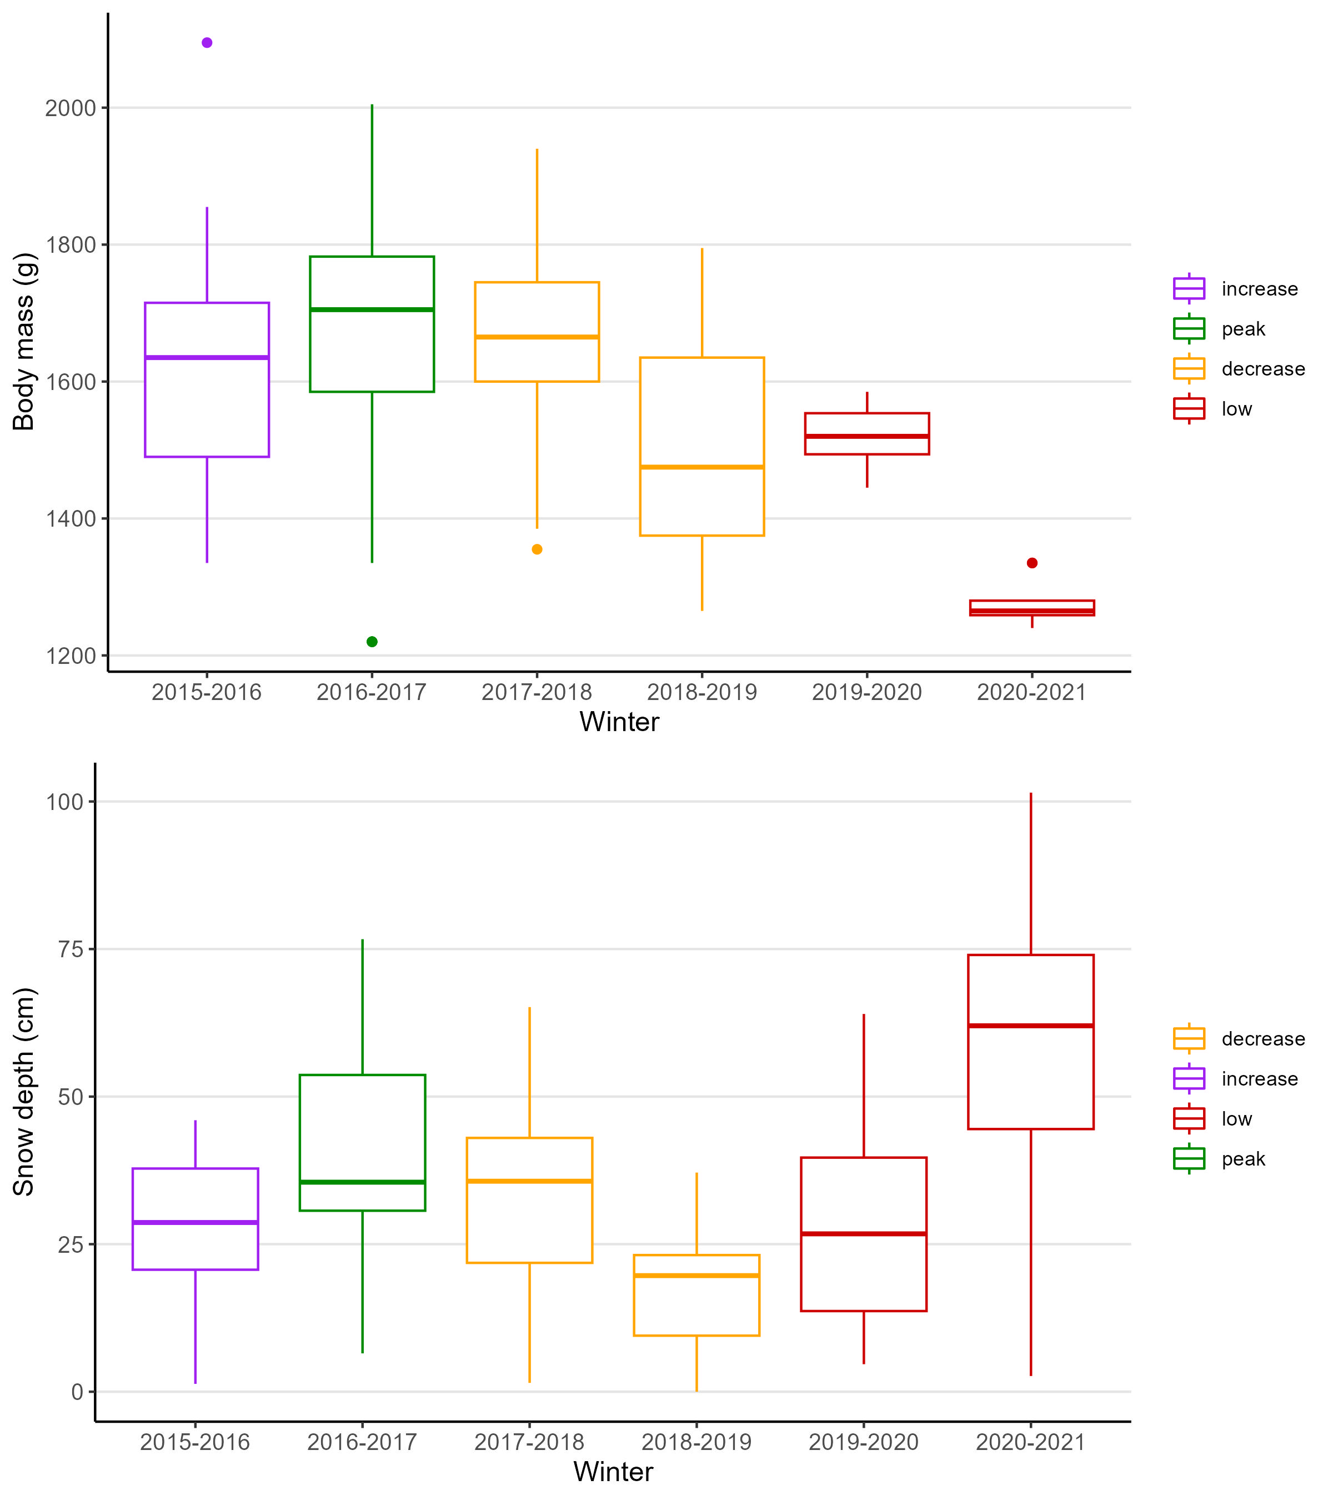

Figure 2. Resource variables over the sampled years.

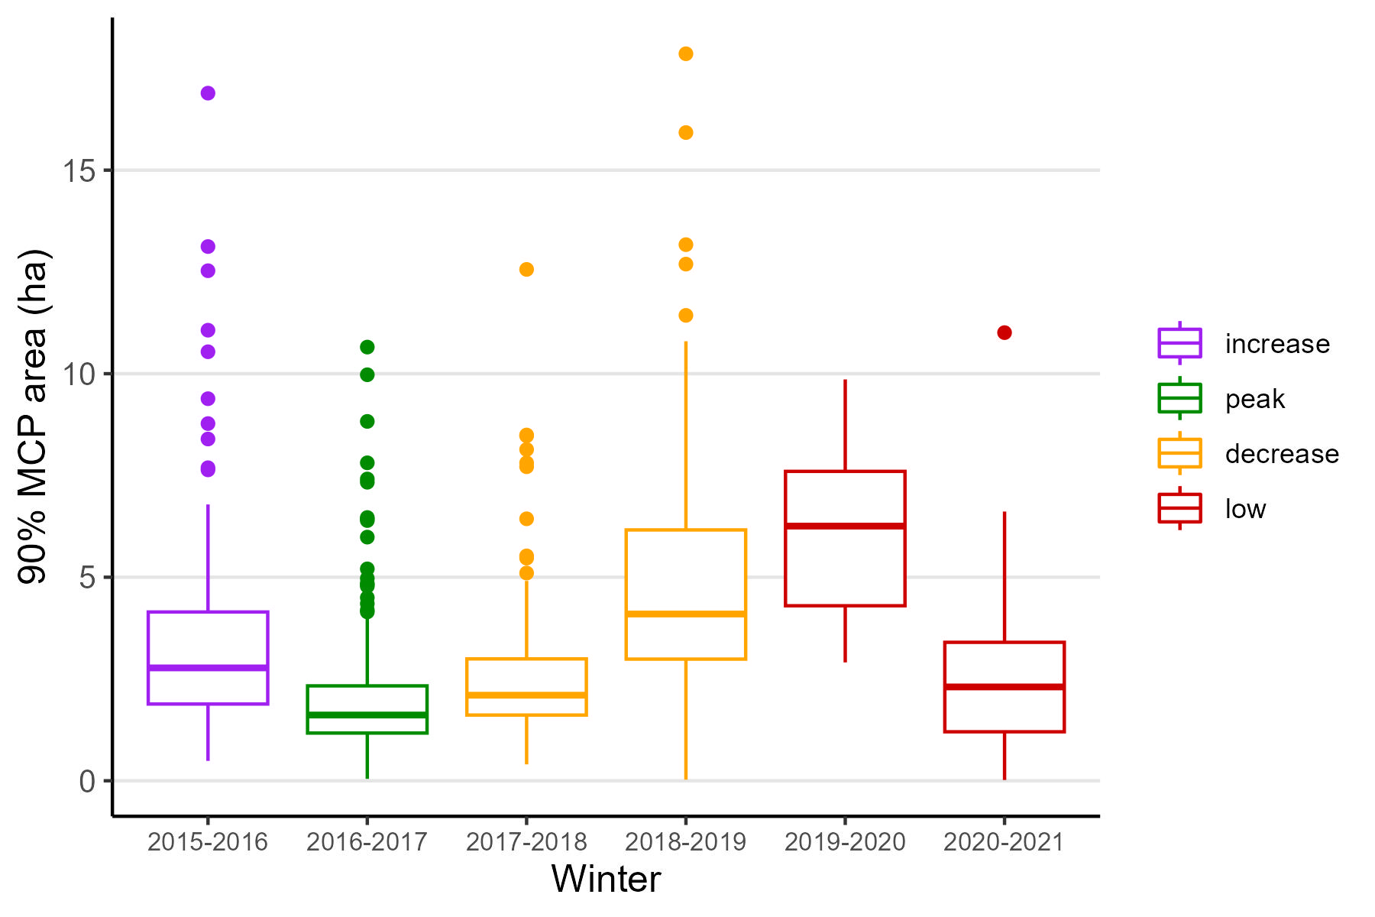

Figure 3. Home range by year.

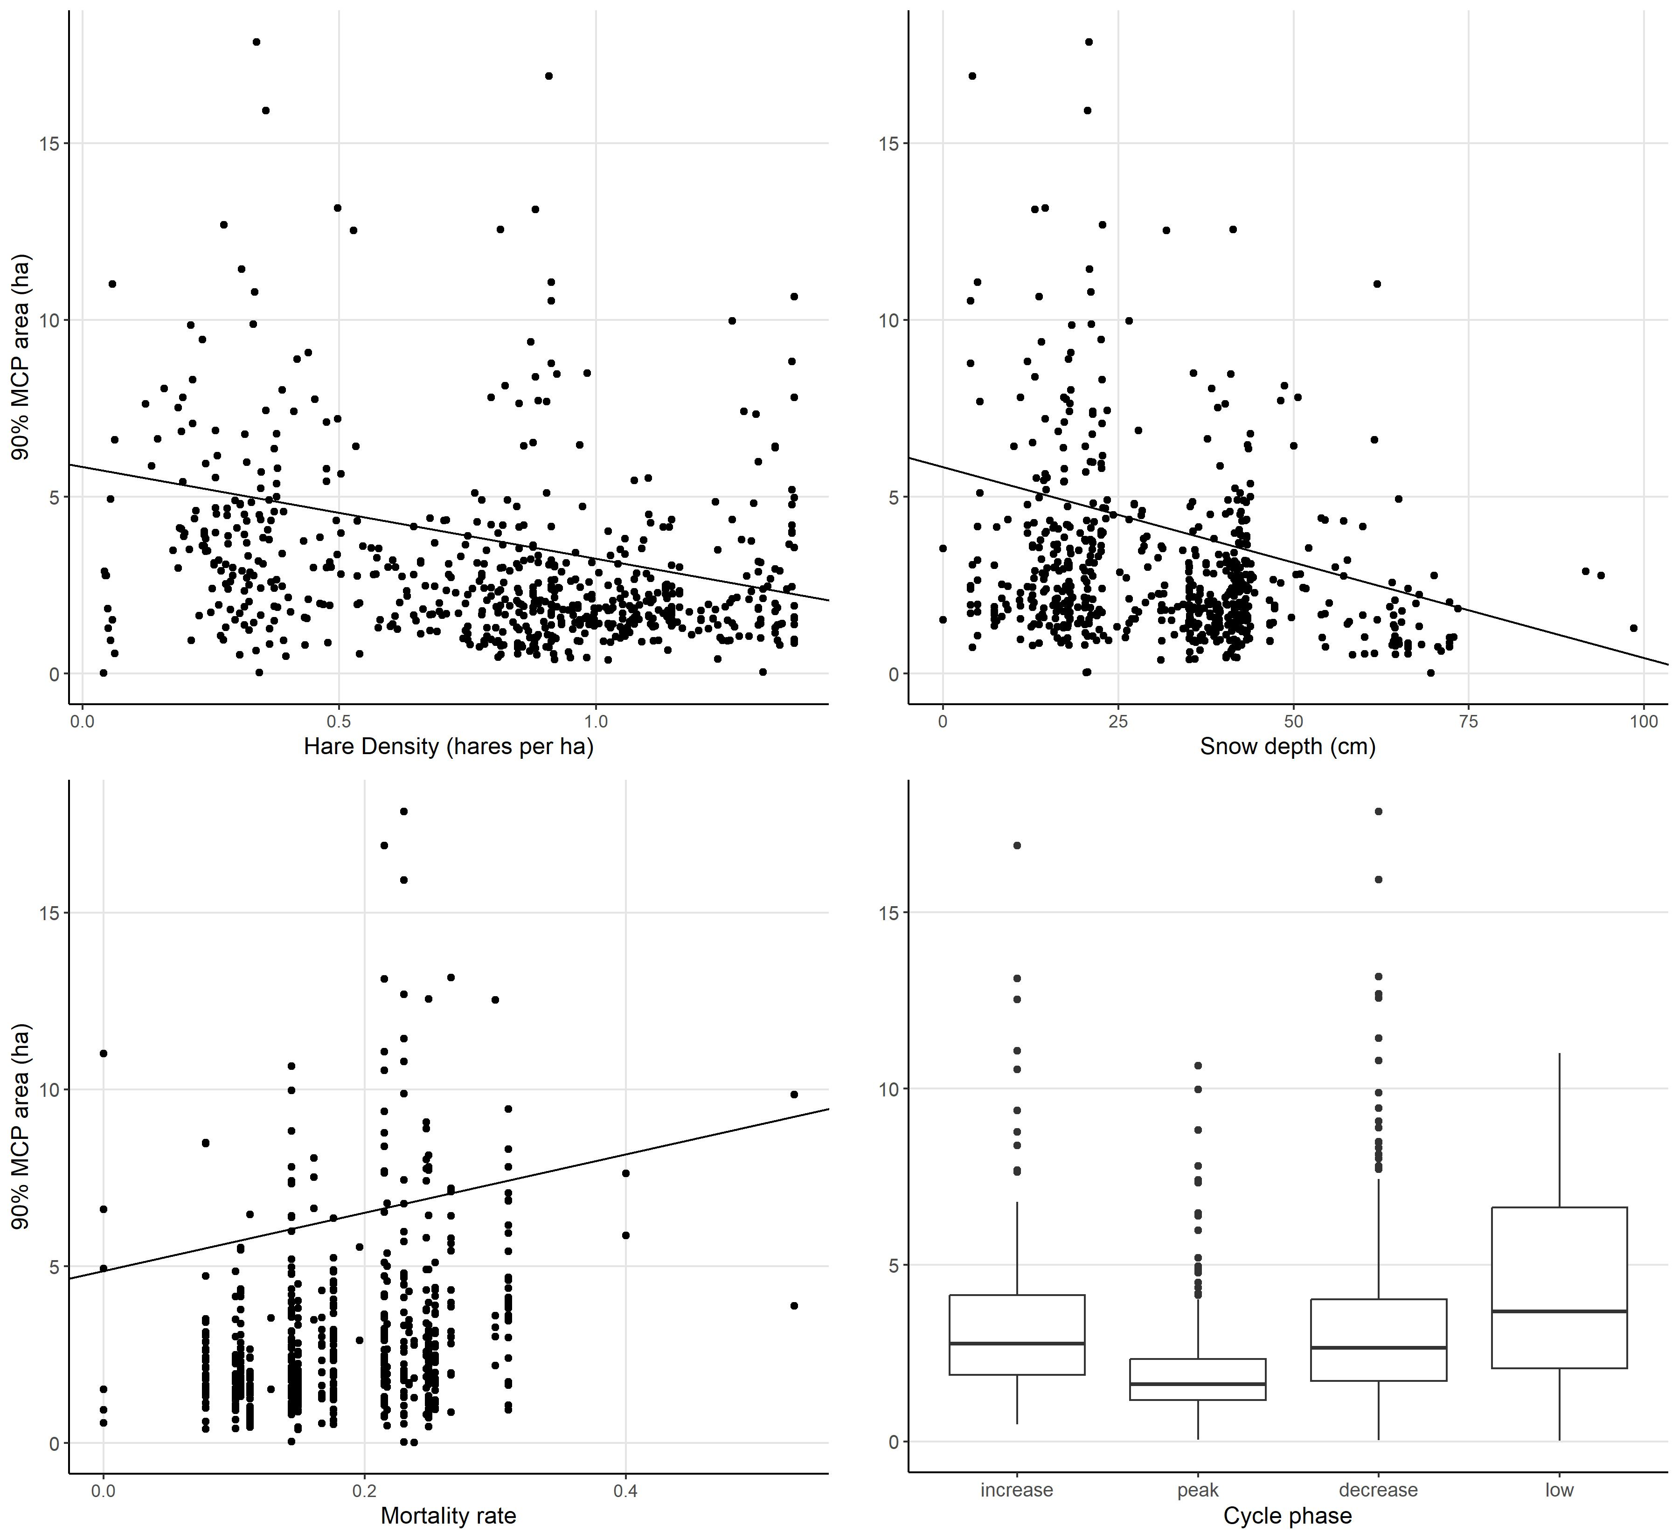

Figure 4. Trends for home range size across the cycle