Preliminary_results
Juliana Balluffi-Fry
2026-06-02

Preliminary Analysis
Below is the basic relationship between growth rate, litter size, and density.
#this model is Growth Rate ~ Litter Size x Local Density Category
bmod <- lm(growthrate ~ littersize*density_cat, control)
anova(bmod)
## Analysis of Variance Table
##
## Response: growthrate
## Df Sum Sq Mean Sq F value Pr(>F)
## littersize 1 48.16 48.160 246.6033 < 2e-16 ***
## density_cat 2 1.38 0.692 3.5418 0.02907 *
## littersize:density_cat 2 0.08 0.039 0.2003 0.81849
## Residuals 3274 639.39 0.195
## ---
## Signif. codes: 0 '***' 0.001 '**' 0.01 '*' 0.05 '.' 0.1 ' ' 1
#plot regressions on top of raw data
ggplot(control, aes(x = littersize, y = growthrate, group = interaction(density_cat))) +
geom_point(alpha = 0.3, aes(color = density_cat)) +
geom_smooth(method = "lm", aes(color = density_cat), se = FALSE) +
labs(x = "Litter size", y = "Growth rate (g/day)", color = "Density") +
theme_minimal()
## `geom_smooth()` using formula = 'y ~ x'
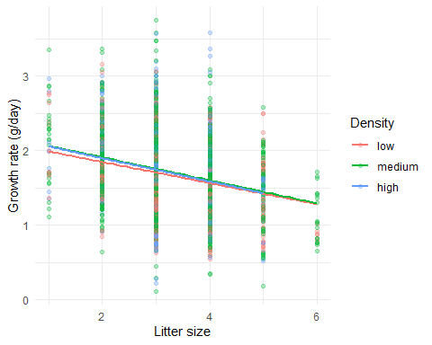
#this model is Growth Rate ~ Litter Size x Local Density Category using standardized
bmod_std <- lm(growthrate_std ~ littersize_std*density_cat, control)
anova(bmod_std)
## Analysis of Variance Table
##
## Response: growthrate_std
## Df Sum Sq Mean Sq F value Pr(>F)
## littersize_std 1 246.87 246.871 273.9708 < 2e-16 ***
## density_cat 2 5.88 2.942 3.2653 0.03831 *
## littersize_std:density_cat 2 3.30 1.651 1.8324 0.16019
## Residuals 3266 2942.94 0.901
## ---
## Signif. codes: 0 '***' 0.001 '**' 0.01 '*' 0.05 '.' 0.1 ' ' 1
#plot regressions on top of raw data
ggplot(control, aes(x = littersize_std, y = growthrate_std, group = interaction(density_cat))) +
geom_point(alpha = 0.3, aes(color = density_cat)) +
geom_smooth(method = "lm", aes(color = density_cat), se = FALSE) +
labs(x = "Litter size", y = "Growth rate (g/day)", color = "Density") +
theme_minimal()
## `geom_smooth()` using formula = 'y ~ x'
## Warning: Removed 8 rows containing non-finite outside the scale range
## (`stat_smooth()`).
## Warning: Removed 8 rows containing missing values or values outside the scale range
## (`geom_point()`).
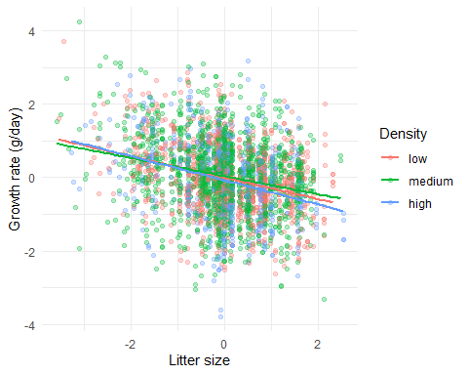
Next, same thing but using the food data set. Add in food treatment as factor.
fmod <- lm(growthrate ~ littersize*density_cat*treatment_food, food)
anova(fmod)
## Analysis of Variance Table
##
## Response: growthrate
## Df Sum Sq Mean Sq F value Pr(>F)
## littersize 1 50.21 50.211 252.3836 < 2.2e-16
## density_cat 2 4.32 2.161 10.8636 1.954e-05
## treatment_food 2 36.15 18.077 90.8630 < 2.2e-16
## littersize:density_cat 2 0.12 0.060 0.3016 0.7396179
## littersize:treatment_food 2 3.59 1.794 9.0164 0.0001231
## density_cat:treatment_food 4 2.04 0.509 2.5584 0.0367850
## littersize:density_cat:treatment_food 4 1.49 0.373 1.8733 0.1121596
## Residuals 5756 1145.15 0.199
##
## littersize ***
## density_cat ***
## treatment_food ***
## littersize:density_cat
## littersize:treatment_food ***
## density_cat:treatment_food *
## littersize:density_cat:treatment_food
## Residuals
## ---
## Signif. codes: 0 '***' 0.001 '**' 0.01 '*' 0.05 '.' 0.1 ' ' 1
ggplot(food, aes(x = littersize, y = growthrate, group = interaction(density_cat, treatment_food))) +
geom_point(alpha = 0.3, aes(color = density_cat)) +
geom_smooth(method = "lm", aes(color = density_cat), se = FALSE) +
facet_wrap(~treatment_food, labeller = label_both) +
labs(x = "Litter size", y = "Growth rate (g/day)", color = "Density") +
theme_minimal()
## `geom_smooth()` using formula = 'y ~ x'
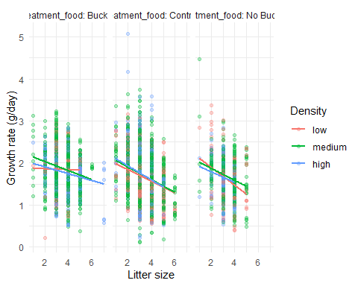
fmod_std <- lm(growthrate_std ~ littersize_std*density_cat*treatment_food, food)
anova(fmod_std)
## Analysis of Variance Table
##
## Response: growthrate_std
## Df Sum Sq Mean Sq F value
## littersize_std 1 341.5 341.47 374.2897
## density_cat 2 11.5 5.73 6.2790
## treatment_food 2 22.0 11.00 12.0526
## littersize_std:density_cat 2 0.5 0.23 0.2472
## littersize_std:treatment_food 2 8.2 4.10 4.4964
## density_cat:treatment_food 4 13.6 3.41 3.7380
## littersize_std:density_cat:treatment_food 4 19.3 4.82 5.2834
## Residuals 5745 5241.3 0.91
## Pr(>F)
## littersize_std < 2.2e-16 ***
## density_cat 0.0018881 **
## treatment_food 5.978e-06 ***
## littersize_std:density_cat 0.7810042
## littersize_std:treatment_food 0.0111888 *
## density_cat:treatment_food 0.0048379 **
## littersize_std:density_cat:treatment_food 0.0003027 ***
## Residuals
## ---
## Signif. codes: 0 '***' 0.001 '**' 0.01 '*' 0.05 '.' 0.1 ' ' 1
ggplot(food, aes(x = littersize_std, y = growthrate_std, group = interaction(density_cat, treatment_food))) +
geom_point(alpha = 0.3, aes(color = density_cat)) +
geom_smooth(method = "lm", aes(color = density_cat), se = FALSE) +
facet_wrap(~treatment_food, labeller = label_both) +
labs(x = "Litter size", y = "Growth rate (g/day)", color = "Density") +
theme_minimal()
## `geom_smooth()` using formula = 'y ~ x'
## Warning: Removed 11 rows containing non-finite outside the scale range
## (`stat_smooth()`).
## Warning: Removed 11 rows containing missing values or values outside the scale range
## (`geom_point()`).
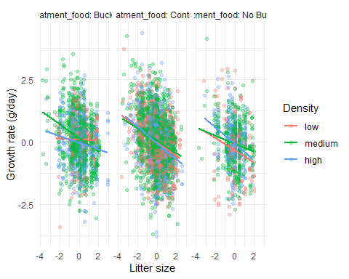
Lastly, same thing but for the rattle data set. Incorporate rattle treatment.
rmod <- lm(growthrate ~ littersize*density_cat*treatment, rattle)
anova(rmod)
## Analysis of Variance Table
##
## Response: growthrate
## Df Sum Sq Mean Sq F value Pr(>F)
## littersize 1 15.911 15.9112 86.0559 < 2.2e-16 ***
## density_cat 2 3.938 1.9689 10.6487 2.964e-05 ***
## treatment 1 0.297 0.2969 1.6061 0.20564
## littersize:density_cat 2 0.969 0.4846 2.6212 0.07372 .
## littersize:treatment 1 3.506 3.5063 18.9639 1.619e-05 ***
## density_cat:treatment 2 1.178 0.5890 3.1854 0.04221 *
## littersize:density_cat:treatment 2 1.709 0.8546 4.6223 0.01026 *
## Residuals 496 91.707 0.1849
## ---
## Signif. codes: 0 '***' 0.001 '**' 0.01 '*' 0.05 '.' 0.1 ' ' 1
ggplot(rattle, aes(x = littersize, y = growthrate, group = interaction(density_cat, treatment))) +
geom_point(alpha = 0.3, aes(color = density_cat)) +
geom_smooth(method = "lm", aes(color = density_cat), se = FALSE) +
facet_wrap(~treatment, labeller = label_both) +
labs(x = "Litter size", y = "Growth rate (g/day)", color = "Density") +
theme_minimal()
## `geom_smooth()` using formula = 'y ~ x'
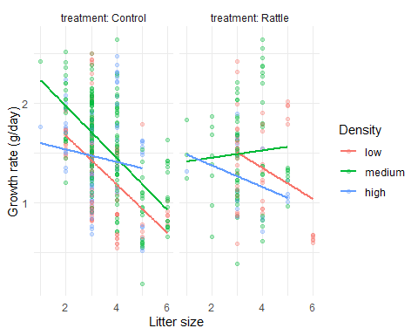
rmod_std <- lm(growthrate_std ~ littersize_std*density_cat*treatment, rattle)
anova(rmod_std)
## Analysis of Variance Table
##
## Response: growthrate_std
## Df Sum Sq Mean Sq F value Pr(>F)
## littersize_std 1 17.20 17.1972 19.1783 1.473e-05 ***
## density_cat 2 12.26 6.1320 6.8384 0.001183 **
## treatment 1 0.05 0.0508 0.0566 0.812050
## littersize_std:density_cat 2 0.02 0.0107 0.0119 0.988135
## littersize_std:treatment 1 14.62 14.6191 16.3032 6.314e-05 ***
## density_cat:treatment 2 0.71 0.3541 0.3949 0.673968
## littersize_std:density_cat:treatment 2 0.07 0.0348 0.0388 0.961934
## Residuals 464 416.07 0.8967
## ---
## Signif. codes: 0 '***' 0.001 '**' 0.01 '*' 0.05 '.' 0.1 ' ' 1
ggplot(rattle, aes(x = littersize_std, y = growthrate_std, group = interaction(density_cat, treatment))) +
geom_point(alpha = 0.3, aes(color = density_cat)) +
geom_smooth(method = "lm", aes(color = density_cat), se = FALSE) +
facet_wrap(~treatment, labeller = label_both) +
labs(x = "Litter size", y = "Growth rate (g/day)", color = "Density") +
theme_minimal()
## `geom_smooth()` using formula = 'y ~ x'
## Warning: Removed 32 rows containing non-finite outside the scale range
## (`stat_smooth()`).
## Warning: Removed 32 rows containing missing values or values outside the scale range
## (`geom_point()`).
