Preliminary Results
Juliana Balluffi-Fry
2026-06-01

Density Summary Plots
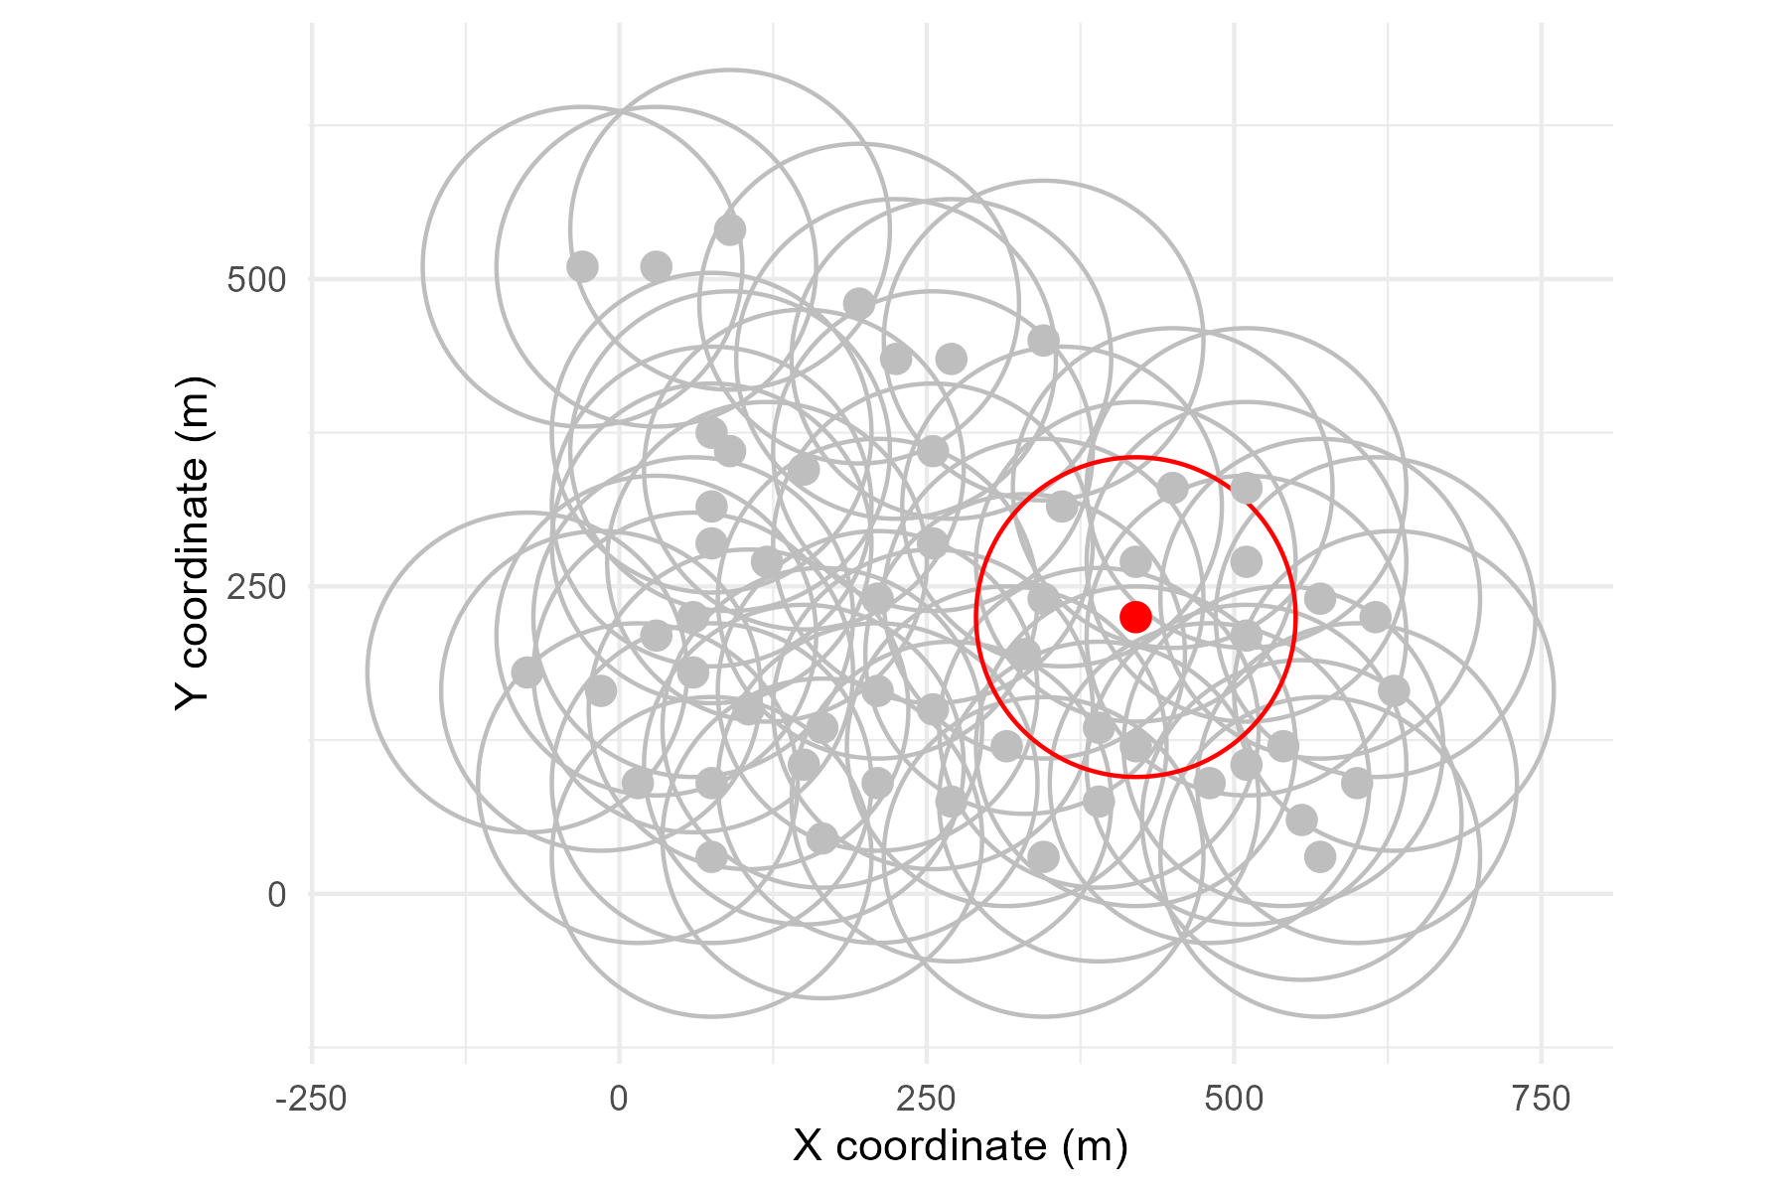
Example of how local density is estimated. All grey points represent the locations (meters) of censused squirrels on one grid during one spring, with one squirrel randomly selected in red. Density was calculated for each squirrel each spring by tallying the number of censused squirrels whose locations fell within a 130 m radius (red circle) of that squirrel’s location divided by the area ((pi*radius^2)/10000.
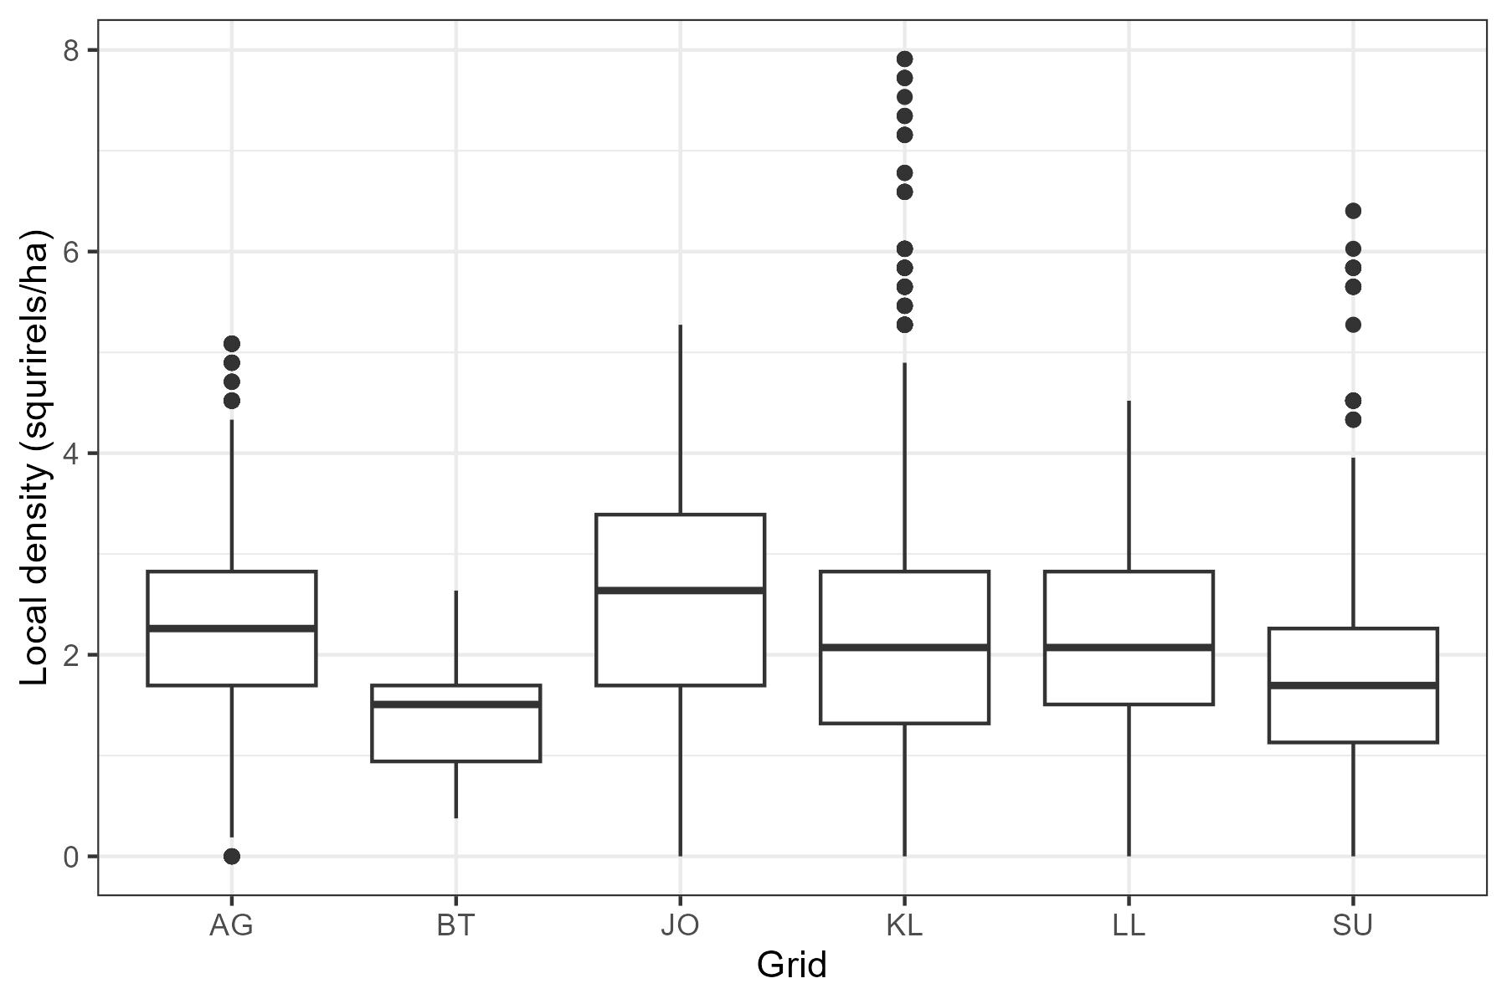
Local densities in May by grid, summarizing census records from 1989 to 2025.
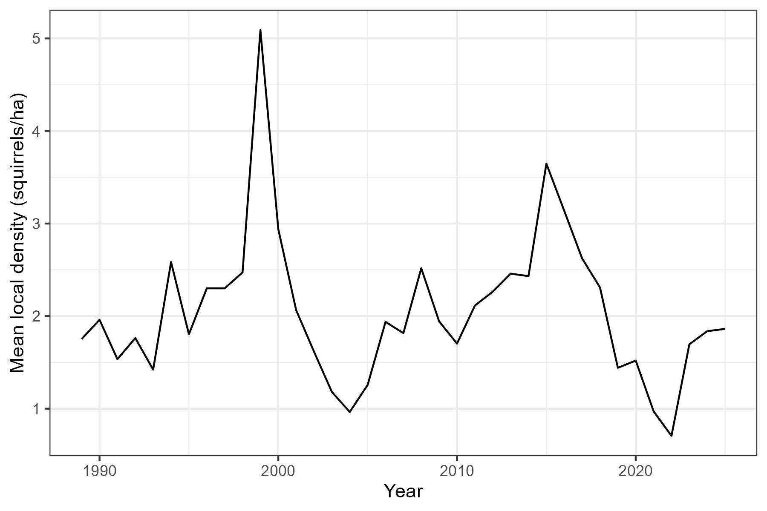
Average local density in May across all grids from 1989 to 2025.

Growth Rate Summary Plots
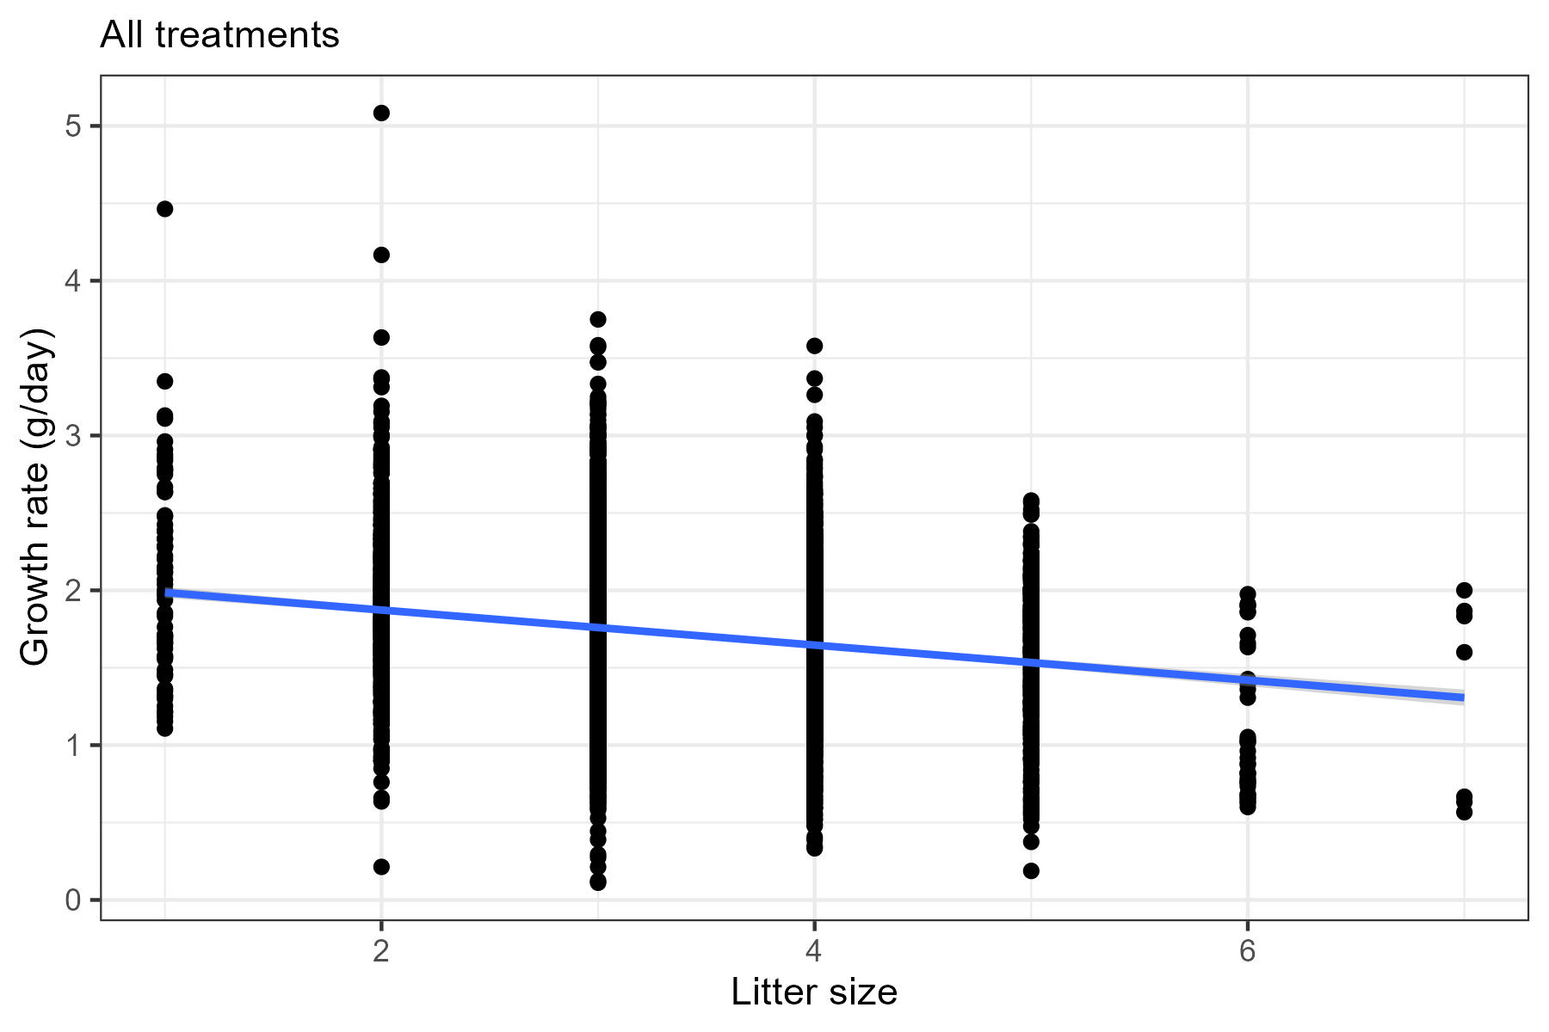
Growth rate (g/day) of first litter juveniles in response to categories of litter size. Data includes all years and all treatment grids (n = 5948).
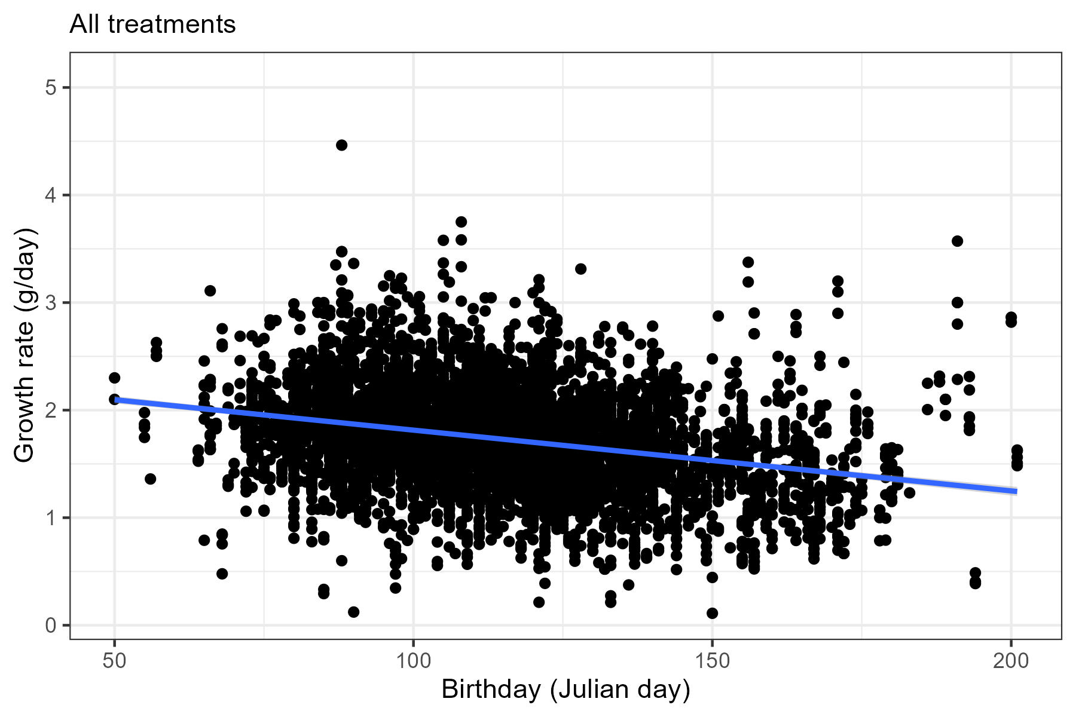
Growth rate (g/day) of first litter juveniles in response to birth month. Data includes all years and all treatments (n = 5948).
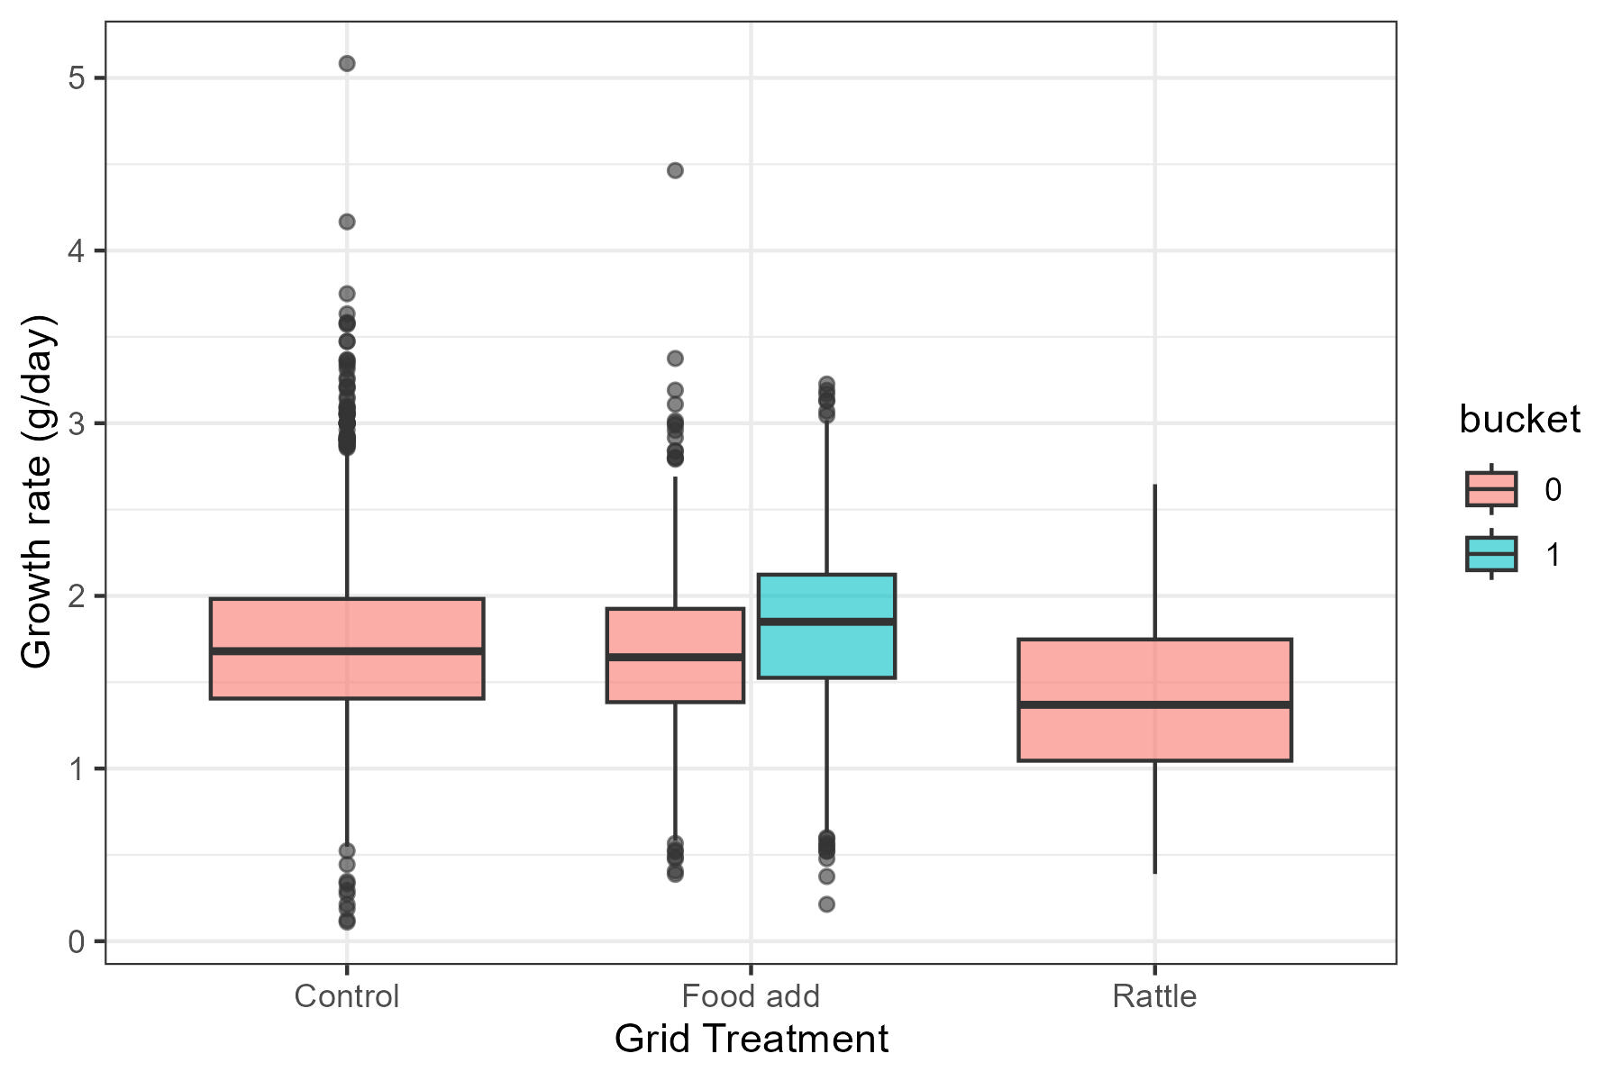
Growth rate (g/day) of first litter juveniles in response to one of four grid treatments, control (n = 3470), food add (n = 2341), or rattle playback (n = 137).
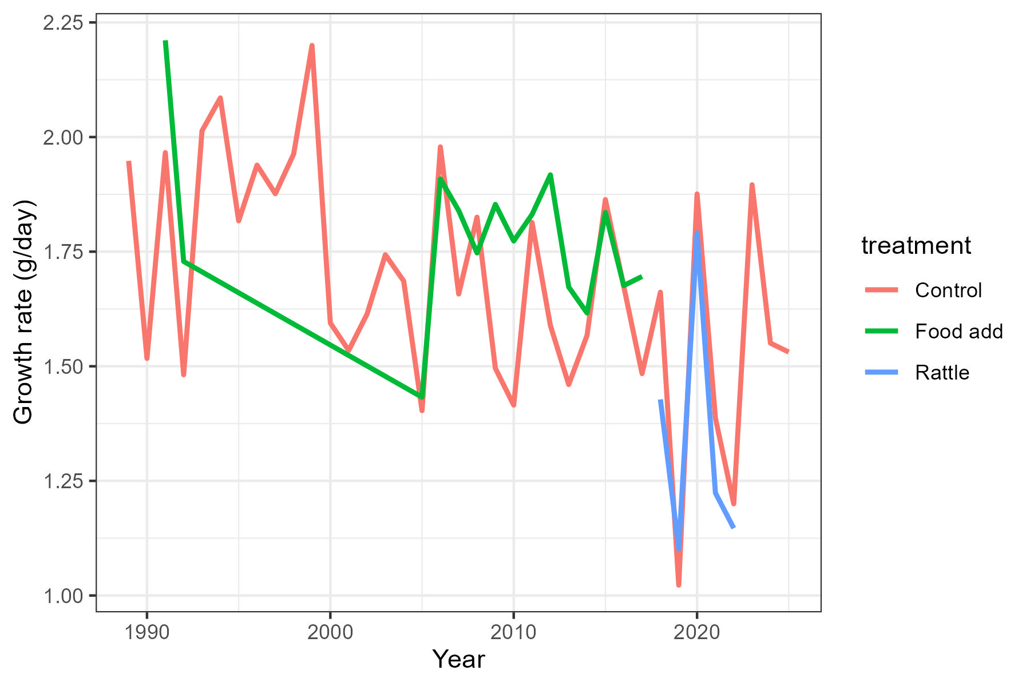
Average annual growth rates (g/day) of first litter juveniles, grouped by grid treatment which here included control (red; n = 3470), food add (green; n = 2341), or rattle playback (blue; n = 137).

