W3 School – React Tutorial – Project – React CSS
Revised: 3 Jan, 2021

Create React App – W3 Schools
https://www.w3schools.com/react/

Uses Create React App (See: https://create-react-app.dev/)

https://www.w3schools

https://www.w3schools.com/react/react_css.asp

React can be styled using:

- Inline Styling
- CSS Stylesheet
- CSS Modules

Inline Styling:

In React, to style an element with an inline style attribute, the value of that attribute must be a JavaScript object.

Note: Double curly brackets must be used because JSX expressions use them and JavaScript objects also use them.

Note: Properties with multiple names must be written in camelCase because they are in a JavaScript object.

I combined their two examples.

class MyHeader extends React.Component {
render() {
return (
<div>
<h1 style={{color: 'red', backgroundColor: 'lightblue'}}>Hello Style!</h1>
<p>Add a little style.</p>
</div>
);
}
}
ReactDOM.render(<MyHeader />, document.getElementById('root'));

Renders:

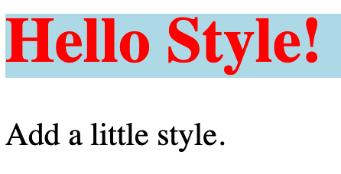

Using a JavaScript Object for Inline Styling:

Create an object with your styling information, and refer to it in the style attribute.

class MyHeader extends React.Component {
render() {
const mystyle ={
color: "white",
backgroundColor: "DodgerBlue",
padding: "10px",
fontFamily: "Arial"
};
return (
<div>
<h1 style={mystyle}>Hello Style!</h1>
<p>Add a little style.</p>
</div>
);
}
}
ReactDOM.render(<MyHeader />, document.getElementById('root'));

Renders:
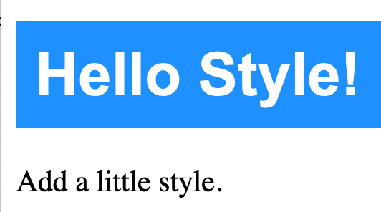

CSS Stylesheet:

CSS styling can be put in a separate file, with a .css filename extension.

MyApp.css:

body {
background-color: #282c34;
color: white;
padding: 40px;
font-family: Arial;
text-align: center;
}

index.js:

import React from 'react';
import ReactDOM from 'react-dom';
import './MyApp.css';

class MyHeader extends React.Component {
render(){
return (
<div>
<h1>Hello Style!</h1>
<p>Add a little style.</p>
</div>
);
}
}
ReactDOM.render(<MyHeader />, document.getElementById('root'));

Renders:

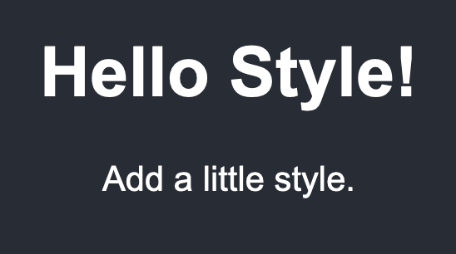

CSS Modules:

CSS modules are a way of packaging CSS that prevents namespace conflicts.

I modified their example to demonstrate preventing namespace conflicts.

index.js:

import React from 'react';
import ReactDOM from 'react-dom';
import Vehicles from './Vehicles.js';

ReactDOM.render(<Vehicles />, document.getElementById('root'));

Vehicles.js:

import React from 'react';
import styles01 from './mystyle01.module.css';
import styles02 from './mystyle02.module.css';

class Vehicles extends React.Component {
render() {
return (
<div>
<h1 className={styles01.myblue}>Hello Car!</h1>
<h1 className={styles02.myblue}>Hello Bus!</h1>
</div>
);
}
}
export default Vehicles;

mystyles01.module.css:

.myblue {
color: DodgerBlue;
padding: 40px;
font-family: Arial;
text-align: center;
}

mystyles02.module.css:

.myblue {
color: Blue;
padding: 20px;
font-family: Times;
text-align: left;
}

Renders:



